Controlled Speaking Practice:

Contrasted Sounds in Tongue Twisters

- Divide class into two groups.

- Hand out tongue twisters. Ask students which contrasting features are highlighted in each one.

- Have group 1 underline all words with one feature, and group 2 underline the second feature.

- Recite tongue twisters aloud: group 1 should say all words with feature one, and group 2 should say all words with feature 2. Instructor will say all other words. See how fast it can go.

Group 1: /sk/  A basket of biscuits,  A box of biscuit mix,  And a biscuit mixer | Group 2: /ks/  A basket of biscuits,  A box of biscuit mix,  And a biscuit mixer | Instructor  A basket of biscuits,  A box of biscuit mix,  And a biscuit mixer

Group 1: /s/
She sells seashells by the seashore.
The shells she sells are surely seashells.
So if she sells shells on the seashore,
I’m sure she sells seashore shells.

Group 2: /ʃ/
She sells seashells by the seashore.
The shells she sells are surely seashells.
So if she sells shells on the seashore,
I’m sure she sells seashore shells.

Instructor
She sells seashells by the seashore.
The shells she sells are surely seashells.
So if she sells shells on the seashore,
I’m sure she sells seashore shells.

Tongue Twister Worksheet

Which contrasting sounds are highlighted in the tongue twisters below?

A basket of biscuits,  A box of biscuit mix,  And a biscuit mixer |  | 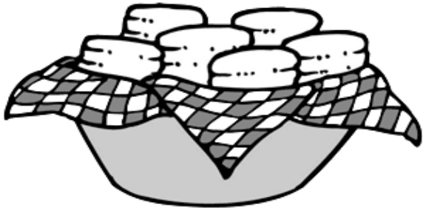
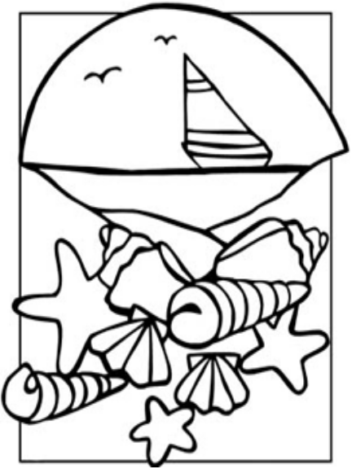 | She sells seashells by the seashore.  The shells she sells are surely seashells.  So if she sells shells on the seashore,  I’m sure she sells seashore shells.

