Final Project

專案名稱: Bowl

描述:設計一個養魚遊戲

遊戲功能:買魚、餵魚、賣魚

使用:

1. Using Inheritance and Polymorphism
2. Using Exception Handling
3. Using Abstract Classes and Interface
4. Event-Driver Programming
5. Using Graphical User Interfaces
6. File I/O (optional)
7. JPanel、JLabel、JButton、ImageIcon
8. ActionListener、TimeListener

創建四個class:

Bowel class:

(set frame)

FrameWork:

JPanel jp_title

JPanel jp_main

JPanel jp_option

JLabel user_grade

JLabel user_experience

JLabel user_money

JButton jb_fish_status

JButton jb_fish_feeding

JButton jb_fish_shop

JButton jb_setFrameWork

JButton jb_exit

User class:

private member:

string username

double money

double experience

Fish class:

private member:

int age

boolean satiety

int speed

double position_x

double position_y

ImageIcon fish_Image

流程圖: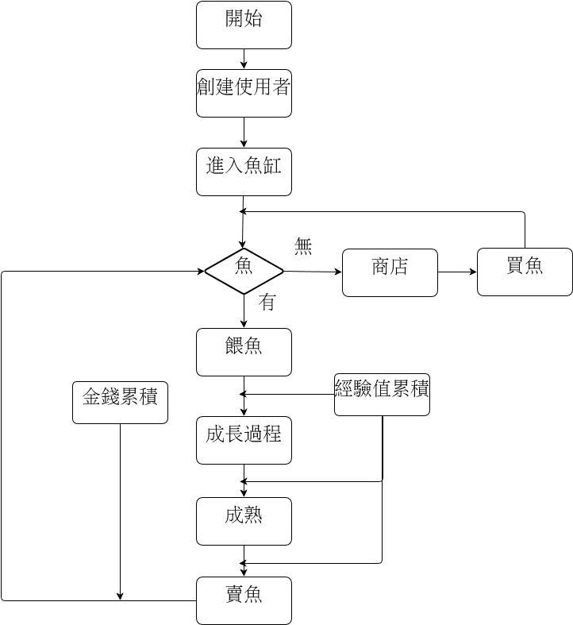

GUI:

