

**AHSANULLAH UNIVERSITY OF SCIENCE & TECHNOLOGY**

**Department of CSE**

# Counting Number of Fingers From Image

Section: B

Group: B1

**Submitted To**

Mr. G.M. Shahriar Shibli

Lecturer

Mr. Mohammad Imrul Jubair

Assistant Professor

**Submitted By**

|  |  |
| --- | --- |
| Samir Sadek | 15-02-04-070 |
| Sajib Kumar Saha Joy | 15-02-04-076 |
| Rimon Shill | 15-02-04-077 |

# Problem Description

Our Problem is counting number of fingers from image. Some images of hand will be given as input. We have to find how many fingers are up in the image.

# Input Description

1. Number of image: There are total 5 images of hand. Different number of fingers are up in different image.
2. Dimensions: The dimension of each images are 742x 680 pixels.
3. Format: png (Transparent Background).

# Methodology

The process of counting number of fingers from image is given below.

Step-1: Read Input Image.

Step-2: Convert the image of step 1 to Binary Image.

Step-3: Preprocessing (Small Object Removal, Filling Holes) the image of step 2.

Step-4: Eroding the image of step-3.

Step-5: Dilating the image of step-4.

Step-6: Subtracting the image of step-5 from the image of step-2.

Step-7: Removing noise from the image of step-6.

Step-8: Counting Number of object (fingers) by using bwlabel function.

**Flow Diagram**

Flow diagram of our project is shown in figure 1.

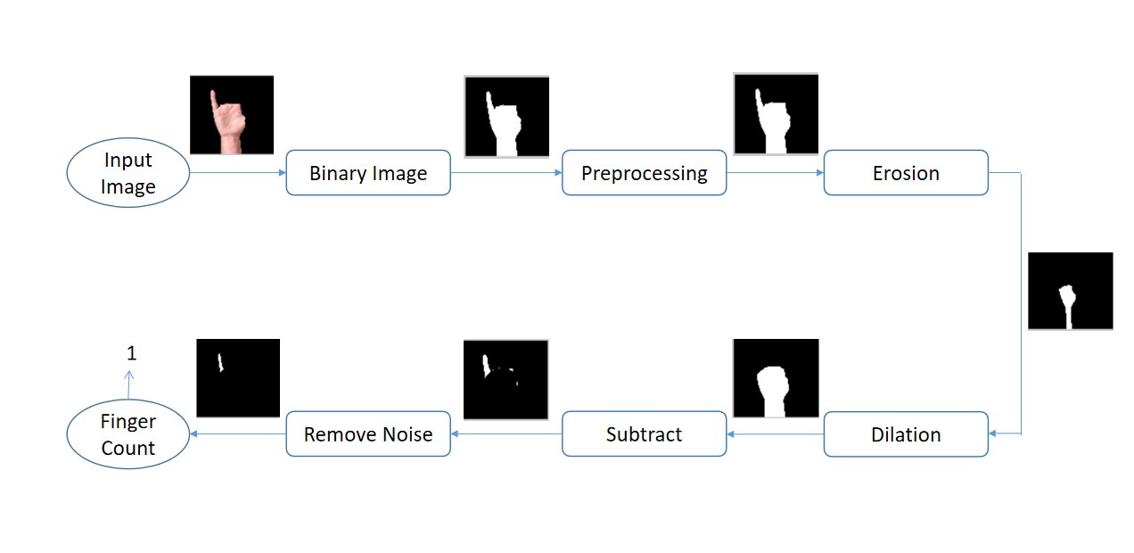

Figure 1: Flow Diagram of Counting Number of Finger

**Used Functions**

1. **imread(‘directory_of_image/image.format’):** Reading image.
2. **subplot(row,colunm,index):** Subploting image in index position on a row*column grid.
3. **imshow(image):** Showing image.
4. **im2bw(image,level) :** Converting image to binary with threshold=level.

5. **strel('disk',r):** Return disk shaped structured element of radius r.

6. **imerode(image,se):** Return eroded image after performing erosion with se.

7. **imdilate(image,se):** Return dilated image after performing dilation with se.

8. **bwareaopen(image,n):** Remove objects which are less than n pixel and return new image.

9. **imfill(image,'holes'):** Fill tiny holes on the image and return new image.

10. **bwlabel(image):** Return labeled object and number of object from the image.

# 

# Discussion

In our project we use some parameter which is fixed for the images we used. We may not get proper output if we use different types of input images. To make it dynamic, we should use some sort of classification algorithm like neural network. We don’t implement classification algorithm in our project. We just implement a simple process which can count number of finger from the some fixed images.