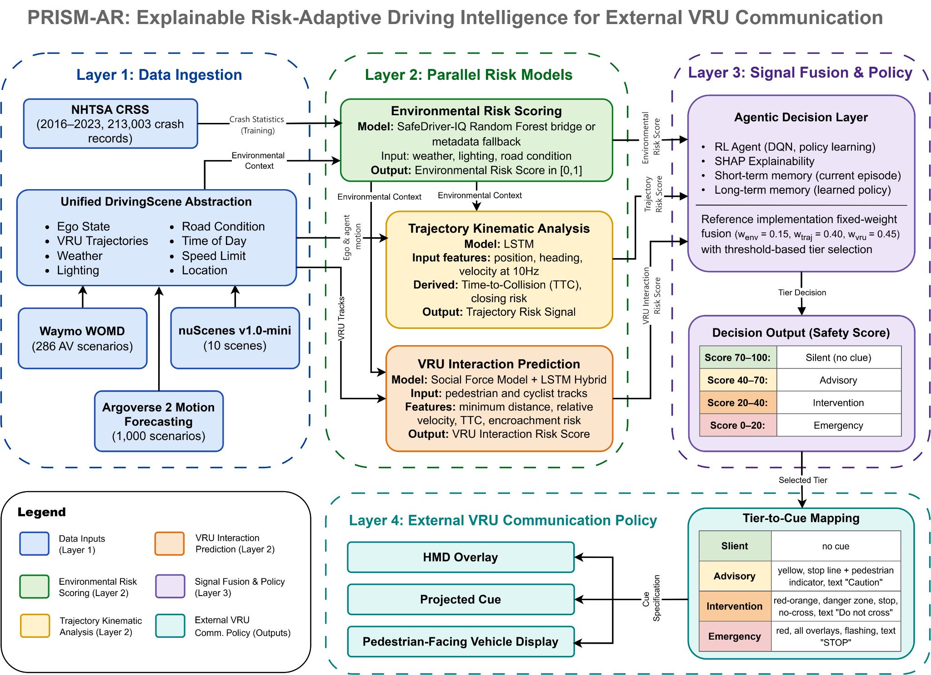

PRISM-AR Phase 3 Architecture Summary
PRISM-AR is Phase 3 of a safety-intelligence research line. Phase 1, SafeDriver-IQ, established the 0-100 inverse crash-probability safety score. Phase 2, PRISM, extended this into multi-model AV risk reasoning. Phase 3 adds the external communication layer that turns internal risk states into adaptive eHMI and AR cues for pedestrians and cyclists.
Architecture Layer | Purpose
Layer 1: Data ingestion | NHTSA CRSS supplies crash-statistical context. Waymo WOMD, Argoverse 2, and nuScenes provide AV scenario clips. All inputs are normalized into a unified DrivingScene abstraction with ego state, VRU trajectories, weather, lighting, road condition, and time-of-day.
Layer 2: Parallel risk models | Three risk streams run in parallel: environmental risk scoring, trajectory kinematic analysis, and VRU interaction prediction. Their outputs describe context risk, motion conflict, and pedestrian/cyclist proximity dynamics.
Layer 3: Fusion and policy | The reference implementation uses fixed-weight fusion and threshold-based tier selection to produce a 0-100 safety score. The broader PRISM lineage supports agentic policy learning, SHAP explainability, and memory-enabled reasoning.
Layer 4: External communication | The selected tier is mapped to cue specifications for HMD overlays, projected cues, or pedestrian-facing vehicle displays. Cue intensity escalates across silent, advisory, intervention, and emergency tiers.

What is new in Phase 3: PRISM-AR does not replace the internal risk engine. It extends the risk intelligence outward so the AV can communicate risk-adaptive guidance to vulnerable road users.
Why this matters: Most eHMI concepts communicate fixed intent states, such as yielding or stopping. PRISM-AR links cues to the vehicle actual risk reasoning, including proximity, closing motion, visibility, weather, and road condition.
Collaboration angle: This phase connects autonomous driving risk intelligence, connected transportation, external human-machine interfaces, and VRU safety communication, which aligns naturally with vehicular communications and connected mobility research.

