**Design and Development of Fire Safety Inspection Management System with GIS-Based Fire Susceptibility Mapping of Panabo City**



Davao Del Norte State College

New Visayas, Panabo City

A proposed project title submitted by:

Basilio, Micho

Ortega, Miguel Luis

Panungcat, Joylan

Sabandal, Jay Art

Vasquez, Regie

March 2021

**Chapter 1**

**INTRODUCTION**

**Background of the Project**

Fire imposes an extreme danger in every developing nation and posture critical danger to life, construction, property, and the environment. In addition, the establishment should be designed to meet the acceptable level of fire safety to minimize the risks from elements such as heat and smoke.

Fire departments are local institutions. They help the people to be more aware of how dangerous fire can be. In some regions, their association gives firefighting administrations. And in some areas, they may likewise give specialized salvage, fire security, fire examination, crisis clinical benefits, and perilous material relief [1]. With rising of technologies, it has never been better for the said department to be more advanced in their process, the GIS (Geographic Information System) has been proved useful to the Fire Department as they gathered the data improves the relationship of the inhabitants and their safety through its firm management and its location services, not only it boosts the possibility of recording the emergencies, there many uses on how can the GIS be utilized like Mapping, Navigation, etc. [3].

In eastern Canada, workers in a small department with less than 20 personnel lie in a small local group of fire-fighters, these dedicated firemen aim to preserve the safety of their local area of roughly 3000 individuals. In managing such hectic work, the respective department used FireQ, a Fire Department Software, this application tracks incident response, training, hazard mapping, record management, and all other types of fire department activities, giving both the firefighter and the Fire Chief an accurate tally of the hours dedicated and how they were spent. The FireQ Fire Department Software, with its Member Statistics feature, further provides the local group of fire-fighters with the instruments they need to ease the administrative process of the Fire Department [4].

In Madrid, the Madrid Volunteer Fire Department also used FireStation® Software, it holds the same features where it does give the Fire Department ease of the process, features of the said software include apparatus checks, expiration date tracking. This software gives preplanning, subscriptions, Fire Inspection, as well a time tracker for the Firefighter in their training progress. But the most important part of FireStation® Software is the practical filing of records in record management [17].

With the importance of records, every Fire Department should maintain a healthy discipline of record management. IBM stated that 90% of the world’s data was created in 2 years alone [6]. In that little period, the world had gathered so much information, so imagine an establishment as large as Fire Department without maintaining a regular schedule of monitoring data, this would cause chaos as large volumes of data becomes nearly impossible to track. That is why maintaining a regular schedule of managing records benefits the establishment, as well as the way of record management effectively sorts out the useful information to keep rather than keeping a large number of files. This in turn grants the establishment an effective and easy retrieval of records as this automates the workflow enabling business continuity [7].

In the Philippines, the DILG Region 8 has experienced problems due to the limitations influenced by COVID, the Department had adjusted their operations to the new normal. The employees are encouraged to use the Document Management System, the accessibility of DMS supports thru desktop or mobile. The DMS had proved that it will become more efficient in managing and tracking documents. This includes the features like document management, workflow automation, reports and dashboard, and more features that will improve the existing process in the said department. [18].

In Western Visayas, the Bureau of Fire Protection dispatched a versatile application called Fire Out 6 that will permit quicker revealing by the general population of any fire occurrence and empower an immediate reaction from the BFP. The application includes a registry of all fire stations in the district, BFP news, fire safety, and emergency treatment tips, and even permits the BFP to find the fire scene through photographs sent by the public which in turn shall the command center finds through Google Maps [5].

With GIS like Google Maps, susceptibility maps have been proved useful in terms of mapping out landslides, fire outrage, and other hazards. The importance of susceptibility maps makes the tracking of information sorted into simpler data where the likelihood of hazard is collected through the help of GIS [8]. As far as Fire Department takes responsive actions in fire hazards, an emergency distress call is a viable indicator for improving the current organization as Emergency Distress Signal or Emergency Distress call can show that the establishment needs help and require immediate assistance [9]. But prank calls have been abusing these kinds of systems as it threatens somebody via telephone just as hanging up the telephone once the receiver has responded to the telephone. It was reported the Department of Interior and Local Government (DILG) uncovered that it got 2.54 million prank calls out of the 18.5 million brings in their 911 hotline in the year 2019 [10]. Prank calls can add up to stalking and harassing. One should exercise judgment and understand that prank calls can make dread and trouble others specifically pranking the government agency may pose a grave threat and may get you arrested [11].

Panabo, formally the City of Panabo, is a third-class part city in the area of Davao del Norte, Philippines. As indicated by the 2015 statistics, it has a populace of 184,599 individuals [16]. The said city is a part of the Davao Metropolitan Area as it imparts lines to Davao City. The city expands to an area of 25,123 hectares.

The Fire Department is one of the reputable establishments in Panabo City, as it serves its people not only when there are disasters in regards to fire, but also introducing a legal process of inspection for Fire Safety papers compliance like reviewing the old, new, and would be establishments inside the city to see if they pass the inspection.

However, the said department ran into some difficulties. Below is the list of problems that are identified by conducting interviews and observations; The Fire Department in the area of Fire Safety is still using a manual process in encoding the whole information for the application of Fire Safety resulting in misplacement of files and mixing with other documents that are not involved with Fire safety. Additionally, The Fire Department encountered emergency distress calls in which the Fire Department responded to turn out to be a prank call. Lastly, Fire Safety Inspectors encounter problems in backing up evaluation forms from their inspection as paper-based documents are susceptible to external elements like water, dust, coffee, fire, etc.

The group has decided to improve the current state of the mentioned problems, the BFP in Panabo City, and proposed a Fire Safety Inspection Management System. This system will provide a solution that includes saving certain information inside the Fire Department that regulates the establishment, inspections, fees, processes that are required for the fire safety certificate.

**OBJECTIVES OF THE PROJECT**

**General Objectives**

The main goal of this project is the Design and Development of Fire Safety Inspection Management System with GIS-Based Fire Susceptibility Mapping of Panabo City.

**Specific Objectives**

Specifically, the capstone team plans a system that will be capable of doing the following:

1. Provide a mobile application for the applicants for compliance with the requirements like Fire Safety clearance and certificates.
2. Provide a mobile application for the Fire Safety inspectors for the inspection processes of the applicants and the establishment.
3. Allow inspector to record the fire inspection details.
4. Allow the owner to notify the department of a fire emergency via Emergency Distress Call thru SMS or Push Notifications.
5. Allow process payment like applicant fees and penalties.
6. Provide susceptibility map
7. Determine the status of the establishments that need an immediate renewal of the documents list.
8. Determine application status of application whether approved, rejected or recommended for re-inspection as well as to provide notification for a new application.
9. Provide statistical reports
   1. List of Approved Applications
   2. List of Rejected Applications
   3. List of reported Establishment for Renewal
10. Generate the following:
    1. Fire Safety Inspection Certificate (FSIC)

a. FSIC for Occupancy

b. FSIC for Business

c. FSIC for Business Renewal

b. Fire Safety Evaluation Clearance (FSEC)

**SCOPE AND LIMITATION**

The project’s goal is to develop a web and mobile based system for Panabo City’s Fire Department in the Fire Safety Inspection Area. Its focus is to make an enhanced web-based system for the Administrator, and mobile-based for the Fire Safety Inspector and Applicants, this system aims to manage the manual existing process of the Fire Safety Inspection. The project scope includes access to the system for the Administrator, Fire Safety Inspectors, and Applicants.

The system aims to provide a web-based process for the Administrator and mobile-based for the Fire Safety Inspector and the Applicants. Allows inspector to record the fire inspection details. Provide a web application for the applicants for compliance with the requirements. Determine the status of the establishments that require immediate renewal. Also, determine application status. Notify the Applicants for their approval whether they passed the inspection or not. It will also calculate applicant fees and penalties with the service of allowing the applicant to pay online. It also provides notification for new applications and provides a susceptibility map. Susceptibility map is a map that features regions or places that tracks the information that are frequently influenced by or are vulnerable against a specific hazards. They are regularly made for hazards, like quakes, volcanoes, avalanches, flooding and fire outbreak. Susceptibility map assist with preventing harm and deaths. Also, the proposed project will provide the necessary statistical report and will generate certificates for fire safety.

Additionally, the recording of daily attendance of firemen, are excluded from the functionality of the system, and other process that are also not mentioned in the objectives means will not be included in the system. The system can only be used within Panabo City. The project aims to solve the problems that are stated above and to provide convenience to the Applicant, Fire Inspector, and the Fire Department.

**SIGNIFICANCE OF THE PROJECT**

**Fire Station Department.** This project will redound to the benefit of the Panabo City’s Fire Department as it will improve current the Fire Inspection Process.

**Fire Safety Inspectors.** This will ease up the effort from the paper works to a paperless approach, therefore, maximizing the performance, time, and effort spent on the inspection.

**Applicants.** will be offered a convenience to reduce the time spent going back and forth for the application and processes going to the Panabo City Bureau of Fire Protection. The applicants are not limited to the residents of Panabo City but also those who are not living here but have set a business inside the city.

**Developers.** The study would help further improve the researcher’s skills as well as enhancing their knowledge in developing systems.

**Future developers.** The study would benefit future developers that will tackle the same study. This will serve as a basis for future upgrades and usage of the project system.

**DEFINITION OF TERMS**

**Emergency Distress Call.** Is a call to authorities notified by the unfortunate establishment that are threatened by serious or imminent danger like fire outbreaks and requires immediate assistance.

**Fire Safety.** Refers to planning and infrastructure design aimed at reducing the risk of fire or impeding the spread of fire when one does break out.

**Fire Department.** The project team’s project topic is an organization that provides firefighting services. In some areas, they may also provide technical rescue, fire protection, fire investigation, emergency medical services, and hazardous material mitigation.

**GIS**. Geographic Information System

**Inspectors**. is a person working from the fire station, whose job is to find out whether people are obeying official regulations of the Fire Inspection if they have passed or failed the evaluation.

**Reports.** A compilation of information that archives all transactions done by the establishment in the Fire Department.

**Susceptibility Map.** A digital map that functions to track all recorded hazards in the area. The frequency of the areas shows how many times that certain area have been struck by the hazard such as fire outbreak.

**CHAPTER II**

**METHODOLOGY**

This chapter’s purpose is to primarily discuss all the techniques, processes, and methods that are crucial in building the system. The project team strictly follows the process of the Iterative Model SDLC or the Iterative Model System Development Cycle to conduct the necessary process and steps in developing the system. The Iterative Model SDLC has plenty of phases to cover such as Initial Planning, Requirement Phase, Design Phase, Implementation and Test, and Evaluation Phase.

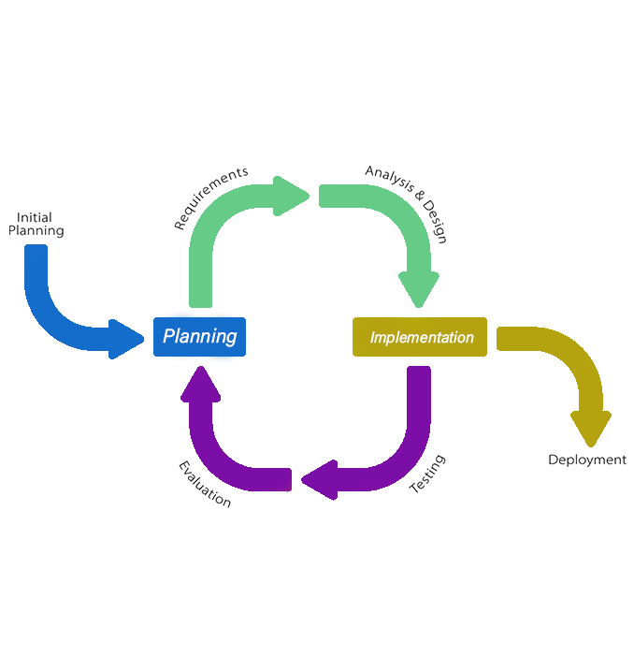The project team used this process to focus on the main purpose as well as the goals of this study as well as a guide in developing the system. The applied steps and methods to meet the needs in developing the project. Figure 1 shows the Iterative Model System Development Life Cycle.

***Figure 1: System Development Life Cycle (Iterative Model)***

**Initial Planning**

This phase is the progression for distinguishing the risks related to the project system and guaranteeing the parameter of the requirements in each cycle.

Planning is the drive that tries to distinguish, plan, and select one advancement project among all potential ventures that could be attempted. The project team has presented a proper request for the development of the project to SNSP Janeth B. Mapesos – Lequigan, the acting city fire director of Panabo City Bureau of Fire Protection. The project team led an environmental scanning and interviewed one of the staff in regards to the issues experienced inside the establishment as well as in the area of fire safety. The Project team distinguished the difficulties the establishment had experienced and had to provide answers for the presented issues.

The Fire Department in the area of Fire Safety currently relies on Microsoft Excel in encoding the whole information for the application of the renewal of establishment. Additionally, from the inspector’s side of their process, they tend to also have their problems with their listed inspection recorded along with the financial prerequisites like inspection fees, fines, etc. that is crucial for the affirmation of the fire safety inspection certificate that is currently on a paper-based approach. Thus, the project team discovered that the issues that are laid should be assembled and computerized measure time, proficient and bother free.

**Organizational Structure**

This is the project development team. This chart refers to the assigned roles of each member functioning together in developing the system. Further information on the organizational structure is shown in figure 2.

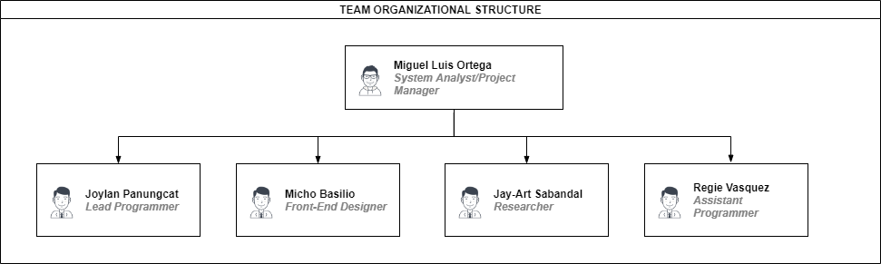

***Figure 2. Project Development Team***

**Role and Responsibilities**

The **System Analyst** isin charge of helping the researchers and the programmer in testing the stability of the system for the Fire Safety Inspection Management System of Panabo City Fire Station Department. This includes the communication between the overall works of the team.

The **Project Manager** isresponsible for playing the lead role in planning, executing, monitoring the progress of the Fire Safety Inspection Management System of Panabo City Fire Station Department.

The **Lead** **Programmer** isresponsible for the overall coding and the integration of the features of the Fire Safety Inspection Management System of Panabo City Fire Station Department.

The **Assistant** **Programmer** isresponsible for the codebase, attend design meetings, write basic code, fix bugs, and assist the Senior Programmer and the integration of the features of the Fire Safety Inspection Management System of Panabo City Fire Station Department.

The **Front-End Designer** is in charge of the user interface part of the system and responsible for assisting the Lead Programmer as well as the revision the user interface for the client’s needs as the front-end designerensures a good user experience executing both a great visual design and code.

The **Researcher** isincharge of the other miscellaneous that the team needs, this includes the financial support, information collection, as well as recording of documentation to assist the System Analyst.

**Work Breakdown Structure**

For the team to create a healthy flow of management in the project schedule, the team has been encouraged to create a Work Breakdown Structure (WBS). The sole purpose of creating this is to serve as a guide to monitor the project effectively, as shown in figure 3.

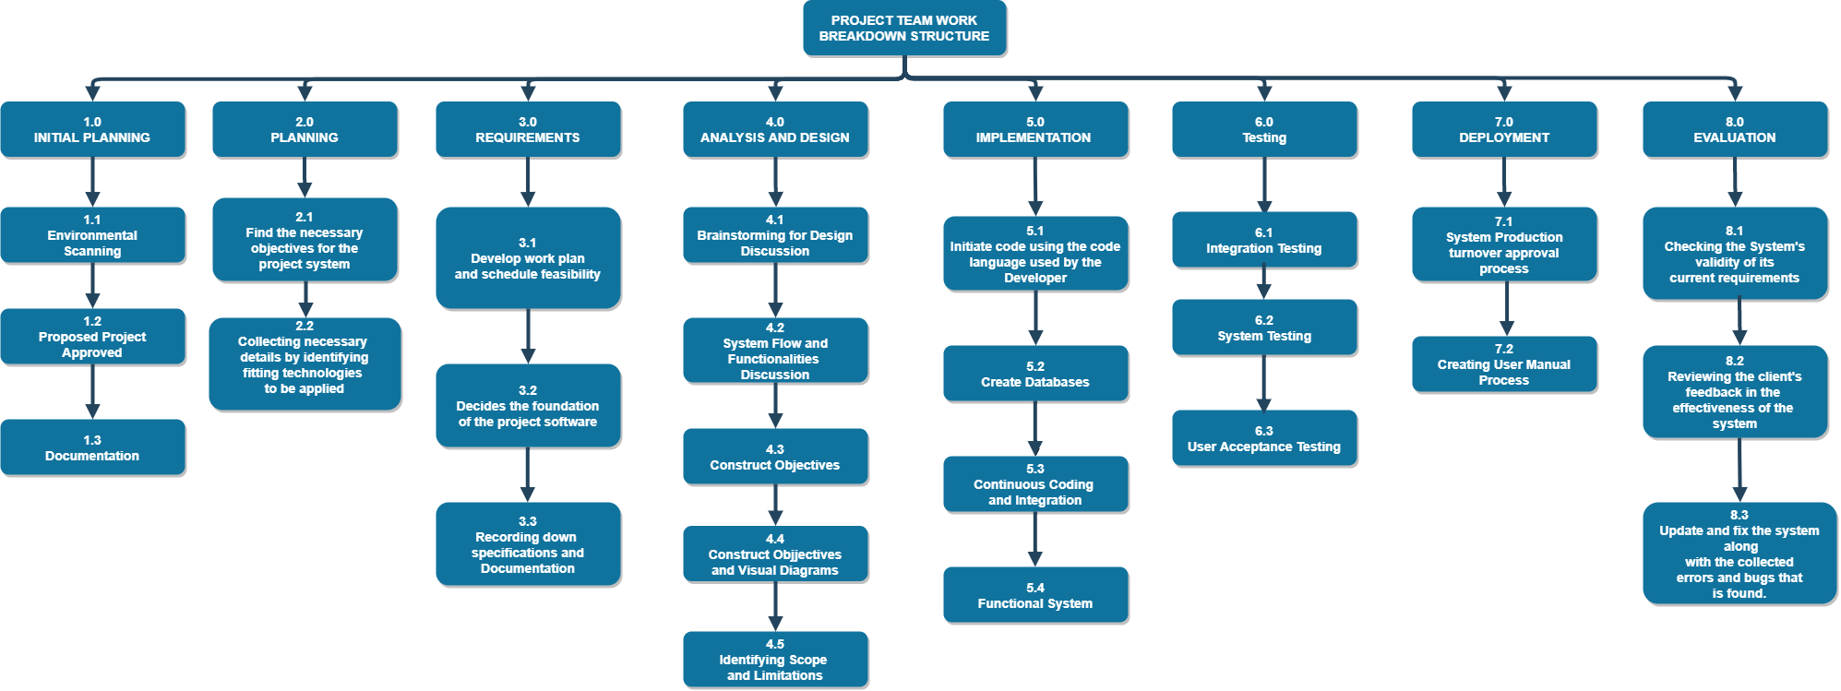

***Figure 3.*** *Work Breakdown Structure*

**Gantt Chart**

The Gantt chart has been utilized for the tracking of the schedule for the creation of the system. The development is based on the different phases found in the System Development Life Cycle where the phases of the system have been conceptualized and coded by the project team. Figure 4 shows the activities in a fixed schedule in realizing the system and its project development.

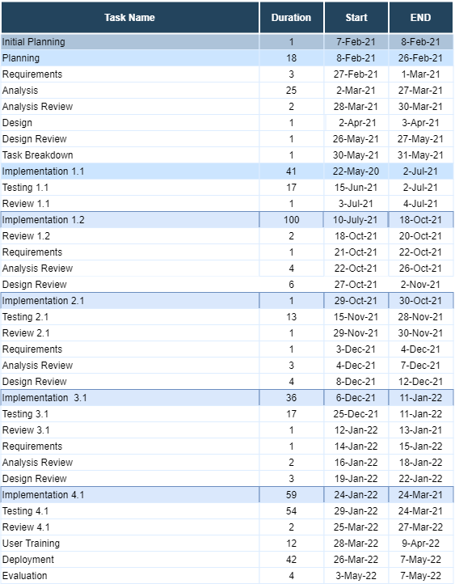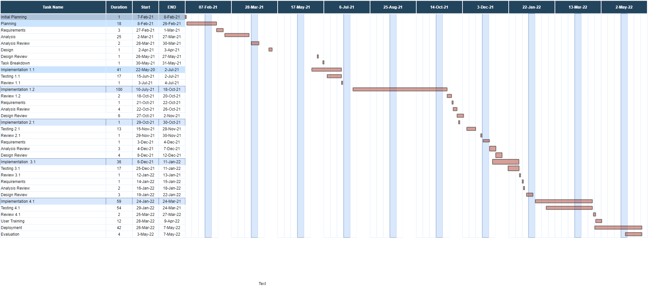

***Figure 4.*** *Gantt Chart*

**Requirements**

The proposed system is a management system about the Fire Department’s Fire Safety processes and because of that, the project team envisions the final state of the released system would do for the client and for the fact that it is a management system, the team expected that the system should provide information in accordance to what the said establishment needs like the inspector’s inspection information, susceptibility map, and the applicant’s payment credential in obtaining the Fire Safety clearances. For this reason, the project team had gathered data about the Fire Safety’s flow of process in terms of receiving payments, the inspector’s way of inspection, and the information given by the applicants when there is an actual application of establishments, whether their course of action would be applying for a new establishment or renewing their credibility of their Fire Safety Clearance.

**Analysis and Design Phase**

In this phase, the project system is ready to meet the necessities for the plan. The design shall settle the database models and specialized technical requirements following the system’s design.

**Analysis**

Ensuring the planning phase has been followed, the project team has carried an analysis in which they have carefully observed the contents that will be fit for the project system. The system consists of two applications: mobile and web. The web-based application functions for the admin part of the system but worth noting that the application should run with the availability of the internet or else the system will not run. The features of the administrator, like managing the client’s application and their submitted information. It also has the monitoring of inspection status for the applicant, like for inspection, rejected, recommending for re-inspection, and approval.

Once the inspection has been successfully approved for the applicant, it will be moved for payment status acquiring the certificate, these cases are for the buildings that are high-rises where inspection comes first. Other than the Fire Safety Process, added features are the Susceptibility Map and Emergency Distress Call, these features added the usefulness where the admin can track the probability of fire incidents in Panabo as well as responding to the distress calls from the unfortunate establishment who have caught. Additionally, extra measures have been made by the project team on the distress calls to lessen the prank calls and increase the legitimacy of the emergency. The admin serves as the main control in handling the information coursing through both the inspectors and applicants, it has the privilege of viewing the applicant’s data, editing the status of the applicant, and overseeing the information held by the inspector.

The mobile part of the system is divided into two parts; inspector and applicant. Before tackling the users, it is advised to use the mobile part of the system to have internet access first to fully utilize the features of the system. The inspector part of the system is composed of checking the status of the inspected establishment, this part of the system is where the applicants are determined whether they are passed or be put again of re-inspection. As for the applicant part of the system, the features are where they can apply for new establishments, renewal of the old ones, payment credentials, and direct contact to the Fire Department through Emergency Distress Call.

In addition, the developers have come to establish their solution in regards to their plans in guide to improving the system for them. With the analysis followed, the project team had come up with guides in the form of diagrams that will further enforce the solidity of the flow of the application’s progress as shown in Figure 6. Also, Figure 7 shows the Context Flow Diagram, which describes the broad overview of the system and the interaction along with the entities that are external in the process. Figure 8 shows the Data Flow Diagram, this diagram shows the way information flows through a process or system this includes the inputs and outputs of data and data stores. Lastly, Figure 8 or the Use Case Diagram deals with the summarizations of the relationships like the variety of use cases in which the user is involved.

The flowchart displays the flow of the system. When the administrator opens the application, the administrator will be directed to the log in page where it needs to log in its account. The administrator has the feature to schedule an application to the applicant where it can input the application details as well as the inspection schedule and assigned inspector details. It also has the feature adding new applicant and decide whether the details are eligible to apply. Lastly, the administrator can generate certificate for the applicants who passed the fire safety evaluation as seen in Figure 5.A and specifically the flow of the administrator in Figure 5. B.

For the Applicant part of the system, the applicant shall input its details in the registration if there is not an existing account for the applicant yet. After the login credentials have been successfully met. The account can now bind to connect its application details, if the application details that have been presented is legitimate it shall now be bind to the account. Payment is also a feature here in the applicant part of the system for the additional fees and evaluation fee, the payment will undergo thru this application and will notify the administrator about the transaction. Lastly, the Emergency information is one of the important parts of this system as the building can send a distress call to the Fire Station Department to confirm the fire hazard as seen in Figure 5.A and specifically the flow of the applicant in Figure 5.C

For the Inspector part of the system, the inspector input its login details to the system, if it is not a valid account it will return to the login page, if the credentials are right it will proceed to the home page of the inspector’s application. The inspector can view the schedule information of inspections and input the evaluation information to send it to the administrator. For the inspection, the inspector conducts the evaluation, the establishment shall undergo multiple re-inspection if the applicant doesn’t address to comply the evaluation and ultimately falls to the closure of the establishment if it failed the re-inspection for three times. If there is no issue or the issue had been resolved, the inspector will proceed to the issue of Fire Safety Inspection Certificate, sending the application report to the administrator as seen in Figure 5.A and specifically the flow of the administrator in Figure 5. D.

Administrator

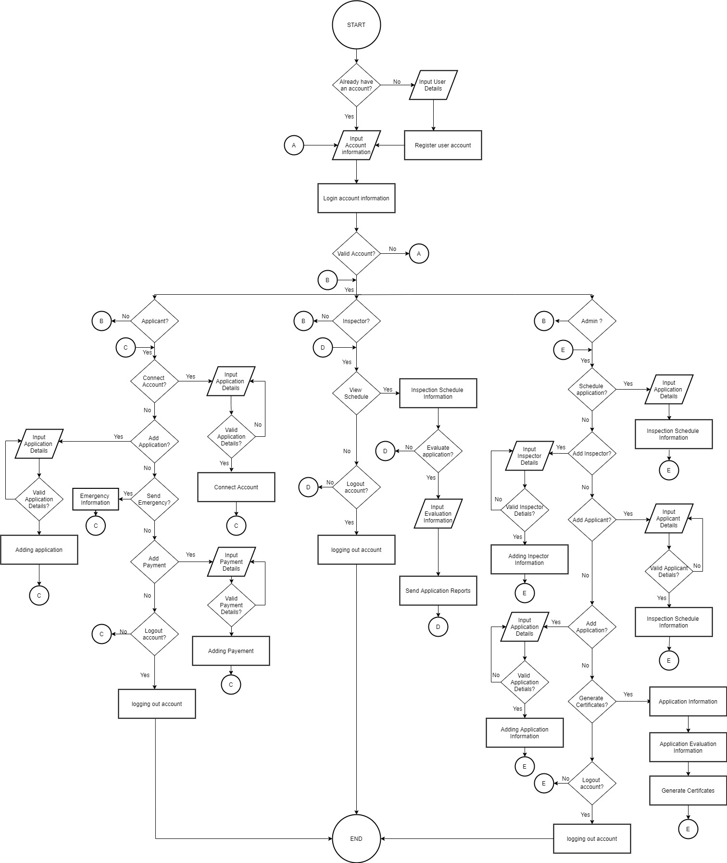

Inspector

Applicant

**Figure 5. A** Flow Chart of the Proposed System (Overall Flow Layout)

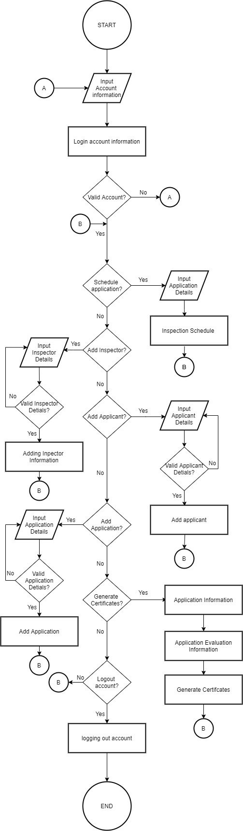

**Figure 5. B** Flow Chart of the Proposed System (Administrator)

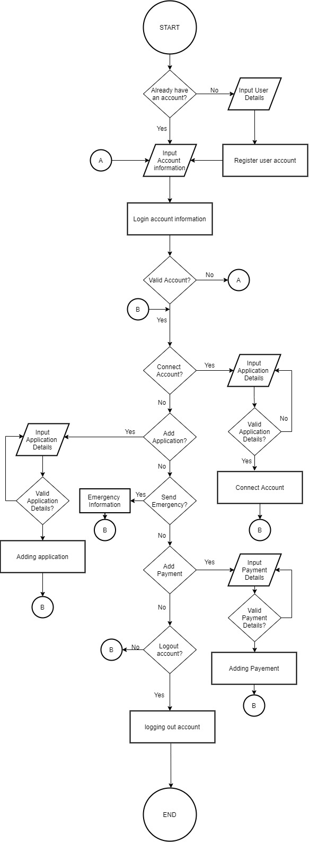

**Figure 5. C** Flow Chart of the Proposed System (Applicant)

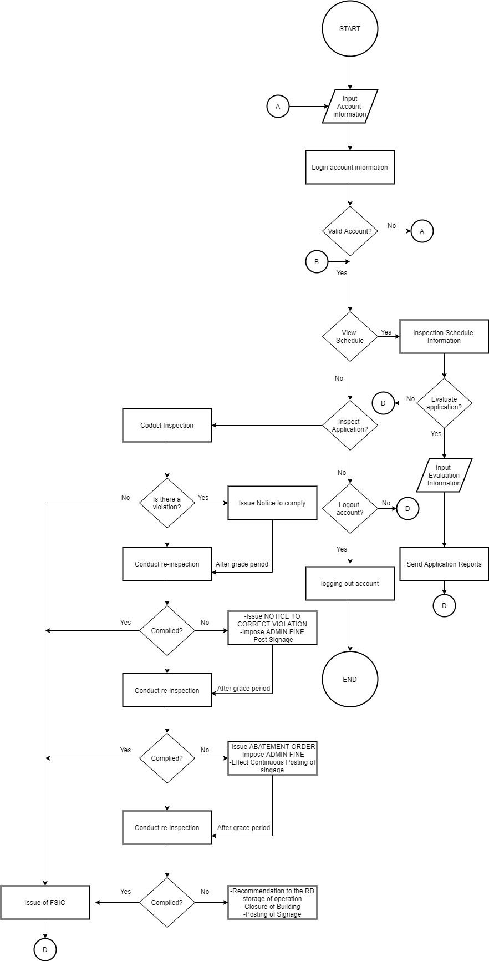

**Figure 5.D** Flow Chart of the Proposed System (Inspector)

**Context Flow Diagram**

The presented diagram shows the progressions of data between the system and outside elements. It is shown how the information from the user and administrator interfaces with the system. The whole project system is displayed as a one process.

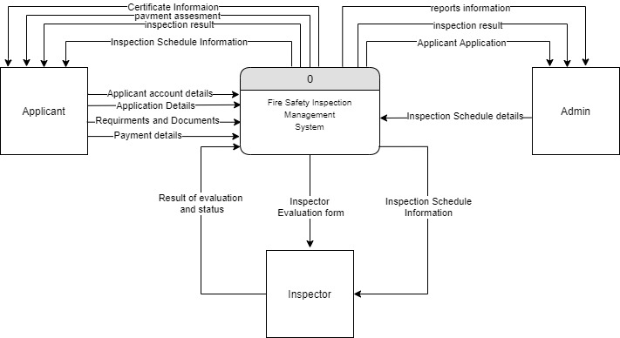

**Figure 6.** Context Flow Diagram of the Proposed System

**Data Flow Diagram**

The Data Flow Diagram (DFD) shows how information is handled by a framework as far as data sources and yields. As its name shows its emphasis is on the progression of data, where information comes from, where it goes and how it gets put away.

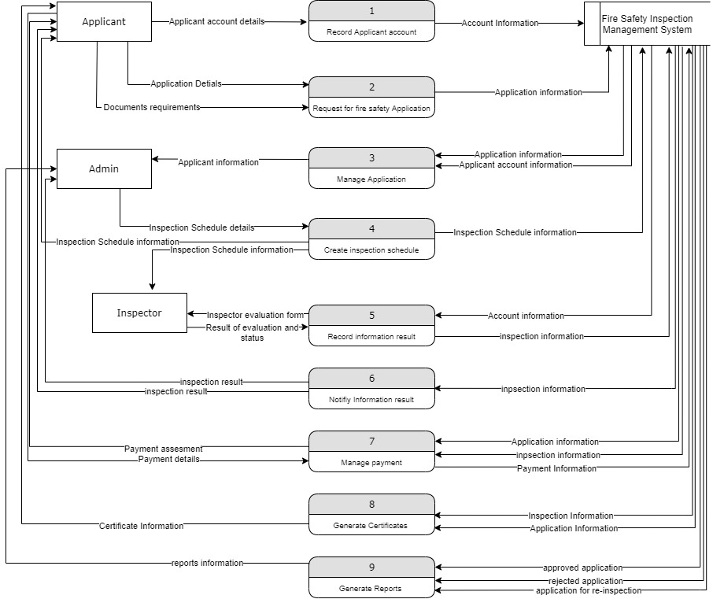

**Figure 7.** Data Flow Diagram of the Proposed System

**Use Case Diagram**

As seen in figure 8, the Applicant can create an account and manage it afterwards. The user can also use the features provided by the system such as making payments, viewing of their certificates, as well as view their account schedule in receiving documents. The Fire Safety Inspector can also view schedule, evaluate the application, and also send application reports to the administrator. Lastly, the Administrator can manage the information provided by the by the applicants and inspectors. It also manages the reports and can generate certificates.

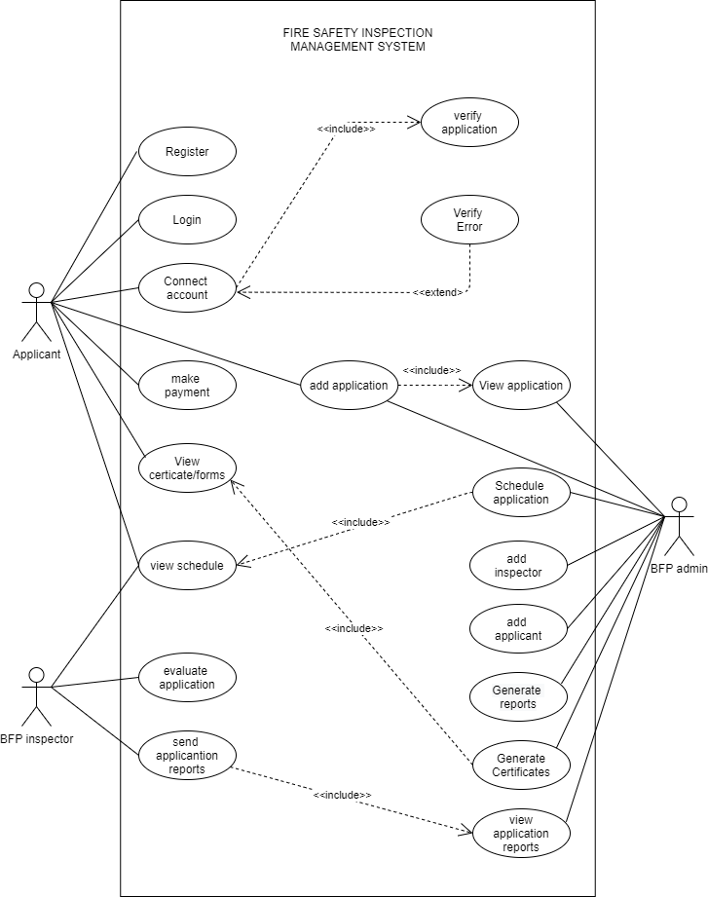

**Figure 8.** Use Case Diagram of the Proposed System

**Design**

This stage is where the project team sheds light between the issue and the proposed project system done in a manner of sensibility by finishing the plan and portraying the system’s capacities and its functionalities. All aspects of the project system, including its highlights and usefulness, are characterized by the project team, at that point, the team used various instruments and programming applications to accomplish the proposed system’s overall functionality. At first, the project team is ready and planned the UI into an easy to use by executing interface that aims to be straightforward for the clients to utilize.

In planning out the general design of the system, the project team had used programming applications. Sublime Text 3 for coding the system, and PHP is the programming language that is utilized for the proposed application. The said programming language is an open-source, worker side, HTML implanted prearranging language used to make dynamic site pages reasonable for this venture. Furthermore, the project team used the XAMPP control board to oversee Apache and MySQL.

**Entity Relationship Diagram**

The Entity Relationship Diagram (ERD) shows the connections of entity sets put away in a data set. An element in this setting is an article, a segment of information. An element set is an assortment of comparative substances. These elements can have ascribes that characterize its properties. By characterizing the elements, their properties, and showing the connections between them, an ER diagram delineates the legitimate construction of information bases. ER Diagrams are utilized to portray out the plan of a database.

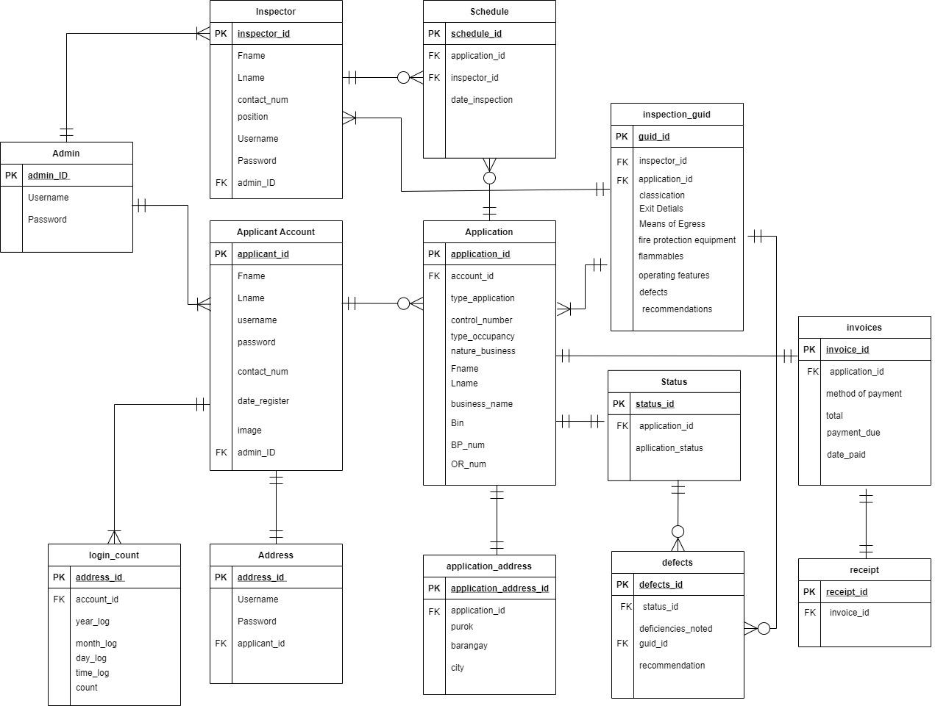

**Figure 9**. Entity Relationship Diagram of the Proposed System

**Data Dictionary**

The Data Dictionary is applied to be brought together as the storehouse of data that gives subtleties and portrayals of the information. Every data contains the name of the field, the type of data, key type, and a description of the table's structure as portrayed in the Entity Relationship Diagram.

Table 1. Data Dictionary of Fire Safety Inspection Management System with GIS-Based Fire Susceptibility Mapping

**Table 1.1** Admin

|  |  |  |  |
| --- | --- | --- | --- |
| **FIELD NAME** | **DATATYPE** | **KEY TYPE** | **DESCRIPTION** |
| admin_ID | INT | PRIMARY KEY | User’s account database ID. |
| Username | VARCHAR |  | User’s account username. |
| Password | VARCHAR |  | User’s account password. |

**Table 1.2** Inspector

|  |  |  |  |
| --- | --- | --- | --- |
| **FIELD NAME** | **DATATYPE** | **KEY TYPE** | **DESCRIPTION** |
| Inspector_id | INT | PRIMARY KEY | Inspector’s account database ID. |
| Fname | VARCHAR |  | Inspector’s First Name Information |
| Lname | VARCHAR |  | Inspector’s Last Name Information |
| contact_num | INT |  | Inspector’s Contact Number Information |
| position | VARCHAR |  | Inspector’s Position Information |
| Username | VARCHAR |  | Inspector’s account username. |
| Password | VARCHAR |  | Inspector’s account password. |
| admin_ID | INT | FOREIGN KEY | User’s account database ID. |

**Table 1.3** Applicant Account

|  |  |  |  |
| --- | --- | --- | --- |
| **FIELD NAME** | **DATATYPE** | **KEY TYPE** | **DESCRIPTION** |
| applicant_ID | INT | PRIMARY KEY | Applicant’s account database ID. |
| Fname | VARCHAR |  | Applicant’s account First name. |
| Lname | VARCHAR |  | Applicant’s account Last Name. |
| username | VARCHAR |  | Applicant’s account username. |
| password | VARCHAR |  | Applicant’s account password. |
| contact_num | INT |  | Applicant’s contact number. |
| date_register | VARCHAR |  | Applicant’s date of registration. |
| image |  |  | Applicant’s profile image |
| admin_ID | INT |  | User’s account database ID. |

**Table 1.4** Login Count

|  |  |  |  |
| --- | --- | --- | --- |
| **FIELD NAME** | **DATATYPE** | **KEY TYPE** | **DESCRIPTION** |
| address_ID | INT | PRIMARY KEY | User’s account address ID. |
| account_id | VARCHAR | FOREIGN KEY | User’s account ID |
| year_log | VARCHAR |  | User’s yearly log history |
| month_log | VARCHAR |  | User’s monthly log history |
| day_log | VARCHAR |  | User’s daily log history |
| time_log | VARCHAR |  | User’s time log history |
| count | INT |  | User’s log history count |

**Table 1.4** Address

|  |  |  |  |
| --- | --- | --- | --- |
| **FIELD NAME** | **DATATYPE** | **KEY TYPE** | **DESCRIPTION** |
| address_ID | INT | PRIMARY KEY | User’s account address ID. |
| Username | VARCHAR | FOREIGN KEY | User’s account Username |
| Password | VARCHAR |  | User’s account Password |
| applicant_id | VARCHAR |  | Applicant’s account database ID |

**Table 1.5** Schedule

|  |  |  |  |
| --- | --- | --- | --- |
| **FIELD NAME** | **DATATYPE** | **KEY TYPE** | **DESCRIPTION** |
| schedule_ID | INT | PRIMARY KEY | Inspection account schedule ID. |
| application_id | INT | FOREIGN KEY | Applicant’s Account Application ID. |
| inspector_id | INT | FOREIGN KEY | Inspector’s Account ID |
| date_inspection | VARCHAR |  | Inspector’s Inspection Date |

**Table 1.6** Application

|  |  |  |  |
| --- | --- | --- | --- |
| **FIELD NAME** | **DATATYPE** | **KEY TYPE** | **DESCRIPTION** |
| application_ID | INT | PRIMARY KEY | Applicant’s Account Application ID. |
| account_id | INT | FOREIGN KEY | User’s account ID |
| type_application | INT |  | Applicant’s Business Application type |
| control_number | VARCHAR |  | Applicant’s Business Unique Control Number |
| type_occupancy | VARCHAR |  | Applicant’s Business Occupancy Type |
| nature_business | VARCHAR |  | Applicant’s Nature of Business type |
| Fname | VARCHAR |  | Applicant’s Account First Name |
| Lname | VARCHAR |  | Applicant’s Account Last Name |
| business_name | VARCHAR |  | Applicant’s Business Name |
| Bin | INT |  | Applicant’s Bin number |
| BP_num | INT |  | Applicant’s Business Permit Number |
| OR_num | INT |  | Applicant’s Official Receipt Number. |

**Table 1.6** Application Address

|  |  |  |  |
| --- | --- | --- | --- |
| **FIELD NAME** | **DATATYPE** | **KEY TYPE** | **DESCRIPTION** |
| Application_address_ID | INT | PRIMARY KEY | Application’s account address ID. |
| application_id | INT | FOREIGN KEY | Applicant’s Application ID. |
| Purok | VARCHAR |  | Applicant’s Building place of interest Purok Information |
| barangay | VARCHAR |  | Applicant’s Building place of interest barangay Information |
| city | VARCHAR |  | Applicant’s place of interest city information |

**Table 1.7** Inspection Guide

|  |  |  |  |
| --- | --- | --- | --- |
| **FIELD NAME** | **DATATYPE** | **KEY TYPE** | **DESCRIPTION** |
| guide_id | INT | PRIMARY KEY | Application’s account address ID. |
| application_id | INT | FOREIGN KEY | Applicant’s Application ID. |
| classification | VARCHAR |  | Inspection classification type |
| Exit Details | VARCHAR |  | Building information in exits |
| Means of Egress | VARCHAR |  | Building information on non-obstructed areas for fire evacuation |
| Fire Protection equipment | VARCHAR |  | Inspection for the fire protection equipment if present |
| Flammables | VARCHAR |  | Inspection for potential materials susceptible to flames |
| Operating features | VARCHAR |  | Building features include the certain operation the building is running |
| Defects | VARCHAR |  | List of defects that are found during the inspection |
| Recommendations | VARCHAR |  | Comments to the building after the inspection |

**Table 1.8 Status**

|  |  |  |  |
| --- | --- | --- | --- |
| **FIELD NAME** | **DATATYPE** | **KEY TYPE** | **DESCRIPTION** |
| Status_id | INT | PRIMARY KEY | Application’s Status ID. |
| application_id | INT | FOREIGN KEY | Applicant’s Application ID. |
| Application_status | VARCHAR |  | The Applicant’s Application status |

**Table 1.9 Defects**

|  |  |  |  |
| --- | --- | --- | --- |
| **FIELD NAME** | **DATATYPE** | **KEY TYPE** | **DESCRIPTION** |
| Defects_id | INT | PRIMARY KEY | Building Defects ID |
| Status_id | INT | FOREIGN KEY | Application’s Status ID |
| Deficiencies_noted | VARCHAR |  | Deficiencies that had been noted during the inspection |
| guid_id | INT |  | Guide ID |
| recommendation | VARCHAR |  | Comments to the building after the inspection |

**Table 1.11 Invoices**

|  |  |  |  |
| --- | --- | --- | --- |
| **FIELD NAME** | **DATATYPE** | **KEY TYPE** | **DESCRIPTION** |
| invoice_id | INT | PRIMARY KEY | Application’s account invoice ID. |
| application_id | INT | FOREIGN KEY | Applicant’s Application ID. |
| method_of_payment | VARCHAR |  | Applicant’s method of payment |
| Total | INT |  | Total payment from transaction |
| Payment_due | VARCHAR |  | Due date for payment |
| Date_paid | VARCHAR |  | Recorded date for successful payment. |

**Table 1.12 receipt**

|  |  |  |  |
| --- | --- | --- | --- |
| **FIELD NAME** | **DATATYPE** | **KEY TYPE** | **DESCRIPTION** |
| receipt_id | INT | PRIMARY KEY | Receipt ID |
| invoice_id | INT | FOREIGN KEY | Applicant’s Application ID. |

**Technologies Applied**

**Laravel Framework**

Laravel is a web framework for making custom applications. It runs on PHP, and is entirely free and open source. basically utilized for building custom web applications utilizing PHP. It's a web structure that handles numerous things that are to construct by your own, for example, routing, templating HTML, and verification. It is completely server-side, because of running on PHP, and spotlights vigorously on information control and adhering to a Model-View-Controller plan. A structure like React may put a large portion of its consideration on client association and sparkling highlights, yet Laravel just presents a strong foundation for you to work off.

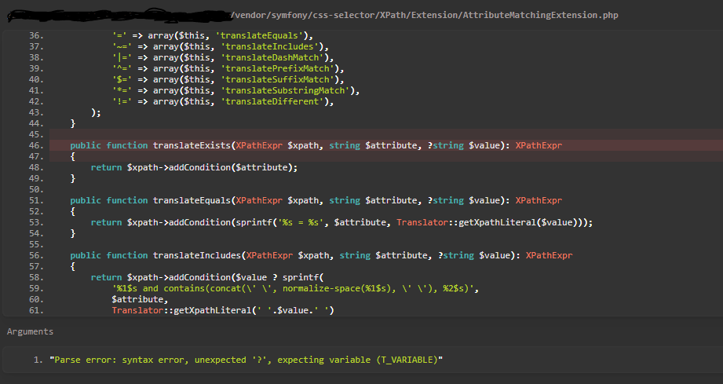

**Figure 10.** Laravel Framework

**Sublime Text 3**

Sublime Text shareware cross-stage source code supervisor with a Python application programming interface (API). It locally upholds many programming dialects and markup dialects, and capacities can be added by clients with modules, commonly local area constructed and kept up with under free-programming licenses. It will be used as the primary code builder for the creation of the project system [12].

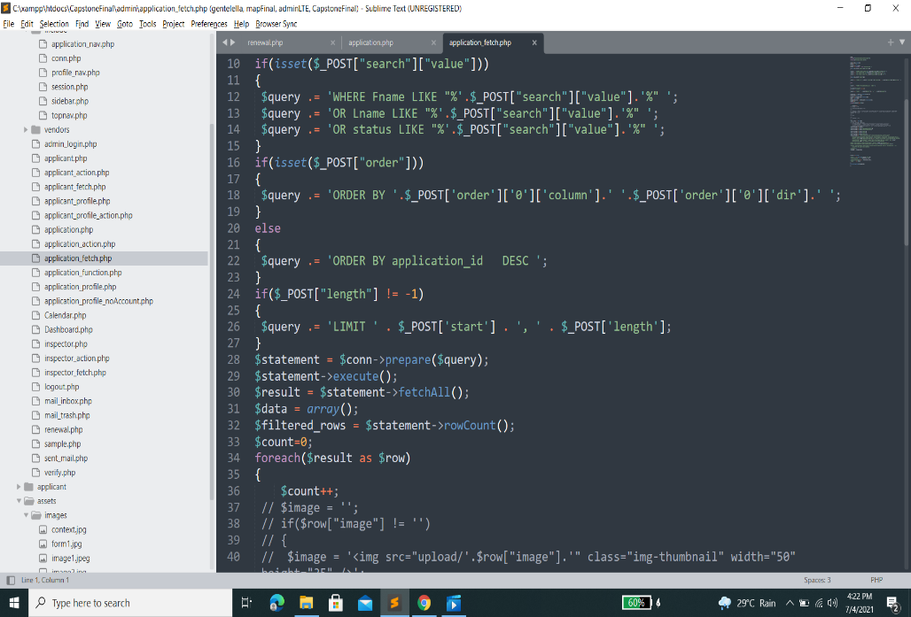

**Figure 11.** Sublime Text 3 Editor Interface

**XAMPP**

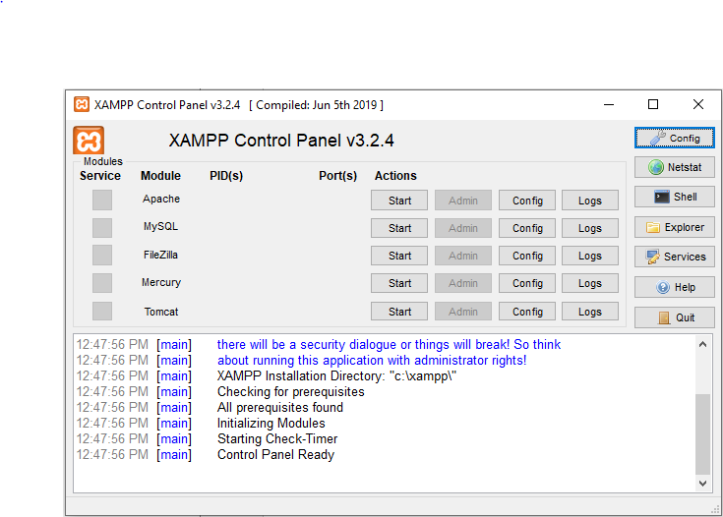XAMPP is a free and open-source cross-stage web worker arrangement stack bundle created by Apache Friends, comprising chiefly of the Apache HTTP Server, MariaDB information base, and translators for scripts written in the PHP and Perl programming languages [13]. It's qualified for Windows, MAC, and Linux stages. No setup is needed to fuse Php with MySQL. It's an ideal decision for this course and offers a genuinely effortless arrangement and an approach to deal with arrangement changes. Also, it is supported PhpMyadmin, which offers a GUI interface to administer the MySQL databases[14].

**Figure 12.** XAMPP Control Panel

**Draw.io**

Draw.io is exclusive software for making outlines and graphs. The product permits you to browse a programmed design work, or make a custom format. They have a huge determination of shapes and many visual components to make your graph or diagram unique. The simplified component is anything but an extraordinary-looking graph or diagram.

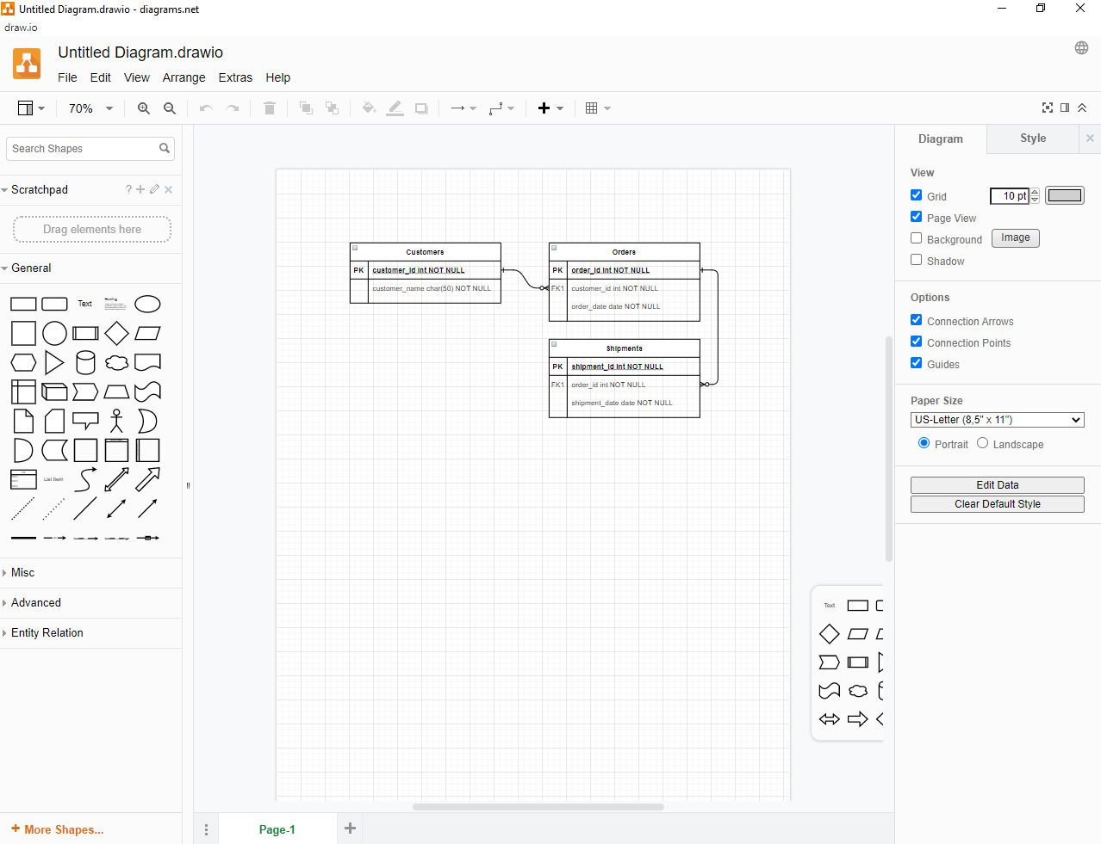

**Figure 13.** Draw.io Interface

In arranging out the overall plan of the system, the project team had used several applications that contributes to the overall framework of establishing the project from the ground up. Sublime Text 3 for coding the system, and PHP is the programming language that is utilized for the proposed application, primarily used the Laravel Framework. The said programming language is an open-source, worker side, HTML implanted prearranging language used to make dynamic site pages reasonable for this venture. Furthermore, the project team used the XAMPP control board to oversee Apache and MySQL. The Draw.io was used to map out the database flows, as well as the overall flow of the system from theory.

**Implementation and Testing**

In this progression, the system has developed the design and overall functionality that is needed to meet the system’s specifications. This is also where we determine and pinpoint what’s not working or performing to expectations.

The system is subjected to various conditions before the project team concludes the system is viable for implementation. The Fire Safety Inspection Management System of Panabo City Fire Station Department shall be presented to the panels for further modifications and improvements to the existing features. The project team shall improve the proposed system under the panel’s corrections and comments as the panels will monitor to determine the viability of the said proposed system after the revision. The project team will have an orientation by the users in Panabo City Fire Station Department in regards to how to effectively use the system.

**Evaluation**

This phase is the place where the product is assessed and checked according to the current necessity. Then, at that point, further prerequisites are examined and evaluated to propose a revision in the next following cycle.

During this phase, errors were found and functionalities were improved within the testing. In regards to the system’s functionality, the project team demonstrates the features of the system. After the team’s presentation, users are expected to rate the system and report any anomalies like bugs or features that became missing in the implementation while using the system.

The project team formulated questionnaires that will be given to the users based on the overall performance of the system following the installation phase.

**Table 2.** Rating Equivalence Based on the Performance of the System

|  |  |  |  |
| --- | --- | --- | --- |
| **Numerical Description** | **Range** | **Descriptive Equivalent** | **Rating Description** |
| 5 | 4.50 – 5.00 | Very Efficient | The software meets all the requirements of the system’s objective. |
| 4 | 3.50 – 4.49 | Efficient | The software meets more than the average requirements of the system’s objectives. |
| 3 | 2.50 – 3.49 | Moderately Efficient | The software meets the minimum requirements of the system’s objectives. |
| 2 | 1.50 – 2.29 | Less Efficient | The software meets less than the average requirements of the system’s objectives. |
| 1 | 1.0 – 2.49 | Poor | The software does not meet the requirements of the system’s objectives. |

**Deployment**

After the system going the several comprehensive tests by the users, the project team has handled the distribution reports, in which the malfunctions, errors, and insufficiencies which the user has utilized in recording the said shortcoming of the system. The system is in progress where it is not perfected at the moment as there were operations in the said system that are still in consideration that will be needed to be fixed. The errors found in the system were thoroughly recorded and have been taking actions for further improvement for the benefit of the end-users.

**REFERENCES**

|  |  |
| --- | --- |
| [1] | D. P. Coppola, Introduction to International Disaster Management. Woburn, MA: Butterworth-Heinemann, 2021. |
| [2] | F. William E. Koffel P. E., “Automated equipment inspection and testing,” *Hfmmagazine.com*. [Online]. Available: https://www.hfmmagazine.com/articles/3758-automated-equipment-inspection-and-testing. [Accessed: 30-Jun-2021]. |
| [3] | A. Prell, “GIS and the fire service,” Redzone.co, 21-Jun-2019. [Online]. Available: https://www.redzone.co/2019/06/21/gis-and-the-fire-service/. [Accessed: 30-Jun-2021]. |
| [4] | “New FireQ updates: Responders on the map & more!,” Bretonsmartek.com. [Online]. Available: https://bretonsmartek.com/new-fireq-updates-responders-on-the-map/. [Accessed: 08-Jul-2021]. |
| [5] | G. Momblan, “BFP launches mobile app for faster fire response,” Philippine News Agency, 29-Aug-2019. [Online]. Available: https://www.pna.gov.ph/articles/1079027. [Accessed: 08-Jul-2021]. |

|  |  |
| --- | --- |
|  |  |
| [6] | importer, “Big Data and What it Means,” Uschamberfoundation.org, 28-May-2013. [Online]. Available: https://www.uschamberfoundation.org/bhq/big-data-and-what-it-means. [Accessed: 07-Jul-2021]. |
| [7] | “Records management 101: Why is it important?,” Vitalrecordscontrol.com, 07-Nov-2018. [Online]. Available: https://vitalrecordscontrol.com/records-management-why-is-it-important/. [Accessed: 07-Jul-2021]. |
| [8] | T. Mersha and M. Meten, “GIS-based landslide susceptibility mapping and assessment using bivariate statistical methods in Simada area, northwestern Ethiopia,” Geoenvironmental disasters, vol. 7, no. 1, 2020. |
| [9] | corporateName=Department of Transport, Main Roads, jurisdiction=Queensland, and sector=government, “Distress signals, flares and emergency beacons,” 2009. |
|  |  |

|  |  |
| --- | --- |
| [10] | “Government emergency hotline received 2.5 million prank calls in 2019,” *Cnnphilippines.com*. [Online]. Available: https://cnnphilippines.com/news/2020/3/4/DILG-prank-calls-receive-million.html?fbclid=IwAR2WUWIfpPP83PrxStsvBMjQSJlEHv5UanxAgJKvPF4WnCnTjzOzB11zL0M. [Accessed: 07-Jul-2021]. |
| [11] | A. Lu, “Can prank calls get you arrested?,” Findlaw.com, 29-Nov-2012. . |

|  |  |
| --- | --- |
| [12] | N. Schäferhoff, R. A. Brown, J. Hughes, and B. J. Keeton, “The sublime text code editor – an in-depth review,” *Elegantthemes.com*, 22-Dec-2016. [Online]. Available: https://www.elegantthemes.com/blog/resources/the-sublime-text-code-editor-an-in-depth-review. [Accessed: 07-Jul-2021]. |
| [13] | “Working with XAMPP,” Phpknowhow.com. [Online]. Available: http://www.phpknowhow.com/basics/working-with-xampp/. [Accessed: 07-Jul-2021]. |
| [14] | P. Ganesan, “What is XAMPP and How to Install XAMPP on your Local Computer?,” Wpblogx.com, 23-Jun-2021. [Online]. Available: https://wpblogx.com/what-is-xampp/. [Accessed: 07-Jul-2021]. |
| [15] | “Diagramming, modeling, and how to get started with Draw.IO,” Skylinetechnologies.com. [Online]. Available: https://www.skylinetechnologies.com/Blog/Skyline-Blog/June_2018/diagramming-modeling-how-to-get-started-draw-io. [Accessed: 07-Jul-2021]. |
| [16] | “Panabo · Population,” Population.city. [Online]. Available: http://population.city/philippines/panabo/. [Accessed: 02-Jul-2021]. |
| [17] | “Fire Station Software - easy and affordable for your department,” Firestationsoftware.com. [Online]. Available: https://www.firestationsoftware.com/. [Accessed: 08-Jul-2021]. |
| [18] | “DILG Region 8 adopts online Document Management System - Regional News - DILG,” Gov.ph. [Online]. Available: https://dilg.gov.ph/regional-news/DILG-Region-8-adopts-online-Document-Management-System/NC-2020-1258. [Accessed: 08-Jul-2021]. |