GUI PROJECT IN ITE121 ITERMEDIATE PROGRAMMING

**SUBMITTED BY**: ALDUEZA, JOYLIMIE B.

BSCS-1A.1

**SUBMITTED TO**: MRS. UNIFIE O. CAGAS

**DESCRIPTION OF THE PROJECT**

The "Items You Can Buy" application is a user-friendly graphical user interface (GUI) program developed to assist individuals in budgeting and planning their purchases. It offers a straightforward platform for users to input their total budget, a list of items they wish to purchase, their corresponding prices, and whether they are sold by kilos or not. The program then calculates what items can be bought within the specified budget and displays the results.

**WHAT THE PROJECT IS ALL ABOUT?**

The project revolves around helping users make informed purchasing decisions within a defined budget. By inputting their total budget and a list of items with their prices, users can quickly determine which items they can afford to purchase. Additionally, the option to specify whether items are sold by kilos adds flexibility for users dealing with varying product measurements.

The GUI interface ensures ease of use, allowing users to input their data comfortably and receive instant feedback on their purchasing options. Whether planning a grocery trip, shopping for household items, or managing expenses for an event, the application offers a practical solution for budget management and purchasing optimization.

**BENEFIT**

The "Items You Can Buy" this website makes budgeting and shopping easier. It helps you see what you can afford to buy with your budget. This saves you time and helps you make smarter spending choices. Whether you're on a tight budget or just want to spend wisely, this website helps you shop better.

**Top of Form**

**IMPORTANCE**

The "Items You Can Buy" application is significant as it tackles a common challenge in budgeting and purchasing decisions. By offering a straightforward platform for calculating what items can be bought within a given budget, it addresses a fundamental need in personal finance management. This tool is valuable for individuals across various domains, including students managing their allowances, professionals planning project expenses, and households budgeting for groceries or household items. By simplifying the process of budgeting and shopping, the application saves time, reduces errors, and empowers users to make more informed spending choices. Ultimately, it contributes to better financial management and improved decision-making in everyday life.

**PURPOSE**

The purpose of the "Items You Can Buy" project is to develop a user-friendly graphical user interface (GUI) application that simplifies budgeting and purchasing decisions. By providing an intuitive platform for users to input their total budget and a list of items with corresponding prices, the project aims to help individuals determine what items they can afford to buy within their budget. This tool serves to enhance financial management, optimize spending choices, and promote informed decision-making in various contexts, including personal shopping, event planning, and household budgeting.Top of Form

**FEATURES:**

1. GUI built using the Tkinter library for Python.
2. Input fields for entering the

* Total Budget
* Item names
* Prices
* Whether items are sold by kilos.
* Calculate items

1. Button to initiate the calculation process.
2. Error handling for invalid input values.
3. Result display area to show the items that can be purchased within the specified budget.
4. Responsive layout with proper alignment and spacing for optimal user experience.
5. Stylish design with customizable colors and fonts to enhance visual appeal in the background is color light pink.
6. Flexibility to handle different budget scenarios and types of items.
7. Support for various activities, including grocery shopping, household budgeting, and event planning.
8. Contribution to better financial management and smarter spending choices for users.

**FUNCTIONALITIES**

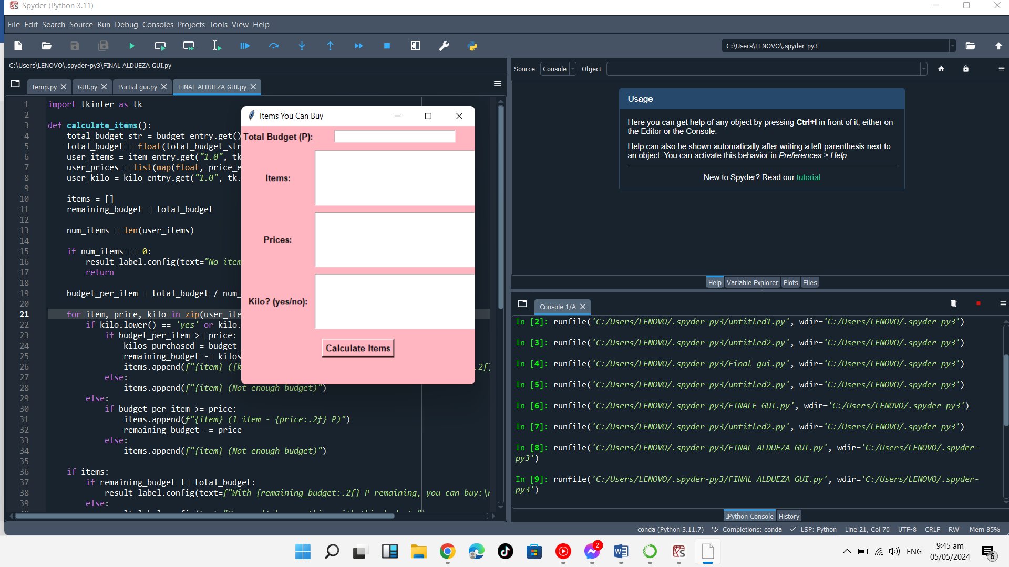

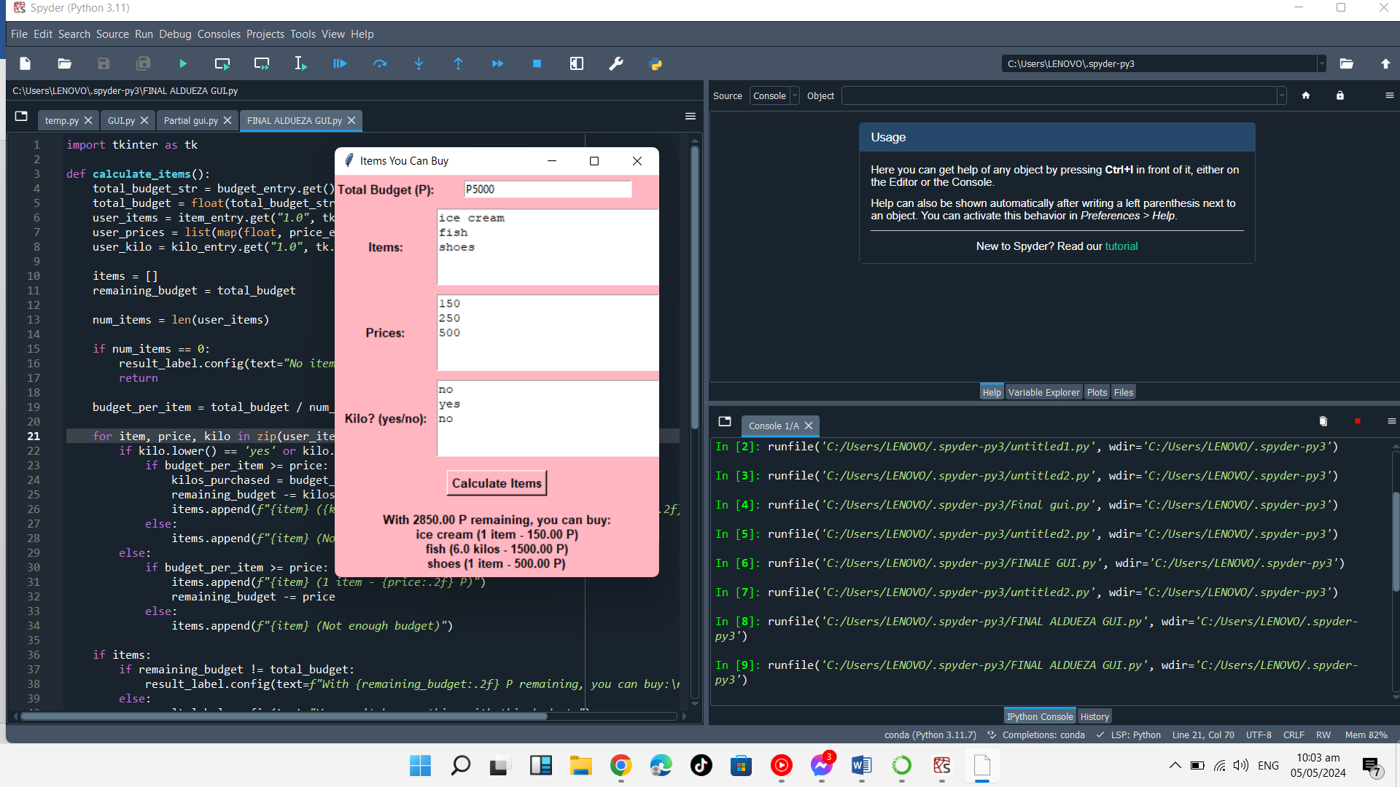

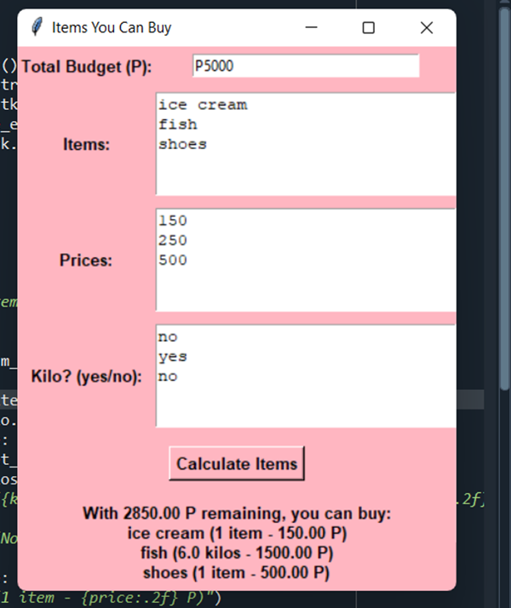This first column it shows the Total Budget when the user wants to input of total budget want to calculate.

The second column shows when the user inputs the items they want to buy and calculates them on a separate line.



The third column shows the prices of the items the user wants to buy because this is one of the elements included in budgeting the total amount of the user's budget.

The last box contains a yes or no question regarding whether the purchased item is measured in kilograms. If the purchased item is measured in kilograms, the user inputs 'yes'; if not, the user inputs 'no' on separate lines.



The last step is to calculate the total items once the user completes inputting the boxes. When they calculate the items, it will display the remaining amount and the budget for the items.

**CODE:**

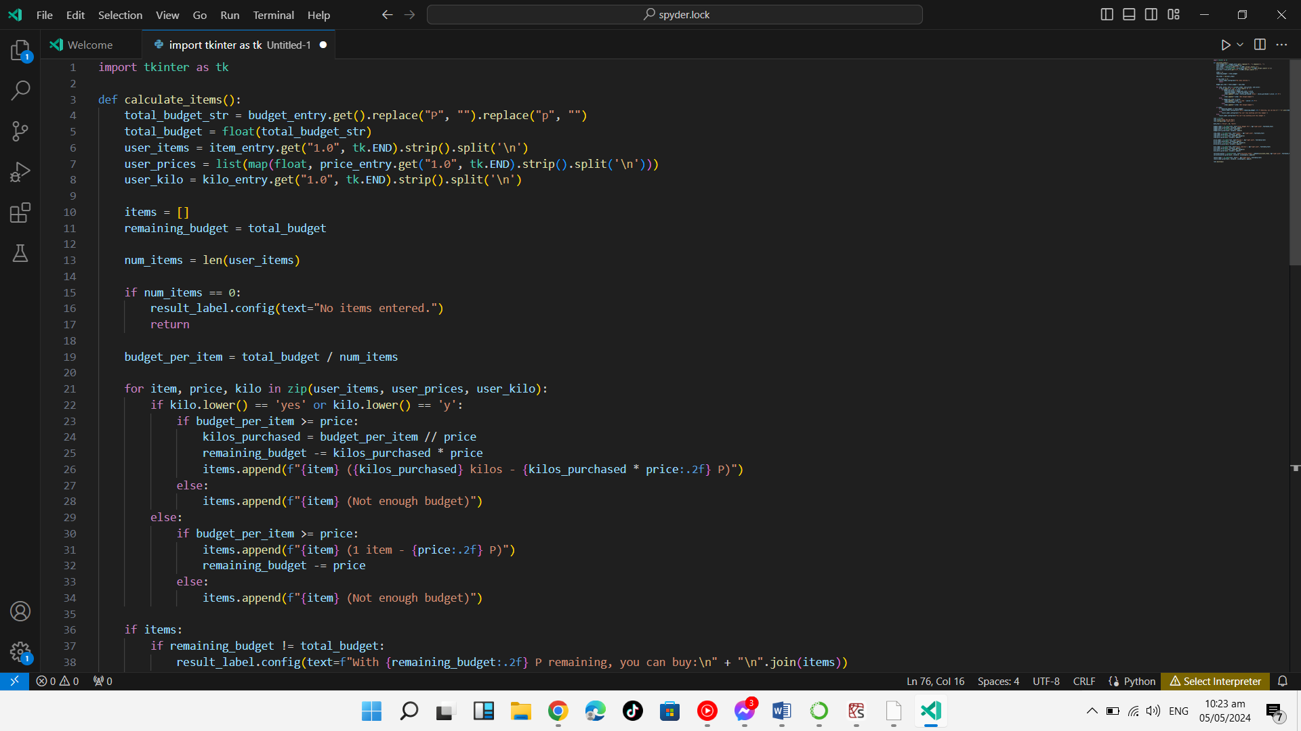

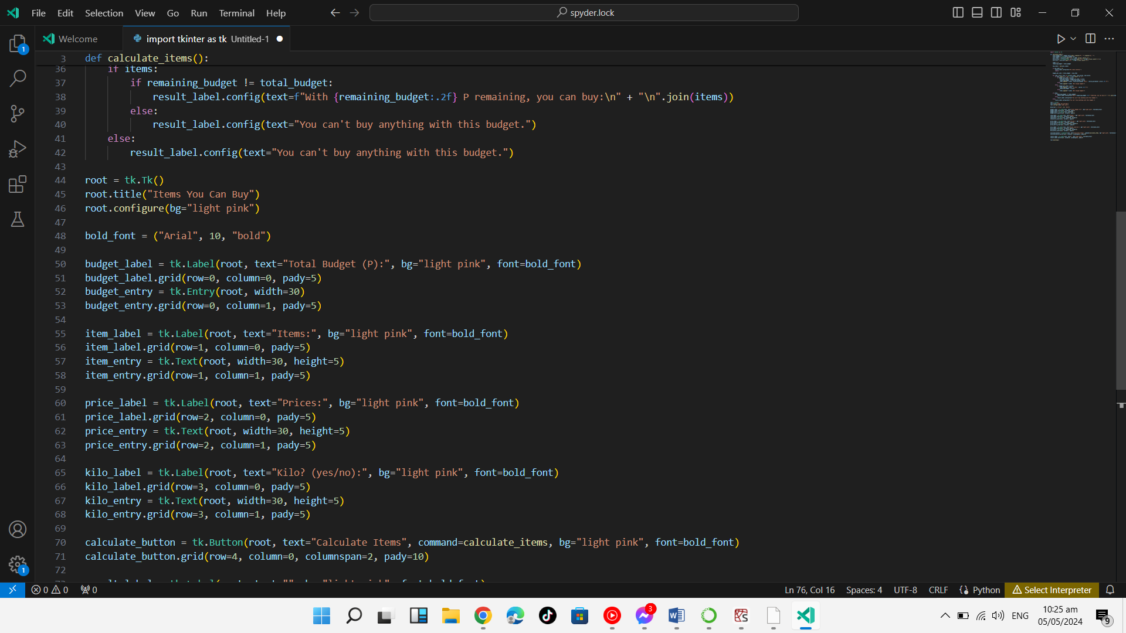

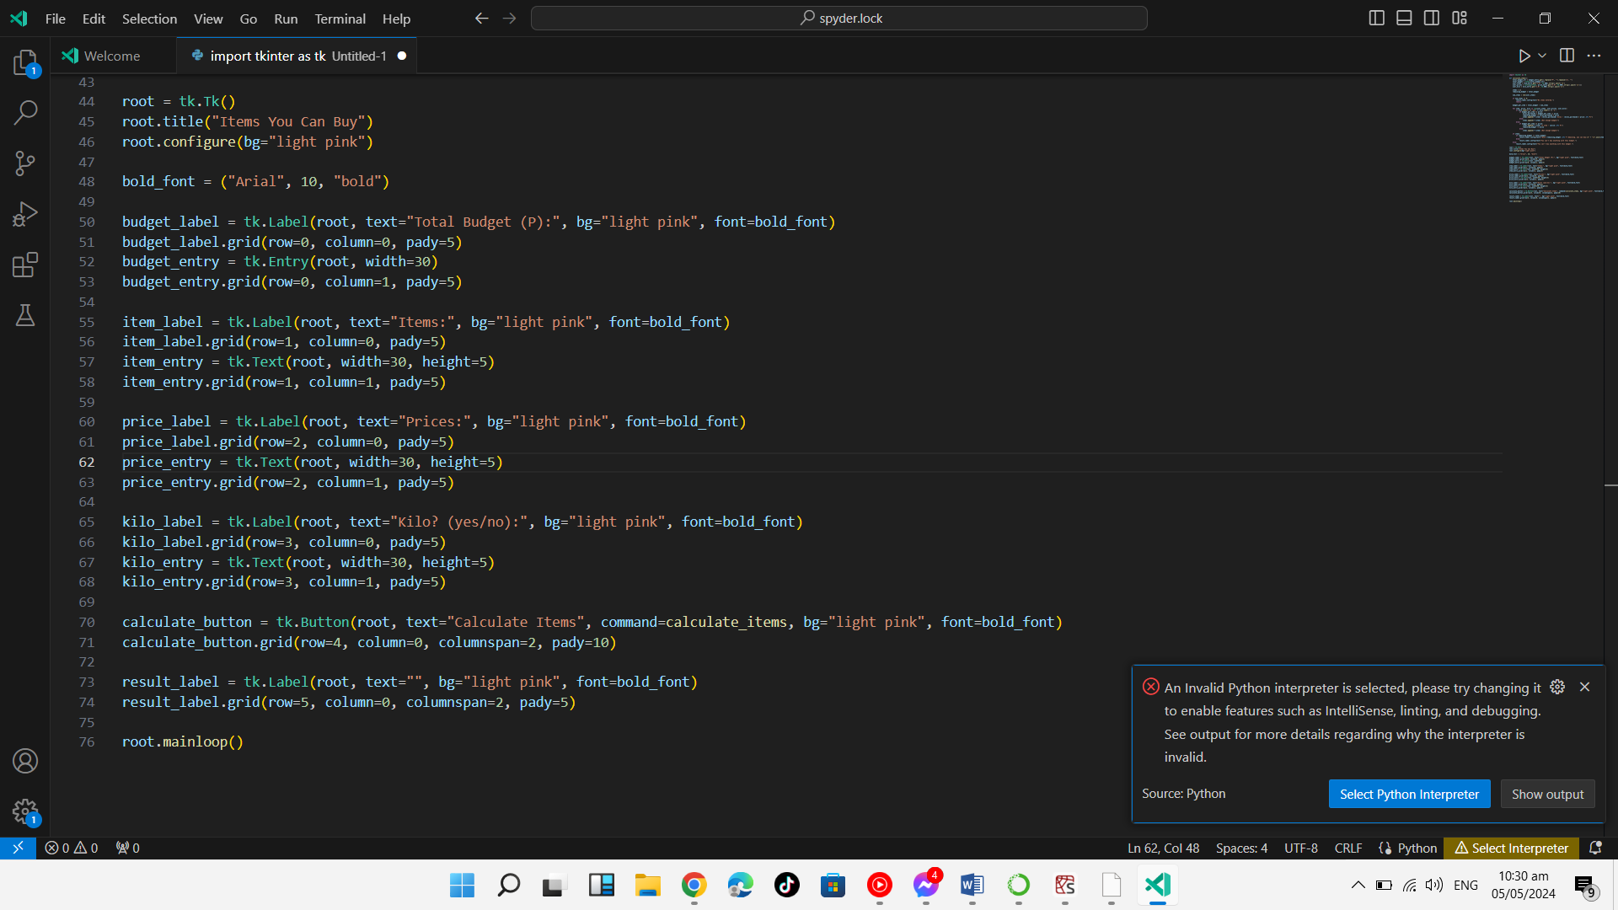

**REFERENCES:**

https://youtu.be/ibf5cx221hk