Buyer and seller:

Buyer

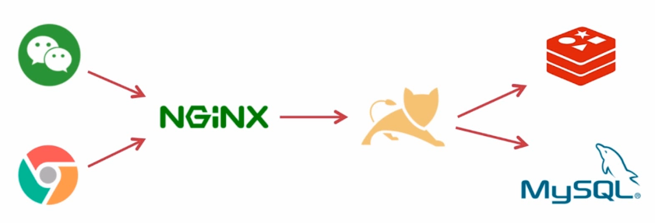

**Deployment**

Orders

Goods

Seller