Info

* Janus Linux account
  + user=root pass=pmcsp

Requirement

* Attention: audience shall have basic knowledge on how to configure/use the GHS Probe
* a help_host runs Windows
  + requires a RS232 serial port
  + requires a NIC to connect to GHS Probe
* a GHS Probe attaches to Janus board
* a network connection between help_host and Probe
* required help_host software
  + a favorite serial terminal to access firmware serial console
    - Windows example: putty, teraterm
  + a favorite 3rd text editor which supports UNIX EOL format
    - Windows example: notepad++, ultraedit
  + GHS Multi 517d
    - setup a GHS connection (NIC or USB) for your Probe, suppose the name is "connect-to-my-probe"
* required files: flash_block.data, sp_probe_config.txt
  + release package containing the files
    - \\diqing\shareddocs\engineering\ESD\Projects\Janus\firmware\build\sp-sdk-0.06.01.24\internal\_internal-sp-sdk-binary-0.06.01.24.tar.bz2
  + path to store the files in help_host
    - Windows: c:\host\path\to\

Configure

* configure the GHS Probe
  + attach the help_host's serial port to GHS Probe
  + open the serial console for further GHS Probe operation
  + reset the GHS Probe and wait until the serial console outputs the command prompt
  + use 3rd text editor to open the c:\host\path\to\sp_probe_config.txt, and copy the whole content
  + paste the content into the serial console and make sure all command are been applied into the GHS Probe
  + Attention: you'll get strange behavior if some steps failed

Step

* bootup Janus and help_host
* connect to Probe with connection "connect-to-my-probe", the GHS debugger interface shall appears now
* reset and halt the Janus by type in "Debugger-MULTI-CMD panel" with following command
  + reset halt
* open the GHS "Flash Programmer" in Debugger window
  + highlight the "MIPS32, Id 0" in "Target panel" by single click
  + click menu>Target>Flash, a "MULTI Fast Flash Programmer" shall appears
* make sure the Programmer paramters are set as figure below
  + 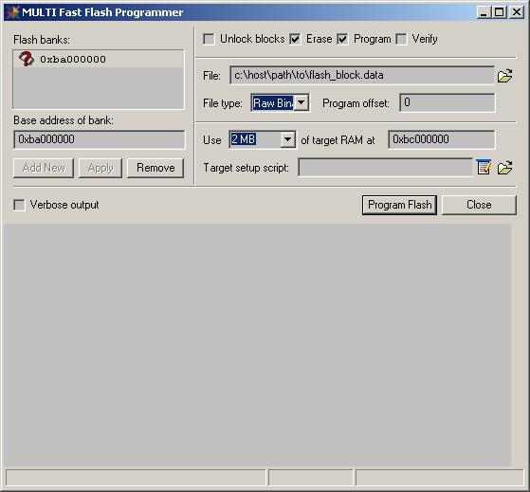
* click "Program Flash" to start
* Close the Programmer and Debugger when programmer completing without error within 5 minutes
* connect help_host RS232 to Janus UART0(115200-8n1), which is the Linux/Bootrom shared UART
* open the serial console utility in help_host to read the Linux/Bootrom info
* power reset the Janus board
* the "BOOTROM" message shall appears in the serial console
* login with root when Linux login prompt appears
* check the output for command "uname -r", the result shall be "2.6.35.9-sp-0.06.01.24"
* the next step is to follow release_note:sec-5.6.3 to upgrade the rootfs