ReadMe File:
For Junior Developer assessment project, ref: 1499255-HOM/962/16.

- To run: The project has been developed with Netbeans IDE. To run the project, ideally a Netbeans ide with glassfish server 4.1.1 or a similar application server are required. Moreover, a database is required with the name of gov_dev. To populate the required data I have include a sql dump file (called gov_dev.sql) which can be used to create required tables and data in order to view the data correctly on a browser. I have not used ruby on rails before hence I am unable to use your toolkit for lack of time. I have install ruby on rails in my system but to be honest I did not have enough time to learn and do this project on ruby. Please see the screenshots below for creating a rails project.
- MVC design pattern: This project is developed with Java web technologies such as servlet and jsp. For styling I have used bootstrap library such as css and js and so on.
- I have designed the project considering the MVC design pattern. Therefore, the home page is called home.jsp which is a main view of mvc. There are a few jsp pages located in the web folder directory which is a view folder for this project. The controller directory is located in the source package (in Netbeans) or src folder in the folder directorie which are called com.dao.controller and com.servlet.controller. The reason for having two controllers is because I have kept the servlet class separate from the main controller class and here in this project I have only one controller class which is called DaoClass. Moreover, I have two model sections too. The first one is only for database connection class because it will be reused almost everywhere whenever I interact with the data. The second part is the entity classes only.
- Classes and jsp’s descriptions: In this application I have a total of five Java classes and one test class. DaoClass is the main controller class which includes most of the logics and different methods for different functions. DbConnection Class is only for connecting to the database. ApplicationServlet class to deal with the request and response purpose. There are two entity classes called Applicants and CV, which are generated according to the DB table by using the IDE JPA feature. Finally the test class is created with one @Test method to test some functions using Junit.
There are a total of five jsp pages. Home.jsp is for the primary home page. ViewSearchResult.jsp is to display search result, but instead of showing the result in a different page I have included just the result on the home page for end user convenience. Cv.jsp is to just handle the file opening code and functions. In addition, there are two separate pages, one for header.jsp and one for the footer.jsp to loosely couple the view.
- Screenshots: I have included almost every view’s and function’s screenshots below for information only and, as a proof that I have run the project successfully in my system.

Project explorer view
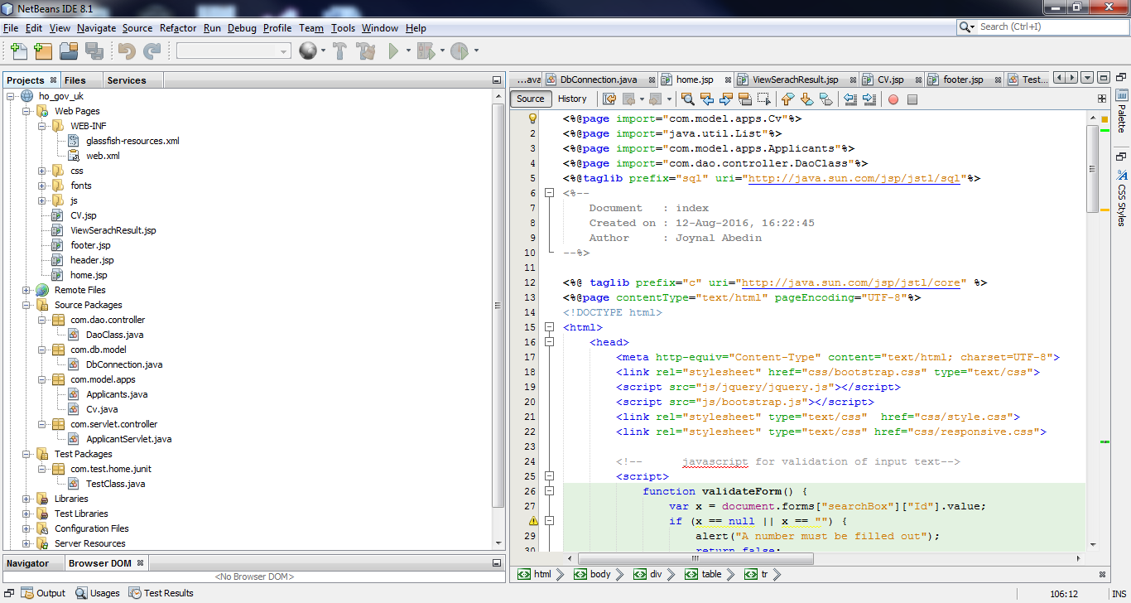

Home page:
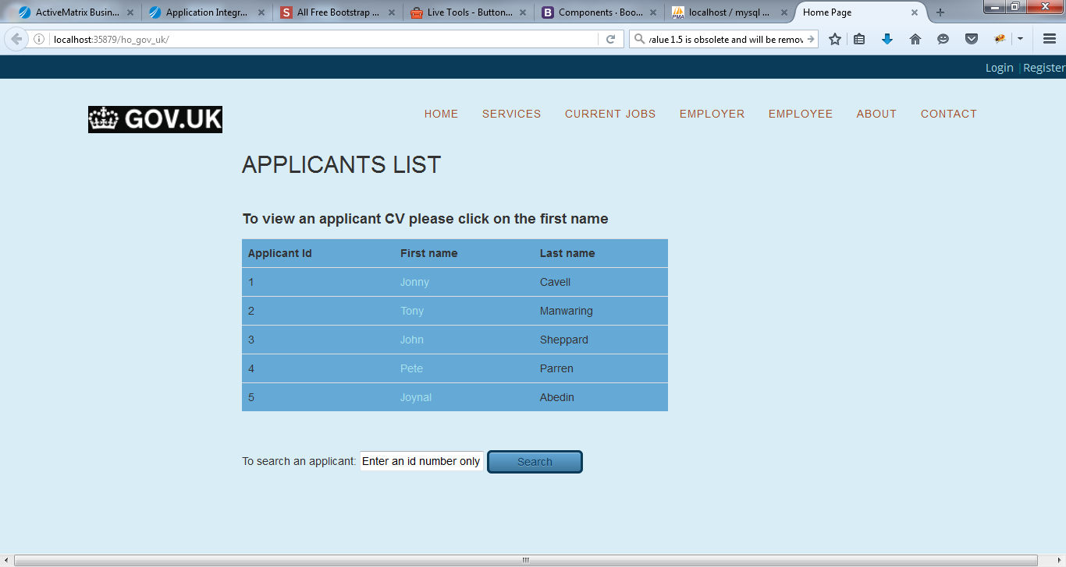

Selecting a name to view cv:
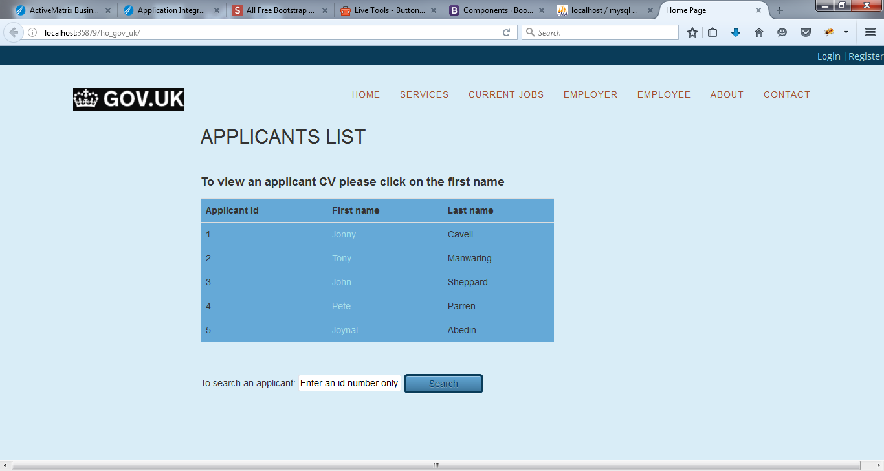

By clicking a name to view cv and then file opening window opens:
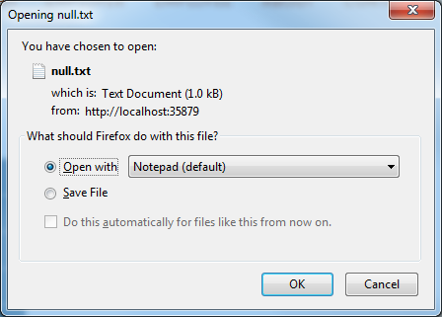

After clicking ok button a text file opens:
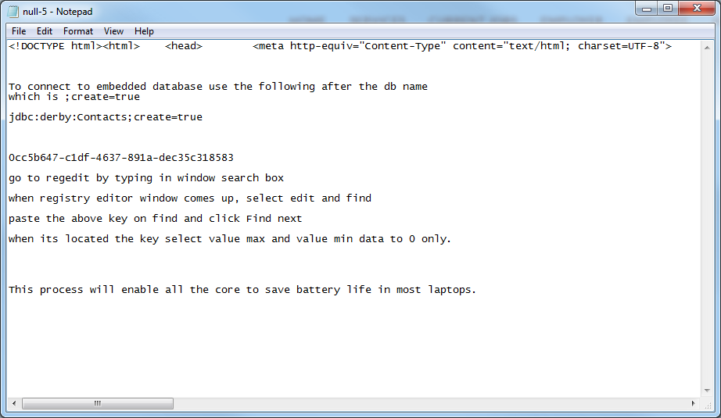

Javascript validation for input field:
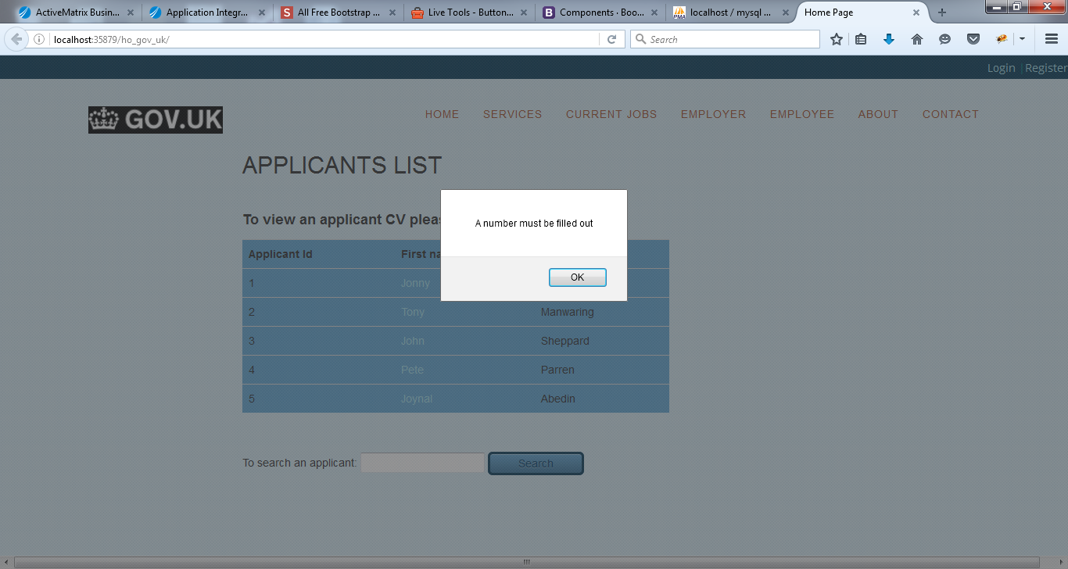

After entering an id number 1, the result table is displayed on the same page:
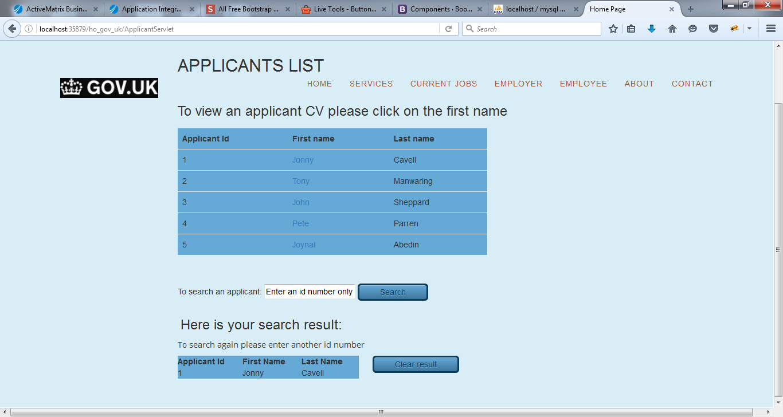

After viewing the search result, the result table can be cleared just by clicking on the Clear result button and back to home view screen:
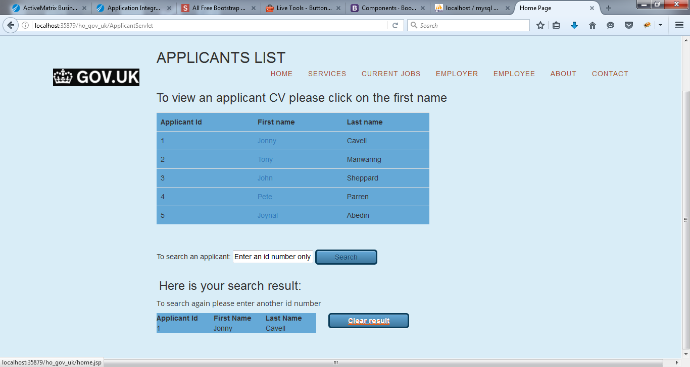
One test result with Junit 4.12:
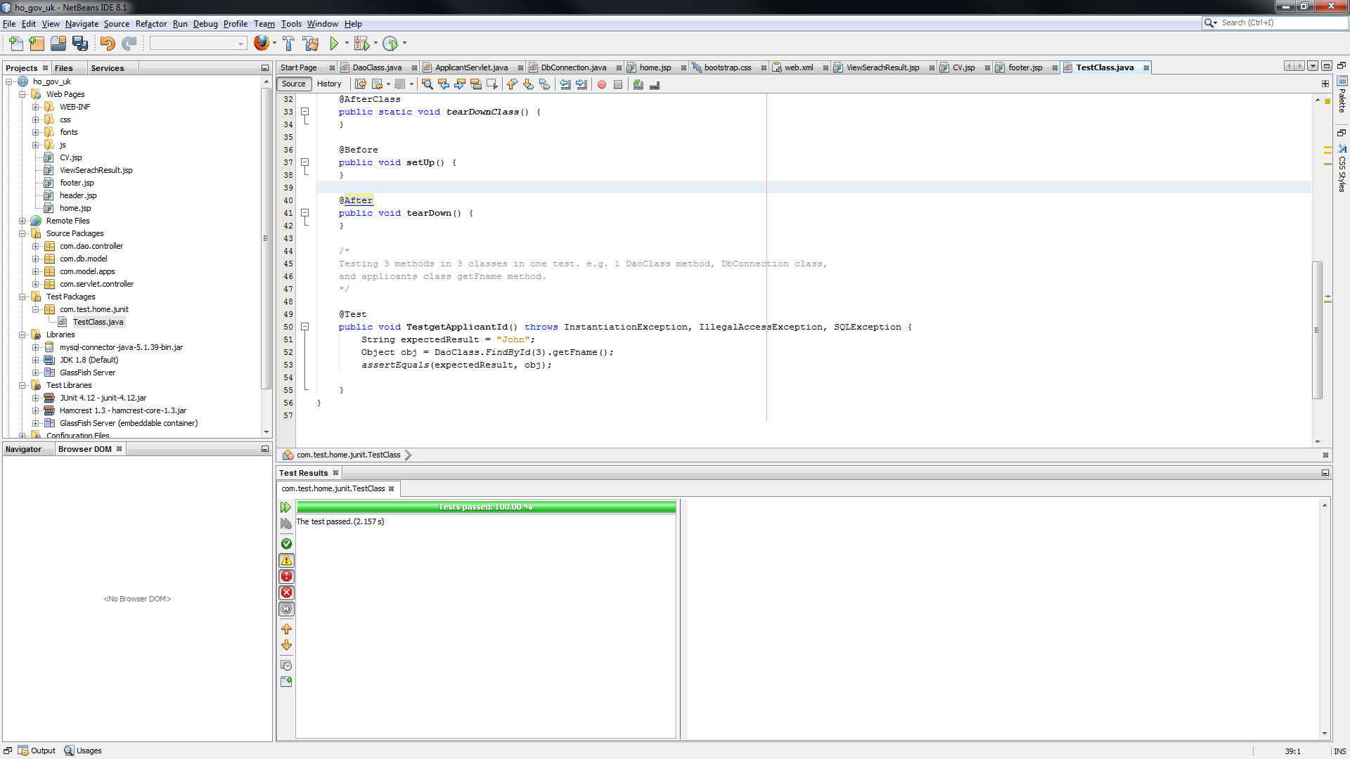

Database created with a name of gov_dev with two table called applicants and cv.
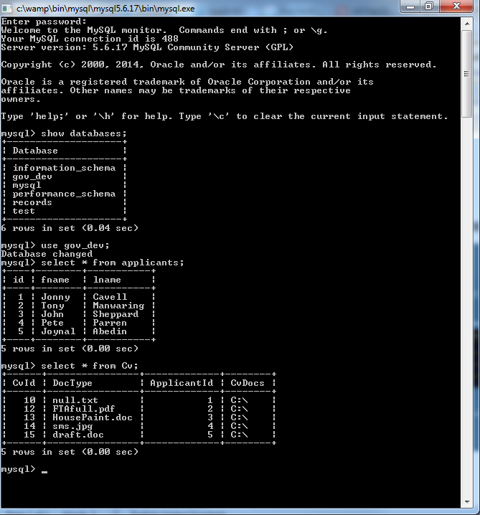

Two screenshots Installed and created a rails project:

