Please note: This is my first attempt to create a cluster with Kubebernetes and GC.

1. Terraform as code:

In this repo you will find Terraform code (IaC) to provision a GKE cluster in Google Cloud with node count value set to 2, this will create a six nodes cluster. I have not created variables.tf, oufile.tf, tfvars and beckend.tf files for lack of time in this solutions.

To create new cluster with the same spec in the same project please make a copy of tf_IaC foler and change/edit the cluster name on the main.tf file. In addition, remove all the files are generated by the terraform after the first run and start from scratch with terraform init, plan and apply. If it is in a different evn then need a key file for access to the project.

1. Kubernetes cluster and orchestration:

After the cluster is deployed, to deploy the voting-app application by running the command:

kubectl create -f . to run all files at once or each file: kubectl create -f filename.yml

I have used off the shelf docker images from the Docker Hub.This application has five images. There are four services in total, two for internal service such as db and redis. The other two are external services in order to view the voting and result pages with loadbalancers that gives an external ip’s for both pages.

Please find the screenshots after running the cluster and the application below:

Cluster nodes-info:

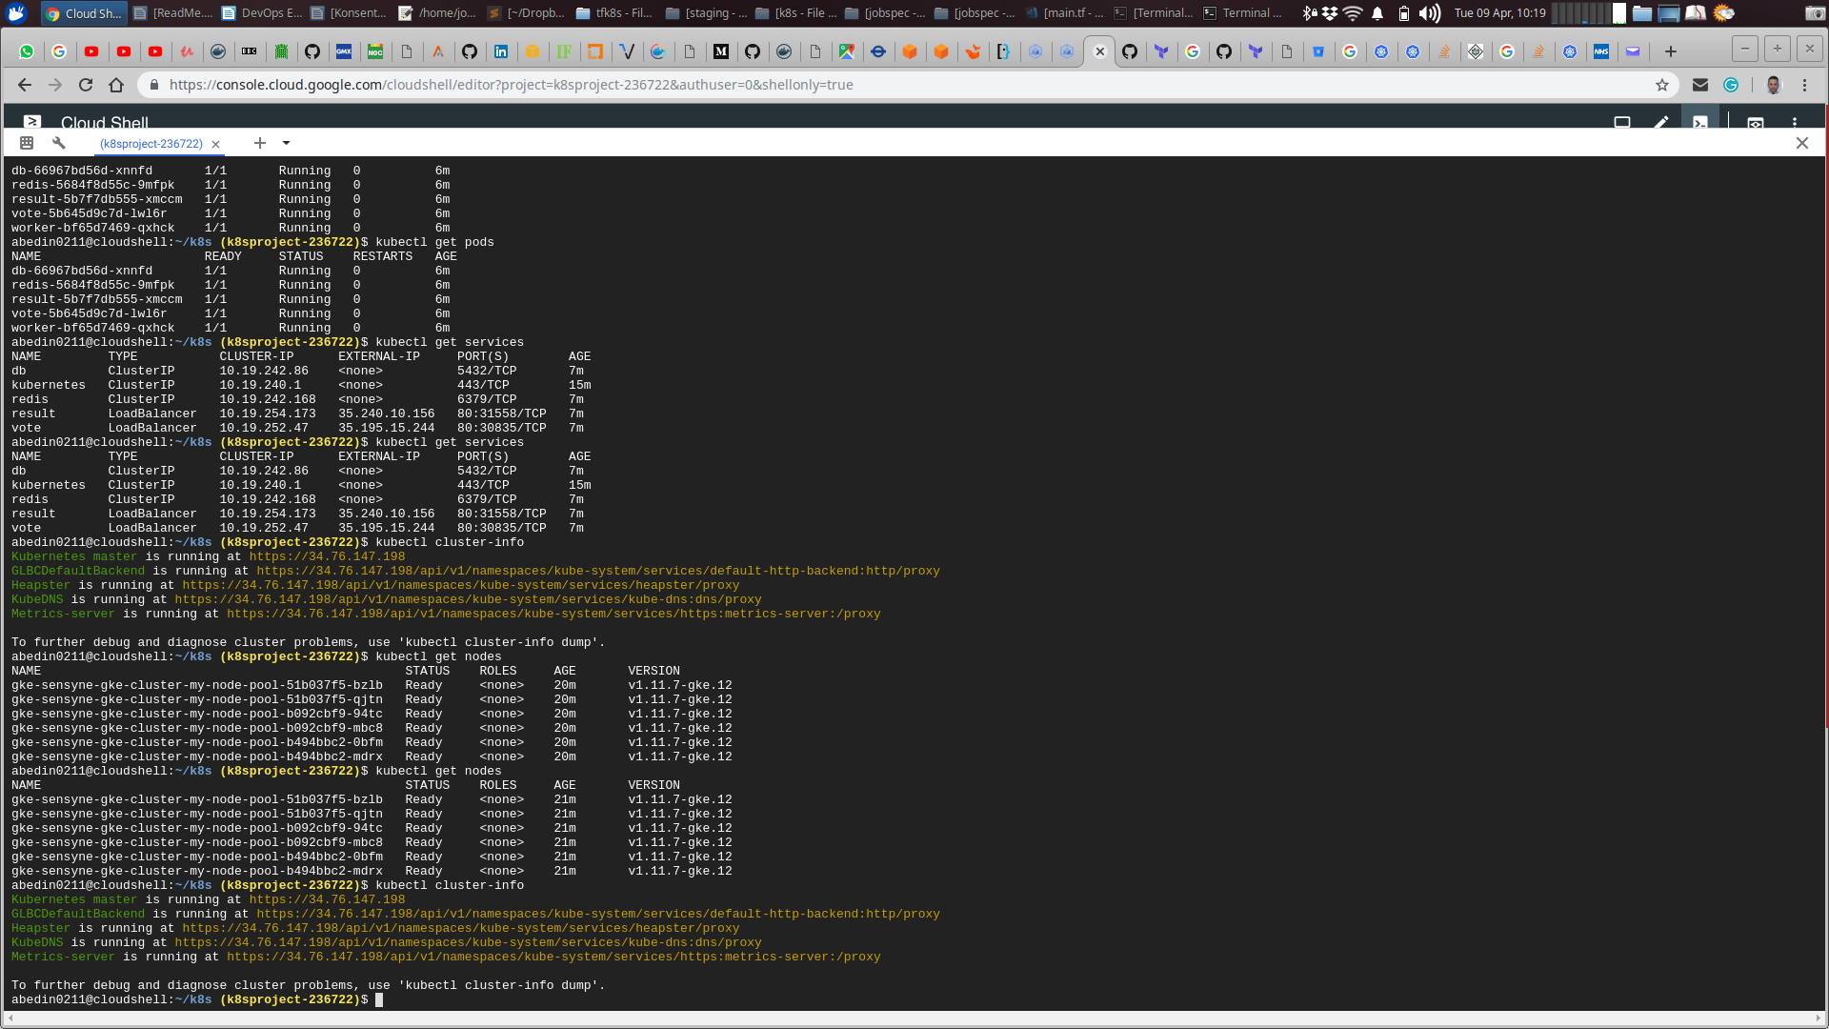

Describe pods:

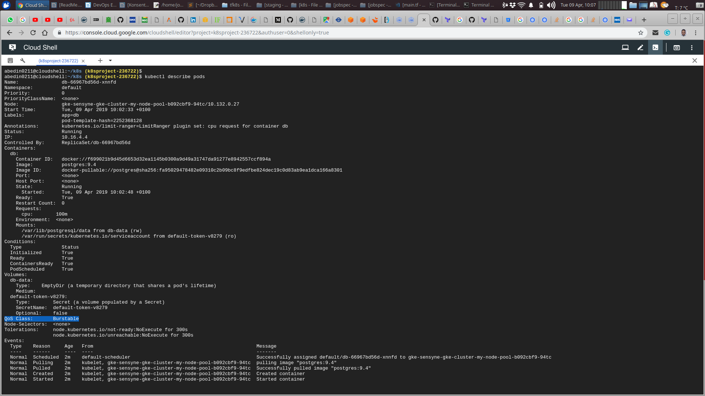

Get pods and services:

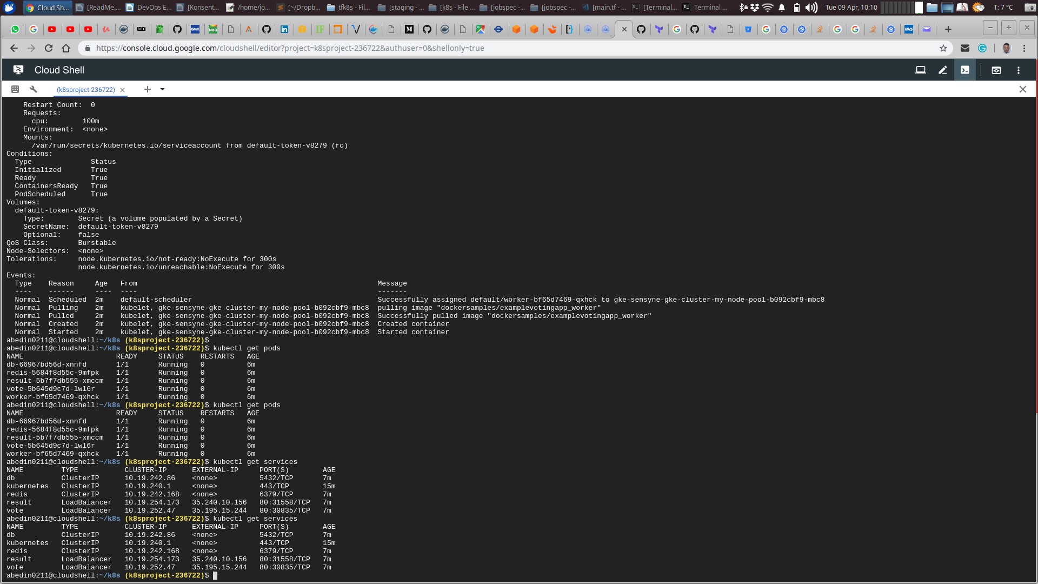

Cast vote page:

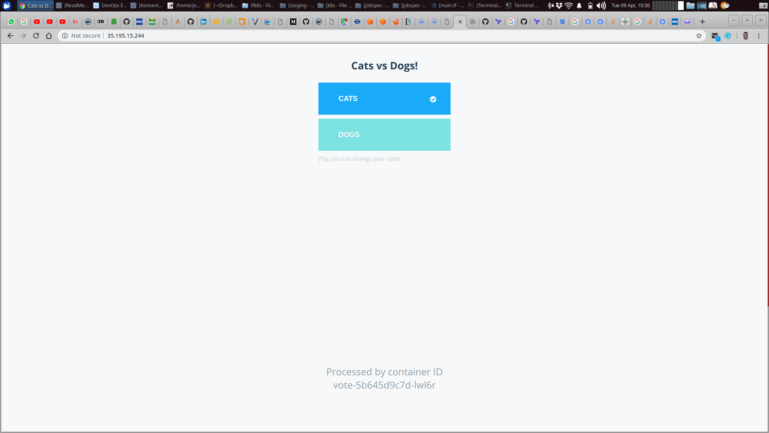

Vote result page:

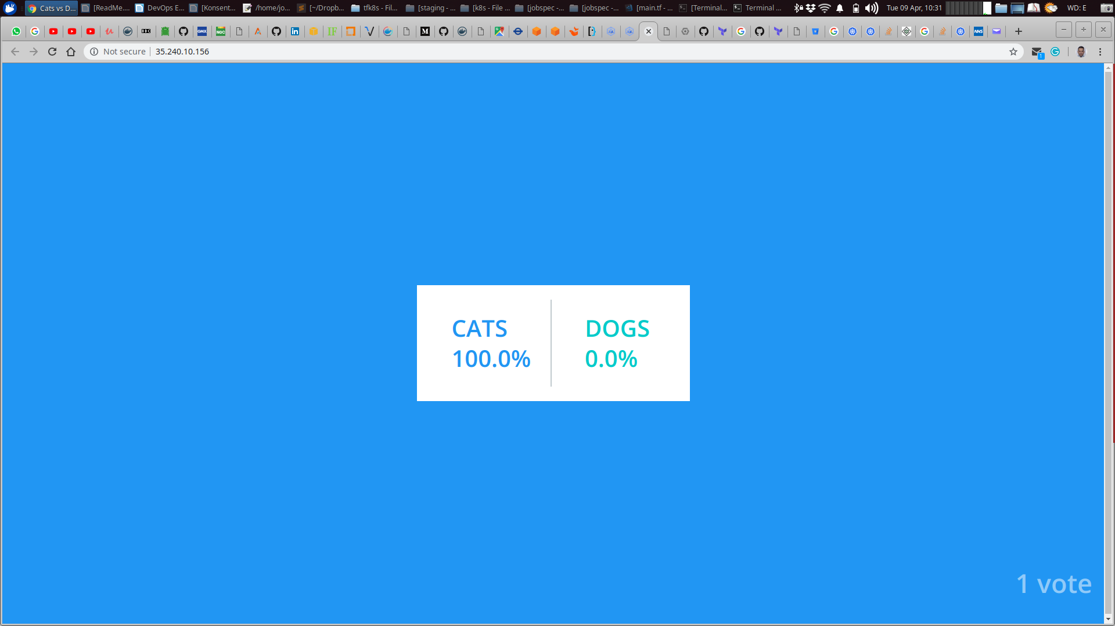

Refferences:

<https://www.terraform.io/docs/providers/google/r/container_cluster.html>

<https://kubernetes.io/docs/tasks/configure-pod-container/quality-service-pod/>

redis config instructions:

<https://kubernetes.io/docs/tutorials/configuration/configure-redis-using-configmap/>