**Workstation Map**

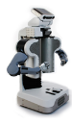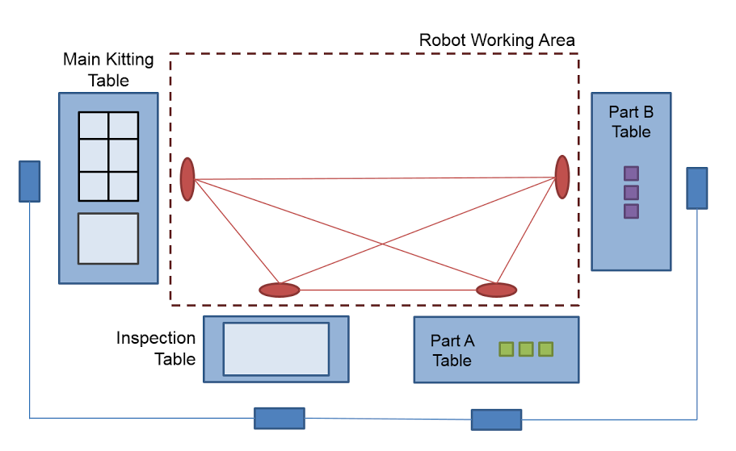

**Distances between Tables** (assumed to be same for human and robot)

* Main table <-> Inspection table 15 [ft]
* Main table <-> Part A table 20
* Main table <-> Part B table 30
* Inspection table <-> Part A table 10
* Inspection table <-> Part B table 20
* Part A table <-> Part B table 15

**Agent Capabilities**

|  |  |  |  |  |
| --- | --- | --- | --- | --- |
|  | GoTo Speed | Grasp time | Inspect time | Kit time |
| Human | 5 ft/s | 1 sec | 3 sec | 5 sec |
| Robot | 5 ft/s | 3 sec | 5 sec | 10 sec |
| Human ergonomics cost | = [distance] / 10 | = 0 | = 1 | = 2 |

* Each agent can hold only one item at a time

**Initial Locations:** both agents start at the main kitting table

**Goal:** Blocks {A1, A2} and {B1, B2} kitted at the main table (we can increase the number of objects if we want)

**Optimization metric (minimize):**

= 1 * total-time + 2 * human ergonomics cost