**Note:**

1.Need to ask whether we have any condition for program 1 (substance abuse) like for program 2(sex offense),program3(intensive)

2.Clarity for substance abuse-Program 1 prediction is working (rare cases)

_____________________________________________________________________

1.Client code: 55222

1. Alcohol_Use:1-Yes
2. Drug_Use:1-Yes
3. YLS_Subab_Score:5

****Previous Results in DB when Morgan tested: Program-3(overwritten by condiiton)

Results Now:

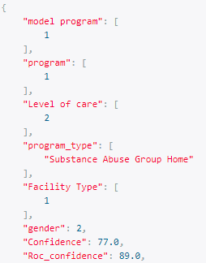

2..Client code: 66222

1. Alcohol_Use:1-Yes
2. Drug_Use:1-Yes
3. YLS_Subab_Score:5

Previous Results: Program-3(cans,yls impact more)

Results Now:

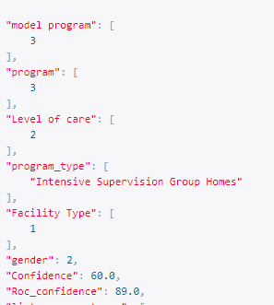

3.Client code: 43969

1. Alcohol_Use:0-No
2. Drug_Use:1-Yes
3. YLS_Subab_Score:3

****Previous Results: Program-3(input data got trained more on Program 3-Results based on Model predcition )

Results Now:

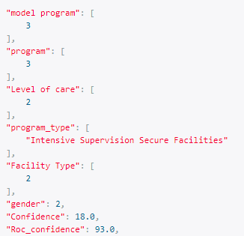

4.Client code: 77222

1. Alcohol_Use:1-Yes
2. Drug_Use:1-Yes
3. YLS_Subab_Score:3

****Previous Results: Program-3(input data got trained more on Program 3-Results based on Model predcition )

Results Now:

