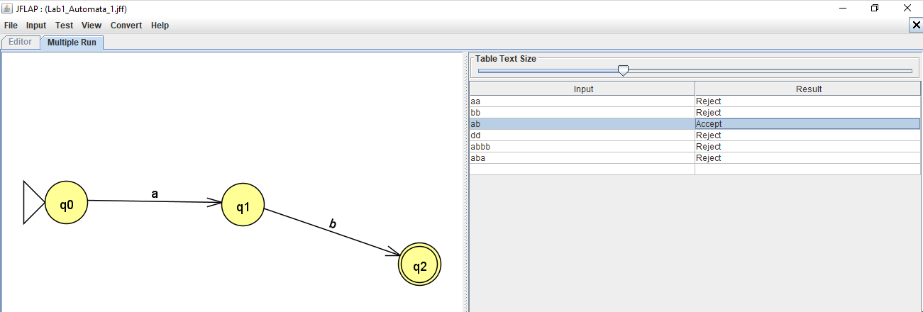

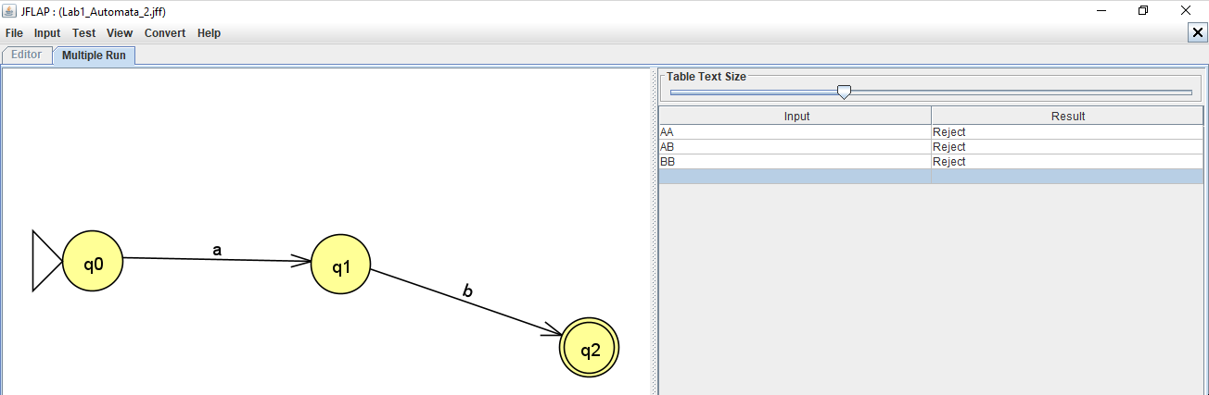

|  | A | B |
| --- | --- | --- |
| Q0 | Q1 | --- |
| Q1 | --- | Q2 |
| Q2 | --- | --- |

