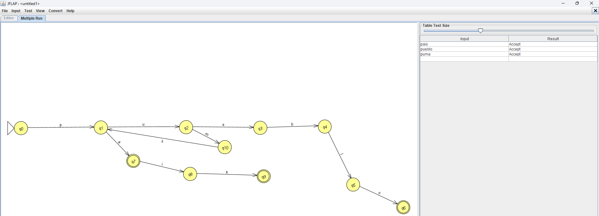

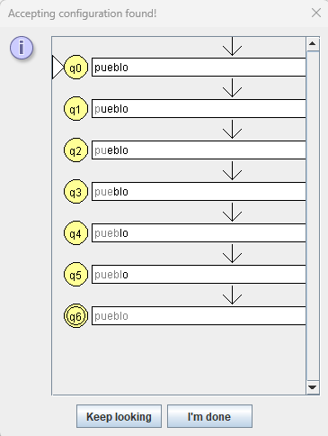

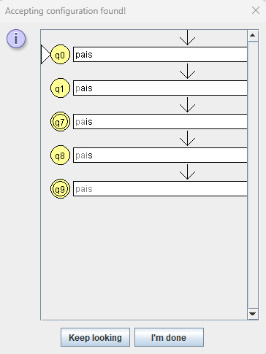

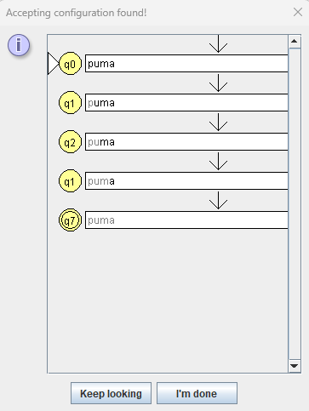

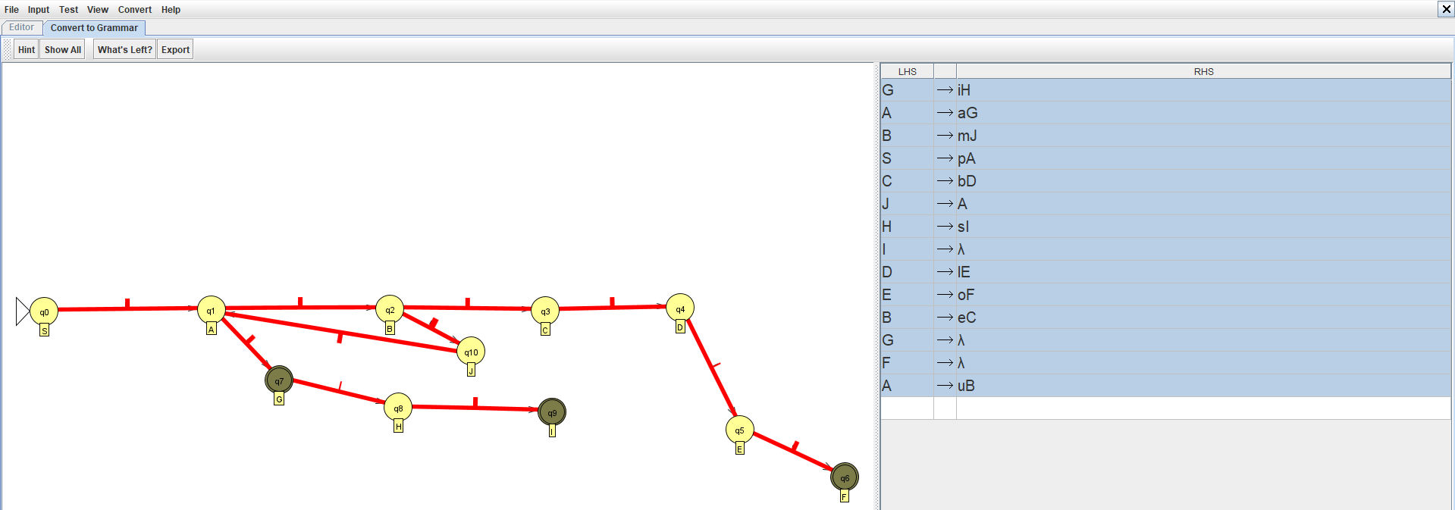

|  |  |  |  |  |  |  |  |  |  |  |
| --- | --- | --- | --- | --- | --- | --- | --- | --- | --- | --- |
| Estados | Elementos | | | | | | | | | |
|  | p | u | a | i | s | m | e | b | l | o |
| S | A |  |  |  |  |  |  |  |  |  |
| A |  | B | G |  |  |  |  |  |  |  |
| B |  |  |  |  |  | J | C |  |  |  |
| C |  |  |  |  |  |  |  | D |  |  |
| D |  |  |  |  |  |  |  |  | E |  |
| E |  |  |  |  |  |  |  |  |  | F |
| F |  |  |  |  |  |  |  |  |  |  |
| J |  |  |  |  |  |  |  |  |  |  |
| G |  |  |  | H |  |  |  |  |  |  |
| H |  |  |  |  | I |  |  |  |  |  |
| I |  |  |  |  |  |  |  |  |  |  |

