II.

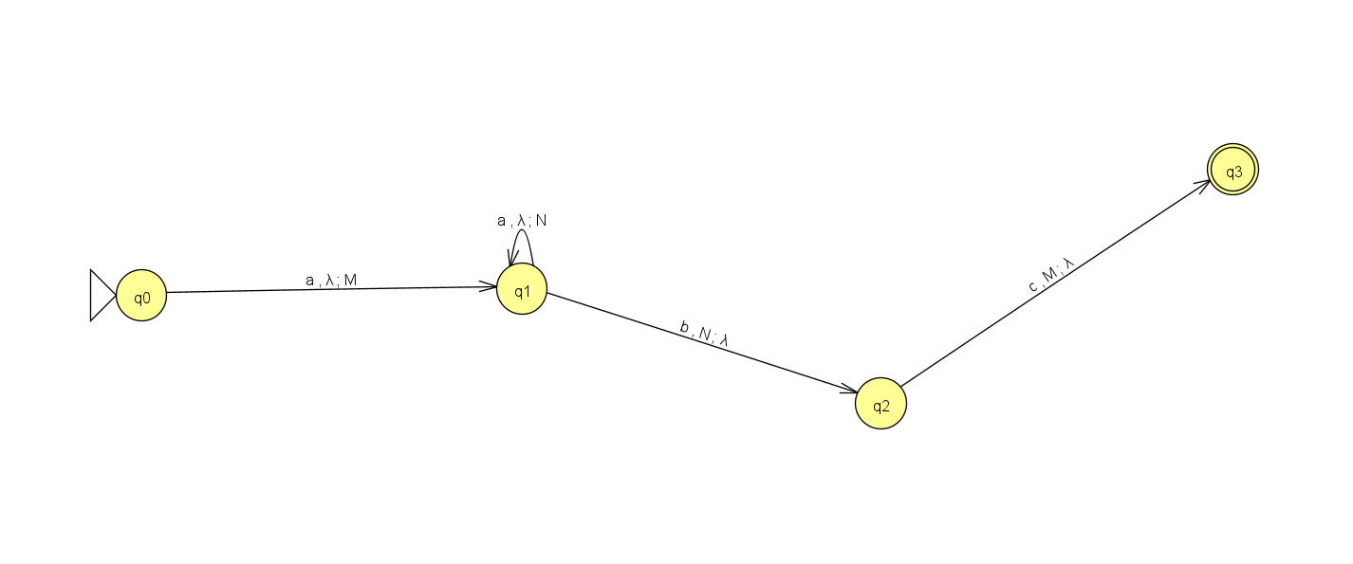

|  |  |  |
| --- | --- | --- |
| **Pila** | **Entrada** | **Transiciones** |
| Z | λ | q0 |
| MZ | aabc | q0, a, λ ; q1, M |
| NMZ | abc | q1, a, λ ; q1, N |
| MZ | bc | q1, b, N ; q2, λ |
| Z | c | q2, c, M ; q3, λ |

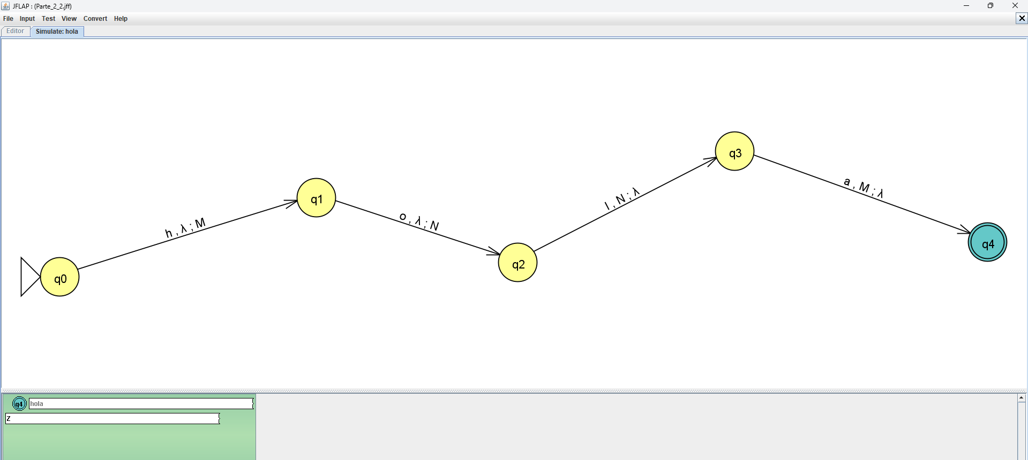

|  |  |  |
| --- | --- | --- |
| **Pila** | **Entrada** | **Transiciones** |
| Z | λ | q0 |
| MZ | hola | q0, h, λ ; q1, M |
| NMZ | ola | q1, o, λ ; q2, N |
| MZ | la | q2, I, N ; q3, λ |
| Z | a | q3, a, M ; q4, λ |

Cree un autómata que lea la cadena pensamiento, la pila debe llenarse y vaciarse. Cree la matriz de transiciones.

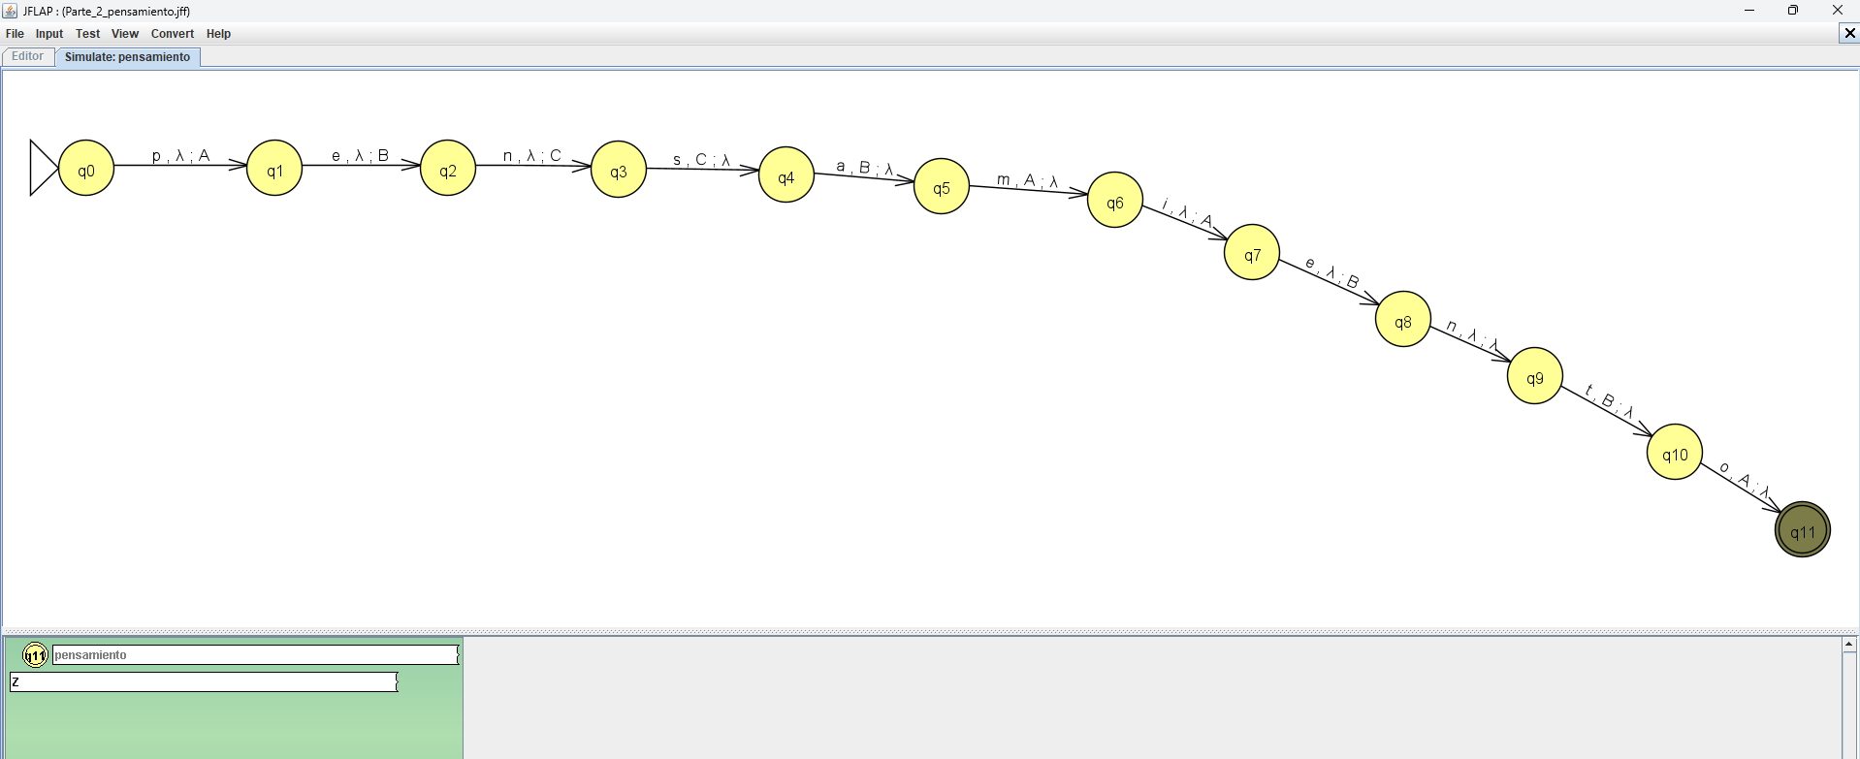

|  |  |  |
| --- | --- | --- |
| **Pila** | **Entrada** | **Transiciones** |
| Z | λ |  |
| AZ |  |  |
| BAZ |  |  |
| CBAZ |  |  |
| BAZ |  |  |
| AZ |  |  |
| Z |  |  |
| AZ |  |  |
| BAZ |  |  |
| BAZ |  |  |
| AZ |  |  |
| Z |  |  |

III. Cree un autómata de pila en base al siguiente lenguaje

L = cddfgg

