# Processor Information

## Descriptive Statistics

Descriptive statistics for each processor type:

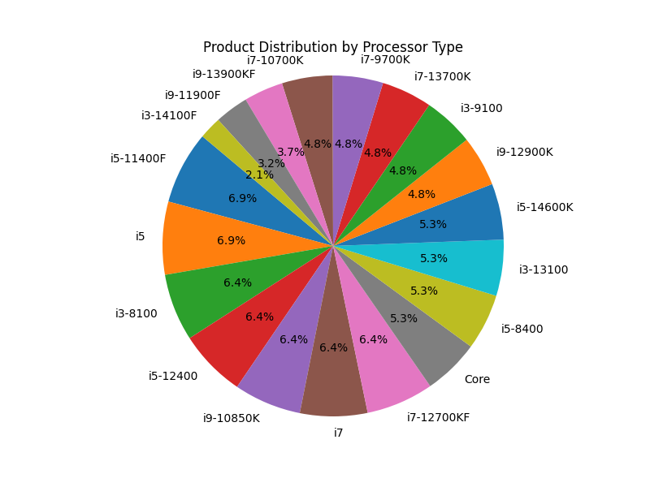

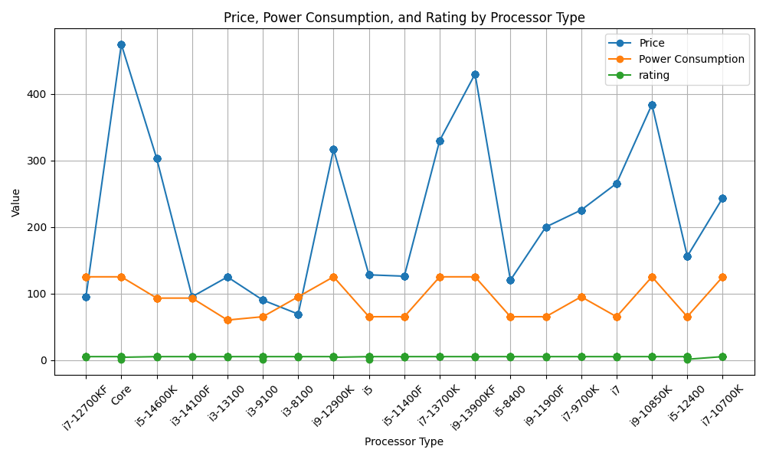

## Insights for i7:

Missing values in rating for i7: 0

Number of Products: 51

Average Rating: 4.96078431372549

Processor with highest power consumption among i7 processors:

Product Name Intel Core i7-12700KF Gaming Desktop Processor...  
Price 94.99  
Power Consumption 125.0  
rating 5.0  
processor_type i7-12700KF  
Name: 0, dtype: object

Processor with lowest price among i7 processors:

Product Name Intel Core i7-12700KF Gaming Desktop Processor...  
Price 94.99  
Power Consumption 125.0  
rating 5.0  
processor_type i7-12700KF  
Name: 0, dtype: object

Processor with highest price among i7 processors:

Product Name Intel Core i7-13700K Gaming Desktop Processor  
Price 329.99  
Power Consumption 125.0  
rating 5.0  
processor_type i7-13700K  
Name: 128, dtype: object

Processor preferred based on highest number of positive sentiments among i7 processors:

Product Name Intel Core i7-12700KF Gaming Desktop Processor...  
Price 94.99  
Power Consumption 125.0  
rating 5.0  
processor_type i7-12700KF  
positive_sentiments 49  
Name: 0, dtype: object

## Insights for i5:

Missing values in rating for i5: 0

Number of Products: 58

Average Rating: 4.758620689655173

Processor with highest power consumption among i5 processors:

Product Name Intel Core i5-14600K New Gaming Desktop Proces...  
Price 302.94  
Power Consumption 93.0  
rating 5.0  
processor_type i5-14600K  
Name: 22, dtype: object

Processor with lowest price among i5 processors:

Product Name Intel Core i5-8400 Desktop Processor   
Price 120.0  
Power Consumption 65.0  
rating 5.0  
processor_type i5-8400  
Name: 144, dtype: object

Processor with highest price among i5 processors:

Product Name Intel Core i5-14600K New Gaming Desktop Proces...  
Price 302.94  
Power Consumption 93.0  
rating 5.0  
processor_type i5-14600K  
Name: 22, dtype: object

Processor preferred based on highest number of positive sentiments among i5 processors:

Product Name Intel Core i5-14600K New Gaming Desktop Proces...  
Price 302.94  
Power Consumption 93.0  
rating 5.0  
processor_type i5-14600K  
positive_sentiments 55  
Name: 22, dtype: object

## Insights for i3:

Missing values in rating for i3: 0

Number of Products: 35

Average Rating: 4.8

Processor with highest power consumption among i3 processors:

Product Name Intel Core i3-8100 Desktop Processor  
Price 69.0  
Power Consumption 95.0  
rating 5.0  
processor_type i3-8100  
Name: 55, dtype: object

Processor with lowest price among i3 processors:

Product Name Intel Core i3-8100 Desktop Processor  
Price 69.0  
Power Consumption 95.0  
rating 5.0  
processor_type i3-8100  
Name: 55, dtype: object

Processor with highest price among i3 processors:

Product Name Intel Core i3-13100 Desktop Processor 4 cores ...  
Price 124.81  
Power Consumption 60.0  
rating 5.0  
processor_type i3-13100  
Name: 36, dtype: object

Processor preferred based on highest number of positive sentiments among i3 processors:

Product Name Intel Core i3-14100F Desktop Processor 4 cores...  
Price 94.99  
Power Consumption 93.0  
rating 5.0  
processor_type i3-14100F  
positive_sentiments 30  
Name: 32, dtype: object