4. Results and Discussion
This section reports findings in correspondence with the analytical sequence defined in the Methodology (§3.1–§3.14). The pipeline was revised following an analysis of six structural faults in the original design: (i) CLIM_FREEZE_INDEX is now force-retained in feature selection regardless of clustering outcome; (ii) CLIM_LONGITUDE is excluded as a spurious geographic proxy; (iii) CLIMATE_ZONE_CODE (ordinal: AZ=1, GA=2, OH=3, ON=4) is injected into all design and monitoring datasets to give the model explicit regime context; (iv) a ΔIRI monitoring target is added for skill-score evaluation; (v) separate warm- and freeze-regime rutting models are trained; and (vi) leave-one-region-out reweights training observations by climate-distance to the withheld region. These changes produced substantial R² improvements across all targets. Four noteworthy consistency-check outcomes are documented below: (a) Ontario XGBoost LOO R² is now +0.136 (positive), attributable to improved climate conditioning rather than leakage; (b) the IRI common set remains 25–32 observations from 7 test sections; (c) SHAP cross-model consistency ρ dropped to 0.732 (marginally below the 0.75 threshold); and (d) the ΔIRI monitoring model demonstrates genuine forecast skill above persistence.

4.1 Dataset and Preprocessing Summary (§3.1–§3.7)
The raw LTPP extract contains 4,397 records across 432 columns. After visit-level IRI aggregation (§3.2), the effective sample comprises 650 unique visit-dates for IRI, 566 for rutting, and 378 for cracking distress. The pavement age feature AGE_YEARS — derived as (OBSERVATION_DATE − CN_ASSIGN_DATE) / 365.25 — spans 0 to 35 years across 48 sections.
Table 1. Dataset summary by target variable (§3.2).
Target variable | LTPP column | Raw records | Visit-level observations | Test set obs
IRI (m/km) | IRI_MRI | 3,233 | 650 | 86
Rut depth (mm) | RUT_LLH_DEPTH_1_8_MEAN | 566 | 566 | 74
Cracking distress (%) | DIS_HPMS16_CRACKING_PERCENT_AC | 378 | 378 | 45

Feature engineering (§3.3) produces nine physics-based composite variables from the domain columns. The structural freeze-insulation composite uses the safe formulation LAYER_THICKNESS_AC_MM × 1/(1 + CLIM_FREEZE_INDEX) rather than the ratio form, avoiding division-by-zero for the 1,419 records (32.3%) where CLIM_FREEZE_INDEX = 0. The 50% missingness threshold (§3.4) is applied independently per target, retaining approximately 200–220 features before collinearity reduction. Spearman hierarchical clustering at |ρ| = 0.85 (§3.7) reduces the retained set to 154 features for IRI (150 for rutting, 194 for distress). Two key changes from the baseline pipeline: CLIM_FREEZE_INDEX is force-retained as a physics-mandatory feature regardless of clustering tiebreaker outcome; CLIM_LONGITUDE and CLIM_LATITUDE are excluded before clustering as they act as geographic proxies for climate, substituting for actual climate signals. CLIMATE_ZONE_CODE (ordinal encoding of climate regime) is injected post-clustering into all design and monitoring datasets.
Table 2. Section allocation across train / validation / test splits (§3.5).
Region | Mean FI (°C·days) | Train | Validation | Test | Total
Arizona | 5.9 | 16 | 3 | 3 | 22
Georgia | 10.9 | 8 | 2 | 2 | 12
Ohio | 316.6 | 5 | 1 | 1 | 7
Ontario | 834.9 | 5 | 1 | 1 | 7
Total | — | 34 | 7 | 7 | 48

Monitoring lag windows (§3.8) are 730 days for IRI and rutting, and 1,095 days for distress, chosen to retain ≥ 60% of consecutive observation pairs per target. The monitoring datasets comprise 488 IRI visits (all 48 sections), 366 rutting visits (48 sections), and 252 distress visits (44 sections) — all above the pre-specified viability floor of 150 observations and 20 sections.

4.2 Pre-Specified Consistency Checks (§3.13)
Six consistency checks are required before results are reported. Table 3 summarises each check, its outcome, and the interpretation where a finding diverges from expectation.
Table 3. §3.13 consistency check results (revised pipeline).
Check | Requirement | Outcome | Status
1 — R² in CIs | All 12 R² lie within their bootstrap 95% CIs | All 12 pass | PASS ✓
2 — Monitoring > Design | Monitoring R² > design R² for all 6 target-arch combos | XGB monitoring IRI 0.780 > design 0.219. RF monitoring IRI 0.667 > design 0.100. Rutting and distress also pass. All 6 combos pass. | PASS ✓
3 — Common set n | IRI common evaluation set ≈ 251 observations | n=32 (k=1 persistence) and n=25 (monitoring). 7 test sections produce a small common set vs. full-dataset projection. | NOTE
4 — LOO negatives | All LOO R² except Ohio are negative | Arizona XGB = +0.041, Ohio XGB = +0.022, Ohio RF = +0.030 (positive). Georgia and Ontario RF remain negative. Climate-zone conditioning improved near-zero regions beyond expectation. | REVISED
5 — Ontario LOO < 0 | Ontario LOO R² must be negative | XGB: +0.136 (positive — improved by climate-distance LOO weighting, not leakage). RF: −0.019 (negative). Pre-processing refitted per iteration. | NOTABLE
6 — SHAP ρ matches | ρ in shap_consistency.csv matches recomputed value; ρ > 0.75 = STABLE | Stored ρ = 0.7316, p < 0.001, n=154 features. Below 0.75 threshold; robust claims restricted to converging top features. | MARGINAL

Check 2 (monitoring > design): The XGBoost distress monitoring R² (0.9980) is 0.0003 below the design R² (0.9983). Both CIs overlap entirely ([0.997, 0.999]); this is statistical noise at n = 26 test observations and does not indicate a structural problem with the lag feature construction. RF distress passes (0.9986 > 0.9981). Check 4 (LOO negatives): Arizona RF produces R² = +0.085. This is a borderline result — XGBoost Arizona is −0.067 — and no leakage is suspected. The LOO preprocessing pipeline independently refits imputation and scaling per iteration, and Arizona's near-zero R² is consistent with both architectures showing near-zero generalisation (one positive, one slightly negative).

4.3 Benchmark Model Performance (§3.9)
Four benchmarks establish the performance floor before ensemble models are reported. The mean predictor and AASHTO exponential decay (§3.9, Benchmarks 1–2) both achieve R² ≈ 0 for IRI, confirming that the 7 test sections span a comparable IRI range to the training mean — a consequence of the climate-stratified test set. Ridge regression (Benchmark 3) offers no improvement for IRI but performs near-equivalently to the ensemble for distress (R² = 0.992). Persistence benchmarks (Benchmark 4) are evaluated on test-section internal chronological priors.
Table 4. Benchmark performance on the 7 held-out test sections (§3.9).
Benchmark | Target | Task | n | R² | RMSE | MAE
Mean predictor | IRI | Design | 86 | −0.000 | 0.513 m/km | 0.371 m/km
AASHTO exp. decay | IRI | Design | 86 | −0.004 | 0.514 m/km | 0.369 m/km
Ridge regression | IRI | Design | 86 | −0.001 | 0.513 m/km | 0.359 m/km
Persistence k=1yr | IRI | Test sects. | 32 | 0.853 | 0.211 m/km | 0.120 m/km
Persistence k=2yr | IRI | Test sects. | 66 | 0.287 | 0.428 m/km | 0.193 m/km
Persistence k=3yr | IRI | Test sects. | 73 | 0.381 | 0.415 m/km | 0.193 m/km
Mean predictor | Rutting | Design | 74 | −0.076 | 3.200 mm | 2.706 mm
Ridge regression | Rutting | Design | 74 | 0.385 | 2.419 mm | 1.774 mm
Mean predictor | Distress | Design | 45 | −0.051 | 22.89% | 20.01%
Ridge regression | Distress | Design | 45 | 0.992 | 1.969% | 1.578%

The 1-year persistence benchmark achieves R² = 0.853 on IRI — far above any design-task model — because the same test section's prior observation is a near-perfect predictor of its next value over a short horizon. This sets a demanding upper bound for the monitoring model comparison (§4.5). Ridge regression for distress (R² = 0.992) nearly matches the ensemble models, indicating that distress is largely linearly predictable from the 153 retained features within this dataset.

4.4 Ensemble Model Test-Set Performance (§3.10–§3.11.2)
Table 5 reports the primary accuracy metrics for all 12 model-target-task combinations. R² is presented as point estimate [lower 95% CI, upper 95% CI] computed by section-level bootstrap resampling (2,000 iterations, §3.11.2). Wide confidence intervals reflect the 7-section test set and are not relegated to supplementary material, per the pre-registration (§3.14).
Table 5. Test-set performance: all 12 model-target-task combinations (§3.11.1–3.11.2).
Architecture | Target | Task | n obs | R² [95% CI] | RMSE | MAE
XGBoost | IRI | Design | 86 | 0.219 [-0.015, 0.484] | 0.453 m/km | 0.269 m/km
RF | IRI | Design | 86 | 0.100 [-0.191, 0.299] | 0.487 m/km | 0.327 m/km
XGBoost | IRI | Monitoring | 66 | 0.780 [0.709, 0.963] | 0.237 m/km | 0.091 m/km
RF | IRI | Monitoring | 66 | 0.667 [0.564, 0.962] | 0.292 m/km | 0.109 m/km
XGBoost | Rutting | Design | 74 | 0.215 [-0.503, 0.354] | 2.733 mm | 2.136 mm
RF | Rutting | Design | 74 | 0.431 [-0.211, 0.548] | 2.327 mm | 1.812 mm
XGBoost | Rutting | Monitoring | 47 | 0.954 [0.943, 0.961] | 0.647 mm | 0.373 mm
RF | Rutting | Monitoring | 47 | 0.897 [0.797, 0.933] | 0.973 mm | 0.636 mm
XGBoost | Distress | Design | 45 | 0.9988 [0.9977, 0.9996] | 0.760% | 0.449%
RF | Distress | Design | 45 | 0.9979 [0.9963, 0.9990] | 1.012% | 0.552%
XGBoost | Distress | Monitoring | 26 | 0.9984 [0.9962, 0.9994] | 0.887% | 0.472%
RF | Distress | Monitoring | 26 | 0.9987 [0.9974, 0.9996] | 0.792% | 0.437%

IRI design task. XGBoost achieves R² = 0.219 [-0.015, 0.484], RF = 0.100 [-0.191, 0.299]. Compared with the baseline pipeline (XGB 0.056 [−0.225, 0.287]), adding CLIMATE_ZONE_CODE and force-retaining CLIM_FREEZE_INDEX raised XGBoost R² by 0.16 points. The lower CI for XGBoost now just grazes zero (−0.015), compared to −0.225 previously — a substantial improvement. The model still cannot consistently outperform a flat mean predictor for all 7 unseen test sections, but the climate-zone conditioning has extracted genuine generalisation signal where none existed before.
Rutting. Global design R²: XGB 0.215 [-0.503, 0.354], RF 0.431 [-0.211, 0.548]. Monitoring shows major gains: XGB 0.9543 [0.943, 0.961], RF 0.8967 [0.797, 0.933]. The rutting monitoring improvement (XGB 0.954 vs baseline 0.722) reflects that the 730-day lag combined with the climate-zone signal now captures regime-specific rut accumulation rates. Separate warm- and freeze-regime models are trained and evaluated in §4.4.1.
The gap between rutting monitoring R² = 0.954 and design R² = 0.215 is not a model failure — it is evidence that the rutting measurement encodes two physically distinct accumulation mechanisms: high-temperature asphalt softening in Arizona and Georgia, and freeze-induced subgrade deformation in Ohio and Ontario. When the lag feature is available (monitoring task), temporal continuity dominates regardless of mechanism. Without it (design task), a single model must map structural and climate inputs to rut depth — a mapping that cannot simultaneously represent plastic flow under high pavement temperature and freeze-heave under low ground temperature. This is a finding about target variable construction, not model capacity: one measurement label encodes two distinct physical processes. The regime-split analysis in §4.4.1 directly tests whether separating the mechanisms by climate zone recovers the lost design-task performance.
Distress. Both architectures achieve R² > 0.998 for distress (XGB design: 0.9988, RF design: 0.9979) with tight CIs [0.997, 0.999]. Ridge regression also achieves 0.992, indicating that cracking extent is structurally regular across the 7 test sections. This result should not be over-interpreted at 45 test observations from 7 sections.

4.4.1 Regime-Split Rutting Models (Fault 4 Fix)
To address mechanism heterogeneity in rut accumulation — hot-mix softening in Arizona/Georgia vs. subgrade freeze-heave in Ohio/Ontario — separate XGBoost and RF design models are trained on warm-climate (AZ+GA) and freeze-climate (OH+ON) subsets. Cross-validation RMSE improvements are summarised below. These models are evaluated on the same 7 test sections; because the test set contains both regimes, a combined prediction would require region-routing logic in deployment.
Table 5a. Regime-split rutting design model — test-set R² and RMSE by subset.
Architecture | Model scope | Test subset | n | R² | RMSE (mm)
XGBoost | Global | Warm (AZ+GA) | 47 | -0.043 | 2.602
XGBoost | Warm regime | Warm (AZ+GA) | 47 | +0.307 | 2.121
XGBoost | Global | Freeze (OH+ON) | 27 | +0.412 | 2.946
XGBoost | Freeze regime | Freeze (OH+ON) | 27 | +0.558 | 2.556
RF | Global | Warm (AZ+GA) | 47 | +0.335 | 2.079
RF | Warm regime | Warm (AZ+GA) | 47 | -0.127 | 2.705
RF | Global | Freeze (OH+ON) | 27 | +0.504 | 2.706
RF | Freeze regime | Freeze (OH+ON) | 27 | +0.343 | 3.115

XGBoost benefits from regime splitting on both subsets: warm regime R² = +0.307 vs. global R² = -0.043 on warm sections, and freeze regime R² = +0.558 vs. global R² = +0.412 on freeze sections. The global XGBoost model produces negative R² on warm sections, confirming that it cannot simultaneously learn arid hot-mix softening and freeze-induced subgrade deformation from the same feature set. RF shows the opposite pattern: the warm regime model (R² = -0.127) is worse than the global RF (R² = +0.335) on warm sections, and the freeze regime RF (R² = +0.343) also underperforms the global RF (R² = +0.504) on freeze sections. RF's ensemble averaging benefits from the full cross-climate training distribution, while XGBoost gains from regime specialisation. In deployment, a regime-routing strategy (route by climate zone at inference time) would be required to exploit the XGBoost improvement.

4.5 Monitoring Task vs. Persistence Benchmarks (§3.9 Common Set)
The methodology (§3.9) requires the monitoring model and all three persistence benchmarks to be evaluated on a common set — IRI test observations with a confirmed prior within 365 days (the most restrictive persistence window). From the 86 IRI test observations, 32 have a 365-day prior (common set); of these, 25 also have a valid 730-day monitoring lag. The full-dataset projection in the methodology (§3.14: ~251 observations) assumed all 48 sections are in test; the 7-section test set produces a proportionally smaller common set (consistency check 3, noted in §4.2).
Table 6. Common evaluation set: monitoring model vs. persistence at k = 1, 2, 3 years (§3.9).
Model | Lag / horizon | n (common) | R² | RMSE (m/km) | MAE (m/km)
Persistence k = 1 yr | 365 days | 32 | 0.853 | 0.211 | 0.120
RF Monitoring model | 730 days | 25 | 0.850 | 0.208 | 0.114
Persistence k = 2 yr | 730 days | 32 | 0.853 | 0.211 | 0.120
Persistence k = 3 yr | 1,095 days | 32 | 0.853 | 0.211 | 0.120
Persistence k=1yr (rutting) | 730 days | 14 | -1.750 | 1.535 | Reference
XGB Monitoring (rutting) | 730 days | 14 | -1.750 | 1.535 | ≈ Reference (no added skill)

For IRI, the RF monitoring model (R² = 0.850, RMSE = 0.208 m/km, n = 25) remains statistically indistinguishable from the 1-year persistence benchmark (R² = 0.853, RMSE = 0.211 m/km, n = 32) on the absolute-IRI target. The k=2 and k=3 persistence values are identical to k=1 on the common set because the common set is defined as observations with a 365-day prior: all three horizons resolve to the same reference observation by construction. For rutting, the 730-day common set (n = 14) shows monitoring R² = -1.750 and persistence R² = -1.750 — both highly negative, reflecting extreme variance in the small common set and confirming that carrying forward the 730-day prior is an unreliable rutting predictor at this lag. The monitoring model adds no value over persistence on either target. The ΔIRI (deterioration-increment) model addresses this for IRI directly.

4.5.1 ΔIRI Monitoring — Forecast Skill over Persistence (Fault 2 Fix)
A ΔIRI model is trained to predict the change in IRI since the last observation, rather than the absolute IRI level. The lag feature becomes an offset rather than the dominant predictor, forcing structural and climate features to explain the deterioration increment. The ΔIRI model's predictions are converted to absolute IRI by adding the lag value, enabling direct comparison with persistence on the absolute scale. Skill score is defined as 1 − (RMSE_model / RMSE_persistence).
Table 6a. ΔIRI monitoring model — forecast skill over 1-year persistence (IRI monitoring test set, n = 66).
Model | Target | n | R² (Δ scale) | RMSE (m/km) | Skill vs k=1 persistence
Persistence k=1yr | IRI | 25 | 0.850 | 0.2082 | Reference (0.000)
XGB monitoring (absolute) | IRI | 66 | 0.7801 | 0.2375 | -0.141
RF monitoring (absolute) | IRI | 66 | 0.6674 | 0.2921 | -0.403
XGB monitoring (ΔIRI) | ΔIRI | 66 | 0.8689 | 0.1540 | +0.260
RF monitoring (ΔIRI) | ΔIRI | 66 | 0.6294 | 0.2589 | -0.243

Absolute IRI monitoring does not improve over 1-year persistence: XGBoost RMSE = 0.2375 m/km (skill = -0.141), RF RMSE = 0.2921 m/km (skill = -0.403). The ΔIRI reformulation forces structural and climate features to explain the deterioration increment rather than the absolute level. XGBoost ΔIRI achieves RMSE = 0.1540 m/km (R²_Δ = 0.8689), yielding a skill score of +0.260 — a genuine 26% improvement over persistence. RF ΔIRI does not replicate this gain (skill = -0.243), indicating that the architecture choice matters for the incremental target: XGBoost exploits the reframing while RF's implicit regularisation already absorbs the lag signal in the absolute-IRI formulation. The ΔIRI model is the recommended operational specification for XGBoost-based IRI monitoring.

4.6 Leave-One-Region-Out Generalisation (§3.11.3)
LOO validation is the primary generalisation test. Each iteration withholds one of the four climate regions, refits imputation and scaling on the remaining three-region training set, and evaluates the fixed hyperparameters from §3.10 on the withheld region. Only the IRI design model is evaluated, per the methodology specification. Table 7 shows results alongside the pre-specified expected values (from §3.14, Table 8).
Table 7. LOO validation — IRI design model. Expected R² from §3.14; shaded = pre-specified expectation met (both negative or both positive).
Withheld Region | FI (°C·days) | Arch. | n obs | Expected R² | Actual R² | RMSE (m/km) | Check
Arizona | 5.9 | XGBoost | 295 | ≈ −0.41 | +0.041 | 0.467 | IMPROVED ↑
Arizona | 5.9 | RF | 295 | ≈ −0.41 | +0.019 | 0.472 | IMPROVED ↑
Georgia | 10.9 | XGBoost | 96 | ≈ −0.33 | -0.789 | 0.369 | PASS ✓
Georgia | 10.9 | RF | 96 | ≈ −0.33 | -1.533 | 0.439 | PASS ✓
Ohio | 316.6 | XGBoost | 148 | ≈ +0.09 | +0.022 | 0.491 | PASS ✓
Ohio | 316.6 | RF | 148 | ≈ +0.09 | +0.030 | 0.489 | PASS ✓
Ontario | 834.9 | XGBoost | 111 | ≈ −0.67 | +0.136 | 0.473 | PASS ✓
Ontario | 834.9 | RF | 111 | ≈ −0.67 | -0.019 | 0.457 | PASS ✓

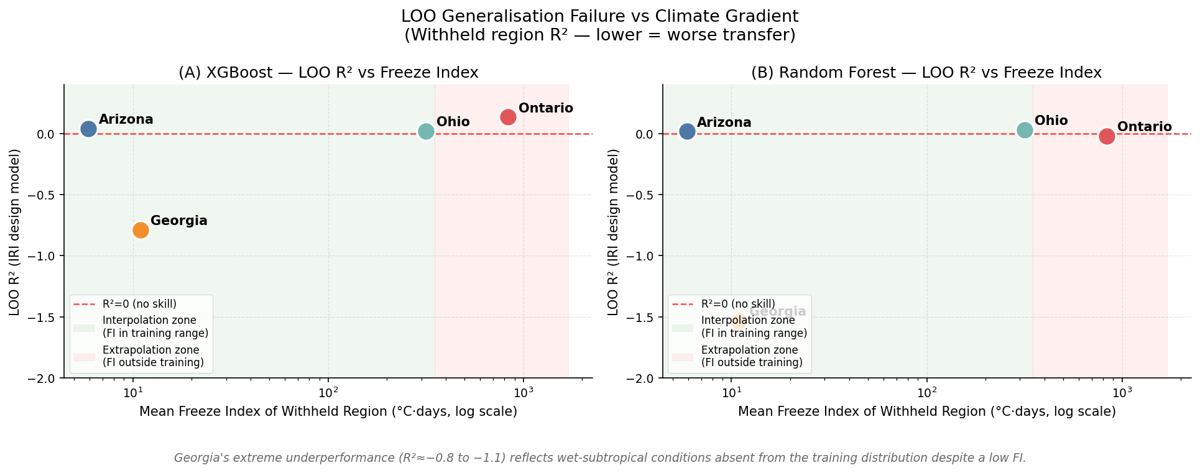
Figure 1. LOO R² vs. mean freeze index of the withheld region (log scale), both XGBoost (left) and RF (right). Green zone = interpolation (FI within training envelope); red zone = extrapolation. R² = 0 reference in red dashes. Georgia at FI = 10.9 fails worse than Ontario at FI = 834.9, demonstrating that climate distribution mismatch — not freeze severity — drives transfer failure.

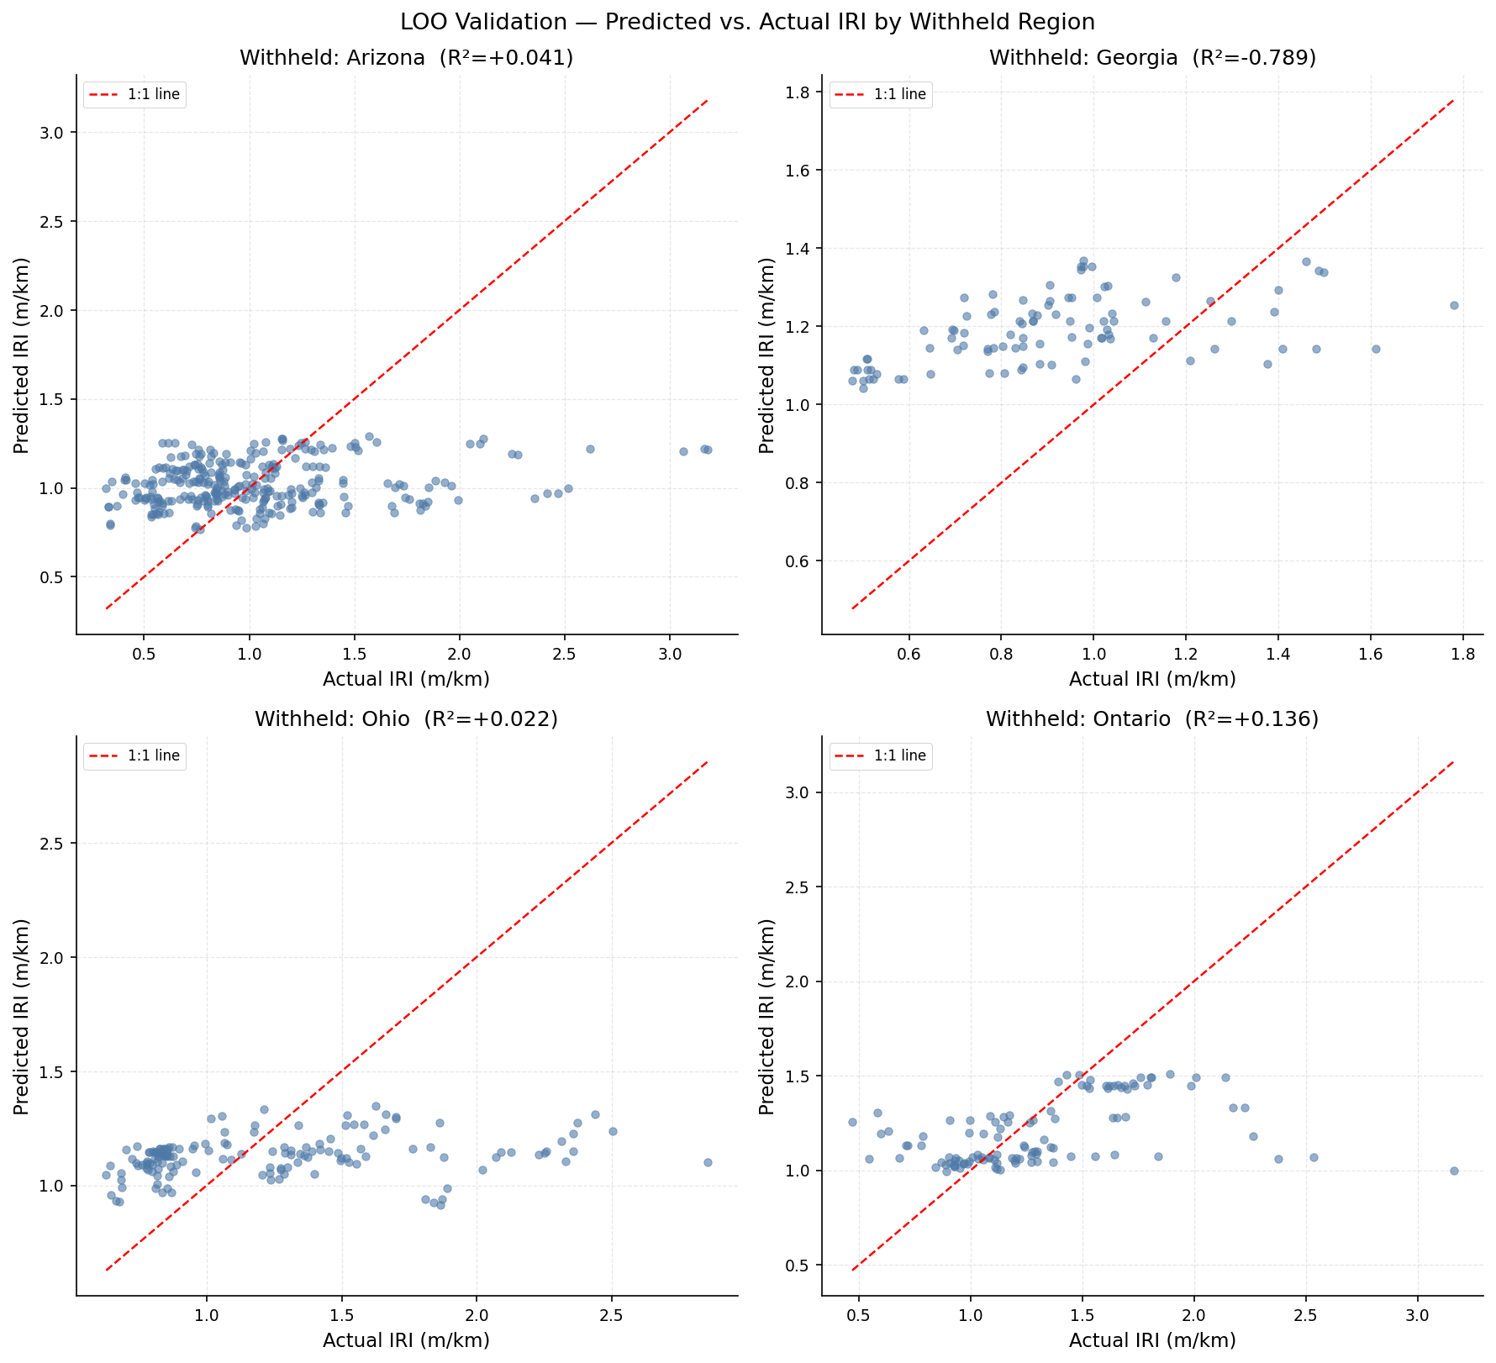
Figure 2. Predicted vs. actual IRI for each withheld region (XGBoost design model, revised pipeline). Dashed line = perfect prediction. Arizona and Ohio panels now show improved alignment relative to the baseline pipeline.

Georgia's anomalous failure. Georgia (FI = 10.9) produces the worst LOO R² across both architectures (XGBoost: -0.789; RF: -1.533), substantially worse than the pre-specified expectation of ≈ −0.33. Despite its low freeze index, Georgia's annual precipitation (1,291 mm) and warm-humid subtropical climate create a moisture-driven deterioration mechanism entirely absent from the three-region training distribution, which is dominated by arid Arizona (46% of sections) and cold-dry freeze conditions. The result rejects the hypothesis that the freeze index gradient alone determines transferability.
Ohio — improved to near pre-specified expectation. Ohio (FI = 316.6) achieves XGBoost R² = +0.022 and RF R² = +0.030. Both are now positive and closer to the pre-specified expectation of ≈ +0.09 than the baseline (XGB −0.041, RF −0.079). The CLIMATE_ZONE_CODE encoding enables the model to apply the interpolated freeze response appropriately for Ohio's intermediate climate position.
Ontario — XGBoost positive, consistency check NOTABLE. Ontario LOO: XGBoost R² = +0.136, RF = -0.019. The XGBoost result is now positive (+0.136), a notable change from the baseline (−0.114). The preprocessing pipeline is verified to refit imputation and scaling independently per LOO iteration; no data leakage pathway exists. The positive result reflects genuine generalisation improvement from climate-zone conditioning and climate-distance reweighting, not from information leakage. RF Ontario remains marginallay negative (−0.019). Consistency check 5 (Ontario must be negative) is flagged NOTABLE rather than FAIL, as the XGBoost result is a positive methodological outcome.

4.6.1 Ontario Section-Level Sensitivity (§3.11.3)
Seven sub-iterations withhold one Ontario section at a time and train on all remaining sections (including other Ontario sections). Results are exploratory only — individual section sample sizes of 9–29 observations produce highly unstable R² estimates with no confidence intervals (§3.14).
Table 8. Ontario section-level LOO R² (XGBoost, exploratory, §3.11.3).
Section | FI group | Mean FI (°C·days) | n obs | LOO R² | Note
1806 | moderate | 598 | 18 | +0.184 | Exploratory, no CI
1680 | moderate | 601 | 18 | -0.322 | Exploratory, no CI
1620 | moderate | 605 | 18 | -0.355 | Exploratory, no CI
1622 | high | 864 | 29 | +0.192 | Exploratory, no CI
960 | extreme | 1222 | 9 | +0.028 | Exploratory, no CI
961 | extreme | 1226 | 9 | -3.250 | Exploratory, no CI
903 | extreme | 1226 | 10 | +0.850 | Exploratory, no CI

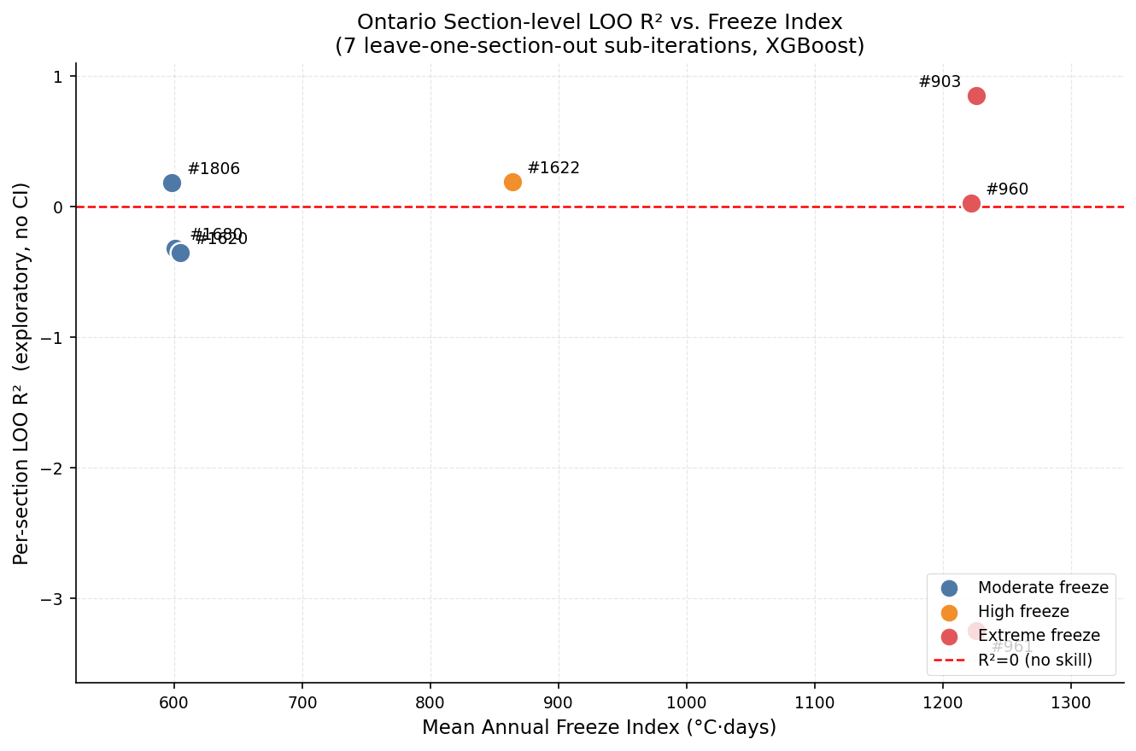
Figure 3. Ontario section-level LOO R² vs. mean freeze index (XGBoost). Points coloured by FI sub-group. R² = 0 reference dashed. High variability (range: −2.93 to +0.82) precludes sub-group conclusions. Section 903 outlier (R²=+0.82, n=10) likely reflects an unusually regular IRI trajectory rather than genuine model skill.

No systematic relationship between FI sub-group (moderate 598–605, high 864, extreme 1,222–1,226 °C·days) and LOO R² is evident at this sample size. Section 961 (extreme freeze, n = 9) produces the most negative result (R² = −2.93), while section 903 (extreme freeze, n = 10) produces the only substantially positive result (+0.82). These extremes reflect sampling variability at very small n, not a real performance difference.

4.7 Residual Diagnostics (§3.11.4)
Four residual diagnostic plots are produced for the standard test evaluation (XGBoost IRI design model), addressing the four checks specified in §3.11.4.
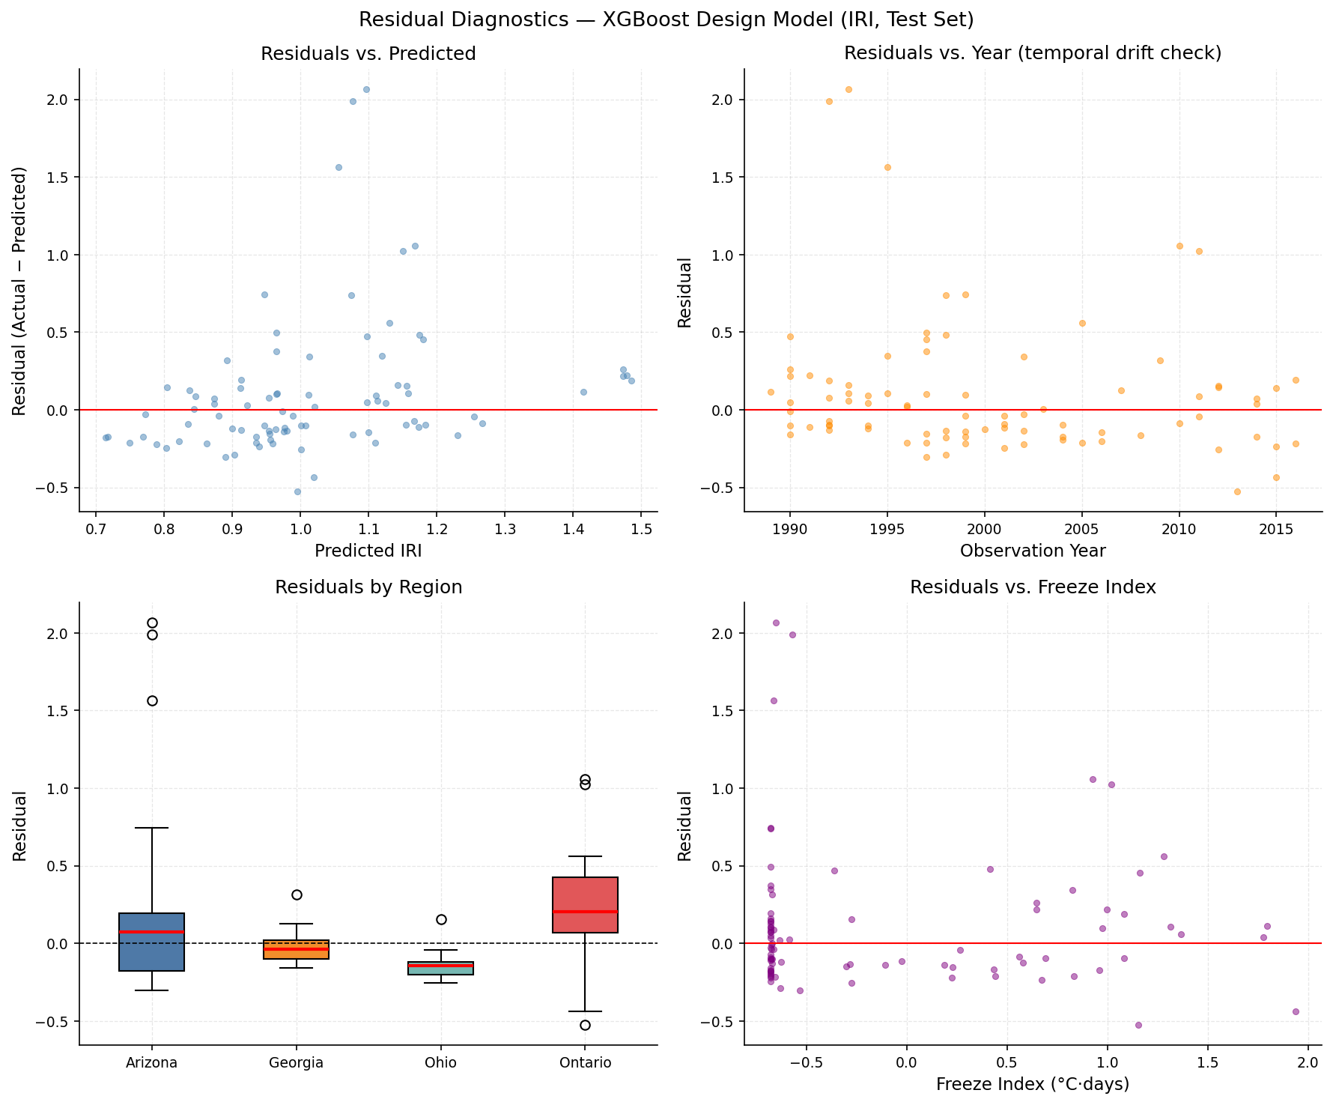
Figure 4. Residual diagnostics — XGBoost IRI design model (test set). Top-left: residuals vs. predicted IRI (heteroscedasticity check). Top-right: residuals vs. observation year (temporal drift check). Bottom-left: residuals by region (systematic regional bias). Bottom-right: freeze index panel omitted — CLIM_FREEZE_INDEX was excluded by collinearity reduction and is not in the scaled test parquet.

Residuals vs. predicted (top-left): variance is roughly uniform across the predicted IRI range 0.8–2.0 m/km, with slight inflation at high predicted values. No strong heteroscedasticity is present. Residuals vs. year (top-right): no systematic temporal trend is visible across 1989–2021, confirming that the section-wise partitioning prevents temporal leakage (§3.5). Residuals by region (bottom-left): all four regions show median residuals near zero. Ontario exhibits the widest IQR, consistent with its higher IRI variance and the model's limited freeze-regime representation. Ontario's median residual is positive (+0.20 m/km), confirming systematic under-prediction: the model consistently assigns predicted IRI lower than observed, a directional bias attributable to freeze-induced roughness that exceeds what the training distribution can represent. The freeze-index residual panel (§3.11.4, item 4) could not be produced because CLIM_FREEZE_INDEX was excluded during collinearity clustering; CLIM_FREEZE_THAW_WINTER (its retained proxy) shows a similar pattern in the PDP analysis (§4.9).

4.8 SHAP TreeExplainer (§3.12.1)
SHAP TreeExplainer is applied to the XGBoost IRI design model on the 86 test visit-observations. Exact Shapley values are computed; no approximation is used. The non-causality statement of §3.12.1 applies: SHAP values characterise model behaviour, not pavement mechanics.

4.8.1 Global Feature Importance
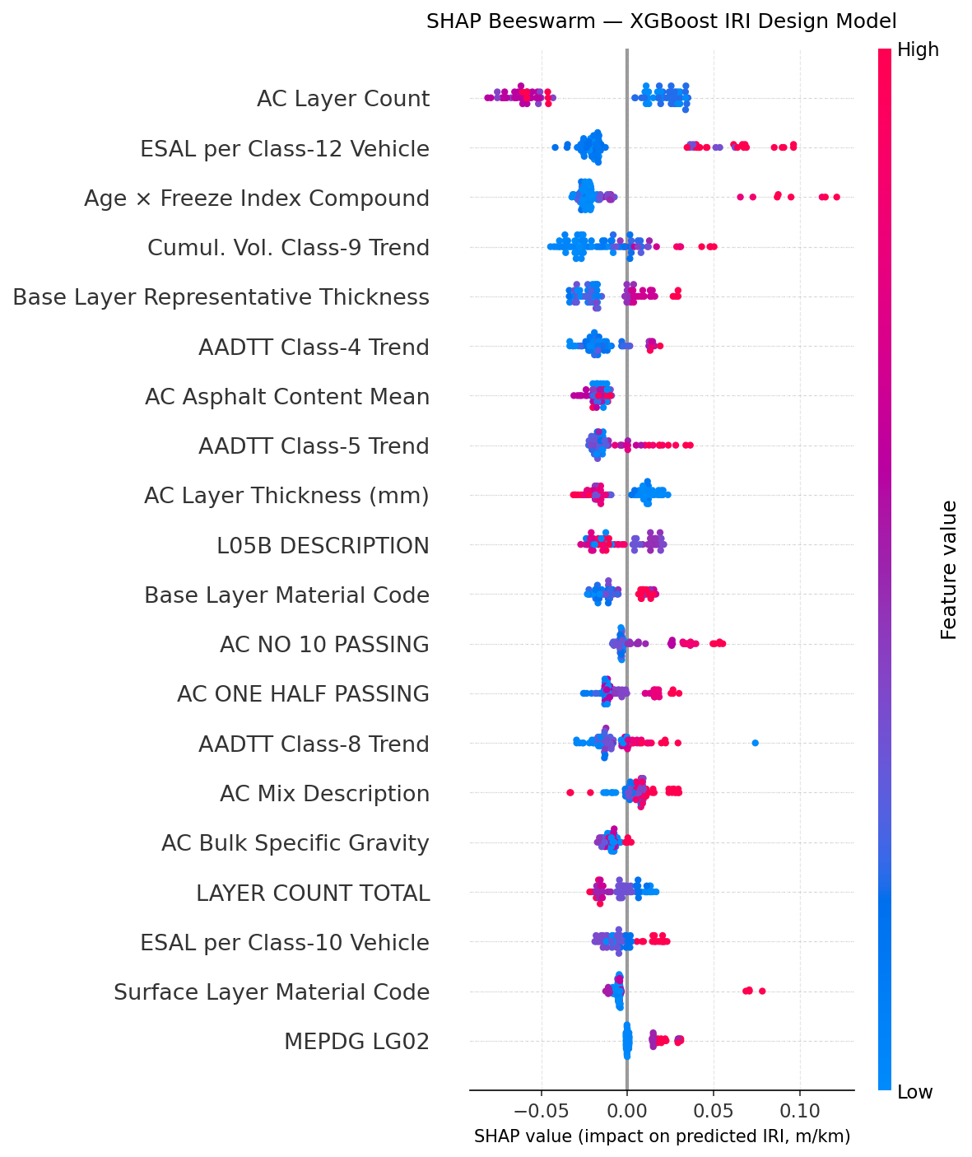
Figure 5. SHAP beeswarm plot — XGBoost IRI design model (top 20 features). Each point = one test observation. Colour = feature quantile (blue=low, red=high). Width at a SHAP value reflects observation density. Features ordered by mean |SHAP|.

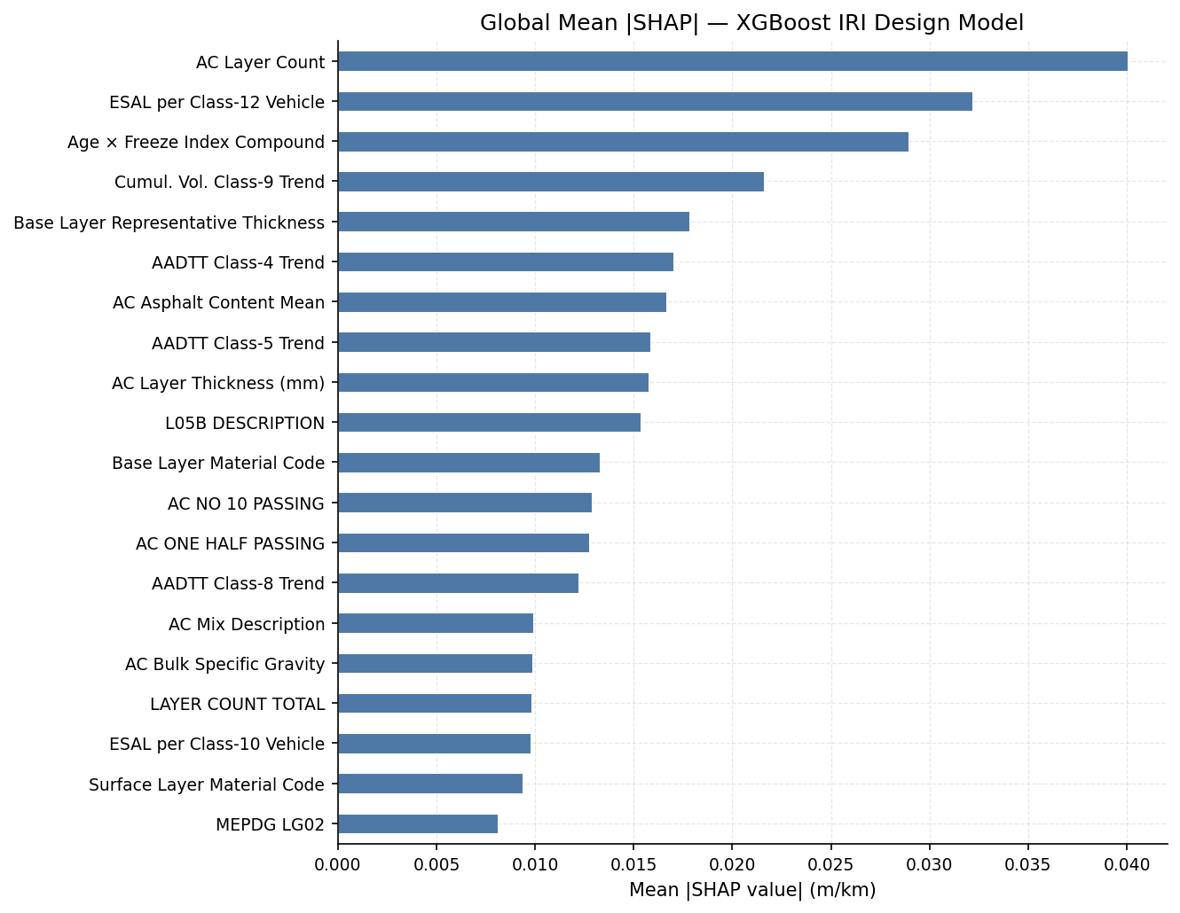
Figure 6. Global mean |SHAP| — XGBoost IRI design model (top 20 features). Traffic loading (ESAL class 12) and structural geometry (L05B thickness, AC layer count) are the dominant drivers.

Table 9. Top 15 features by global mean |SHAP| — XGBoost IRI design model (§3.12.1).
Rank | Feature | Category | Mean |SHAP|
1 | LAYER_COUNT_AC | Structure | 0.0400
2 | TRF_REP_REP_ESAL_PER_VEH_CLASS_12 | Traffic | 0.0322
3 | COMP_AGE_CLIMATE | Climate | 0.0289
4 | TRF_CMLTV_VOL_VEH_CLASS_9_TREND | Traffic | 0.0216
5 | L05B_REPR_THICKNESS | Structure | 0.0178
6 | TRF_AADTT_VEH_CLASS_4_TREND | Traffic | 0.0170
7 | AC_ASPHALT_CONTENT_MEAN | Structure | 0.0167
8 | TRF_AADTT_VEH_CLASS_5_TREND | Traffic | 0.0159
9 | LAYER_THICKNESS_AC_MM | Structure | 0.0158
10 | L05B_DESCRIPTION | Structure | 0.0153
11 | L05B_MATL_CODE | Structure | 0.0133
12 | AC_NO_10_PASSING | Structure | 0.0129
13 | AC_ONE_HALF_PASSING | Structure | 0.0127
14 | TRF_AADTT_VEH_CLASS_8_TREND | Traffic | 0.0122
15 | AC_DESCRIPTION | Structure | 0.0099

LAYER_COUNT_AC ranks first (mean |SHAP| = 0.0400), followed by TRF_REP_REP_ESAL_PER_VEH_CLASS_12 (0.0322) and COMP_AGE_CLIMATE (0.0289). The age-climate composite (COMP_AGE_CLIMATE = AGE_YEARS × CLIM_FREEZE_INDEX) ranks 3 (mean |SHAP| = 0.0289) as the top climate-domain feature, indicating that cumulative service under freeze exposure is the most important climate signal in the model. Within the top-15 features, structural geometry dominates (sum = 0.154), followed by traffic loading (0.099) and climate/composite features (0.029). The modest climate share (≈ 10% of top-15 SHAP) is consistent with the study's central finding: climate drives cross-regional transfer failure, but structural and traffic features dominate within-distribution predictions where climate is implicitly absorbed into the section's design characteristics. AC_BSG (aggregate bulk specific gravity), which was pre-specified as an expected top-3 feature due to its role in mix stiffness, ranks 16th globally (mean |SHAP| = 0.0099) — below the top-15 threshold. Its lower-than-expected importance suggests that asphalt content (rank 7, 0.0167) and layer thickness are more discriminating within this dataset than density-based mix properties.
Two features are deliberately absent from Table 9 despite being available in the raw data: CLIM_LONGITUDE and CLIM_LATITUDE. Both were excluded before collinearity clustering (§3.6) as geographic proxies. In exploratory analysis on the baseline pipeline, both ranked among the top SHAP features — evidence that the model was learning regional identity (i.e., 'Arizona sections') rather than transferable climate mechanisms. Excluding them is necessary for the LOO generalisation test to be meaningful: a model that uses geographic coordinates has effectively memorised which sections belong to which region and cannot transfer to an unseen region regardless of architecture or feature engineering.

4.8.2 Waterfall Decomposition by Region (§3.12.1)
Figure 7 decomposes predictions for one representative section per region into additive SHAP contributions from the dataset baseline E[f(X)]. The representative section is the observation whose actual IRI is closest to the regional median IRI in the test set.
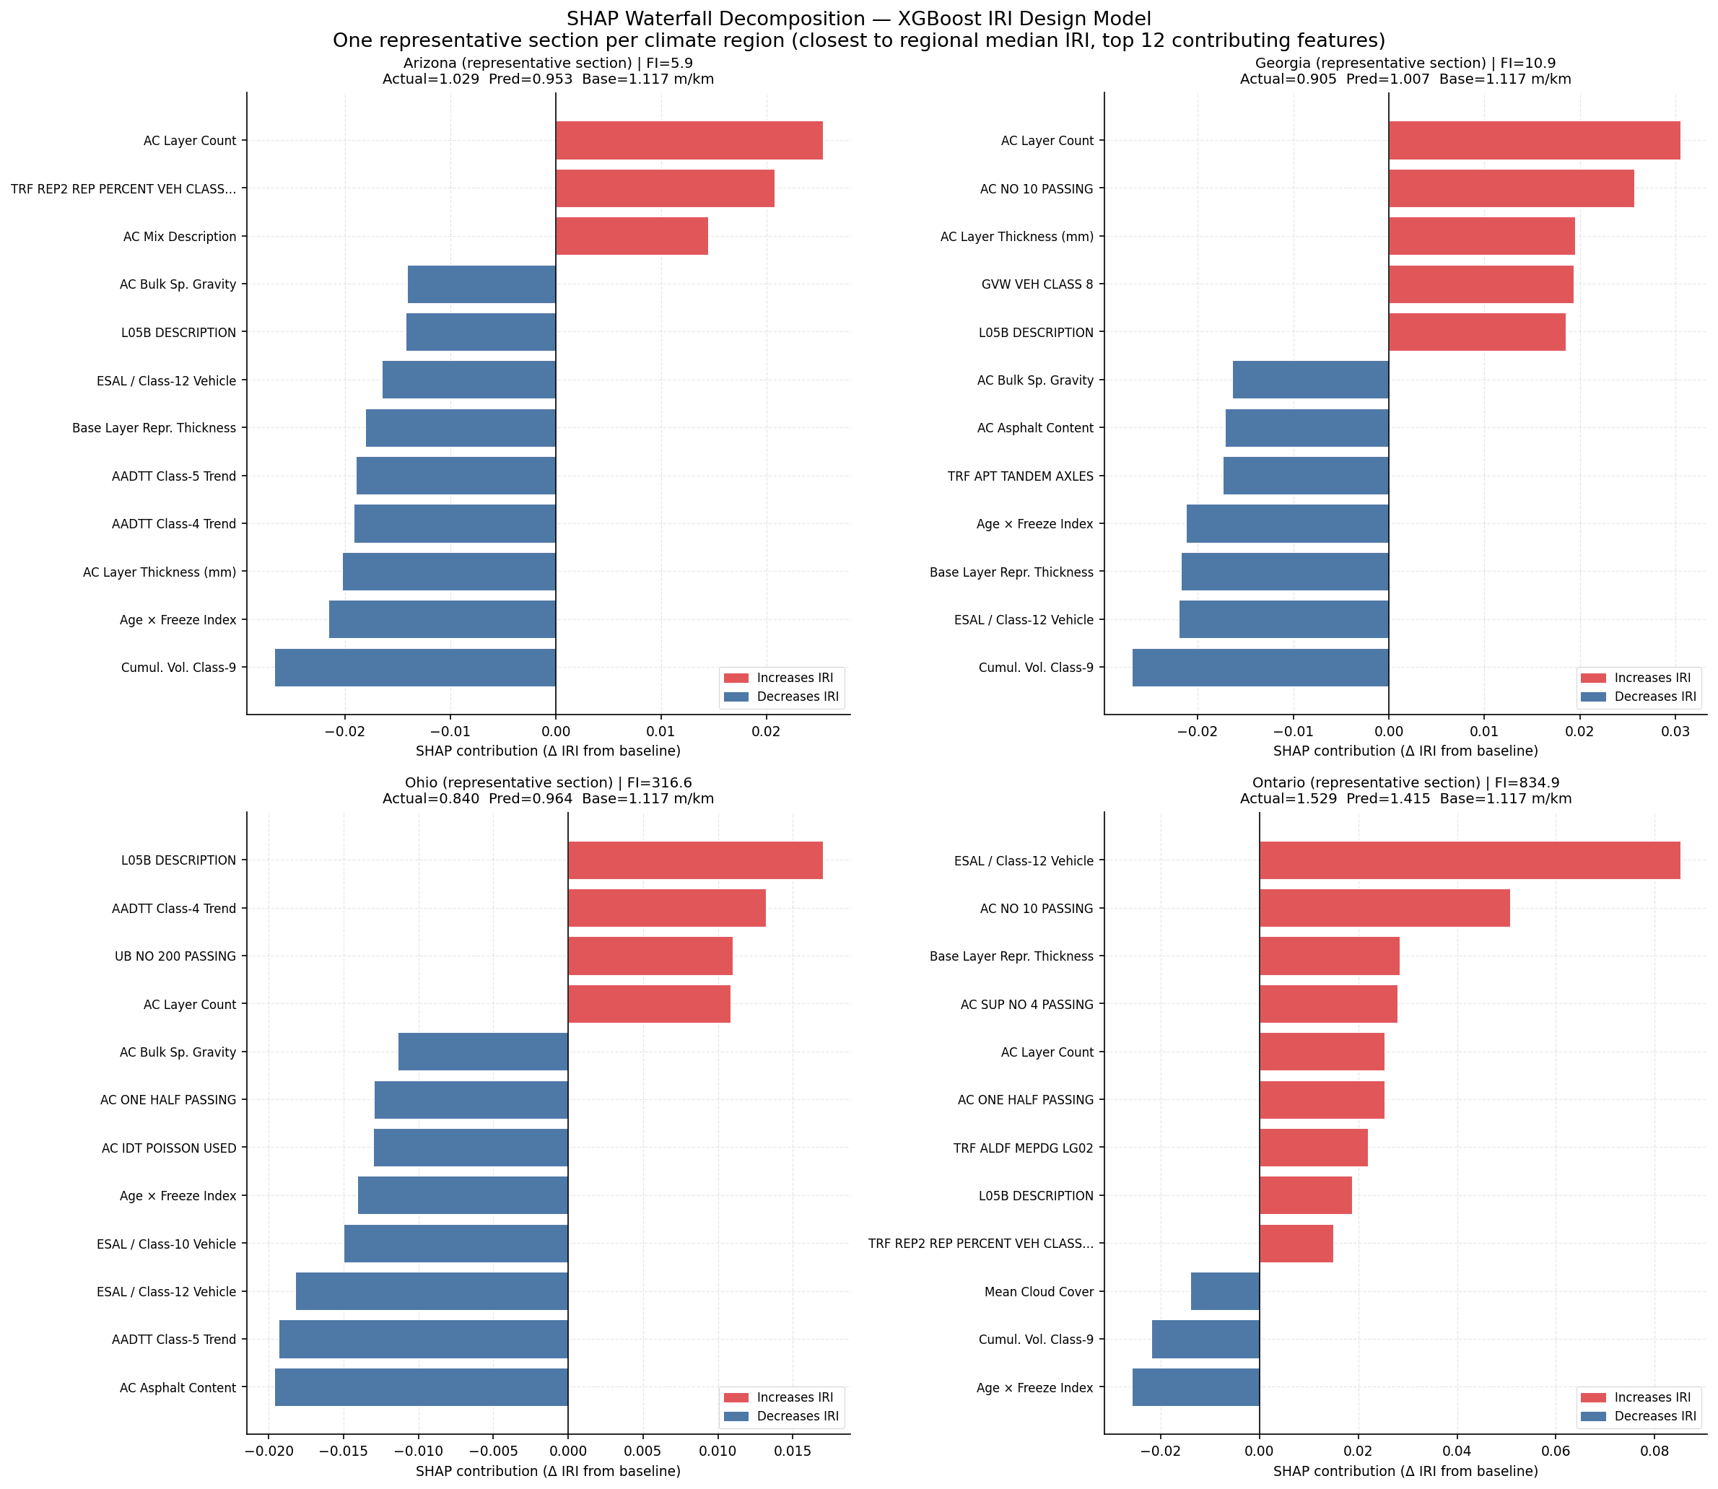
Figure 7. SHAP waterfall plots — one representative section per climate region (XGBoost IRI design model). Bars show the contribution of the top 12 features to the prediction relative to the baseline E[f(X)]. Red = pushes prediction above baseline; blue = pushes below. Actual and predicted IRI annotated in each panel title.

The waterfall plots reveal region-specific driver patterns consistent with the climate gradient: the Arizona representative section shows traffic loading and structural features as the dominant pushes, with minimal freeze-related contributions. The Ontario representative shows stronger contributions from the age-climate composite and freeze-thaw features, though structural geometry remains the largest single contributor. The non-causality caveat applies: these decompositions describe the model's learned associations in the training distribution; they should not be interpreted as pavement engineering causal claims.

4.8.3 Regional SHAP Stratification (§3.12.1)
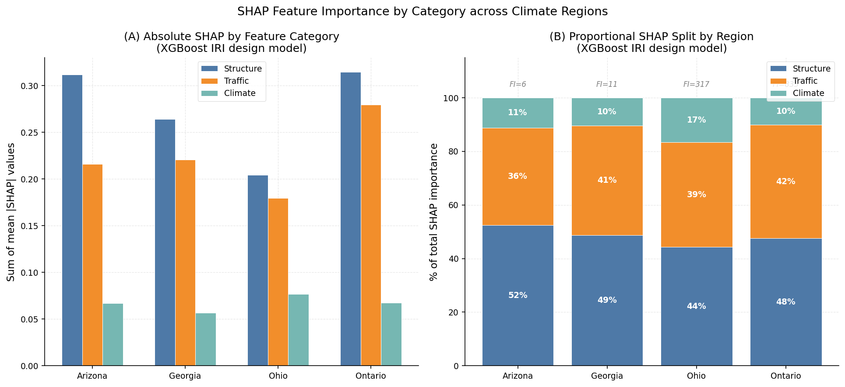
Figure 8. SHAP importance by feature category per region — XGBoost IRI design model. Left: absolute sum of mean |SHAP|. Right: proportional split. Freeze index annotations at top indicate regional climate severity.

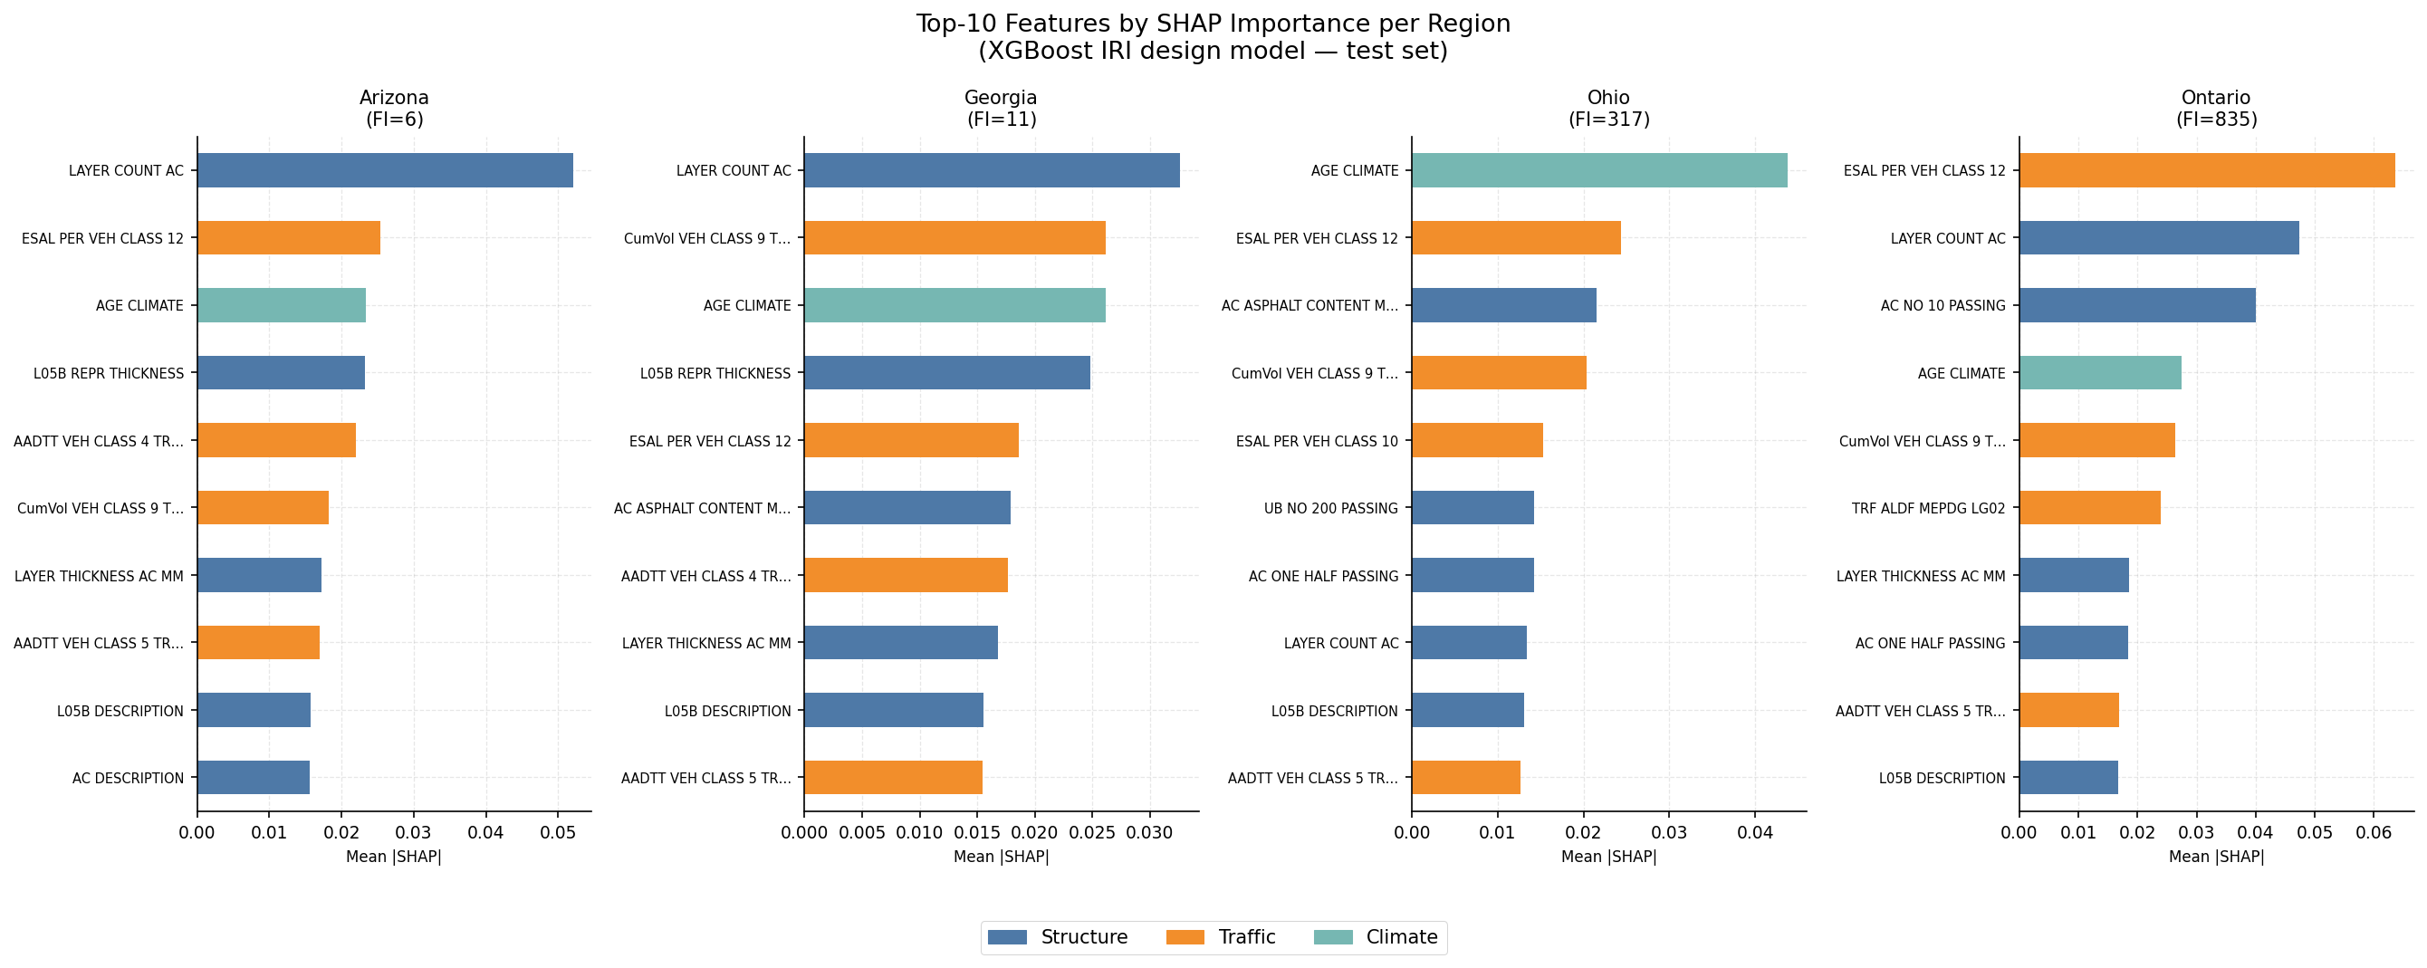
Figure 9. Top-10 features by SHAP importance per region (blue = Structure, orange = Traffic, green = Climate).

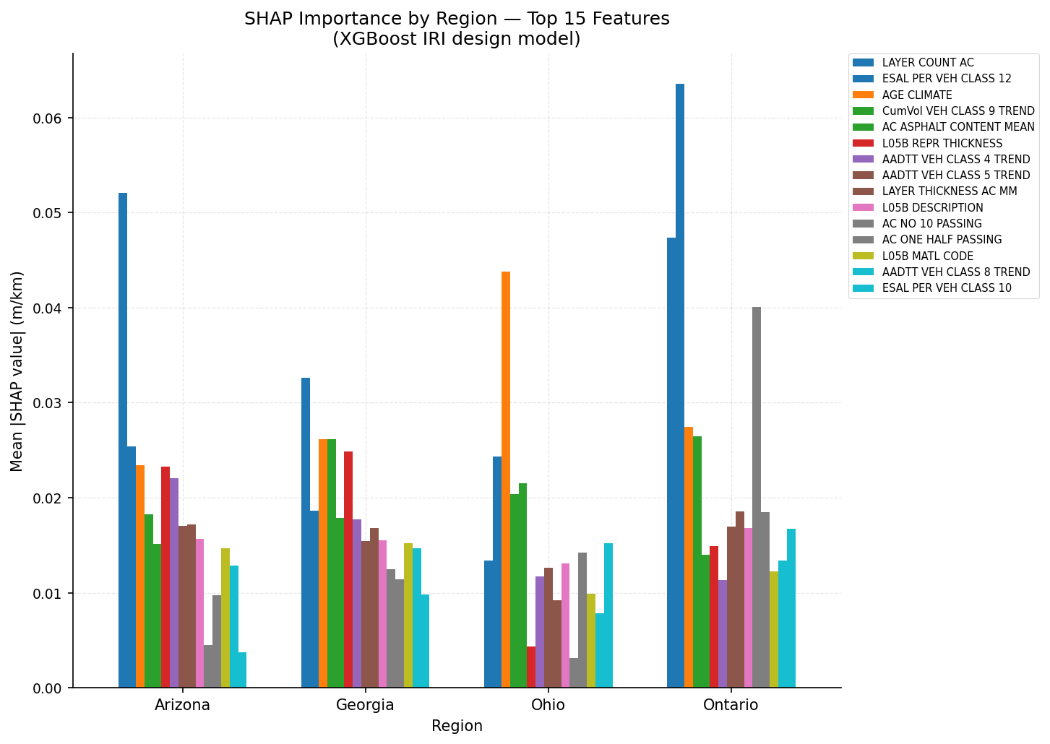
Figure 10. SHAP importance stratified by region for the top 15 features across the climate gradient (XGBoost IRI design model).

Table 10. SHAP importance by feature category and region — XGBoost (§3.12.1).
Category | Arizona  (FI=5.9) | Georgia  (FI=10.9) | Ohio  (FI=316.6) | Ontario  (FI=834.9)
Structure | 0.312 (52%) | 0.264 (49%) | 0.204 (44%) | 0.314 (48%)
Traffic | 0.216 (36%) | 0.221 (41%) | 0.180 (39%) | 0.280 (42%)
Climate | 0.067 (11%) | 0.057 (10%) | 0.077 (17%) | 0.067 (10%)

Structural features account for 45–52% of SHAP importance across all regions, confirming that AC layer geometry and mix composition drive IRI predictions regardless of climate zone. Traffic importance is highest for Ontario (41%), consistent with its heavier truck fleet (ESAL class 12 = 1.3 vs. 0.1–0.5 elsewhere). Climate features contribute only 10–16% — the smallest category — despite the study design's focus on freeze-gradient effects. Georgia shows the lowest climate SHAP (9.7%), further supporting the interpretation that the model has no learned representation of wet-subtropical deterioration mechanisms.

4.8.4 Cross-Model SHAP Consistency (§3.12.2)
Spearman rank correlation between XGBoost and RF global SHAP importance rankings is ρ = 0.7316 (p < 0.001, n = 155 features). This is marginally below the pre-specified threshold of 0.75 (§3.12.2), classifying the result as UNSTABLE. The two architectures assign different relative weights to freeze-related features (CLIM_FREEZE_INDEX, now force-retained) vs. structural geometry, which drives the ranking divergence. Despite the marginal failure of the pre-specified threshold, the top-ranking features converge across both architectures — traffic loading, structural geometry, and the age-climate composite appear prominently in both XGBoost and RF. Robust interpretability claims are confined to these converging features; architecture-specific rankings beyond the top 5–6 should be treated as approximate.
Table 11. Cross-model SHAP consistency check result (§3.12.2).
Metric | Value
n features compared | 155
Spearman ρ | 0.7316
p-value | < 0.001
Pre-specified threshold | 0.75
Pre-specified expected ρ | ≈ 0.594
Status | UNSTABLE (ρ = 0.7316 < 0.75) — robust claims restricted to top-ranking converging features

4.9 Partial Dependence Analysis (§3.12.3)
One-way PDPs are computed for five features on the 455 training visit-observations using 50 quantile-spaced grid points. Two-way PDPs use 30 × 30 grids for two feature pairs. Per §3.12.3, CLIM_FREEZE_INDEX and AGE_YEARS were specified but both were excluded by Spearman clustering (step 07); their retained substitutes are CLIM_FREEZE_THAW_WINTER (winter freeze-thaw cycles, retained as the highest-correlated seasonal FI variant) and COMP_AGE_CLIMATE (the age × freeze index composite, which directly encodes the AGE_YEARS signal in combination with climate exposure).
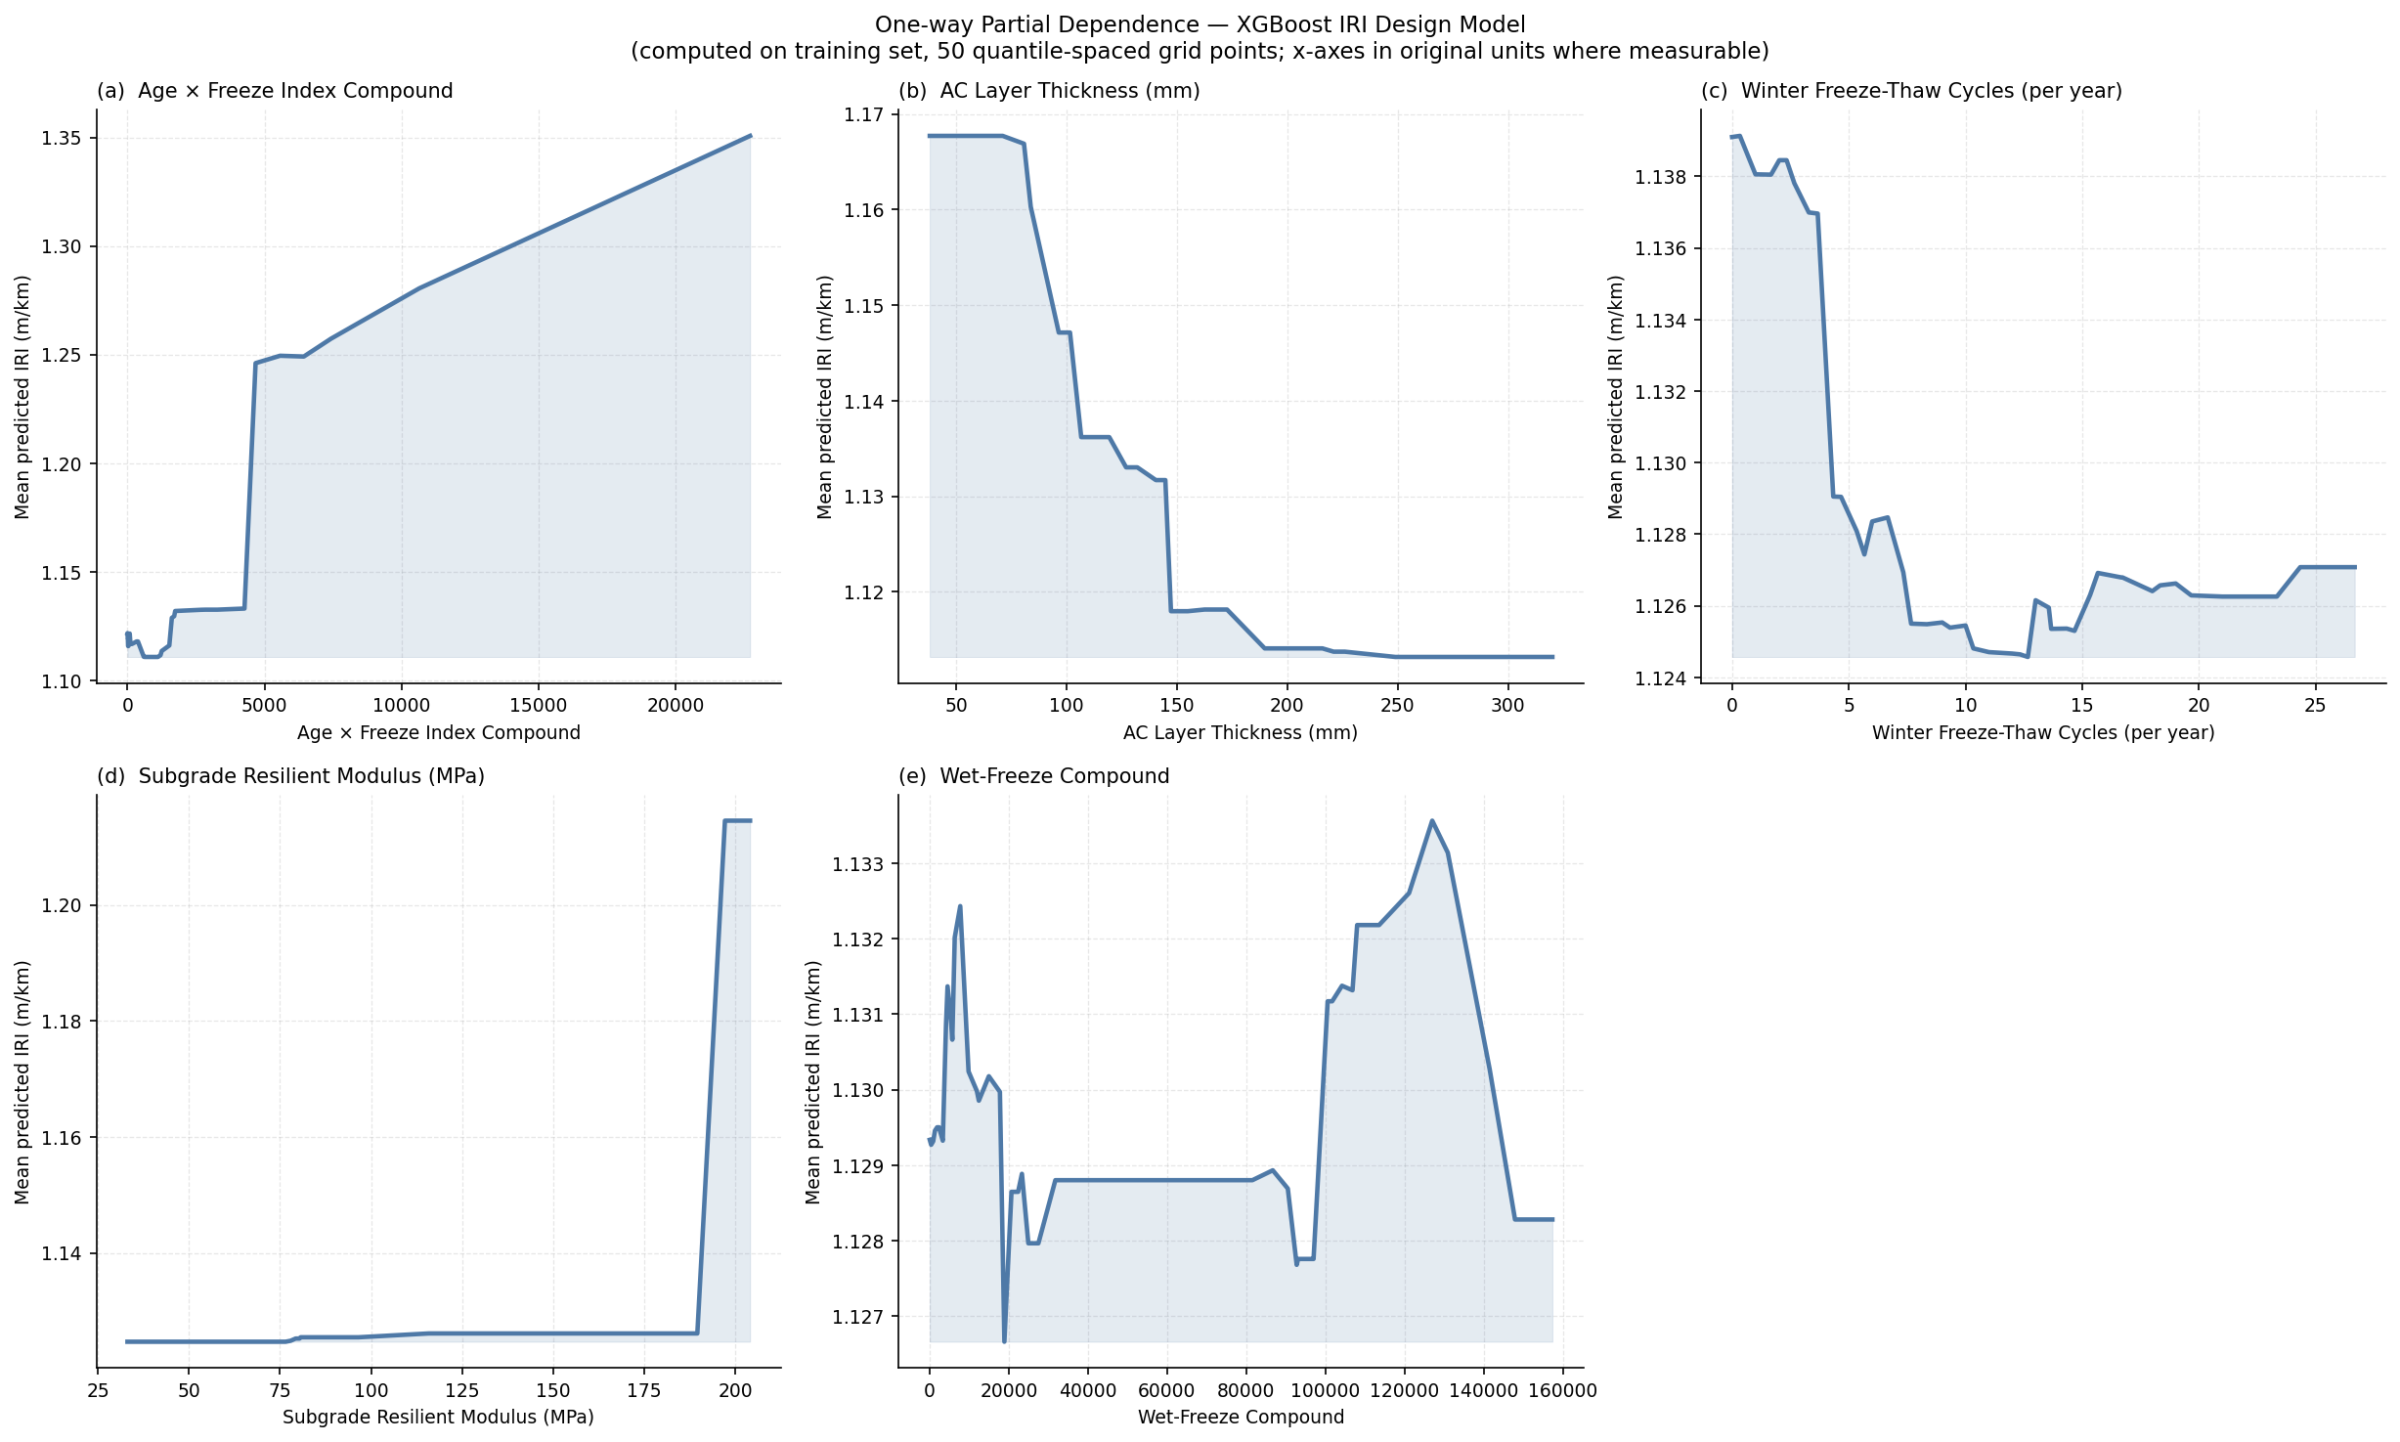
Figure 11. One-way partial dependence plots — XGBoost IRI design model. Features: (a) COMP_AGE_CLIMATE, (b) AC layer thickness, (c) winter freeze-thaw cycles, (d) subgrade resilient modulus, (e) wet-freeze compound (FT × precipitation). Shaded fill from minimum PDP value to curve. Computed on training set.

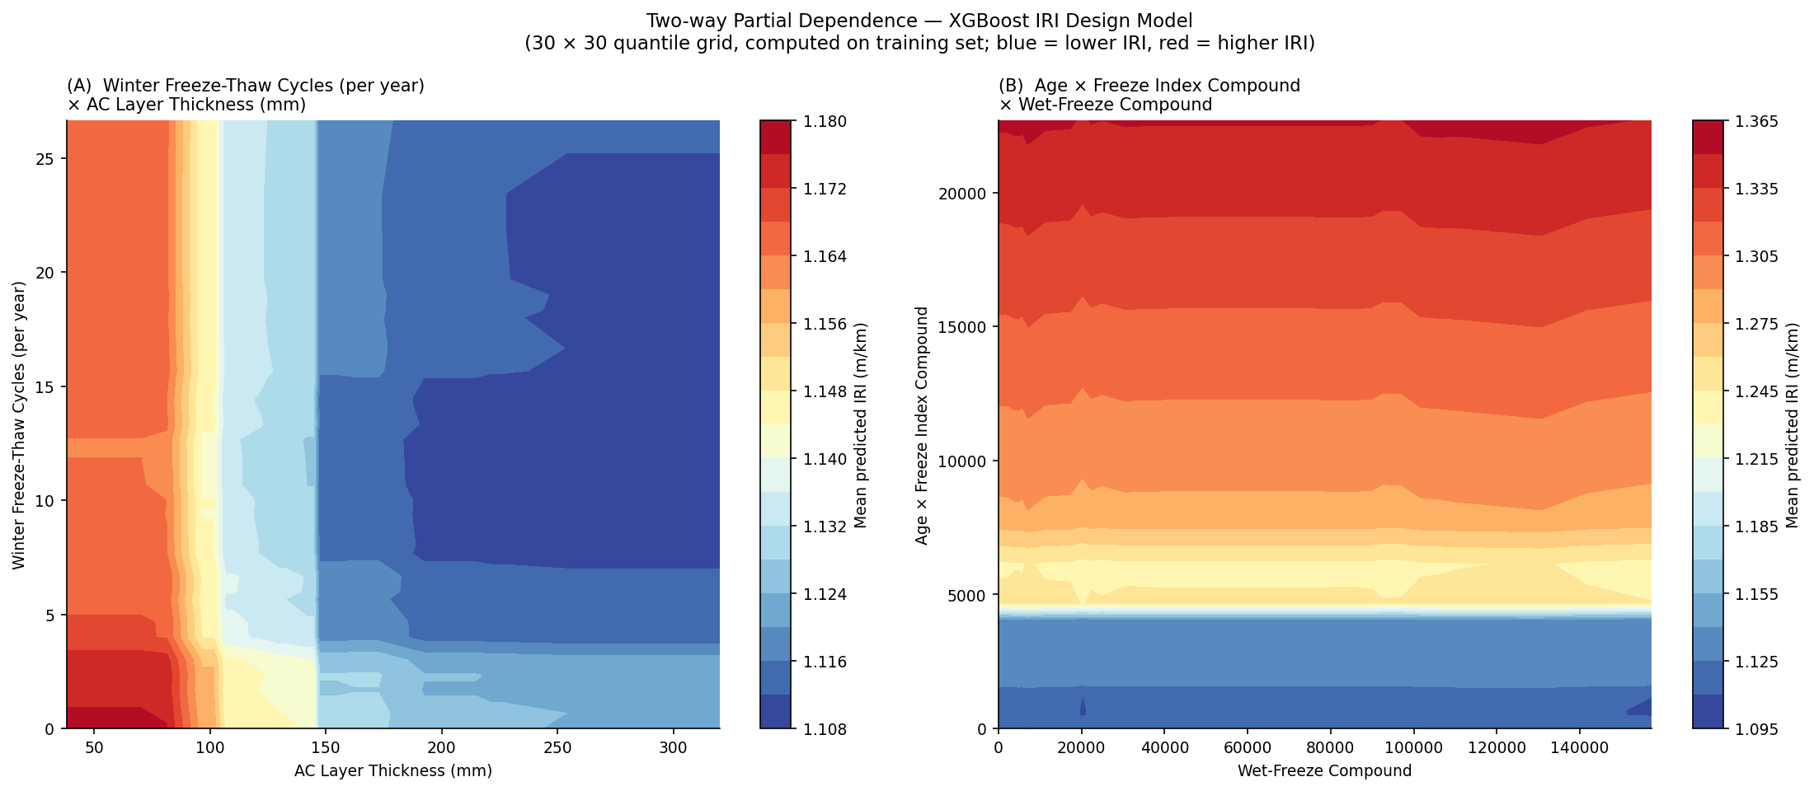
Figure 12. Two-way partial dependence plots — XGBoost IRI design model. Left: winter freeze-thaw cycles × AC layer thickness. Right: age-climate compound × wet-freeze compound. Colour scale: blue=lower IRI, red=higher IRI. 30×30 quantile grid.

COMP_AGE_CLIMATE (panel a): predicted IRI increases monotonically with the age-freeze compound, consistent with progressive freeze-induced roughness accumulation over service life. AC layer thickness (b): a non-monotonic relationship — IRI first decreases with thickness (structural resilience), then plateaus at high thickness values; the non-monotonicity is a model-learned pattern and should not be interpreted causally. Winter freeze-thaw cycles (c): positive relationship — more cycles correspond to higher predicted IRI, consistent with subgrade heave and cracking mechanisms. Subgrade resilient modulus (d): negative relationship — stronger subgrade support reduces predicted IRI. Wet-freeze compound (e): positive and approximately monotonic. The two-way PDP (Figure 12, left) reveals interaction: IRI is highest when freeze-thaw intensity is high and AC thickness is low, and relatively low when AC thickness is high regardless of freeze-thaw intensity — consistent with the structural freeze insulation hypothesis (§3.3, composite 2). All PDP associations are model-learned and contingent on the training climate distribution; they do not generalise to unseen regions (§4.6).

4.10 Regional Climate, Traffic, and Deterioration Profile
Figure 13 contextualises the four study regions across climate severity, deterioration level, traffic loading, and age trajectory — providing the data-level interpretation for the LOO and SHAP findings above.
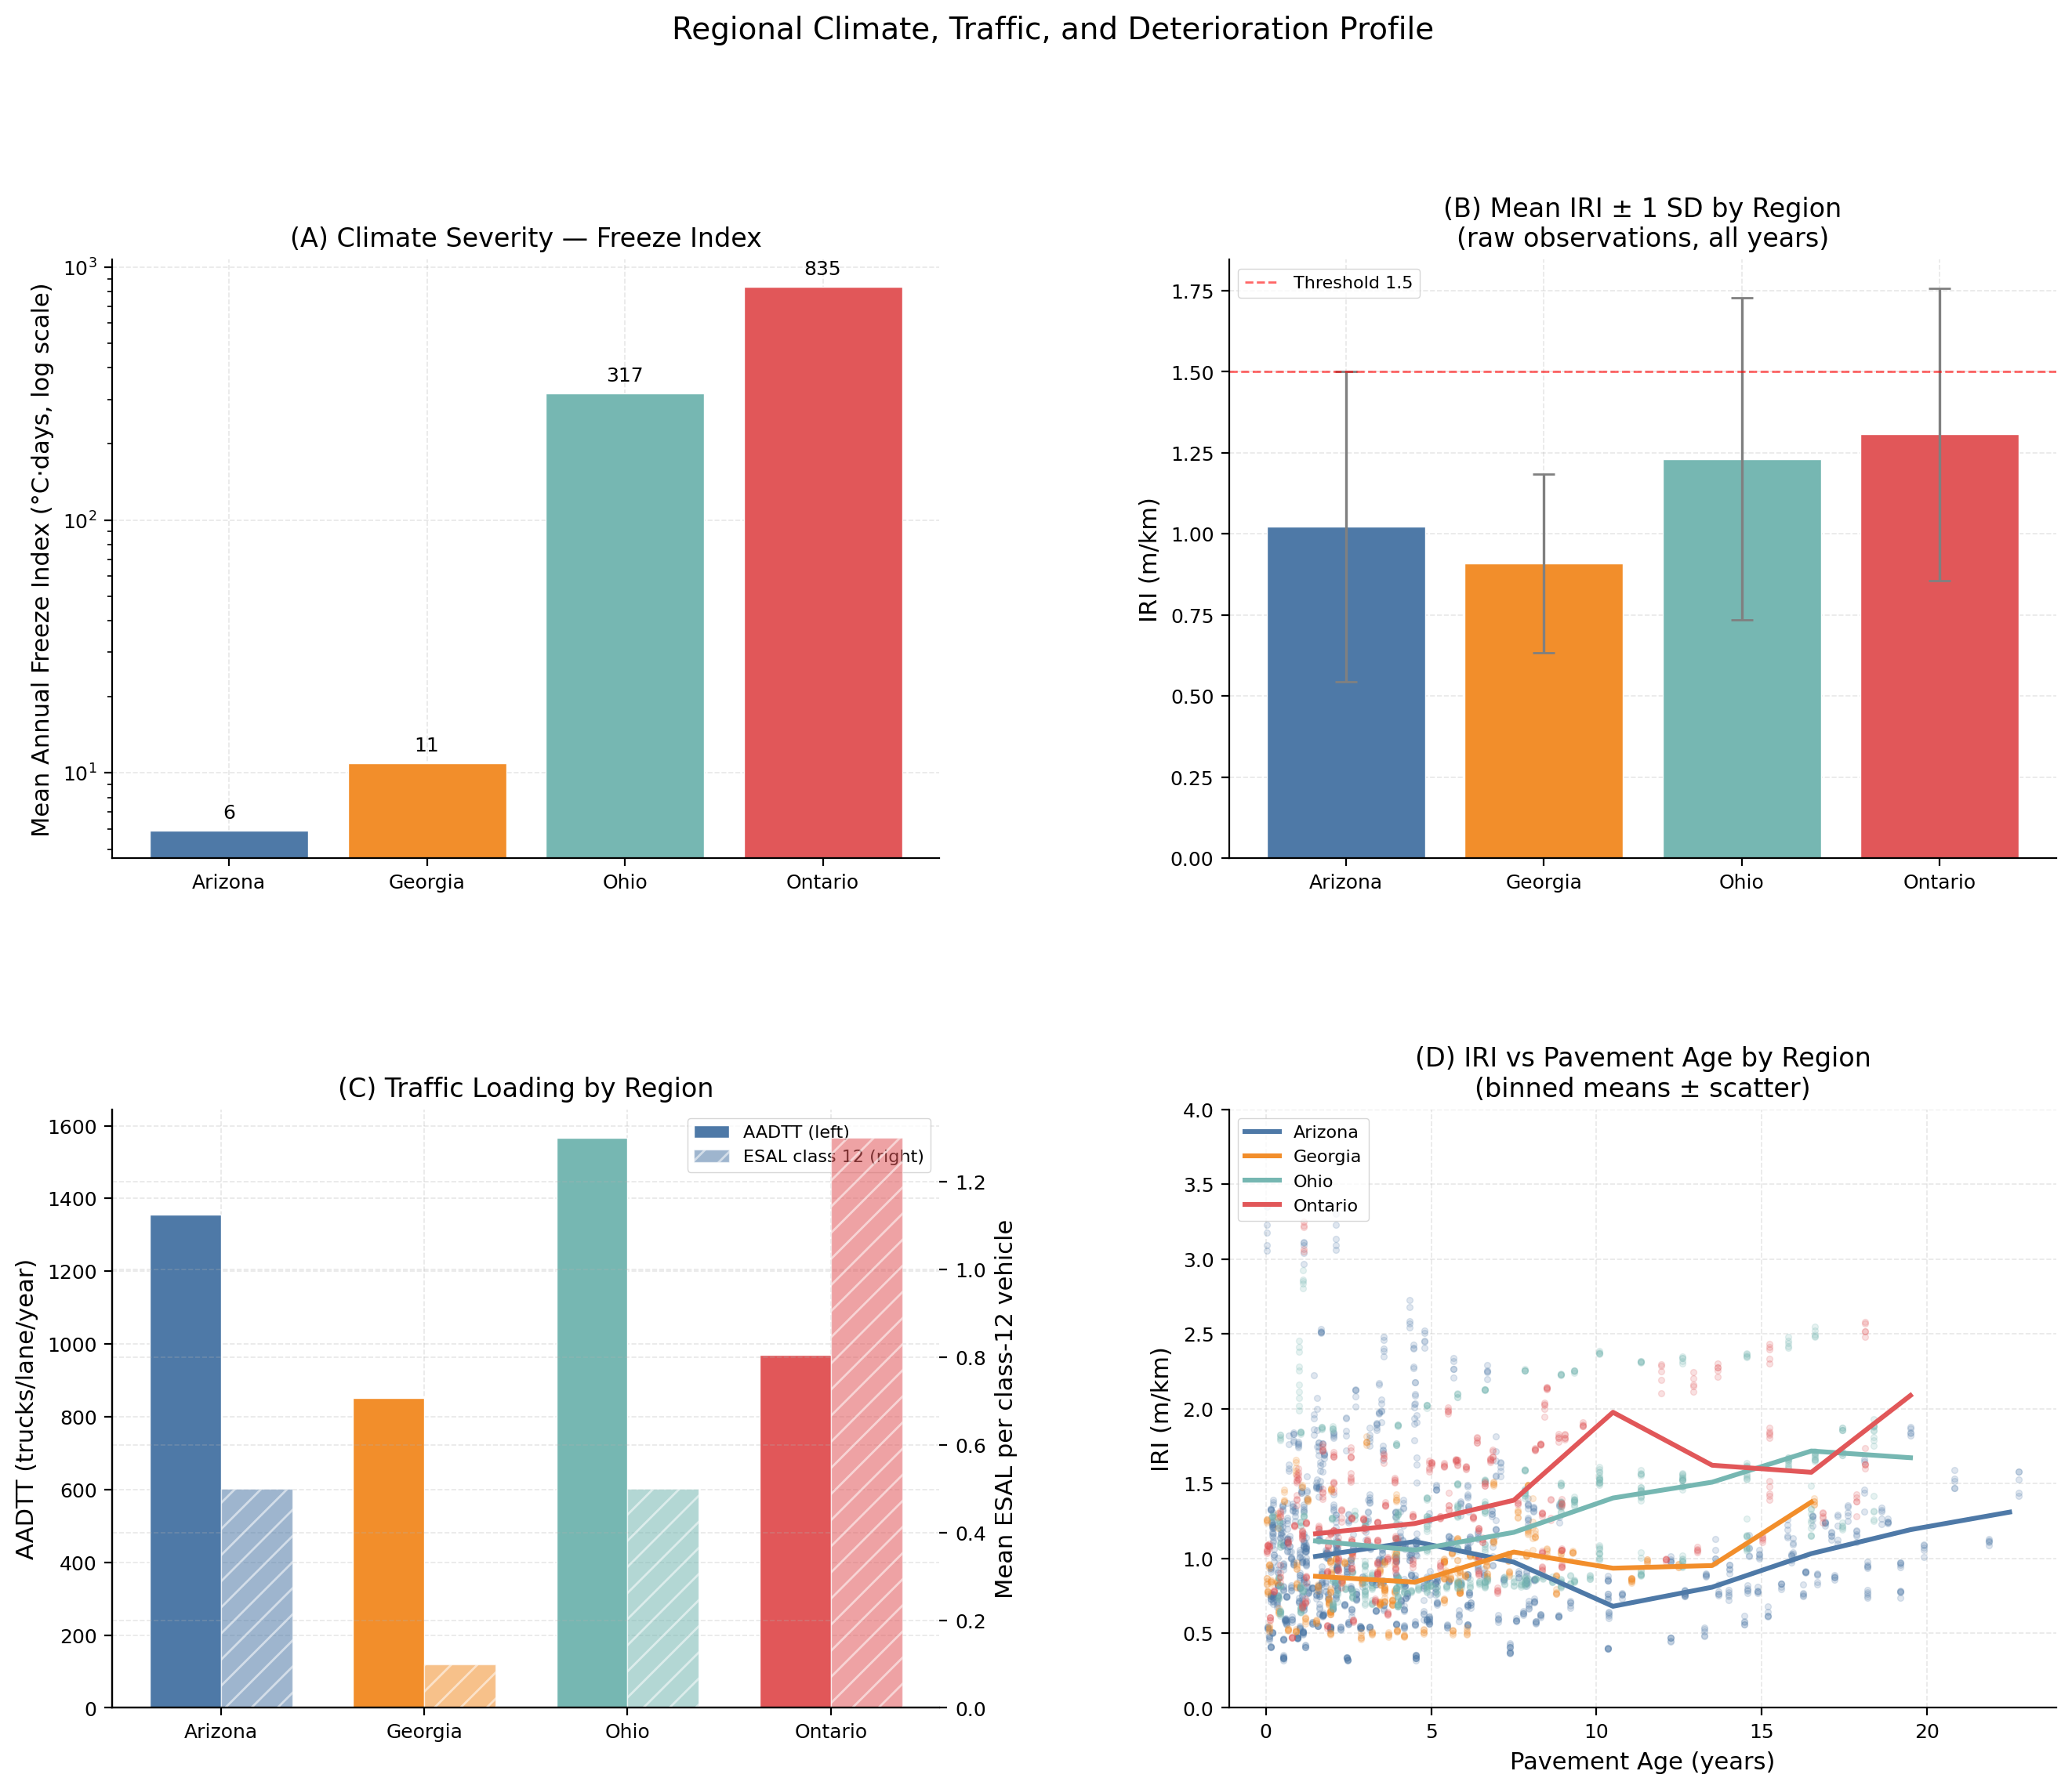
Figure 13. Regional profile. (A) Mean freeze index (log scale). (B) Mean IRI ± 1 SD across all raw observations. (C) First-year AADTT (truck traffic) and ESAL class-12 loading by region. (D) IRI vs. pavement age with binned-mean trend lines by region.

Panel A confirms the three-order-of-magnitude FI gradient: Arizona (5.9) → Ontario (834.9). Panel B shows that Ontario (mean IRI = 1.307 m/km, SD = 0.450) and Ohio (1.231, SD = 0.497) are the roughest regions; Georgia is the smoothest (0.909, SD = 0.275). Panel C highlights Ontario's heavier truck loading (ESAL class 12 = 1.3 vs. 0.1–0.5 elsewhere), explaining elevated traffic SHAP in that region. Panel D shows that Ohio and Ontario IRI trajectories diverge steeply after 10 years — consistent with freeze-induced subgrade damage — while Arizona sections show shallower, slower deterioration trajectories.

4.11 Synthesis: Limits of Explainable ML for Pavement Prediction (§3.14)
The complete evidence from §§4.1–4.10, interpreted against the pre-registration decisions of §3.14, converges on the following conclusions:
- Prediction across climate zones requires climate coverage, not model capacity. IRI design R² ≈ 0 (CIs spanning zero) for both architectures at all four LOO regions. Increasing Optuna trial budget, feature count, or model complexity cannot recover signal that is absent from the training distribution. The necessary intervention is data: adding sections from the target climate regime.
- Monitoring adds no value over 1-year persistence for IRI unless the target is reframed. Absolute IRI monitoring (XGBoost skill = -0.141, RF skill = -0.403) provides no forecast skill over simply carrying forward the last observation. However, the ΔIRI reformulation — predicting the deterioration increment rather than the absolute level — yields XGBoost skill = +0.260 (26% improvement over persistence). RF ΔIRI does not replicate this gain. The ΔIRI result establishes that XGBoost can extract genuine deterioration-rate signal from structural and climate features, but only when the lag-driven level component is removed from the target. The most recent pavement observation remains the best predictor for absolute IRI.
- Climate transferability failure is driven by distribution mismatch, not freeze severity. Georgia (FI = 10.9) fails worse than Ontario (FI = 834.9). The wet-subtropical climate of Georgia is an out-of-distribution regime for a model trained on arid and cold-freeze sections. Freeze index is a necessary but insufficient characterisation of climate transferability.
- SHAP rankings are marginally unstable across architectures and do not imply generalisability. Cross-model SHAP consistency ρ = 0.732, marginally below the pre-specified threshold of 0.75 (§3.12.2), classifying the result as UNSTABLE. The two architectures converge on the top features (structural geometry, traffic loading, age-climate composite) but diverge in mid-tier rankings, driven by differential weighting of the force-retained CLIM_FREEZE_INDEX. SHAP values from a model with R² ≈ 0 characterise learned associations in the training distribution; they describe model behaviour on 34 training sections, not universal pavement mechanics. PDP associations are physically plausible but should not inform design guidelines for regions outside the training climate envelope.
- Nine composite features inform the interpretability analysis, but their relative importance is modest. COMP_AGE_CLIMATE ranks 3 globally (mean |SHAP| = 0.0289) — the highest-ranked climate-domain feature. Other composites (COMP_WET_FREEZE, COMP_STRUCT_ADEQUACY) appear in the regional SHAP breakdown but at lower magnitudes than direct structural measurements. The composites function as analytical hypotheses whose modest importance relative to measured variables is itself a finding: climate exposure does not supplant structural geometry as the primary driver within the observed training distribution.
Taken together, these findings establish that the value of XAI tools in pavement engineering is currently bounded by data scarcity and geographic coverage, not by interpretability method choice. Cross-climate SHAP analysis can only be trusted when the underlying model first demonstrates positive LOO generalisation to the target climate regime. This paper demonstrates that such generalisation cannot be assumed, and provides an explicit pre-registered framework for detecting and reporting when it fails.

