4. Results and Discussion
This section reports the corrected primary analysis after removing same-visit condition-measure leakage, excluding geographic/region proxy features, fixing section-level bootstrap resampling, and recomputing monitoring-vs-persistence comparisons on identical section/date rows. The results should be read as a stress test of transferability, not as an exercise in maximizing R2.

4.1 Benchmark Performance
Mean, AASHTO age-only, Ridge, and persistence benchmarks establish the reference frame for the ensemble models. Ridge no longer produces near-perfect distress performance after the distress sub-indicator leakage was removed.
Table 1. Benchmark model performance.
model | n | R2 | RMSE | MAE
mean_design_iri | 86 | -0.0003 | 0.5132 | 0.3708
aashto_design_iri | 86 | -0.004 | 0.5142 | 0.3694
ridge_design_iri | 86 | 0.0408 | 0.5026 | 0.3629
mean_monitoring_iri | 66 | -0.0177 | 0.5109 | 0.3714
aashto_monitoring_iri | 66 | -0.021 | 0.5118 | 0.3683
ridge_monitoring_iri | 66 | -0.0441 | 0.5175 | 0.3722
mean_design_rutting | 74 | -0.0758 | 3.2 | 2.706
ridge_design_rutting | 74 | 0.3781 | 2.433 | 1.802
mean_monitoring_rutting | 47 | -0.124 | 3.21 | 2.639
ridge_monitoring_rutting | 47 | 0.2457 | 2.63 | 1.973
mean_design_distress | 45 | -0.0514 | 22.89 | 20.01
ridge_design_distress | 45 | 0.0928 | 21.26 | 18.76
mean_monitoring_distress | 26 | -0.0211 | 22.48 | 19.79
ridge_monitoring_distress | 26 | 0.1569 | 20.43 | 17.62

4.2 Ensemble Test-Set Performance
Design-task performance remains modest and uncertain across targets. Monitoring improves pooled test metrics, but this improvement must be interpreted against persistence because lagged condition is highly informative.
Table 2. Corrected test-set performance with section-bootstrap R2 intervals.
model | n_obs | n_sections | R2 | R2_CI_lower | R2_CI_upper | RMSE | MAE
xgb_design_iri | 86 | 7 | 0.1576 | -0.2872 | 0.4241 | 0.471 | 0.2997
rf_design_iri | 86 | 7 | 0.1296 | -0.2023 | 0.3677 | 0.4787 | 0.311
xgb_monitoring_iri | 66 | 7 | 0.4509 | 0.3213 | 0.564 | 0.3753 | 0.2099
rf_monitoring_iri | 66 | 7 | 0.4688 | 0.3308 | 0.6609 | 0.3691 | 0.191
xgb_design_rutting | 74 | 7 | 0.4322 | -0.0226 | 0.6251 | 2.325 | 1.758
rf_design_rutting | 74 | 7 | 0.3942 | -0.2511 | 0.5318 | 2.401 | 1.87
xgb_monitoring_rutting | 47 | 7 | 0.6719 | 0.1872 | 0.766 | 1.734 | 1.278
rf_monitoring_rutting | 47 | 7 | 0.5915 | -0.0119 | 0.7473 | 1.935 | 1.477
xgb_design_distress | 45 | 7 | 0.2776 | -0.3855 | 0.7142 | 18.98 | 14.23
rf_design_distress | 45 | 7 | 0.21 | -0.5168 | 0.6585 | 19.84 | 15.71
xgb_monitoring_distress | 26 | 7 | 0.7619 | 0.4209 | 0.9602 | 10.86 | 6.949
rf_monitoring_distress | 26 | 7 | 0.7412 | 0.473 | 0.9087 | 11.32 | 8.46

4.3 Monitoring Versus Persistence
The common-set table compares trained monitoring models and persistence on the same held-out section/date rows. Absolute IRI monitoring underperforms one-year persistence on this common set, while the delta-IRI sensitivity model improves absolute-scale RMSE after adding predicted deterioration increments back to the lag.
Table 3. Common-set monitoring and persistence comparison.
model | n | R2 | RMSE | MAE | skill_vs_persist_k1
persist_k1_common_iri | 32 | 0.853 | 0.2108 | 0.1197 | nan
persist_k2_common_iri | 32 | 0.853 | 0.2108 | 0.1197 | nan
persist_k3_common_iri | 32 | 0.853 | 0.2108 | 0.1197 | nan
xgb_monitoring_common_iri | 32 | 0.733 | 0.2841 | 0.1785 | nan
rf_monitoring_common_iri | 32 | 0.727 | 0.2873 | 0.1622 | nan
xgb_monitoring_delta_common_iri | 32 | 0.9404 | 0.1342 | 0.1 | 0.3634
rf_monitoring_delta_common_iri | 32 | 0.9568 | 0.1143 | 0.0808 | 0.4578
persist_k1_common_rutting | 22 | 0.8096 | 1.492 | 0.9545 | nan
persist_k2_common_rutting | 22 | 0.8096 | 1.492 | 0.9545 | nan
persist_k3_common_rutting | 22 | 0.8096 | 1.492 | 0.9545 | nan
xgb_monitoring_common_rutting | 22 | 0.7869 | 1.579 | 1.302 | nan
rf_monitoring_common_rutting | 22 | 0.7116 | 1.837 | 1.498 | nan
persist_k1_common_distress | 6 | -0.4671 | 30.61 | 17.83 | nan
persist_k2_common_distress | 6 | -0.4671 | 30.61 | 17.83 | nan
persist_k3_common_distress | 6 | -0.4671 | 30.61 | 17.83 | nan
xgb_monitoring_common_distress | 6 | 0.7105 | 13.6 | 9.475 | nan
rf_monitoring_common_distress | 6 | 0.6987 | 13.87 | 11.72 | nan

4.4 Leave-One-Region-Out Generalization
LOO validation again shows weak climate transfer. Ontario XGBoost LOO R2 is -0.223, so the corrected primary run does not support the earlier post-hoc claim that Ontario transfer became positive. Georgia also remains a major failure case, showing that climate mismatch is not captured by freeze index alone.
Table 4. Leave-one-region-out IRI design validation.
withheld_region | arch | target | n_obs | R2 | RMSE | MAE
Arizona | xgb | iri | 295 | -0.0786 | 0.4952 | 0.3677
Arizona | rf | iri | 295 | 0.0256 | 0.4707 | 0.3526
Georgia | xgb | iri | 96 | -0.7659 | 0.3669 | 0.328
Georgia | rf | iri | 96 | -0.7006 | 0.36 | 0.3172
Ohio | xgb | iri | 148 | 0.0606 | 0.4814 | 0.3819
Ohio | rf | iri | 148 | -0.0521 | 0.5094 | 0.3941
Ontario | xgb | iri | 111 | -0.2226 | 0.495 | 0.3699
Ontario | rf | iri | 111 | -0.1402 | 0.478 | 0.339

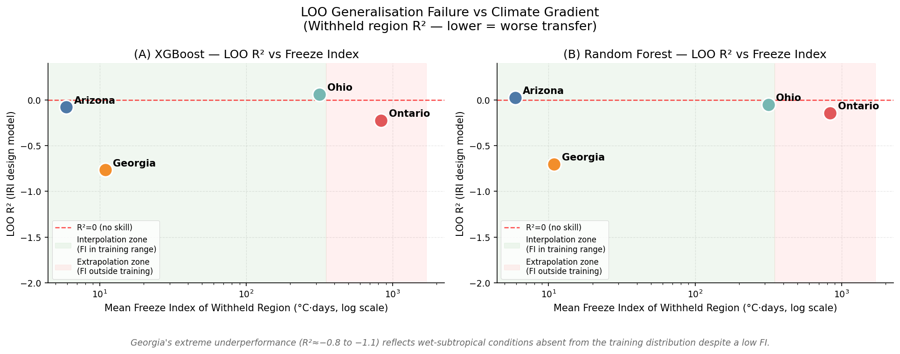
Figure 1. LOO R2 across the climate gradient.

4.5 Interpretability Stability
Cross-model SHAP rank consistency is rho = 0.681, below the pre-specified stability threshold of 0.75. SHAP and PDP outputs therefore describe model behavior on this small dataset; robust claims should be restricted to converging top-ranked features and should not be treated as causal pavement-mechanism evidence.
Table 5. SHAP cross-model consistency.
n_features | spearman_rho | p_value | threshold | status
155 | 0.6808 | 0 | 0.75 | UNSTABLE (ρ = 0.6808 < 0.75) — robust claims restricted to top-ranking converging features

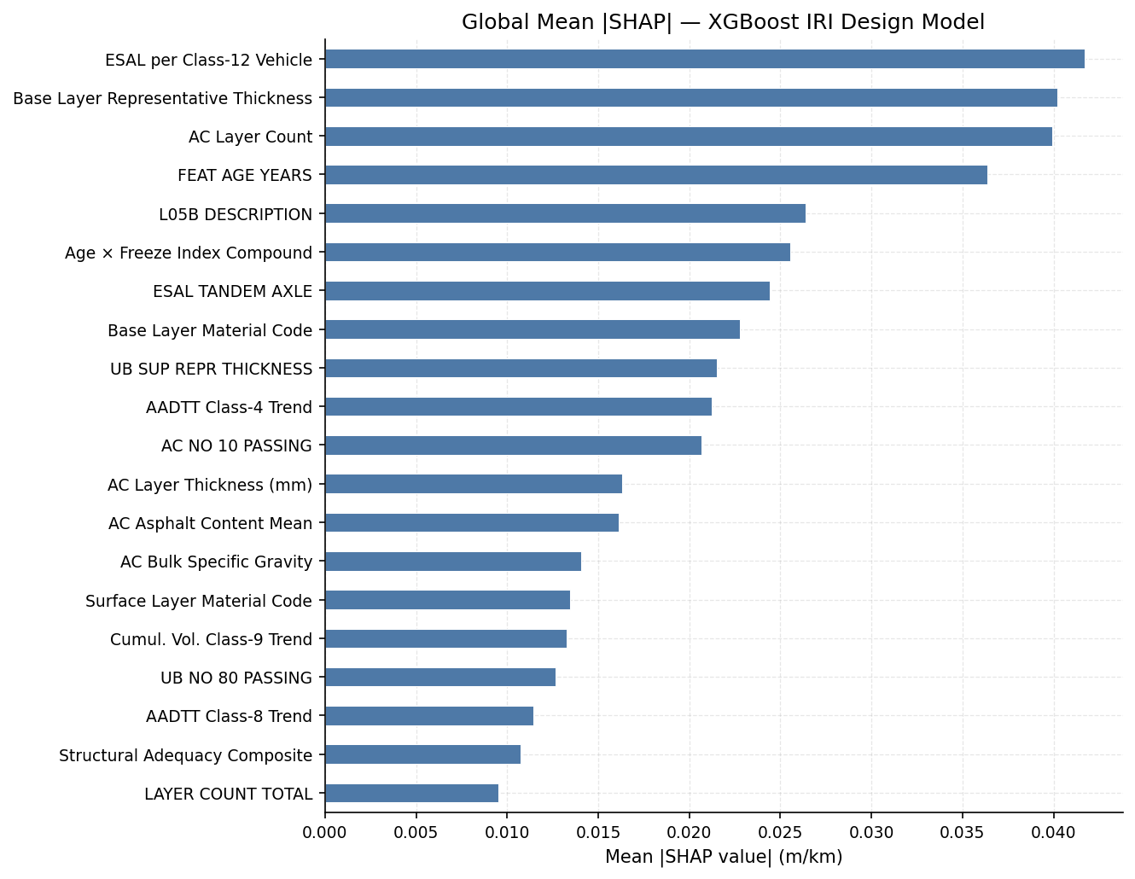
Figure 2. Global SHAP importance for the corrected IRI design model.
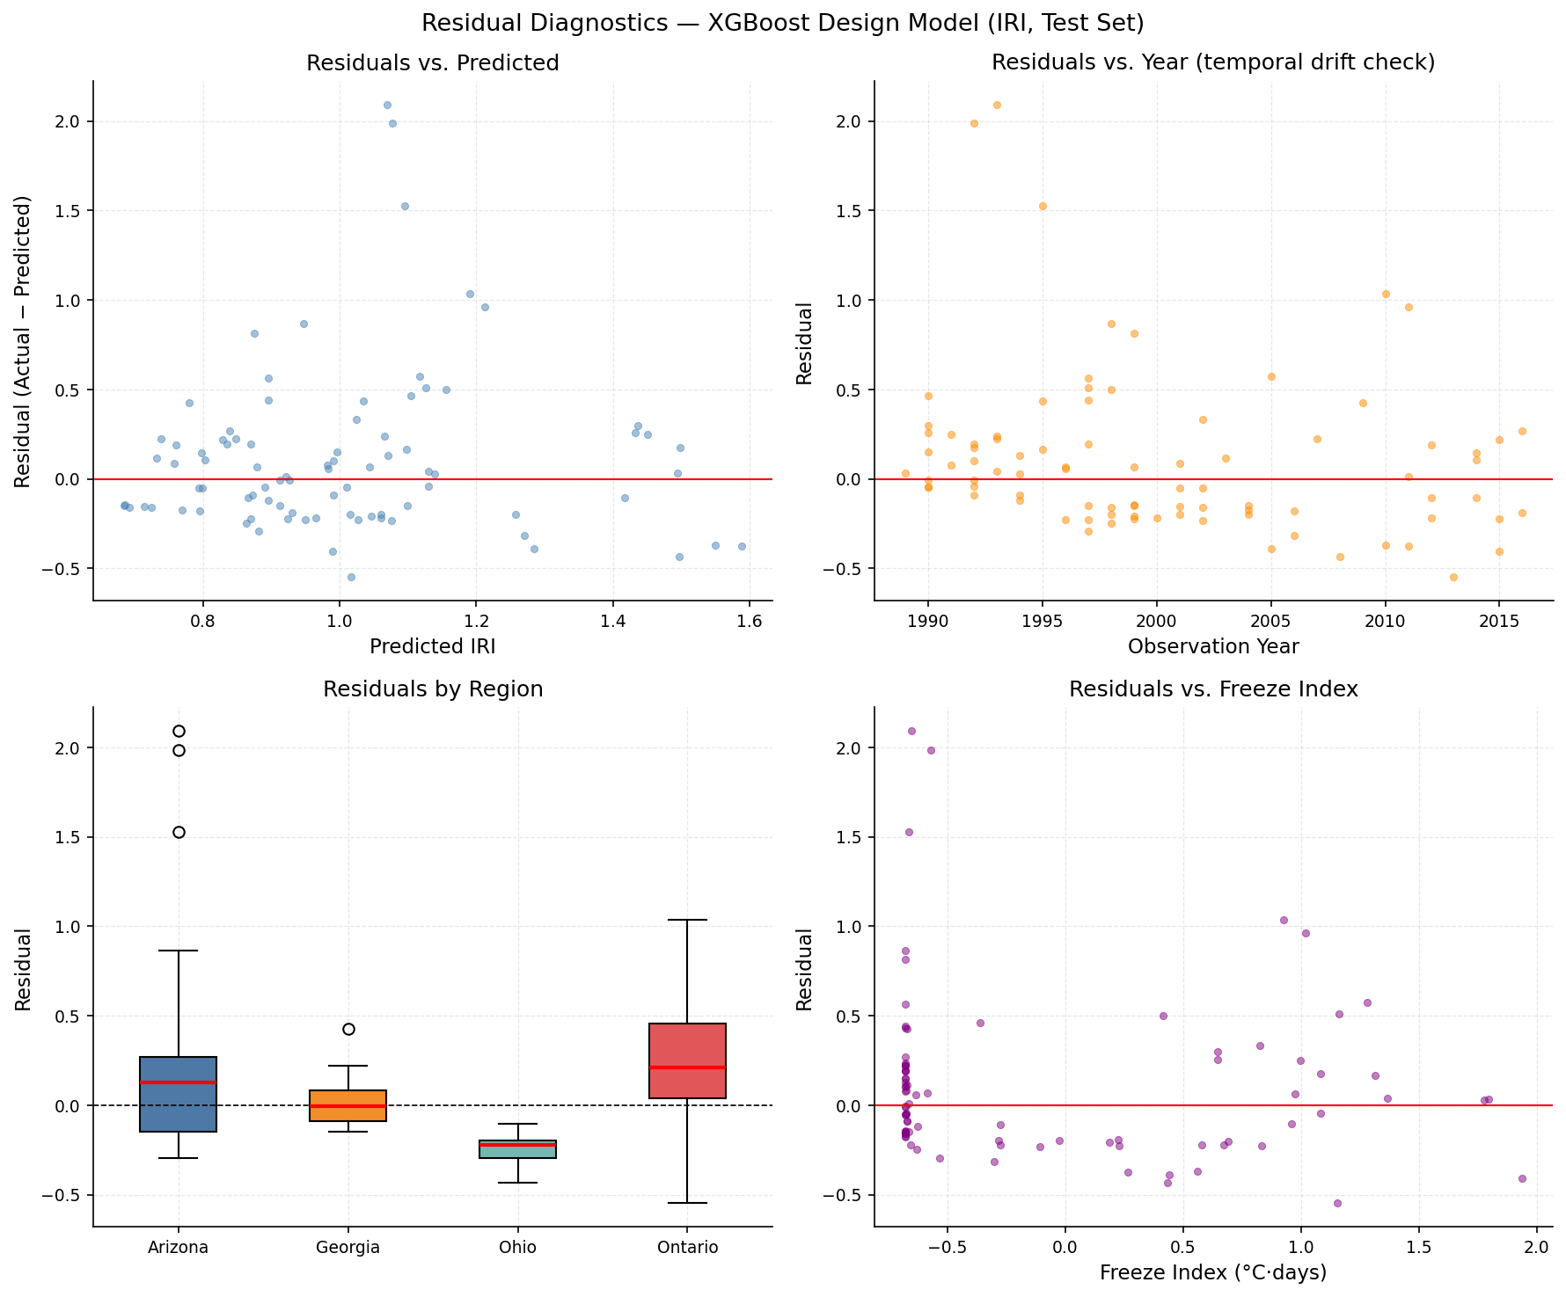
Figure 3. Residual diagnostics for the corrected XGBoost IRI design model.

4.6 Synthesis
The corrected pipeline supports the article's central caution. High apparent accuracy can arise from leakage, lag persistence, regional imbalance, or proxy features. After removing those shortcuts, design-stage transfer remains weak, monitoring must be benchmarked against persistence, and interpretability is bounded by model generalization and cross-model stability.

