Statistical Inference - Simulation

Joy SN

January 3, 2019

# Mean and Variance of Sample Mean for Exponential Distribution

Investigate the exponential distribution in R and compare it with the Central Limit Theorem. The exponential distribution is for 1000 simuulation of averages of 40 exponentials. Lamda is set to 0.2.

1. Packages required

library(ggplot2)

1. Data Setup

set.seed(19)  
lambda <- 0.2  
n <- 40 # size  
simulations <- 1000 # number of simulations  
simData <- replicate(simulations, rexp(n, lambda))  
meanData <- apply(simData, 2, mean)  
rowMeanData <- rowMeans(matrix(data = simData, nrow = simulations, ncol = n))

# Where the distribution is centered at and compare it to the theoretical center of the distribution.

theoryMean <- 1/lambda  
simulatedMean <- mean(rowMeanData) # Mean  
rbind(simulatedMean, theoryMean)

## [,1]  
## simulatedMean 4.991311  
## theoryMean 5.000000

hist(rowMeanData, breaks=50, prob=TRUE, main="Distribution of averages of samples,  
 drawn from exponential distribution with lambda=0.2",  
 xlab="")  
  
# Plot the density curve for the means  
lines(density(rowMeanData))  
  
# Add 'theoretical center of distribution' for comparison  
abline(v=1/lambda, col="red")  
  
# Add 'theoretical density for sample means' for comparison  
xfit <- seq(min(rowMeanData), max(rowMeanData), length=100)  
yfit <- dnorm(xfit, mean=1/lambda, sd=(1/lambda/sqrt(n)))  
lines(xfit, yfit, pch=22, col="red", lty=2)  
  
# Add legend to the chart  
legend('topright', c("Simulated", "Theoretical"), lty=c(1,2), col=c("black", "red"))

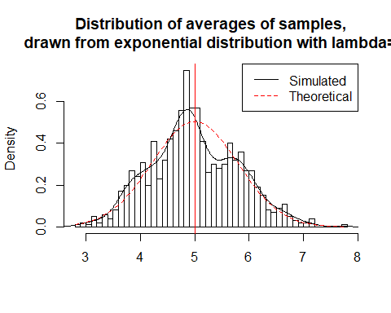

The analytics mean is 4.991311 the theoretical mean 5. The center of distribution of averages of 40 exponentials is very close to the theoretical center of the distribution

# How variable it is and compare it to the theoretical variance of the distribution..

1.standard deviation of distribution

simulatedSd <- sd(rowMeanData) # Standard Deviation  
theorySd <- (1/lambda)/sqrt(n) # Standard Deviation  
rbind(simulatedSd, theorySd)

## [,1]  
## simulatedSd 0.8022153  
## theorySd 0.7905694

simulatedVar <- simulatedSd^2 # Variance  
theoryVar <- ((1/lambda)*(1/sqrt(n)))^2 # Variance  
rbind(simulatedVar, theoryVar)

## [,1]  
## simulatedVar 0.6435493  
## theoryVar 0.6250000

Standard Deviation of the distribution is 0.8022153 with the theoretical SD calculated as 0.7905694. The Theoretical variance is calculated as 0.6250000. The actual variance of the distribution is 0.6435493

# Is the distribution is approximately normal?

data2 <- data.frame(rowMeanData)  
hist <- ggplot(data2, aes(x = rowMeanData))   
hist <- hist + geom_histogram(aes(y = ..density..), colour = "blue",  
 fill = "yellow", alpha = .7,binwidth=.2)  
hist <- hist + stat_function(fun = "dnorm", args = list(mean = theoryMean, sd = theorySd))  
hist <- hist + geom_vline(xintercept=theoryMean,size=1)  
hist <- hist + xlab("Mean")+ylab("Frequency")+ ggtitle("Normal Distribution")  
hist

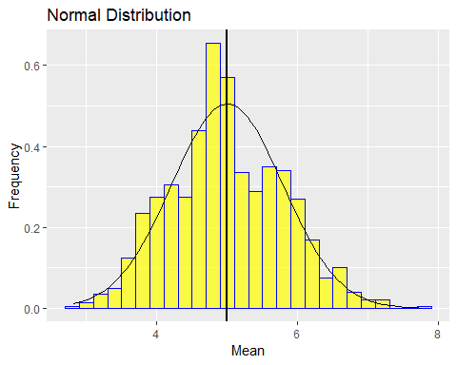

compare the distribution of averages of 40 exponentials to a normal distribution

qqnorm(meanData)  
qqline(meanData, col = 2)

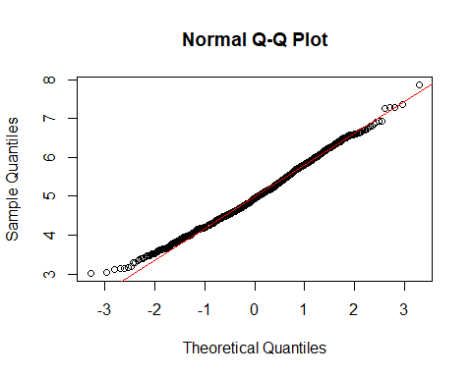

Since the points fall very close to the line due to Normal Distribution, we can say with some confidence that sample means follow normal distribution