Can video games be used for real world skill transfer- an empirical study of Kinect darts
Vaibhav Govilkar  University of Illinois at Chicago  Computer Science Department  vgovil2@uic.edu | Shi Yin  University of Illinois at Chicago  Computer Science Department  syin8@uic.edu | Aashish Tandon  University of Illinois at Chicago  Computer Science Department  aashishtandon007@gmail.com | Suraj Shetty  University of Illinois at Chicago  Computer Science Department  surajshetty1191@gmail.com

ABSTRACT
Motion tracking games have been emulating real world motor functions that can be performed by humans. The Kinect gaming console by Microsoft has many games that mimic physical movements. Therefore, a study based on whether such games can be used for skill-transfer can be of considerable interest. Studies have been conducted which tread on similar areas, e.g. the empirical study with Wii Bowling by Dorrfus et al [3]. But due to the inherent disadvantage of the Bowling game, a study on a more appropriate game is necessary to have a better understanding on this topic. Therefore, this paper aims to study the effects of playing a Kinect Dart game on the performance of novice players, while playing a real world dart game.

Author Keywords
Human Computer Interaction; Human factors; Video Games; Skill Transfer

INTRODUCTION
In recent years, major gaming console manufacturers (Nintendo, Microsoft, Sony) have introduced motion-controlled games into the market. According to the Entertainment Software Association’s (ESA) 2012 statistics [?], the top three genres of games for the year were Action, Sport and Shooter games. An important study in recent years was conducted in Norway, to show the effects of shooter games, such as Call of Duty, in helping the military personnel improve their war strategies. Similar studies have been conducted for sport-based games as well for detecting improvement in performance from exposure to such motion-controlled games.
Several studies have indicated that video game players are better trained for performing multiple tasks at the same time. Surgeons have been shown to perform laparoscopic tasks better with prior gaming experience. This indicates that gaming does help in improving performances in real world tasks that require extensive hand-eye co-ordination. So it can be assumed that there exists a link between motor abilities in the gaming world and the real world. Therefore, it can be argued that gaming consoles equipped with motion-controllers that emulate human movements can be used to improve a person’s abilities in the real world scenario. Hence, we ask the question "Can video games be used for real world skill transfer- an empirical study of kinect darts."
The Kinect controller is a motion-tracking device that is used to play motion-controlled games on the Microsoft Xbox 360 gaming console. Unlike the Nintendo Wii, the Kinect does not require the use of a physical controller in hand. Based around a webcam-style add-on peripheral for the Xbox 360 console, it enables users to control and interact with the Xbox 360 without the need to touch a game controller, through a natural user interface using gestures and spoken commands. It provides full body 3D motion capture, facial recognition and voice recognition capability. It uses an infrared laser to detect the major moving joints of the body and creates a skeletal structure, which is then used to create an avatar in the game.
Microsoft released the game “Kinect Sports Season 2” in 2012, which consisted of a number of sport games that could be played by using the Kinect. Our study involves one of these games called “Kinect Darts”. “Kinect Darts” is a game that allows players to throw a virtual dart on the dartboard. This game is modeled on a professional league of darts tournament. The game has been selected based on its striking similarities with its real world counterpart, namely the posture, position and throwing motion.
We, therefore, conducted a study in which the effect of playing “Kinect Darts” was evaluated. The study would test the assumption that the benefit of this training would be visible in the statistical analysis of the performance of novice players.
The rest of this paper is organized as following. We first introduced some related work of other researchers, followed by the detailed description of our study process. Then we show the result of data analysis, as well as our findings and conclusions.

prior research
Video games have often been proven to improve the performance in various unrelated fields.
James C Rosser et al. provided a hypothesis that video gaming skills correlate with laparoscopic surgical skills [8]. They proposed that video games could be used as a practical teaching tool to train surgeons.
Another study explored the idea of training warfighters using computer based training systems and video games. Amy L Alexander et al. [1] provided examples of various flight and driving simulators and outlined their benefits in training real world subjects. Such video game simulators offer various benefits in training namely due to their adaptability, low cost implementation and their capacity to emulate the real world.
Since we’re focusing on sports, we looked at the use of video game technology to transfer skills in real world games. Studies suggest the use of games to increase cognitive awareness in sports [6]. Most coaches in the NFL use video games in order to test out new strategies and refine their previous ones. With the advent of motion-controlled games that mimic human movements, we expect a higher level of skill transfer to the real world activities. A recent study by students at the Otto-Friedrich University Bamberg, Germany [3] involved the use of the Nintendo Wii to improve the performance in real world bowling. The study divided a group of students into two groups with one group training on the Wii bowling before proceeding to playing a game a real bowling versus a group that just played the real game. The training group’s result was found to be better than the non-training group. This encouraged us to test out other sports that could provide a similar outcome.

SETTINGS

The Game
The video game we used for this study is the “Kinect Darts” game found in “Kinect Sports Season 2” by Microsoft. In the game, players throw darts using motion control with the assistance of a crosshair on screen. Since the game is modeled on the professional league of darts tournament, it uses the same rule system as the professional league, including the use of a competitive dartboard. The board is divided into 20 radial sections. Adjacent sections are in different colors. The 20 sections consist of scores, from 1 to 20. The numbers outside each section indicate the various scores. There are also 2 rings, one in the periphery of each section, worth double the score while the other one is in the middle of each section worth triple the score of that section. In the center of the dartboard, is the bull’s eye. The region around it is worth 25 points and the core itself is worth 50 points.
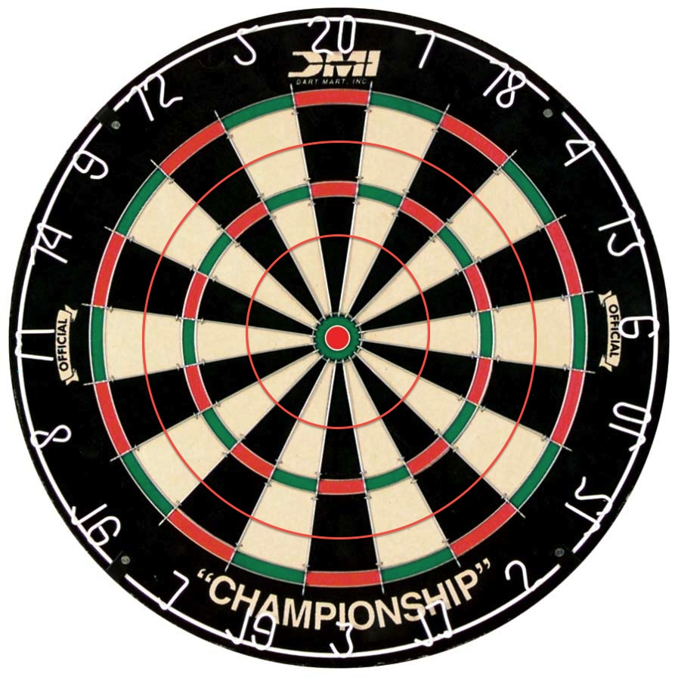
Figure 1: Real Competitive Dartboard
This setting was not only deemed too complicated for participants that have no prior experience but also unsuitable for us to record and interpret. To simplify the rules to make it feasible for our study, all the participants were notified before the start of their session that their goal was to hit the center of the dartboard, the bull’s eye, in both the virtual game as well as the real dart game. This rule was considered simple enough for participants who were playing this game for the first time and for us to conduct the post-experiment analysis.

The Dartboard
The dartboard used in this study is a standard competitive dartboard just like the one in the virtual game. The similarity in the dartboard between the virtual game and the real game was essential for our study. We developed a preliminary scoring system based on our intuitive experience of how difficult it was to hit each region on the board. The area from the border of the dartboard to the outer bound of the double ring was 1 point, the area from the double ring to the outer bound of the triple ring was 2 points, the area between triple ring and the bull’s eye was worth 3 points and the bull’s eye was worth 5 points.

Process
We randomly enrolled 30 participants among colleagues, classmates, roommates and friends. All the participants did not have prior experience in either the Kinect game or a real dart game.
After the participants were selected, they were randomly split up into two equal groups of 15 each with one being the control group and the other the primary testing group.

Figure 2: Our Score Distribution System

Control Group Process
The control group directly played a session consisting of 20 darts each after being given a short description of their goal. They were not given a chance to practice or train on the real dartboard before they could start their sessions.
Each participant had to complete 4 rounds, with each round allowing the participant to throw 5 darts. After each round, the darts were picked up from the dartboard or from the floor and handed over to the participant. Scores of each of the 20 darts were recorded by researchers using the aforementioned scoring system.
The participants in the control group conducted their sessions one by one. One thing that is worth a mention is that in the actual session, the environment was set as the default configuration of the professional league. The horizontal distance between the surface of dartboard and the line where participants standing, was 7’9”, and the vertical distance from the center of the dartboard to the floor of the testing room, was 5’8”.
As the dart did not penetrate the dartboard every time it was being thrown out, an agreement was reached before the study was conducted. When the dart wouldn't penetrate the board and bounce off, if the position where the dart hit the dartboard was seen by majority of the research team, the corresponding score would be recorded, otherwise if researchers wouldn’t agree with each other, the trail would be voided and the participants would be allowed to throw one more dart. During the actual process, almost every dart that bounced off was observed and thus was record as it should be.

Testing Group Process
After the whole control group finished their sessions, the testing group session started. Unlike the control group, the 15 participants in the testing group played the Kinect Darts as a practice session prior to their 20-dart testing session. During the actual study, participants in the testing group were made to play the virtual game either for 5 minutes or 30 darts, whichever reached later. If the participants couldn’t throw 30 darts within a 5 minute interval, they were allowed to continue practice until they used up all their trials. On the other hand, participants who quickly finished all 30 trials were asked to throw additional darts until the time runs out. We found a priory that 5 minutes and 30 darts were enough for a new player who had never played this game before, to arrive at a short-term maximum performance level. We observed that most of the participants were able to constantly throw the dart in a very small area around the bull’s eye in the later phase of their practice session.
Once the game was started, the participant aimed at the center of the virtual dartboard in the same way as in a real world game, but with the help of the crosshair on the screen. The crosshair did not provide any significant benefit as the flick used to throw determined the final trajectory of the virtual dart.
The scores participants got in this part were not recorded as this session is merely a practice phase.
After finishing the practice session, participants proceeded immediately to the testing session that consisted of the same number of trials as for the control group. The process of testing session for the testing group is identical to the session conducted for the control group.

Fidelity of the Process
We have tried to create a simple and controlled environment for both the real dart game and the virtual Xbox game and to make them as similar as possible.
First, the Kinect Dart game was set up next to the real dartboard, and we turned off the audio of the game so that participants wouldn’t be distracted by external interference. Secondly, the distance between the dartboard and the subjects was kept the same in both the real game and the video game. Thirdly, the same goal and a simple one (aim for the bull's eye) was given to the participants from both the in order to get the best result.

analysis
The results from the experiments were tabulated and analyzed in a spreadsheet. Following were some of the statistics evaluated for further processing:
- Individual mean scores for every participant from both groups
- Mean scores per-turn for each of the groups
- The mean, standard deviation and variance for each group.
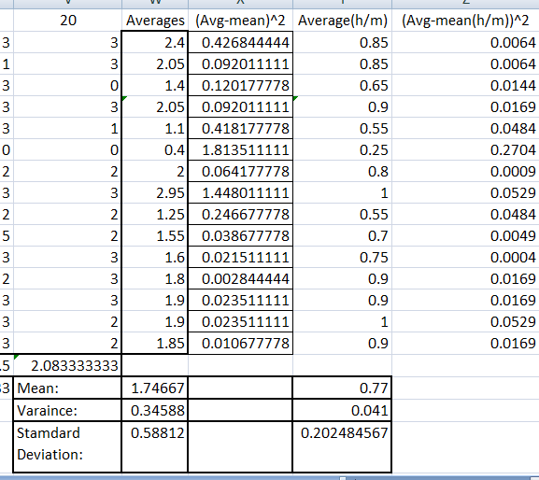Table 1. A screen-shot of the spreadsheet where the scores were recorded and statistics were analyzed
Since the scoring system: 5-3-2-1-0 for different regions on the board was not rigorously verified to be a valid test of skill but more based on intuitive judgment we decided to also analyze an alternative method to judge skill on the dartboard.

It was decided that a measure of whether the participant hit the board or completely missed it could be a potentially more un-biased measure of any notable improvement in skill. If the participants hit the board they would receive 1 point or alternatively 0 points for a miss. The existing observations were easily modifiable for this new system of measure. The aforementioned vital statistics like individual means, per-turn means, group means, standard deviation and variance was recalculated for the alternative scoring system.

Effect on Learning Curves
We created the learning curve for the control group and the testing group with a quadratic fit for the values, with the turn in question (1 to 20) on the x-axis and the Scores on the y-axis. See Figure 3 & 4.

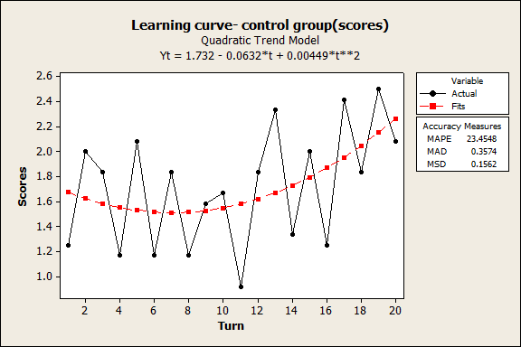
Figure 3: Learning Curve – control group (scores)

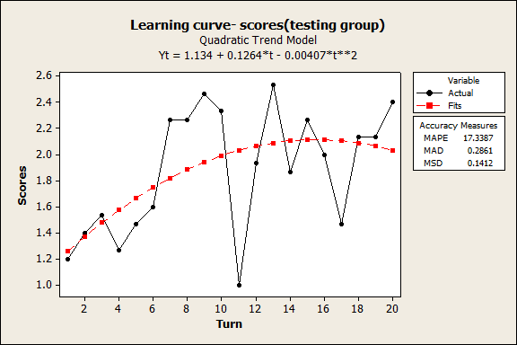
Figure 4: Learning Curve – testing group (scores)

As is clear from both the graphs there is a clear upward trend in both groups. The testing group seems to show a quicker rise in skill in the beginning only to plateau out at the 10th turn and in fact dip slightly near the end.
The graphs don't show any conclusive evidence of effect on the Kinect practice on the learning curve. But the curves themselves show an interesting pattern. The actual value graph shows consistent dips after the consequent turn immediately succeeding the multiples of 5. This trend is most apparent at the 11th turn, where both the curves show a sharp dip in performance. Upon observation and careful study of some of the video recordings, it seems that this behavior can be attributed to the number of darts available. There was a break in the rhythm of throwing darts one after another after every 5 turns as there were only 5 darts available. The researcher had to collect the darts after 5 turns and hand it back to the participant.
The learning curves for the hit-miss system of assessment were also evaluated. See Figure 5 & 6.
These curves show a very similar upward trend to the scoring system of skill evaluation. There is no discernible difference or noteworthy observation in these new graphs.

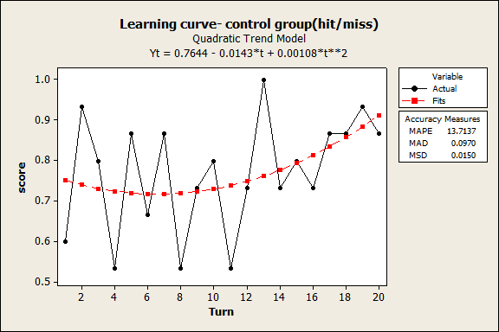
Figure 5: learning curve – control group (hit/miss)

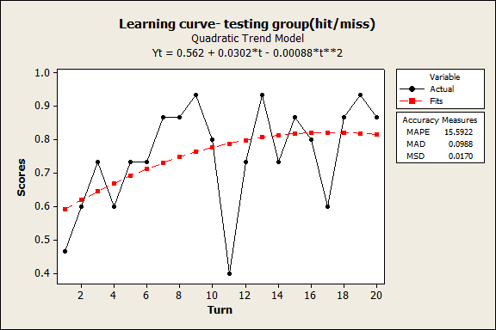
Figure 6: learning curve – testing group (hit/miss)

Distribution
Following are the distributions of participants with the score on the x-axis and number of people on the y-axis for both the (5-3-2-1-0) scoring system and the hit/miss (1-0) system. See Figure 7 & 8.
These normal distributions show a sharper curve for the testing group as opposed to the control group with a higher density of participants around the mean.
There is also a significant overlap in both cases, of the two curves in question.

T-test
Using the data gathered and the values of variances and means the t-test was carried out for both the skill-evaluation systems:
T-value for scoring (5-3-2-1-0) = 0.6542
T-value for hit/miss (1-0) = -0.2529
Both the methods of skill assessment yielded a very small t-value showing conclusively that there is statistically no significant difference between the two testing groups by either scoring method at an alpha value of 0.05.

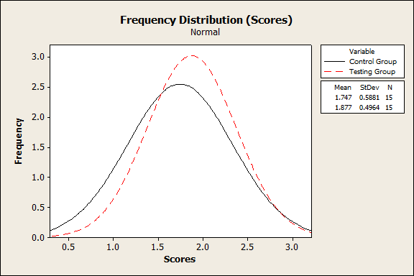
Figure 7: Frequency Distribution (Scores)

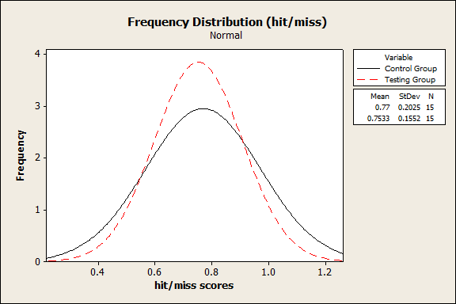
Figure 8: Frequency Distribution (hit/miss)

Feedback
We had gathered feedback from 10 random subjects from the testing group regarding their experience with the virtual game and their performance on the real game subsequently. These subjects were asked questions such as: “How similar was the virtual game to the real game?”, “Did the exposure to the virtual game help them in any way in the real game?”, “Would your performance improve if you would get more time on the virtual game?”etc. Based on their feedback, we noticed that there was a general consensus among these subjects that the virtual game did not help them in any way with the real game, with 9 out of 10 participants claiming the same. One participant did state that the virtual game helped him in learning more about the game and how to play it. However, his scores were not noticeably different from any of the other subjects in the testing groups. This subject was also the only one who felt that his real world performance could have improved, if he would have spent more time on the virtual game. A significant majority of the participants who gave feedback (7 out of 10) felt that the virtual game was quite different from the real game. 4 of these 7 participants felt that the crosshair was actually making it easier for them to get a better score, while 3 of them complained about the crosshair, stating that it does not always hit at the targeted spot. These participants were informed that even though the crosshair sets a target, the Kinect controller also tracks the hand movement after the target has been fixed. Therefore, fixing the target was not the only criteria for throwing the dart at a particular point.
Some participants in the testing group complained the dartboard was too high for them for them to use the same gesture to throw a dart like they did in the game console.

Discussion

Findings and Implications
Based on the analysis of the data as well as the feedback from the participants, our main finding was that the Kinect game did not positively affect the performance of the testing group subjects. This can be attributed to various factors: the lack of a physical appendage to hold in the virtual game. This may have affected the subject’s perception of the dart in the real game, as the weight of the dart becomes a decisive factor. Although the game takes into consideration the parabolic path that the imaginary dart thrown by a user would follow, it does not entirely simulate with the real world. This could also have been a factor that does not make the Kinect game an ideal skill-transfer environment.

Conclusion and Future work
This study was aimed at analyzing the effect of playing video games with motion control capabilities and their implications on real world tasks. Despite previous studies showing that video games do facilitate the transfer of skills in real life, our study did not cohere with those arguments. We think it was down to some elementary flaws in the video game as well as the study that lead to this result. An improved study with different configurations and settings can be conducted to verify this outcome. Some of the improvements include setting a more accurate score criteria for the real dartboard, having a larger sample space and making arrangements for the addition of a weighted dart so as to nullify the lack of a physical dart in the Kinect Darts game.

ACKNOWLEDGMENTS
We thank all the volunteers, The University of Illinois at Chicago, the computer Science Department and Professor Tom Moher.

REFERENCES
- Alexander, A.L., Brunye, T., Sidman, J., Weil, S.A. From Gaming to Training: A Review of Studies on Fidelity, Immersion, Presence, and Buy-in and Their Effects on Transfer in PC-Based Simulations and Games. Aptima, Inc (2005).
- Bonk, C.J., Dennen, V.P. Massive Multiplayer Online Gaming: A Research Framework for Military Training and Education. DTIC 2005.
- Dorrfus, K., Bader, F., Wegener, R., Siemon, A., Schwake, J.U., Hofman, F., Hieber, T., Schimd, U. Video Games can Improve Performance in Sports: An Empirical Study with Wii Sports Bowling. In Proc. KI 2009 Workshop on Human-Machine-Interaction.
- Essential Facts About the Computer and Video Game Industry, Entertainment Software Association,
http://www.theesa.com/facts/pdfs/ESA_EF_2012.pdf
- Kershner, K. Virtual reality: Danger Ahead. USA Today (1995).
- Mulligan, D., Dobson, M., McCracken, J. The Use of Video Game Technology for Investigating Perceptual and Cognitive Awareness in Sports. In Proc. DiGRA 2005 Conference: Changing Views – Worlds in Play.
- Naone, E. AMA Considers a New Addiction: Video Games. MIT Technology Review (2007).
- Rosser, J.C. Jr, Lynch, P.J., Cuddihy, L., Gentile, D.A. The Impact of Video Games on Training Surgeons in the 21st Century, Arch Surg 2007, 181-186

