電通二乙微處理器實驗 實驗結報

實驗名稱 |  | Lab 04 – 四合一七段顯示器
組員 | 06050013鄞若伃

- 實驗目的
- 了解七段顯示器之顯示原理
- 共陰極與共陽極七段顯示器之不同
- 實驗步驟
- Arduino接好四合一七段顯示器之電路
- 每隔0.3秒跳一個數字 0000->0059 ->0100跳至2359後歸零
- 程式碼
(1)
#include "SevSeg.h"
SevSeg sevseg;
int Hour = 0, Min = 1;
void setup() {
sevseg.setBrightness(90);
byte numdigits = 4;
byte digitPins[] = {2, 3, 4, 5};
byte segmentPins[] = {8, 9, 10, 11, 12, 13, 14, 15};
sevseg.begin (COMMON_CATHODE, numdigits, digitPins, segmentPins);
}
void loop() {

sevseg.setNumber(Hour * 100 + Min, 4);
Min = Min + 1;
if (Min == 60)
{
Min = 0;
if (Hour == 23)
Hour = 0;
else
Hour++;
}

for (int i = 0; i <= 54321; i++)
{
sevseg.refreshDisplay();
}
}
(2)
#include "SevSeg.h"
SevSeg sevseg;
int Hour = 0, Min = 1, sw = 6;;
void setup() {
sevseg.setBrightness(90);
byte numdigits = 4;
byte digitPins[] = {2, 3, 4, 5};
byte segmentPins[] = {8, 9, 10, 11, 12, 13, 14, 15};
sevseg.begin (COMMON_CATHODE, numdigits, digitPins, segmentPins);
pinMode(sw, INPUT);
}
void loop() {

if (digitalRead(6) == HIGH)
{
Hour = 0;
Min = 0;
sevseg.setNumber(Hour, 4);
}

else
{
sevseg.setNumber(Hour * 100 + Min, 4);
Min = Min + 1;
if (Min == 60)
{
Min = 0;
if (Hour == 23)
Hour = 0;
else
Hour++;
}
}

for (int i = 0; i <= 543211; i++)
{
sevseg.refreshDisplay();
}
}
(3)
#include "SevSeg.h"
SevSeg sevseg;
int Hour = 0, Min = 0;
void setup() {
sevseg.setBrightness(90);
byte numdigits = 4;
byte digitPins[] = {2, 3, 4, 5};
byte segmentPins[] = {8, 9, 10, 11, 12, 13, 14, 15};
sevseg.begin (COMMON_CATHODE, numdigits, digitPins, segmentPins);
pinMode(6, INPUT);
pinMode(A2, INPUT);
}
void loop() {

if (digitalRead(6) == HIGH)
{

sevseg.setNumber(0000 , 4);
}

else if (digitalRead(A2) == HIGH)
{
Min--;
if (Min == -1)
{
Min = 59;
if (Hour == 0)
Hour = 23;
else
Hour--;
}
sevseg.setNumber(Hour * 100 + Min, 4);

}
else
{
Min = Min + 1;
if (Min == 60)
{
Min = 0;
if (Hour == 23)
Hour = 0;
else
Hour++;
}
sevseg.setNumber(Hour * 100 + Min, 4);

}

for (int i = 0; i <= 54321; i++)
{
sevseg.refreshDisplay();
}
}

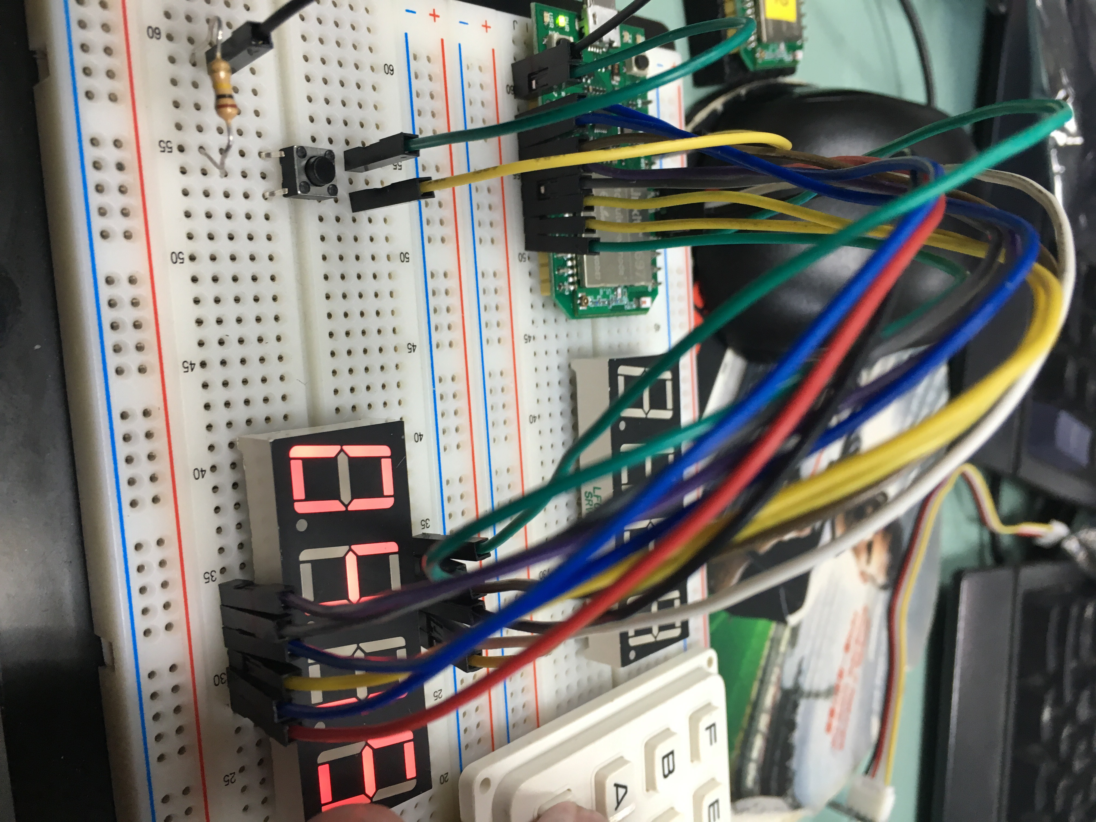
- 實驗結果及分析

- 電路圖
- 心得討論
覺得這個實驗還滿有趣的 不過在接線上面卡了很久才了解要怎麼用

