**電通二乙微處理器實驗 實驗結報**

|  |  |  |
| --- | --- | --- |
| **實驗名稱** | | Lab 04 – 四合一七段顯示器 |
| **組員** | **06050013鄞若伃** | |

1. **實驗目的**
2. **了解七段顯示器之顯示原理**
3. **共陰極與共陽極七段顯示器之不同**
4. **實驗步驟**
5. **Arduino接好四合一七段顯示器之電路**
6. **每隔0.3秒跳一個數字 0000->0059 ->0100跳至2359後歸零**
7. **程式碼**

|  |
| --- |
| **(1)**  **#include "SevSeg.h"**  **SevSeg sevseg;**  **int Hour = 0, Min = 1;**  **void setup() {**  **sevseg.setBrightness(90);**  **byte numdigits = 4;**  **byte digitPins[] = {2, 3, 4, 5};**  **byte segmentPins[] = {8, 9, 10, 11, 12, 13, 14, 15};**  **sevseg.begin (COMMON_CATHODE, numdigits, digitPins, segmentPins);**  **}**  **void loop() {**  **sevseg.setNumber(Hour * 100 + Min, 4);**  **Min = Min + 1;**  **if (Min == 60)**  **{**  **Min = 0;**  **if (Hour == 23)**  **Hour = 0;**  **else**  **Hour++;**  **}**    **for (int i = 0; i <= 54321; i++)**  **{**  **sevseg.refreshDisplay();**  **}**  **}** |
| **(2)**  **#include "SevSeg.h"**  **SevSeg sevseg;**  **int Hour = 0, Min = 1, sw = 6;**  **void setup() {**  **sevseg.setBrightness(90);**  **byte numdigits = 4;**  **byte digitPins[] = {2, 3, 4, 5};**  **byte segmentPins[] = {8, 9, 10, 11, 12, 13, 14, 15};**  **sevseg.begin (COMMON_CATHODE, numdigits, digitPins, segmentPins);**  **pinMode(sw, INPUT);**  **}**  **void loop() {**  **if (digitalRead(6) == HIGH)**  **{**  **Hour = 0;**  **Min = 0;**  **sevseg.setNumber(Hour, 4);**  **}**  **else**  **{**  **sevseg.setNumber(Hour * 100 + Min, 4);**  **Min = Min + 1;**  **if (Min == 60)**  **{**  **Min = 0;**  **if (Hour == 23)**  **Hour = 0;**  **else**  **Hour++;**  **}**  **}**  **for (int i = 0; i <= 543211; i++)**  **{**  **sevseg.refreshDisplay();**  **}**  **}** |
| **(3)**  **#include "SevSeg.h"**  **SevSeg sevseg;**  **int Hour = 0, Min = 0;**  **void setup() {**  **sevseg.setBrightness(90);**  **byte numdigits = 4;**  **byte digitPins[] = {2, 3, 4, 5};**  **byte segmentPins[] = {8, 9, 10, 11, 12, 13, 14, 15};**  **sevseg.begin (COMMON_CATHODE, numdigits, digitPins, segmentPins);**  **pinMode(6, INPUT);**  **pinMode(A2, INPUT);**  **}**  **void loop() {**  **if (digitalRead(6) == HIGH)**  **{**    **sevseg.setNumber(0000 , 4);**  **}**  **else if (digitalRead(A2) == HIGH)**  **{**  **Min--;**  **if (Min == -1)**  **{**  **Min = 59;**  **if (Hour == 0)**  **Hour = 23;**  **else**  **Hour--;**  **}**  **sevseg.setNumber(Hour * 100 + Min, 4);**  **}**  **else**  **{**  **Min = Min + 1;**  **if (Min == 60)**  **{**  **Min = 0;**  **if (Hour == 23)**  **Hour = 0;**  **else**  **Hour++;**  **}**  **sevseg.setNumber(Hour * 100 + Min, 4);**  **}**  **for (int i = 0; i <= 54321; i++)**  **{**  **sevseg.refreshDisplay();**  **}**  **}** |

1. 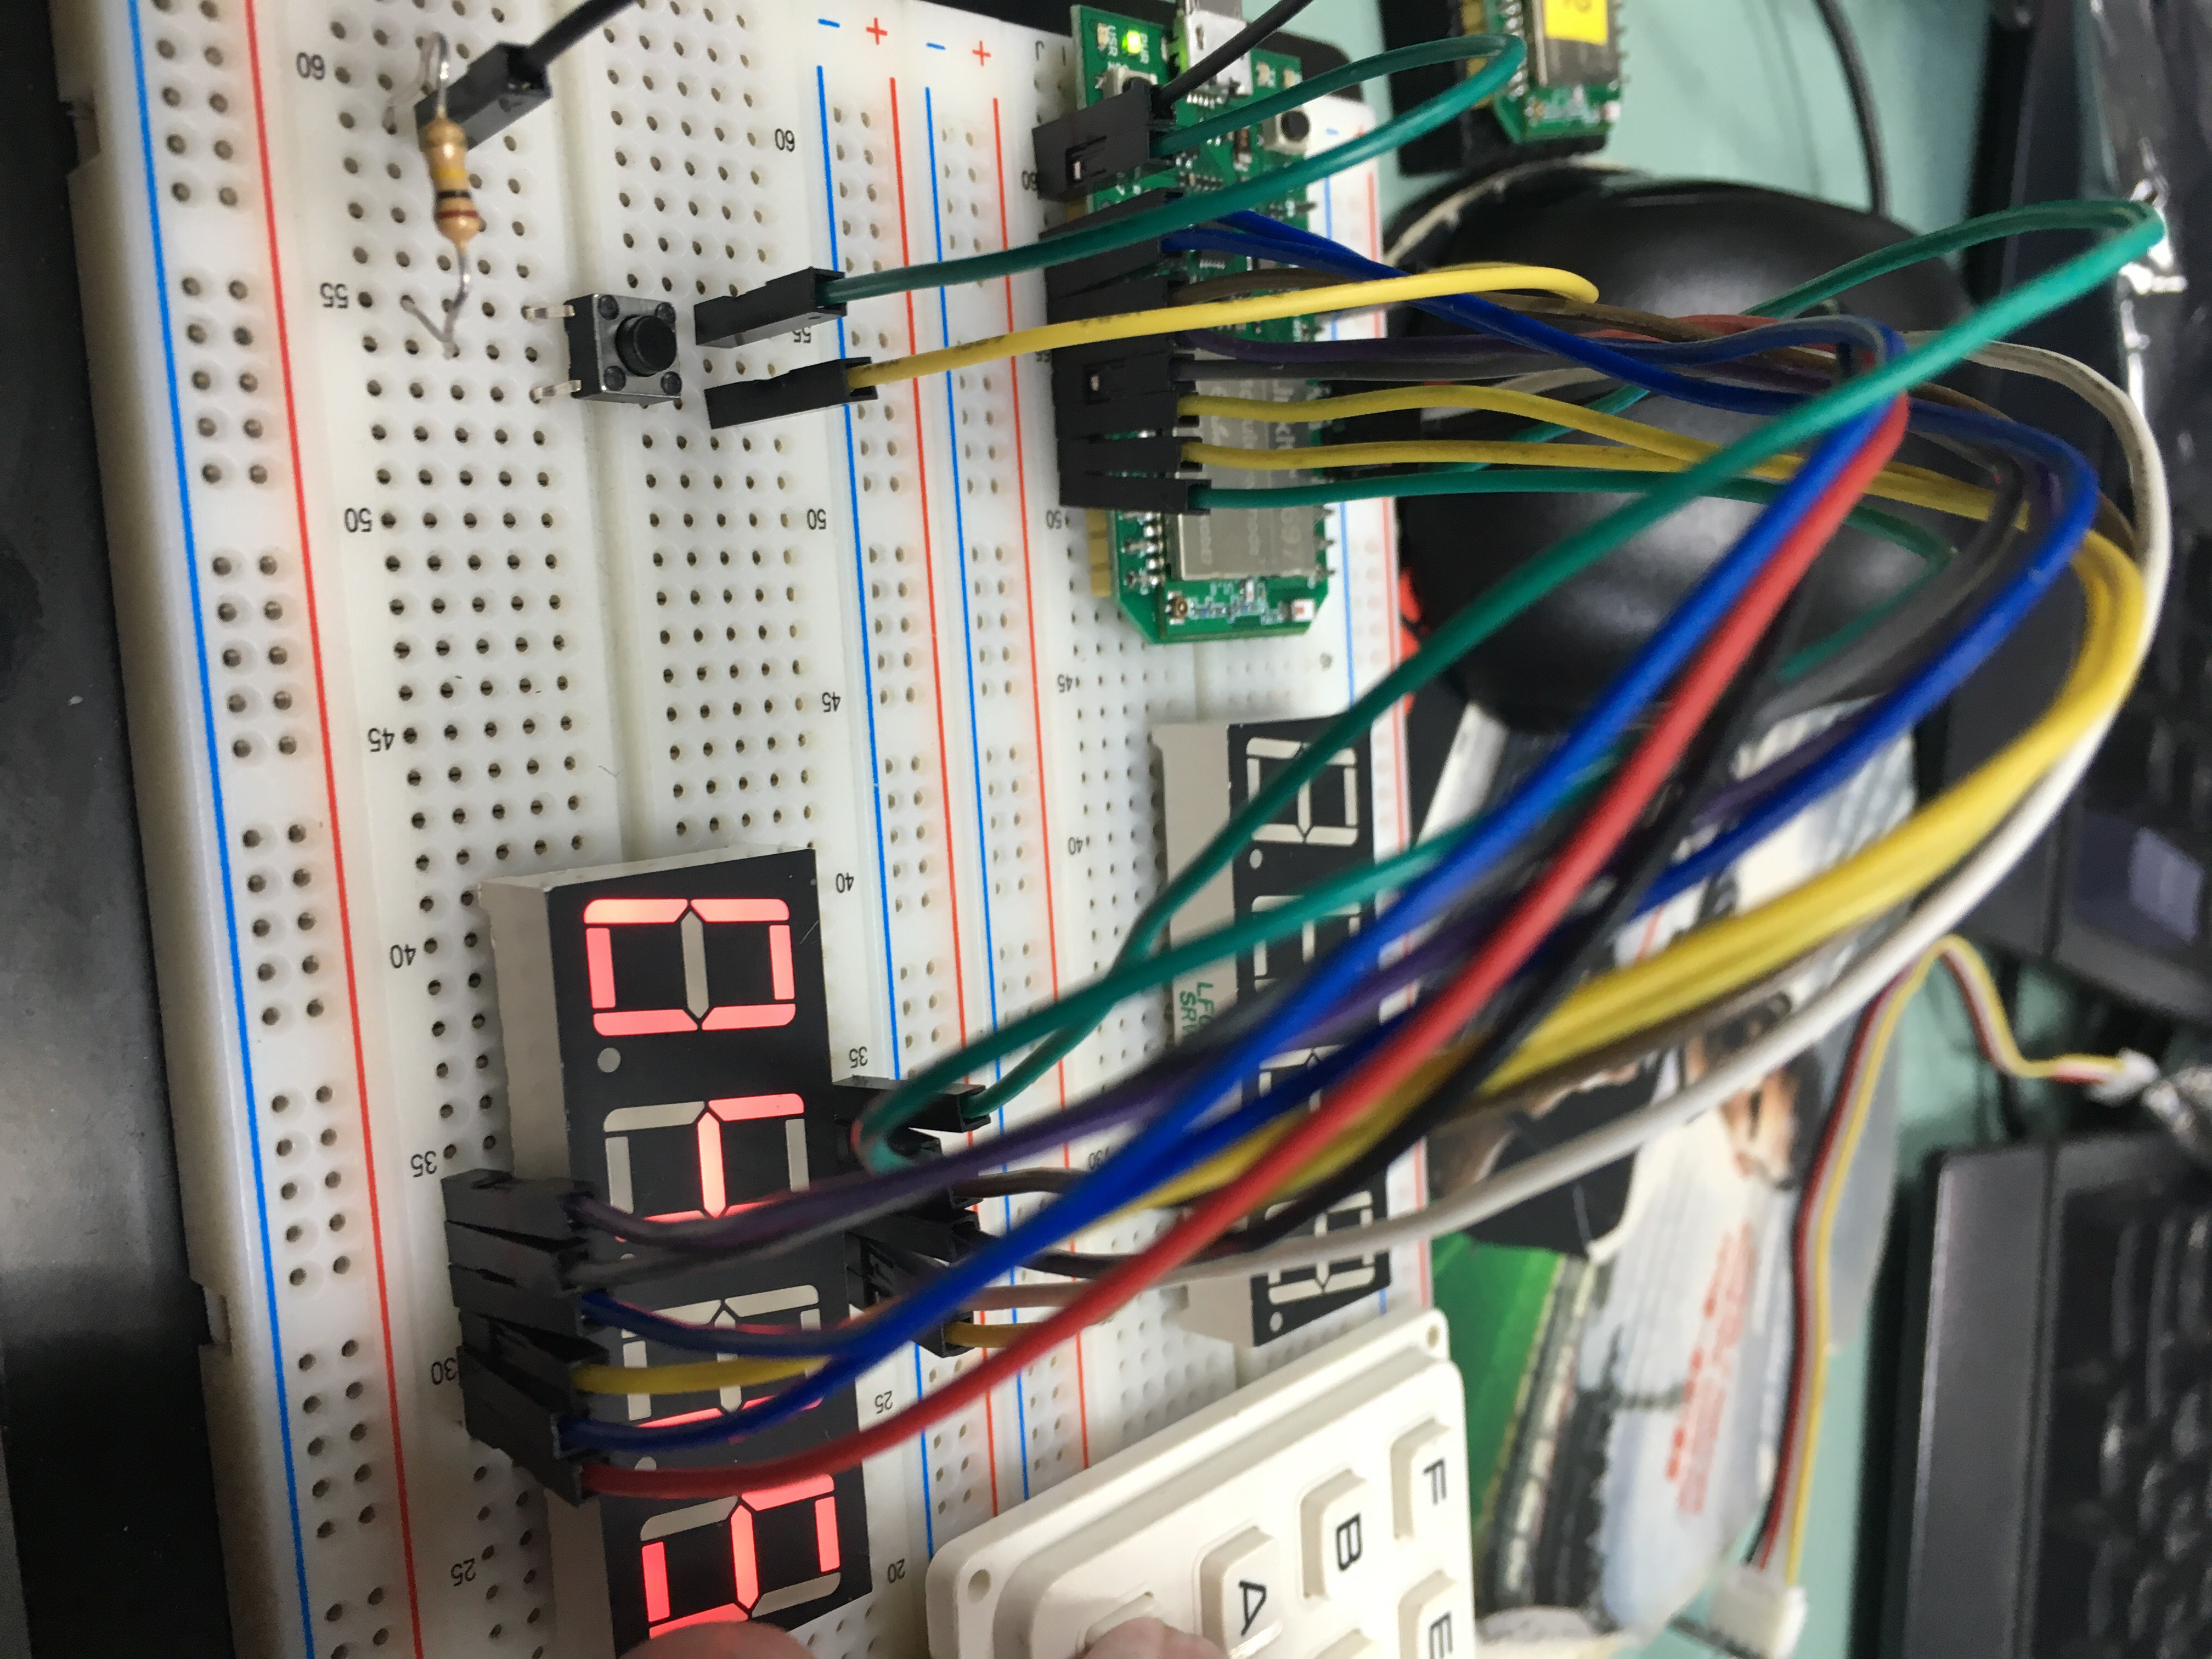**實驗結果及分析**
2. **電路圖**

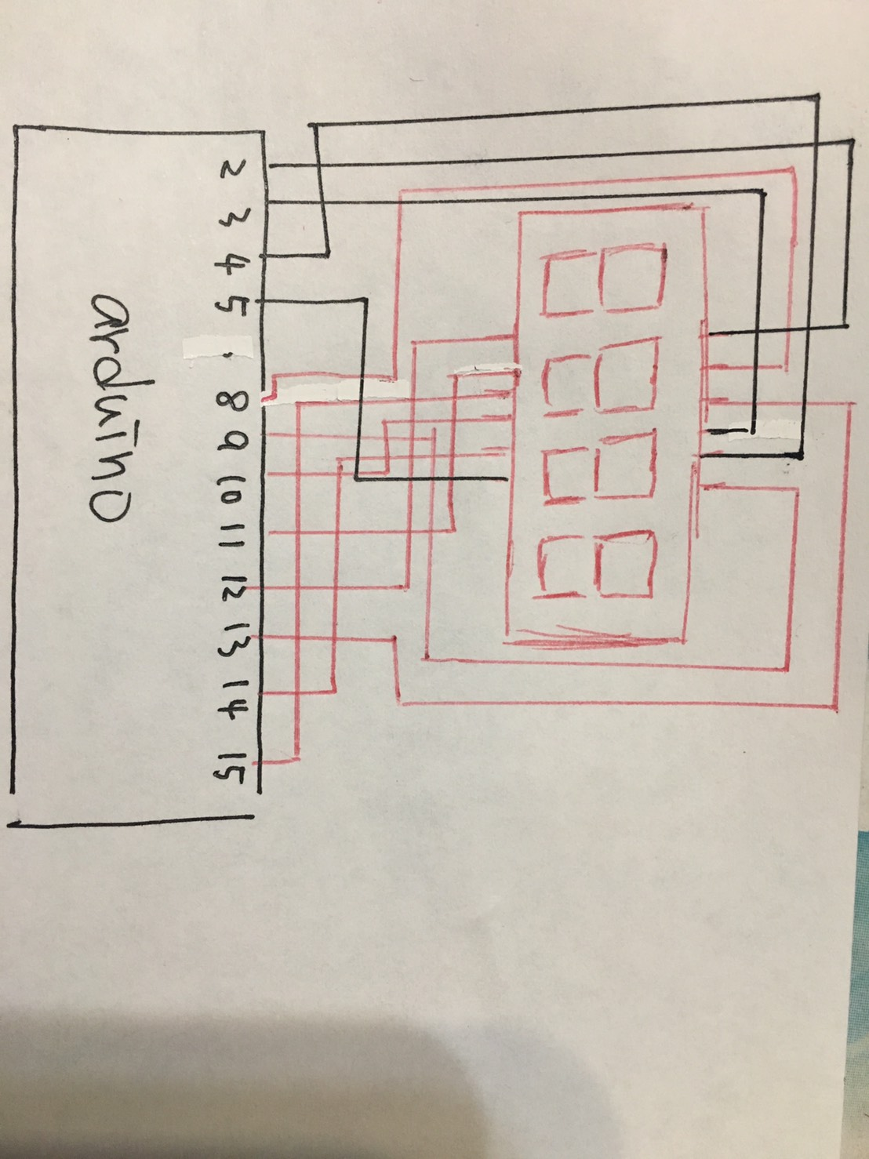

1. **心得討論**

**覺得這個實驗還滿有趣的 不過在接線上面卡了很久才了解要怎麼用**