電通二甲微處理器實驗 實驗結報

實驗名稱 | Lab 06 – 音樂教室
組員 | 06050013鄞若伃

- 實驗目的
如何使Arduino 發出特定旋律的聲音?
(1)Arduino接喇叭如何接線?
(2)如何使用 tone library?
(3)如何演奏一段音樂?
(4)如何使用4X4 鍵盤演奏音樂?
(5)如何發報摩斯密碼?
- 實驗步驟
- Arduino 演奏一段特定的音樂，旋律不得是小蜜蜂
- 使用 4X4 鍵盤演奏音樂
- 發報摩斯密碼
- 程式碼
(1)
#define MI 329
#define RE 294
#define DO 261
#define FA 349
#define WHOLE 1 //¥þ¤À²Å
#define HALF 0.5 //¥b¤À²Å
#define QUARTER 0.25

int tune[] = {MI,RE,DO,RE,MI,MI,MI,RE,RE,RE,MI,MI,MI,MI,RE,DO,RE,MI,MI,MI,RE,RE,FA,RE,DO};

float duration[] = {QUARTER,QUARTER,QUARTER, QUARTER, QUARTER, QUARTER,HALF, QUARTER, QUARTER,HALF, QUARTER, QUARTER,HALF, QUARTER,QUARTER,QUARTER, QUARTER, QUARTER, QUARTER,HALF, QUARTER, QUARTER, QUARTER, QUARTER,WHOLE };
int length = sizeof(tune) / sizeof(tune[0]);
void setup() {
// put your setup code here, to run once:
pinMode(8, OUTPUT);

}

void loop() {
// put your main code here, to run repeatedly:

for (int x=0; x<length; x++) {
tone(8, tune[x]);
delay(1300 *duration[x]);
noTone(8);
}
delay(5000);
}
(2)
#include <Keypad.h>
#include "SevSeg.h"
SevSeg sevseg; //Instantiate a seven segment object
const byte ROWS = 4; // 4 Rows
const byte COLS = 4; // 4 Columns

#define DO 261
#define RE 294
#define MI 329
#define FA 349
#define SO 392
#define LA 440
#define SI 493

#define DOO 523
#define REE 587
#define MII 659
#define FAA 698
#define SOO 784
#define LAA 880
#define SII 988

#define DDO 139
#define RRE 147
// 定義 Keypad 的按鍵
char keys[ROWS][COLS] = {
{'7', '8', '9', 'C'}, {'4','5','6', 'D'},
{'1', '2', '3', 'E'}, {'0', 'A', 'B', 'F'}
};

// 定義 Keypad 連到 Arduino 的接腳
byte rowPins[ROWS] = {10, 9, 8, 7};
// 連到 Keypad 的 4 個 Rows
byte colPins[COLS] = {14, 13, 12, 11};
// 連到 Keypad 的 4 個 Columns
// 建立 Keypad 物件
Keypad keypad =Keypad( makeKeymap(keys), rowPins,colPins, ROWS, COLS );
void setup(){
byte numDigits = 1;
byte digitPins[] = {5};
byte segmentPins[] = {2,3,4,6,15,16,17};
sevseg.begin(COMMON_CATHODE, numDigits, digitPins,segmentPins);
Serial.begin(9600);
pinMode(5, OUTPUT);
}
void loop(){
char key = keypad.getKey(); // 讀取 Keypad的輸入
if (key != NO_KEY){
switch(key)
{
case 'F':tone(5,DO,500);break;
case 'E':tone(5,RE,500);break;
case 'D':tone(5,MI,500);break;
case 'C':tone(5,FA,500);break;
case 'B':tone(5,SO,500);break;
case '3':tone(5,LA,500);break;
case '6':tone(5,SI,500);break;
case '9':tone(5,DOO,500);break;
case 'A':tone(5,REE,500);break;
case '2':tone(5,MII,500);break;
case '5':tone(5,FAA,500);break;
case '8':tone(5,SOO,500);break;
case '0':tone(5,LAA,500);break;
case '1':tone(5,SII,500);break;
case '4':tone(5,DDO,500);break;
case '7':tone(5,RRE,500);break;
}
}
}
(3)

char *morse[]={"01","1000","1010","100",
"0","0010","110","0000",
"00","0111","101","0100",
"11","10","111","0110",
"1101","010","000","1",
"001","0001","11","1001",
"1011","1100"};
char *ptr;
char index,chr;

void setup() {
pinMode(8,OUTPUT);
Serial.begin(9600);
}

void loop() {
if(Serial.available())
{
chr = Serial.read();
Serial.println(chr);
if((chr-'A')>=0 && (chr-'Z')<=0)
{
index = chr - 'A';
ptr = morse[index];

while(*ptr!='\0')
{
if(*ptr == '0')
{
tone(8,440,100);
delay(100);
}
else if(*ptr == '1')
{
tone(8,440,300);
delay(300);
}
ptr++;
delay(100);
}
delay(300);
}
}
}

- 實驗結果及分析
實驗一 : 順利地依照陣列設定好的頻率播出音樂
實驗二 : 鍵盤設定好之後也依照數字大小發出不同頻率的聲音
實驗三 : 利用指標來讀取要發長音或短音 然後用tone()函式設定發出的頻率跟持續時間
- 心得討論
這次還滿簡單的 而且可以自己做出類似電子琴的東西 覺得很有趣

- 電路圖
(1)
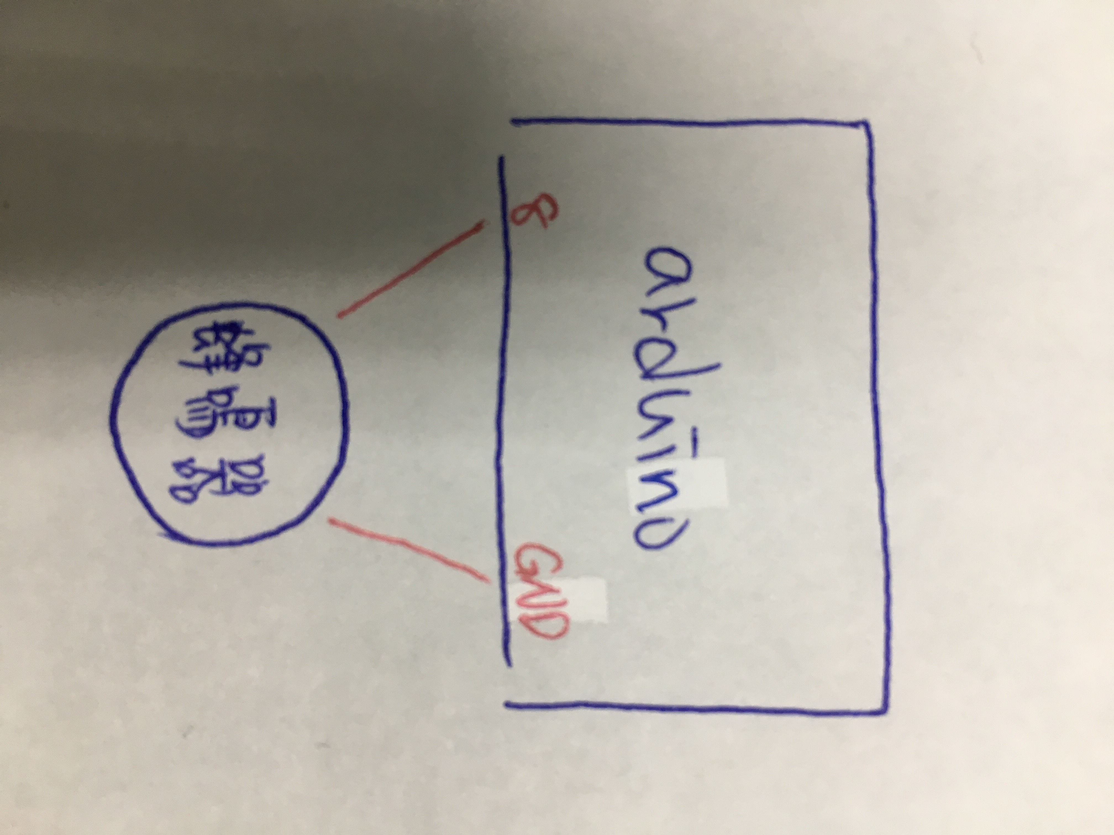
(2)
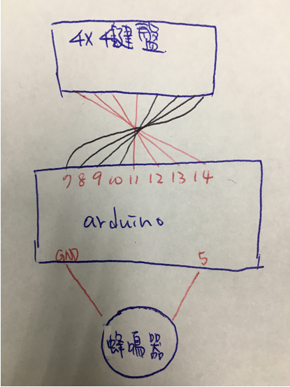
(3)

