**Assignment-based Subjective Questions**

**1.From your analysis of the categorical variables from the dataset, what could you infer about their effect on the dependent variable?**

**Answer:**

In the bike sharing dataset, let's consider the effect of the categorical variable ‘weathersit’ on the target variable ‘cnt’. While performing EDA, I visualized the relationship between the categorical variables and the target variable. During the weather situation 1 (Clear, few clouds, partly cloudy, a high number of bike rentals were made, with the median being 50,000 approximately. Similarly, certain inferences could be made ‘season’ and ‘yr’ as well.

Also, during model building on inclusion of categorical features such as yr,season etc we saw a significant growth in the value of R-squared and adjusted R-squared. This implies that the categorical features were helpful in explaining a greater proportion of variance in the dataset.

**2.Why is it important to use drop_first=True during dummy variable creation?**

**Answer:**

During dummy value creation (dummy encoding) it is advisable to use drop_first=True, otherwise we will get a redundant feature i.e. dummy variables might be correlated because the first column becomes a reference group during dummy encoding. For example, suppose we have a categorical feature ‘is_male’. We use dummy encoding to get two features is_male_0 and is_male_1. After applying, get_dummies we get a table such as this. Notice that we have got a redundant feature, hence requiring only one of them.

**3.Looking at the pair-plot among the numerical variables, which one has the highest correlation with the target variable?**

**Answer:**

The numerical variable ‘registered’ has the highest correlation with the target variable ‘cnt’, if we consider all the features. But after data preparation, when we drop registered due to multicollinearity the numerical variable ‘atemp’ has the highest correlation with the target variable ‘cnt’.

**4. How did you validate the assumptions of Linear Regression after building the model on the training set?**

1. There should be a linear and additive relationship between dependent (response) variable and independent (predictor) variable(s). A linear relationship suggests that a change in response Y due to one-unit change in X¹ is constant, regardless of the value of X¹. An additive relationship suggests that the effect of X¹ on Y is independent of other variables.
2. There should be no correlation between the residual (error) terms. Absence of this phenomenon is known as Autocorrelation.
3. The independent variables should not be correlated. Absence of this phenomenon is known as multicollinearity.
4. The error terms must have constant variance. This phenomenon is known as homoskedasticity. The presence of non-constant variance is referred to heteroskedasticity.
5. The error terms must be normally distributed.

**5. Based on the final model, which are the top 3 features contributing significantly towards explaining the demand of the shared bikes?**

Temperature, Weather Situation 3, Year are the top 3 features contributing significantly towards explaining the demand of the shared bikes. This is because their coefficient values.

**General Subjective Questions**

**1.Explain the linear regression algorithm in detail.**

**Answer:**

Linear Regression is a machine learning algorithm based on supervised learning. It performs a regression task. Regression models a target prediction value based on independent variables. It is mostly used for finding out the relationship between variables and forecasting. Different regression models differ based on – the kind of relationship between dependent and independent variables they are considering and the number of independent variables being used.

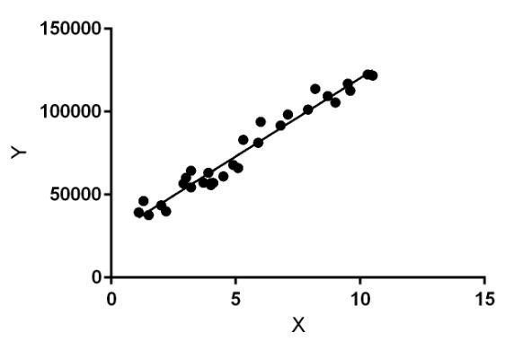

Linear regression performs the task to predict a dependent variable value (y) based on a given independent variable (x). So, this regression technique finds out a linear relationship between x (input) and y(output). Hence, the name is Linear Regression.

In the figure above, X (input) is the work experience and Y (output) is the salary of a person. The regression line is the best fit line for our model.

Attention geek! Strengthen your foundations with the Python Programming Foundation Course and learn the basics.

To begin with, your interview preparations Enhance your Data Structures concepts with the Python DS

Course. And to begin with your Machine Learning Journey, join the Machine Learning - Basic Level Course

Hypothesis function for Linear Regression:

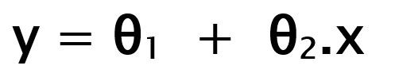

While training the model we are given: x: input training data (univariate – one input variable(parameter)) y: labels to data (supervised learning)

When training the model – it fits the best line to predict the value of y for a given value of x. The model gets the best regression fit line by finding the best θ1 and θ2 values.

θ1: intercept θ2: coefficient of x

Once we find the best θ1 and θ2 values, we get the best fit line. So, when we are finally using our model for prediction, it will predict the value of y for the input value of x.

How to update θ1 and θ2 values to get the best fit line?

Cost Function (J):

By achieving the best-fit regression line, the model aims to predict y value such that the error difference between predicted value and true value is minimum. So, it is very important to update the θ1 and θ2 values, to reach the best value that minimizes the error between predicted y value (pred) and true y value (y).

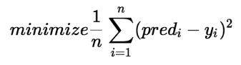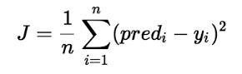

Cost function(J) of Linear Regression is the Root Mean Squared Error (RMSE) between predicted y value (pred) and true y value (y).

Gradient Descent:

To update θ1 and θ2 values in order to reduce Cost function (minimizing RMSE value) and achieve the best fit line the model uses Gradient Descent. The idea is to start with random θ1 and θ2 values and then iteratively update the values, reaching minimum cost.

**2.Explain the Anscombe’s quartet in detail**.

**Answer:**

Anscombe’s quartet comprises four datasets that have nearly identical simple statistical properties, yet appear very different when graphed. Each dataset consists of eleven (x,y) points. They were constructed in 1973 by the statistician Francis Anscombe to demonstrate both the importance of graphing data before analysing it and the effect of outliers on statistical properties.

Simple understanding:

Once Francis John “Frank” Anscombe who was a statistician of great repute found 4 sets of 11 data-points in his dream and requested the council as his last wish to plot those points. Those 4 sets of 11 data-points are given below.

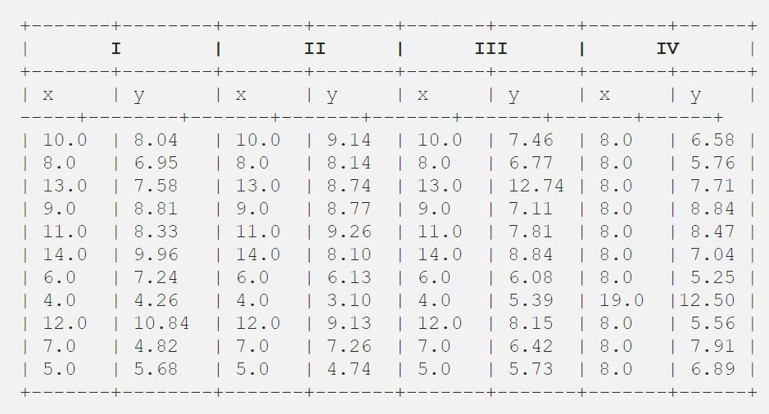

After that, the council analysed them using only descriptive statistics and found the mean, standard deviation, and correlation between x and y.

Code: Python program to find mean, standard deviation, and the correlation between x and y

# Import the required libraries import pandas as pd import statistics from scipy.stats import pearsonr

# Import the csv file df = pd.read_csv("anscombe.csv") # Convert pandas dataframe into pandas series

list1 = df['x1'] list2 = df['y1']

# Calculating mean for x1 print('%.1f' % statistics.mean(list1))

# Calculating standard deviation for x1 print('%.2f' % statistics.stdev(list1))

# Calculating mean for y1 print('%.1f' % statistics.mean(list2))

# Calculating standard deviation for y1 print('%.2f' % statistics.stdev(list2))

# Calculating pearson correlation corr, _ = pearsonr(list1, list2) print('%.3f' % corr)

# Similarly calculate for the other 3 samples

# This code is contributed by Amiya Rout

Output:

9.0

3.32

7.5

2.03

0.816

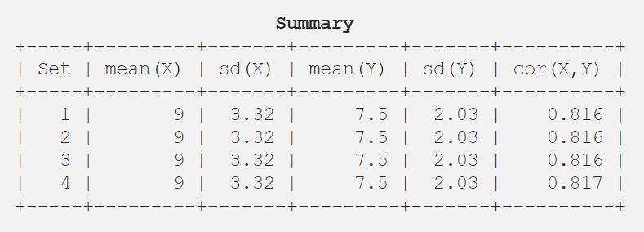

Code: Python program to plot scatter plot

# Import the required libraries

from matplotlib import pyplot as plt import pandas as pd

# Import the csv file df = pd.read_csv("anscombe.csv")

# Convert pandas dataframe into pandas series list1 = df['x1'] list2 = df['y1']

# Function to plot scatter plt.scatter(list1, list2)

# Function to show the plot plt.show()

# Similarly plot scatter plot for other 3 data sets

# This code is contributed by Amiya Rout

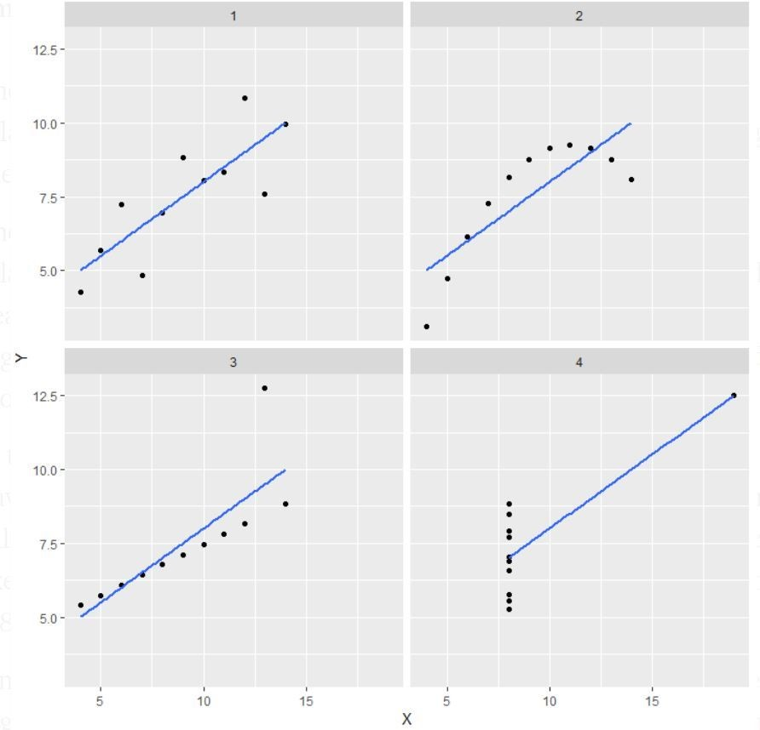

Explanation of this output:

* In the first one (top left) if you look at the scatter plot you will see that there seems to be a linear relationship between x and y.
* In the second one (top right) if you look at this figure you can conclude that there is a non-linear relationship between x and y.
* In the third one (bottom left) you can say when there is a perfect linear relationship for all the data points except one which seems to be an outlier which is indicated to be far away from that line.
* Finally, the fourth one (bottom right) shows an example when one high-leverage point is enough to produce a high correlation coefficient.

Application:

The quartet is still often used to illustrate the importance of looking at a set of data graphically before starting to analyse according to a particular type of relationship, and the inadequacy of basic statistical properties for describing realistic datasets.

**3.What is Pearson’s R?**

**Answer:**

The Pearson's correlation coefficient varies between -1 and +1 where:

r = 1 means the data is perfectly linear with a positive slope (i.e., both variables tend to change in the same direction)

r = -1 means the data is perfectly linear with a negative slope (i.e., both variables tend to change in different directions)

r = 0 means there is no linear association r > 0 < 5 means there is a weak association r > 5 < 8 means there is a moderate association r > 8 means there is a strong association

The figure below shows some data sets and their correlation coefficients. The first data set has an r=0.996, the second has an r = -0.999 and the third has an r= -0.233

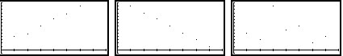

**4.What is scaling? Why is scaling performed? What is the difference between normalized scaling and standardized scaling?**

**Answer:**

**What?**

It is a step of data Pre-Processing which is applied to independent variables to normalize the data within a particular range. It also helps in speeding up the calculations in an algorithm.

**Why?**

Most of the time, the collected data set contains features highly varying in magnitudes, units and range. If scaling is not done then the algorithm only takes magnitude in account and not units hence incorrect modelling. To solve this issue, we have to do scaling to bring all the variables to the same level of magnitude.

It is important to note that scaling just affects the coefficients and none of the other parameters like t-statistic, F-statistic, p-values, R-squared, etc.

**Normalization/Min-Max Scaling:**

* It brings all of the data in the range of 0 and 1. sklearn.preprocessing.MinMaxScaler helps to implement normalization in python.

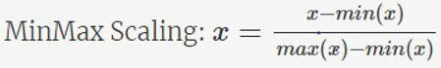

**Standardization Scaling:**

* Standardization replaces the values by their Z scores. It brings all of the data into a standard normal distribution which has mean (μ) zero and standard deviation one (σ).

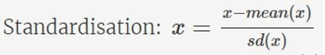

* sklearn.preprocessing.scale helps to implement standardization in python.
* One disadvantage of normalization over standardization is that it loses some information in the data, especially about outliers.

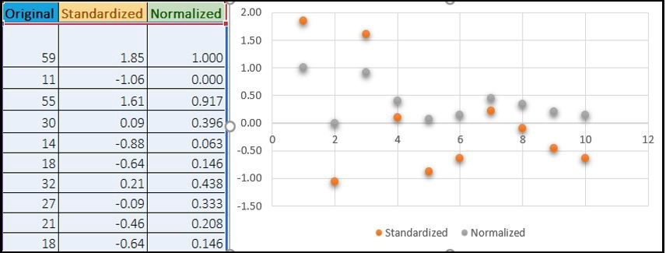

**5.You might have observed that sometimes the value of VIF is infinite. Why does this happen? Answer:**

If there is perfect correlation, then VIF = infinity. This shows a perfect correlation between two independent variables. In the case of perfect correlation, we get R2 =1, which lead to 1/(1-R2) infinity. To solve this problem, we need to drop one of the variables from the dataset which is causing this perfect multicollinearity.

An infinite VIF value indicates that the corresponding variable may be expressed exactly by a linear combination of other variables (which show an infinite VIF as well).

**6.What is a Q-Q plot? Explain the use and importance of a Q-Q plot in linear regression Answer**:

Q-Q Plots (Quantile-Quantile plots) are plots of two quantiles against each other. A quantile is a fraction where certain values fall below that quantile. For example, the median is a quantile where 50% of the data fall below that point and 50% lie above it. The purpose of Q Q plots is to find out if two sets of data come from the same distribution. A 45-degree angle is plotted on the Q Q plot; if the two data sets come from a common distribution, the points will fall on that reference line. A Q Q plot showing the 45-degree reference line:

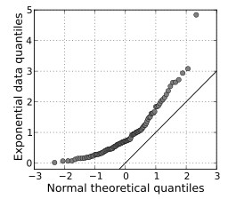

If the two distributions being compared are similar, the points in the Q–Q plot will approximately lie on the line y = x. If the distributions are linearly related, the points in the Q–Q plot will approximately lie on a line, but not necessarily on the line y = x. Q–Q plots can also be used as a graphical means of estimating parameters in a location-scale family of distributions.

A Q–Q plot is used to compare the shapes of distributions, providing a graphical view of how properties such as location, scale, and skewness are similar or different in the two distributions.