Part 1 – Widgetario Welcome

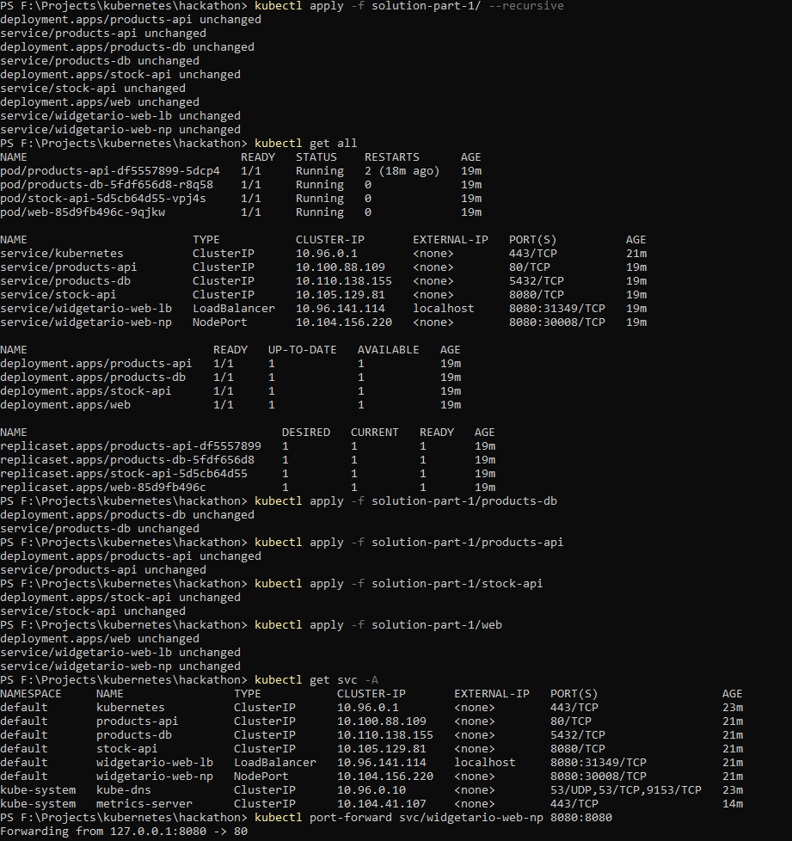

Part 2 – Configuration

Part 3 – Storage

Part 4 – Ingress

Part 6 – Observability

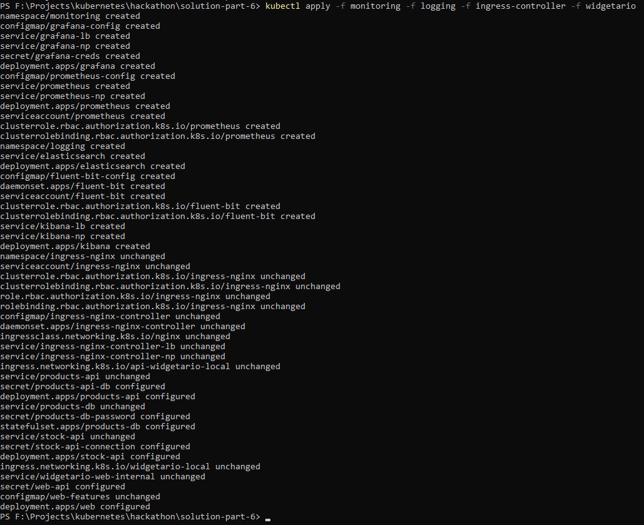

One challenge faced was that the default admin/admin for Grafana was not working. So here’s the solution together with the dashboard images.

Part 7 – CI/CD



