**Fundamental Analysis**

The Great Britain Pound (GBP) has reduced in value ever since the vote for Brexit began in 2016. Many investors have pulled out from the European market as there were many uncertainties regarding the future of the United Kingdom. The vote for Brexit started on 23rd June 2016, as a refugee crisis made migration a subject of political rampage across the entire Europe. Reflected in Figure 1.1 below, each Brexit vote caused a severe decline in the value of GBP. For example, the value of GBP before the Brexit Vote in 23rd June 2016 was recorded at $1.48. The next day on the 24th June 2016, the value of GBP plunged to $1.36. This shows a severe impact that the Brexit negotiations have on the economy.

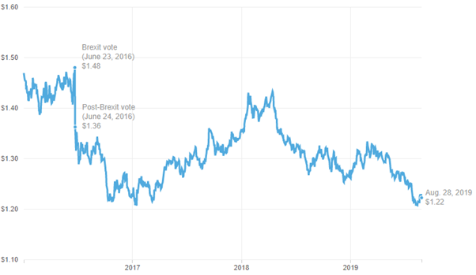

Figure 1.1

Europe is Britain’s most important export market and it is the largest source of foreign investment. The membership of Britain to the European Union has also helped London to lay a strong foundation as a global financial center. With the ongoing discussions of Brexit, the government has projected a rough estimate of 4% - 9% decline in the country’s economy without The United Kingdom. Figure 1.2 below reflects the business confidence index that businesses have towards the European Union. Ever since 2018, tensions regarding Brexit has been increasing at a comensual rate, thereby causing businesses to lose its confidence in the EU market.

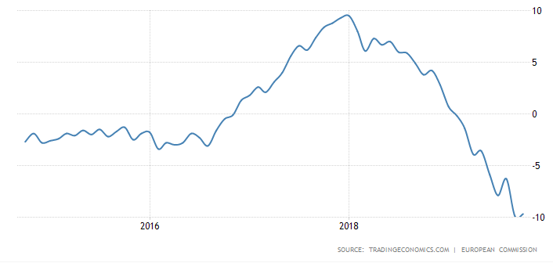

Figure 1.2

In Figure 1.3 below, an extreme plunge in GPB’s value was observed in year 2008 to 2009. This is due to the great recession occurred during year 2008 to year 2013. The recession came after credit crunch that happened in 2007/2008. During this period of time, the credit crunch caused immense problems for a particular bank, the Northern Rock. They had a high percentage of risky loans that curiously also had the highest percentage of loans financed through reselling within the capital market. As the sub-prime crisis reaches its shores, Northern Rock could no longer raise sufficient time within the usual capital market. They had to resort to asking the Bank of England for emergency funds. This caused many of its customers to withdraw their savings from the bank even though their savings weren’t directly affected by the crisis.

After mortgages were deemed as hard to obtain, the demand for houses naturally declined accordingly, causing a fall in house prices and even deemed as a negative equity. The impact of credit crunch period eventually led to a fall in investment count and lower the general consumer spending. The recession also led to a sharp increment of government borrowings. The UK and other countries within the Euro-zone economies took the approach of fiscal austerity - cutting spending or impose higher taxes as a measure to try and reduce levels of government borrowing. Unemployment was also on a rise during the crisis. 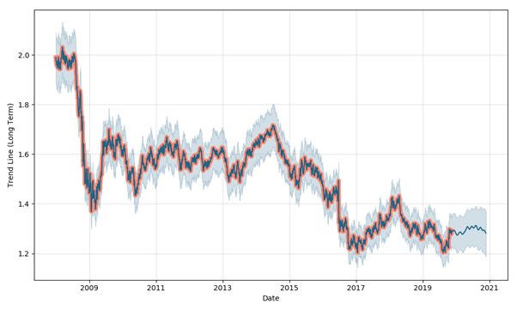

Figure 1.3

**Order 1, 19/11/2019 at 8:30pm**

According to the 4-hour chart as shown in Figure 1.1 below, an upward trending market can be observed between the period of 9th October 2019 to 21st October 2019. This upward trending market caused severe over buying of stocks as shown in Period #1 in Figure 2.1 below. After this period, the market experienced a sideway trend with low volatility in the stocks prices until 9th November 2019. Due to the (oversold) trend seen as per Point #A in Figure 2.1 on the RSI chart, I enter a short trade at market price of 1.2941 with 100,00 standard units at 5% Risk Capital with a stop loss of 23.8 pips which is a maximum of

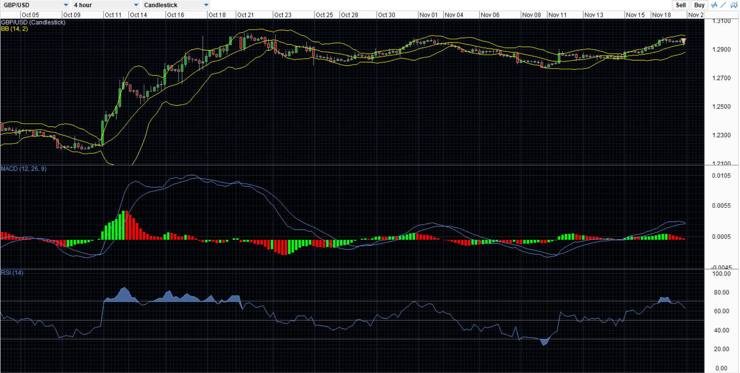

Point #E

Point #A

Point #D

Point #C

Period #1

Figure 2.1

Period #2

Point #B

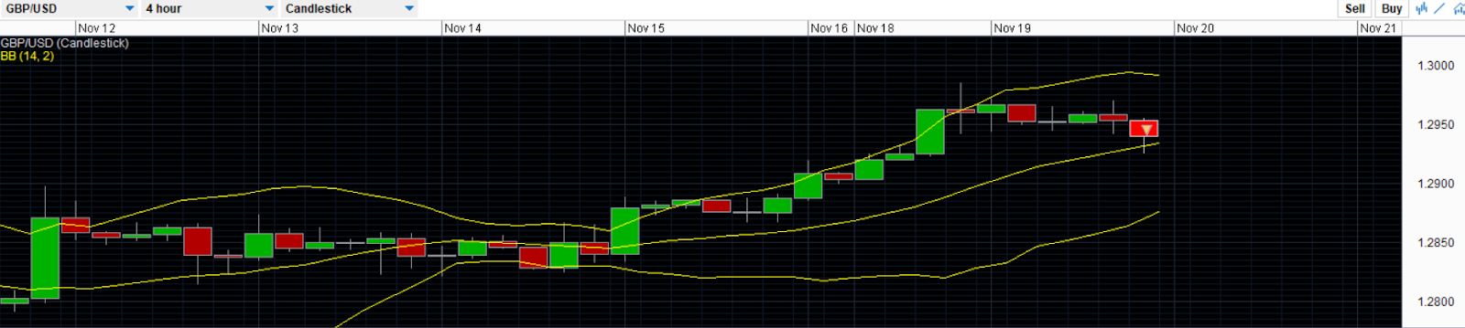

Figure 2.2

Period #3

Patterns Identified:

A Bullish Rectangle Pattern was observed from 9th October 2019 to 19th November 2019

At Period #2 in Figure 2.2 we can see that there was a morning star, the prices drop and a small body candlestick was formed. The candlestick then shows the reversal.

Technical Indicators used:

* (Bollinger Band) At Point #B in Figure 2.2, price action exceeded the edge of the higher band, causing a higher likelihood of a reversal which will come back within the band range. During Period #2 in Figure 2.2, the candlesticks are moving around the dynamic support range of the band indicating that prices will start to reverse. Also, the standard deviation band is increasing in size as compared to 14th November which then shows a higher volatility. At Period #3, we can see the narrowing of the band which will also tell us that the volatility is about to increase drastically which will cause the price to either increase or decrease significantly.
* (RSI) An instrument is deemed to be overbought once the RSI is above the 70 level at Point #C. Once it hit the overbought level, there will then be a reversal in the market resulting in a drop-in value which is shown at Point #D. It could potentially mean that the stocks could be getting overvalued and is a good candidate for a pull back or a reversal.
* (MACD) At Point #E, the MACD line and signal are about to crossover which shows the increase in trend has completed is about to reverse to the downtrend run. Thus, I predicted there will then be a drop-in market prices

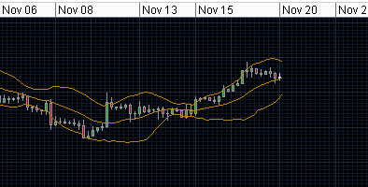

Figure 2.3

After almost 3hrs of entering the trade, I checked back and found out that the order closed due to a stop loss limit that I have set of 1.29500. In Figure 2.3, we can see a Bullish trend instead of Bearish trend of what I predicted. This then triggered the stop loss limit causing the order to be closed. By setting a stop loss limit, this then reduce the amount of money that was lost due to wrong analysis that was made. When I close the order, I have a lost a total of $9 from the trade.

**Order 2, 20/11/19, 7:00pm**

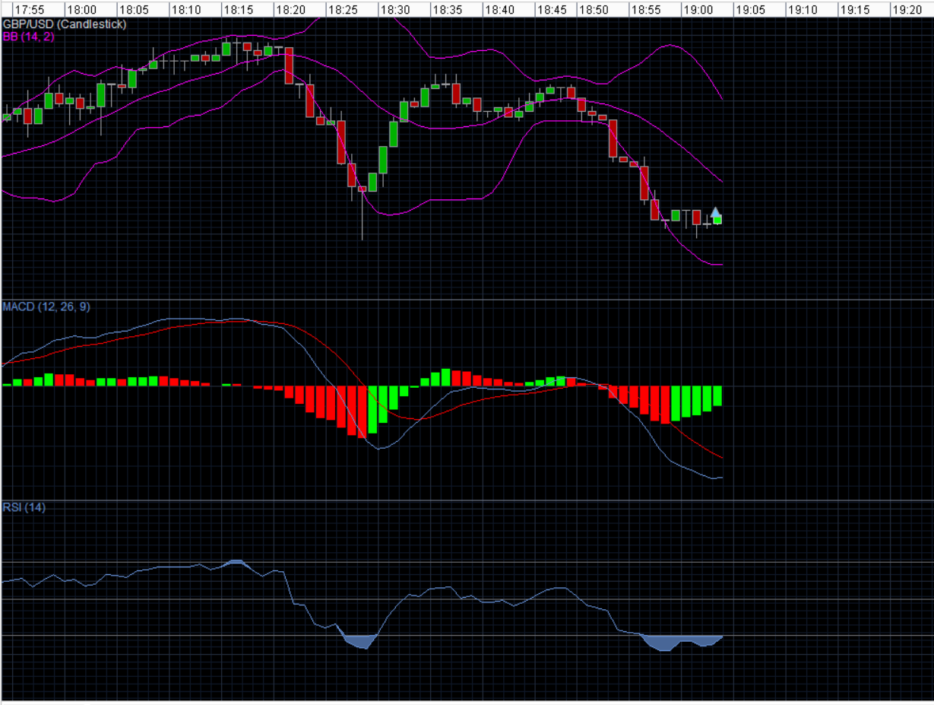After doing a 4-hr trade, I decided to do a 1-minute to see the difference and find out how much more volatile is it. I decided to place a long market order at 1.2902 of 100,000 units. I place a capital order of 5% Risk Capital with a stop-loss of $5,000.

Point #F

Period #1

Figure 3.1

Patterns Identified:

The first pattern that was identified was Morning Star. Before Point #F in Figure 3.2, the candles were showing a bearish candle which was part of a recent downtrend. Point #F in Figure 3.2 shows a small body indicating that there could either be bullish or bearish. Point #E in Figure 3.2 will then confirm the direction that the trend would be going towards.

The second pattern that was identified was Evening Star. At Point #D in Figure 3.2 then shows another small body indicating that there could be either be a bearish or bullish trend and at point #A then shows that the confirmation of the reversal.

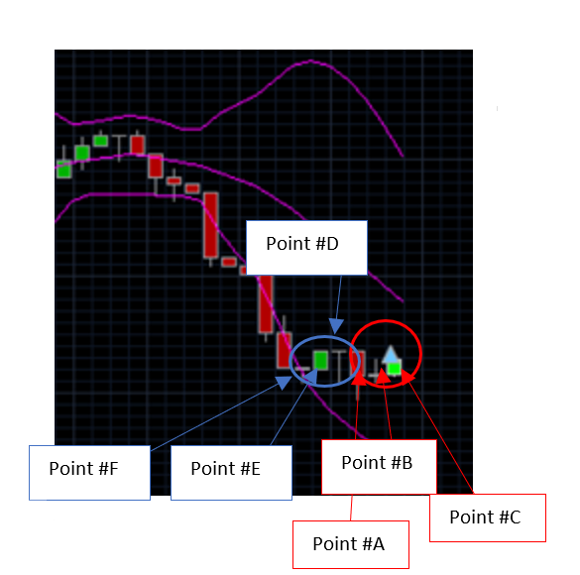

Figure 3.2

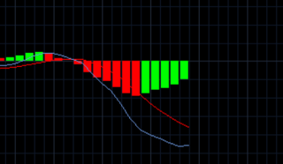

Figure 3.3

Technical Indication :

* ( Candlestick) After looking at the trend, I analyse and found a morning star trend. After realising that at Point #C in Figure 3.2 show the Bullish candlestick. We can see that the difference between the upper band and lower band are the largest at this point shows how volatile the trade is. At Period #1 in Figure 3.1, we can see that there is a narrow in the band which will result in a sharp increase in the volatility.
* (MACD) In the MACD line we can see that the signal line and the MACD line is about to cross each other in Figure 3.3 which will show a reversal in the market. The histogram also shows an increase in the trend which shows that there will be an upward trend which shows that it will be making a recovery soon.
* (RSI) The RSI line shows that the market shares was oversold at Point #I in Figure 3.1 and it shows that there will be an increase in the trend thus more investors are starting to buy the shares as the prices are now low. With many investors starting to buy the shares, the trend will reverse and will be an upward trend.

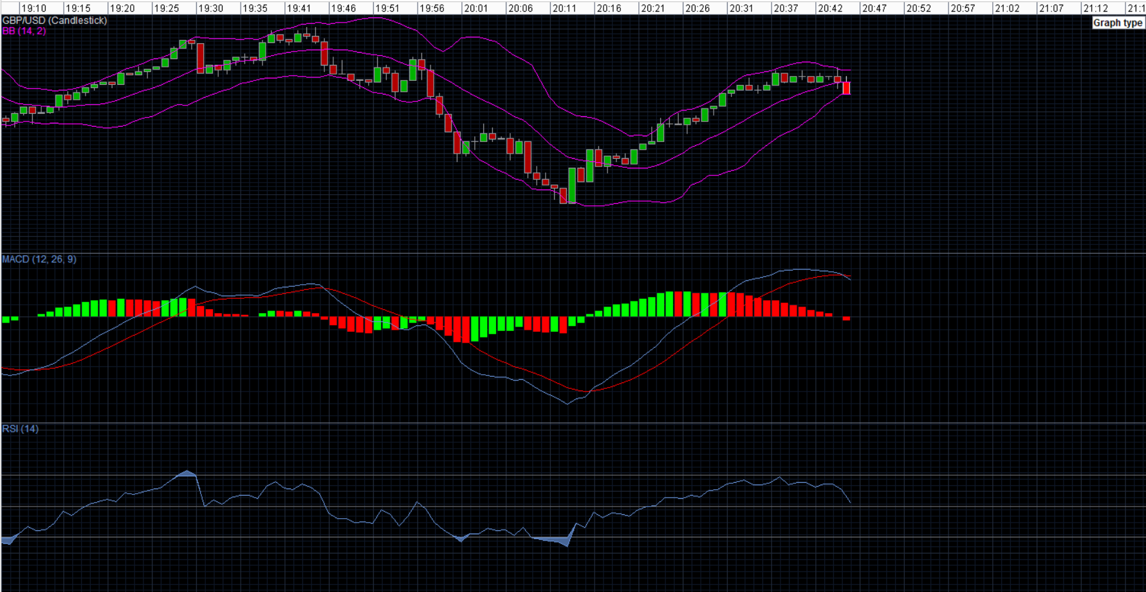I closed my trade at 8:44pm on 20th November 2019. At Point #G, we can see that the Bollinger band has narrowed significantly which shows that the volatility is about to increase drastically. However by looking at the MACD, we can tell from the trend of the histogram that the prices are starting to drop below the neutral line and the MACD line and Signal line has crossed as shown in Point #H. This shows the reversal in prices and it will then start to drop. The prices would not be able to increase as the MACD line has hit the peak. Not only that, by looking at the RSI, we can see that it is starting to increase and the shares were almost overbought, by comparing it with the MACD line, we can see that there will soon be a drop in price thus many people started to sell their shares. As the price was high and there will soon be a reversal, I decided to close my order and I made $17 from this order.

Point #H

Point #G

**Overall Profit/Loss**

$100,000.00 – S9.00 + $17.00 = $100,008.00

Overall, I made a profit of 0.008%.

**Summary**

In my first trade, I did a sell order as I was expecting a bearish downtrend due to the high prices. The Bollinger Band shows us that there is a big gap between the upper band and lower band which shows there is an increase in volatility rate. By analysing the MACD line we could see the MACD line and Signal line, we could see that the lines just crossed and there was a downtrend. The RSI Line shows the market price was overbought and that many would start to sell the shares. However instead of a bearish downtrend that was predicted, I observed a bullish uptrend instead. Thus for my second trade, I decided to do a shorter trade to be able to have a macro view of the currency before I decided to do a long or short order.