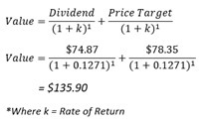CVS Health stands for Consumer Value Stores Health provides products and services that caters to their consumers health. CVS currently have 6200 stores in 43 states and they have a revenue of $194.58 billion annually. They specialise in providing high quality private testing and treatment for a wide range of cardiovascular conditions.

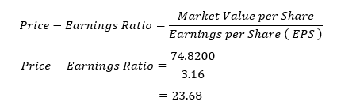Dividend discount model (DDM) is a methodology used to value a company based on the theory that a stock (common of preferred) is worth the discounted sum of all its future dividend payments. This model helps to evaluate stocks relative to the net present value of future dividends. Dividends serve as a measure of cash flows returned to the shareholder upon successful investments. The theory suggests that the value of a stock equates to the worth of all future cash flows expected to be generated by the firm, discounted by the appropriate risk-adjusted rate.

P/E Ratio (Price-Earnings Ratio) is a ratio of company’s current share price compared to its per-share earnings. Using P/E Ratio, we can find out the company growth rates and use the trends to analyse the trade allowing investors to find out when a stock is overpriced. By comparing the Ratio Market Average against CSV Health P/E ratio and their company growth rates, we are able to find out if a P/E ratio is low or high.

Currently, the Price-Earning Ratio for CSV Health is at 23.68 while the industry average is 24.05. We can see in the later part of 2018 that CSV Health is financially in trouble as they have had the highest profit in the previous months before they had a drastic increase in the profit. While comparing the growth rate of CSV Health and their industry average, CSV Health do not have a low P/E Ratio and are financially stable.

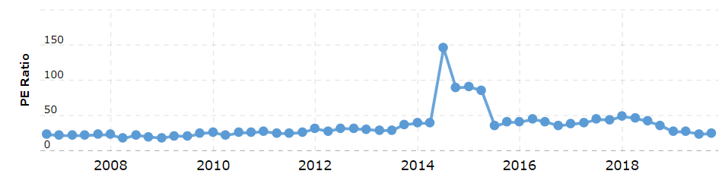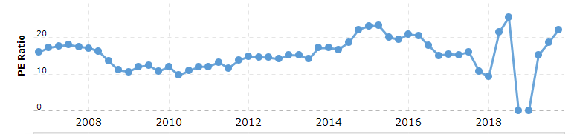 P/E Ratio for CVS Health

P/E Ratio for CVS Health

<https://www.macrotrends.net/stocks/charts/HCSG/healthcare-services/pe-ratio>