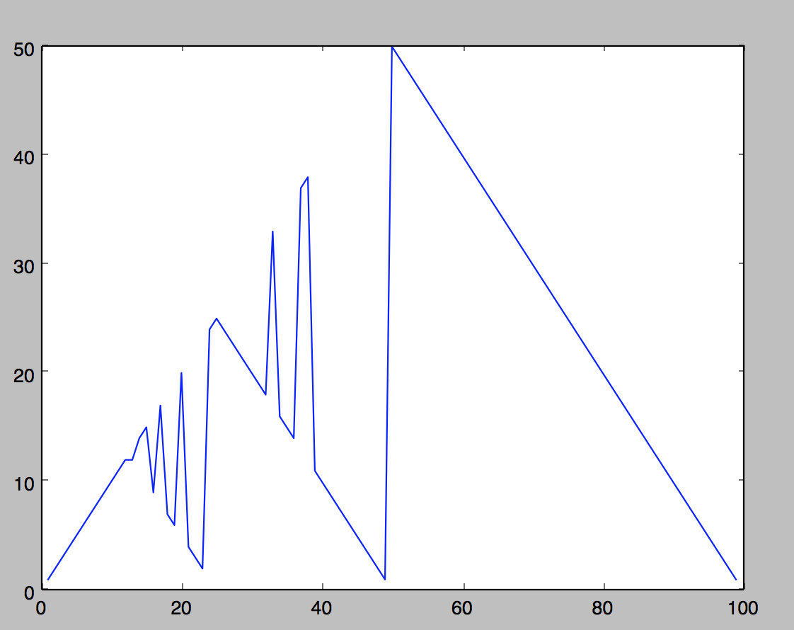

Final policy w.r.t capital for p = 0.2

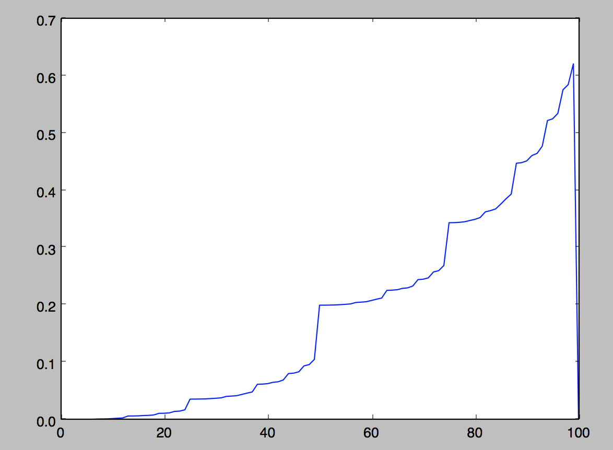 Value estimate w.r.t capital for p = 0.2 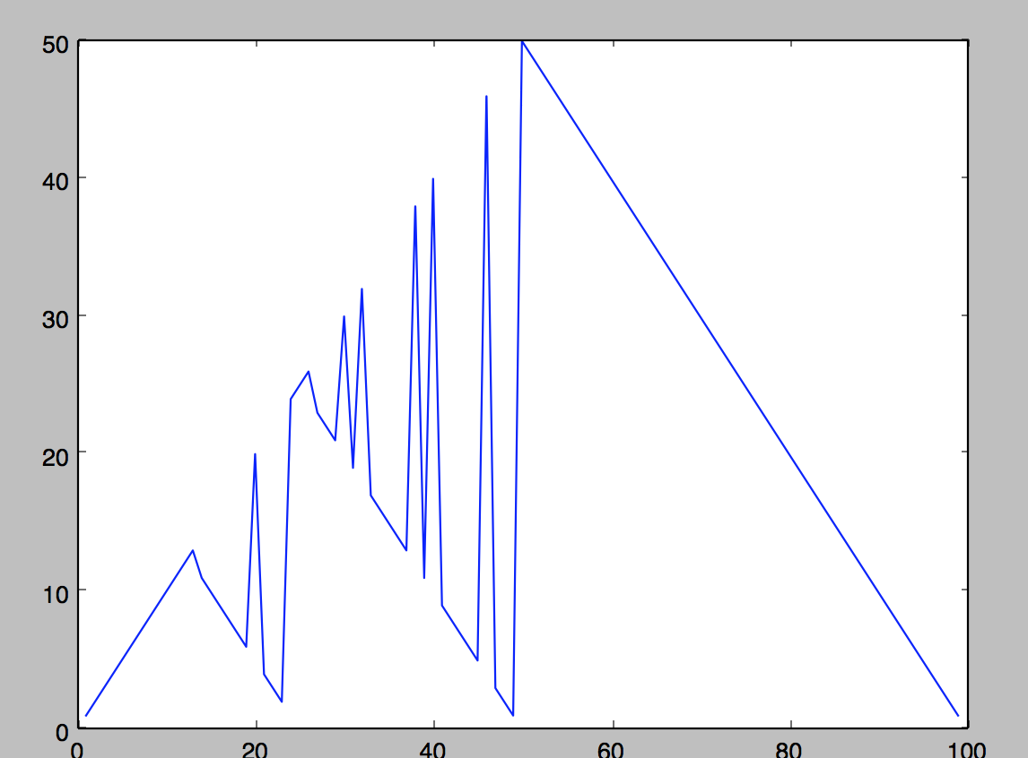 Final policy w.r.t capital for p = 0.4

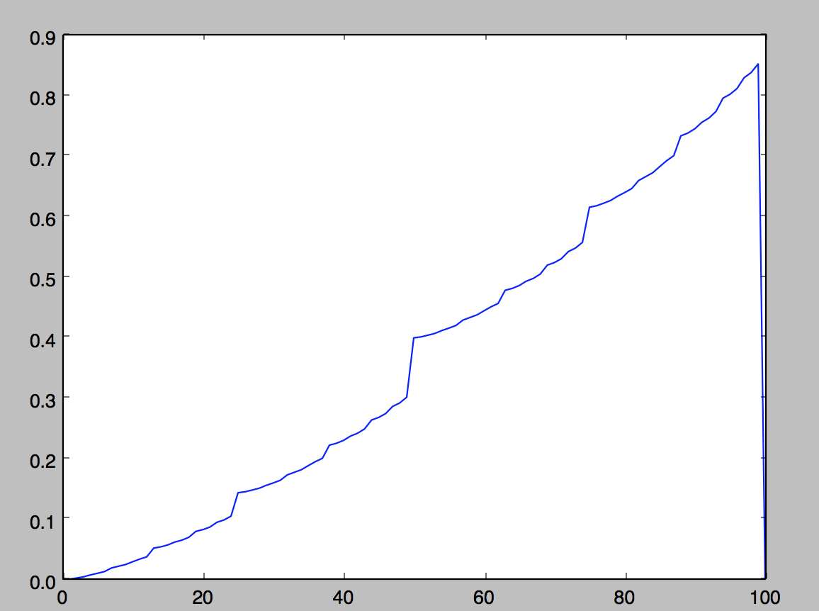 Value estimate w.r.t capital for p = 0.4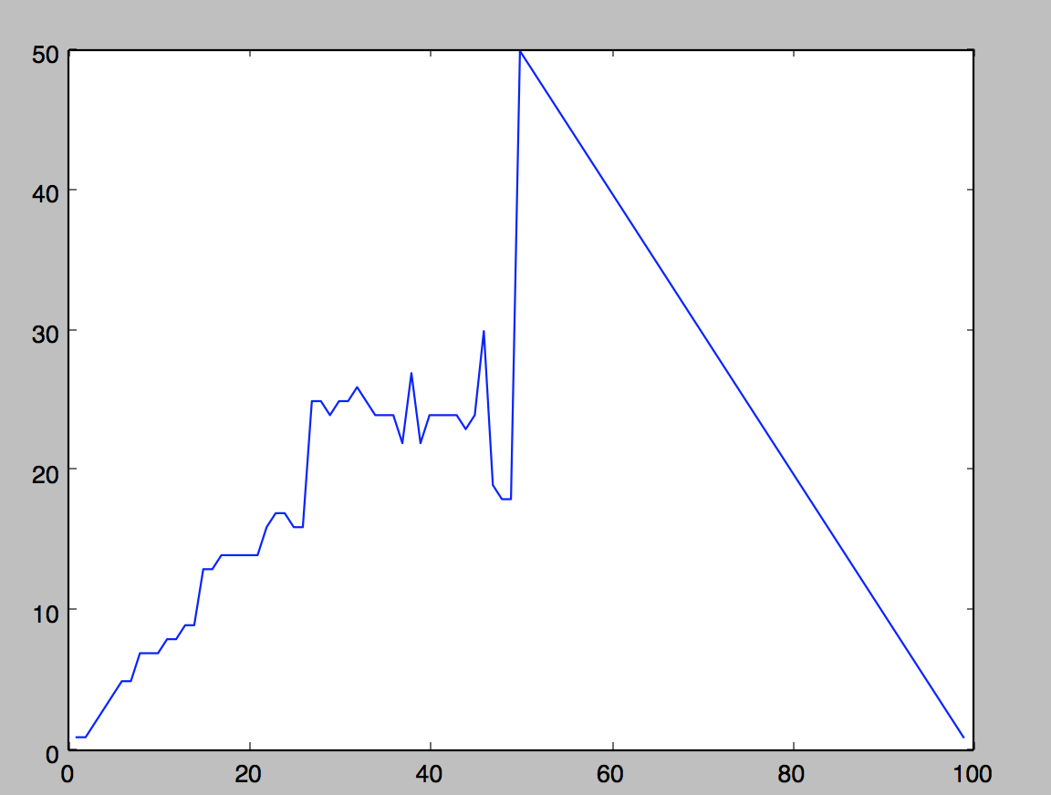 Final policy w.r.t capital for p = 0.55

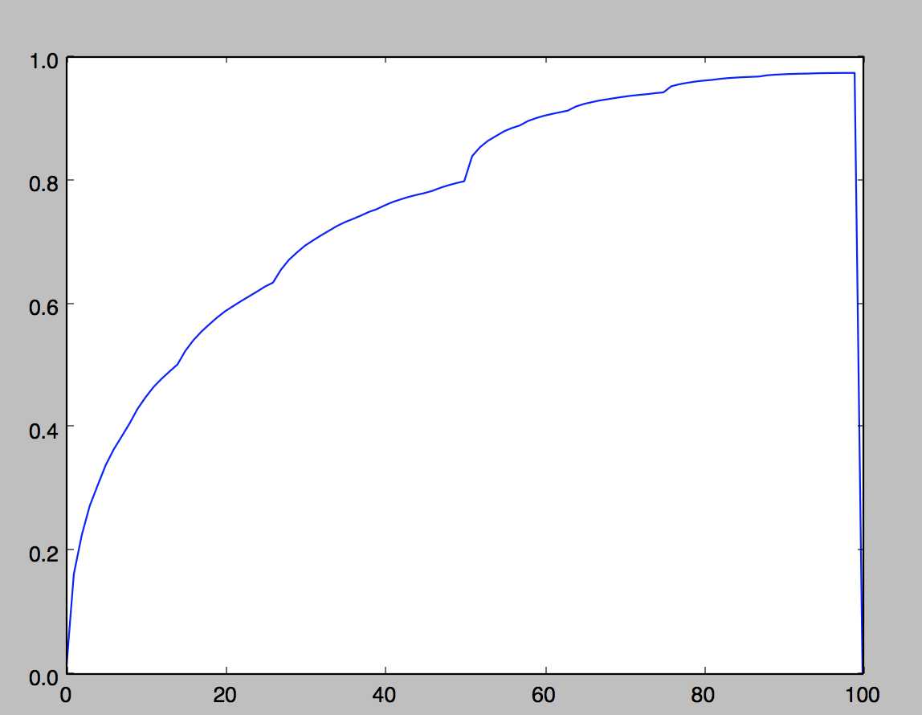 Value estimate w.r.t capital for p = 0.55 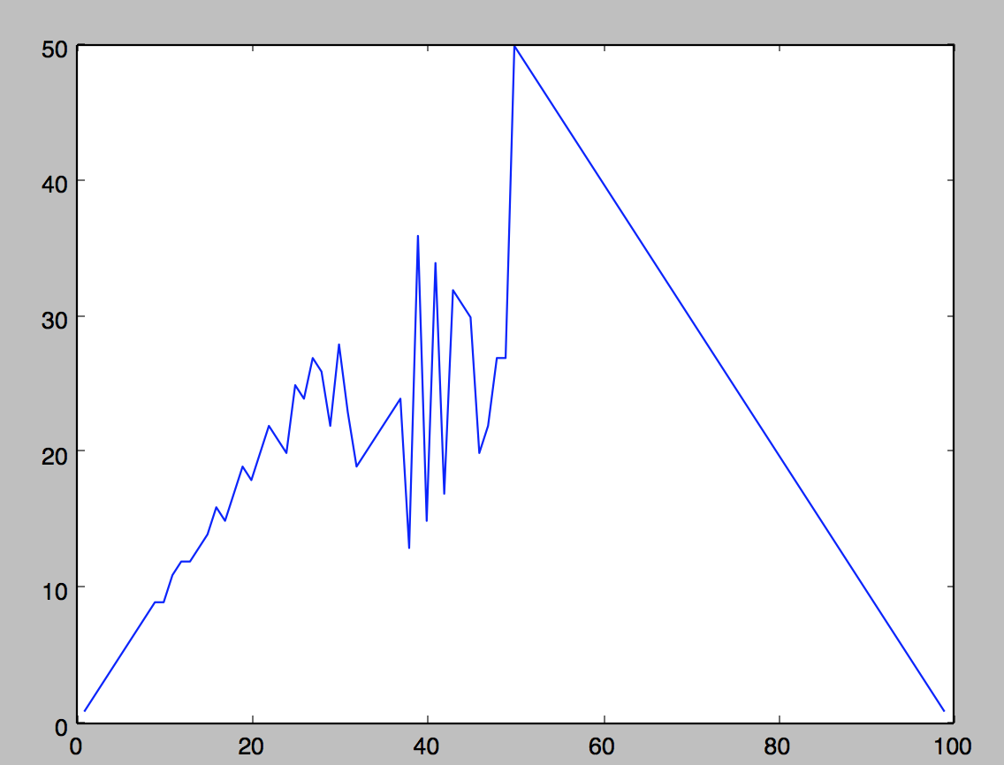 Final policy w.r.t capital for p = 0.8

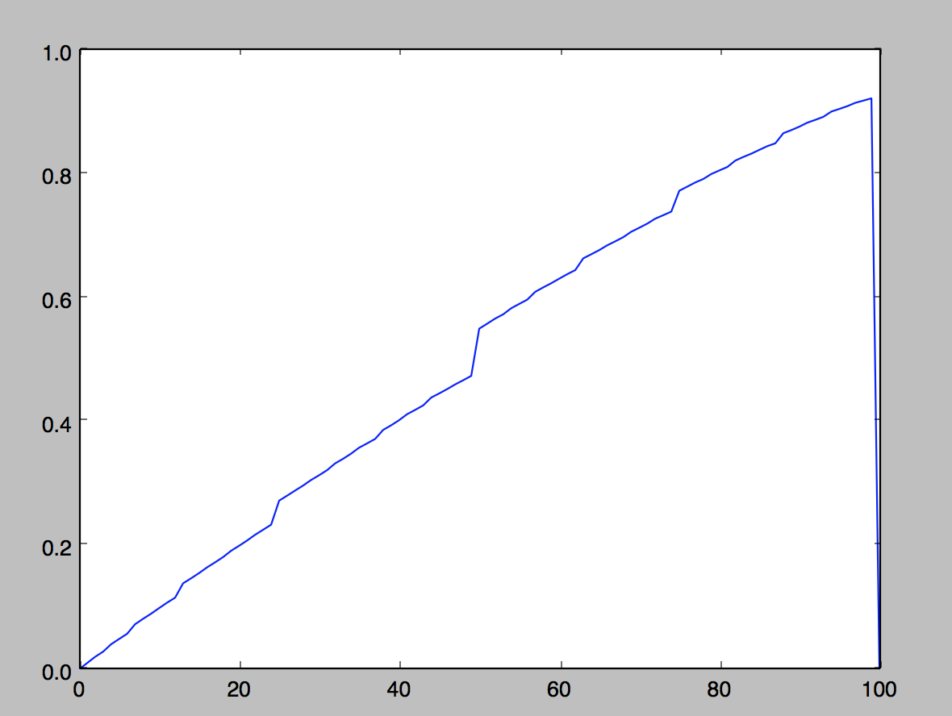 Value estimate w.r.t capital for p = 0.8