HUNTINGTON BANKS

7 EASTON OVAL
COLUMBUS, OHIO 43219
ACH FILE SPECIFICATIONS
CORPORATE TRADE EXCHANGE
(CTX)

These specifications comply with the National Automated Clearing House Association Rules and Regulations.
Arrangements for testing must be made with your Financial Services Representative. If changes are made in the creation of your company’s file, the new format must be tested.
* Regulation E, issued by the Board of Governors of the Federal Reserve System, requires the Receiving Depository Financial Institution to provide this information to their customer.
** The National Automated Clearing House Association recommends that the Receiving Depository Financial Institution provide this information to its customers.
# Field must be right justified and zero filled.
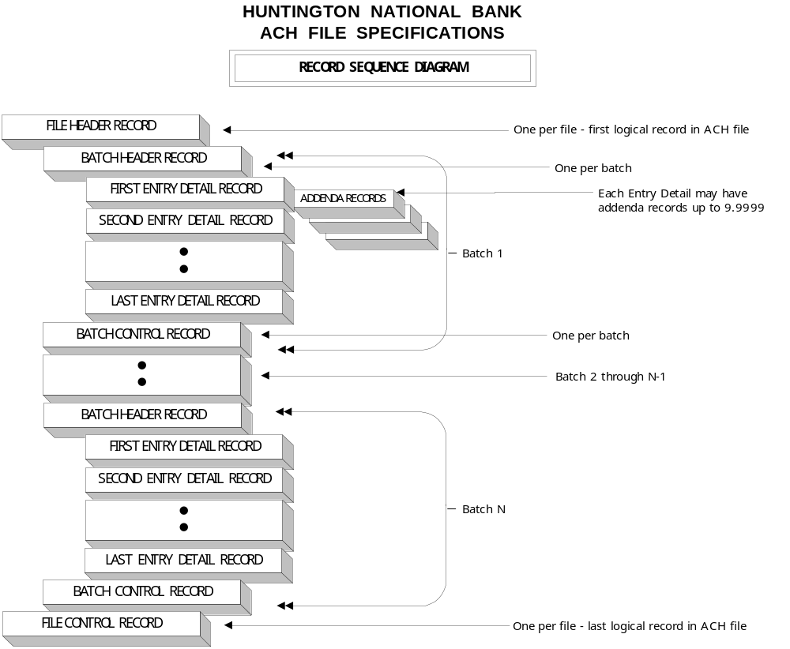
HUNTINGTON NATIONAL BANK
ACH FILE SPECIFICATIONS
FILE HEADER RECORD
 | FIELD | POSITIONS | SIZE | FIELD NAME | CONTENTS OF FIELD
 | 1 | 1 | 1 | RECORD TYPE CODE | “1"
 | 2 | 2-3 | 2 | PRIORITY CODE | “01"
 | 3 | 4-13 | 10 | IMMEDIATE DESTINATION | “ 044000024" (Note: first position is blank)
 | 4 | 14-23 | 10 | IMMEDIATE ORIGIN | First position is blank; followed by the originating company or service bureau IRS Employer Identification Number (EIN) or Data Universal Numbering System number (DUNS)
 | 5 | 24-29 | 6 | TRANSMISSION OR CREATION DATE | Transmission or creation date in YYMMDD format
 | 6 | 30-33 | 4 | TRANSMISSION OR CREATION TIME | Transmission or creation time in HHMM format
 | 7 | 34 | 1 | FILE ID MODIFIER | “A” or “1" (if multiple files use B,C,...Z or 2,3,...9)
 | 8 | 35-37 | 3 | RECORD SIZE | “094"
 | 9 | 38-39 | 2 | BLOCKING FACTOR | “10"
 | 10 | 40 | 1 | FORMAT CODE | “1"
 | 11 | 41-63 | 23 | DESTINATION NAME | “HUNTINGTON NATIONAL BKS”
 | 12 | 64-86 | 23 | ORIGIN NAME | Origin name (i.e., originating company name or service bureau name)
 | 13 | 87-94 | 8 | REFERENCE CODE | Optional

* Regulation E requires this information be provided to the customer.
** National Automated Clearing House Association recommends this information be provided to the customer.
# Field is right justified and zero filled.

HUNTINGTON NATIONAL BANK
ACH FILE SPECIFICATIONS
BATCH HEADER RECORD
 | FIELD | POSITIONS | SIZE | FIELD NAME | CONTENTS OF FIELD
 | 1 | 1 | 1 | RECORD TYPE CODE | “5"
 | 2 | 2-4 | 3 | SERVICE CLASS CODE | “200"
 | 3 | 5-20 | 16 | COMPANY NAME | Company name
 | 4 | 21-40 | 20 | COMPANY DISCRETIONARY DATA | Sending company’s bank account number may be placed in this field.
 | 5 | 41-50 | 10 | COMPANY IDENTIFICATION | Identification Code Designator and corresponding Identification Number  “1" and IRS Employer Identification Number (EIN),  “3" and Data Universal Numbering System Number (DUNS),  “9" and a user assigned number.
 | 6 | 51-53 | 3 | STANDARD ENTRY CLASS | “CTX”
 | 7 | 54-63 | 10 | COMPANY ENTRY DESCRIPTION | Description of items (i.e., TRADE PAY)
 | 8 | 64--69 | 6 | COMPANY DESCRIPTIVE DATE | Date that company initiated the transfer - YYMMDD
 | 9 | 70-75 | 6 | COMPANY EFFECTIVE DATE | Date the items are due to post - YYMMDD
 | 10 | 76-78 | 3 | SETTLEMENT DATE | Julian date or zeros
 | 11 | 79 | 1 | ORIGINATOR STATUS CODE | “1”
 | 12 | 80-87 | 8 | ORIGINATING DFI IDENTIFICATION | “04400002"
# | 13 | 88-94 | 7 | BATCH NUMBER | Batch number

* Regulation E requires this information be provided to the customer.
** National Automated Clearing House Association recommends this information be provided to the customer.
# Field is right justified and zero filled.

HUNTINGTON NATIONAL BANK
ACH FILE SPECIFICATIONS
ENTRY DETAIL RECORD
 | FIELD | POSITIONS | SIZE | FIELD NAME | CONTENTS OF FIELD
 | 1 | 1 | 1 | RECORD TYPE CODE | "6"
 | 2 | 2-3 | 2 | TRANSACTION CODE | “22" - credit to Demand Deposit (checking); prenote is “23"  “27" - debit to Demand Deposit (checking); prenote is “28"  “32" - credit to Savings; prenote is “33"  “37" - debit to Savings; prenote is “38"
 | 3 | 4-12 | 9 | ROUTING TRANSIT NUMBER | Routing transit (RT) number of the Receiving Depository Financial Institution (RDFI)
 | 4 | 13-29 | 17 | ACCOUNT NUMBER | Individual’s account number at the Receiving Depository Financial Institution
# | 5 | 30-39 | 10 | AMOUNT | Dollar amount of entry
 | 6 | 40-54 | 15 | IDENTIFICATION NUMBER | Originator may insert its own number for tracing purposes
 | 7 | 55-58 | 4 | NUMBER OF ADDENDA RECORDS | Total number of addenda records associated with this Entry Detail Record
 | 8 | 59-74 | 16 | RECEIVING COMPANY NAME/ID NUMBER | Identifies the Receiving Company and may contain the name or an identifying number for that Company
 | 9 | 75-76 | 2 | RESERVED | Blanks
 | 10 | 77-78 | 2 | DISCRETIONARY DATA | May be used to designate code(s) significant to the originating institution and/or company
 | 11 | 79 | 1 | ADDENDA RECORD INDICATOR | “0” if no addenda record follows  “1” if addenda record follows
 | 12 | 80-94 | 15 | TRACE NUMBER | Positions 80-87 – “04400002”  Positions 88-94 – numbered sequentially beginning with “0000001”

* Regulation E requires this information be provided to the customer.
** National Automated Clearing House Association recommends this information be provided to the customer.
# Field is right justified and zero filled.

HUNTINGTON NATIONAL BANK
ACH FILE SPECIFICATIONS
ADDENDA RECORD
 | FIELD | POSITIONS | SIZE | FIELD NAME | CONTENTS OF FIELD
 | 1 | 1 | 1 | RECORD TYPE CODE | “7"
 | 2 | 2-3 | 2 | ADDENDA TYPE CODE | “05"
 | 3 | 4-83 | 80 | PAYMENT RELATED INFORMATION | Contains payment related ANSI ASC X12 data segments or NACHA endorsed banking conventions
# | 4 | 84-87 | 4 | ADDENDA SEQUENCE NUMBER | Numbered sequentially beginning with “0001"
# | 5 | 88-94 | 7 | ENTRY DETAIL SEQUENCE NUMBER | Contains the last 7 digits of the associated Entry Detail Record

* Regulation E requires this information be provided to the customer.
** National Automated Clearing House Association recommends this information be provided to the customer.
# Field is right justified and zero filled.

HUNTINGTON NATIONAL BANK
ACH FILE SPECIFICATIONS
BATCH CONTROL RECORD
 | FIELD | POSITIONS | SIZE | FIELD NAME | CONTENTS OF FIELD
 | 1 | 1 | 1 | RECORD TYPE CODE | “8"
 | 2 | 2-4 | 3 | SERVICE CLASS CODE | “200"
# | 3 | 5-10 | 6 | ENTRY/ADDENDA COUNT | Number of Entry Detail and Addenda records in the batch
# | 4 | 11-20 | 10 | ENTRY HASH | First eight digits of the RDFI routing transit numbers (on the Entry Detail records) are accumulated for the batch (overflow is ignored)
# | 5 | 21-32 | 12 | TOTAL DEBIT ENTRY DOLLAR AMOUNT | Accumulated amount of the debit Entry Detail records in the batch
# | 6 | 33-44 | 12 | TOTAL CREDIT ENTRY DOLLAR AMOUNT | Accumulated amount of the credit Entry Detail records in the batch
 | 7 | 45-54 | 10 | COMPANY IDENTIFICATION | Identical to field 5 of the Batch Header Record
 | 8 | 55-73 | 19 | MESSAGE AUTHENTICATION CODE  (not currently in use, replace with blanks) | Eight character code derived from special key used in conjunction with the DES algorithm
 | 9 | 74-79 | 6 | RESERVED | Blanks
 | 10 | 80-87 | 8 | ORIGINATING DFI IDENTIFICATION | “04400002"
# | 11 | 88-94 | 7 | BATCH NUMBER | Batch number identical to field 13 of the Batch Header Record

* Regulation E requires this information be provided to the customer.
** National Automated Clearing House Association recommends this information be provided to the customer.
# Field is right justified and zero filled.

HUNTINGTON NATIONAL BANK
ACH FILE SPECIFICATIONS
FILE CONTROL RECORD
 | FIELD | POSITIONS | SIZE | FIELD NAME | CONTENTS OF FIELD
 | 1 | 1 | 1 | RECORD TYPE CODE | “9"
# | 2 | 2-7 | 6 | BATCH COUNT | Number of batches in the file
# | 3 | 8-13 | 6 | BLOCK COUNT | Number of physical blocks in the file
# | 4 | 14-21 | 8 | ENTRY/ADDENDA COUNT | Number of Entry Detail and Addenda records in the file
# | 5 | 22-31 | 10 | ENTRY HASH | First eight digits of the RDFI routing transit numbers (on the Entry Detail records) are accumulated for the file (overflow is ignored)
# | 6 | 32-43 | 12 | TOTAL DEBIT ENTRY DOLLAR AMOUNT | Accumulated amount of the debit Entry Detail records in the file
# | 7 | 44-55 | 12 | TOTAL CREDIT ENTRY DOLLAR AMOUNT | Accumulated amount of the credit Entry Detail records in the file
 | 8 | 56-94 | 39 | RESERVED | Blanks

* Regulation E requires this information be provided to the customer.
** National Automated Clearing House Association recommends this information be provided to the customer.
# Field is right justified and zero filled.

