**ACH Validation**

1. Search for Settlement Work Area
2. Click on the Settlement run which you are validating

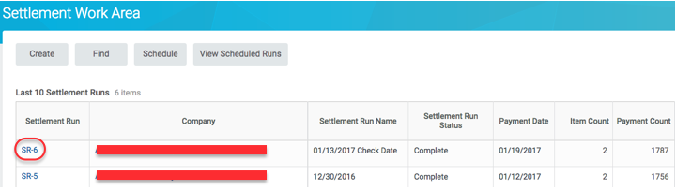

1. Click on the Payment Message ID for the Direct Deposit row

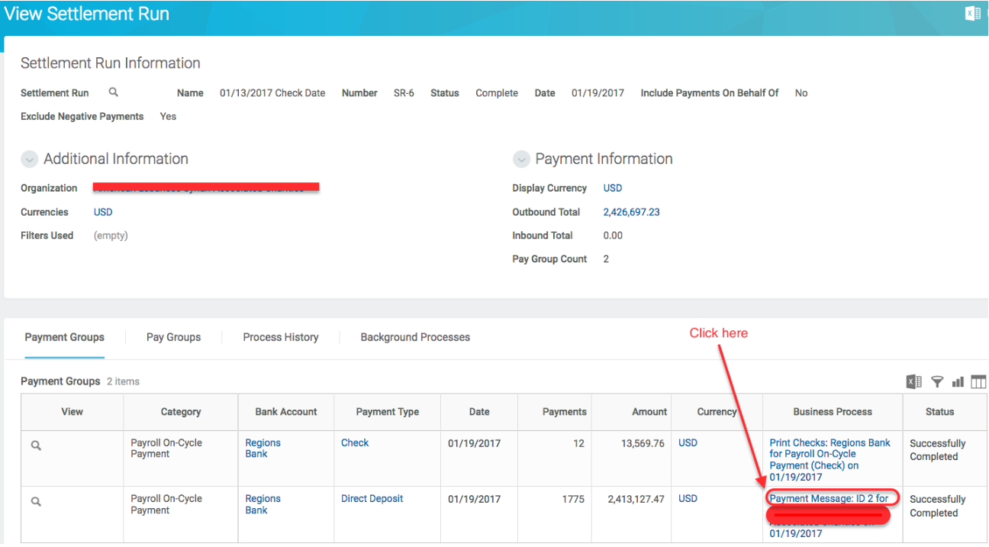

1. Access the file at the bottom of the page

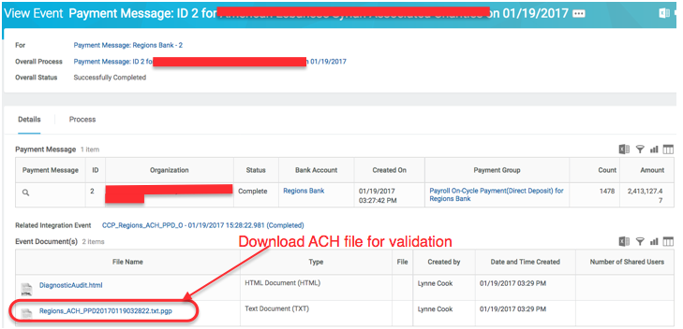

1. Total Debits and Credits in the file can be found on records 8 and 9 as follows:
   1. Record 8:
      1. Total Debit (decimal implied) – Position 21-32
      2. Total Credit (decimal implied) – Position 33-44
   2. Record 9:
      1. Total Debit (decimal implied) – Position 32-43
      2. Total Credit (decimal implied) – Position 44-55