ACH process

1. Determine the Payment Message ID for the payroll or on-demand ach payment
2. Type “Settlement Run” or “set run” in search bar, then select Find Settlement Runs

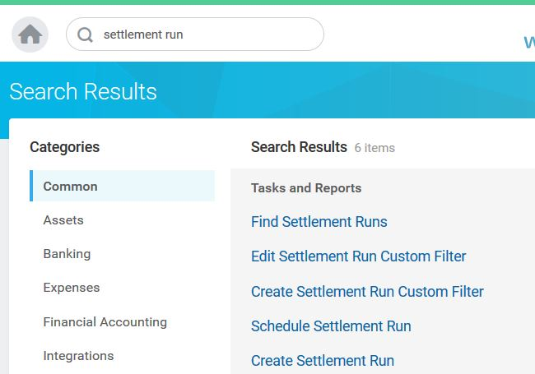

1. Enter the Start and/or End date(s) of the settlement run you are looking for or simply click on “OK” for all settlement runs.

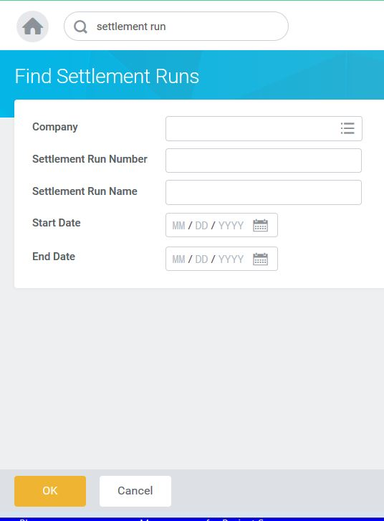

1. Locate the settlement you want to send, then click on the search icon to the left

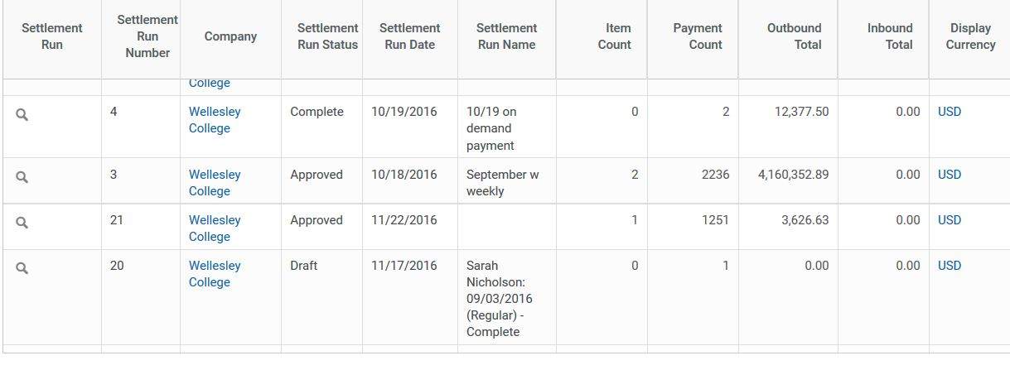

5. Look for the Payment Message ID in the business process column.

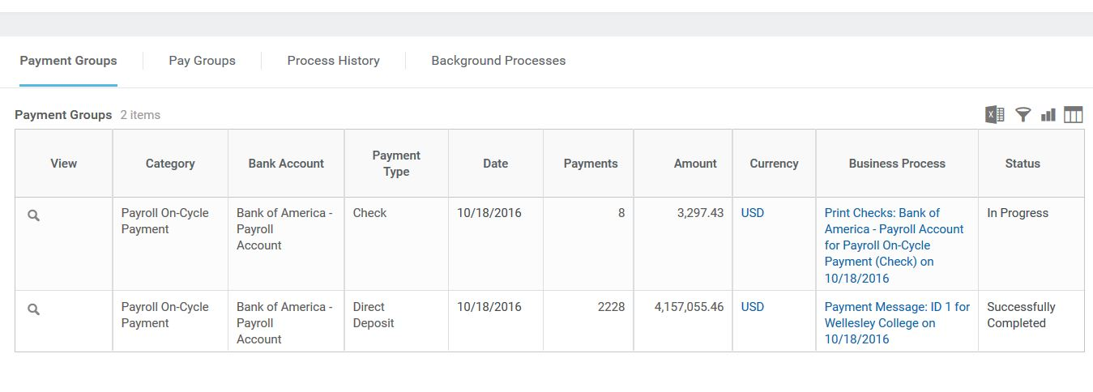

6. Go back to the main search bar and enter ‘intsys:ach” (for integration system: ach)

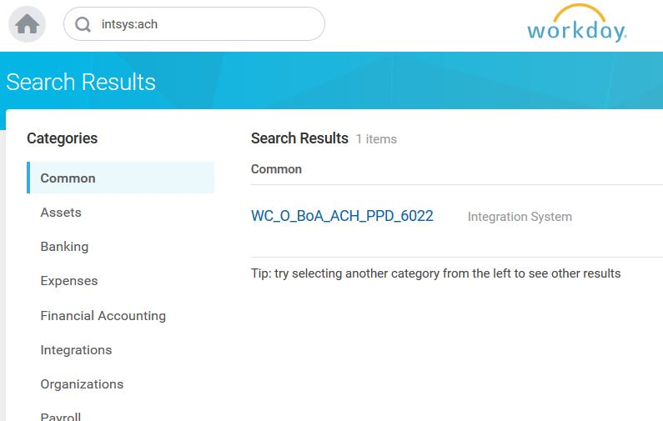

7. Click on the related actions icon beside the process, then click on integration and then launch/schedule

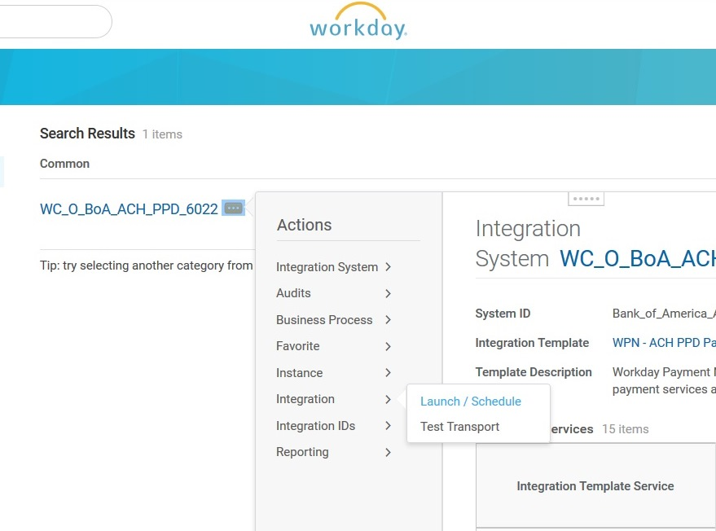

8. Click OK to “Run Now”

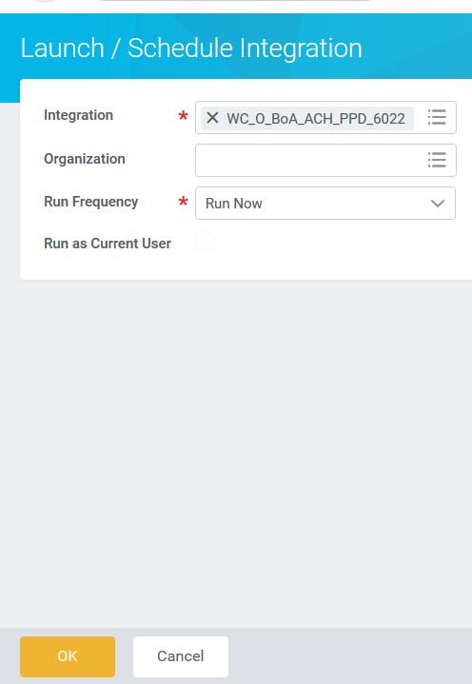

9. Enter the value for Payement Message ID then click on “OK”

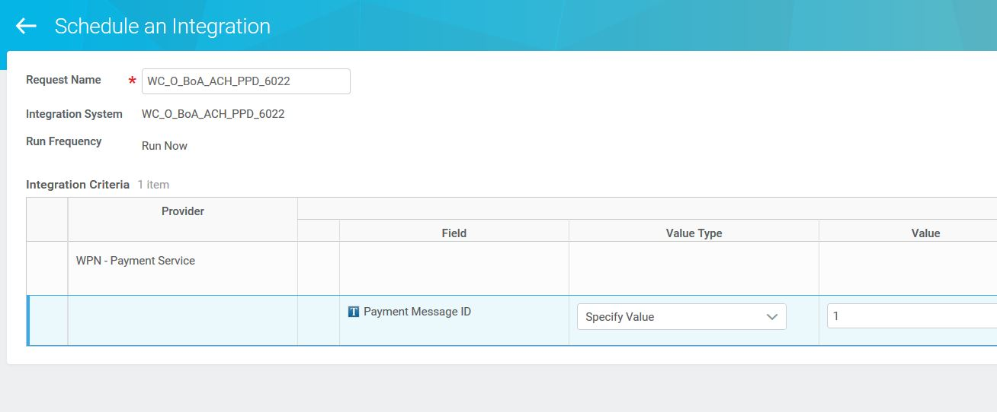

10. The integration will begin to process, you can refresh the screen by clidking on the title bar or the browser refresh button

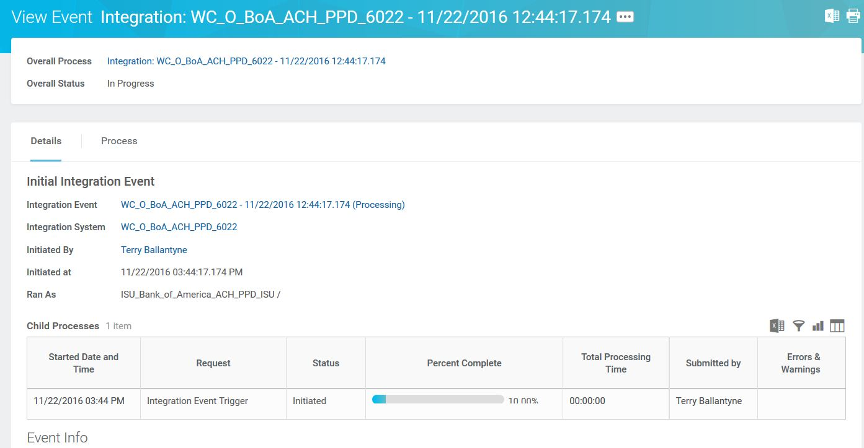

11. Once the process has completed it will display the status and any errors or warnings

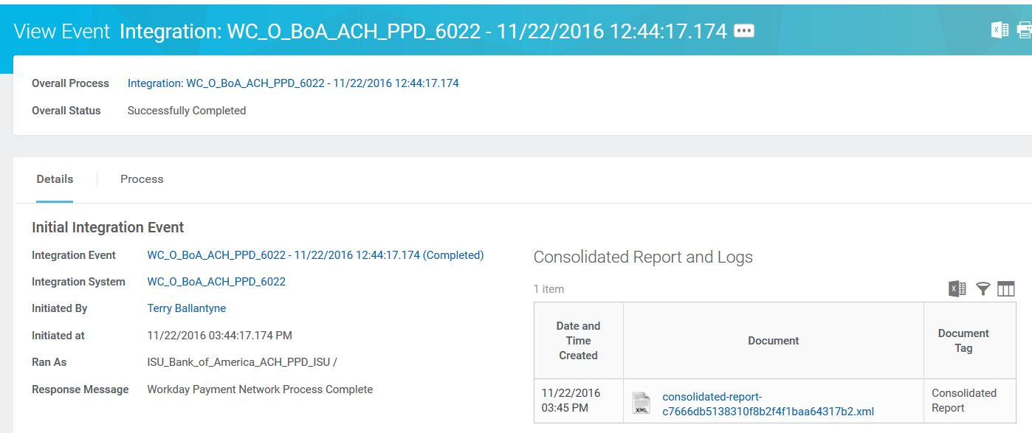

12. Errors and warnings

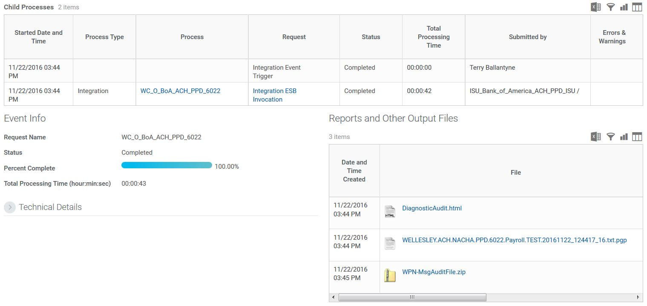

13. And all files generated

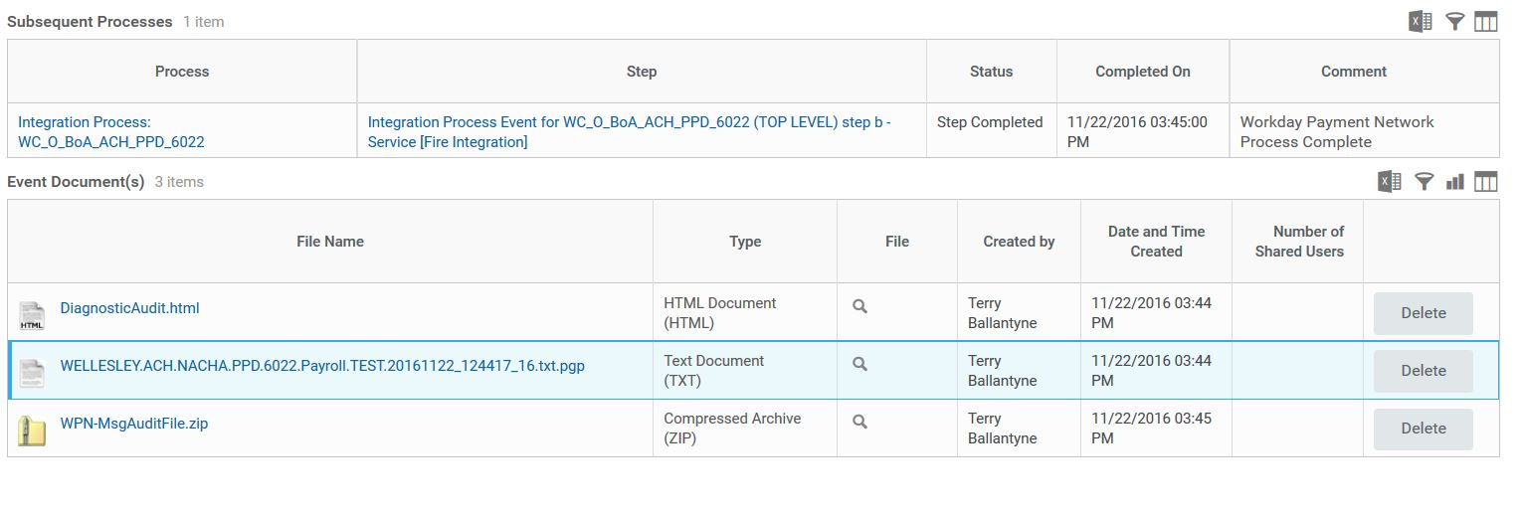

Example of diagnostic audit file (Extract Summary)

