Dear Valued Partner,

Due to CA vendor change for HP Inc., we are moving from Entrust CA Certificate to DIGICERT CA Certificates. Even though HP Inc. current AS2 certificate is valid till 2022, we will be revoking the current certificates after we move to DIGICERT based on the timelines given below.

Also please note that the new certificate will have one year of validity as per the industry CAB guidelines – please refer to the [link](https://protect-us.mimecast.com/s/1sw3CNkjqjfVpv8M8SjcegI?domain=urldefense.proofpoint.com).

**PROD** certificat**e should not** be applied **before** Sunday **7 March, 8 AM CST (2 PM UTC).**

**TEST** Certificate need to be applied now – it has been already applied in HP system on Feb 17.

1. Please download the new certificates in a zip file from the link below.

Link: <https://hpiwksp.awsapps.com/workdocs/index.html#/share/document/0dd863b56cc7d47ef2c62576bca2f395538a53da571762050af4862747c1a2a7>

Access Code: 4599



1. Unzip the downloaded file and keep the two files in a directory as per your convenience.

Please follow the certificate change process as outlined next page.

You can renew the TEST system certificate now as below:

1. Go to <http://localhost:2480/hp> in a web browser where the HP AS2 Connector (Lobster) is installed and Login to TEST system (If you do not remember password, please follow the password reset process at the bottom of this document).

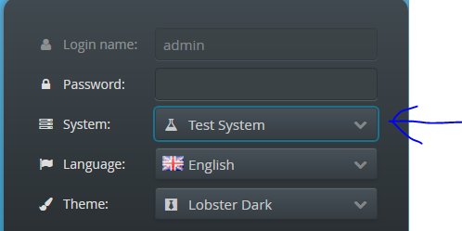

1. Go to certificate tab and click on Import Partner Certificate

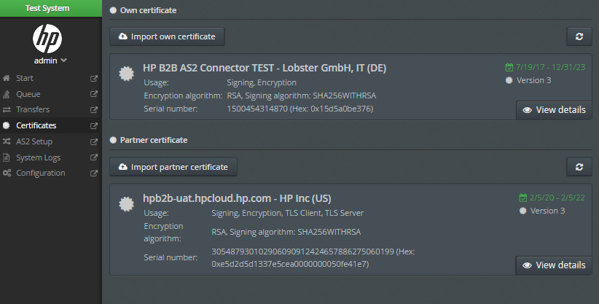

1. Drag “TEST-hpb2b-uat.hpcloud.hp.com.crt.txt” file and drop into the circle as shown in below screen.

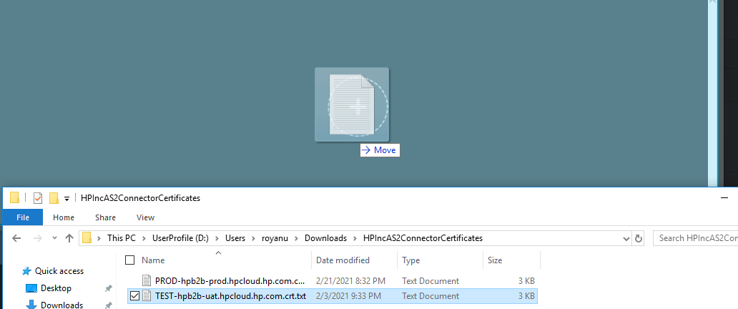

1. After this, the new cert should be shown as below –

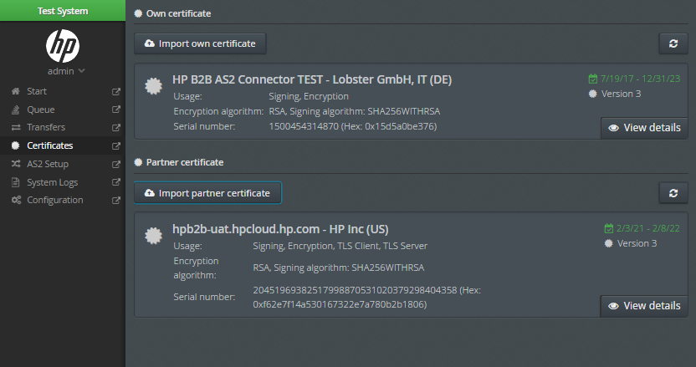

1. It completes the cert renewal for TEST system. You can log off from test system after this.

**PROD:**

**Caution: PROD certificate should not be renewed before 7 March, 8 AM CST (2 PM UTC) or it will break the production connection till 7 March.**

1. Login to PROD system.

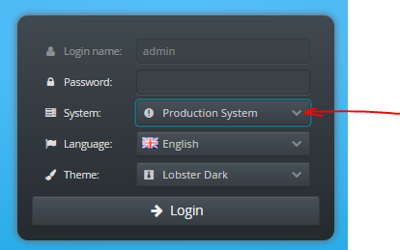

1. Go to certificate tab and click on Import Partner Certificate

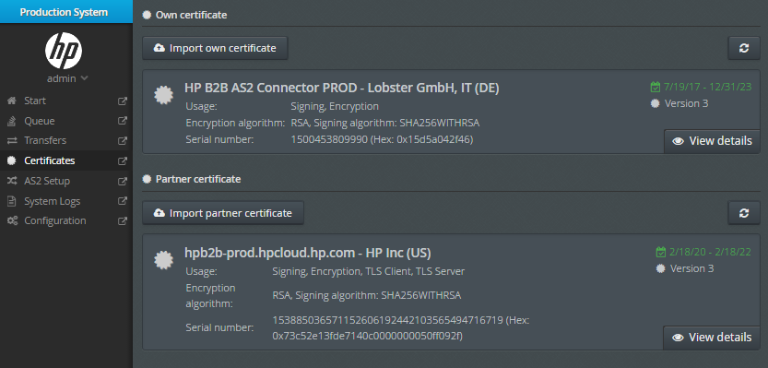

1. Drag “PROD-hpb2b-prod.hpcloud.hp.com.crt.txt” file into the circle and drop it as shown in the below screen.

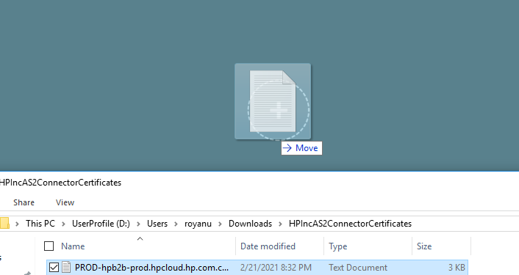

1. After the above, it should show the partner certificate with date as shown –

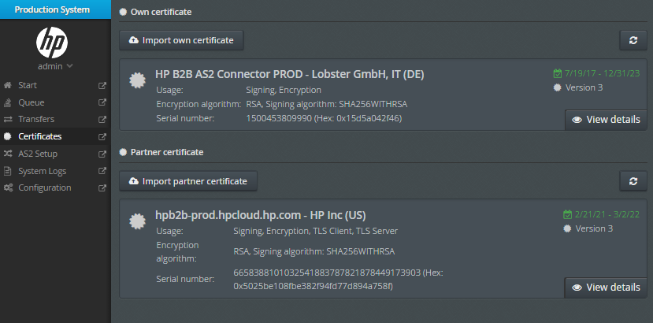

1. It completes the cert renewal for PROD system. You can log off from PROD system after this.

**Appendix**:

In case you forgot the password for admin user please follow below steps to reset it.

1.            Go to HPconnector folder on your server.

2.            Go to etc folder

3.            Delete usr.pwd file

4.            Restart HPconnector services

5.            Go to <http://localhost:2480/hp>

6.            Login with default username: admin and password: admin

7.            Then you will be prompted to setup a new password.