Installation of BIS Link Plus consist of three phases:

• Downloading and stating the setup executable

• Going through the steps of the Installation Wizard

• Completing the configuration and finishing the roll-out process in the Configuration Wizard

1. Use the link in the invitation e-mail corresponding to your operating system type.

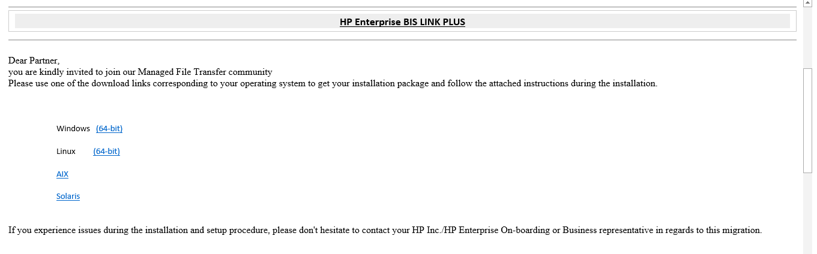

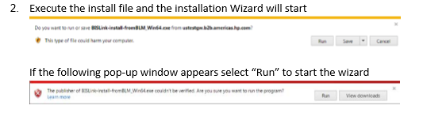

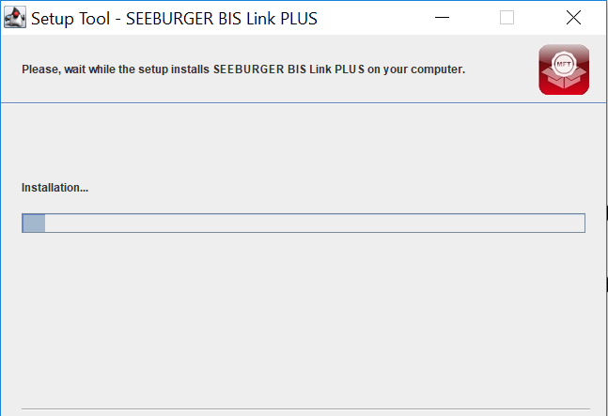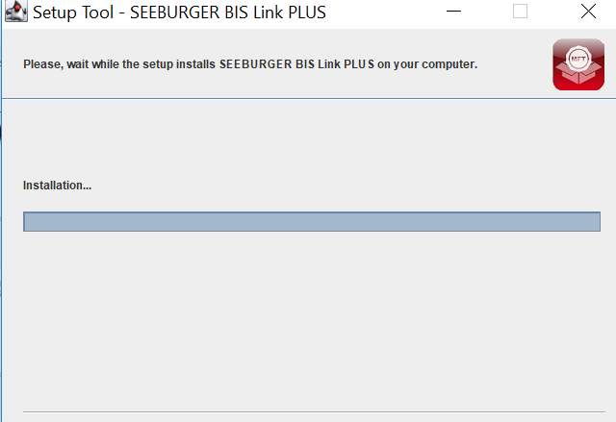

Continue with the default values thru the setup wizard

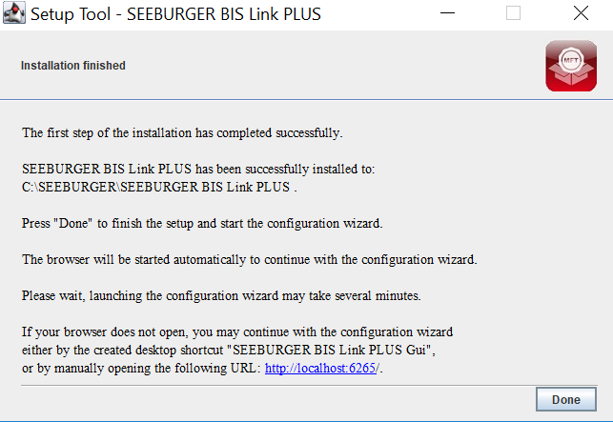

You can see the below icon in your desktop

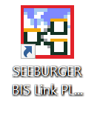

Continue with the wizard using the SEEBURGER BiS Link Plus GUI shortcut on your desktop to complete the installation. Alternatively open <http://localhost:6267/slmp> to continue to the configuration wizard.

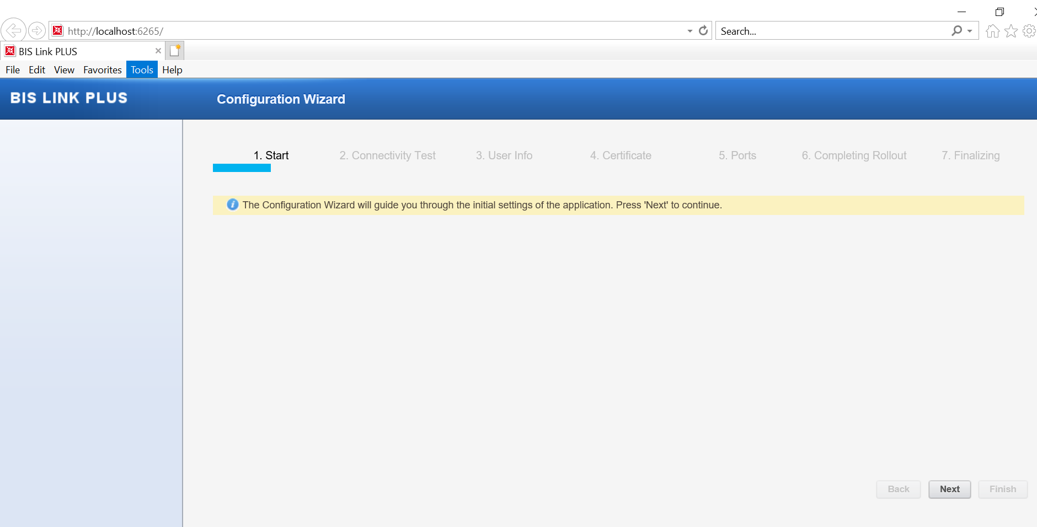

Enter your HTTP proxy values and do a Connectivity Test.

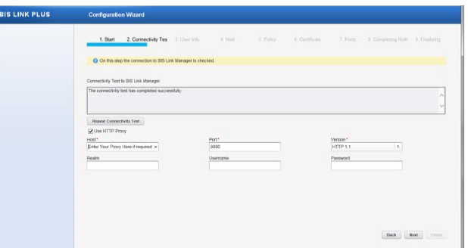

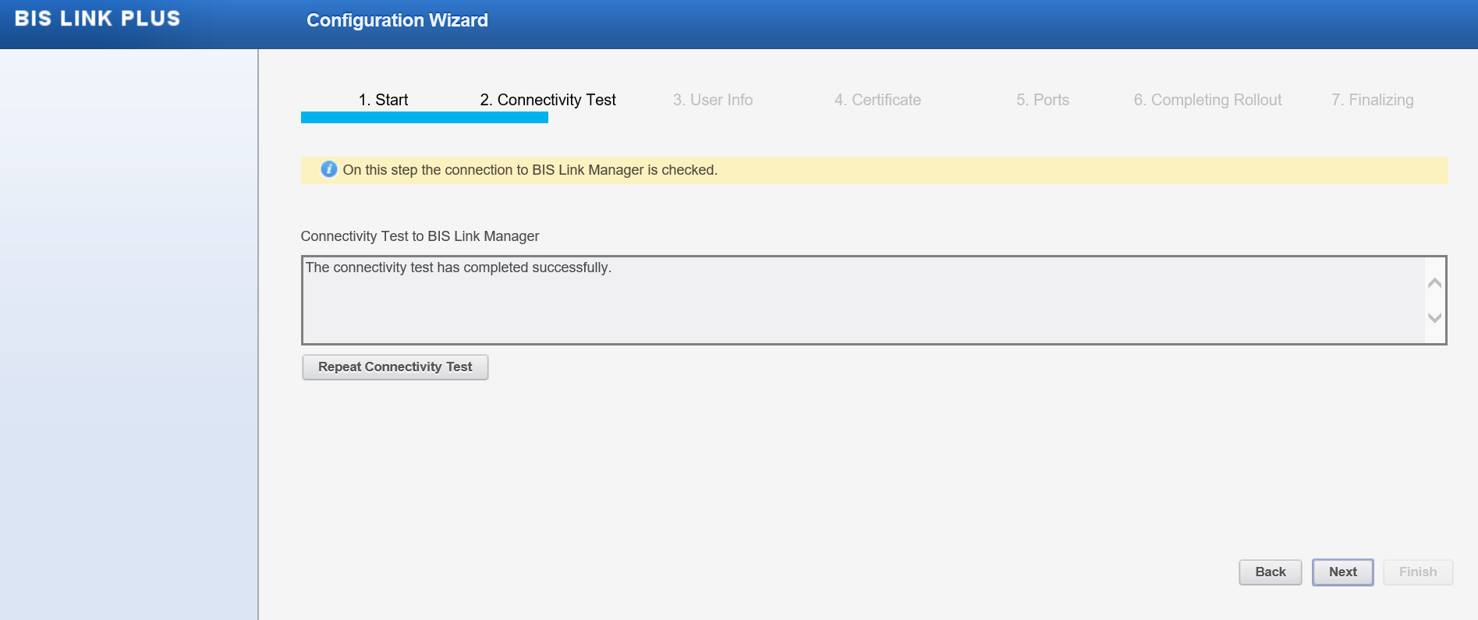

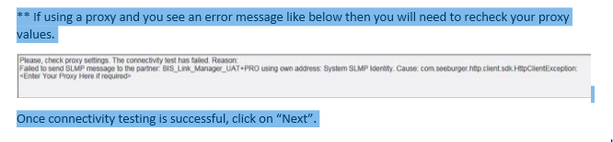

Enter the Administration information. The password you enter and user “admin” will be your default logon user information and click “Next”

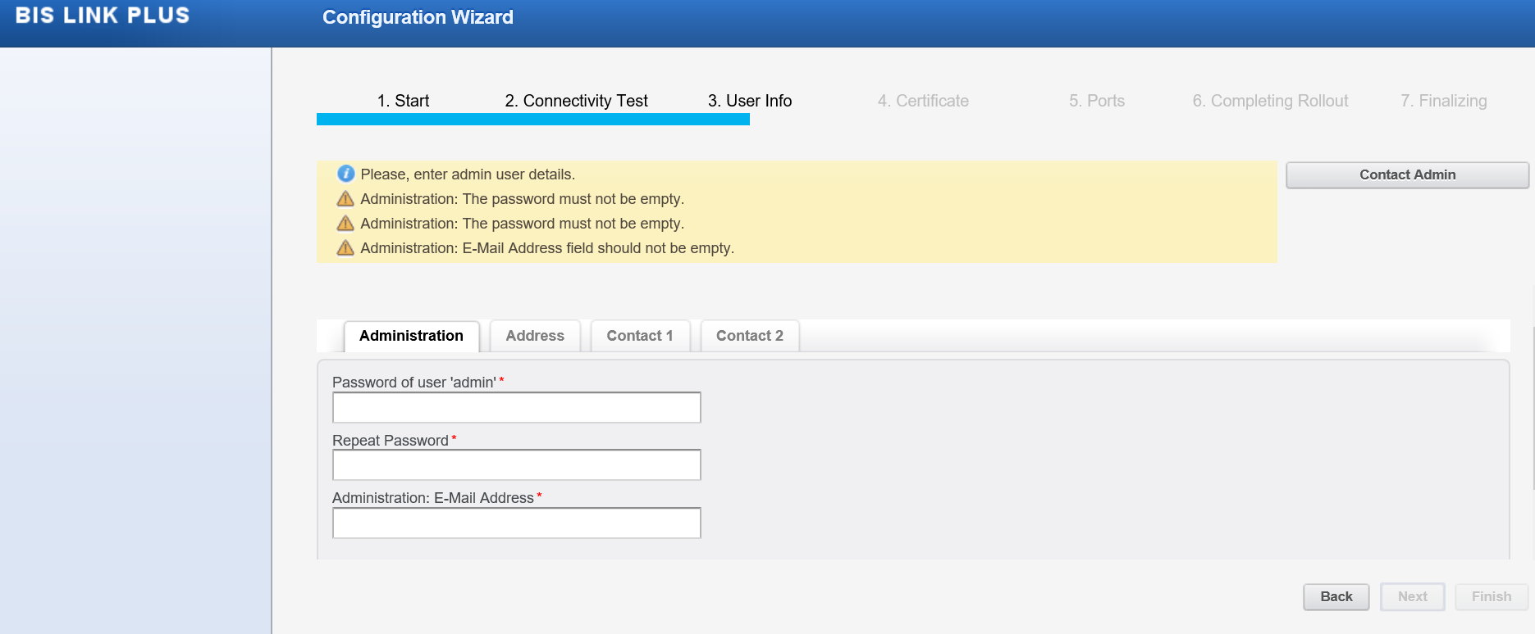

Please enter the details below

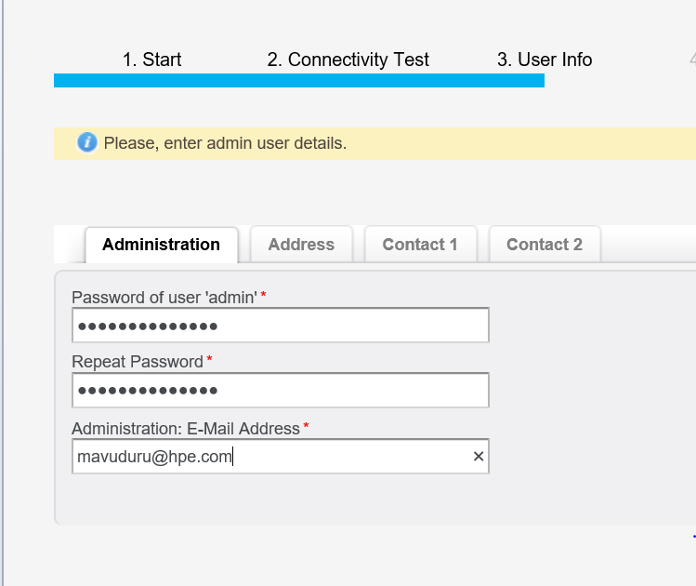

Click Next

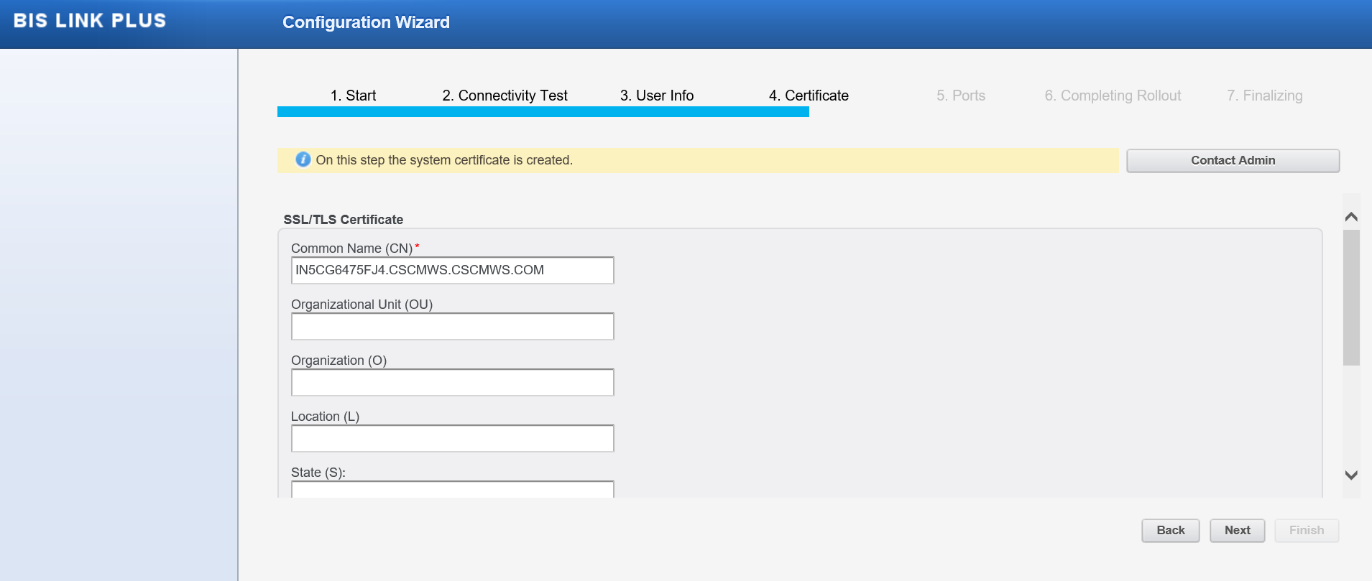

Click Next

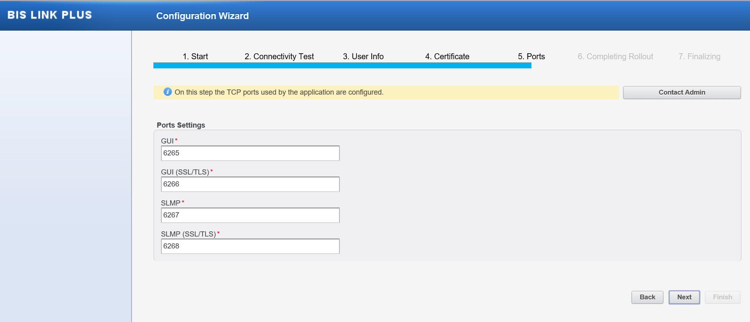

\* Click “Refresh” button from time to time to see progress.

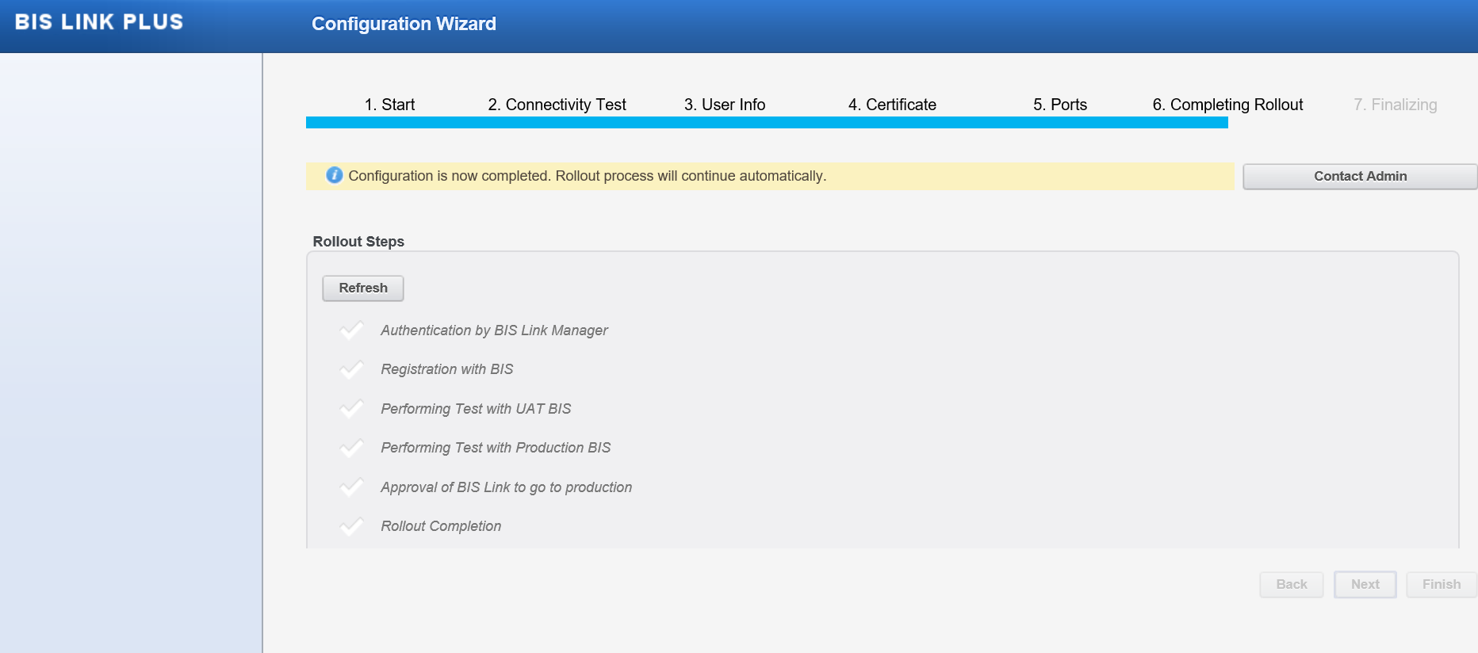

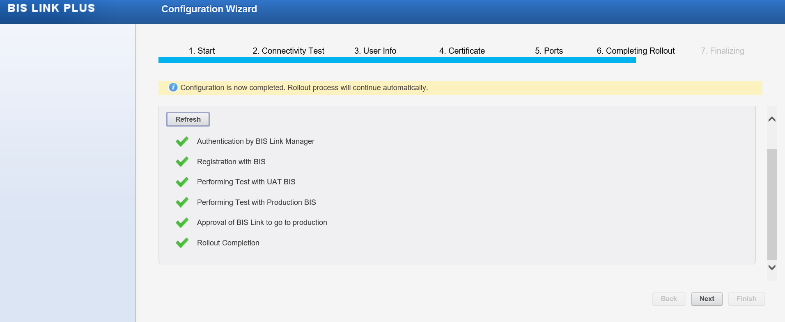

Once done click on finish

