**BIS LINK PLUS**

**PREREQUISITE INSTALLATION CHECK LIST**

Contents

Installation perquisites

BIS Link Plus installation invitation email

“admin” user

Proxy configuration

# Installation perquisites

Before installing BIS Link Plus please ensure you have the following perquisite information available.

* Minimum Hardware/Software requirements (see system requirements section)
* Have received the BIS Link Plus installation invitation email
* Please ensure network connectivity to HP Enterprise SLMP Port 6267 and 6268 . You may need to check with you network administrator for this.

# 

# BIS Link Plus installation invitation email

Each Partner would receive and email like seen below from which the corresponding link for your operating system would be clicked to start downloading the software package. The download file will be ~255MB.

You may need to check you “spam” or “junk” folder if not found in your mailbox inbox.

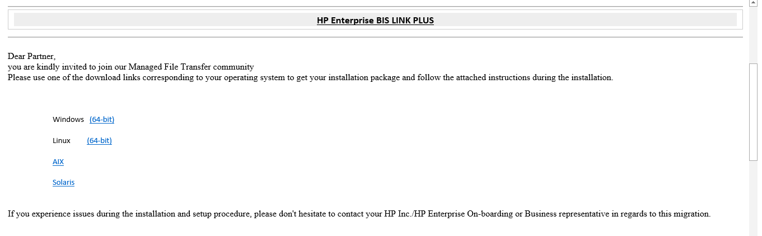

# “admin” user

The default user is “admin”. You will only need to provide a password and email address for this installation step.

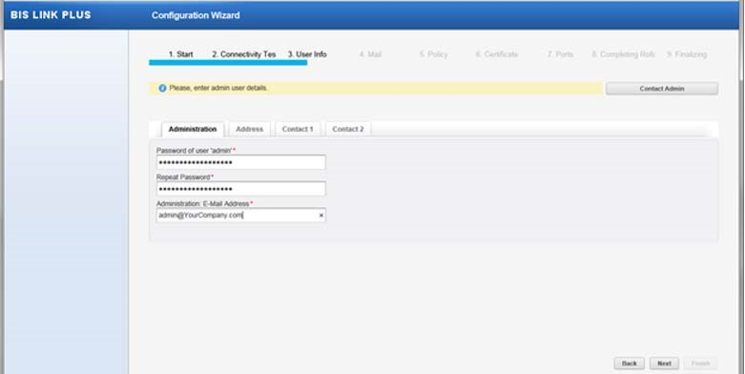

You will be required to enter the Administration information. The “admin” user logs onto the GUI using this password (default logon).

** Optional: provide your company contact information and a backup contact in the tabs Contact 1 and Contact 2. This information will assist us in reaching out to you should the need arise in future for support / issue related matters.

# Proxy configuration

• During step 2 of the installation process your proxy information will be needed.

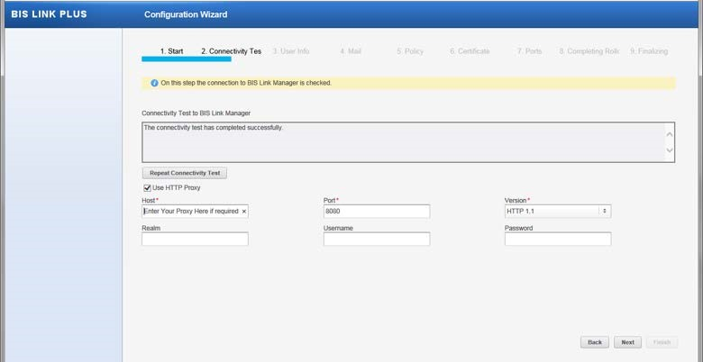

# BIS LINK PLUS directory structure – message usage

The follow table shows the use of the BIS LINK PLUS directory structure for sending or receiving files.

|  |  |
| --- | --- |
| **Inbound to Partner from HPE Gateway** | |
| [install path]\ports\hpe\[prod|test]\inbound\acks | Special folder for SmartEDI ACKs. |
| [install path]\ports\ hpe \[prod|test]\inbound\binary | Non-EDI data (like flat file data) would be delivered to this directory |
| [install path]\ports\ hpe \[prod|test]\inbound\edifact | EDI EDIFACT data would be delivered to this directory |
| [install path]\ports\ hpe \[prod|test]\inbound\edix12 | EDI ANSI X12 data would be delivered to this directory |
| [install path]\ports\ hpe \[prod|test]\inbound\eiaj | Japan EDI (eiaj / hwsw) data would be delivered to this directory |
| [install path]\ports\ hpe \[prod|test]\inbound\tradacom | EDI Tradacom data would be delivered to this directory |
| [install path]\ports\ hpe \[prod|test]\inbound\xml | XML files would be delivered to this directory |
| **Outbound from Partner to HPE Gateway** | |
| [install path]\ports\ hpe \ [prod|test]\outbound\any2any | Non-EDI data (like flat file data) would be sent from this directory should that data go thru a data transformation (mapping) process on the HPE Gateway |
| [install path]\ports\ hpe \[prod|test]\outbound\binary | Non-EDI data (like flat file data) would be delivered to this directory |
| [install path]\ports\ hpe \[prod|test]\outbound\edifact | EDI EDIFACT data would be sent from this directory |
| [install path]\ports\ hpe \[prod|test]\outbound\edix12 | EDI ANSI X12 data would be sent from this directory |
| [install path]\ports\ hpe \[prod|test]\outbound\eiaj | Japan EDI (eiaj / hwsw) data would be sent from this directory |
| [install path]\ports\ hpe \[prod|test]\outbound\qspeak | Special folder to our qspeak partners. Not used unless you are a qspeak partner. |
| [install path]\ports\ hpe \ [prod|test]\outbound\tradacom | EDI Tradacom data would be sent from this directory |
| [install path]\ports\ hpe \ [prod|test]\outbound\xml | XML data files would be sent from this directory |

system requirements section

