

WEB DESIGN
PROJECT REPORT

PROJECT TEAM
Student No. | Student Names
20244835 | Aidan Carrigy
20231857 | João Paulo Cavalcante

Project Name: C & C Tours

Website URL: Home | C&C Tours (jp-aidan.github.io)
YouTube URL: C & C Tours Welcome Video! - YouTube
CSS Files are on top of About Us page.

Table of Contents
Overview ……………………………………………………………………………………………..3
Section 1 – Design …………………………………………………………………………………...4
Research and Investigation ………………………………………………………………….4
Requirements and technical approach ………………………………………………………4
Sitemap ……………………………………………………………………………………...6
Wireframe …………………………………………………………………………………...7
Section 2 – Development …………………………………………………………………………….9
HTML ……………………………………………………………………………………….9
CSS …………………………………………………………………………………………..9
JavaScript …………………………………………………………………………………... 9
JQuery ………………………………………………………………………………………14
JSON ………………………………………………………………………………………..15
Validation and Errors ……………………………………………………………………….17
Website HTML and CSS validation ………………………………………………..17
Section 3 – Deployment ……………………………………………………………………………..19
Website URL ………………………………………………………………………………..19
SEO Search ………………………………………………………………………………….19
Section 4 – User testing ……………………………………………………………………………...20
Sample responsive testing …………………………………………………………………...20
Google page speed test ………………………………………………………………………21
JavaScript Form validation testing …………………………………………………………..22
Section 5 – Project Team ……………………………………………………………………………..23
Section 6 – Conclusion ……………………………………………………………………………….24
Section 7 – Reference and Appendix …………………………………………………………………25

Overview

After some discussion, we decided that we would set up a small business offering escorted tours to small international groups around Ireland. We decided to concentrate on the English speaking market as it would be easier to get staff for that market in Ireland than offering a variety of languages. In particular, we intend to focus our attention on the US market as the US has an Irish dispora of almost 40 million people and has good connection links with over 20 direct flights into Ireland during the busy summer season.

Our business will focus on the planning of iteneries and marketing the product online in the US while the transportation will be outsourced to third party chaffuer and coach companies who own the vehicles. This saves capital start up costs considerably by not having to invest in vehicles and also reduces potential liability in the event of a road traffic accident. Clients will book accomodation independently as this saves our company on staff administration costs and having to set up as a certified bonded agent to offer those services.

Tourism was a huge part of the Irish economy pre-pandemic employing 260,000 people and contributing almost 9 Billion Euro to the Irish ecomomy from the over 11 million people that visisted here in 2019.

We forsee alot of pent up demand in international travel in 2022 as people have alot of savings built up and now with vaccination rates in Ireland over 90% consumers will have have confidence in travellling here again but may be more comfortable in taking a small group vacation rather than a coach tour with 40+ people so that is another big reason why we are focusing on the small group market.

We intend to focus on the typical tourism season which in Ireland runs mostly from mid-march around St Patricks Day to Halloween at the end of October to start off with. Since Ireland is now referred to as the Silicon Valley of Europe we intend to tap into the corporate market in the off season winter months. Dublin hosts a number of major conferences in Ireland in the areas of tech, aviation, pharma and and medical science over the winter months. We feel there is great potential to enter this market where business travallers who come to Ireland for a conference may bring their partner or families and add on a few days to their trip and take an escorted tour with us. These travellers tend to have disposable income and most of their flight and accomadation cost are covered by their employer so it would be a cheap holiday for them. This would be a great benefit to our business as it would give us a 12 month season rather than a 8/9 month season like our competitors.

Section 1: Design

Research / Investigation

We carried out research on a number of competitors in order to gain ideas on the standard lay out that is used in the industry and to see what aspects we could apply to our own site. The three competitors that we had a look at are listed beleow and we have a included their URL also.
Competitor One: 2022 & 2023 Guided Tours - Cosmos® Affordable Tours
We looked at this company as by numbers they have a huge market share of the inbound tours market here in Ireland. We studied their pricing structure but soon realised they deal in volume in the 3- & 4-star market so we thought as we could not compete in price with them and decided to focus on the higher end 5-star market.
Competitor Two: 3-8 Day Budget Friendly Tours of Ireland (shamrockeradventures.com)
This website had a nice flow to it and nice use of images. This company however focused on the budget end of the market focused on more students and back-packers and stayed in hostels. We decided that between this company and another company called Paddywagon Tours, that this end of the market was well served and we stuck to our focusing on the high end 5 star market.
Competitor Three: Luxury Tours of Ireland & Scotland | Hammond Tours
This site was very impressive indeed. A lot of style and attention went into it. They also focused on the high end 5-star market like us. A site like this I am sure would enhance consumers to part ways with their hard-earned money. We felt that we would have an advantage over this company in that we would be an Irish Owned company offering tours of Ireland whereas this company was registered and based in the USA.

After looking at these competitor’s websites we set about designing our own. We decided to keep ours a little more basic, cleaner and fresher. What we mean by that is that some of the websites we viewed had a huge amount of colour and had a lot of images, some of which were not accurate to the tour and location they were marketing.

Requirements & Technical Approach

After the decision was made on what business to cover, we set about how to go about building the project. One member of the group had some familiarity with the industry we choose so with their previous knowledge along with research of competitor’s website we were able to gather and implement some ideas and plan about how we would accommodate them on our website.

Our first drafts of the site were constructed using mostly HTML and CSS until we got the flow and direction of the site the way we wanted. We did have to change this on a few occasions. We originally wanted all our tours on one page using J-Query but with loading issues we had to resort to 4 individual pages and that resolved the slow loading issue.
We also had an issue with our booking page not carrying the name, price and tour description from the tour page when clicked. A piece of JSON code sorted this out and gave the site a much more professional feel. Both issues are described in greater detail in this report.
A lot of research on how to carry out this project came from the notes on Moodle and both members of the group had previous coding experience which was a great help for a project like this.
We did also use online sources for some issues we got stuck on and these sources are included in the References at the end of this report. Pluralsight for example, was very useful for ideas on HTML and CSS.

Sitemap & Wireframe

Sitemap for C & C Tours:
This is the flow and version we went with in the end. As you can see, we have the index.html as the starting point. This links to the three pages of About Us, Tours and Contact Us. We originally tried to get all 4 tours on one page but it affected the loading speed of the site, so we went and put the four tours on separate html pages. This resolved the issue and improved the flow and speed greatly.
So as you can see the Tours page links to the four individual tours where the details and itinerary of the tours are each displayed.
When the user reviews the tour, they can click on a Book Now button from either of the four pages and this brings them to the booking page.

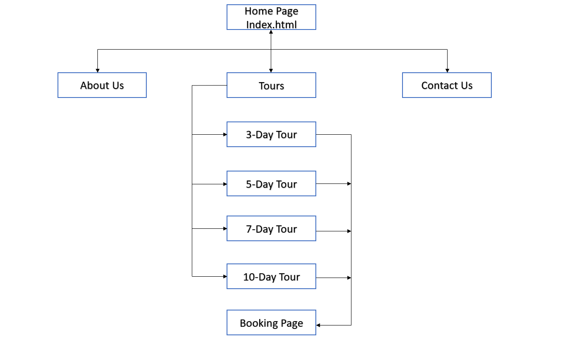

Index Page WireFrame:

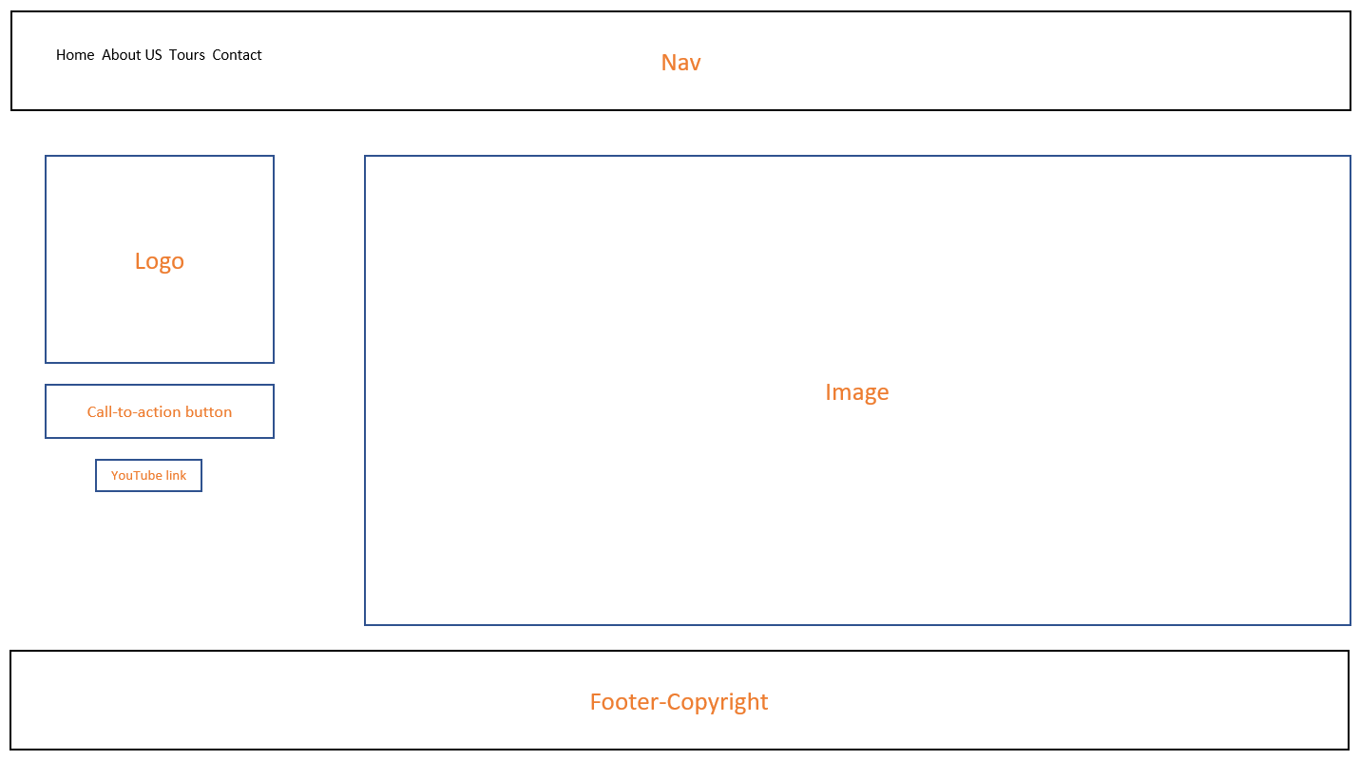

About Us Page WireFrame:

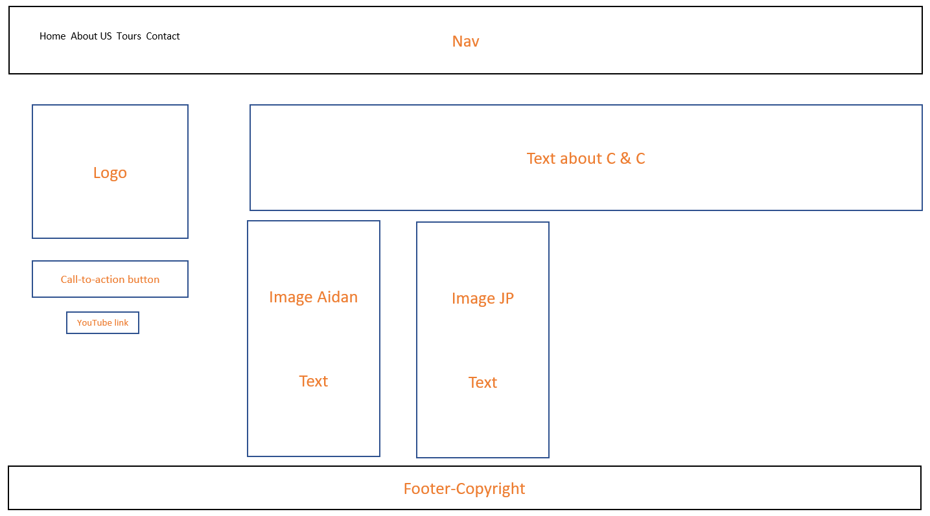

Tours Page WireFrame:

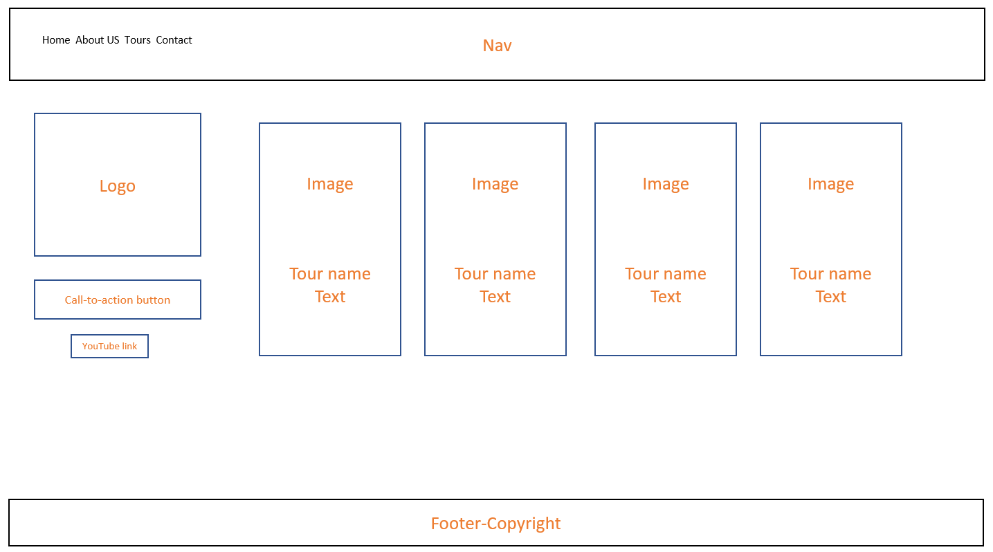

Contact Us Page WireFrame:

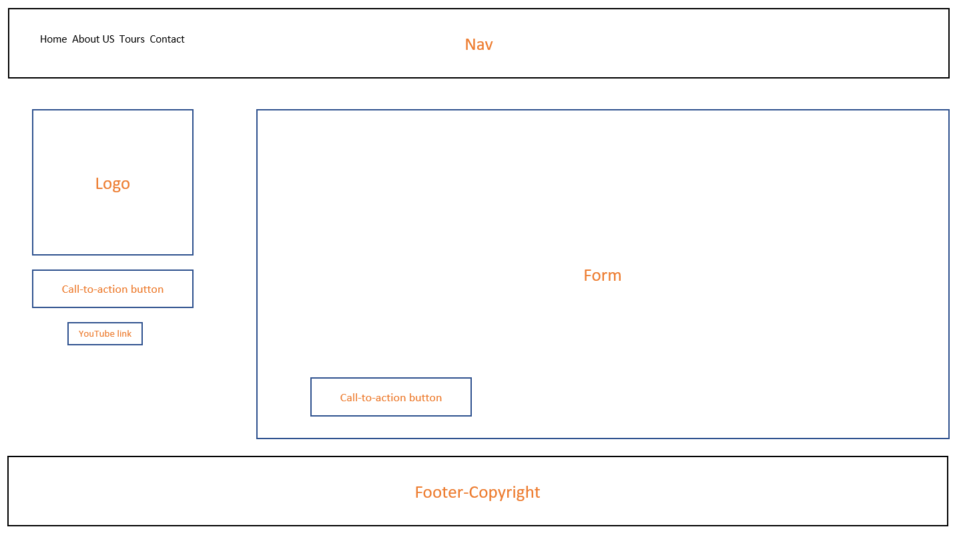

Section 2: Development

HTML:
As shown on the wireframe we decided to use the HTML as simple as possible to get a user friendly and clean website. The main tag was chosen to be used as we did not intend to repeat information across the other elements. We used the aside tag as a side bar and put elements in it as we needed. The article element is self-contained, so it made sense to use it. Forms were used in the booking and contact page to better organize the inputs needed. The section tag was used as we found it easier to use the responsive in the about and tours page.

CSS:
We worked together with our main goal to make the pages totally responsive. We used @media only screen and min-width which made everything work fine. We also tested on a smartphone and the results were satisfactory. The colours were chosen after some brainstorming and the combination and contrast with the logo show us a fresh website. We did not want to put too much on it as we wanted it to look classy, so the font is also simple.

JAVASCRIPT:
For the form validation we used JavaScript as much as we could, as shown on the snippets down:
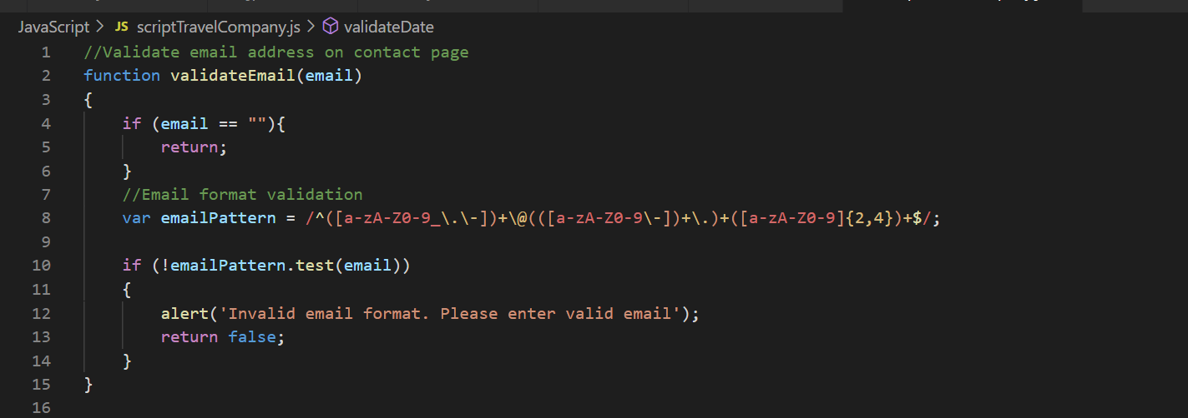
Simple email validation form on the contact page.
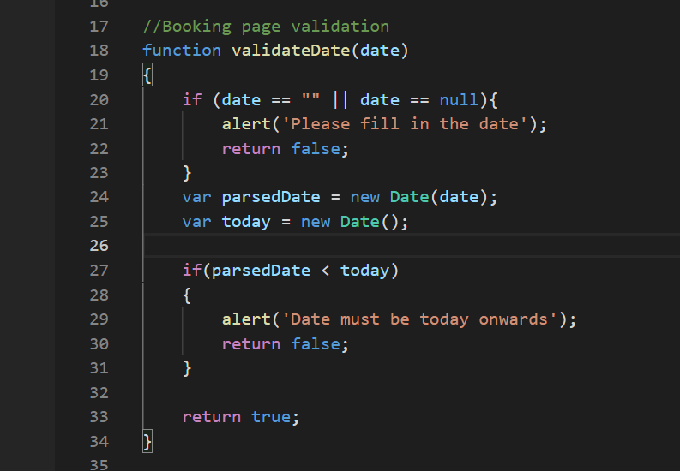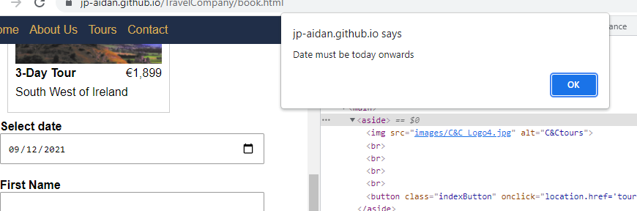
On the left code used for date validation (user must choose) a date that is greater than today and also date field must be filled.
Below window pop up with message for the user.

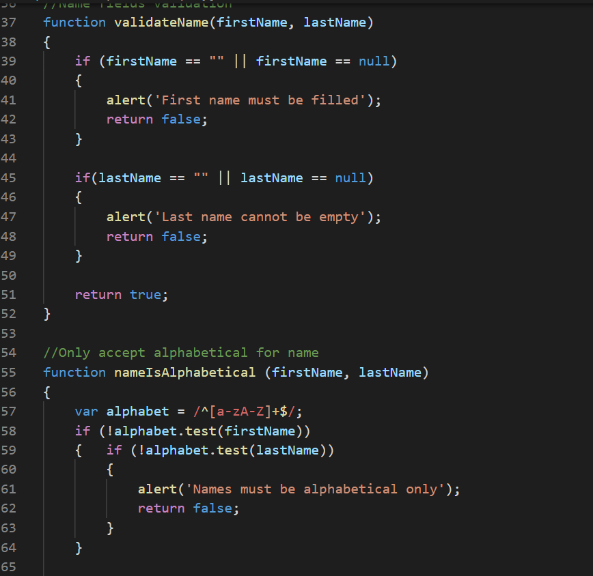
Part of the name validation code

We also had some mistakes during the code writing as seen below, the code to validate Address and Postal Code were wrong, showing an error validatePostalCode is not defined, this was a typo and spotted after a long check on the code. Also, the method “Match” did not work and after some testing and research we used the method “Test” to validate numeric only Postal code.
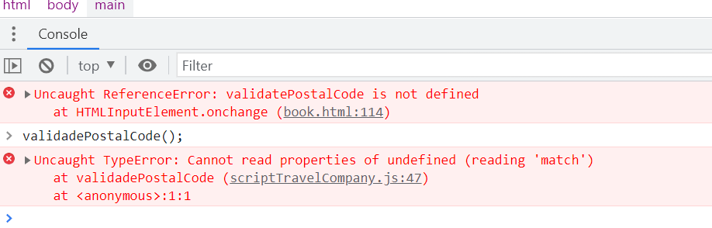

Bellow we had an error in the function validateAddress because the condition was not written correct. It was identified and changed to (!alphaNum.test(address)).
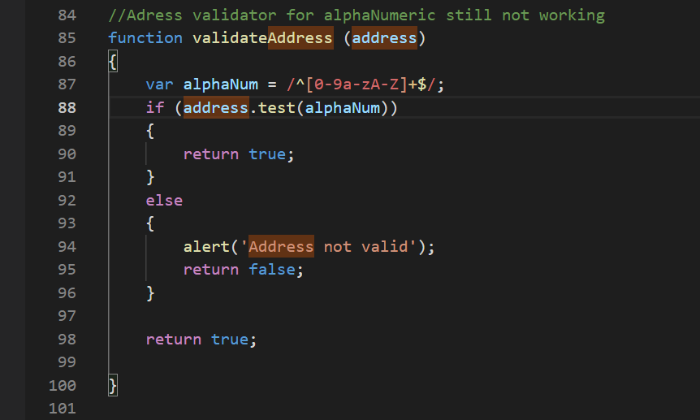

There was also a bug on the validate Address function, due to a wrong Regex that was used on the picture above. After some research, we found a regex that accepted space in between numbers and words.
On the left the bug, on the right the correct regex.
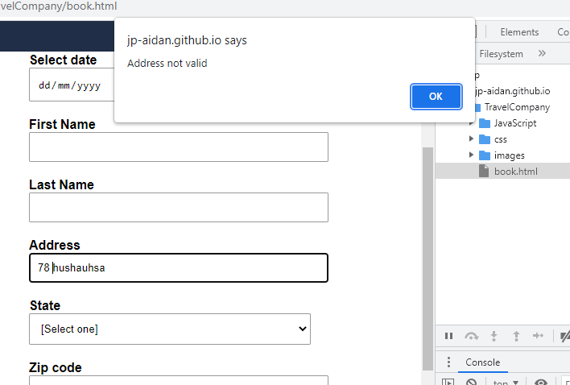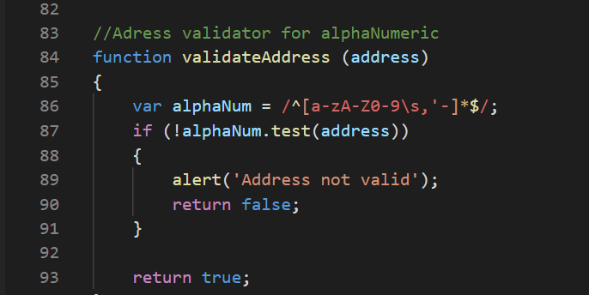

Down below snippet of the address function working properly as it needs to contain numbers and words.
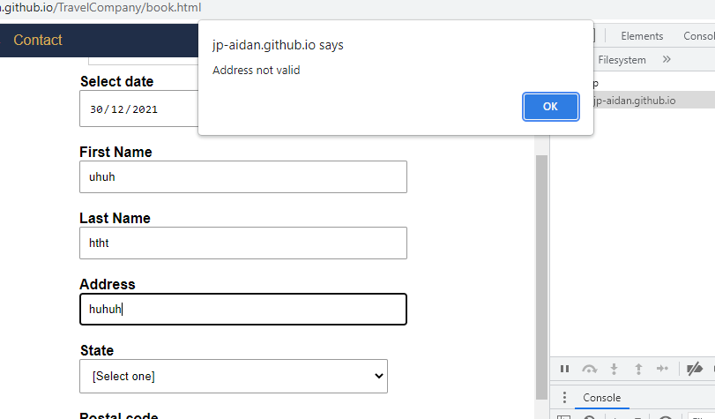

We also face a problem because the email trigger was working even with the pop ups as shown in the snippets down:
On the left the email window opened even though the function alert worked.
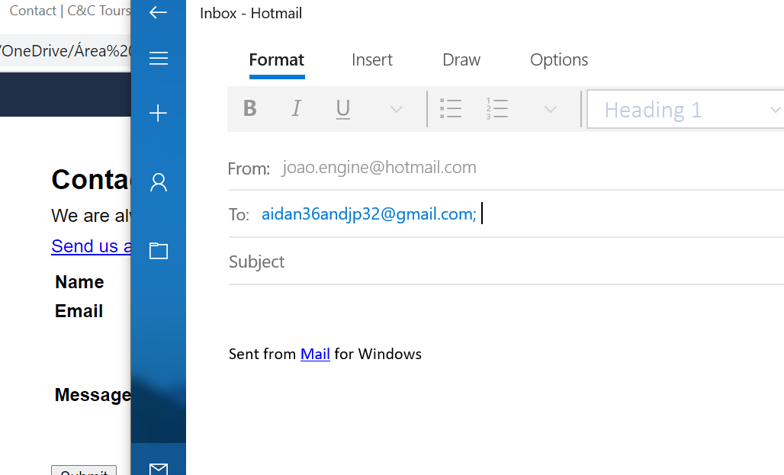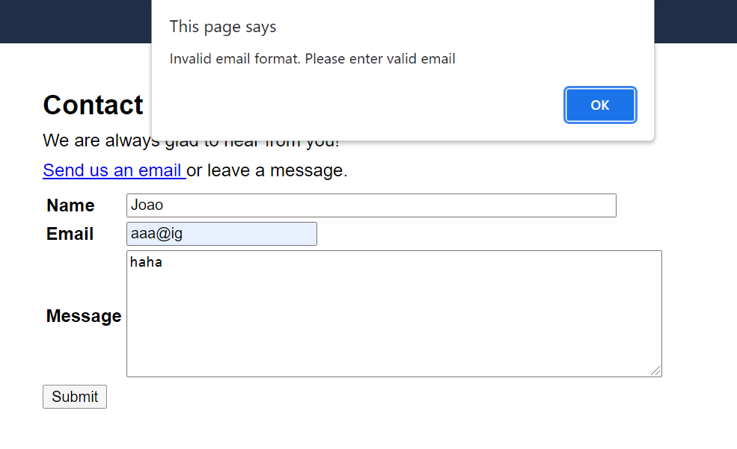

That was corrected with the code shown below used on onsubmit on the form:
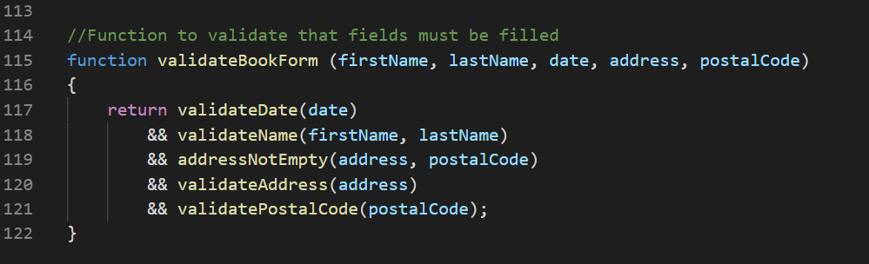

We also decided to use the website https://formspree.io as a way of having the information the user input sent to our company email.

The method POST was missing on the first tries (left picture) and it was easily solved as shown down and on the right:

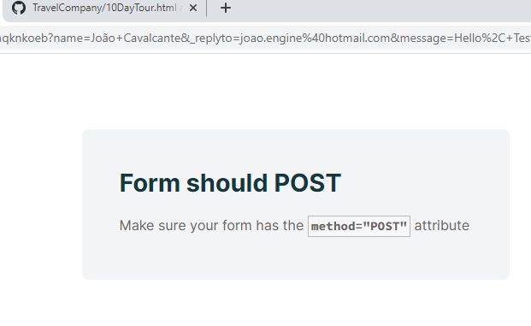
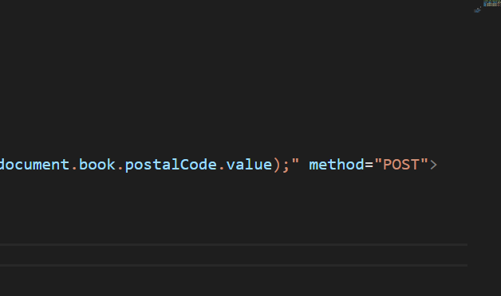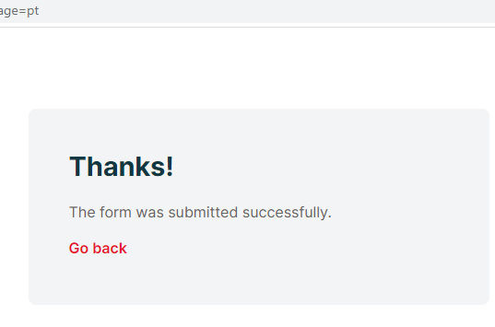

We opted to restrict the submission that would come through our forms so our company would not suffer too much from spam:
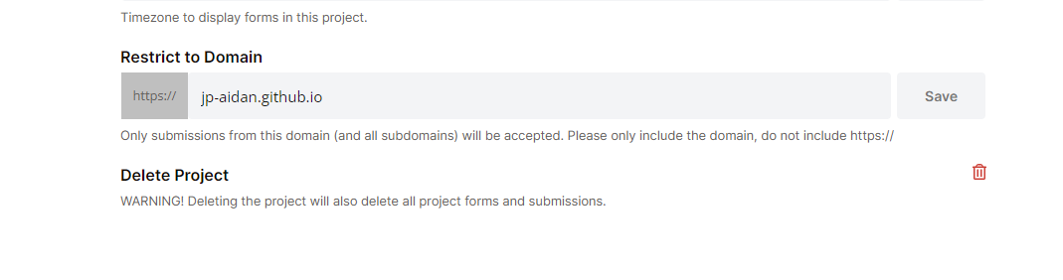

Down below a snippet of a test we have done to guarantee the information sent to our email was complete:
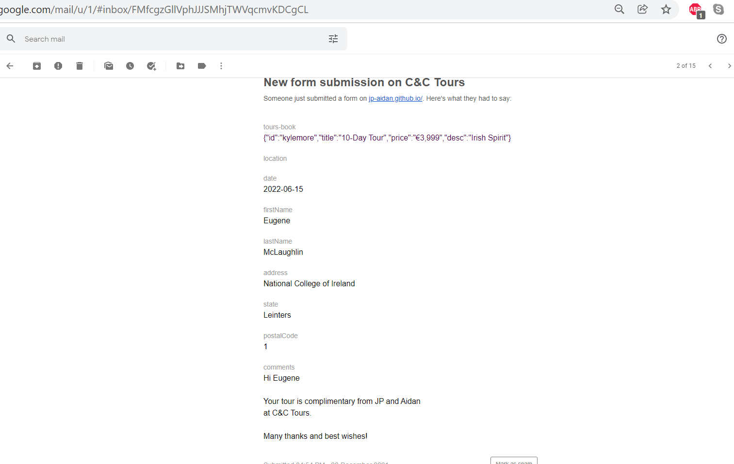

JQUERY:
We tried to use JQUERY to make our separate tours all in one, but the result was not satisfactory as the page took approximately a minute to load and we could not bring the Tours information and images with it. We decided not to go on that direction, we made four different pages and used JSON instead.
Down below the code we tried to use (https://jqueryui.com/tabs/) to create tabs and the tabs example we were going to use:
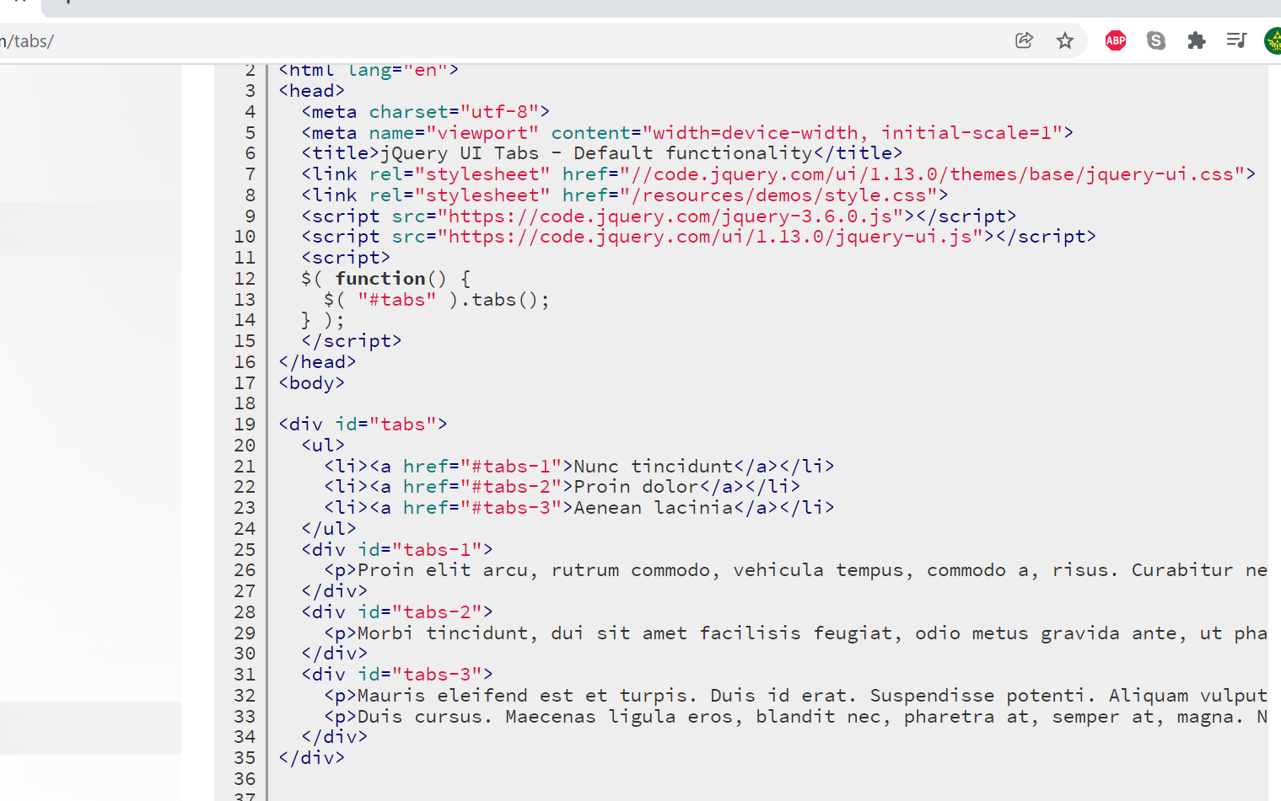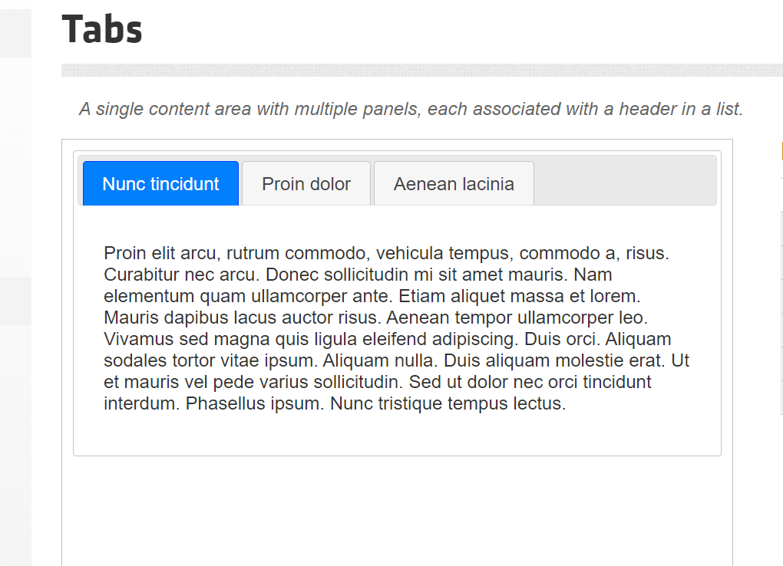
JSON:
Even having to add a few more pages, the result of the JSON code was very well accepted by both of us. Basically, we put a piece of JSON under each of the tours page and to the Booking page, which will run after all elements on the page are loaded. So, the elements are fetched and brought along to the Booking page. This way, the user has a clear image of the service they are buying and it is also considerably quicker than JQUERY.
Down below the snippets of the code, commented. First from the tours page, then for the booking.

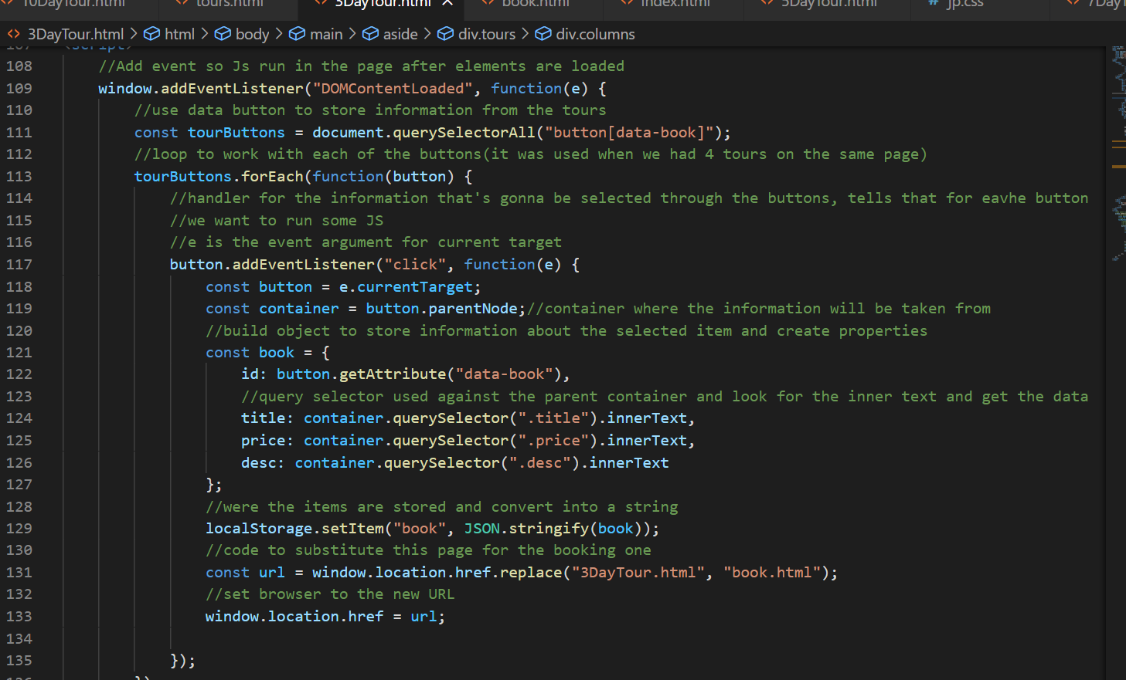

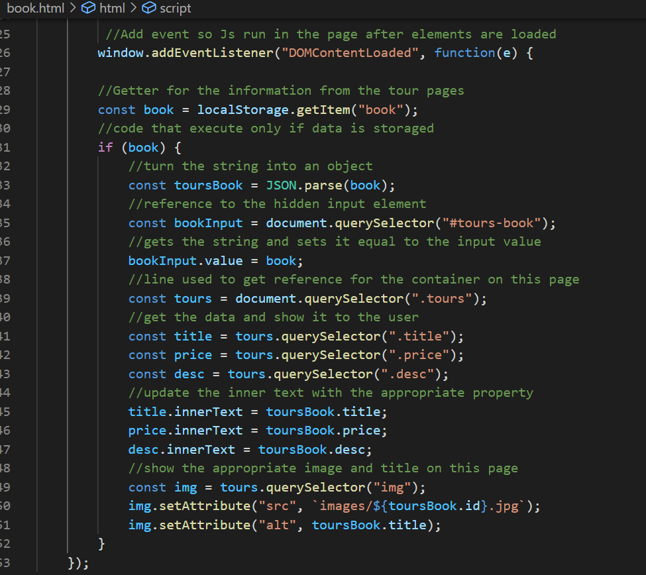

We had an issue with we users clicked on the selected tour on the tours page when it went to the booking page it did carry the name of the tour and image (show )with it but we resolved the issue in the end by using JSON.
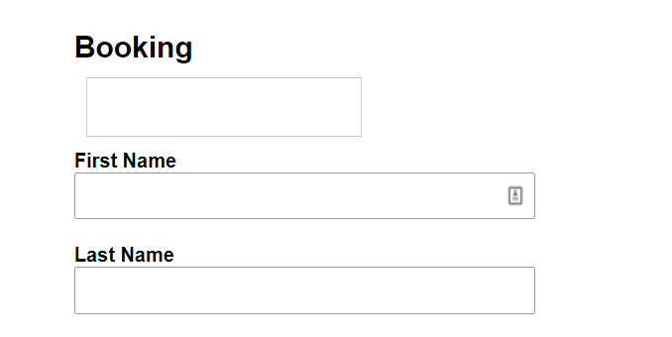

This is the corrected version of the booking page (code is on the page above). We also included a box to select the dates of the tours.
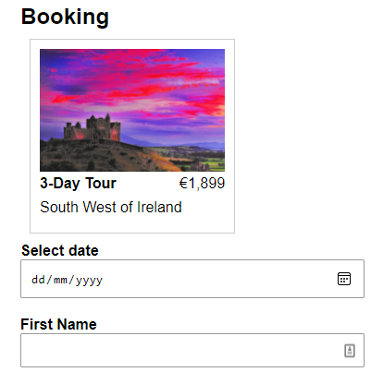

This is the code we were going to use to store the location of the user, but in the end we decided not to use as it would not add much to the website.
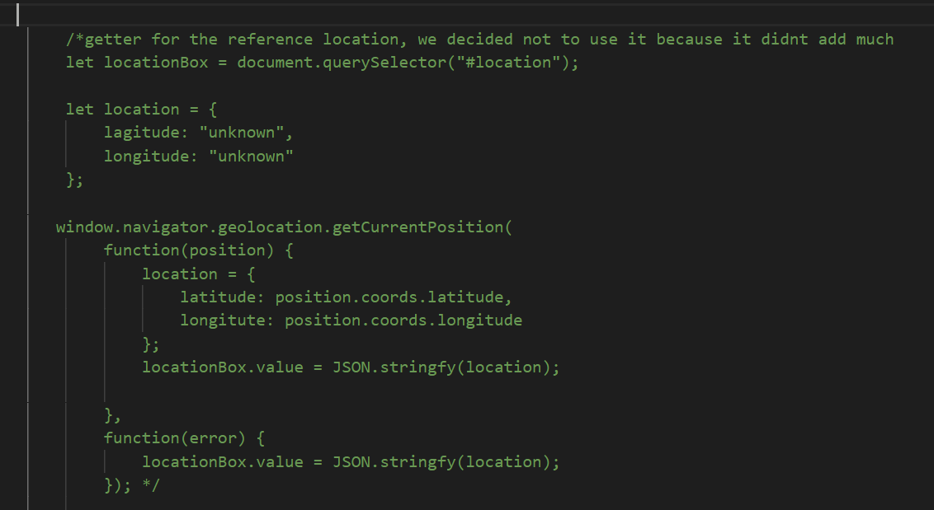

Validation & Errors

Website HTML Validation:
We put our code the HTML validator and as you can see the results were successful.

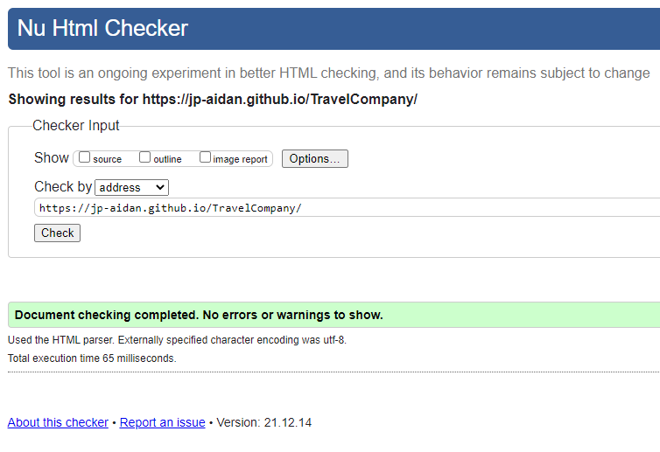

Website CSS Validation:
The code for the CSS was validated using this tool and as you can see from the screen shot our code had no errors.

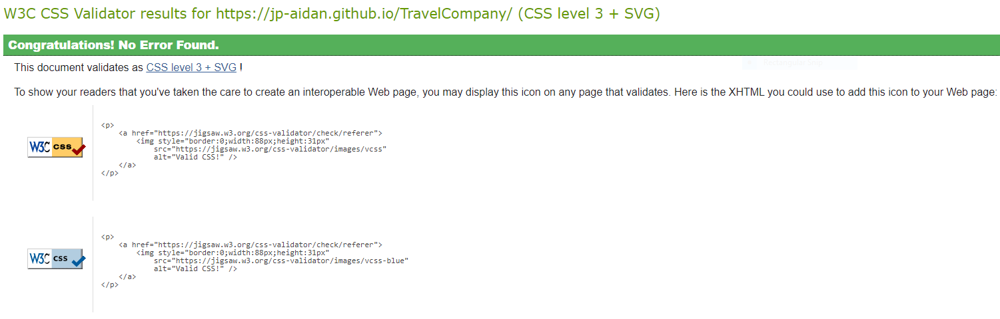



Had difficulty getting our “call-to-action” button on the index page to sit under the Logo on the index page but after a bit of persistence we got it to sit under the Logo as we wanted along with the link to the YouTube channel. As you can see the logo was changed before the end of the project. We set up an account on Wix with our new Gmail address and created the logo from there.

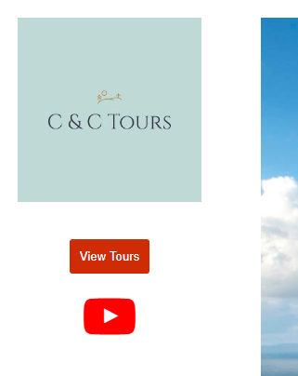

Section 3: Deployment

Website URL: https://jp-aidan.github.io/TravelCompany/

For this project and to make life easier for the two of us we set up a new Gmail account. This allowed us to set up a new GitHub account for the project and we saved the files and folders in one location for both of us to access them when we needed.

The new Gmail account also allowed us to set up social media profiles for the business like a YouTube channel and we were able to use the project Gmail address for our mailto section of our booking and contact us pages.

SEO Search:
As we used the free version of GitHub to deploy our website and did not register a domain with say WordPress or GoDaddy. We did look into this but both domains CCtours.com and CCtours.ie was not available to register. As you can see below our website URL did not pick up on a Google search but did pick up chauffeur company from Co. Clare in Ireland with a similar name to ours. We based our company name C & C Tours based on our last names which both start with c, Cavalcante & Carrigy.

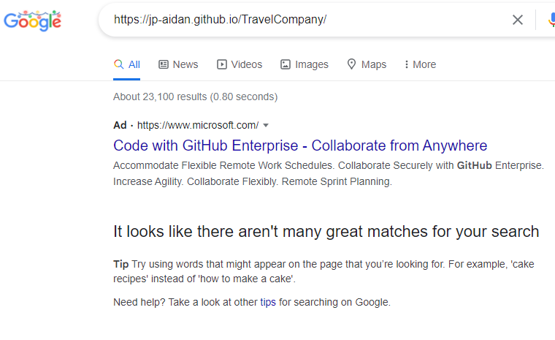

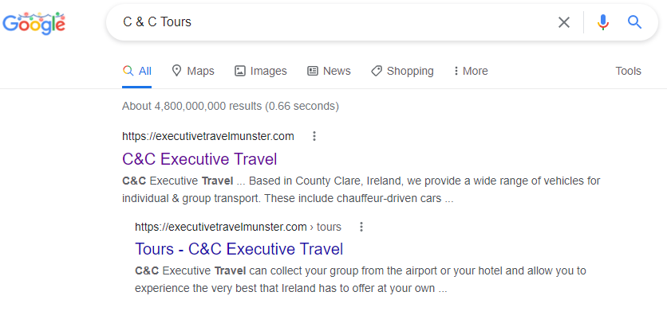

If we had more time, we would have registered a domain for the business which would have helped with SEO. Also as mentioned later we would have created a blog page and uploaded a few relevant posts related to the business. This is a great way for search engines to pick up on your business.

Section 4: User Testing

Sample Responsive Testing:
This is a sample of responsive testing of the site on the index page. The images were taken using the snippet tool which makes it hard to capture the narrow version and may leave the images slightly out of scale but as you can see the site is fully responsive.

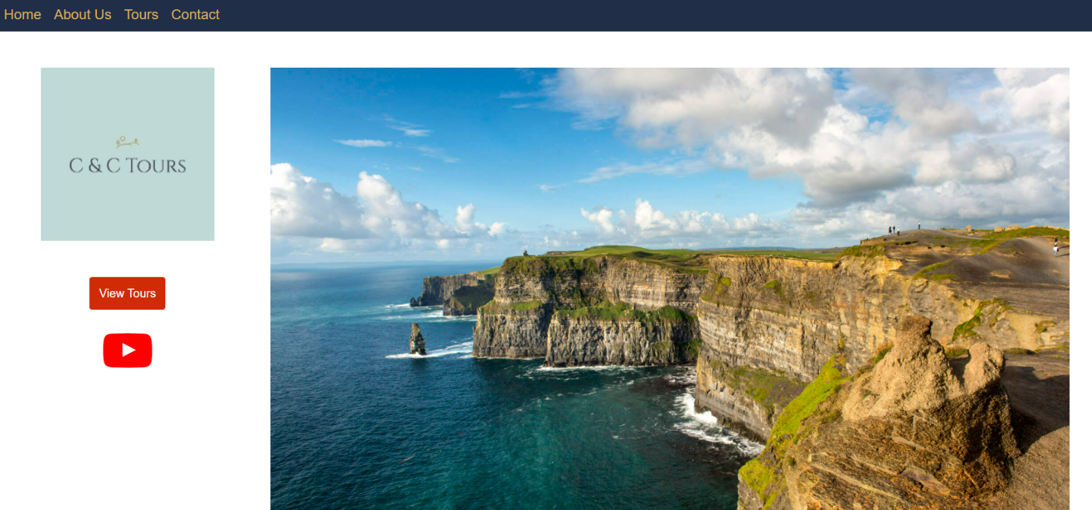

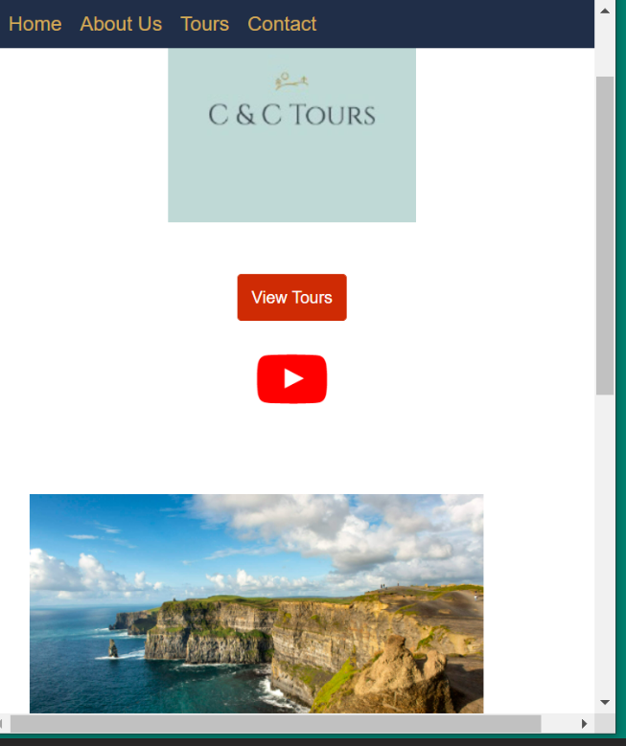
Google Page Speed Test:
We used the link that you provided in the chat in the last class for the speed test.
As you can see our site scored an excellent performance of 96%. The logo in the screenshot was changed after the test was carried out.

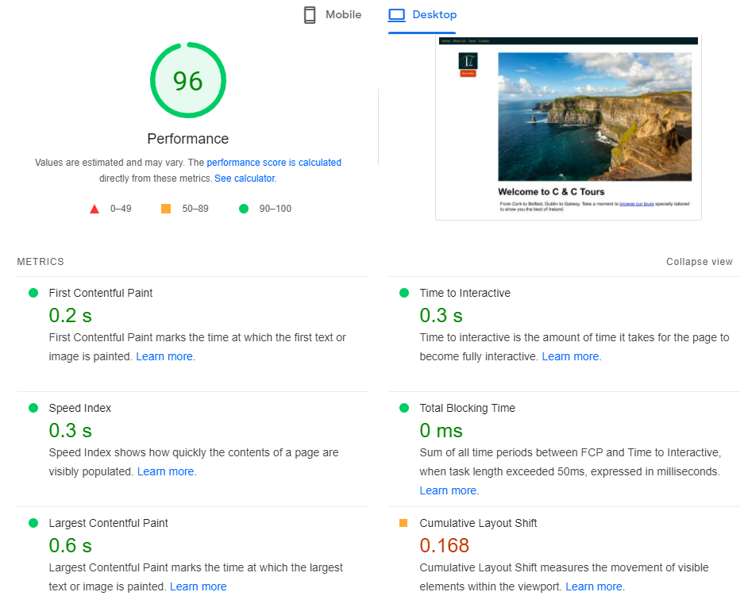

JavaScript Form Validation Testing:
As you can see using the tizag example as a basis our form on the contact page returns a message if the email address is not inputted in the correct format.

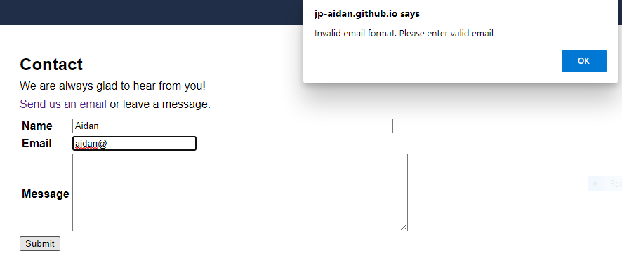

This is a second example of JavaScript testing on our booking page form. A message pops up when the Book button is pressed if the first name entry field is left empty.

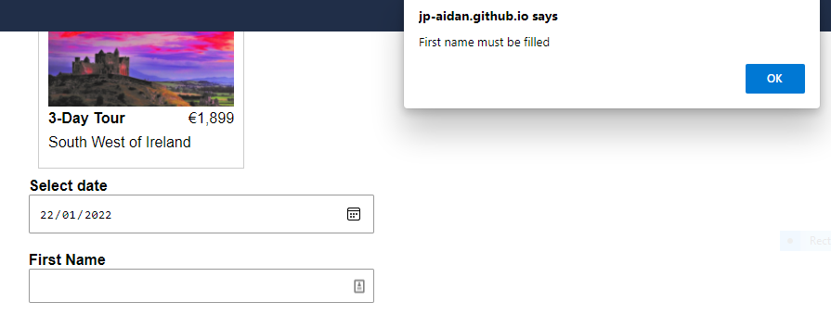

Section 5: Project Team

There were no team issues in this group as we had worked together on other modules in this Higher Diploma and the working relationship has always been good, efficient and productive.

There was a constructive debate at the start of the project in relation what industry and what kind of business we would cover. Another area that had to be decided was the layout of the pages and how the pages would link together. Once those points were ironed out and the wireframing and sitemap drawn out the coding process could begin.
The HTML and CSS were shared between both of us. One of us had some done some JavaScript before this program so they were able to concentrate on some of the trickier aspects with that. While the other member of the group had worked previously in the tourism industry, so they covered a lot of the dialogue that was on the pages that appeared on the website.

Section 6: Conclusion

In the end we were happy with the website we produced. We tried to design it as best we could sticking to the marking scheme but also trying to input some personal touches to make it look professional and up to industry standards. We think we created a clean, professional and user-friendly website for selling small escorted tours of Ireland as we had planned at the outset.

We decided to do the about us page our common page for the CSS test and added links so it makes it easier to change the style on the page.

As can be the case time was an issue and if given a little more of it there would be a few different things that we would have liked to do. We felt another page named “Gallery” would have added to the website as we could have put in some extra images of different locations around Ireland and some of the vehicles that we carry out our tours on like a Mercedes car or mini coach.

A blog page would add to the website and the business also. It would not add visual impact but a blog page with regular postings on topics related to the business is an excellent way for the business to get up higher in Google search rankings and benefit our business when it comes to SEO, Search Engine Optimisation.

A third feature we would implement would be a testimonials page where customers can leave a review on the specific tour that they did. They are a common feature in most travel websites where past passengers leave a review, say if they would recommend the tour and rate the tour from one to five stars. To prevent possible fake reviews from competitors we would make users input their full name and booking number from their tour with us. This would prevent fake reviews damaging the business reputation as can happen with people creating fake profiles on platforms such as TripAdvisor and Yelp.

Another option we would have liked to have more time to tackle was trying to reduce the number of pages. We did try to get the four tour pages on one page using J-Query but due to slow loading issues influencing the speed of the site we choose to go with four individual HTML pages. This resolved the problem and it made the design cleaner.

Even though time was an issue we did make a YouTube channel for the business and went to the extra effort of making a personalised message to market the business and show our appreciation for our semesters work so please make sure you click on the link to the YouTube channel on the site. We hope you enjoy it!

Section 7: References / Appendix

CSO (2021) Central Statistics Office. Available at Tourism and Travel - CSO - Central Statistics Office (Accessed: 21 December 2021) – Website to obtain figures on tourism numbers in Ireland.

Failte Ireland (2021) Ireland’s Tourism Governing Body. Available at Failte Ireland - Irish Tourism Trade Support | National Tourism Development Authority | (Accessed: 21 December 2021).

Tourism Ireland Media Room (2021). Available at Tourism Ireland Media Room- Images and Video (Accessed: 21 December 2021) – Website we used for many of the images on the site (had to create an account).

JQuery write less do more (2021). Available at Data | jQuery API Documentation (Accessed: 21 December 2021) - Website for J-Query that gave us ideas to put all the tour pages on one page.

JQuery user interface (2021). Available at https://jqueryui.com/tabs/ (Accessed: 21 December 2021) – Tabs idea for our all in one webpage.

Erack Network (2003-2008) Tizag. Available at Javascript Tutorial - Form (tizag.com) (Accessed: 21 December 2021) - This website gave us a basis to work from for the booking and contact page forms.

Stack Overflow (2021). Available at https://stackoverflow.com (Accessed: 21 December 2021) – Ideas for the validation forms.

Wix Logo Maker (2021). Available at Log In | Wix (Accessed: 21 December 2021) - This website after creating an account allowed us to make the business logo.

Craig Shoemaker (2020) Building Websites with HTML, CSS, and JavaScript: Getting Started. Available at Sign In | Pluralsight (Accessed: 21 December 2021) - Some of the ideas for HTML and CSS came from this URL.

Formspree (2021). Available at https://formspree.io (Accessed: 21 December 2021) – API service for email management.

