The following project it’s a rest api designed to be a forum in wich authors can post topics and also reply to topics already existent.

The subject of the forum are TV and Cine related, and this API will get data from an extern API to register Medias at the moment of creating Topics.

There’s an endpoint to see all the media registered, and it is:

[GET] /medias

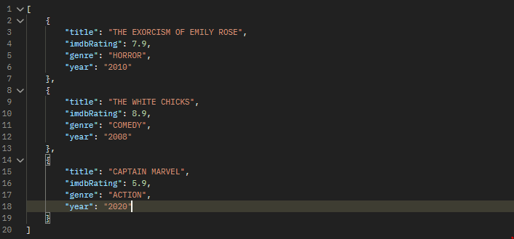

To create a topic, a post requisition need to submited at endpoint “/topics”, as the image bellow shows. The JSON must follows exactly what is shown in the image.

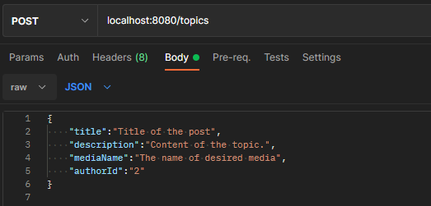

There’s some ways to read topics:

- see all topics: [GET] /topics:

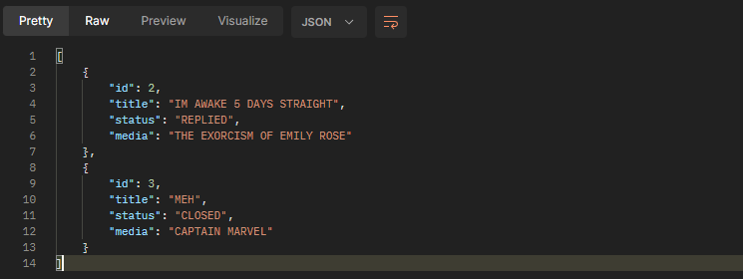

- see an specific topic: [GET] /topics/id

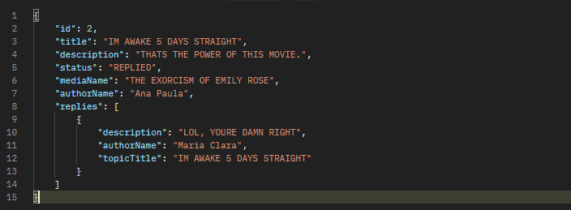

- By media name: [GET]/ topics?mediaName=

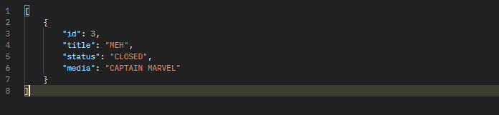

As you can see, the only method that comes with all information about the topic – replies inclued – is the second option.

To post a reply, a POST requisition should be done at the following endpoint:

- Post reply: [POST] /topics/id

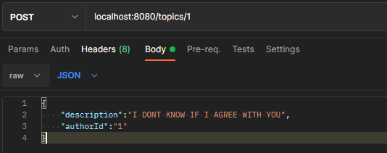

By doing this, it will be created a reply to Topic with ID #1. The JSON must follow image.

To change a topic status to closed, a PUT requisition must be made at the following endpoint:

- Close topic: [PUT]/topics/id



No JSON must be sent. Just the requisition.

Finally, the operation of deleting a Topic is done by a DELETE requisition at:

-Delete Topic: [DELETE]/topics/id



No JSON must be sent. Just the requisition.

It’s only possible to create replies if the topic in question isn’t closed and the API assures that. The deletion is only possible if the topic isn’t closed nor replied. The deletion of replies is not possible at all.

The UML of the entities are in the folder /modeling; the documentation in PDF it’s in the folder DocumentationPDF (and it’s also avaiable at: localhost:8080/swagger-ui.html).