Van Monitor
Getting Started Guide

ESP32-S3 · ST7789T3 Touch Display · Venus OS MQTT

Contents

1. Product Overview 3
Hardware 3
Key Features 3
Connectivity 4
2. Touch Display 5
2.1 Dashboard 5
2.2 Calibrate 6
2.3 System 7
3. Web Interface 8
3.1 Web Dashboard 8
3.2 Settings Menu 9
4. Quick Start 10
4.1 First Power-On 10
4.2 Calibrating the Water Sensor 10
4.3 Connecting to Venus OS 11
4.4 Firmware Updates 11

1. Product Overview
Van Monitor is an embedded monitoring system for campervans and motorhomes, running on an ESP32-S3 microcontroller. It provides real-time visibility of water level and battery/solar status through two interfaces: a compact touch-screen display mounted in the van, and a web dashboard accessible over Wi-Fi from any phone or browser.

Hardware
The device is built around the Waveshare ESP32-S3-Touch-LCD-2 module:
- ESP32-S3 dual-core processor with 8 MB PSRAM
- ST7789T3 colour display — 240 × 320 pixels, 2-inch portrait
- CST816D capacitive touch controller
- QMI8658 IMU (accelerometer/gyroscope, reserved for future use)
- 4–20 mA current loop input for water level sensor (shunt to ADC)

Key Features
Feature | Description
Water level | 4–20 mA loop sensor, 0–2 m range. 2-point calibration for Empty/Full.
Battery & solar | State of charge, voltage, current, solar yield and load — pulled from a Victron Venus OS device via MQTT.
Touch display | 240 × 320 dark-theme UI with three pages: Dashboard, System, and Calibrate. Auto-dims after inactivity; brightens on touch.
Web interface | Responsive single-page app served from the device. Accessible at http://van-monitor.local on the same Wi-Fi network.
OTA updates | Firmware updates pulled from GitHub Releases, triggered via MQTT or the web Settings menu.
mDNS hostname | Device advertises itself as van-monitor.local — no need to remember an IP address.

Connectivity
Van Monitor connects to your existing Wi-Fi network as a client. Once connected it is reachable at https://van-monitor.local. The device also subscribes to a Venus OS MQTT broker (port 1883) to receive battery and solar data, and publishes water-level readings back to the broker.

2. Touch Display
The 240 × 320 touch display uses a dark theme designed for low-light cabin use. Three pages cycle with a tap on the nav bar at the bottom of the screen. The display dims automatically after 30 seconds of inactivity and brightens on the next touch.

2.1 Dashboard
The Dashboard is the default screen, showing the two most important readings at a glance.

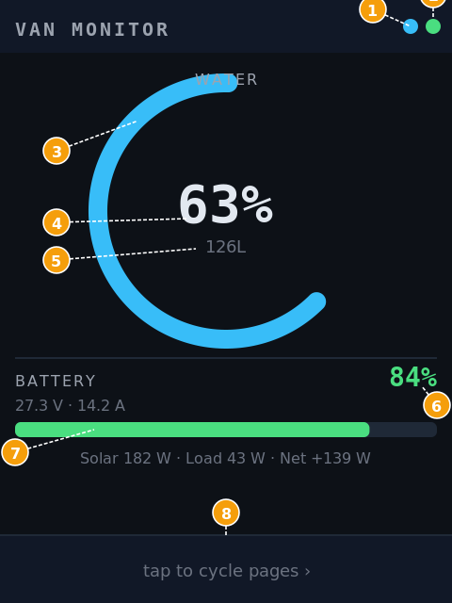  Figure 1 — Dashboard screen | 1 Wi-Fi indicator — Cyan dot = connected; grey = no link.  2 MQTT indicator — Green dot = broker connected; grey = offline.  3 Water arc — Cyan arc sweeps from empty (bottom-left) to current level. Turns amber below 10 % or above 90 %.  4 Water percentage — Large numeric readout of the current tank fill level.  5 Volume in litres — Calculated from the percentage and the configured tank capacity.  6 Battery SOC — State of charge from Venus OS. Green = normal; red = critical (< 20 %).  7 Battery bar — Visual bar of battery SOC. Shows voltage and current on the row above.  8 Nav button — Tap anywhere in this bar to advance to the Calibrate screen.

The solar and load power figures appear on the row below the battery bar (e.g. "Solar 182 W · Load 43 W · Net +139 W"). When water is critically low the arc turns amber and a warning banner appears at the top of the screen.

2.2 Calibrate
The Calibrate screen allows the water sensor to be calibrated to match the actual tank. Calibration is a simple two-point process: fill the tank to a known level, press the corresponding button, and the device stores the sensor voltage at that point.

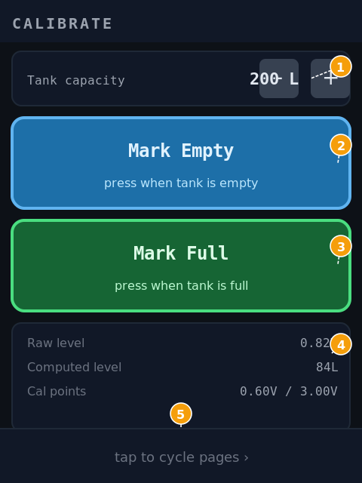  Figure 2 — Calibrate screen | 1 Tank capacity — Set the total tank volume in litres using the − and + buttons (steps of 10 L). This is used to convert the computed depth into a volume reading.  2 Mark Empty — Press when the tank is empty. Records the current sensor voltage as the zero reference.  3 Mark Full — Press when the tank is completely full. Records the current sensor voltage as the full reference.  4 Raw readout — Live panel showing: IIR-filtered voltage (Raw level), computed volume in litres (Computed level), and the two stored calibration voltages (Cal points).  5 Nav button — Tap to advance to the System screen.

Calibration values are stored in non-volatile storage (NVS) and survive power cycles.

2.3 System
The System screen shows the device's network identity and connection status, useful for confirming the device is properly connected.

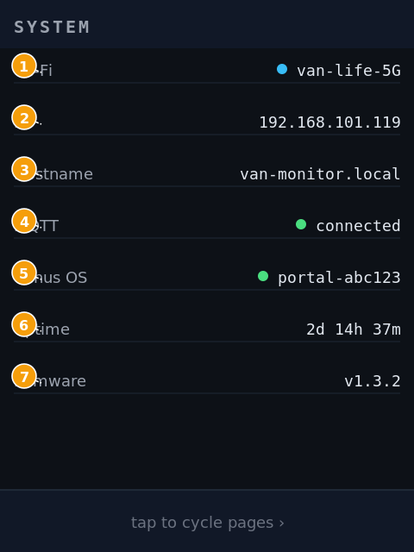  Figure 3 — System screen | 1 Wi-Fi network — SSID of the connected Wi-Fi network. Dot colour reflects link state.  2 IP address — Current IPv4 address assigned by DHCP.  3 Hostname — mDNS name — use this in your browser, e.g. http://van-monitor.local.  4 MQTT status — "connected" with a green dot when the Venus OS broker is reachable.  5 Venus OS portal — The portal ID string from the Venus OS MQTT topic hierarchy.  6 Uptime — Time since last power-on or firmware reset.  7 Firmware version — Running firmware version, e.g. v1.3.2.

3. Web Interface
The web interface is served directly from the device and is accessible on any phone, tablet, or laptop on the same Wi-Fi network. Open a browser and navigate to:
http://van-monitor.local
The interface mirrors the three-tab structure of the touch display, with additional controls available in the Settings menu.

3.1 Web Dashboard
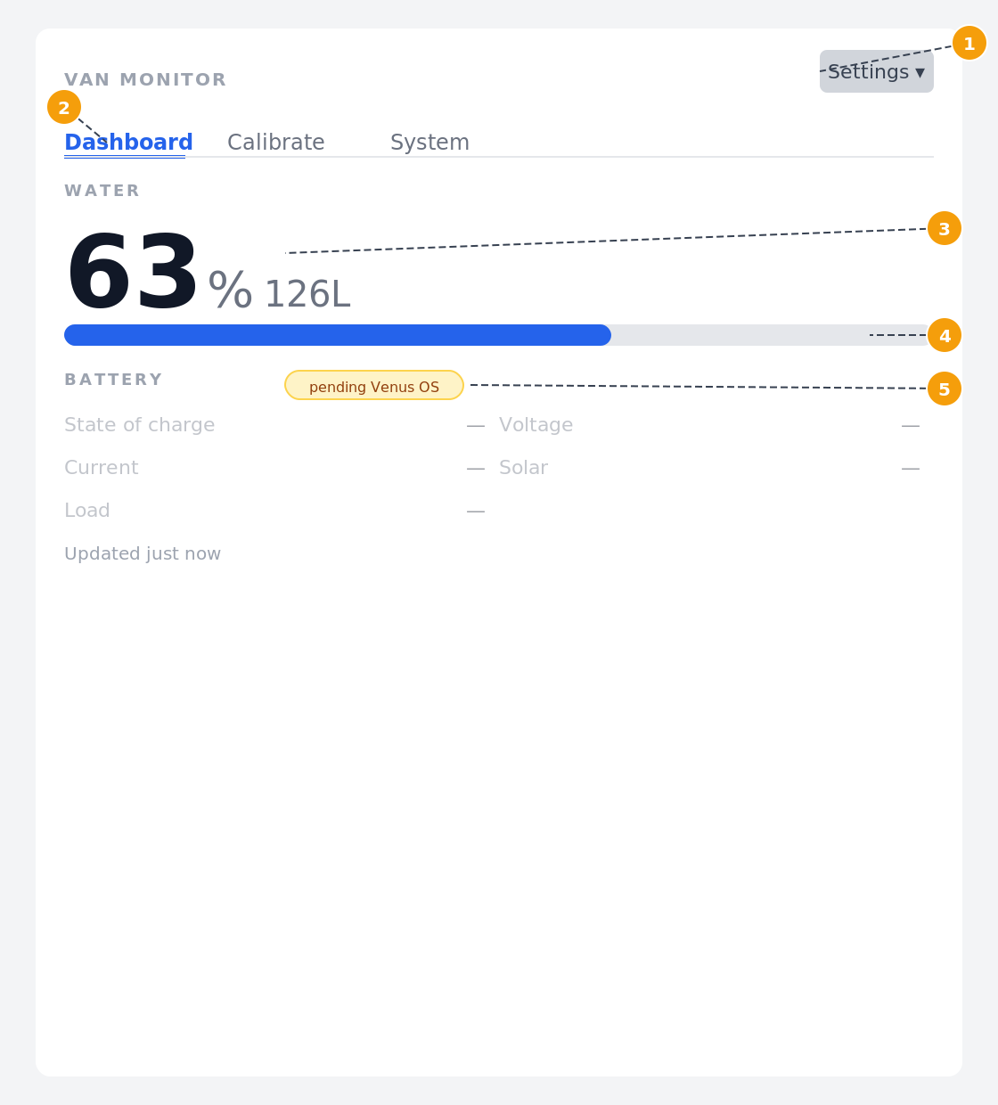
Figure 4 — Web dashboard (Dashboard tab)
- 1 Settings menu — Access Wi-Fi configuration, firmware update (OTA), device information, and security settings.
- 2 Tab bar — Switch between Dashboard, Calibrate, and System views. The active tab is highlighted in blue.
- 3 Water level readout — Current tank fill as a large percentage with volume in litres. Updates automatically every few seconds.
- 4 Water gauge bar — Visual fill indicator scaled to 0–100 %.
- 5 Battery section — Shows SOC, voltage, current, solar yield, and load. The "pending Venus OS" badge indicates MQTT is not yet configured; once connected, live values populate automatically.

3.2 Settings Menu
The Settings menu (top right of any page) provides access to:
- Wi-Fi — change the network the device connects to
- Firmware — trigger an over-the-air update, view partition status
- Device — view chip ID, MAC address, partition table
- Security — configure HTTP basic authentication
- About — firmware build info and framework version

4. Quick Start

4.1 First Power-On
On first boot, Van Monitor creates a Wi-Fi access point named VanMonitor with password vanmonitor. Connect your phone or laptop to this network, then open http://192.168.4.1 to reach the setup interface.

1. Change the default password
Go to Settings → Security and set a new password before doing anything else. This secures the web interface before the device joins your network.

2. Connect to Wi-Fi
Go to Settings → Wi-Fi, enter your home or vehicle network credentials, and save. The device will reboot and join your network. Once connected, the web interface is available at http://van-monitor.local.

3. Set the tank capacity
On the touch display, go to Home → Calibrate and use the − and + buttons to set the total tank volume in litres. This is used to convert the sensor reading into a volume. The empty and full calibration points are best set on the device once the tank is at a known level — see section 4.2.

4.2 Calibrating the Water Sensor
Before the water level reading is meaningful, the sensor must be calibrated to match your tank:
- Ensure the tank is completely empty (or at a known reference level).
- On the touch display, navigate to the Calibrate screen and tap Mark Empty.
- Fill the tank completely.
- Return to the Calibrate screen and tap Mark Full.
- Set the tank capacity in litres using the − / + buttons, then navigate away to save.
The same steps can be performed from the Calibrate tab of the web interface.

4.3 Connecting to Venus OS
To receive battery and solar data, configure the Venus OS MQTT broker address in the device settings. Van Monitor expects the broker on port 1883. Once connected, the MQTT dot on the display will turn green and all battery fields will populate.

4.4 Firmware Updates
Van Monitor supports over-the-air (OTA) updates. When a new firmware release is available:
- Open the web interface and go to Settings → Firmware.
- Click Check for Updates. If an update is available, click Install.
- The device will download and apply the update, then reboot automatically.

