MBA Project Report

A Study of Quality Assurance to Improve Operations Management in Automotive & Engine Manufacturing Sector

Case Study: Tata Motors
This section presents an in-depth case study of Tata Motors, focusing on its quality assurance frameworks, lean manufacturing practices, and continuous improvement methodologies. Tata Motors has implemented IATF 16949 standards, automated inspection systems, and supplier quality audits to enhance reliability.

Sample Quality Performance Data
Year | Defect Rate (%) | Production Volume
2020.0 | 4.5 | 450000.0
2021.0 | 3.8 | 470000.0
2022.0 | 3.1 | 520000.0
2023.0 | 2.4 | 560000.0

Defect Rate Trend Chart
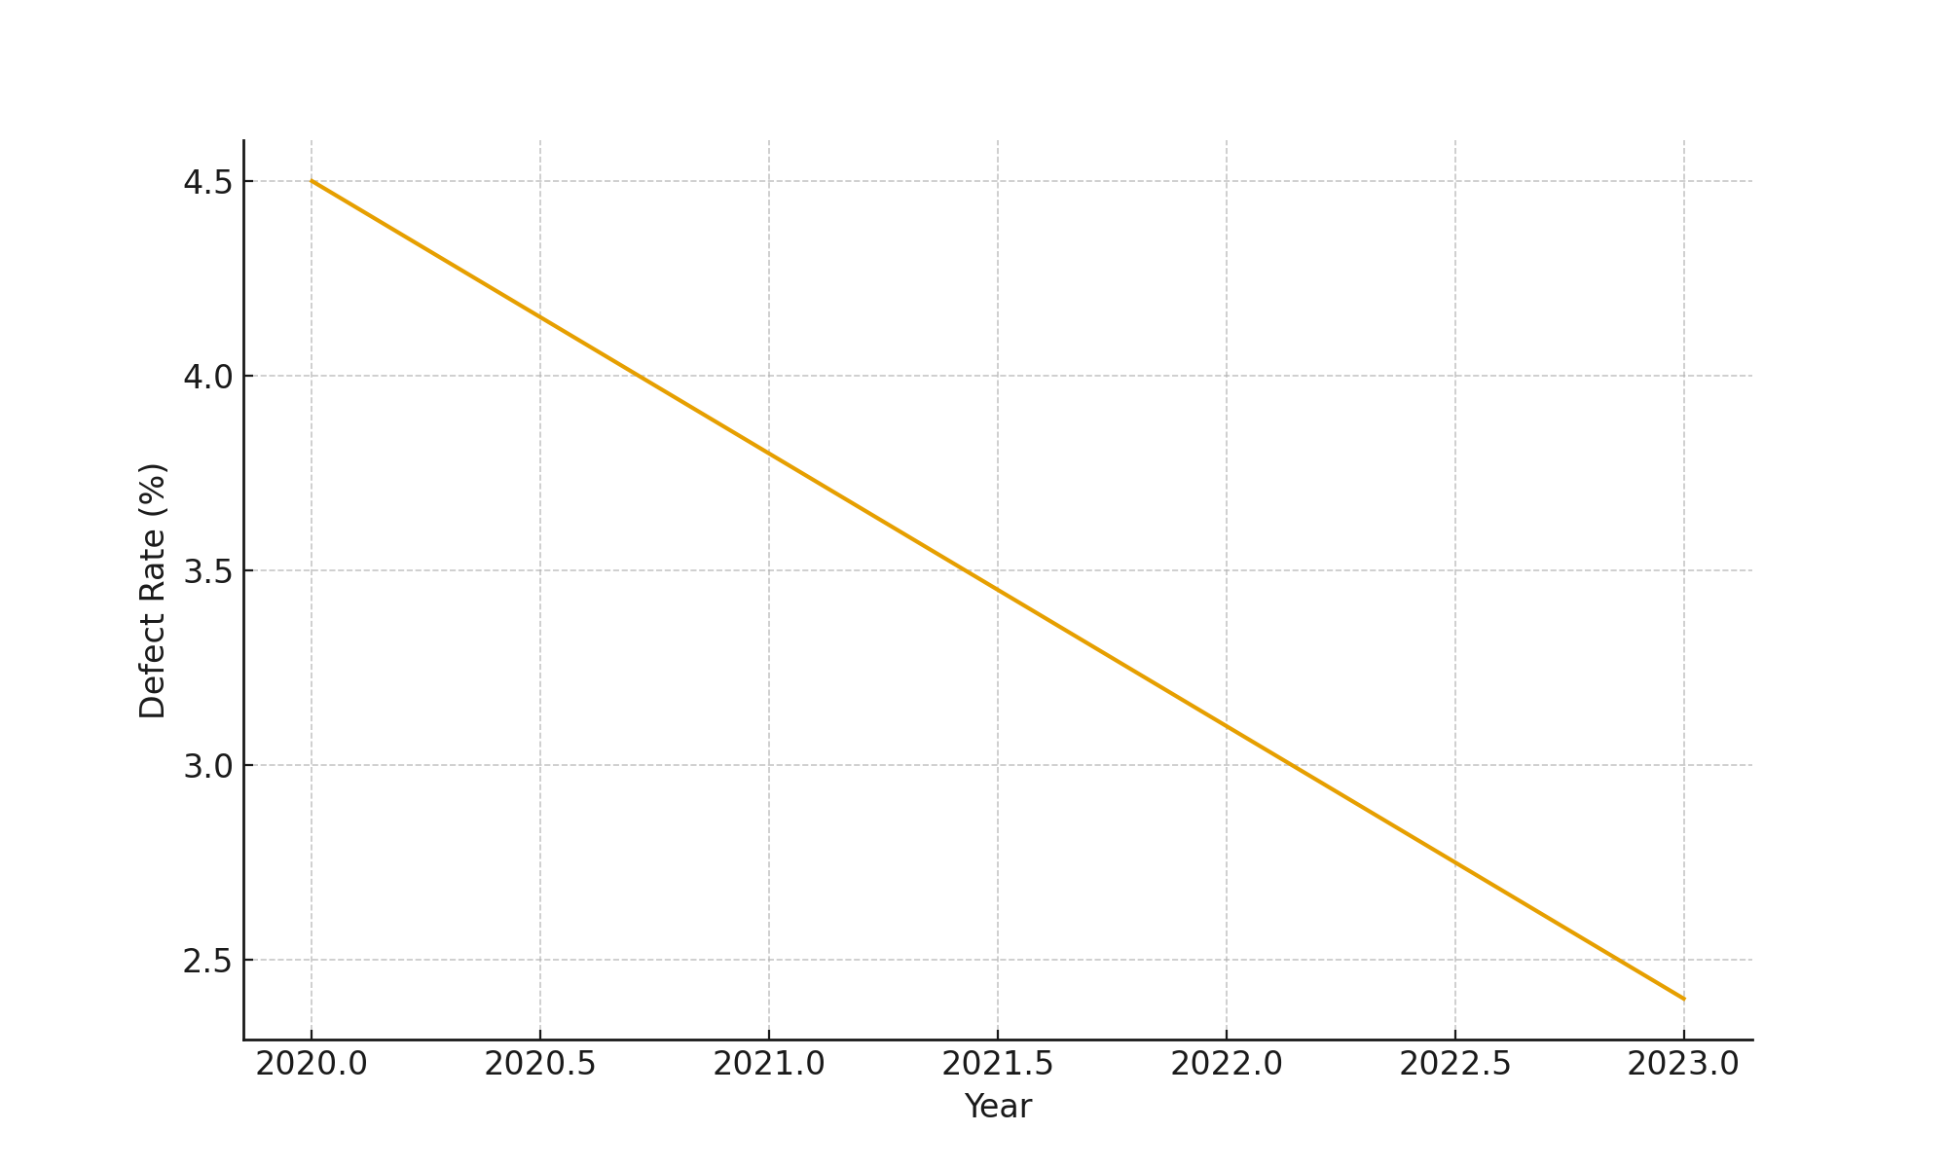

Questionnaire
1. How effective are the current QA practices in your organization?
2. What challenges do you face in implementing QA procedures?
3. How frequently do quality audits take place?
4. Are employees trained regularly on QA tools?
5. What improvements do you believe can enhance operational efficiency?

Questionnaire Analysis
Analysis of the questionnaire responses indicates a strong need for continuous improvement training, greater automation, and enhanced supplier quality monitoring. Respondents commonly highlighted delays in inspection processes and lack of advanced testing tools as major concerns.

