B10915045

4Var.pla

.i 4

.o 1

.ilb a b c d

.ob f

.p 3

1-11 1

-110 1

010- 1

.e

4Var.dot

digraph ROBDD {

{rank=same 1}

{rank=same 2}

{rank=same 3}

{rank=same 5}

{rank=same 6}

{rank=same 7}

{rank=same 11}

{rank=same 13}

0 [label="0", shape=box];

1 [label="a"];

2 [label="b"];

3 [label="b"];

5 [label="c"];

6 [label="c"];

7 [label="c"];

11 [label="d"];

13 [label="d"];

16 [label="1", shape=box];

1 -> 2 [label="0", style=dotted]

1 -> 3 [label="1", style=solid]

2 -> 0 [label="0", style=dotted]

2 -> 5 [label="1", style=solid]

3 -> 6 [label="0", style=dotted]

3 -> 7 [label="1", style=solid]

5 -> 16 [label="0", style=dotted]

5 -> 11 [label="1", style=solid]

6 -> 0 [label="0", style=dotted]

6 -> 13 [label="1", style=solid]

7 -> 0 [label="0", style=dotted]

7 -> 16 [label="1", style=solid]

11 -> 16 [label="0", style=dotted]

11 -> 0 [label="1", style=solid]

13 -> 0 [label="0", style=dotted]

13 -> 16 [label="1", style=solid]

}

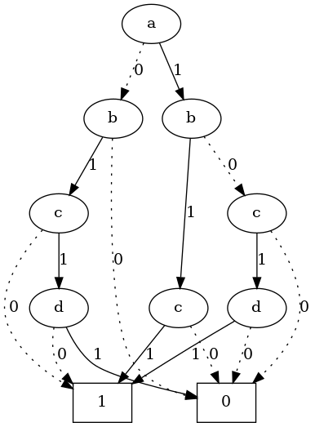

5Var.pla

.i 5

.o 1

.ilb a b c d e

.ob f

.p 6

10-01 1

-010- 1

010-1 1

1-010 1

0-101 1

--1-1 1

.e

5Var.dot

digraph ROBDD {

{rank=same 1}

{rank=same 2}

{rank=same 3}

{rank=same 4}

{rank=same 6}

{rank=same 7}

{rank=same 9}

{rank=same 12}

{rank=same 14}

{rank=same 19}

{rank=same 25}

0 [label="0", shape=box];

1 [label="a"];

2 [label="b"];

3 [label="b"];

4 [label="c"];

6 [label="c"];

7 [label="c"];

9 [label="d"];

12 [label="d"];

14 [label="d"];

19 [label="e"];

25 [label="e"];

32 [label="1", shape=box];

1 -> 2 [label="0", style=dotted]

1 -> 3 [label="1", style=solid]

2 -> 4 [label="0", style=dotted]

2 -> 19 [label="1", style=solid]

3 -> 6 [label="0", style=dotted]

3 -> 7 [label="1", style=solid]

4 -> 0 [label="0", style=dotted]

4 -> 9 [label="1", style=solid]

6 -> 12 [label="0", style=dotted]

6 -> 9 [label="1", style=solid]

7 -> 14 [label="0", style=dotted]

7 -> 19 [label="1", style=solid]

9 -> 32 [label="0", style=dotted]

9 -> 19 [label="1", style=solid]

12 -> 19 [label="0", style=dotted]

12 -> 25 [label="1", style=solid]

14 -> 0 [label="0", style=dotted]

14 -> 25 [label="1", style=solid]

19 -> 0 [label="0", style=dotted]

19 -> 32 [label="1", style=solid]

25 -> 32 [label="0", style=dotted]

25 -> 0 [label="1", style=solid]

}

