Futura AssetTracker
This document details the implementation of AssetTracker from installation through configuration.
- Creating AssetTracker database in SQL Studio
  - Create an AssetTracker database. Right-click on the Databases folder > New Database (Standard naming – Client’s Prefix_AssetTracker - ‘TVL_AssetTracker’)
  - Click on Tools > Restore Database.
Point to the location of the .bak file that has been uploaded with the package file of the latest installer. From the Options tab of the Restore wizard check “Overwrite the existing database” and change the Restore As path to the database name.
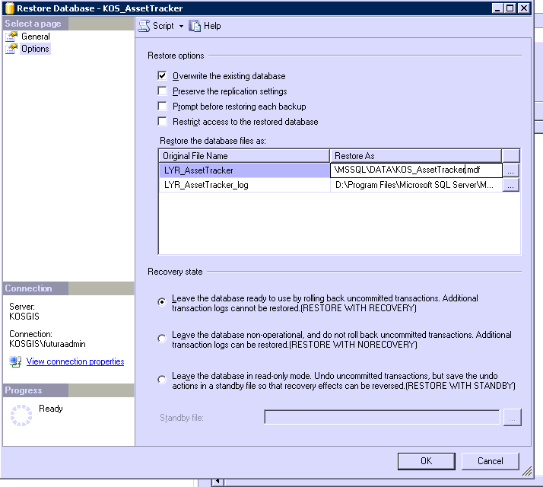
If this is an upgrade the sql query needs to run to update the existing database. Compare the database version in the latest installer package files to the existing database version to see if an upgrade is needed.
- Configure SDM before installation
  - Make sure the AssetTracker database name has been configured in the Setting > Common in Server Deployment Manager before installing.

- Creating Service
  - Beginning with 3.0 the service is now an instance withing the GSP service. To add the instance go to Start > Futura Systems > FuturaGIS > Configure FuturaGDP
  - From the Instances tab click New to add the new instance.
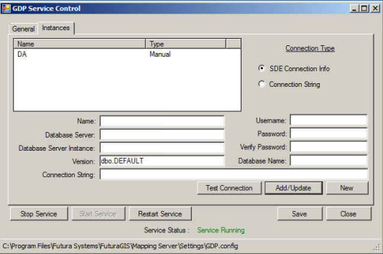
  - Enter the connection information. After testing the connnection click Add/Update to add the ASSETTRACKER instance. Then save the settings.
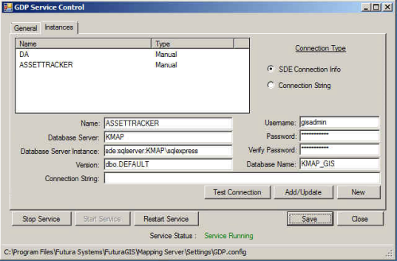
- Creating views
  - The views should be created automatically in a 10.1 database. This can be confirmed by looking in SQL Studio under the GIS database’s Views. If the views for the asset and bank tables are missing then the create tables tool will need to be ran.
  - Start > Program Files > Futura Systems > AssetTracker > Create\Delete View
  - Service #: 5152
  - Username and password – gisadmin
  - Create
If it is SQLEXPRESS use the following settings.
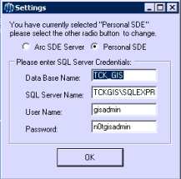
- Make sure to install Crystal Report located ftp://ftp.futuragis.com/Support/GISServerSetupDVD/Deployment/FuturaSystems/FuturaWeb/
Copy CRDevelopment folder to client’s server

- Test – http://servername/assettracker
Login username and password: admin, admin

-Setup > Manage Settings > Server Setup
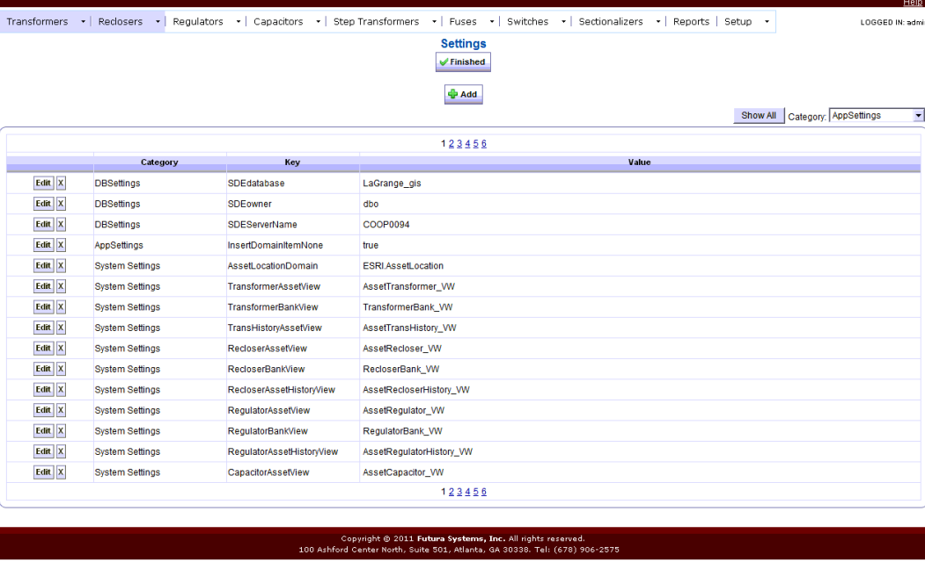
Also change the remote host name on the last page.
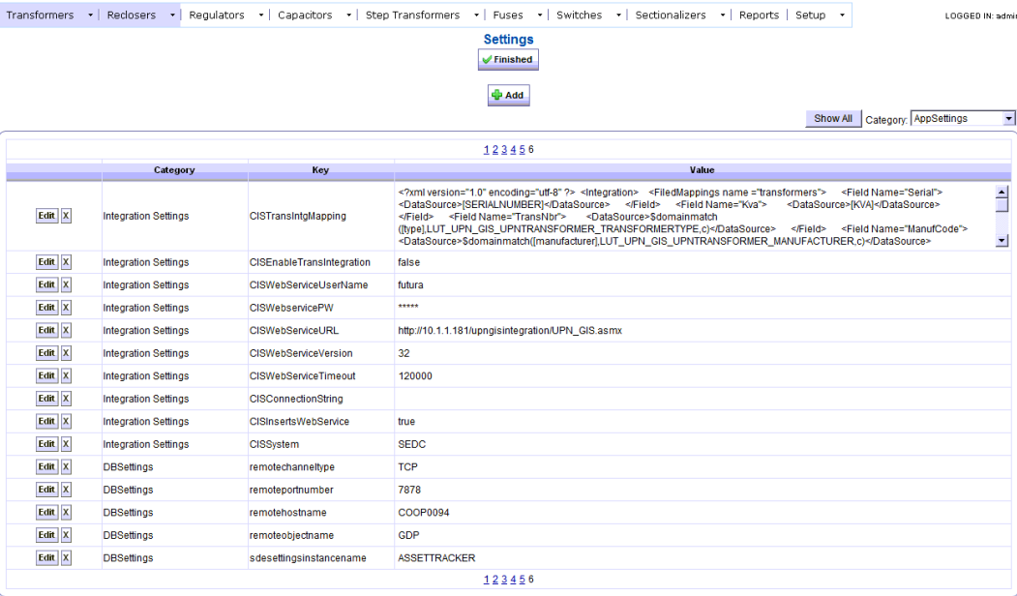

-If they are SQL Express the Manage Settings in AssetTracker will be the same. However, the the web.config in inetpub must contain the path to the servername\sqlexpress.
-If they have Futura Webmap configure the WebMapUrl with the following settings:
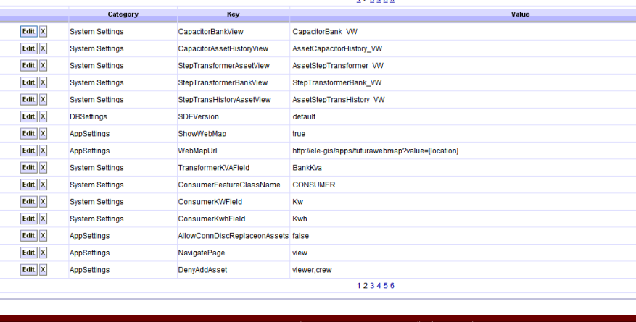

-Make sure the following behavior has been configured in Futura Webmap.
- Go to Tools -> Behaviors -> Manage.
- Add a new Map Behavior named ViewMap
- Make sure one of the layers and fields is the TransformerBank Mapnumber
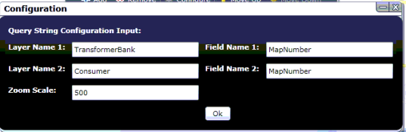

-To update domain, go to Setup. Choose Populate Domain Tables.
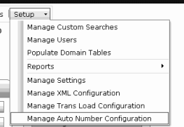

Note –The default username and password is futurasa, n0tfuturasa. Some client’s username and password is sa, n0tsa. To change the credentials - Inetpub\wwwroot\AssetTracker\web.config. Use Find tool.

Configuring Views
Go to the Manage XML Configuration on the setup tab to configure the Asset Tracker views.
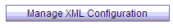
Drop Down Lists, Dynamic Tables, and Grid Colums will appear in the Choose XML menu
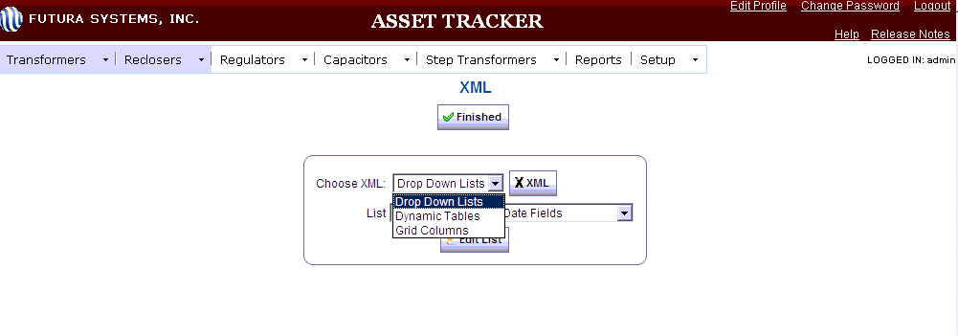
Grid Colum is the view seen on each Assset’s home tab
Example:
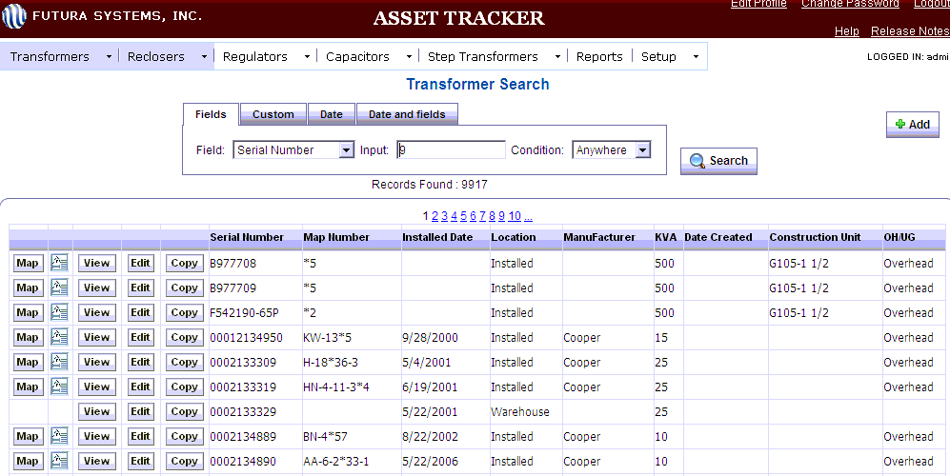
Dynamic Table is the view seen when looking at a specific Asset. Equipment references fields from the Asset table while Location references fields from the Bank table.
Example:
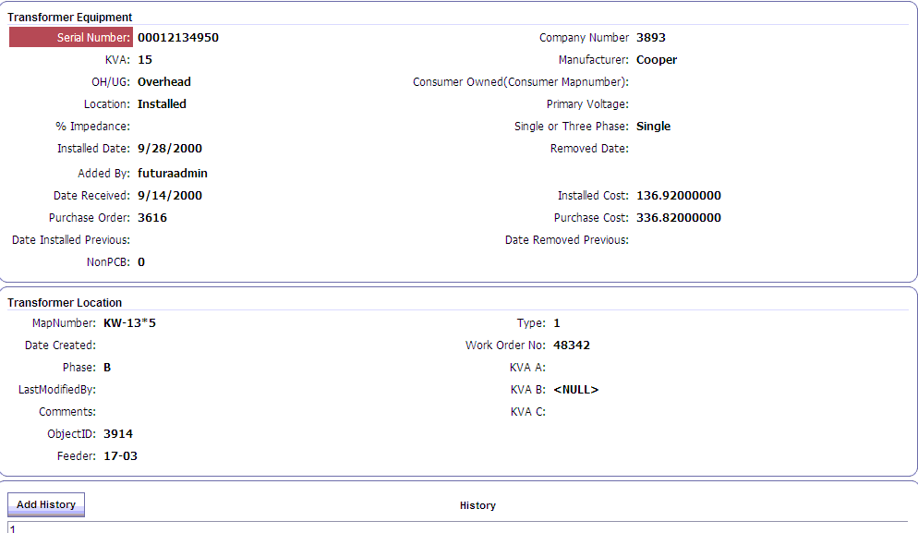
Fields can be added, deleted, and rearrange on the view from the XML Page Layout. The arrows can move both fields in the row up or down and delete will delete the entire row. The FuturaGUID and BankGUID must be in the Dynamic Table view for Equipment, but Deny View can be checked for all permission levels. If these fields are not in the Dynamic Table the related bank will not appear in the Location View
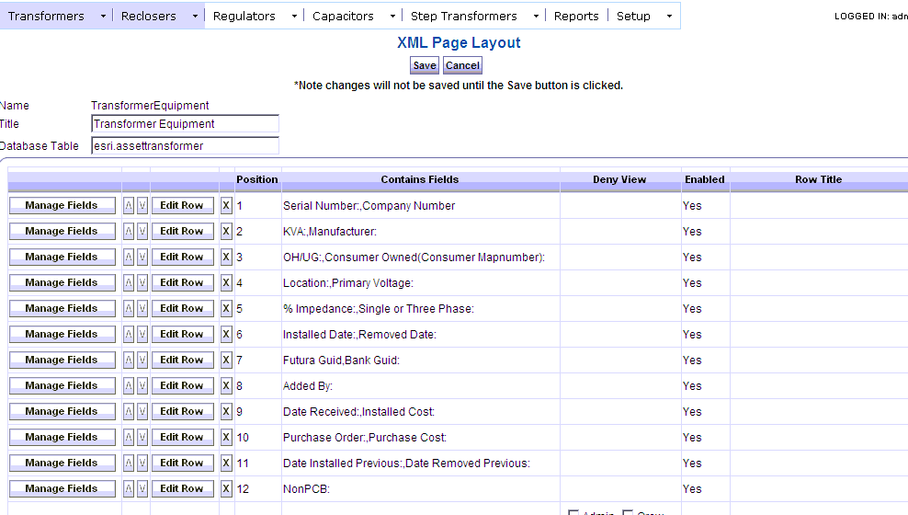
To edit the fields in the row hit Manage Fields. The row position of each field can be changed individually from here.
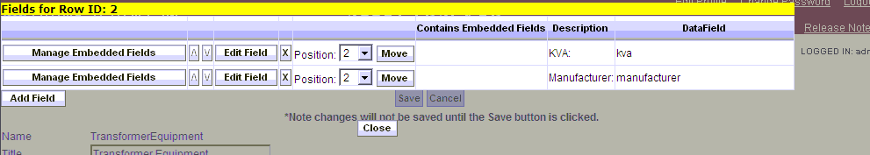
Click Edit Field to make change to a field’s properties.
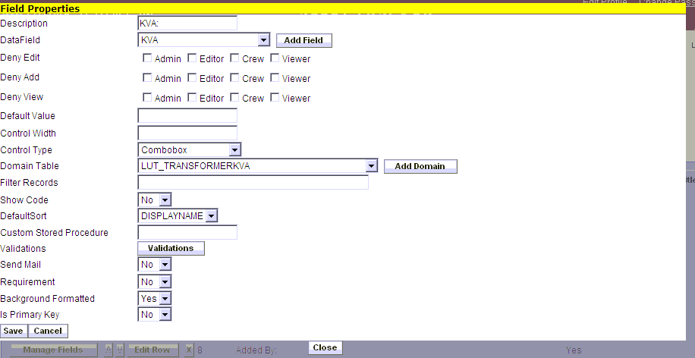
The description field can be different than the data field. If the data field says OTHER that means the field it is looking for is no longer in the table or is spelled differently. If the Control Type is just a text field it will be SingleLineTextBox. Combobox is used if the field is referencing a domain. A list of all domains from the database will appear with the prefix LUT is the Populate Domains tool ran properly. Note: If upgrading from an older version the domains will not be referecing the lookup tables. They will have the domain name typed out. Ex. ESRI.TransformerKVA. Please check all fields to change the domains to the lookup tables.

