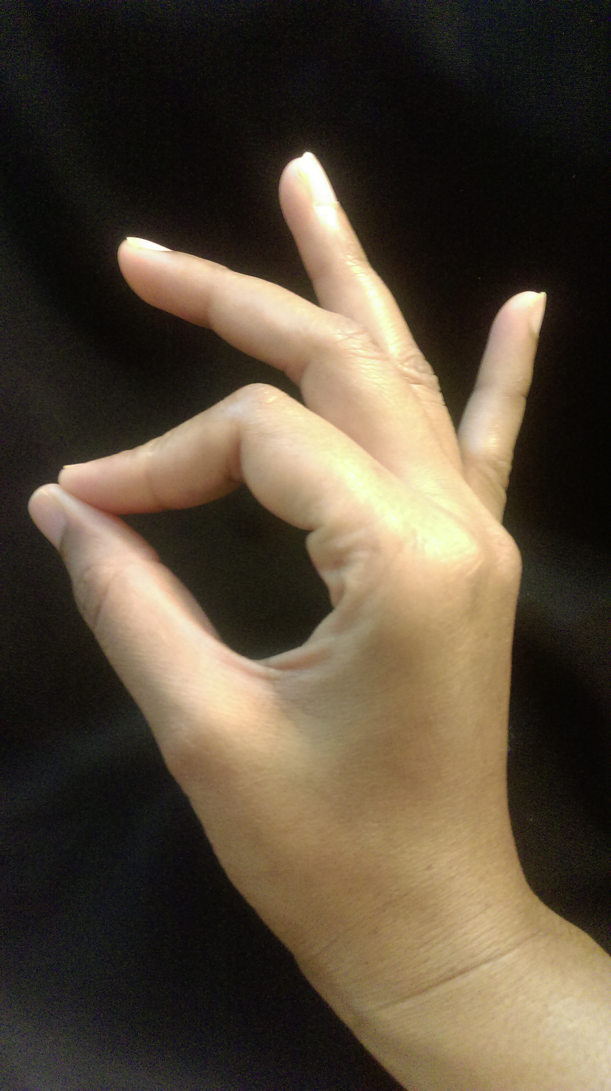

KATHAK
TAAL NOTATION

Free ebook from Kathak Odyssey

Draft I
Dec 31st 2016

Feel free to share this ebook, as long as its left completely intact unaltered and delivered via this PDF file. You may republish excerpts as long as they are accompanied by an attribution link back to https://kathakodyssey.blogspot.com.
This work is licensed under a Creative Commons Attribution-NonCommercial-ShareAlike 4.0 International License
© https://kathakodyssey.blogspot.com

Preface

Welcome to Kathak Odyssey!

Kathak Odyssey is a blog created by a student to other kathak students all over the world. This blog was born out of my disappointment to the dearth of digital content for millennial kathak students. And also my fear of losing my notes I received in my class which were merely bunch of loose papers pushed me to convert them to digital. However, I can't emphasize enough the importance of practicing writing these compositions with notation on paper.
I hoped to help other students in the same boat and found amazing response to my blog. I am a huge fan of open source which is a model that encourages open collaboration and free distribution. Which is why I am working towards making this blog a universal kathak platform and I invite all kathak students/teachers to contribute or share this resource with attribution.
Thank you for downloading the first free kathak ebook that you can find online (please let me know if you find other similar resources).

Introduction

As you may or may not know kathak education has levels that is followed some by dance institutions. Following are the levels -
- Prarambhik/Beginner
- Elementary/Praveshika Pratham
- Praveshika Purna/ Intermediate
- Madhyama Pratham/ Pre-Diploma
- Madhyama Purna/ Diploma
- Visharad Pratham/ B.A. Part 1
- Visharad Purna/ B.A. Part 2
- Alankar Part 1/ M.A. Part 1
- Alankar Part 2/ M.A. Part 2

In this ebook you will find taals that you learn in beginner/elementary or intermediate kathak classes but it may not be in that this order. Taal in Kathak is nothing but rhythm. Usually any composition you learn are based on a taal. This ebook illustrates 5 types of taal – Teentaal, Jhaptaal, Ektaal, Dadra and Keherva each followed by its definition, notation and 2 links.
Notation is to kathak dance like grammar is to language or syntax is to programming language. The beats, khali and taali are color coded for any student to get a hang of reading composition with notation. The links that follow are to audio files and a video to follow along to practice the bol with theka.
These audio files are approximately 5 minutes in length which are very useful for practicing footwork or theka. You can also play the audio files online in a loop. I'd love to hear your feedback on the blog. Feel free comment about this ebook there or online channels on soundcloud and youtube.

TEEN TAAL

- Beats 16
- Sections 4
- Khali 9
- Taali 1st, 5th, 13th

Notation

1 | 2 | 3 | 4
Dha | Dhin | Dhin | Dha |
(x) |  |  |  | 5 | 6 | 7 | 8
 |  |  |  | Dha | Dhin | Dhin | Dha |
9 | 10 | 11 | 12 | (2)
Ta | Tin | Tin | Ta |
(0) |  |  |  | 13 | 14 | 15 | 16
 |  |  |  | Dha | Tin | Tin | Ta |
1 |  |  |  | (3)
Dha
(x)

You can download the Teen Taal audio here and practice theka with the video here Teen Taal Theka

JHAP TAAL

- Beats10
- Sections 4 (2 beats, 3 beats, 2 beats, 3 beats)
- Khali 6th
- Taali 1st, 3rd, 8th

Notation

1 | 2 | 3 | 4 | 5
Dhin | Na | | Dhin | Dhin | Na |
(x) |  | (2) |  | 6 | 7 | 8 | 9 | 10
 |  |  |  | Tin | Na | | Tin | Tin | Na |
1 |  |  |  | (0) |  | (3)
Dhin
(x)

You can find a video of theka here Jhap Taal Theka and download the audio here for footwork practice.

EK TAAL

- Beats 12
- Sections 6
- Khali 3,7 beat
- Taali 1st, 5th, 9th,11th

Notation

1 | 2 | 3 | 4
Dhin | Dhin | Dha | Traka |
(x) |  | (0) |  |  | 5 | 6 | 7 | 8
 |  |  |  |  | Dhin | Na | Kat | Ta |
9 | 10 | 11 | 12 1 |  | (2) |  | (0)
Dha | Traka | Dhin | Na | | Dhin
(3) |  | (4) | (x)

You can find a video of theka here Ek Taal Theka and download the audio here for footwork practice.

DADRA TAAL

- Beats 6
- Sections 2
- Khali 4th
- Taali 1st

Notation

1 | 2 | 3
Dha | Gi | Na |
(x) |  |  | 4 | 5 | 6
 |  |  | Dha | Tu | Na
 |  |  | (0)

You can download the Dadra audio file here to practice footwork.

KEHERVA TAAL

- Beats 8
- Sections 2
- Khali 5th
- Taali 1st

Notation

1 | 2 | 3 | 4
Dha | Gi | Na | Ti |
(x) |  |  |  | 5 | 6 | 7 | 8
 |  |  |  | Na | Ka | Dhin | Na
 |  |  |  | (0)

You can download the keherva audio file here to practice footwork.

Thank you!

Feel free to comment if you find errors in this ebook here. You can also download practice files from online channels like soundcloud and youtube.This ebook is a work in progress so it'll keep updating and I welcome your collaboration.

