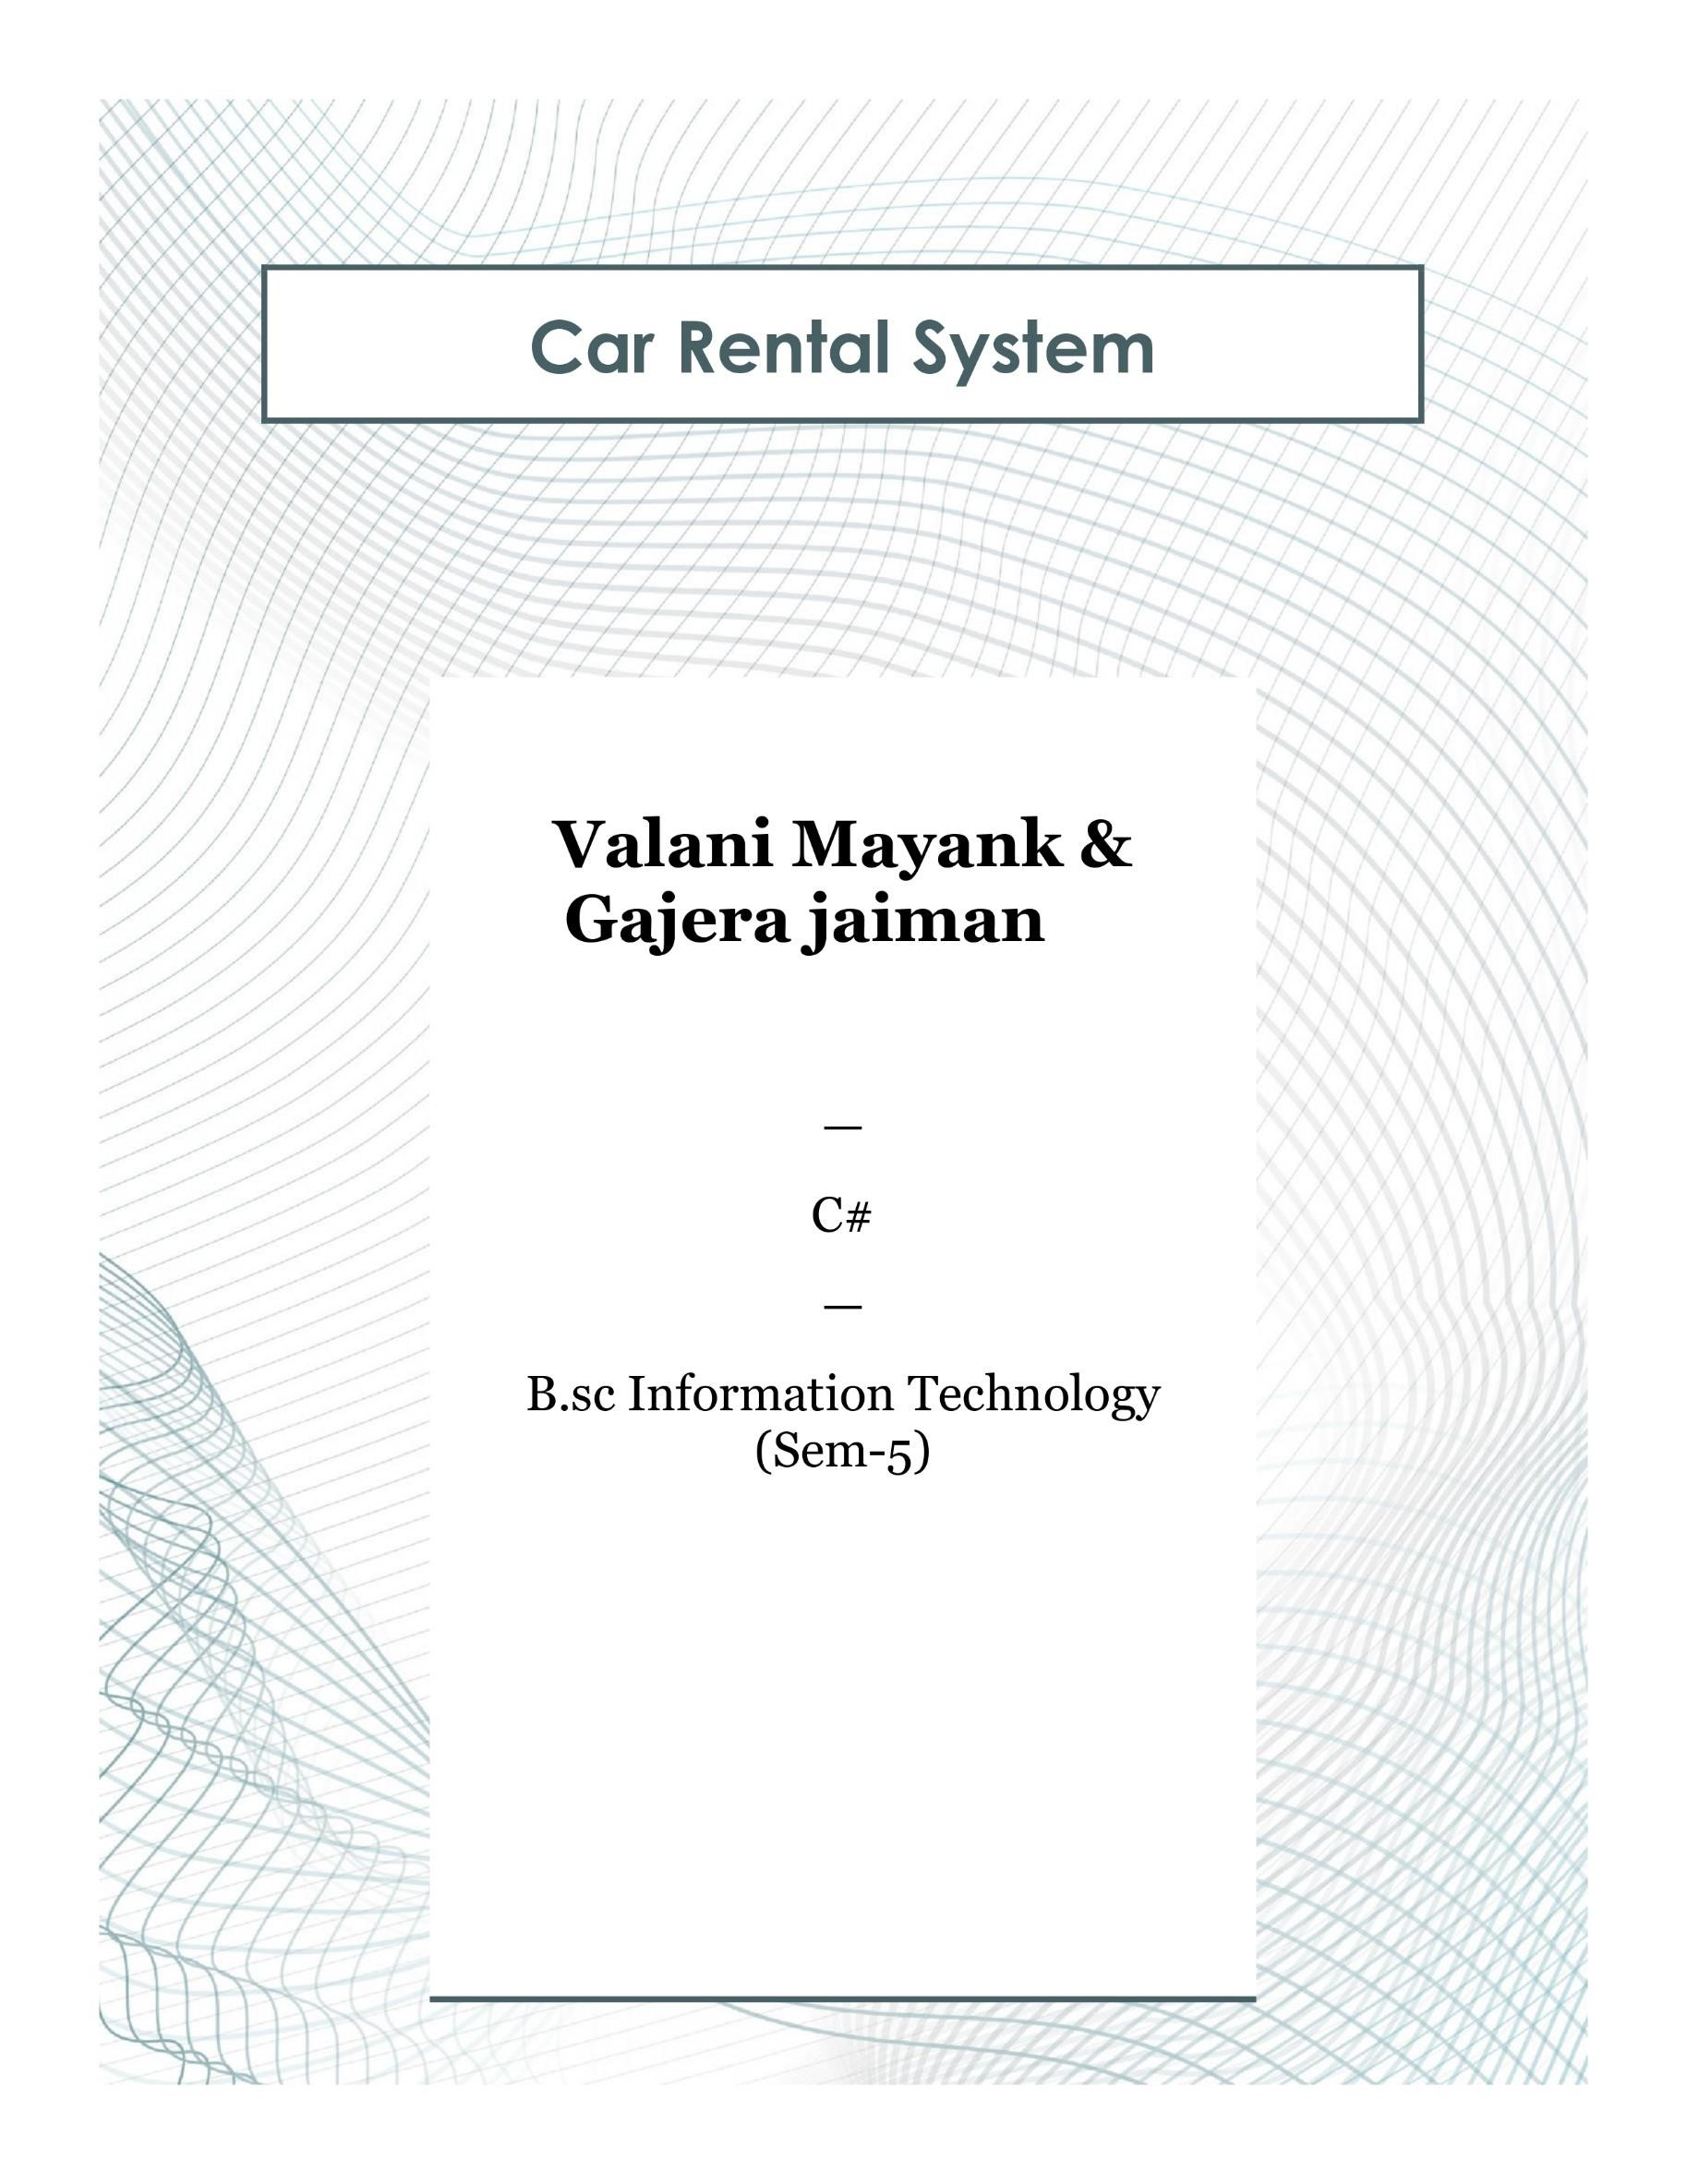

**System Requirements (Hardware and Software)**

**Hardware Requirements:**

* Processor: Intel Core i3 or higher
* RAM: 4GB or higher
* Hard Disk: 500GB or higher
* Monitor: 15" or larger
* Keyboard and Mouse

**Software Requirements:**

* Operating System: Windows 10 or higher
* .NET Framework 4.7 or higher
* Integrated Development Environment (IDE): Visual Studio 2019 or higher
* Database: SQL Server
* Additional Libraries: Entity Framework

**Description About Project**

**Project Description:**

customer information. The goal of the project is to simplify the administrative

tasks involved in renting out cars, improving efficiency and customer service.

**Key Features:**

* Car Inventory Management
* Customer Management
* Rental Booking and Management
* Reporting and Analytics
* User Authentication and Authorization

The project uses C# for the backend and frontend development, leveraging the .NET Framework to create a robust and user-friendly application. The user interface is built using Windows Forms for a seamless and interactive experience.

