**A PROJECT REPORT ON**

# Car Rental System

**SUBMITTED TO:**

**Geetanjali Group of Colleges**

**FRONT END :**

C#.NET

**BACK END :**

SQL SERVER

**AFFILIATED BY :** Saurashtra University

**ACADEMIC YEAR :**

2024-2025

**PROJECT GUIDE:**

**Prof . Pranav Trivedi**

**PREPARED BY:**

## Gajera Jaiman Valani Mayank

**Acknowledgement**

 

* First of all we are sincerely thanked to Saurashtra University for giving a project as a particular subject.
* I am also greatly grateful to our Geetanjali Group of colleges
* I am also greatly grateful to our college. We would like to thanks **Prof. Brijesh Shah** (HOD) for providing us opportunity to prepare this project.
* To complete this project many persons help me. But I am specially thanked to Prof. Kishorsinh Vala for guiding my project analysis and development. They help me conceptualized the idea of the project and also helped me in streamline my work by providing me every facility required
* Not only college and guide help me but all the well wisher who gives me excellent support in during project.
* Thank to all.

## Yours Faithfully,

**Gajera Jaiman**

**&**

**Valani Mayank**

**Preface**

* In 21st Century of Technology, Computer and related service is the most useful, automatic and highly speed of work. Bsc.It is course in which practical aspect is important as theoretical aspect. In the present world importance of education is increasing. The project training in a student’s life is like a live experience in the industry. If we have experience then & then we get top of the level.

* Most Important Factor of **Bsc.It** Course is Project Work. The Project Work is Must for Every Student in Different Government or Private Organization during the Study Period.

* I am developing project in 5th Semester of **Bsc.it** I am the student of Geetanjali Group of Colleges Is Affiliated with Saurashtra University, Rajkot.

* This project report presents the development and implementation of a Car Rental System designed to streamline the process of renting and returning vehicles. The system is intended to automate various aspects of car rentals, including user authentication, car management, rental processing, and return handling. The project was undertaken to enhance efficiency and accuracy in managing car rental transactions and customer interactions.

* I have gone through and study necessary information, which is collected and presented in this report. I am trying my best in this project. I have taken almost care that are information provided in The project is true and project is in a smooth running condition and errorfree.

**Index**

|  |  |  |
| --- | --- | --- |
| **SR.NO** | **TOPICNAME** | **PAGENO.** |
| 1 | Project Profile | 5 |
| 2 | Project Requirement | 6 |
| 3 | Technology Requirement | 7 |
| 4 | Data Flow Diagram | 8 |
| 5 | E-R Diagram | 9 |
| 6 | Data Dictionary | 10 |
| 7 | Test cases | 12 |
| 8 | Screenshots | 13 |
| 9 | Future requirements of project | 24 |
| 10 | Webliography | 25 |

### Project Profile

* **Project Title:** Car Rental System
* **Development Software:** Visual Studio 2022
* **Front End:** C#.NET
* **Back End:** SQL Server
* **Academic Year:** 2024-2025
* **Developed By:** Gajera Jaiman & Valani Mayank
* **Submitted To:** Geetanjali Group Of Colleges
* **Documentation Tool:** Microsoft Word
* **Operating System:** Windows 10

### Project Requirement

* **Processor:** Intel core i3 or higher.

* **RAM:** 8 GB.

* **Hard Disk:** 250 GB or more

**Technology Requirement**

* **Platform:** Intel core i3 or higher.
* **Operating System:** Windows 10
* **Front End Tools:** C#.NET
* **Back End Tools:** SQL Server
* **Editing Tool:** Visual Studio 2022

### Data Flow Diagram

DFD Level ( 1 )

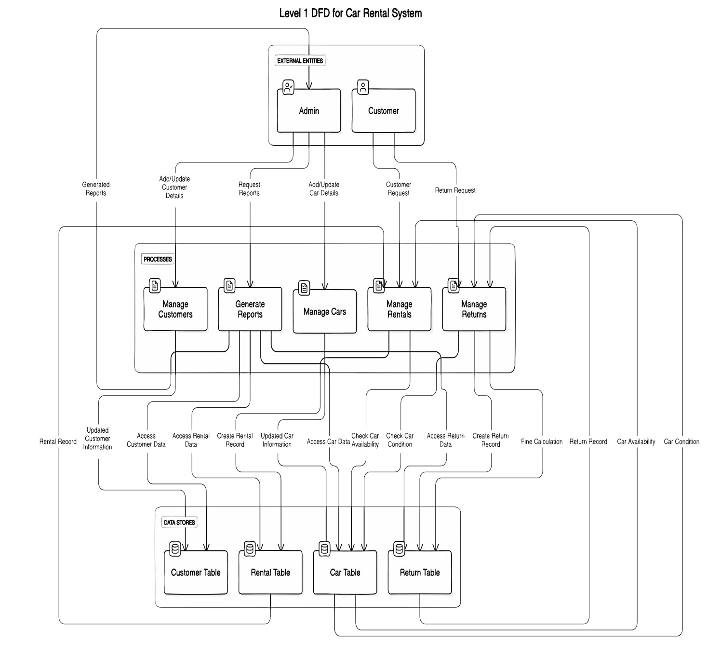

### E-R Diagram

➢ An entity Relationship Diagram (ERD) is a data modeling technique that graphically illustrates an information system’s entities and the relationship between those entities . An ERD is a conceptual and representation model of data used to represent the entity from work infrastructure .

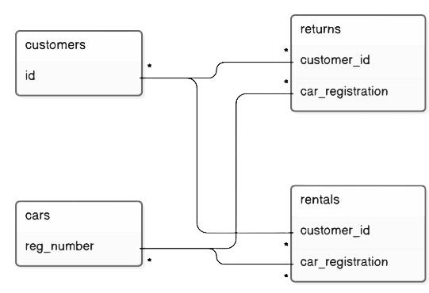

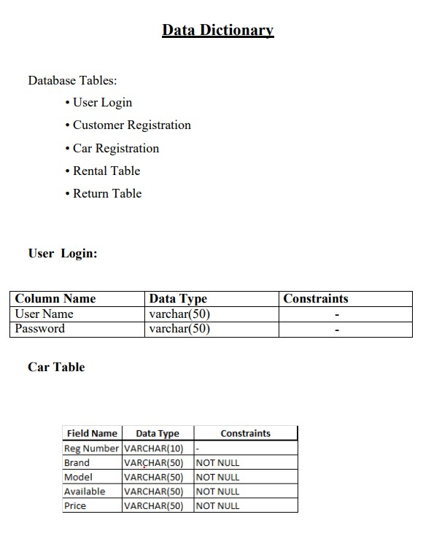

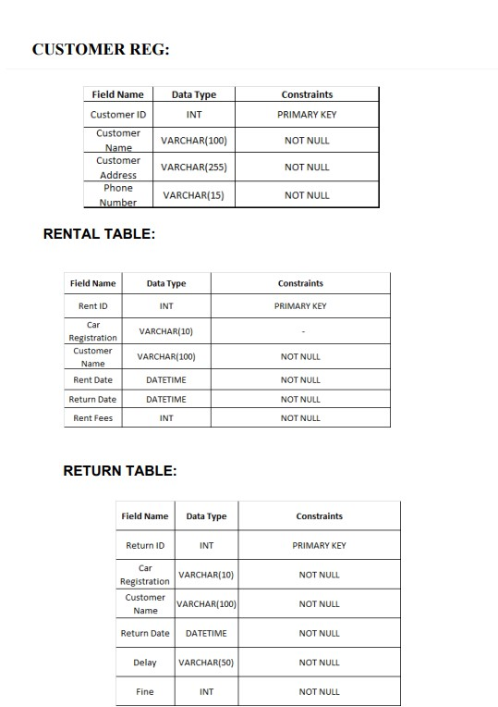

**Test Cases**

|  |  |  |  |
| --- | --- | --- | --- |
| **Case Name** | **Case Description** | **Actual Output** | **Test Result** |
| **Login** | Log in with valid credentials. | User is logged in and redirected to the homepage. | Pass |
| **Login Invalid** | Attempt to log in with invalid credentials. | Error message indicating invalid login credentials. | Pass |
| **Register User** | Register a new user with valid details. | User is successfully registered and can log in. | Pass |
| **Register Existing User** | Attempt to register a user with an already existing email. | Error message indicating the email is already in use. | Pass |
| **Rent Car** | Rent a car with valid details. | Car is successfully rented, and details are recorded. | Pass |
| **Return Car** | Return a rented car within the rental period. | Car is successfully returned, and the rental record is updated. | Pass |
| **View Rental History** | View the rental history for a user. | A list of all past rentals for the user is displayed. | Pass |
| **View Car De-**  **tails** | View details of a specific car. | Details of the specific car are displayed. | Pass |
| **Search Car** | Search for cars based on various filters (e.g., make, model). | List of cars matching the search criteria is displayed. | Pass |
| **Add Admin** | Create a new admin user. | Admin user is created and has admin privileges. | Pass |
| **Remove Admin** | Remove an existing admin user. | Admin user is removed from the system. | Pass |
| **View Available Cars** | View a list of cars available for rent. | List of currently available cars is displayed. | Pass |
| **Add Car** | Add a new car to the inventory. | Car is successfully added and listed in the available cars. | Pass |
| **Remove Car** | Remove an existing car from the inventory. | Car is successfully removed from the inventory. | Pass |
| **Update Car De-**  **tails** | Update details of an existing car. | Car details are updated and saved. | Pass |

### Screen Shots

**Loding Page:**

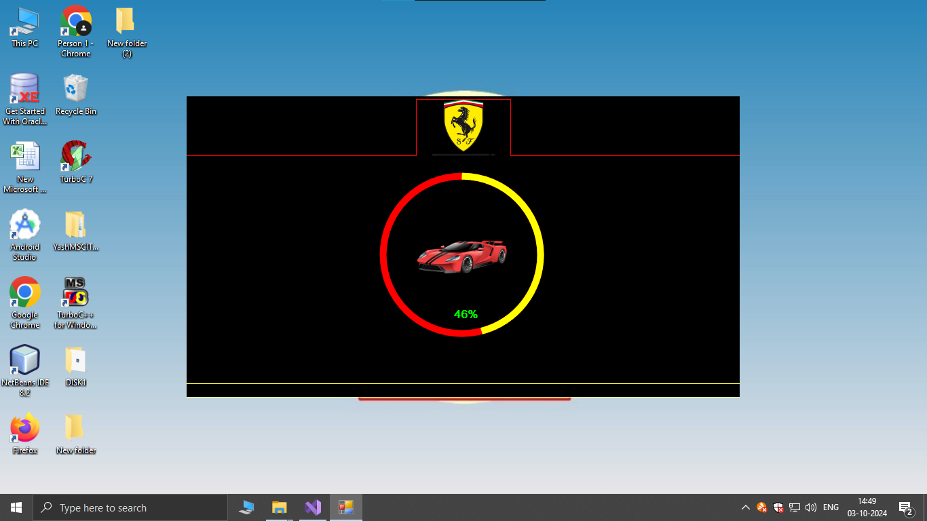

* This is the loading page for the software.

**Screen Shots**

**Login Page:**

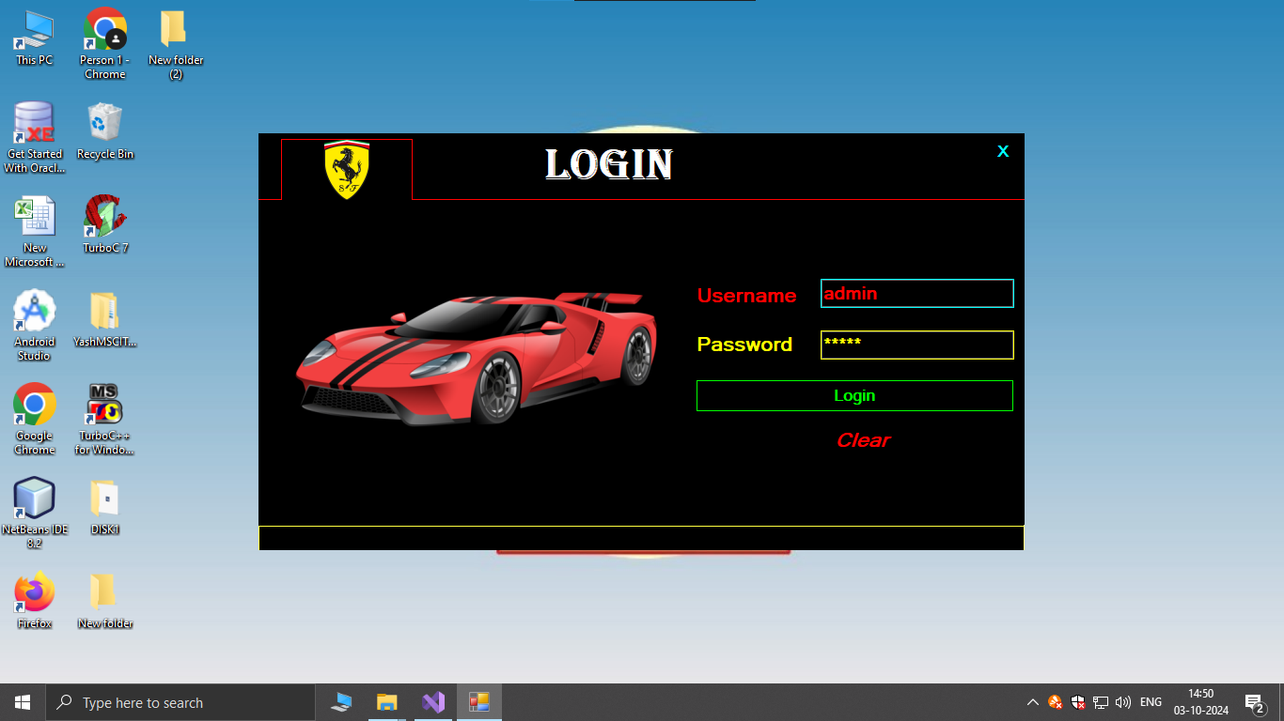

* This is the login page for the software.
* Admin can login using this page.

**Home Page:**

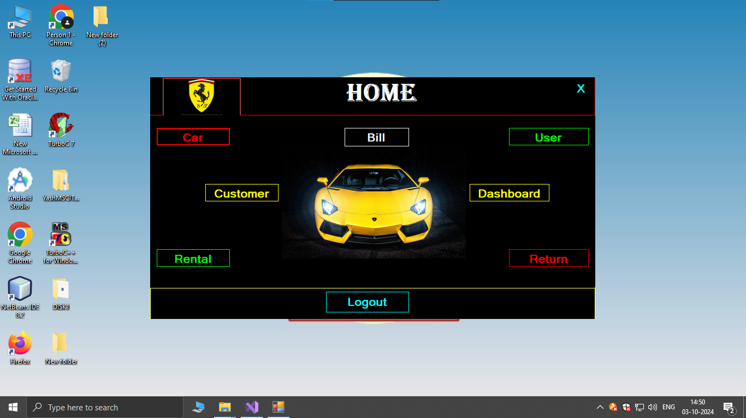

* This is a home page. It’s used rent car, add car, return car, create users and all.

**Car Register:**

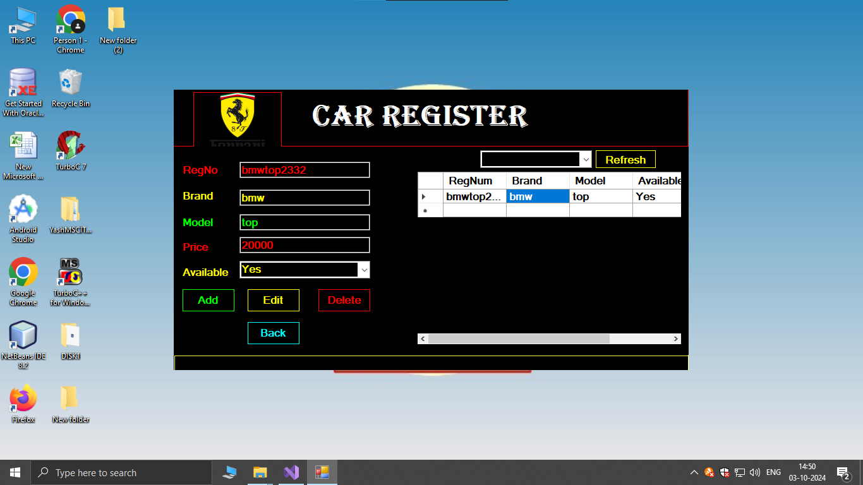

* This page is used to register car details.

**Customer Page:**

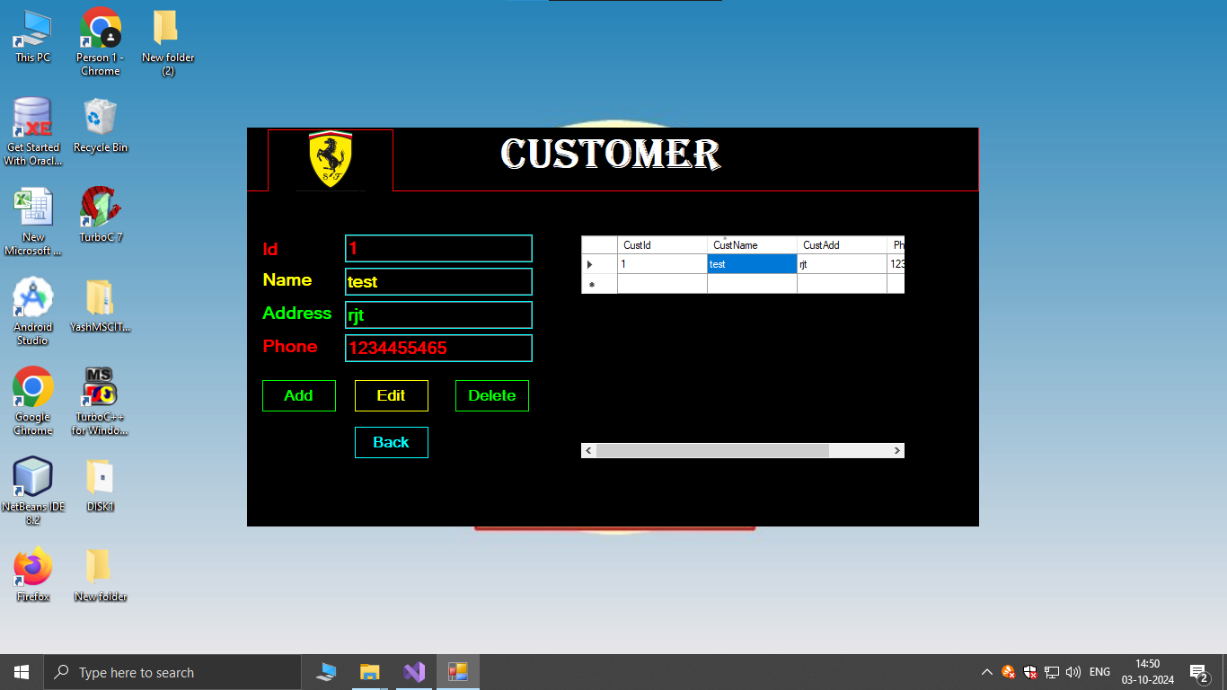

* This page is used to upload details of Customer.

**Rental Page:**

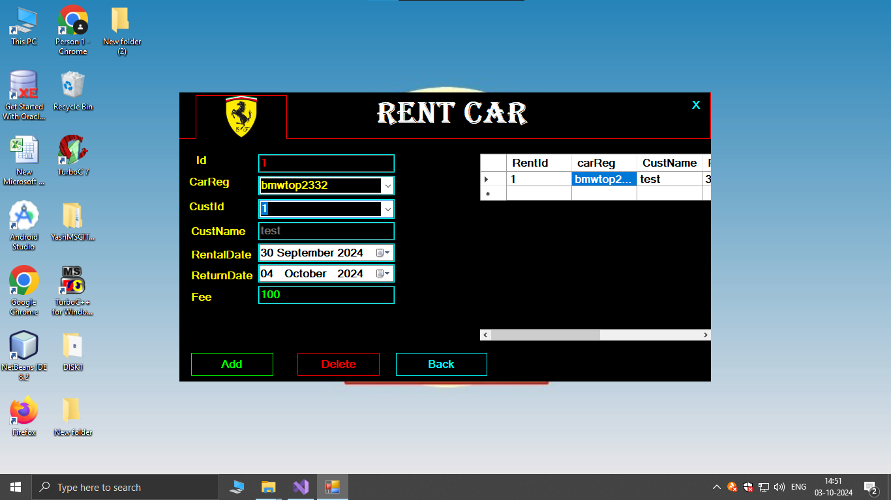

* This page is used to give cars on rent.
* This page also shows all the rental details.

**Bill Page:**

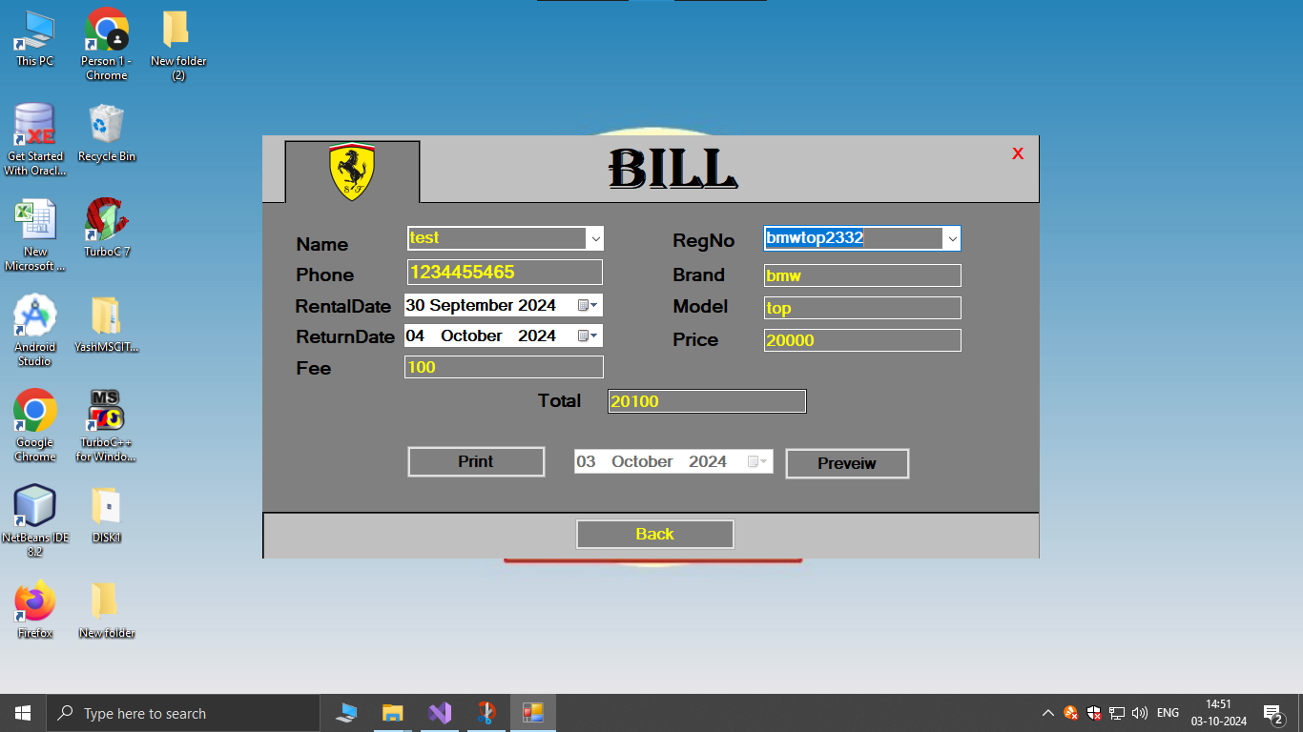

* This page Generates Bills.

**Bill Preview Page:**

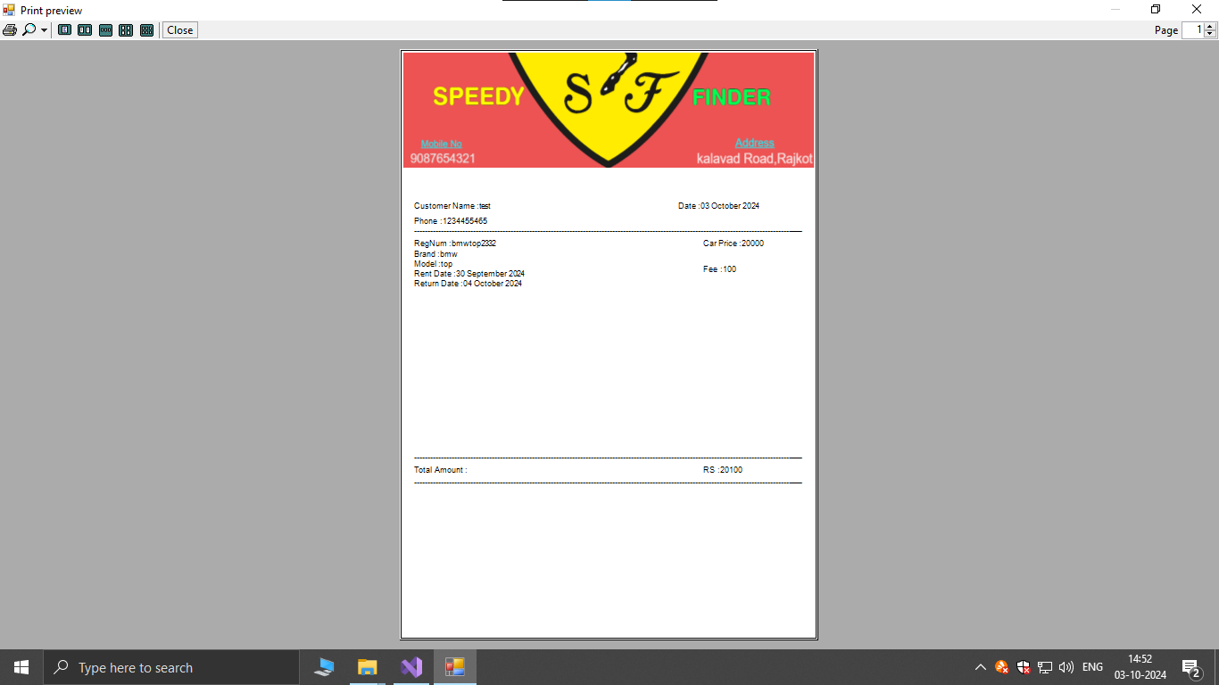

* This is Page shows Preview of Bill.

**Return Page:**

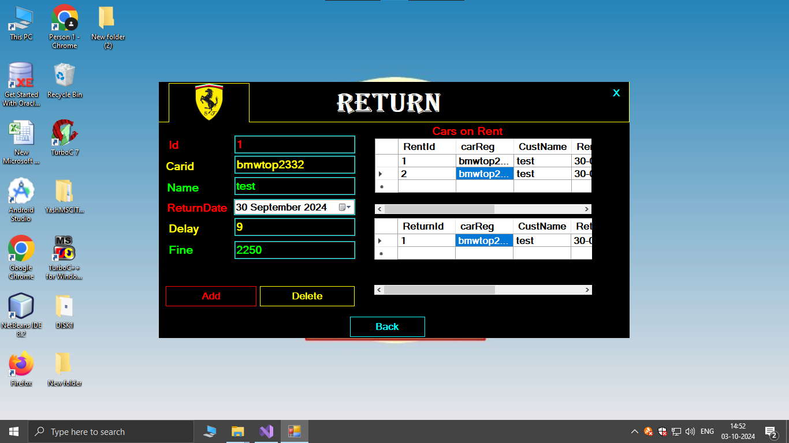

* This Page is used to Return Car and it also shows all the details of Rented Cars and returned cars.
* You can also add FINE to the late Returns.

**Profile Page:**

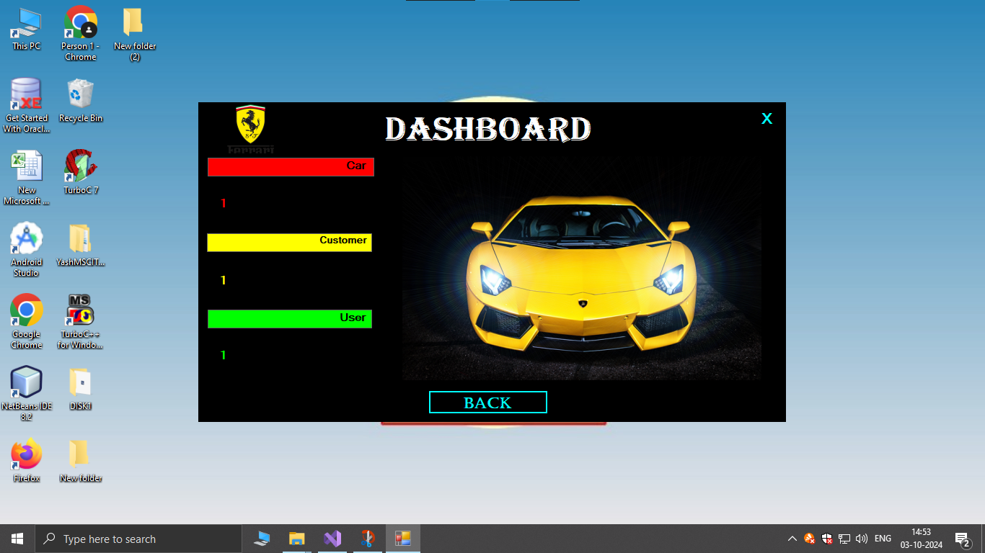

* This is a Dashboard Page.

**User Register Page:**

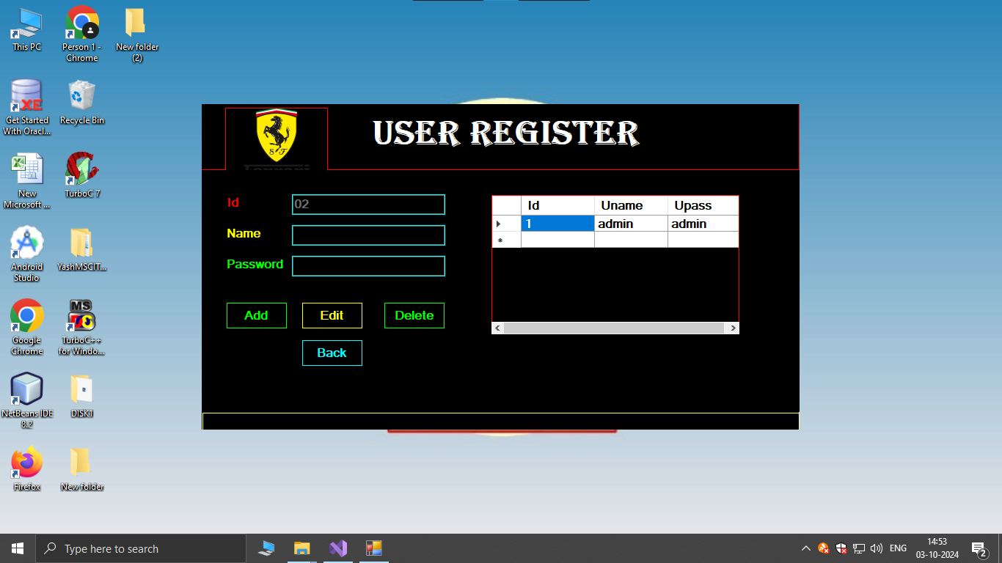

* This is Page is used to create users.

### Future Enhancement

* **Dynamic Pricing Model**
* Adjust rental rates based on demand and other factors.
* **AI-Based Recommendations**
* Offer personalized car recommendations based on user preferences.
* **Subscription Model**
* Provide monthly rental plans with benefits and discounts.
* **Enhanced Analytics Dashboard**
* Track rental patterns, user demographics, and financial performance.
* **Customer Feedback System**
* Allow users to rate and review their rental experience.

### Webliography

 

* <https://learn.microsoft.com/en-us/dotnet/>
* <https://learn.microsoft.com/en-us/dotnet/csharp/programming-guide/concepts/>
* <https://stackoverflow.com/>
* <https://www.geeksforgeeks.org/csharp-programming-language/>