## 

# TECHVOLUTION: A NEW PHILOSOPHY

by Johnny Majic

October 2019

*For the people in the open-source community. For the unspoken philosophy you handed down to me. For caring so unconditionally when updating Wikipedia, writing free software, and building cool new tech for us all. For showing me who the protagonists are. It’s the best education a political guy can get. I hope I learned enough.*

*For the antagonists, the self-entitled delegators keeping Blockbuster alive, thanks for causing history to repeat itself yet again. I hope you learn something.*

*To the extras. When it’s time for you to act, I pray you pick the right side.*

*We are really the revolutionaries in the world today—not the kids with long hair and beards who were wrecking the schools a few years ago.*

Gordon Moore, co-founder of Intel, 1973.

# PROLOGUE

## The Beginning

It all started with a door in my face. I few more actually. I’m either too stubborn or too hopeful. Either way, I eventually learned my lesson. I was selling a product upper management were never going to buy.

Before you wonder, it wasn’t the price, there was no price. It wasn’t the competition. None of that either. And I can promise it worked, because I had spent years in a cubicle doing the frontline job it worked for.

I figured out how to solve a problem—and save 100 million dollars, 300,000 hours of productivity, and even several lives—with an app that was virtually free. All I wanted was to give it away. After years of working on political and economic theory, I’ve written (another) book about the untapped possibilities of new tech like apps, bio-monitors, and bitcoin. I wanted real-world proof, and maybe get some real-world credentials, to help validate my ideas.

But I was a fool. I wasn’t even knocking on doors. I was knocking on gates. See, I wasn’t talking to the frontline workers suffering through the problem I solved, but the bureaucrats, lawyers, managers, and executives, who were paid to “deal” with those problems. Solving their problems was asking them to fire themselves. They put up gates to shut out, not promote, innovation.

In fact, they never said *no* to me. *No* needs a reason. Instead, they said it was against the rules to say yes. Obscure rules, hidden inside regulations and contracts. They believed in these rules, especially the one against frontline workers taking matters into their own hands.

I’m not going to talk about my experience too much. All that’s important is there was a problem, a big one wasting millions of your dollars, weeks of workers time (lots of its unpaid overtime), and maybe even your life, and it was against the rules to solve it.

## The Power of Stories

Do you love stories? I think it’s a safe bet to say that you do. Who doesn’t? They entertain us after a hard day of work, bring us together to share our joys, and (my favorite) open our minds to the different rules and philosophies of foreign cities, mythical worlds, and galaxies far far away.

Stories are so powerful because they’re so simple. Protagonists are good because they want to fix a problem. Antagonists are bad because they don’t. Stories aren’t debates. We take the protagonist’s side. Thus, Romeo and Juliet’s love is beautiful and worth dying for, while their families’ feud is ignorant and stupid. Luke Skywalker’s rebellion is good and worth fighting for, while Darth Vader’s empire is wicked and should be destroyed.

Our moral clarity about a problem turns the protagonists into our heroes and the antagonists into our villains. We thus follow their story with strong emotions, which burst out at the climax, where we find out who wins.

Our hero fights hard to defeat the story’s problem, but his superior morality, justice, and heroism isn’t enough. He’s often too weak or unskilled, and the villain beats him bloody. On the verge of failure, the hero needs to find something, something that’ll turn the tide. He searches, sees, and reaches for his salvation: a tool or a weapon—whether it’s a gun, magic book, or lightsaber.

Will our hero reach it first, or will the enemy? We in the audience, like extras in the story, hold our breath because the story’s society is controlled not by desires, opinions, or rules, but by which character holds the tools. The wielder is the victor. The victor writes the rules. It’s a lesson we need to learn for ourselves.

## A New Empowering Philosophy Called Techvolution

The rules. We think they control us. They don’t. I’ll show you why.

Talk to any political junkie, no matter when, and they’ll say there’s a big election coming up. They’ll say something like “if the red team wins this one, then education, healthcare, infrastructure, and everything else will go to shit.” What he means is elections decide the rule makers, and that blue rules are good while red rules are evil.

If you buy it—and most of us have at some point—you watch blue cable news, read blue blogs, listen to blue talk radio. You fill your head with blue’s philosophy. Soon enough, your car has blue bumper stickers, you’re waving blue bristol boards while screaming blue chants at rallies, marches, and protests. You feel like a hero! You’re fighting against the evil red philosophy!

Let me ask you, if you’re a regular middle-class person, and you ignored the election, how much would you bet, that you would know who won, just by living your life.

I mean when team blue wins, does traffic suddenly disappear? When team red wins, does everyone suddenly eat healthy? Do you breathe fresher air, or see fitter neighbors, i.e. do your real-life problems get solved, when one color’s philosophy writes the rules?

If you think regulations, laws, and marches change the world; if you think the red vs blue storyline decides the future of our society, you can stop reading. There’s lots of blogs, shows, and books waiting to sing to their choir, telling you to fight the enemy until you’re blue in the face.

If you don’t like the choir, or you’re starting to realize the “other side” is part of the same struggling middle class, you’d probably like to keep reading. I wrote this book for you.

Whichever color wins an election today and re-writes the rules, regular people will still pay taxes, have a huge mortgage, waste hours in traffic, pay increasing energy bills, under sleep, buy unhealthy food, watch climate change, overpay for questionable education, get confused by their health insurance, endure customer abuse, work unpaid overtime, get micro-managed by ever more managers, and hope their job (which they likely hate) isn’t downsized or outsourced.

Under blue or red rules, the struggling middle class lifestyle stays the same, because the tools in which we live our lives, like suburban homes, gas cars, call centres, centralized power stations, paper based tax forms, mass produced unhealthy food, movies remakes and sequels, occasional doctor checkups, television for entertainment, an insatiable education industry, and everything else in suburban America and Canada, stays the same.

The rules, no matter what color, don’t control us. The tools determine our way of life. And nothing changes between red and blue, because neither’s philosophy—from conservatism to progressivism, capitalism to Marxism—is about putting new tools into our hands.

It’s not our politicians’ fault. The philosophies they follow were created when our toolboxes were nearly empty. Their philosophical fathers like Adam Smith, Edmund Burke, John Stuart Mill, and Karl Marx never had running water, listened to music, read an eBook, made a phone call, opened a fridge, took penicillin, knew about electricity, started a motor, learned about evolution, or typed on a keyboard.

Instead red/blue’s philosophical fathers had mud roads, thatched roofs, and abacus calculators. When one saw a doctor, he might be prescribed leeches. Red/blue philosophers wanted to improve this primitive world with better tools. Our economically poor ancestors used their philosophies to come together and build the first rudimentary steam engines, sanitation systems, broadcast televisions, and computers the size of rooms.

During massive industrialization the masses needed to be extras, regulated and managed inside simplistic color-coded parties, because someone needed to be on the factory floors and front offices using primitive tools make better ones. To their credit, blue and red philosophies at least gave extras a voice in how our tools’ factories, regulations, and profits were controlled.

Today however, we live inside the world old philosophies dreamed to make. Mass industrialization is over. It’s time to de-industrialize and free the extras using the tools they worked so hard to create.

Wonderfully powerful digital tools like iPhones, Tesla Solar Roofs, Lyft, WhatsApp, Kickstarter, YouTube, 23 and Me, Snapmaker, Khan Academy, Nano Membrane Toilets, SquareSpace, Onnit, AirBnB, and Firefox are so wonderfully power and easy to make we can customize every person’s toolbox to solve their individual problems. Thus, we don’t need to fight to control our tools, but fight to spread them. This doesn’t come naturally to us, however, because we’re using the rules of old philosophies based on competing over, not sharing, tools.

Techvolution is a new philosophy about making regular people the hero of their own story. It does so by empowering them with new tools.

With Techvolution, you won’t by an extra fighting political battles with bristol boards or painted faces. You’ll be a hero economically exercising your right to vote, by deciding which tools best solve your problem at home, work, and play. Unlike me, you’ll never need to deal with any gatekeepers, because you won’t have to knock at anyone’s door asking permission to do what’s best for you.

I’m not talking about an idealist world from story time. This place of sharing tools already exists. Wikipedia, YouTube, StackOverflow, VS Code, GitHub, Linux, Mozilla are only a few examples of the wonderful world of cooperation that exists today. It’s called the open-source community because software and ideas are “openly shared” to help create new tools. Millions of creators and contributors, designers and coders, who don’t care about a person’s title but only how well they solve problems, are already working and living inside a fundamentally new story that’s responsible for our online world. I only want to rid our society of old philosophies holding it back, to let these protagonists prosper.

People often say we’re addicted to our phones. We aren’t. Checking news feeds, downloading ping-pong games, taking endless photos is regular people learning what our new tools can do. Our ancestors did the same the last time they were extras learning printed books, telescopes, and muskets.

These were simply addicting toys until new philosophies turned them into lightsabers. Despite the rules, these new tools empowered the people to read unknown history, see the Universe for themselves, and fight royalty. We can stop using our tools, and start wielding lightsabers to fight for a better way of life, with the new philosophy of Techvolution.

# ACT ONE

## Introduction

Fighting to spread the power of new tools is an archetypal human story. Galileo fought a religious establishment with a telescope, George Washington fought a political establishment with a musket, and Steve Jobs fought an economic establishment with an iPod.

Likewise, I want to empower you with tools. Yet, this is not a book about how to invent tools. Amazing books like *Rework* and *Zero to One* already do that. Nor is it a book about the history of invention. *The Innovators* does that better than I could dream. If you want brilliant critiques of our society, *The Incerto* and *The Great Degeneration* are waiting for you. Instead, this is a book about how new tools empower society, and how we can distribute their power to improve the lives of regular people today.

It all comes down to changing the rules of our society with a new philosophy. Today’s philosophies don’t mix well with modern technology. They consider us, the middle class, as extras. People who are just around to watch the story unwind around them. Even if we watch our problems pile up at home and at work, we’re not supposed to solve them until we pass through the gatekeepers of old tools in government bureaucracies, bloated corporations, high-end lawyer offices, or endless consultant meetings. This is the equivalent of Blockbuster writing rules to keep us renting DVD’s instead of saving time and money with YouTube and Netflix; basically, the opposite of evolution.

Techvolution is inspired by Nature. Notice gatekeepers don’t exist there. Evolution doesn’t have anyone telling a cheetah she’s running too fast, that the ants are too cooperative, or that a camel is too water efficient. Lifeforms adapt as best they can to their own problems and the winners survive. There are no middleman, no gatekeepers, just problem solvers. And the problem solvers live on.

However, human biological adaptions take so long ours have effectively stopped. We’ll never biologically evolve to fly, do advanced calculations, or breath Martian air. Humanity continues life’s evolution with tools. We’re basically cyborgs who adapt and solve problems by upgrading tools to the latest problem in transportation, calculation, and breathing. Hold a pen, calculator, smartphone, plane joystick, space suit, and you’re a different cyborg each time.

However, our problem solving is held back by old philosophies that empower gatekeepers. People in control of old tools like Blockbuster, getting to decide when, and if, humanity will upgrade our tools.

In *Star Wars*, the Force is an all-powerful energy field. Luke Skywalker’s Jedi warriors harness the light side to help others. Darth Vader’s evil Sith lords harness the dark side to help themselves.

We call technological protagonists “trailblazers”. Like Jedi, they empower us cyborgs with new tools. But since some gates are good, like the security ones, we don’t have a political name for the antagonists. Thus, I call antagonists to our technological evolution Darth Blockbuster; people who prevent human evolution for their self-interest.

Biological adaptions and upgrades are called evolution. I call human technological evolution *Techvolution*. This book is about inventing Techvolution, a philosophy to re-write the rules of society, to kill Darth Blockbuster, so regular people can solve our problems with technological upgrades as smoothly in human society, as evolution does in Nature.

And to make it happen, you, the current extra, must join the fight. Human evolution depends on you picking the right side between an old ruling philosophy filled with rules to keep your frontline problems alive, and this new one that says solving real-life problems makes you a hero.

## Cast of Ideas and Characters

Before we go any further, I want to lay out the philosophy of Techvolution more clearly. To do so, here are a few terms that will enable us to all be on the same page:

===

Philosophy: the largely unspoken ideals that tell members of society what’s right and wrong, good and bad, in science, art, morals, politics and economics. Philosophy is a civilization’s collective consciousness used by members to make rules around questions like: what is scientific truth? Who should govern? And how should resources be organized?

Ruling philosophy: is a civilization’s chosen philosophy. One that all factions agree on. Like the “Divine Rights of Kings” derived from Christian theology used in royalist Europe, “Marxist-Leninism” of the Soviet Union, or the combination of “red/blue” philosophies of our philosophy today.

Rule book: the written and unwritten social, workplace, and legal rules that govern everyday life. The rule book is interpreted from the ruling philosophy.

Technology: a catchall term for things we make tools from, like concrete, lumber, nails, shingles, insulation, and bricks.

Tool: a catchall term for things we create with technology to solve a problem, like guns to kill bad guys, books to record and pass on knowledge, and houses to shelter in.

Frontline: The point of contact between a tool and the problem. Nurses giving vaccines, cleaners cleaning a city bus, soldiers on the battlefield. People on the frontline have jobs to solve problems.

Hierarchy: Every tool develops a power structure to manage its use in society. Kings and queens having the keys to the castle for example. People in the hierarchy have titles like prince and executive to mark their position in the power structure.

The story of civilization: The invention of new technology and creation of new tools to overcome whatever problem troubles us. We use tools to evolve.

Protagonists: people who invent, spread, and use new technology and new tools for the greater good. Usually close to the problems on the frontline, they individually struggle, but their continued self-sacrifice slowly improves life on Earth. I call them Jedi. We call their leaders trailblazers who often skirt the rules; Nikola Tesla, Steve Jobs, Michael S. Hart, Bill Gates, Linus Torvalds, Elon Musk.

Antagonists: people who selfishly resist new tools to defend their wealth, power, and prestige. Often called establishment or elites, antagonists usually manage companies or institutions based on dated technologies and think working on the frontline is beneath them. They work to control the rule book so they can hide behind it. We don’t often individually identify them. I invented “Darth Blockbuster” so we can.

Extras: everybody in the middle of a battle between antagonist and protagonist. Because they have no direct loyalty to either side or their tools, extras can pick winners and losers. Usually extras are in the middle class; not so poor as to be desperate, but not so powerful they want to keep the world the same. Sadly, extras don’t realize their power.

The Death Star: The rule book when its controlled by Darth Blockbuster. Today it exists inside countless regulations, contracts, laws, and manuals that prevent new tools being used by people.

Techvolution: a new philosophy empowering seamless human technological evolution by ridding Darth Blockbuster of his power, by empowering extras to decide when society should upgrade our tools.

## Nice to Meet You, Stargazer

Here the story to master human technological evolution begins. Not in a foreign city, mythical world, or galaxy far far away. Right here and now wherever you are on this Earth. We need to change our ruling philosophy to take advantage of digital tools. Only you can make it happen.

A little about me first. I’m nobody special. In my youth I was a cleaner, drywaller, movie usher/projectionist, and die-hard ideologue. After dropping that bad habit, I studied political philosophy and innovation at the University of Toronto; usually while working full-time. I lucked out, because I learned far more about innovation continuing to work on the frontline as a line worker, an account manager, a claims adjuster. Making an app and meeting my personal Darth Blockbuster was an education unto itself. All this taught me Techvolution. Watching my friends struggle owning, maintaining, and working with the old tools motivated me to write it down.

So that’s a snapshot. But I’m not important. You are. Because from hospital cleaners, to internet technical support, nursing to adjusting, only workers on the frontline know the tools our society needs to keep us healthy in the story of civilization.

So, you are the hero of Techvolution. It’s not surprising. Average joes are always the heroes. Luke Skywalker, Princess Leia, Neo, and Cinderella were regular people. They became heroes when called upon to defeat the bad guys.

Now you’re called upon. Like Obi-Wan Kenobi, Morpheus, or the fairy godmother, I, Le-Marius, am merely the guide to teach you how to defeat the villains. So, the time is now young Stargazer (that’s what I’m calling you), to leave the farm, and join the rebellion.

What is the rebellion. It’s not rallies, marches, or protests. It’s a rebellion of the mind. We must change our ruling philosophy. We must destroy the Death Star that keeps his old tools in power and prevents us from using new tools to solve frontline problems. Only when the Death Star is gone will the middle-class flourish once again.

# ACT TWO

## The Magic of Evolution

Well young Stargazer, before you face Darth Blockbuster and go off to blow up his Death Star, you must learn the weapons that can do it. The most important being the all-powerful energy field inside every lifeform. No not the Force. I’m talking about evolution.

Evolution empowers life by giving every new lifeform a slightly different variation. With variations life can constantly test for environmental changes in things like water levels, temperature, and food supply. The variations unfit for the changed frontline die off and the fittest survive. This natural selection finds which lifeforms best represent life on Earth.

Evolutions works so well because its constant variation production creates biodiversity. The more lifeforms there are, the more life can probe and better adapt to environmental changes. When temperatures increase or rain patterns change, the more lifeforms there are that feel the pain, the sooner life can evolve a solution to the frontline problem.

However, if the environment is stable, lifeforms need a caretaker. Someone to keep them in shape, ready to act for when the environment does change. That’s why Nature put in a system of checks and balances called ecosystems. Inside ecosystems is where lifeforms form communities and cooperate to keep each other on their toes.

Ecosystems are a food chain of many different plants, herbivores, carnivores, and decomposers; each living off the same resources. To keep the ecosystem sustainable, each must reciprocate to be sure no one hoards or freeloads. Reciprocation inside ecosystem keep lifeforms in shape, ready to respond when the environment changes.

Evolution may not be the Force, but it’s certainly magical. Without any lifeform being aware of its tricks, evolution turned a lifeless planet into an oasis. The big drawback is time. Biological variations can take millions of years to respond to environmental changes. Think of the poor polar bears. They’ll never understand why Artic ice isn’t coming. And even if they could, no lifeform can proactively change their biology.

In contrast, humanity can change (hopefully in time to help the polar bears). Not our biology; but our “cyborgology” if you will. We feel frontline pain, reflect on the problems causing it, and create a new tool to overcome the problem.

Techvolution is therefore intentional evolution. A better form of evolution that isn’t a magical mystery, like evolution is to polar bears, but something we can understand. Question is, what drives us to evolve, when the rules often say it’s wrong?

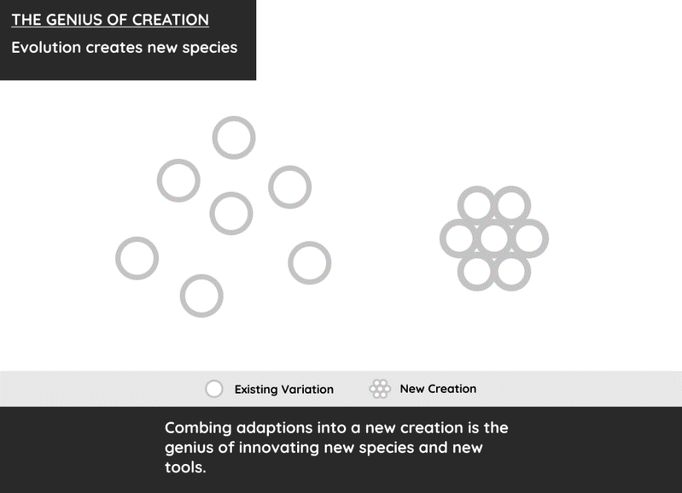

## The Majic of Techvolution

We call it genius when someone uses existing technology to make a new tool. Happily, these trailblazers are self-motivated and we already celebrate their genius and innovations. But innovation isn’t the only step to Techvolution. Only when the extras use a tool do we evolve.

So, what trick does Nature play on extras to reach for new tools and risk Darth Blockbuster’s wrath. The answer is a force inside our souls.

Unlike evolution, the trick is not magic, because extras understand they’re dropping one tool and attaching another; like swapping out the DVD player for Netflix. Yet, there’s still something wonderfully mystical about choosing to leave one’s comfort zone to learn a new cyborgolgy, I call it majic. Pronounced like magic, but spelled differently to note it’s the free choice of a regular person to evolve life, even if they don’t know exactly how when they jump in.

We underappreciate how cool it is to learn new tools. But every time try we’re like a drowning desert fox wearing fins and goggles yelling “I’m getting better!”. And, it’s majic that has us keep jumping in.

Think of majic like a bonding agent. Carbon atoms are sticky and thereby bond other atoms to form the Universe’s many molecules. Genius in the protagonist’s minds bonds existing ideas into original ones. Good storytelling bonds audiences with different worlds and glues them to their seats. And majic bonds people’s minds and bodies with new tools to advance humanity in the story of civilization.[1]

Techvolution is the ruling philosophy letting extras majically bond with any tool they want so they can solve frontline problems. And what do we do when the rules say it’s wrong? Stargazer, let’s find out with a quick lesson.

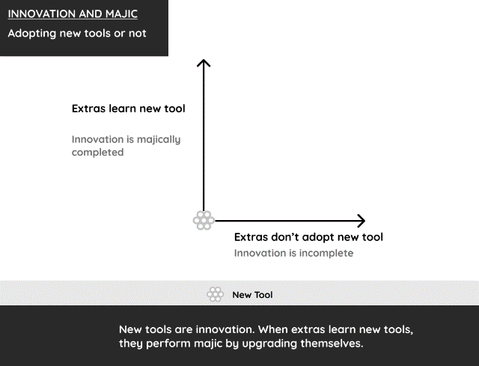

## The Lesson

Despite our problems with our current one, society always needs a ruling philosophy. We use it to create the rules that glue society together. Without a ruling philosophy the story of civilization would be a story of chaos.

Darth Blockbuster fights to control the ruling philosophy. When he succeeds, he writes rules to keep the tools he controls, and therefore himself, in power. Corporate manuals, university guidelines, social justice blogs are among the pages of his Death Star rule book. These rules interfere with regular people majically bonding with new tools.

Maybe. Whose to know which rules are the bad ones. Maybe they’re interfering with majic. Maybe they’re just good rules. Darth Blockbuster doesn’t tell people he’s Darth Blockbuster. Instead he says he’s an Executive Vice President, Human Resources Representative, or expert lawyer. Are these people genuine authority figures in the story of civilization, or Darth Blockbusters protecting their paychecks?

To answer that, we need to clearly identify the difference between majic and rules, so we can filter out the good and bad rules in our everyday life. This lesson takes us to small farm in Maryland, and a young boy who worked hard to better himself with tools.

===

Our story is about a Maryland farm boy named Frederick using tools to overcome ignorance. His farm is one of those you might have seen on shows like *Little House on the Prairie*. Salt of the earth farmers raising crops and families in 19th century rural America. No internet, no school systems, no much to learn by how to survive.

Frederick worked the fields with his mother. It was hard labor of course, there weren’t many machines around, so he had to work hard, for himself and his mother.

In a few years, Frederick was sent to work with a relative in Baltimore. The house was large and the young family could use a hand cleaning, shopping, doing chores. It made his mother happy he wouldn’t sweat so much, yet Frederick was a farmer and unsure of the big city.

The father of the house was Hugh. He wasn’t around much. His new wife Sophia was. She was a foreigner used to colder climates who didn’t know many people yet, so she stayed in a lot. Sophia was nice and treated Frederick nice too. Not as a farmer, but as an interesting person. She made Frederick feel at ease.

One day, Sophia handed Frederick a list of items to pick up from the store. Frederick’s eyes looked down, his shoulders slouched, like a dog who disappointed its masters. Frederick mumbled “I can’t read.”

“My God, well that won’t do!” Sophia responded, then continued “Reading is good. How else can a person give and receive information from… from… the world! I’ll teach you; we’ll do it together.” So, Sophia taught Frederick to read. Just a few weeks, and he got the basics. Sophia performed majic and was overjoyed.

Frederick even more so! Finally, all those markings in the store, on street corners, in books, in newspapers, in the Holy Bible, mean something, a new world! Go left, turn right, open, closed, discounted, welcome, and Salvation, all a door to a new world.

Now Frederick danced to the store, he whisked himself to do his chores, because he was learning to read a little more every day. He loved how the world kept getting bigger, and information kept pouring in.

One day Hugh came home early. He saw Sophia and Frederick reading at the dinner table. Hugh walked into the room. “Boy, get out, and wait in the hallway. Face the wall.”

Frederick got out, went outside, and faced the wall. Seconds turned to minutes. Frederick rolled the newspaper in his hands tighter. He didn’t want to go back to the farm. But even more, he didn’t want his angel to get in trouble.

Inside the room, Sophia was curious “What is it?”. Hugh responded “This isn’t Ohio…Darling you can’t do that. We could get in a lot of trouble. You can’t teach them to read.”

Sophia responded “everyone learns to read in Ohio.”

Hugh takes a seat. “This isn’t a free State. He is a slave. What do you think happens when slaves read? Don’t you think they’ll start thinking?” Sophia’s eyes went wide. Hugh continued “It’s against the rules to teach a slave to read…. now teach the boy.”

As Frederick heard the hallway door open, he straightens up, and grips his newspaper.

Sophia says “Turn around.”

Frederick does, and looks at his angel, the one who talked with him like he was a person. And she looked back and only saw *her boy*.

Sophia slapped the newspaper from her boy’s hand. He didn’t let go. She slapped again, and again and again. Each slap hurt more than a dozen whips on his scarred back.

She slapped, and slapped, and slapped, and slapped. She will not do evil. Sophia was clicked by society’s rule book. Now she was a demon protector of vile racism to justify human slavery.

Frederick’s world shutdown again. The one white person ignorant enough to treat him like a person, was now an educated convert to the rules that put him into chains. Physical chains if needed, but evil prefers mental chains of ignorance; they stay on so much easier.

Weeks later Frederick was in despair. His daily routine was the same. Yet, working under demonic masters is just different. He didn’t dance to the store, he didn’t whisk to do his chores, and he never saw Sophia smile again. Demons are always on guard.

One day while doing his chores, Frederick saw a newspaper, the avenue to knowledge whose path Frederick was once on. He looked at the markings, saw some words he knew, and one word he didn’t. Yet he still stared at it. Why?

The answer slapped him harder than the demon ever did, he read the words “The Free States in the North”. He heard the word freedom before, but he didn’t know freedom was a real place.

A shockwave went through him when he realized if slavery was a place, then so must freedom be a place too. Frederick realized he could break chains. Because ignorance was always his demon, and knowledge was always his angel. And he fought ignorance, and received knowledge, whenever he read.

So, Frederick taught himself to read. He practiced with ignorant white kids on the streets. He practiced reading items at the grocery store. He practiced on every street sign. And he practiced every time he was at the Baltimore dock; the dock I said, you know the place, where ships will take you anywhere in the world. If you can read the schedule.

One day Sophia waited for her boy to return. But the boy died when the man Frederick Douglass walked onto the ship headed north to freedom. The man knew the exact time, place, and fare he needed to get on. He read it, himself, on the schedule. Reading opened the world to Frederick, and now the free world was opened to him.

The story gets better. Frederick Douglass becomes a brilliant orator and writer. In a world with no radio, video, or telephones, he travels the Northern States and Europe telling everyone the truth about slavery. When the American Civil War (1861-1865) broke out, his books helped Britain reject recognizing the South, and thus deprived it of much needed support. The irony of a slave educating people about slavery, and thereby helping to end slavery, is the cherry on top of this great story.

Story adapted from *A Narrative of the Life of Frederick Douglass*. Free on Project Gutenberg.

## Douglass’ Lessons

Frederick Douglass is a true Jedi Master. His great bravery, persistence, and intelligence showcase humanity’s endless potential. The big lesson we need to learn here Stargazer, is how to use majic to tell the difference between good and bad rules.

Sophia taught Douglass to read. She wasn’t told to. She did it because we love teaching our chosen tools. It’s as natural to spread our tools, as it is for a species to propagate.

When a magician makes a playing card disappear, we smile in awe and childish wonder. That’s cool, but nothing new was created, so we soon lose our joy. However, when a majician connects someone with biking, building, or reading, they’ve similarly performed something awesome, but it’s not a trick; they’ve upgraded someone’s cyborgology and effectively created a new and improved person. This makes us smile for a long time. Majic is Nature’s long-lasting dopamine fix.

Yet human made rules *sometimes* say upgrading to a new tool is wrong. Medieval parishioners couldn’t read a science book, French peasant farmers couldn’t have a musket, a 1990’s kid couldn’t download a digital song. Today millions of tired mothers can’t telecommute. Why?

There is no easy answer. Remember in no story does anyone ever say they’re evil. Society’s rule book will never call itself a Death Star. The lesson Stargazer is it’ll never be easy to know the difference between good and bad rules. Humans too easily speak and write rules to filter out the bad ones.

Majic is thus our best judge of the rules. It naturally makes us smile. From teaching a kid to walk, to teaching a grandmother to “Skype in” and watch her grandkids first steps; teaching and learning new tools opens our hearts because it solves problems and improves our way of life.

So, when you’re teaching or learning a new tool and someone steps in your way with a rule, ask yourself if you feel wonderfully inspiring majic, and if you do, ask the rule maker why he doesn’t. Perhaps there’s a good reason. But keep Sophia in mind. Performing majic made her feel good, while following the rules only made her feel safe.

And safety is fleeting Stargazer. No ruling philosophy lasts forever, thus all rule books eventually expire. Majic never will. It always was, and always will be, in our souls. It’s how we naturally test our rule book. Electricity, the microchip, the iPhone were all made by people who skirted the rules. Yet we celebrate their innovators today because they invented new tools that let us feel and spread majic. History’s already forgotten their rule makers for a reason.

Ignore majic at your peril. Look at Sophia, she gave one of our greatest writers and orators his start, yet she lived a miserable life watching him achieve greatness because she broke the rules. The inevitable punishment to everyone who ignores their soul.

## A World Without Majic

Stargazer, the story of civilization is stalling. We already have Jedi in the open-source community creating new tools to solve frontline problems. We already have extras feeling the pain of frontline problems. What we don’t have is the freedom of extras to majically bond with new tools. For that we need Techvolution.

But let’s talk about the good news. There’s always good news and it’s vital to mention to fend off negativity and despair. It’s safer to live now than in any other point in human history. The amount of us dying violent deaths has consistently gotten lower.

Think about this, in the Stone Age, about 10-20% of people died violently, most often by murder. In Rome’s peak civilization it was around 2-5%. In the Dark Ages it was above 5%. But by the 18th century, when the Industrial Revolution started, it went well under 5%. Now, less than 1% of us die violently. All those figures are worldwide and include wars.

More good news. We have enormously powerful digital tools that keep getting better. Look at microchips, the “brains” of a computer. In 1972, we could put 3,000 transistors on a microchip. In 2018 we put 10 billion. In 46 years, we’ve increase computer power by three million percent.

Digital tools thus hit their stride in the 1970’s; when protagonists like Grace Hopper, Vint Cerf, and Al Alcorn used microchips to created personal computers, the internet, and email.

And now for the bad news. Digital tools were a threat. It was in the 1970’s Darth Blockbuster showed up and started making his Death Star. The transition from an industrializing economy mass producing primitive tools, to a knowledge economy making customized digital tools that could liberate the extras didn’t sit well with him. He didn’t control digital tools.

So, he started writing contracts nobody can understand, regulations nobody can find, and enforced politically correctness nobody likes. All to keep his primitive tools like gas cars, call-centres, endless PowerPoint meetings, and company manuals made with Word instead of websites, in use and himself in power.

Our society’s biggest problems are wounds of the Death Star’s many attacks. But stay positive. We can solve them all once we liberate digital uses with Techvolution. Let’s look at some stats to better understand our problems.

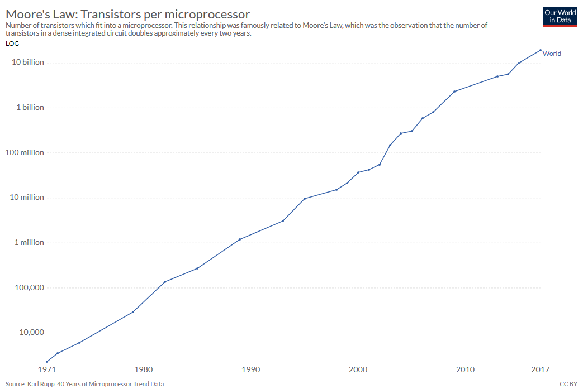

1 Moore’s law. Transistor’s power electronics. They amount in a microchip can roughly double every two years.

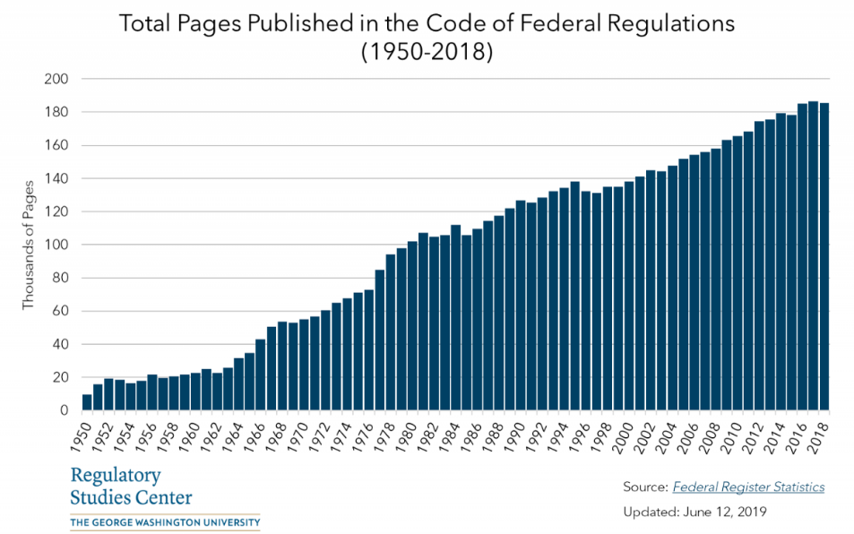

2 Measuring red tape. The Code of Federal Regulations is the rule book of the federal government’s department and agencies. The number of total pages published provides a sense of the volume of existing regulations.

[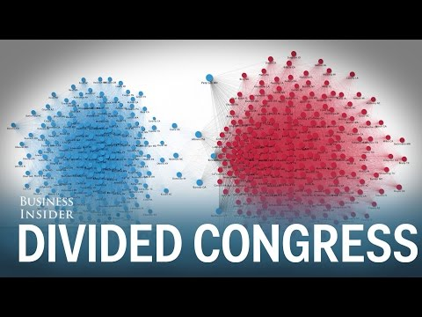](https://www.youtube.com/watch?v=tEczkhfLwqM)

3 Blue and red hatred. Gotten far worse since 1970’s. Note, color code for progressives and conservatives changes in USA, Canada, Australia, United Kingdom, but the trend is the same.

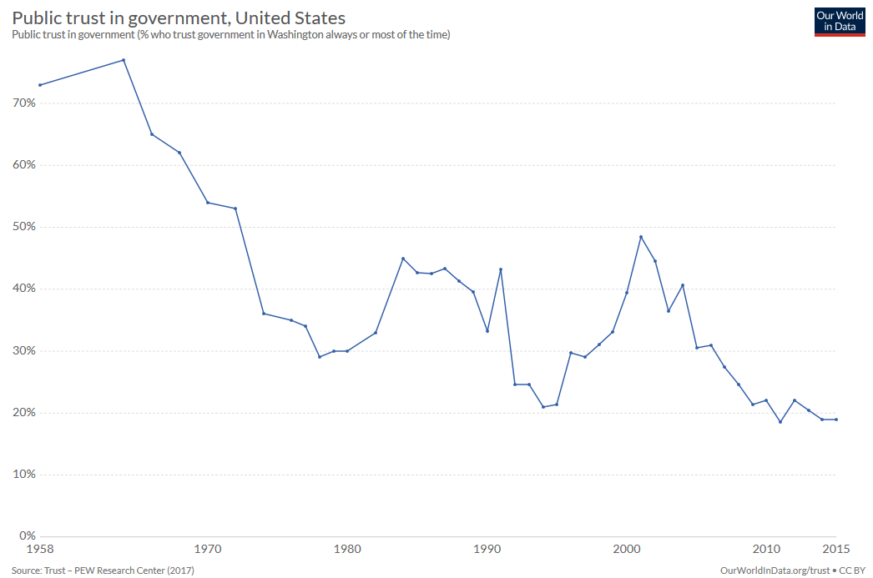

4 American trust in their government.

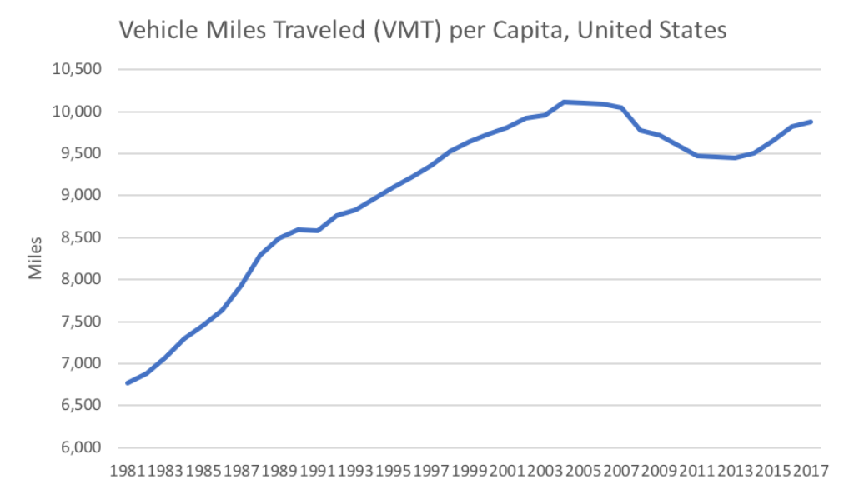

5 The number of miles Americans must drive each year.

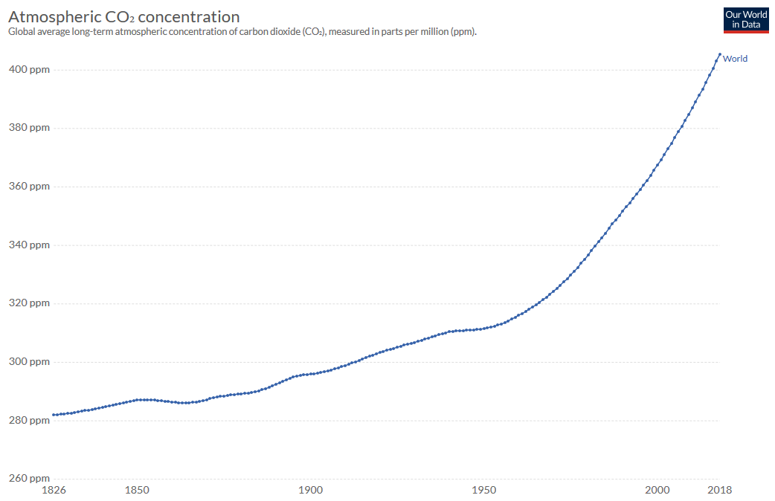

6 Carbon Dioxide emissions since 1826. Notice the spike in the 1970’s.

## Things Won’t Get Better, Until

Most of our problems started in the 1970’s for a reason. That’s when protagonists’ created digital tools, and Darth Blockbuster showed up with his Death Star to keep our car driving, suburban living, broadcast television watching, 9-5 working, two car garage home living, unhealthy food eating, central power station buying, university admission test taking, shopping too much lifestyle going past its expiration date. Despite totally new tools, the American way of life hasn’t changed. It’s still the “American Dream” to live in a post-World War II baby boomer suburb.

Using old philosophies, our politics agrees with the antagonists. For example, because university libraries and lecture halls are still considered “formal education” (and the goal of every suburban parent), red/blue endlessly debate who should get into university and how the massive expense should be paid. Endless battles over affirmative action, student loan rates, and state education subsidies are the result.

All while better tools are ignored. Digital tools can educate anyone willing. Wikipedia, YouTube, Khan Academy, Udemy, Skillshare, Curiosity Stream, Brilliant, Project Gutenberg, The Great Courses, are merely the first new digital education tools. They do wonderful jobs while costing a tiny fraction of formal education and getting no official support. Yet, we don’t teach kids to read or update Wikipedia in schools. We don’t track student progress in Khan Academy’s micro-lessons. We don’t recognize “degrees” from Udemy, or YouTube, even though most computer programmers and designers learn far more there than in any college classroom. I used these resources to write this book, and never once looked back at my university lecture notes.

Our society suffers keeping the baby-boomer suburban dream alive. Despite way too much carbon in the atmosphere, gridlocked roads, housing bubble bursts, massive student debt, and horrible individual health, our politics keeps us using gas cars, mass produced homes with no solar panels, super-expensive college education, and very confusing health insurance. Our entire frickin climate is changing because our ruling philosophy is not.

Things like middle class quality of life, political cooperation, and climate change, won’t get better until the extras join the protagonists, step-up to the antagonists, and freely use digital tools to solve frontline problems. To change our cyborgology we need Techvolution. Without it, we’ll basically polar bears trying to survive in the Amazon.

But don’t despair. Never despair Stargazer. The good news is, we can majically adapt our cyborgology, we just need the extras.

# A TECHVOLUTION BATTLE SCENE

## Battle Introduction

In the 1970’s the transistor, internet, computer monitors, microchips, and other digital technology, started to leave labs and research centres and make new tools. Finally, society had tools powerful enough to change our way of life. Of course, that’s when Darth Blockbuster starting firing Death Star blasts defending his way of life.

Some examples. In the 1970’s AT&T defended the telephone communications by successfully lobbying government to ban Americans from using internet modems. In 1984, the entertainment industry defended broadcast television by suing home video cassette recorders (VCRs) (and only losing by one vote in the Supreme Court). In 2001, the music industry defended music compact discs (CDs) by successfully suing digital songs. Likewise, Tesla, Uber, AirBnB biggest competition has been in the courtroom. Throughout society the antagonists found ways to keep digital tools from the people.

The antagonists even resisted help. As Napster was introducing digital songs to America-and being sued for it- Steve Jobs wanted to improve digital songs with iTunes. Music executives had already tried and failed horribly to make their own platform. Despite the supposed crisis of Napster, Jobs said he’d “never spent so much of my time trying to convince people [music executives] to do the right thing for themselves”.

The problem wasn’t Napster. It was Darth Blockbuster. To be fair, he knew how to manage a huge corporation, make a product people (had) wanted to buy, and got his employees paid. Yet he didn’t know anything about new technology and so fought against losing his job with rules, not tools.

From Galileo to Washington, Tesla to Jobs, the battle between antagonist, protagonists, and extras has always been the same. We have to win it again to reverse our bad trends that started in the 1970’s. Let’s look at how the classic battle happens before we go fight it ourselves.

## How New Tools Start the Fight

In biological evolution there are continual adaptations of existing lifeforms, and then sometimes entirely new lifeforms. In Techvolution this is the difference between a new technology, and a new tool.

Upgrading a technology is an iterative change; like going from sedan’s to SUV’s, VHS to DVD’s, tube TV’s to LCD’s. Each is different technologically, but they do the same job, so no new majic is needed to attract users. As a result no political battles are started.

But when we’ve upgraded enough technologies, like microchips, touchscreens, batteries, and Wi-Fi, a genius can unlock a new tool like smartphones. And this requires new majic and thus is a big deal.

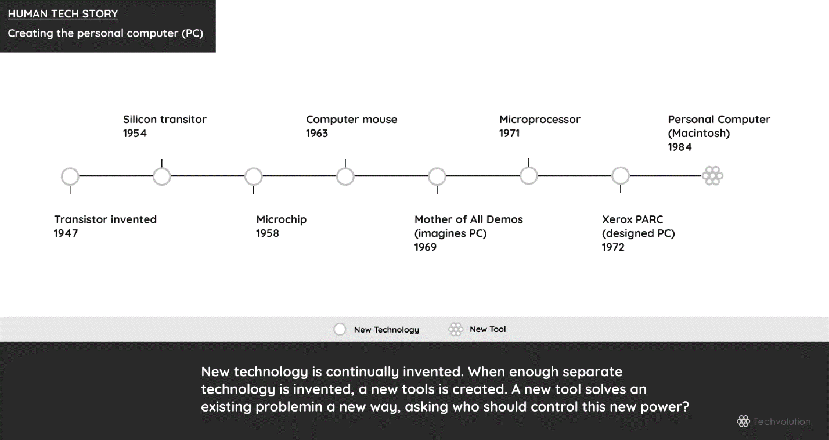

Why? Well, because creating a new tool asks a climactic and political question: who controls it? After all, whoever does, is more powerful. The wielder of the new tool can let extras connect with it to solve their problems. Or withhold it and convince the extras to keep using old tools. Like muscle cars trying to keep customers away from Tesla with techniques like mass advertising, car culture, and spectacular chromes plated V8 power! I call these techniques to keep people away from new tools dark majic.

Thus, while civilization is a struggle to overcome problems by upgrading technology and inventing new tools, it’s also a battle to control them. The people with the old tool fight to retain their power, while inventors and innovators imagine a new society that shares it.

The eternal story of civilization is thus protagonists like Jobs making new tools, antagonists like music company executives attacking new tools, and many extras watching them fight. Our politics is an ongoing history of technological change, with protagonist and antagonist both reaching to control the tool and make themselves the winner.

Today the extras are not self-aware of their power to decide the outcome. I’ll show Stargazer how important they are. Here’s how they can change the world just by being curious and loving majic.

## 

## Extras Killed Wikipedia’s Evil Twin

The environment keeps changing. Life needs to know how and uses its lifeforms to probe for answers. Similarly, people always have questions; like why are the movies so expensive, or more importantly what are proven techniques to stop malaria infections. Constant questions are a problem and we need a tool to solve it. True to ourselves, we make a reference tool with the technology available and upgrade it when possible.

Our first reference tool was the wisdom of our elders. The first technological upgrades were papyrus scrolls and ink (500 BC) and books (500), which turned some elders into experts like Hippocrates and Aristotle. When wood-pulp paper (1200) and the printing press (1456) were invented, humanity unleashed mass-produced books. Now experts could share knowledge between themselves and educate the masses. We called the reference books encyclopedias.

People loved encyclopedias. Of course, they did, they answered many questions. The *Encyclopedia Britannica* (1878) was the standard. It went into continuous publication (1933) to keep people updated to the latest facts. In the following decades, the computer, digital printer, and telecommunications meant encyclopedias were written and stored digitally. But they remained a set of printed books and CD’s controlled by experts.

Then came the world wide web (1991), a new technology that unlocked many new tools like websites, forums, blogs, and something called “wikis”. Wiki software lets anyone write or edit a webpage by pressing “edit now”. All changes are saved, so anyone can erase errors or vandalism by pressing “undo now”. For years programmers used wikis to collaboratively write technical manuals.

As web tools boomed in the late ’90’s, protagonist Jimmy Wales wondered if the web could upgrade encyclopedias. Today, most of us who were curious about things like the movies or malaria know this story ends with a free online encyclopedia anyone can edit called Wikipedia. But it didn’t start out that way.

Wikipedia started as Nupedia (2000). Nupedia was a free online copycat of Encyclopedia Britannica where only “expert” professors made articles. Wikipedia (2001) was a side project. Only programmers knew “community content creation” would work.

Everyone else assumed regular people would only read the work of professors. The first issue with this theory was that the professors didn’t like to share their knowledge. In its first year, Nupedia had 12 articles. Wikipedia had 40,000, which most professors loved to belittle as rubbish. Professors even disallowed students from referencing Wikipedia’s articles in their school work. Yet professors refused to improve, or to assign students to improve, Wikipedia.

The second issue was that it turned out “expert” answers and “regular” answers are the same. The movies are expensive because of a 1948 government rule banning studio’s from owning or collaborating with theatres-so they can’t vary ticket prices regardless of movie budgets- and mosquito nets are a simple and effective tool against malaria infections.

Thirdly, Wikipedia was so easy to use many extras became protagonists! A huge community of non-academics voluntarily shared their knowledge one “edit now” at a time and fiercely protected their common knowledge with “undo now”. Nobody told them, paid them, or made a rule to force it. Because performing majic, and expanding someone else’s cyborgolgy with things like millions of Wikipedia articles, is Nature’s dopamine rush.

And lastly, so many people loved the performance and flocked to Wikipedia’s answers. The extra’s mass support quickly made Wikipedia king, while giving Nupedia and Encyclopedia Britannica quick deaths.

That’s the story of Wikipedia. Made by new protagonists, made the standard reference tool by extras. Few believed it was possible, because even professors don’t understand new tools always unpower the few, to empower the rest. Interestingly, after I finally conceded temporary defeat to my personal Darth Blockbuster, I uploaded a few pages to Wikipedia instead. Not as helpful as my app, but it took just a few weeks of work, and one “edit now” button, to make it real. It felt majical to bypass the rules.

### 

## You Can Win

Wikipedia’s victory is another example of the archetypal Techvolution story. Like Galileo and his telescope, George Washington and his musket, and Steve Jobs and his iTunes. Wikipedia was a victory for protagonists. What makes it especially cool, is digital tools made it so easy to empower today’s extras.

Now imagine when digital tools are let free! Stargazer, that’s the story you must jump into with lightsabers a-blazin’, dicing up old tools like evil storm troopers, to smooth out humanity’s natural evolution. The open-source community are making new tools. But they are facing down Darth Blockbuster on their own. They need as much help as Wikipedia got.

Note however, our lives cut across thousands to millions of problems. Thus, our villains are not in a massive group like “the rich” or the “the unions” as old philosophies label. Our villains reveal themselves inside thousands of companies, institutions, and organizations, by suppressing new tools to keep their version of the DVD alive.

Together, protagonists and extras can kill all these Darth Blockbusters. I know this because our battle today was fought generations ago with his master, Darth King.

Darth King lived inside palaces, using society’s money to host splendid banquets and balls. His absolute power was hidden inside a ruling philosophy of the “noble’s divine right to rule”. Slowly, as protagonists invented scientific instruments, books, and guns, a new philosophy was born. A philosophy of science, enlightenment, equality, and democracy, made real when the protagonists and extras fought as one in the American and French Revolutions. They were inspired by the new philosophy of Jean-Jacques Rousseau.

# 

# ROUSSEAU’S EXTRAS

## Freeing Cinderella

“Extras are born free; and everywhere they are in chains.” Jean-Jacques Rousseau wrote that in 1762. He was the King of France. No he wasn’t. Was he the richest man in England? Absolutely not. Rousseau was a poor writer who copied sheets of music to make the rent. More than 300 years later, he is recognized as being a great philosopher, a political visionary, and a protagonist who helped free the world with his new philosophy.

Rousseau lived when kings and queens, dukes and duchesses ruled civilization. A time when Mozart played inside exquisite palaces during the nobility’s many banquets and balls. This was the opulence that had Cinderella dreaming her days away as she cleaned a dirty chateau. Sadly, unlike the the fairy tale, the extras didn’t have a fairy Godmother to make their dreams come true. Instead, the commoners cleaned the noble’s vast libraries, used guns while dying in their wars, and were told to ignore what scientific instruments revealed. The extras were excluded from the power of new tools because they believed their beloved Holy Bible said only Darth King had the “divine right to rule”.

Rousseau called bullshit. In truth, Jesus was a carpenter, a commoner just like any other extra—you could argue—who rose to become the ultimate protagonist. Who is anyone to say other extras can’t live up to their own potential? Rousseau said books, guns, and scientific instruments should liberate the extras who were only in chains for the happiness of con artists. The self-proclaimed “divine nobility” didn’t like hearing that. This powerful self-protecting community declared Rousseau a banquet-pooper, and chased him out of Switzerland, France, and England. Maybe that’s why Rousseau rented instead of owned.

Starting in 1776, within Rousseau’s lifetime, Darth King started to face the music when the American people started a revolution. One year after he died, the French had their own revolution in 1789. And on it went from country to country because Rousseau, and others like him, make the extras realize they should become protagonists with a ruling philosophy “of the people, for the people, by the people”. Cinderella soon forgot about the fancy ball, and instead sung the music of freedom in a choir of equals, that sounded something like this:

France that Europe admires Has regained Liberty And every citizen breathes Under the laws of equality, One day its beloved image Will extend throughout the universe. Peoples, you will break your chains And you will have a homeland!

Revolutionary songs like this spread the people’s liberty, equality, and fraternity throughout the world. In a few years, civilization changed its ruling philosophy from knowing the nobles were divine, to knowing they were villains who resorted to hiring mercenaries rather than realize the people didn’t need them anymore.

When the people took control of books, guns, and science, they put presidents and senators, judges and sheriffs in power, who ruled at the request of the people who built a civilization of democracy, equality, and checks and balances, because no one was divine. A change empowered by tools, thought of in philosophy, yet made real with the bloodshed of revolutions on the frontline.

Rousseau died never having found a home. After they won their revolutions, a population of heroes put him to rest inside the glorious Panthéon, heralding him as a renowned breaker of chains, in a free world he helped build. Where any guy can be the prince, and any girl can be Cinderella.

The question for us is, how did Rousseau make an entire people change their ruling philosophy, and how can we do it better, because I’d really like to skip horrible revolutions.

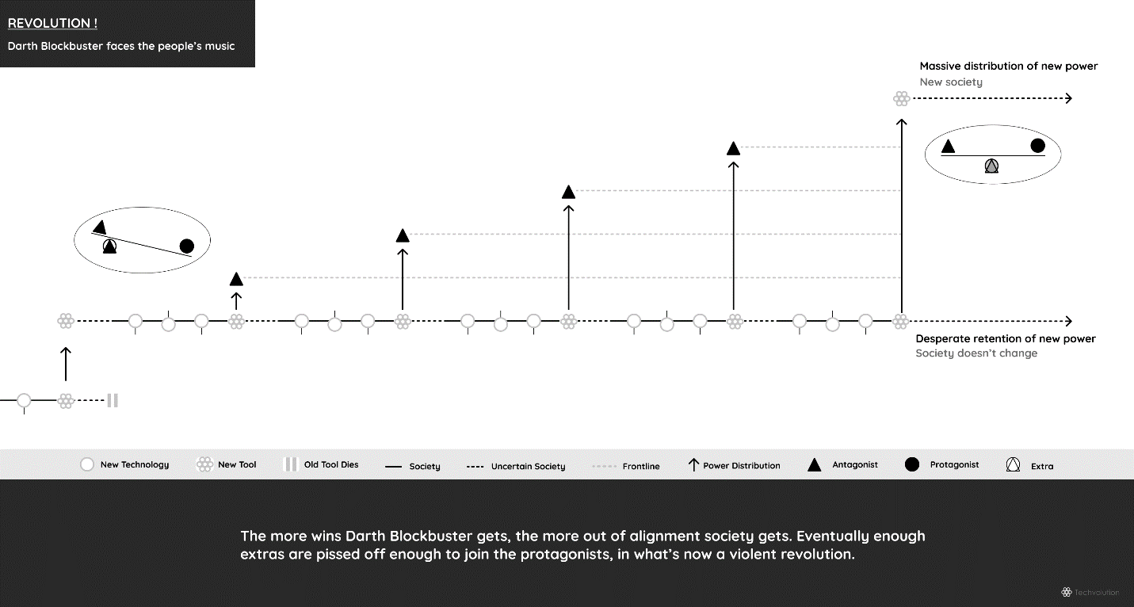

## ~~Revolution~~ Techvolution

Stargazer you look disappointed. You think revolutions are fun. You want to follow *Les Misérables* and march in the streets. Maybe we should. You get the bristol boards, I’ll get the paint, and we’ll change the world! Free college education! Less bank regulations! Affordable health insurance! Continuous tax cuts! We’ll save the planet and the government’s credit rating!

Listen to me. When your cars breaks down, you call a mechanic for help, right? If he showed up with no tools, you’d get mad. No arguments, no discussions. Nothing else matters because no tools means no problem-solving.

Middle class people have a host of problems like increasing insurance, prescription drug, and tutoring bills. You need solutions. When someone says they can help, you must ask what tool they have, or will give you, that will help. Anything else is smoke and mirrors. You don’t need to see regulations, laws, or blog posts anymore then you need to see the mechanic’s favorite car repair manual. You need tools.

Red / blue philosophies show up with no tools. Not because red/blue leaders and supporters don’t care. But because their philosophies don’t know. Stuck on old tools, they tell the middle class to walk to the nearest gas station and hope for help, and blame the other side when we complain.

That’s not horrible, until you consider that with a new digital car, like a Tesla, our broken cars can now call the mechanic, give him a diagnostic to his smartphone immediately, and he’d tell what the problem is, and most importantly, what to do next.

Now consider it’s often against the rules to solve our problems so simply. Patent laws, insurance regulations, nondisclosure agreements, non-compete clauses; a mountain of rules any antagonist search through so he can force us to keep walking to gas stations.

Please realize how much new digital tools help. Here’s a exercise to do it. Every time you want to watch a Netflix show or YouTube video, get in your car, drive five miles, wait 10 minutes, throw away six bucks, drive back home, and then press play. Easy to forget, but that’s what DVDs were like.

Netflix was a big victory. But a rare one. Today, how we pay taxes, recognize education, repair electronics, transfer home ownership, decide our investments, sign sales contracts, get hired, fire someone, use warranties, access medical records, and so much more, works like a DVD. An unnecessary and expensive pain in the ass enforced by a Death Star of rules. Just like our ancestors who were told voting, reading science books, owning a musket was against the rules.

It doesn’t have to be politicians’ job to create, make, market new tools. Just get the Death Star out of the way. Until it’s gone, the power of internet connected digital cars, solar panel roofs, air quality testers, EKG monitors, repairable laptops, safe nuclear reactors, easy to manufacture vaccines, waterless toilets, online education, is impossible to harness with old philosophies obsessed with protecting limited tools, and holding us back in the story of civilization.

Ignore revolutions! Digital tools and their many Jedi innovators, coders, technicians, designers, repair shops, are ready and waiting to solve real-life problems, it’s intoxicating to them. We just need Techvolution, the freedom to choose the best tools to solve our problems at home, work, and leisure. The people majically bonding with whatever tool they want, is the ultimate revolution.

## Good and Bad Stories

And that, in short, is what Rousseau said; let the people prosper with new tools. Let the nobility return to their natural equality inside a democracy. This happened of course, but only through violent revolutions.

It’s important to note, it wasn’t only the nobles who hated Rousseau. Some extras did too. And this is where we must improve on Rousseau, using Rousseau. Because like with Wikipedia, empowered extras are the source of proactive change. We need lots on our side.

We capture the extras by noting Rousseau was also a novelist. He used this in his philosophy by telling the difference between good and bad stories; not in literature, but in human societies. Understanding this difference ourselves will help us disengage any extras distracted by Darth Blockbuster’s dark majic, and get them addicted to the majic of new tools. Note, we’re using movies instead of novels, because they’re more popular.

## One Good Story, Two Bad

Every story is a sequence of events where a protagonist fights an antagonist to overcome a problem. The fight to change reality happens in three parts. The first is the introduction of the problem and characters. The second is protagonist and antagonist thinking up plans and attacking each other. The third part is the conclusion, where we find out which side wins. Although it’s easier to see in some more than others, all stories have this structure.

The difference between good and bad stories is how much thinking and acting each character does. Good stories mix it up, while bad stories have too much of one or the other.

**Classic movies:** are fights over real-life problems. Protagonist and antagonist repeatedly think of new ideas and act on them in a back and forth battle. New ideas give the stories surprises, while fighting to win requires logical actions.

Mixing logical problem solving, with new ideas, gives classic stories “logical surprises”. These plot twists make what’s going to happen next unknown which keeps audiences glued to their seats. The conclusion can be a big victory for the good or bad guys, or anywhere in between.

There’s no way to know which stories will resonate with audiences, but only good stories can resonate with audiences and become classics like Cinderella, Romeo and Juliette, The Matrix, Star Wars.

**Art films:** are not about any specific problem. Like personal journals, they’re more about the protagonist’s thoughts; not acting to overcome a problem. The result is surprising idiosyncratic behavior, but storylines with no problem solving to logically tie events together. Without action, these stories are surprising to the point of being weird, with conclusion that can’t change reality because the hero didn’t try.

Without logical surprises, art films need to get weirder and weirder to maintain interest. To insulate themselves from criticism art filmmakers usually give themselves ever more awards, grandeur, and titles and end up-like their protagonists-on stages talking about themselves. Film festivals like Cannes, Sundance, Toronto mainly show art films.

**Spectacle movies:** are about an obvious problem, i.e. Godzilla is here, so run like hell and keep running until the movie is over. Spectacle movies are thus very logical because the problem is very simple; survive or die. However, since the action is so instinctual, there’s no time for the protagonist to think of new ideas. The result is very logical but unsurprising stories that can’t change reality because no new ideas were introduced.

To maintain interest, spectacle movies have to keep reusing successful stories and characters while ramping up special effects, gore, and raunchiness. It doesn’t work for too long, so spectacle producers look for new customers with hype-filled mass marketing campaigns. Most franchise movies, sequels, and remakes are spectacle movies.

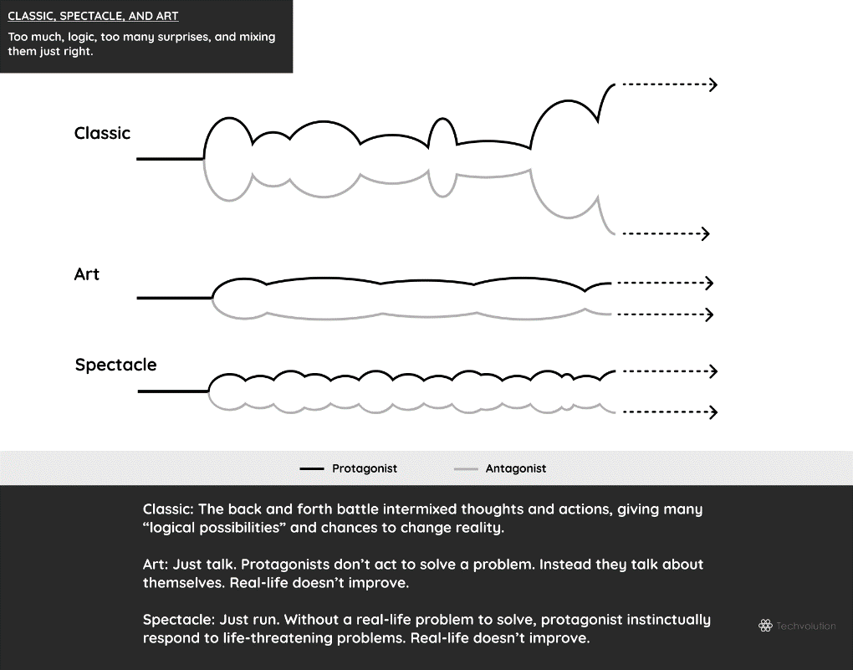

===

To summarize, in storytelling, logic and surprises counter-balance each other. Withholding one makes art films that are self-important, and withholding the other makes spectacle movies that are simple. Classic stories are good because they mix the two and create “logical surprises” that open our minds and change things. This is why art/spectacle stories don’t have “spoilers”, while we want to “go in fresh” for classic stories.

You can see the difference in your favourite sitcom such as *The Office, Seinfeld, Friends, HIMYM, The Big Bang Theory*. They start off as classic stories, with characters who deal with relatable problems like not liking their jobs or being tired of dating. As these characters keep encountering common problems, we learn more about them.

However, in later seasons, to keep their now popular characters alive, the sitcoms keep them living the same stories. Kramer can’t get a job, Raj can’t get a girl, Michael Scott can’t get self-aware. Here sitcoms become art and spectacle stories. Art, as in these characters can’t overcome their problems. And, spectacle, because we the audience keep watching even though we already know what’s going to happen. We watch our favorite actors, characters, sets, catch-phrases, instead of waiting for logical surprises.

Rousseau noticed society has these classic, art, and spectacle stories, and that human society’s travel through them; like happens in long running sitcoms. Rousseau also noticed how one story works for equality and democracy, and the other two work to enrich the artists and distract the masses.

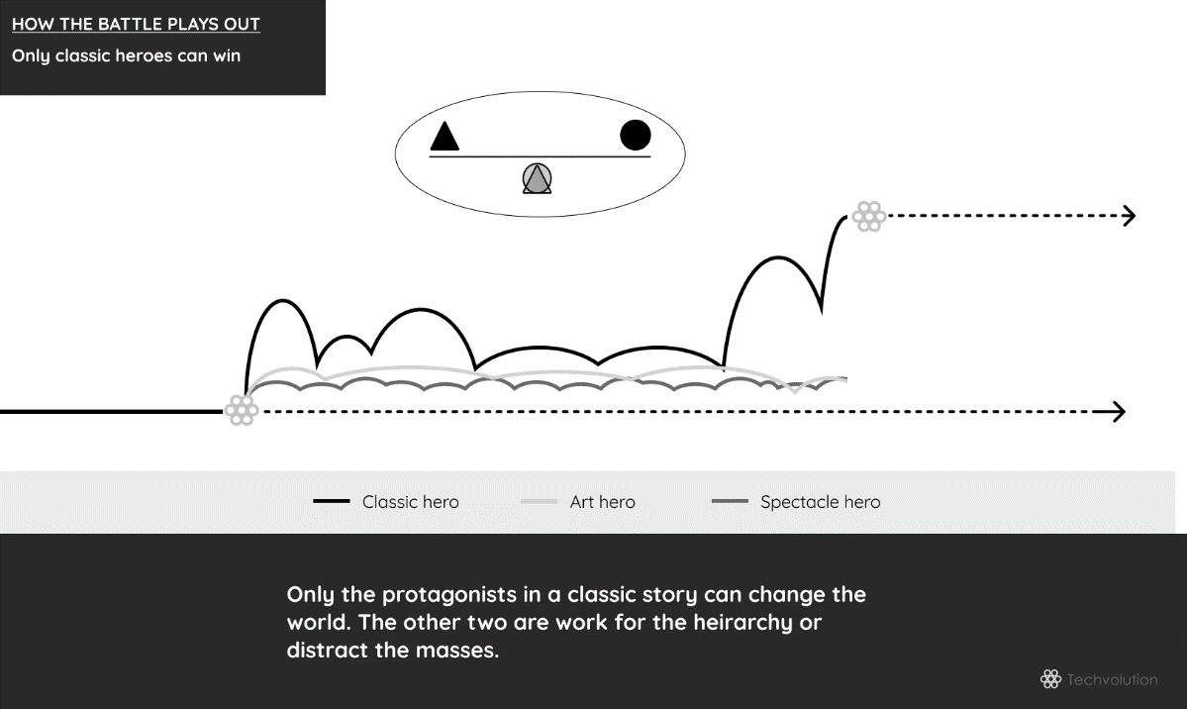

## Politics of Stories

Classic stories tackle real-life problems. Art stories talk about themselves. Spectacle stories are a distraction.

For politics, this means classic stories are about equality and democracy, while art and spectacle are about maintaining a hierarchy. I’ll explain why.

Let’s use *The Matrix* for this example. This story depicts a dystopian future in which most of humanity is unknowingly trapped inside a simulated 1990’s reality called the matrix. It’s created by machines to distract humans while using their bodies as an energy source. Neo is recruited to help the few untapped humans’ rebel against the machines. His job is to make the sleeping masses inside the matrix realize their reality is fake.

This story is basically majic vs. the rules. Neo wants the masses to realize the matrix’s rules are bullshit. When they do, they can remove the plug, and re-learn the majic of using their own tools to live a free life.

The machines antagonist, Agent Smith, can control much of the matrix, but not all of it. Enforcing the rules of the ruling philosophy of slavery, makes “the agents” bound to its rules too. Neo has a new ruling philosophy of freedom. Thus, he isn’t bound by the matrix’s rule book. A freedom he wants to teach others.

Neo takes on the machines. Unbound by its ruling philosophy, he learns to manipulate the matrix better and better. He jumps higher, runs faster, and soon dodged bullets. The machines, unable to match his wisdom, fight back with dark majic.

They get one of the freed humans to turn on Neo and his supporters. Not with the allure of power, but with the allure of going back into the comfortable matrix. The familiar spectacle of Rolling Stone concerts, television sitcoms, and V8 engines is all he wants. The traitor knows its fake, but will accept it because “ignorance is bliss”. The machines agree to give this to him, so they can forever stay on top.

The traitor losses. Neo is too powerful. In the final battle with Agent Smith, he not only can dodge bullets, but stop them in mid-air. He completely sees past the “spectacle” of items that the traitor said was “bliss”, and only sees the matrix’s code, and can thus rewrite it as he wants. Neo soon kills the agents, calls the machines, and says:

*I came here to tell you how this is going to begin. I’m going to hang up this phone. And then I’m going to show these people what you don’t want them to see. I’m going to show them a world without you. A world without rules and controls, without border or boundaries A world where anything is possible. Where we go from there, is a choice I leave to you.*

Since this is a classic story, once Nero’s done showing the people, him and his friends return to being equal members of the free community. Neo’s hierarchy of support was temporary, being based on solving a frontline problem. Perhaps he’ll be the hero of the next story, but maybe not. It depends on the problem and who the people want to be their problem solving here to be.

Spectacle and art stories do not solve frontline problems. Thus, their hierarchies can go on for as long as they can convince people to watch them, or live inside them. The leaders are self-important, self-involved, who can’t solve problems, and the masses are just like the people stuck inside the matrix; distracted from the truth with a world of spectacle like shiny cars, copyrighted music, 9-5 work days, and sitcom re-runs, which people stay attached to via dark majic of advertisements, marketing, and loyalty to an old culture.

This is the hard side of majic. The real-world in the matrix is cold, dark, and damp. Neo must convince the people this unpleasant reality is better than the pleasant fiction full of the spectacle and dark majic.

The longer the spectacle lasts, the longer the self-important artists, like Darth King, and Darth Blockbuster, can go on talking about themselves. They’re happy with the way things are. They want to be heroes atop the hierarchy forever.

But like an aging sitcom, it never lasts. Eventually the people’s problems pile up, and they soon need a true hero again.

## Neo Douglass

The story of the matrix is a common one. Most oppressed peoples could sympathize with it. Frederick Douglass certainly could. Mister Auld was the agent of slavery, Douglass the hero responsible for waking himself and everyone else up. And Sophia is the masses, who must choose between majic and the rules.

Douglass, and Rousseau, are Neo. They both woke people up to the reality that spectacle and art is bullshit, and society should about solve real-life problems by empowering people with tools. Real heroes fight for this individual empowerment, and when done let their hierarchies melt away into the free soil of equality.

Telling the difference between a “classic hero” and a selfish one can be hard. That’s why we worked to improve Rousseau. To tell the difference, we only need to know, what story are we in. Rousseau defeated Darth King, by making the people realize they were watching re-runs while the nobility was in banquets and balls.

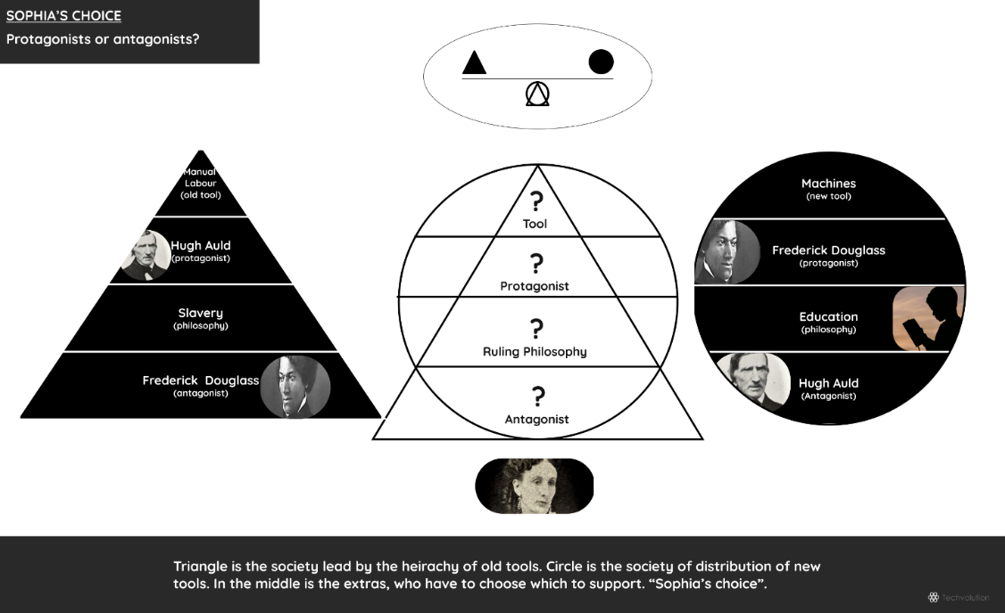

## Protagonist Kings

It’s important not to be too negative. It leads people to blame and hate someone else for their problems. It’s what the marches with megaphones do. So we’re going to take some time to appreciate the good kings.

In Rousseau’s time “holy” noble families ruled every European country. But they were in power because of their ancestors. After western Rome fell in 476 western Europe entered the Dark Ages (500-1000). So called because there was no books, ink, or literate people to write anything down. Nor was there much else, like sanitation, military, judicial systems. Civilization was gone. Anarchy ruled. The Dark Ages sucked.

People like Clovis I, Charles Martel, and Alfred the Great took charge. They were master warriors who uses swords, bows, armor, and cavalry to fight off invaders. Even better, they headed large families who kept some peace. They built castles to protect the newly remade wells, hospitals, and markets.

This was a classic story. A hero saw a real-life problem, was determined to change it, rallied supporters, and took on the evil villains. All stories have this hierarchy because the protagonist is in charge and their success at grabbing hold of the all-powerful tools, determines if society improves or not.

Fittingly, a hierarchy formed around society’s use of these primitive tools. We call it feudalism. You’ve probably seen it in Robin Hood, Monty Python, or Game of Thrones. Feudalism was a rigid hierarchy of kings, bishops, dukes, sheriffs, knights, priests, tradesman, and peasants. In return for loyalty, the people got was called the “King’s peace”, which slowly let the people update their cyborgolgy with shovels, oxen, thatched houses, buckets, sickles, and more.

The people happily declared the leaders holy, for they experienced the holiness with ever warmer beds and fuller stomachs. And until their society had political institutions like dependable judicial systems and government, the personal rule of the nobility was a needed stand in. Kind of like a mafia.

The people were an audience who watched fiction become reality; believing in divinity was the logical reaction, like laughter is to comedy. However, the story took generations to finish. By the Renaissance nobody could remember why it started.

As Europe went through the Middle Ages, the Renaissance, the Enlightenment, the invaders were increasingly gone, the water was running, the roads were clean, the markets were busy. Europe had vastly better tools of a vastly better civilization. The only thing that didn’t change was the rules.

## Antagonist Kings

The nobles were no longer military leaders fighting off Vandals, Vikings, and brigands, but simply born with “noble blood”. They only waged war against each other, and usually only for personal glory. But otherwise they sat atop a hierarchy who paid no taxes, did no work, and answered to no one. The nobles used relative peace and prosperity to replace armor with dresses, castles with palaces, and battlefields with banquets and balls.

Loving life, and without opposition, these nobles conned the people, and themselves, with art and spectacle. They lived inside an art culture, where ever more self-importance, eccentricity, gossip, and titles, was the norm. And they distracted the people with spectacle to watch. Brilliant cathedrals, palaces, and wars against other kingdoms to keep the masses occupied. Like franchise movies, these got more intense to keep the story interesting.

Visit European classic castles and extravagant palaces, modest churches and brilliant cathedrals, and you’ll see the transformation from function to spectacle in Europe’s buildings. Compare the clothes of armored clad Charles Martel, and the dress wearing Louis XIV, and you’ll see the transformation from function to art.

Frontline problems piled up. The people’s situation barely changed, and arguably got worse, from 1000 to 1778. Their houses were still thatched. Their still used hand tools. They still paid most the taxes. They were still banned from advancing in official society. Feudalism became a caste system controlled by con artists who are rightfully called Darth King for fought against natural equality and distributing the power of new tools to the people.

Darth King used art to tell themselves the rules were sent from God, and should thus never end. The practical reason for noble divinity, fighting off anarchy, was ignored. The nobles lost the plot of their own stories. They held their people back from learning and adopting new tools. It sent Darth King’s civilizations into revolutions, and cost him his head.

## Our Story

All this applies to us too. It’s important to note, while Rousseau’s followers may have been political free, they were economically poor. Hunger, disease, unemployment, illiteracy, were all rampant. The time was basically “economic anarchy”.

Like how society loved the original kings for winning the “King’s peace”, the original economic kings were heroes for winning massive economic growth. They said follow me, recognize my property rights, let me run the economy, my company’s will keep you employed and improve your life with new tools like lightbulbs, stoves, and toaster ovens.

Slowly but surely, they did. They told a good story during the Industrial Revolutions. The people were again an audience who watched fiction become reality as we overcame economic anarchy. And we did that with many of the primitive tools of today. Schools, colleges, and universities educated the masses. Gas trucks and cars moved resources and products much faster. Oil and coal powered everything.

Darth Blockbuster’s forebears like Andrew Stanton, Andrew Carnegie, Cornelius Vanderbilt, did what Clovis I and the rest did. And like how Darth King was only exposed when new tools empowered the extras so they didn’t need to be peasants anymore, Darth Blockbuster was only revealed when digital tools were so powerful, the extras didn’t need to be 9-5 working, consumers anymore.

To defend his today’s primitive tools, he surrounds himself with story of self-importance, and distracts the people with spectacle. John Wayne noticed this started, not surprisingly, in the 1970’s for movies:

*Now the goddamned stock manipulators have taken over. They don’t know a goddamned thing about making movies. They make something dirty, and it makes money, and they say, ‘Jesus, let’s make one a little dirtier, maybe it’ll make more money.’ And now even the bankers are getting their noses into it.*

This same thing happened through suburban “American Dream”. Detached homes got ever more specular, bigger sizes, designer fashion. Cars got bigger, more size, more chrome, more horsepower. Televisions increase in size. All these were used to promote a “Desperate Housewives” suburban lifestyle of drinking win, holding house parties, and being a office worker who didn’t do manual labor but talked a lot of saving the world via red/blue politics.

And, if we’re going to change that, we need to realize all bad stories eventually end badly, so…. shit something is wrong…

# THE BIG FIGHT

## Le-Marius In Trouble

Midway through *Star Wars*, the ship taking Skywalker, Obi-Wan, Leia, and the rest is captured by the Death Star; the very ship the secret plans were stolen to destroy. It’s great writing, because the heroes must escape it, so they can destroy it.

Well I hope you took notes Stargazer. Because they got me! The antagonists have me in a Darth Blockbuster choke hold. And I’m in trouble.

See, I broke the rules. Darth Blockbuster shot his Death Star, sent stormtroopers, and I was over powered. Not by superior reasoning, philosophy, or ethics. No, they over powered me because some extras joined them!

I’m here, like Rapunzel, trapped in the Death Star, under the watch of extras. You have to the secret plans to the rule book. And now must find its weakness, in order to free me. I’m being well treated other than being forced to listen to red/blue cable news. Can you convince the extras I’m a good guy? Can you save me?

Oh, what did I do? I downloaded a movie from the pirate bay.

Hurry up! Cable news is showing people fly to protest climate change. I don’t know how much longer I can take this, never mind the polar bears. Help!

## Stargazer Turns on His Lightsaber

Fucking Le-Marius. How’d he get caught? Caught, I didn’t even know they were chasing us. Shit’s getting serious. Or shit always is. He’d saying something like that.

So, he broke the rules, and the extras agreed, and now he’s trapped, and I must get him out.

Or better put, he watched a digital movie, which broke their rules, and some of the extras agreed. The first step is intelligence. Let’s go on YouTube and see what we can find on Darth Blockbuster. This is from a 60 Minutes report in 2008.



7 <https://www.youtube.com/watch?v=r1mLa9Gk4Ow>

A reporter from a television broadcast, talking to official executives and artists about their problem they think is hurting society. These extras agreed, and turned on Le-Marius. Well many extras were downloading too, but despite that, it was against the rules. Okay, so we got the basics. Let’s use Techvolution, to expand the rebellion of the mind.

## Technological History of the Movies

It’s funny how easy it was to find Darth Blockbuster on YouTube. Now, I need to know how movies and television technologically evolved. This would take weeks at a library. But I have Wikipedia so it’ll take a few hours. Rubbish indeed professors.

So, let’s free Le-Marius.

The first thing to understand, is movies didn’t invent stories. We’ve always, and always will, tell stories. They help us understand our lives and societies. Religious sermons, epic poetry, and stage plays have filled our need of stories throughout the years.

The movies, and later television, are merely tools that help tell stories. Each is a creation of three pieces of technology. Data transmission, data storage, and data viewing. Movies started in 1894 when Thomas Edison’s laboratory invented the kinetoscope; the first machine that moved pictures through a light source fast enough to give the impression of seamless movement. Hence the name “moving pictures”, simplified as “movies”.

The kinetoscope was like a vending machine for movies. Customers looked through a peep hole to see clips of boxing matches or dance routines. It was a popular novelty, kind of like GIFs on Instagram. Edison owned the patents and created the New Jersey based Motion Picture Patent Corporation (MPPC) to make sure everyone in the young movie industry paid their dues.

After a few years of MPPC’s interference and legal threats, in what amounted to shakedowns, movie companies moved to Los Angeles to get away. As new projector technology came, MPPC lost its patent monopoly anyway. The movie industry was free to grow in LA’s good weather, cheap land, and no stifling East Coast corporate hierarchies.

And best yet technology kept improving. New projectors could show movies on huge screens. Although reels weren’t long enough yet to show long movies. With the new projectors, movie theaters called Nickelodeons (because admission cost a nickel) opened up across the country. The movies were still novelties, showing exotic animals, news reels, or sports highlights, but getting better, like Instagram stories, instead of GIFs.

By the 1920’s film reels were long enough to show three act stories. Although sound still wasn’t synched with film, so movies had subtitled dialogue and theatres used live music bands to communicate emotions.

In 1927 film was finally synchronized with sound, giving movies dialogue and music. For the first time in history, full stories were not limited to a physical theatre. Any movie theatre in the world could show any story. A new storytelling tool was thus created.

Like Instagram or Netflix popularity today, the people certainly felt the magic of good storytelling, and the majic of needing the theatre. No longer a novelty, the movies attracted millions every week. American industry rushed to control the booming industry. American culture was told on the silver screen. Leading actors became cultural icons. The industry exploded with profits. Although the people controlled none of it, their interest and loyalty made it happen one movie ticket at a time

Of course, all the technology that made the movie industry so rich and powerful was physical. Data storage, transport, and viewing was physical film, light projectors, and delivery trucks.

This didn’t change until a new tool was born in 1948. Televisions used a different mixture of technologies. Huge magnetic tape reels stored content. Radio transmitted content over the airwaves. And televisions received the transmissions, and displayed the content on tube televisions.

Broadcasts television companies like NBC, ABC, and CBS, now competed with movie theatres. TV story quality wasn’t as good, but the convenience was huge; especially as Americans slowly moved away from the cities packed with movie theatres into the suburbs packed with TV’s.

From the 1950’s to the early 1980’s nothing much changed in the entertainment industry. Movies and television got better technologies. Film reels got clearer, color, and widescreen. Likewise, televisions got bigger and bandwidth improved with cable. But no new tools were created. The people still couldn’t choose or produce their own content.

Then came new tools. The magnetic tapes databases that stored TV broadcasters’ content, got small enough to make home video cassette recorder (VCR). VCR’s cut out the broadcaster, who of course sued the manufacturer Sony for letting people break the rules and “time shift” television shows. The case ended up in the Supreme Court in 1984.

In a 5-4 vote the power to record and watch videos was distributed to the people; the extras were free to add the VCR to their cyborgology. VCRs, home cameras, and renting movies became very popular in the late 1980’s. The most successful video rental company took the name “Blockbuster”, the common term for popular movies. The entertainment industry quickly forgot about its VCR objections, and gladly put its content on Blockbuster’s busy shelves.

Home entertainment tools kept getting better. In the late 1990’s came DVD’s and flat screen televisions. DVD’s were more advanced CD’s, and worked like videotapes, except they were digital. Meaning data was stored as “1 or 0”. Plasma or LCD flat screens televisions were much bigger than tube televisions, and since they were digital too, they were High Definition.

Even more people rushed to upgrade their cyborgology with DVD’s and home theatres. Blockbuster rental stores were even busier, especially as people started buying hundreds of DVD’s for home libraries. The entertainment industry loved it. They didn’t even care movie theatre attendance dropped heavily and many went bankrupt. In fact, they started to use theatres as marketing hype. The money was in DVD sales.

Yet they didn’t notice, that the data transmission, data storage, and data viewing technologies of the movie industry was now almost entirely digital.

Except movie distribution. People still had to drive to pick up their DVD’s or visit a movie theatre. Hence, people still needed to concentrate around movie theatres, rental stores, or TV guides (i.e. the castles with gatekeepers), to access their digital data.

Until they didn’t.

The internet, the transfer of digital information that was used for email and webpages since the 1970’s, had kept getting better and faster. And in the early 2000’s the internet got High Speed, and could finally transfer 1’s and 0’s of a DVD faster then someone driving to pick one up.

And here enters The Pirate Bay (2003). Like Napster, it introduced digital movies to people first. Although the entertainment industry used digital cameras, film projectors, email, webpages, YouTube for years, they didn’t want people using a new tool, but to keep using their profitable DVD technology; they even made two new ones called Blu-Ray (2006) and HD-DVD (2006).

The people wanted the better tool. Pirate Bay was the first to offer it. It was a pain, it was hard to learn, but it was better than driving.

Remember the 60 Minutes report! Customers are pirates! People are evil, people are cheap, people are thieves! Really? Then explain the graph below, the one what shows how the evil people responded with protagonist Reed Hastings made a new internet tool and gave internet movies to the people. What we call Netflix. This was the same fucking time as Darth Blockbuster and the industry was complaining about human evolution.

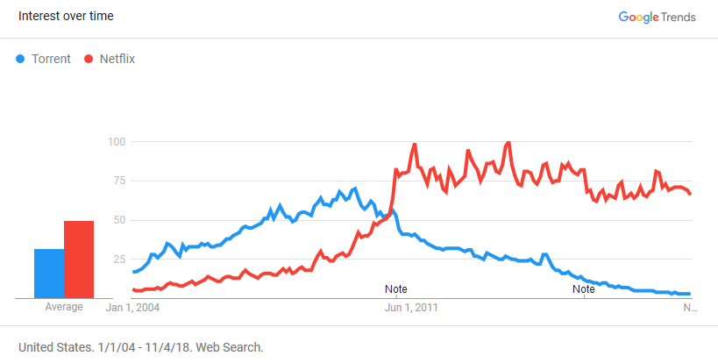

If middle class Americans, Canadians are pirates, why didn’t Blockbuster stores have steel bars? The same reason why we don’t steal Netflix. Blockbuster was a fair deal, until data streaming movies was possible. Then Netflix was.

The people elected to download movies from pirate bay because it was an upgrade available to their cyborgology. The only natural rule is natural selection. The people choose the best tool they evolve into better cyborgs. It’s not the people’s job to wait for an industry to catch up to Nature. But the other way around.

Maybe the industry would have noticed that. But they surrounded themselves with art and wanted people to being distracted with spectacle (Blu-Ray, HD-DVD). While calling their own customer’s thieves, the movie industry held countless banquets and balls on the people’s DVD dollars; movie premieres, talk shows, award shows, and launch parties. Read books like Hollywood Interrupted and the revelation of the #MeToo movement, and these parties were, never mind self-congratulatory, but evil.

The Oscars, Correspondence Dinners, Emmy’s, Golden Globes, Cannes Film Festival, Sundance Film Festival, Toronto International Film Festival, and so many others. All modern version of banquets and balls, with gates to keep you out, and rules put in place to make the good times of the DVD going. Party loving, profit loving, foresight lacking is a recipe for antagonism, hence Darth Blockbuster rose up.

While the spectacle of Blu-Ray and HD-DVD tricked some people. Like with Wikipedia, the vast majority followed the natural majic of online movie streaming instead, even when it was against the rules to improve society.

Digital tools empowered the extras to fight back, and check his self-important art story. Techvolution tells them its right to do it. As for it being against the rules, it was, and maybe it should be, I was naive back then and never downloaded any movies. I was the sucker buying DVD’s.

Hey, do you think Darth Blockbuster will buy back all those DVDs, Blu-Rays, and HD-DVDs he told me, and us, was better than downloading? I’ll take half-price.

## Decision Time

Well extras, stormtroopers, that’s your master. He’s a Sith Lord. While he may be a great person, nice to you and his employees, wears nice clothing, tips well, whoever he is doesn’t matter. He is an antagonist to society. He fought against video tapes, interest songs, and internet streaming. If society was up to Darth Blockbuster, we’d all be paying for long distance, writing directions on napkins, waving down cabs, paying for late charges, and putting quarters into pay phones.

What’s going to happen when 3D printing threatens his merchandising. Or when Virtual Reality let’s people live their own stories. Or whatever! We shouldn’t have to argue for new tools!

But since the 1970’s our society, our politics, has been falling apart because of Darth Blockbuster. We try to fix things with red/blue politics, but they don’t understand real politics is the control of new tools.

So we the people work two jobs to pay the bills. Why our climate is changing. Why our roads are traffic jammed. Because we as digital tools are invented, the Sith keep writing laws, regulations, and fighting lawsuits to try and made us live like it’s 1970 forever.

Let Le-Marius go!

# A SURE VICTORY

Can’t make up your mind. This will help. The force is strong with whoever holds digital tools. And that’s by design. The thousands of protagonists who built digital tools wanted to empower individual people like you against the Sith.

For the internet, they built individual empowerment from the start. And this fact means Darth Blockbuster never did, and never will, stand a chance against today’s internet Jedi.

## Jedi Paul Baran

The internet has many protagonists. Paul Baran is one of the big ones. Here’s why.

The internet is a network. There are many ways of sending data through a network. The simplest is how phone systems do it with a direct circuit link between two phones. A call’s connection only stops when someone hangs up.

Alexander Graham Bell invented “direct circuit links” in 1876 and put it into action when he co-founded the American Telephone & Telegraph (AT&T) in 1885. For generations direct links was how all telecommunications worked. But when the Soviets tested a hydrogen bomb in 1955, Paul Baran took it upon himself to make a new tool to help prevent a nuclear holocaust.

Baran realized to prevent nuclear war, the world needed a communications network that would survive an atomic attack. Only robust and reliable communications would ease American and Soviet trigger fingers during tense times.

Baran worked alone after work. By 1960 he came up with the two ideas he needed. The first was that his network should have no hubs or organizations (like telephone’s have) to control the flow of information. Central hubs make systems vulerable to attack or failure. Instead data flow should be completely distributed so every node can send and receive information equally. Baran’s nodes network looks like a fishnet. When wach node has three or four links, the network can survive any attack.

Next Baran had to figure out how to send information across the network. This led to his second idea, which was to break up the data into standard-size little packets. Each message would be broken into many packets, each of which would scurry along different paths through the network’s nodes and be reassembled when they got to their destination. If one packet didn’t get there in time, it was quickly resent. This way there’d be no “dropped calls” and communication would always stay open. Baran published his ideas into very detailed technical specs and made sure everyone, especially the Soviets, could copy his work.

Baran then walked into a nest of villains in America. When Baran’s employer RAND recommended his “node-packet data network” idea to the Air Force (in control of America’s nuclear missiles) they wanted to build it. But when the Department of Defense got itself and the Defense Communications Agency involved Baran soon found out working with so many bureaucrats was hopeless.

So Baran tried to convince AT&T, in control of America’s telephone network, to supplement their system with his node-packet data network. “They fought it tooth and nail,” he recalled. “They tried all sorts of things to stop it.” They would not even let RAND use the maps of its circuits, so Baran had to use a pirated set. He made several trips to AT&T headquarters in lower Manhattan. On one of them, a senior executive who was an old engineer looked stunned when Baran explained that his system would mean that data could go back and forth without a dedicated link remaining open. “He looked at his colleagues in the room while his eyeballs rolled up sending a signal of his utter disbelief,” according to Baran. After a pause, the executive said, “Son, here’s how a telephone works,” and explained a patronizing and simplistic description.

The metaphorical Death Star rule book became real! It was against the rules to make a reliable communication network that might help prevent a nuclear holocaust. Good thing Jedi’s don’t give up. Baran continued to push. AT&T finally had him and other outsiders to a series of seminars explaining how its telephone system really worked. “It took ninety-four separate speakers to describe the entire system,” Baran marveled. When it was over, the AT&T executives asked Baran, “Now do you see why packet switching wouldn’t work?” To their great disappointment, Baran simply replied, “No.”

To heck with Darth Telephone!

A decade later Baran’s network was built when the US government’s Advanced Research Projects Agency (ARPA) saw the wisdom in a node-packet distributed communications network. In 1969 ARPA used Baran’s technical specs to build ARPAnet, the first version of the internet. The people who made it were hellbent on empowering individuals, and the made sure the internet could not be controlled by any government or corporation.

Baran’s network is why our smartphones, websites, Wikipedia, any digital tool connected to the internet empower individuals. In the DNA of the internet is a distributed node network that nobody can control or shutdown. An individual has the exact same access as any corporation or government.

That’s why the internet is majical. Whoever uses it, is automatically empowered. It’s why Darth Blockbuster was never on the right side of history. So, let Le-Marius go!

*Paul Baran’s story was adapted from Walter Isaacson’s awesome book* The Innovators, *Chapter 7.*

# DARTH KING CHARLES

Although I like to think this has all been convincing. I really like Le-Marius, so I’m going to mention how antagonists may be well intentioned, but they’ll never change their mind. Indeed, the problems we’re having in our world with no majic has happened before. Let’s go back the ruling philosophy of the noble’s divine right, see how it all worked out for Darth King Charles.

## Place in Line

When Rousseau was being chased around Europe in the 1760-70’s, King Louis XVI rule France and King George III ruled England. Both faced revolutions inspired by the pain on the frontline their high-spending lifestyles and government mismanagement caused. However, these weren’t the first kings to face revolts.

Before Rousseau explained frontline problems to the people, the people still revolted against noble’s excesses and incompetent leadership. Among the first to face the people’s wrath was King Charles I, who ruled England from 1625-1649.

Charles ruled as an absolute monarch under the “nobles right to rule” ruling philosophy. England had a Parliament but it was supposed to advise the king and not tell him what to do. After some revolts in the Middle Ages, parliament did however earn the power to approve taxes.

After years of his forebears mismanaging government finances, and overspending himself, Charles needed money. The people and their parliament refused to say yes until they got more political powers. Charles refused to talk. Instead he sent parliament home, and ruled by himself for 10 years. He raised taxes using some very old feudal rules. One retroactively fined some men for not showing up to Charles’ coronation 10 years earlier. Charles’s version of the fine print didn’t endear him to the people.

Parliament eventually got sick of this subversion, raised an army, and fought the English Civil War (1642–1646). The army was local men devoted to their parliament. It’s officers were chosen by merit, while Charles’s men were mostly nobles who hired mercenaries to fight for them. The war between “parliamentarians” and “loyalists” was bad. It inspired the saying that life without a working government is “nasty, brutish, and short”.

After four years Charles lost. He was held under arrest, while rules for a “constitutional monarchy” were being made by the Parliamentarians. But then Charles escaped, hired a new army, and fought the Second English Civil War (1648–1649).

Charles lost again. The victorious Parliamentarians were enraged. They forgot about a constitutional monarch, and charged Charles for crimes against the English people. While they didn’t have a new ruling philosophy, the people were at least questioning the one in power.

Charles didn’t budge. The rules were on his side. The Bible said he was God’s representative on Earth. He was the natural leader the same way a father is the leader of his children. In fact, despite being tried for high-crimes, Charles refused to speak to the court; a father doesn’t answer to his children.

But then Darth King Charles did speak, and that fact, showcases how set the Sith are in their stories.

## Charles Speaks

Charles had a speech impediment. Often called a stammer or stutter. No one then, or even now, understands what causes it. It’s annoying to listen to. Like music coming from a damaged stereo speaker.

That’s because for a stutterer, talking is like playing guitar with music notes written on the fly by a gremlin. Some words are easy to say, some are ~~difficult~~ hard, and some decide which at the last mili-mili-mili-second. The stutterer must jump around the words in real time. Fail and you miss a — beat.

But a stutter isn’t just pausing. Stuttering is like getting hit with a stun gun and having a mini-seizure. Your body seizes. Your neck tenses. You stop breathing. It’s horrible.

The physical pain isn’t even the worst. Getting *that* look from people is. The “what the fuck is wrong with you?” look.

Hello, my ~~name~~ I go by John-ne. I wa-want ~~can~~ want to help ~~master~~ human evol-ution. I’ve been ~~writ~~ trying to write this book for ~~about~~ ah ~~five~~…

The prospect of talking, except to yourself and a dog, which Charles had two of, causes huge anxiety. The idea of never conversing with anyone causes huge loneliness and depression. *The King’s Speech* showed it well. Stuttering usually forces a person to be shy, passive, eager to please, and come up with weird reasons for their erratic speaking like hand gestures, random silence, binge drinking, and swear words (which like being alone or dogs, for some reason never cause a stutter). It’s entirely possible Charles’ relationship with Parliament was so bad because he simply didn’t want to talk with them. Not that he would ever admit he had a impediment. After all, he was a king!

I know this all because luckily enough (kidding) I have the same affliction as Charles. It was the reason I got a job in a car insurance claim department. After a vice president at an old company secretly told my supervisor I wasn’t allowed to talk to customers, for fear of embarrassing the company, I was like shit I guess I don’t have this damn gremlin under control. I wasn’t even that mad about it (although I was that it was an open secret for over a year). I never told anyone I had the impediment, so despite therapy as a kid, it was obviously still a problem.

So, fuck it. I decided to jump in the ocean and sink or swim. A car insurance claim call-centre is like climbing swimming the open ocean for a stutterer. A daily workout of all-day phone calls, angry drivers, customer service expectations, no “outs” like swear words, booze, or wonky behavior to hide behind.

And it was far worse than I thought. The insurance company wanted adjusters to answer ever more phone calls. To incentive us, they’d ring a monotone “bell” because… I don’t know. They never said why, we employees learned questioning “the bell” was a bad idea. Management used it as punishment; “answer more phone calls or we’ll make the bell faster and louder!”.

I’m being serious by the way. We were often more stressed then the person who just had a car crash. Whatever the reason, DING-DING-DING-DING almost all day, which gave people who weren’t stutterers huge anxiety, breakdowns, and stress leaves.

Super-shock speech therapy! After about a year I didn’t have to massage my jaws at night to release it from all the teeth shattering jaw-clenches I did to divert vocal stuttering. I was cured!

The point is this. That’s what it took for me to mostly, except when pretentious cultures limit my word choices, never stutter. It’s like night and day. The anxiety washed away. A hidden outgoing personality was brought out and frankly is fun, although still surreal, to be.

Yet Charles never had this lesson. Despite being adamant he was God’s chosen leader (or perhaps because of it), he was famously shy and quiet his whole life because the gremlin likes it that way. Even when fighting for 16 years defending his ruling philosophy, Charles still probably had to massage his strained jaws every night. I can sympathize. The gremlin is an asshole.

At Charles trial, he was accused of being “a Tyrant, A Traitor, Murderer, and a public enemy to the Commonwealth of England”. Not a bad king, but a bad ruler. The people of England, empowered with many books, scientific instruments, and especially guns of a healthy civilization, were replacing their leader. A novel ideal at the time.

The prosecutors didn’t have Rousseau’s new ruling philosophy to replace the “divine rights of nobles”. They simply said Charles was a tyrant and asked for the death penalty. Charles wouldn’t even acknowledge the trial. He didn’t believe his life was on the chopping block. Kings don’t answer to children.

Charles wasn’t pretending or bluffing. He wasn’t proud, or stubborn. He psychologically couldn’t understand even the idea of being wrong. Like Mr. Auld, he lived in a different story with a different ruling philosophy. One that made him the protagonist.

The judges convicted Charles anyway. He was sentenced to death by removing the head from the body. Charles was flabbergasted. He finally spoke at the execution. Fuck the ringing bell of a claims department, Charles only had words to justify himself to his (supposed) subjects and to history. And… and… no stutter. Not once!

Charles freely, openly, spoke the music of his mind.

He didn’t just speak, he spoke so eloquently many people, even those who hated him, were impressed. He spoke so well, so clearly, the people heard him speak! Fuck… I’m happy for him. It must have felt like God killed the gremlin. What vindication! Indeed, Charles’s last words were a clearly spoken:

*Truly I desire their (the people’s) liberty and freedom as much as anybody whomsoever; but I must tell you their liberty and freedom consist in having of government, those laws by which their life and their goods may be most their own. It is not for having a share in government, Sir, that is nothing pertaining to them. A subject and a ruler are clear different things…therefore I tell you that I am the Martyr of the people. I die a Christian according to the profession of the Church of England, as I found it left me by my father… I have a good Cause and I have a gracious God. I will say no more.*

Clearly spoken words about being totally behind the times. Kings were no longer needed. The people could rule themselves. Charles should have been happy his children grew up. He could have helped them grow up by conceding powers to Parliament and avoiding 16 years of war. Instead he lives in splendor, hide behind spectacle, used the people’s money to hire foreigners to kill them.

Later kings still didn’t learn. Even more distanced from the frontline inside their palaces, banquets and balls, their heads filled with different gremlins that said the rules are just, good, and will never end. France, Spain, Russia had country wide bankruptcies, food shortages, and revolutions, and it didn’t matter. The ultimate gremlin is isolation from the frontline. Many more Darth Kings faced the chopping block with the voice of God calling them martyrs.

So why did you think Darth Blockbuster would ever let Le-Marius go?

# ACT THREE

## Climax

I Le-Marius face Darth Blockbuster. He stares back with hate. I’m still bound. He could strike me down. Instead he lifts his finger, and releases my cuffs.

My lightsaber is on a table. I grab it. Turn it on. He does too. The lights of both hum together, a nice tune that foretells violence.

Darth Blockbuster needs to prove something. Because we were making good points Stargazer and Darth Blockbuster needs people to follow his rules, and no better way than for them to see him the hero. Hero’s don’t murder, they avenge wrong doing. I must die in open combat inside a court of the rules.

So, I fight the Sith lord. We jump up and down. Slice left and right. Slash, kick, punch; we’re beating each other bloody. Neither is reaching for salvation. Nothing divides our powers. We both have the same tools.

And that’s been the problem, the only problem, all along Stargazer.

## Anti-Climax

I mentioned this several times. I tried to give hints to make this a “logical surprise”. Hopefully it worked.

The battle between protagonists and antagonists is as old as the story of civilization. It was fought when we invented swords, bows and arrows, the printing press, muskets, telescopes, rifles, microscopes, vaccines, the internet… Like clockwork, whenever we create a new tool, the Sith fight to retain old power and the Jedi fight to distribute it. When the former wins, the people’s cyborgology stays the same. If the latter wins, the people upgrade their powers and evolve life on Earth.

Galileo, Thomas Hobbes, Friar Bruno, John Locke, Oliver Cromwell, Jean-Jacques Rousseau, George Washington, Frederick Douglas and so many other great people and armies have fought the Sith. Yet the Sith keep coming back. It’s too easy for them to take control of society’s rule book and put society in a matrix of bad stories with bad rules.

But the majic of Techvolution still calls us forward, and we keep fighting the same fight to distribute the power of new tools. But, when will it end?

Remember when we said Stargazer, in no story does one side think their evil. Well that’s not totally true is it. In no story between two human forces does one side think their evil.

To send the Jedi vs. Sith storyline then, we must use rule book nobody writes.

## No More Eggshells

When someone has their own version of reality, a totally unique perspective, we call them nuts. Dealing with this person is said to be like “walking on eggshells”, because it’s very hard to socialize with their singular version of right and wrong. The lesson is, the Sith and Jedi are always walking on egg shells with each other.

They each have their own matrix with its own rule book. We fight wars over them. In retrospect these are mostly ridicules, like the dozens we fought because a few people thought God sent them to party in banquets and balls while believing “I am the Martyr of the people.”

Don’t laugh, we fight over VCRs, CDs. It’s currently against the rules to repair your own laptop, or to watch Netflix across country borders although you’re accessing the same servers. All episodes of walking on eggshells because we fight to fill society’s rule book with our own ideas of right and wrong.

Techvolution only works when everyone seamlessly drops bad tools for better ones. I envy biological lifeforms in Nature. They never walk on eggshells. They search for resources using their biology of tools, nobody cheats, everyone plays equally inside the fair reciprocation of ecosystems. It’s why we must keep animals in cages. They miss the fairness and rationality of Nature.

Thus, it was never my goal to defeat Darth Blockbuster and *this* Death Star. We talked about past battles like Rousseau vs. Darth King, Frederick Douglass vs. Mister Auld, to realize we can never beat the Sith with another human written rule book. For as long as our civilization uses a human created rule book for its politics and economics, killing one king only let’s another come back.

To truly win, we mustn’t destroy the Death Star, but replace it. We need a new rule book that continually enforces our natural evolution. Where the only rule is natural selection.

That’s what I wanted to teach you Stargazer. How to make a tool that will forever kill the Sith. And the time is now, because it’s only possible to build, because of digital tools.

## The End

It’s on your shoulders Stargazer.

Don’t worry. I look at you and see not a kid, but the man who will forever win the war against the Sith. You will make an incorruptible rule book. Where the only rule is natural selection. We call it the Life Star.

You have questions. Big ones. Every journey starts and ends with one footstep. So go off and walk towards the future; I can’t be there for you.

The future can’t be made by old war-torn heroes, sick and embittered by old philosophies. Only new heroes can build the future. The new heroes of the people who think majically connecting with any tool they want is as natural as voting.

So, I lift my sword, and smile my eternal rest.

I’m still smiling as Darth Blockbuster, the ignorant protagonist of a dead ruling philosophy, strikes me down. I die happy. Because you know the lesson. The person who holds the tools wins. Build the Life Star and you’ll never face a Sith lord again. The Life Star, it’s life with perpetual democracy and perpetual profit.

# CONCLUSION

## Remarks

I wrote this for the people on GitHub, Bitbucket, Slack, Figma, Sketch, and whatever else you Jedi are working on. Learning the ecosystem of your tools was super cool. Learning your unspoken philosophy was even cooler.

Most people don’t yet know the power of digital tools. It’s too different, like an animal inside a different ecosystem. The fact any person can visit GitHub, go to the Ruby on Rails site, and download it for free. The same software the runs parts of Netflix and LinkedIn. Not only that, the fact you can see the people who are doing it, and see exactly the work they contributed.

Open source still can’t run the world. Read *The Innovators*, and Walker Isaacson will explain how the trifecta of academic institutions, private corporations, and the military was perfect to create the digital revolution. Open source is so pivotal because it’s a check and balance to anyone trying to control too much.

Work is tracked. Ideas are debated. Results are shared. People work when and where the want, and they give better results because of it. No uniform requirements. No “BEEP-BEEP” of bell. No boss trying to keep. It’s not perfect. Shit happens. But try working elsewhere on the frontline and you’ll see a big difference.

It’s a different world. One that I only wanted to learn about. Now I want to liberate. There’s no difference between the soldiers who fought Darth King Charles, George III, or Louis XVI. You all feel the “majic” of new tools, yet have a hard time explaining to regular people, because humanity still doesn’t really understand how our “cyborgology” changes us every time we pick up a new tool.

It pisses me off red / blue politics seeps into your political conversations and thoughts. I hope you can better explain why you’re making the world a better place to extras wondering why you work so hard with this book and terms like “Darth Blockbuster”, “Death Star rules”, and technological protagonists.

In retrospect, the marching red/blue think it’s 1969 because to them it is 1969. The power of digital tools is completely unseen to them. You could transfer them back in time and they wouldn’t notice. Gas cars, broadcast televisions, 9-5 work days, two car garages homes, retirement savings; their ideal way of life is a never ending *The Simpsons* episode. Red/blue, equally and without difference, are now self-entitled characters in an art film living a life of banquets and balls, or are distracted by the spectacle.

There are many Darth Blockbuster’s in this class of artists. They live by inheriting the control of DVD stores, accounting offices, insurance brokers, bureaucratic office jobs, and political offices. They write rules to stop the hierarchy of old tools sending them back to equality. They do so with the outmost sincerity and conviction that they’re the “martyrs of the people”. The power of digital tools is as long to them as books, guns, and telescopes was to Darth King. It’s too bad. They’re usually very well-intentioned people, but they’re just way behind the times.

The people are distracted like fans of an old sitcom to notice our leaders too often are not solving our frontline problems with new tools. We’re so use to seeing the same names, news broadcast, 60 Minute interviews, product logos, to notice the story sucks. We’re stuck trying to figure out a 5,000-page tax code, which hospital service our insurance pays for, which road is less traffic jammed.

That’s what the matrix is. It’s seeing beyond the layers of reality. The easiest to see is the everyday spectacle of life. Beyond it is rules that antagonists use to keep themselves in power. The protagonists of new tools fight back. They fight back best with a new philosophy. There’s lots of philosophy written in these pages (the cover page is a big hint). It went unnamed because it’s a complication that wouldn’t help me. But this was only to get us started, part one of three, of making a new philosophy.

# EPILOGUE

## My App

My app. Using modern web development, it took just a few months of work. Take some free code from GitHub, an inexpensive cloud computing account, and the design skills of a novice. It was simple. Might not even get me a job in “tech”.

The tool wasn’t polished because new tools never are. It was, would have been, so effective because it came directly from the frontline. A place far away from today’s ruling philosophy.

Here’s how it worked. Today’s car insurance claim system depends on drivers exchanging information like names or insurance policy numbers after a car accident. Drivers are frazzled and scared of strangers so they usually don’t. My adjusting job was talking to these drivers to process their insurance claims. The one supposed to return drivers back to normal; at least as best to normal as money can get them. A big problem was simply knowing who the other driver and adjuster were. Since we often didn’t know, we had to search for it; literally calling around or hoping someone calls you. Delays piled up like crazy.

Adjusting sucks. Our only tools were a telephone, email, voicemail, checkbook, google, and a supervisor telling us to hurry up or get fired. Beyond st-st-stress ~~stressful~~, very emotionally taxing.

Until you speak with a driver who is a real person.

Real person because their accident wasn’t an inconvenience, but a life changing horror. Maybe their arm was amputated, or their friend was ejected from the car, or their kid burned alive twelve hours ago.

You’re mind shuts Darth Call Centre up the moment you talk to this real person. They have a problem and your soul wants to help.

Why did this happen? That’s all drivers want to know. Was someone trying to beat a red light? Was the road not salted for ice. Was it drunk driving? What’s the reason for the sudden terror of pain? It’s soothes people to know why the accident happened; it really helps knowing it won’t happen again.

My app combined several existing technologies, email, internet, GPS, google maps, and web apps, to make a new tool. It let insurance adjusters post an accident on a google map, and verified their identity by their work email. Since every accident shares the GPS coordinates, all adjusters, regardless what drivers do, can find each other. It’s minimal operating cost was paid for by rental car companies and repair shops, who loved the ability to email invoices directly to adjusters without having to call first.

A simple new tool that only someone on the frontline would ever feel the pain to make.

Society would have saved hundreds of millions in insurance claim operating costs. That’s cool. Adjuster’s and drivers would save hours of their day. That’s cool too. But this is the part worth fighting over. With my app, for the first time, we’d have a database of the exact location and causes of car accidents. Thereafter we could cross reference with weather, traffic, demographics, and many other databases. We’d finally learn why car accidents happen, and start to fight back.

This database doesn’t exist today. So, when tree branches grow over stop signs, tires are faulty, intersections jam up too much, pot holes get too big, or anything else repeatedly causes accidents, we don’t even know. With machine learning and artificial intelligence, we’d find trends to the millions of accidents, and tens of thousands of deaths that happen every year. Who loses?

People who don’t feel frontline pain. In my case executives, lawyers, marketers, and consultants. Like Darth Blockbuster, they didn’t know one thing about car accidents or claims. Not one. It existed only to stand above in an art film of self-entitlement. Their introversion, blank faces, clueless looks, arrogant smirks angered me so much it merged years of political theory in my mind, and let me see a new ruling philosophy called Techvolution in my head.

It was still hard writing this book. It was condensing so much political and economic theory and history into such a short space. I was mentally pretty tired, and despite indulging in Jack Jones’ “The Impossible Dream” too much, a little bitter. Then I watched an episode of Netflix’s *Black Mirror* and went back to work.

This episode was the tale of a crazed man, who wants to talk with the powerful CEO of an Instagram like app called Smithereens. He holds a company intern hostage awaiting the CEO’s call. Police surround him, corporate lackies try to deflect him, bullets are fired at him, but he still wants his phone call. Nobody knows why.

I started to cry. I soon wept. I knew this man. I knew why he went crazy.

I knew distracted driving killed someone close to him. The man had been driving, and he checked his Smithereen feed, saw a picture of a dog or something, and he missed a drunk running a stop sign, and his beloved fiancée died.

I didn’t know it was his own distracted driving, but I knew the pain the actor played out so well. He just wanted to tell someone why it happened, so maybe it wouldn’t happen again. I knew that because he told me the same thing dozens of times.

I made a new tool that would have helped. Not solved. Not actual magic, but it majically would have gotten us closer. It was against the rules of introducing a classic story when art and spectacle is what Darth Blockbuster lives on.

He’ll never say that, or even know it. He thinks frontline pain is a thing to stand above, not ever feel and solve with new tools.

I did my best as a protagonist. Not good enough to prevent anyone’s *Smithereens*, but I did my best. The point isn’t self-pity or guilt. The point is neither needs to exist in the digital age. For the philosophy of digital tools isn’t a place of sword wielding heroes with a mass of peasants behind them. I pushed as far and high as I could. Now other protagonists can pick up where I left off. Everyone is either an extra choosing the best tools, or a hero working to earn their favor, in the ruling philosophy of Techvolution.

Rest assured, the protagonists inside the open-source community are making an app far more powerful than my little thing. Darth Blockbuster can’t stop it, because the Sith are defeated. Their lawsuits, corporate rules, red / blue marches worked to suppress digital tools since the 1970’s. No more. Because we’ll won’t use a human-written philosophy to discuss what’s right and wrong for him to corrupt.

It’s always been there. We just couldn’t sense it too well. Digital tools let us.

That’s coming up in the sequel, the book I originally wrote, *Techvolution: Building the Life Star*.

# 

# TECHVOLUTION II: THE LIFE STAR (rough draft)

## Stargazing Eyes

How did life evolve eyes? It's not like one day a lifeform woke up and had 20/20 vision. Adaptions are gradual. The first eyes were cells in a bacterium that simply said light and dark. But this new tool let these bacteria cells probe the environment and sense day and night, and up and down. It worked wonders in the story of life because they found resources better. It's why most lifeforms today have eyes.

Tools increase our senses. Fast forward hundreds of millions of years, humanity had excellent 20/20 vision. We could sense colors, distance, and depth. It's not liked these things weren't always there. Life just couldn't sense them before.

Yet our excellent eyes could only see so far. Looking at the brilliant universe, our minds wanted to make sense of the colors, lights, and revolution of the sky. Myths abounded about running foxes, warring giants, and fireflies struck up there. The biggest question was the simplest. Are we moving, or is the Universe? Our eyes couldn't tell.

Ancient Greek's had two big ideas. Aristotle said the Earth stood still (geocentrism). If it moved, why don't stars in the sky change position. Aristarchus said the Sun is way bigger than the Earth, surely, we must revolve around it (heliocentrism), and the stars don't-look like-they move because they're extremely far away.

Aristotle won out. The best minds in the world choose the wrong answer. They believed it so much they believed the Holy Bible even said so. People used Ptolemy’s "epicycles" to explain the planet's movements and make navigation and weather pattern charts. They worked well enough, but since the premise was wrong, they had to change the math every once and a while.

When Copernicus rediscovered Aristarchus, he thought maybe if the Earth revolved around the Sun, the math would make more sense. He tried it, and it did, although he kept assuming planets move in perfect circles so the math wasn't perfect. He was scared to disagree with Darth Geogentric, so he only published his work on his deathbed.

The powers that be didn't like questioning a huge pillar of science, religious, and political mythology. A young, brash, brilliant, and definitely “nuts” monk didn’t care. He believed God made a wondrous Universe. Humanity should embrace what new senses show us. His name was Friar Bruno (your name sake). Obsessed with looking at the night sky, he went from city to city proclaiming the Earth moved, the Universe had many worlds, and lots of other stuff people hated to think about. Darth Geocentric burned him alive. Let the others be warned.

Then Galileo made his telescope. It was a primitive telescope with hazy lenses made from hazy glass, but magnified our 20/20 vision. We were no longer primitive lifeforms with insufficient senses. Instead of merely telling the difference between up and down, day or night; we could now tell the difference between moving and not moving. Could Darth Geocentric burn everyone who upgrades their cyborgology with a telescope?

Many Sith lords tried. Not with torches and stakes, but with a mountain of rules. Yet the people majically bonded anyway with telescopes, microscopes, books, and more. They probed the environment and sensed the many errors inside the ruling philosophy, mainly the "nobles right to rule", that was enforced to keep the art loving and spectacle making, hierarchy alive. The classic story of tools solving real life problems won out like always.

With the telescope, microscope, and other scientific instruments, human cyborgology sensed more and more of the Universe. We discovered planets, stars, galaxies, super-novae, bacteria, chemicals, atoms, molecules, viruses, and so much more.

Human written rule books, written as art and spectacle stories by kings, nobles, and folklore, about physics, biology, chemistry, botany was slowly replaced with a new rule book called Nature. Nature is incorruptible because it’s not written by us. We can only discover more pages by observation, hypothesis, and experiments. We can never write any ourselves.

Before digital tools, we may have had bacteria eyes to indicate light and dark, but we had no telescopes to probe for clear economic and political answers. We did our best with human made rule books and learned by trial and error in the dark. We searched for visions of the just and good society. We did our best with strong human virtues, ethics, and reasoning, but most of our battles were against Darth Blockbuster.

Now with digital tools our human world will have no art or spectacle, but just the perpetual classic story of conquering Nature.

## What Happens Next

That damn Le-Marius. He probably turned into a ghost like in the movie and went on vacation or wherever. But no worries. For I am Stargazer, destined to save the galaxy and bring the Force to human evolution. So here we go. Let's build the Life Star.

We don't know exactly what it is. Yet we have a great starting point. It's opposite. Light is the opposite of dark the same way full is the opposite of empty. Knowing one, defines the other. The Death Star is a rule book written humans. The Life Star is the opposite of the Death Star.

So what is it? The Life Star is a rule book no human can write. Rules can't be added, fudged, or abused, only uncovered. Happily, we already use this rule book. It's helped us truly understand our world in areas like chemistry, biology and physics. Of course, I'm speaking about Nature; where scientists often feel the majic of discovering rules. Thus we replace human-made rule book, which Darth Blockbuster can so easily corrupt, with one that is incorruptible.

The chemists, physics, doctors, and engineers who already use Nature often argue, and debate. They settle their differences much more often with tests of the incorruptible rule book. Many happily think "failure is always an option", because while we can't add rules to Nature, we can strike off possibilities and thus get closer to an answer.

I'll explain how we use Nature to make the Life Star by asking you a question you can't answer. How old are you?

## The Life Star's First Brick

How old are you. Simple question solved by simple math. Start from your birth day and count how many times you've circled the Sun. It's a fact in all our laws, religions, and science. When we compare each other, objects, or thoughts, we use birthdays. That is how we tell time.

What if someone told you, like a witch or wizard, when you die. Would you still count the days past? Or would you start counting the days left? Wouldn't we live better if we knew our deathday? No more thinking we'll make up for wasted time "later". How many days in traffic, useless meetings, or stress inducing interviews are fueled with "later”? Later implies endless life, stories, and growth. Later is a lie. That's why no stories are about later. Because the stories worth telling happen now. To really live, we must realize our story ends….

THAT’S ALL FOR THIS PREVIEW. I THINK I CAN GET THE REST DONE IN ABOUT 30-40 PAGES.

1. * Majić is my family name. I lucked out it reads like “magic” in English. It’s egotistical to use it here I know, but I couldn’t think of a better word. I’m especially using it for my parents. They’ve been overworked all their life yet still always cleaned and built stuff for other people with care. I wanted to retire them. Instead, I can name the act by which a regular person improves humanity in their name.
   * Sticking it to my personal Darth Blockbuster makes me smile too.

  