# TECHVOLUTION - A New Philosophy

By Johnny Majic

September 17, 2019

Prologue

Introduction

Chapter 1 - The Writer

Chapter 2 - The Backstory

Chapter 3 - The Problem

Chapter 4 - The Protagonist

Chapter 5 - The Plot

Chapter 6 - The Antagonist

Chapter 7 - The Big Picture

Chapter 8 - The Extras

Chapter 9 - The Climax

Epilogue

# PROLOGUE

## Dedication

For the open source community. For the unspoken philosophy you handed down to me. For caring so much when updating Wikipedia, writing free software, and building cool new tech for us all. For showing me who the protagonists are. It’s the best education a political guy can get. I hope I learned enough.

For the antagonists, the self-entitled delegators keeping Blockbuster alive, thanks for making the past come to life. I hope you learn something.

To the extras. I pray you pick the right side.

## The Start

It all started with a door in the face. I’m either too stubborn or too hopeful. Either way, I eventually learned my lesson. I was selling a product they were never going to buy.

Before you wonder, it wasn’t the price, there was no price. It wasn’t the competition. None of that either. And I can promise it worked, because I had done the frontline job it worked for.

I figured out how to solve a problem, and save 100 million dollars, 30,000 hours of productivity, and even several lives, with an app that was virtually free. All I wanted was to give it away. I wrote (another) book about the untapped possibilities of new tech like apps, bio-monitors, and bitcoin. I wanted real-world proof, and maybe get some real-world credentials, to help validate my ideas.

But I was a fool. I wasn’t even knocking on doors. I was knocking on gates.See, I wasn’t talking to the frontline workers suffering through the problem I solved, but bureaucrats, lawyers, managers, and executives, who were paid to deal with problems. Solving problems was asking them to fire themselves. Hence the gates they kept closed to new tools.

That’s why they never said no to me. No needs a reason. Instead they said it was against the rules to say yes. Obscure ones hidden inside regulations and contracts. They believed in these rules, especially the one against letting frontline workers to decide for themselves.

I’m not going to talk about my experience too much. All that’s important is there was a problem, a big one wasting millions of your dollars, weeks of workers time (lots of it unpaid overtime), and maybe even your life, and it was against the rules to solve it.

## The Power Of Stories

Do you love stories? I think it’s a safe bet. Who doesn’t? They entertain us after hard days of work, bring us together to share our joys, and my favroite, open our minds to the different rules and philosophies of foreign cities, mythical worlds, and galaxies far far away.

Stories are so powerful because they’re so simple. Protagonists are good because they want to fix a problem. Antagonists are bad because they don’t. Stories aren’t debates. We take the protagonists side. Thus, Romeo and Juliet’s love is beautiful and worth dying for, while their familes feud is ignorant and stupid. Luke Skywalker’s rebellion is good and worth fighting for, while Darth Vader’s empire is wicked deserves to die.

Moral clarity about a problem turns protagonists into our heroes, and antagonists into our villians. We thus watch their story with strong emotions, which burst out at the climax, where we find out who wins.

Our hero fights hard to defeat the stories problem, but his superior morality, justice, and heroism isn’t enough. He’s often too weak or unskilled, and the villian beats him bloody. On the verge of failure, the hero needs to find something, something that’ll turn the tide. He searches, sees, and reaches for his salvation; a sword, gun, or lightsaber.

Will our hero reach it, or will our enemy? We in the audience, like extras in the story, hold our breadth because the story’s society is controlled not by desires, opinions, or rules, but by which character holds the tools. It’s a lesson we need to learn for ourselves.

## A New Philosophy Called Techvolution

The rules. We think they control us. They don’t. I’ll show you.

Talk to any political junkie, no matter when, and they’ll say there’s a big election coming up. They’ll say something like “if the red team wins this one, education, healthcare, infrastructure, everything will go to shit.” What he means is elections decide the rule makers and blue rules are good, and red rules are evil.

If you buy it, most of us have at some time, you watch blue cable news, read blue blogs, listen to blue talk radio. You fill your head with blue’s philosophy. Soon enough, your face is painted blue, your waving a blue bristol board while yelling blue chants at rallies, marches, and protests. You feel like a hero! You’re fighting evil red philosophy!

Let me ask you, if your a regular middle class person, and you ignored the election, how much would you bet, that you would know who won, just by living your life.

I mean today, when team blue wins, does traffic suddenly disappear? When team red wins, does everyone suddenly eat healthy? Do you breath fresher air, or see healthier neighbors, i.e. do your real life problems get solved, when one color’s philosophy writes the rules?

If you think yes, if you think the red vs blue story is an edge of your seat thriller deciding the future of our society, you can stop reading. There’s lots of blogs, shows, and books waiting to sing to their choir, telling you to fight the enemy until your blue in the face.

If you don’t like the choir, or you’re starting to wonder if blaming the other color is a convenient excuse for both red and blue to distract from middle class stagnation, you’ll probably like to keep reading. I wrote this book for you.

Whichever color wins an election today and writes the rules, regular people still pay taxes, have a mortage, drive in traffic, don’t sleep enough, buy unhealthy food, watch climate change, over pay for questionable education, can’t understand their health insurance, get abused by unhappy customers, work unpaid overtime, don’t know their health records, are micro-managed, and hope a job we likely hate isn’t downsized or outsourced.

Under blue or red rules, our lifestyle stays the same, because the tools in which we live our lives, like suburban homes, gas cars, call centres, paper based tax forms, mass produced unhealthy food, television for entertainment, an increasing education industry, and everything else in suburban America and Canada, stays the same.

The rules, no matter what color, don’t control us. The tools we live our life with do. And nothing changes between red and blue, because neither’s philosophy, from conservatism to progressivism, capitalism to marxism, is about putting new tools into our hands.

It’s not their fault. All of them were invented before we had many tools. Horse and carriages, ships pushed by wind, the moon as a nightlite, were common tools when red and blue were born. Think of it, their philosophical fathers like Adam Smith, Edmund Burke, John Stuart Mill, Karl Marx, never turned on a light-bulb, watched a movie, wore rubber shoes, touched plastic, flew in a plane, drove a car, made a phone call, opened a fridge, took a picture, used penicillin, had an x-ray, started a motor, or listened to the radio.

Red and blue philosphies were invented to group society into a massive collection action. With red and blue philosophies we came together, industrialized, and built the first rudimentary tools like toilets, gas cars, black and white televisions, and computers the size of rooms. The masses needed to be extras, regulated and managed inside massive color coded parties because our tools were few, and couldn’t be shared with everyone. To their credit, blue and red philosophies at least gave extras a voice in how our tools factories, regulations, and profits, were controlled.

Yet today with live in a world far far away from limited tools. Digital tools are so easy to make we can customize them for every person’s individual problems. Netflix, Lyft, Skype, WhatsApp, 3D printing, bio-monitors, air quality sensors, GPS trackers, Kickstarter, YouTube, Khan Academy, smart watches, GitHub, AirBnB, or Firefox are amazingly powerful new tools that are so easy to make, we don’t need to fight to control them, but fight to spread them. We can’t, because the rules of old philosophies based on fighting over, not sharing, tools.

Techvolution is a new philosphy about making regular people the hero of their own story. By empowering them with new tools.

With Techvolution, you wont fight political battles with bristol boards or painted faces. You’ll economically exercise your right to vote, by deciding which tools best solve your problem at home and work. Unlike me, you’ll never see any gatekeepers, because you won’t have to knock at anyone’s door asking permission to do what’s best for you.

I’m not talking about an idealic world from storytime. This place of sharing tools already exists. Wikipedia, YouTube, StackOverflow, GitHub, Linux, Mozilla are only a few examples of the wonderful world of cooperation. It’s called the open-source community because software is “openly shared” to help create new tools. Millions of creators and contributors, designers and coders, are already working and living inside a fundamentally new story that’s responsible for our online world. I only want to rid our society of old philosophies holding it back, to let these protagonists prosper.

People often say we’re addicted to our phones. We aren’t. We getting to know them. They are lightsabres set to destroy the gatekeepers of old philosophies. We’ve just been waiting for a new philosophy to turn them on. That’s techvolution.

## Mastering Our Tools With Techvolution

I want to empower you with tools. Yet, this is not a book about how to invent tools. Amazing books like *Rework*, and *Zero to One* already do that. Nor is it a book about the history of invention. *The Innovators* does that better than I could dream. If you want brilliant critiques of our society, *The Incerto* and *The Great Degeneration* are already waiting for you. Instead, this is a book about how new tools empower society, and how we can distribute their power to improve the lives of regular people today.

That means changing the rules of our society with a new philosophy. Todays philosophies don’t mix well with modern technology. They consider the middle class as extras. People to watch the story. Even if we watch our problems pile up at home and at work, we’re not supposed to solve them until we pass the gatekeepers of old tools in government bureaucracies, creeky corporations, lawyers officers, or consultant meetings. All versions of Blockbuster writing rules to protect themselves in an era of YouTube and Netflix.

We start our new philosophy in nature. Notice gatekeeper’s don’t exist there. Evolution doesn’t have anyone telling a cheetah she’s running too fast, that the ants are too cooperative, or a camel is too water efficient. Lifeforms adapt as best they can to their own problems and the winners survive. No middleman, no gatekeepers, just problem solvers.

Human biological adaptions have stopped. We’ll never evolve to fly, do advanced calculations, or breath Martian air. Humanity continues lifes evolution with tools. We’re basically cyborgs who adapt and solve problems by upgrading our tools to the lastest problem in transportation, calculation, and breathing.

However, our problem solving is held back by old philosophies that empower gatekeepers. People in control of old tools like Blockbuster, getting to decide when, and if, humanity will upgrade our tools. I actually don’t like the term gatekeepers. Some gates are good.

In *Star Wars*, the Force, is an all powerful energy field. The Jedi like Luke Skywalker, harness the light side of the force to help others, while the evil Sith like Darth Vader harness the dark side, to increase their powers. Thus, I call antagonists to our technological evolution Darth Blockbuster. People who prevent human evolution for their self-interest.

We call biological upgrades and adaptions evolution. I call human technological evolution *Techvolution*. This book is about inventing techvolution, a philosophy to re-write the rules of society, to forever kill Darth Blockbuster, so regular people can solve our problems with technological upgrades as smoothly in human society, as evolution does in nature.

## Definitions

Before we go any futher, I want to layout the philosophy our clearly. Here’s what we need to know:

Philosophy: the largley unspoken ideals that tells members of society what’s right and wrong, good and bad, in science, art, morals, politics and economics. A collective consciouness that makes up a civilizations DNA, used by members to make rules around questions like: what is scientific truth? Who should govern? And how should resources be organized?

Ruling philospophy: is a civilization’s chosen philosophy. One that all factions agree on. Like the “Divine Rights of Kings” derived from Christian theology used in royalist Europe, “Marxist-Leninism” of the Soviet Union, or the combination of “red blue” philosophies of our philosophy today.

Technology: a catchall term for things we make tools from, like concrete, lumber, nails, shingles, insulation, and bricks.

Tool: a catchall term for things we create with technology to solve a problem, like guns to kill bad guys, books to learn, and houses to shelter in.

Civilization story: The invention of new technology and creation of new tools to overcome whatever problem troubles us. We use tools to evolve.

Protagonists: people who selflessly invent, spread, and use new technology and new tools. Usually close to the problems on the frontline, they individually struggle, but their continued self-sacrifice slowly improves life on Earth. We call their leaders trailblazers who often skirt the rules like Nikola Tesla, Steve Jobs, Elon Musk.

Antagonists: people who selfishly resist new tools to defend their wealth, power, and prestige. Often called established, or elites, antagonists usually manage companies or institutions based on dated technologies and think working on the frontline is beneath them. They hide behind rules, which they work to control. We don’t often individually identify them. I invented “Darth Blockbuster” so we can.

Extras: everybody in the middle of a battle between two tools. Because they have no direct interest in either side, they can pick winners and losers. Usually extras are in the middle class; not so poor as to be desperate, but not so powerful they want to keep the world the same. Sadly, extras don’t realize their power.

Frontline: The place of contact between a tool and the problem. A movie usher talking to moviegoers, nurses talking to patients, cleaners cleaning a bus, police chasing a robber, soldiers on the battlefield.

Techvolution: a new philosophy empowering seemless human technological evolution by ridding Darth Blockbuster of his power, by empowering extras to decide when society should upgrade our tools.

## A Short Story About Techvolution

So humanity evolves with tools. Some people help, others hurt. Here’s a short explanation of this story. We’ll be expanding on it throughout this book.

Upgrading a technology isn’t a big deal. Sedan’s and SUV’s, tube televisons’s and LCD’s, are basically the same. But when we upgrade enough technologies, like microchips, touchscreens, batteries, and WiFi, we unlock a new tool, ala smartphones. And this is a big deal.

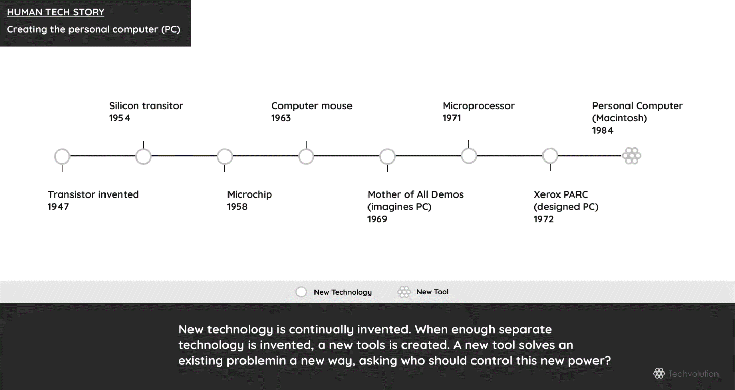

Because creating a new tool asks a climactic and political question, who controls it? After all, whoever does, is more powerful. Thus, while civilization is a struggle to overcome problems by upgrading technology and inventing new tools, it’s also a battle to control them. The people with the old tool usually want to retain their power, while inventors and innovators imagine a new society that shares it.

The eternal story of civilization is thus protagonists making new tools, antagonists attacking new tools, and many extras watching them fight. Our politics is an ongoing history of technological change, with inventor and gatekeeper both reaching for the tool to make themselves the winner.

Today the extras are not self-aware of their power to decide the winner. I’ll show you how important you are. Here’s how you changed the world just by being curious.

## 

## Extras Killed Wikipedia’s Evil Twin

People always have some nagging question. Like why are movie theatres so expensive, or is a candy apple a real apple. Constant questions are a problem and we need a reference tool to solve it. True to ourselves, we make one with the technology available and upgrade it when possible.

Our first reference tools was the wisdom of elders. The first technological upgrades were papyrus scrolls and ink (500 BC) and books (500), which turned elders into experts like Hippocrates and Aristotle. When wood-pulp paper (1200) and printing press (1456) were invented, humanity unlocked mass produced books. Now experts could share knowledge between themselves, and educate the masses. We called the reference books encyclopedias.

People loved encyclopedia’s. For the first time many answers were available on demand. The Encyclopedia Britannica (1878) was the standard. It went into continuous publication (1933) to keep people updated to the latest facts. In the following decades, the computer, digital printer, and telecommunications meant encyclopedia’s were written and stored digitally. But they stayed a set of books controlled by experts.

Then came the world wide web (1991), a new technology that unlocked many new tools like websites, forums, blogs, and something called “wikis”. Wiki software lets anyone write or edit a webpage by pressing “edit now”. All changes are saved, so anyone can erase errors or vandalism by pressing “undo now”. For years programmers used wikis to collaboratively write technical manuals.

As web tools boomed in the late ’90’s, protagoinst Jimmy Wales wondered if the web could upgrade encyclopedias. Most of us curious about things like candy apples know the story ends with a free online encyclopedia anyone can edit called Wikipedia. But it didn’t start out that way.

Wikipedia started as Nupedia (2000). Nupedia was a free online copycat of Encyclopedia Britannica where only “expert” professors made articles. Wikipedia (2001) was a side project. Only programmers knew “community content creation” would work.

Everyone else assumed regular people would only read professors. The first issue was the professors didn’t like to share. In its first year Nupedia had 12 articles. Wikipedia had 40,000, which most professors loved to belittle as rubbish and disallowed students from referencing. Yet professors refused to improve, or assigned students to improve, Wikipedia.

The second issue was it turned out “expert” answers, and answers, are the same. Candy apples are real apples popular in autumn festivals no matter who says it. And thirdly, most importantly, Wikipedia turned many extras into protagonists! A huge community of non-academics voluntarily shared their knowledge one “edit now” at a time and fiercely protected their common knowledge with “undo now”.

And lastly, so many of the remaining extra’s flocked to Wikipedia. The extras mass support quickly made Wikipedia king, while giving Nupedia and Encyclopedia Britannica quick deaths.

That’s the story Wikipedia. Made by new protagoinsts, made the standard reference tool by empowered extras. Few believed it was possible, because even professors don’t understand new tools always unpower the few, to empower the rest. Interestingly, after I finally conceded temporary defeat to Darth Blockbuster, I uploaded a few pages to Wikipedia instead. Not as helpful as my app, but it took a few weeks of work, and one “edit now” button, to make it real.

## 

## What Happens Next

Fighting to spread the power of new tools is an archetypal human story. Galileo fought a religious establisment with a telescope, George Washington fought a political establishment with a musket, and Steve Jobs fought a economic establishment with an iPod.

And that’s the story I want to empower all the extras to join with lightsaber’s a blazin’, dicing up old tools like the evil storm stroopers they are, to smooth out humanity’s natural evolution. It’s vital to realize the story is about problems and tools, not people. So while professors were antagonists to a better reference tool, many of Wikipedia’s facts were discovered by professors, so they’re hardly pure villians.

Our lives cut across thousands to millions of problems. Thus, our villians are not in a massive group like “the rich” or the “the unions” as old philosophies label. Instead we have “micro-villians” inside thousands of companies, institutions, and organizations, withholding new tools, so they can keep their version of the DVD alive.

While, I’ll show the Jedi in the open-source community how to fight Darth Blockbuster better, my audience is the extras. They are the power brokers in our society. They should understand the apps they use, the tools they fund, the rules they follow, drive our society’s future more than any political election ever will.

The extras can kill Darth Blockbuster. I know this because our battle today was fought generations ago with his master, Darth King.

Darth King lived inside palaces, using society’s money to host splendid banquests and balls. His absolute power hidden inside a ruling philosophy of the “noble’s divine right to rule”. Slowly, as protagonists invented scientific instruments, books, and guns, a new philosophy was born. A philosophy of science, enlightenment, equality, and democracy made real when the protagonists and extras fought as one in the American and French Revolutions. These revolutions are our guide to kill not just Darth Blockbuster, but the Sith for good. They were inspired by the new philosophy of Jean-Jacques Rousseau.

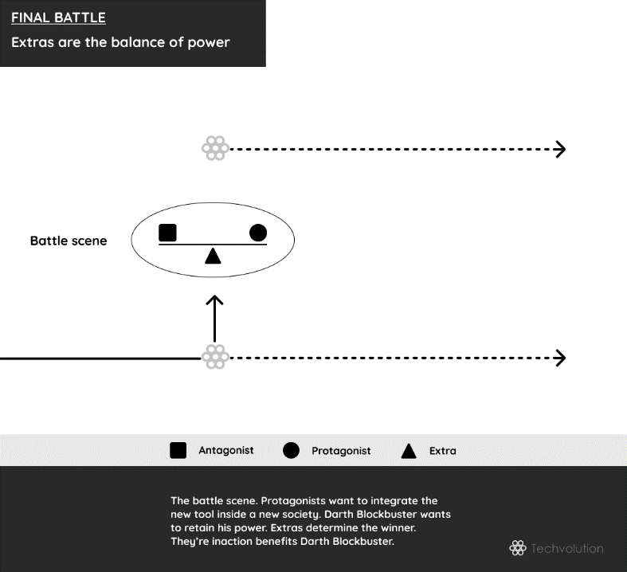

## INTRODUCTION

## Freeing Cinderella

“Extras are born free; and everywhere they are in chains.” Jean-Jacques Rousseau wrote that in 1762. He was the King of France. No he wasn’t. He was the richest man in England. Nope. Rousseau was a poor writer who copied sheets of music to make the rent. More than 300 years later, he is recognized as being a great philosopher, a political visionary, and a protagonist who helped free the world with his new philosophy.

Rousseau lived when kings and queens, dukes and duchesses ruled civilization. A time when Mozart played inside exquisite palaces during the nobility’s many banquets and balls. This was the image of opulence that had Cinderella dreaming her days away as she cleaned a dirty chateau. Sadly, unlike the the fairy tale, the extras didn’t have a fairy Godmother to make dreams come true. Instead, commoners cleaned the noble’s vast libraries, used guns while dying in their wars, and wondered what it looked like through a telescope. The extras were excluded from the power of new tools because they believed their beloved Holy Bible said only noble people had the “divine right to rule”.

Rousseau called bullshit. In truth, Jesus was a carpenter, and books, guns, and scientific instruments should liberate the extras who were only in chains for the happiness of con artists. The self-proclaimed “divine nobility” didn’t like hearing that. This powerful self-protecting community of Darth Kings declared Rousseau a banquet-pooper, and chased him out of Switzerland, France, and England. Maybe that’s why Rousseau rented instead of owned.

Starting in 1776, within Rousseau’s lifetime, Darth King started to face the music, when the American people started a revolution. One year after he died, the French had one too in 1789. And on it went from country to country because Rousseau, and others like him, discovered the magic words for extras to realize they should become protagonists in a civilization “of the people, for the people, by the people”. Cinderella soon forgot about the fancy ball, and instead played the music of freedom, in a choir of equals that sounded something like this:

Do you hear the people sing?

Singing a song of angry men?

It is the music of a people

Who will not be slaves again

When the beating of your heart

Echo’s the beating of the drums

There is a life about to start

When tomorrow comes!

Revolutionary songs like this spread the people’s liberty, equality and fraternity throughout the world. In a few years, civilization changed its philosphy from *knowing* the nobles were divine, to *knowing* they were villians. When the people took control of books, guns, and science, they put presidents and senators, judges and sherriffs in power, who ruled at the request new protagonists who built a civilization with checks and balances, because no one was divine. A change empowered by tools, thought of in philosophy, yet made real with the bloodshed of revolutions.

Rousseau died never having found a home. After they won their revolutions, a population of heroes put him to rest inside the glorious Panthéon; as a renowned breaker of chains, in a free world he helped build. Where any guy can be the prince, and any girl can be Cinderella.

The question for us is, how did Rousseau do it?

## 

## The Road to Techvolution, and the Death of Revolutions

The easy answer is he made people realized they lived on the frontline today, and the ruling philosophy was from the past. See, even though the people didn’t have telescopes, guns, or books, society did. Thus the people were continually disadvantaged. It’s like a student at University today. He can use Wikipedia to find an answer, but still isn’t allowed to reference it in term-paper. So he spends hours searching through books instead.

Likewise, even though French and Americans could read up on current events, they still couldn’t vote their opinion. Rousseau made the people realize the society they lived in, the one filled with tools, was reality, while the ruling philsophy was behind the times.

This change required started revolution, a sudden questioning of a civilization’s ruling philosophy. The American, French and all the others in the 19th centuries were so violent, because the divide between ruling philosophy, and frontline society, was so wide.

Here we must say, the nobility are the gatekeepers of the ruling philosophy, but not necessarily are they Darth Blockbusters. They are group of people who share a mix of characteristics like race, religion, age, gender, family, ideology, or wealth, and they operate civilization’s science, politics, or economics by controlling society’s tools. Every civilization needs a nobility, because every civilization has a ruling philosophy to defend. Note, I often use “nobility”, but you could reword this as royalty, aristocracy, elites, establishment, authorities—it basically refers to anyone with a hand in guarding the ruling philosophy. The noble families of Europe keeping Cinderella out of the party are one example. The rich senatorial families of Republican Rome, and the voting citizens of ancient Athens are others.

Whether anyone is a Darth, depends if they’re withholding the power of new tools for themselvse. Transformative technologies like the printing press, telescope, gun, and steam engine are new tools whose power should be shared.

Revolutions happen because of delayed sharing. For example, when the printing press empowered everyone in society to start reading, many nobles refused to accept once upon a time illiterate peasants/extras were increasingly educated people capable of particpating in their own government. But as nobles refused to distribute political power, they turned what should have been a series of moderate reforms, into a revolution of sudden ones. Thus, to enable techvolution, and rid the world of revolutions, we need a road map of tool development.

Nature doesn’t have Darth Blockbuster, and thus doesn’t have “evolutions”, just continual evolution. Techvolution is about smotthing out human evolution by empowering extras to continually pick better tools for their problems on the frontline. Among the many benefits of that, means we’ll never have revolutions again.

