Regular Window:

Filters hidden.

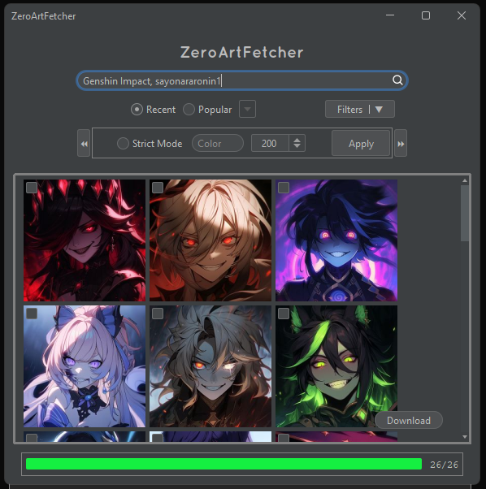

Strict Mode button.

Standalone button

Apply button.

Applies all selected filters.

Next Page Btn.

Prev. Page Btn.

Color Filter.

Allows user to enter any valid color name. (e.g., Blue)

Load Ratio.

No. of how many images are currently loaded.

Entry Limit.

Limits the number of how many images will be loaded per page. (Max. 200)

Regular Window:

Filters shown.

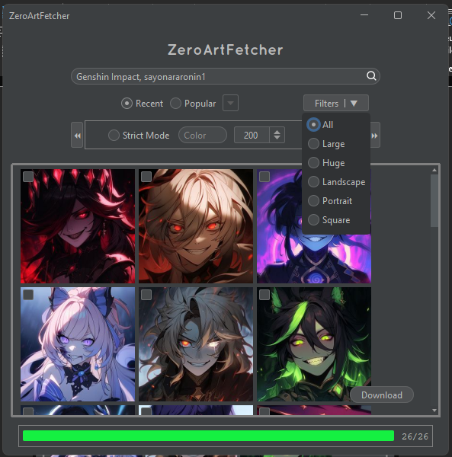

Regular Window:

Popularity Scale shown.

Popularity scale is only available when the Popular option is selected.

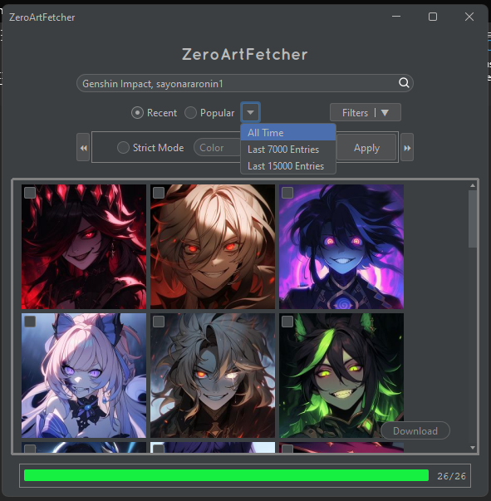

Regular Window:

This is how it looks like when searching for images.

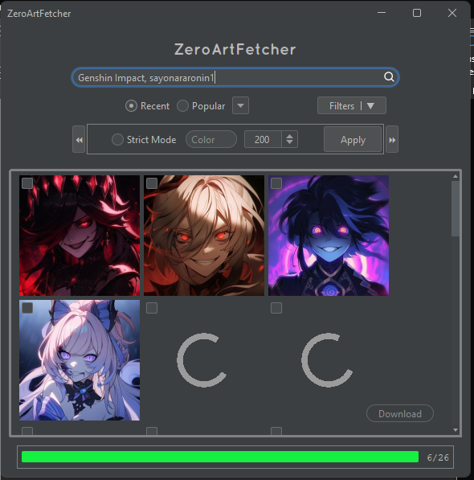

Filters ungrouped.

Basically shows all filters since there is enough space

Maximized Window

