Little Moments: Designing an Interactive Experience
Group members: [Add all group members’ names]
Course: [Add course name]
Current project files:
https://github.com/jp4890-coder/MSTU-5003-5013-project/tree/submission/little-moments-current/little-moments

Idea and Design Intentions
Little Moments is an interactive learning prototype that helps caregivers get to know a young child. Parents share details about temperament, preferences, communication, routines, food needs, and sleep. Caregivers then explore three everyday situations and consider how different responses might fit that child.
A written profile can be a useful reference, but a list of details is easy to skim without imagining how to use them. I wanted to put some of that information into a situation: a child waiting near the door, turning away from lunch, or holding on to a toy when bedtime approaches. My hope is that choosing a response helps caregivers connect what the parent shared with something they might actually do. I have not tested whether this improves memory or care.
I see this as especially useful during the first few days with a new caregiver, a change of daycare, or another transition when adults and children are still getting to know each other. My central question is, “What might work best for this child, and why?” The goal is to encourage attention and flexibility rather than teach one answer that works for every child.
The same idea could eventually be explored in support for older adults or people with disabilities. That would need a separate design process with the people receiving care, their own preferences and communication, and appropriate consent. It is a possible direction, not something the current childcare prototype has been designed or tested to do.

Layout and Style
The welcome screen offers two clear paths: parents can create a profile, and caregivers can open an invitation. The caregiver screen follows the order of my paper sketch: a child summary first, then the situation, response choices, feedback, and navigation. I wanted people to see enough context to make a choice without having to work through a long lesson.
I used cream backgrounds, sage accents, rounded cards, and clear spacing to make the interface calm and approachable. Headings and borders help people see which information belongs together. Each scenario has a small fictional illustration so the situation is easier to picture, without showing a preferred answer.

My paper sketch
[Insert your own paper sketch here before submitting.]
Space for the original paper sketch
Figure 1. My paper sketch helped me decide the order of the caregiver screen before refining the layout in code.

How the HTML and CSS Support the Design
The structure uses header, nav, main, section, and aside elements to separate navigation, the main views, and supporting child information. Labels are connected to form inputs, and fieldset and legend group the three response choices. These native HTML elements make the structure clearer than using only generic containers.
I used padding to create room inside cards and gap to separate related layout items. Borders and background colors distinguish the situation from the choices and feedback. The profile form groups related questions under section headings so it is easier to scan.
CSS Grid handles the scenario layout. On a larger screen, grid-template-columns: minmax(0, 1fr) 240px gives the text flexible space and the illustration a predictable width. At 650px and below, a media query switches the layout to one column. The text stays first and the image moves below it. The form also changes from two columns to one on smaller screens. This changes the arrangement instead of simply shrinking everything.
The response labels provide a larger clickable area around each radio button. The :focus-within style outlines the control being used with the keyboard, while checked-state styling helps show the current choice. Feedback appears in its own card after the user submits a response. These styling decisions communicate what is related, what can be clicked, and what changed.

Interaction and Scenario Content
My design principle became “simple interaction, meaningful personalization.” Each moment has one short situation, three choices, and brief feedback. A caregiver can try another response or move on. The HTML/CSS foundation includes forms, radio buttons, buttons, and navigation; JavaScript makes those elements work beyond the assignment’s minimum requirements.
I noticed that the original bedtime option “put the toys away immediately” made the answer feel too obvious. I changed the choices to three reasonable priorities: help the child reach a small stopping point, introduce a familiar bedtime activity, or offer reassurance. Feedback explains a possible benefit and limitation, with references to relevant parent-reported routines or settling needs. The other situations remain short, and personalization uses predefined rules rather than generated advice.

How I Used AI
I used ChatGPT and Codex to brainstorm, translate my sketch into code, explain HTML/CSS, debug interactions, and generate fictional illustrations. AI made it easier to try alternatives, but testing those alternatives helped me decide what I actually wanted.
One experiment added a second decision, a possible child reaction, and reflection after every scenario. When I tried it, it felt too complicated and text-heavy. I asked to return to the original one-decision structure. We also tried larger homepage layouts and different typography, but I preferred the original homepage and restored it. Those versions were useful for comparison even though I did not keep them.
Two of my requests were “Simple interaction, meaningful personalization” and “the answer is very obvious.” These pushed the work toward shorter interactions and more realistic response choices. I also asked to see an illustration example before approving images for the website.

What I Learned and Checked
I learned that a layout needs to make the main actions easy to find. More whitespace or a larger heading is not automatically better if it pushes those actions out of view. I also learned that changing the number of grid columns can make the same content work on mobile without making the text smaller.
I personally tested versions and used that experience to reject unnecessary complexity. AI-assisted browser checks also covered navigation, fictional profiles, invitations, all three scenarios, image loading, and mobile layouts. One important fix prevents an invited child from silently changing to a sample child after refresh. These checks support functionality; they are not evidence that the project improves caregiving.
The prototype currently uses fictional information and a provisional 18–36 month range. It has not been studied with families or reviewed as a parenting resource. Profiles are saved in the browser, and invitations contain readable copies excluding photos; they are not secure accounts. Any future real-world version would need user testing, instructional review, and a different approach to privacy and sharing.

Current Desktop and Mobile Layouts
These screenshots use the fictional Taeha sample. They show the same bedtime situation arranged for different screen widths.
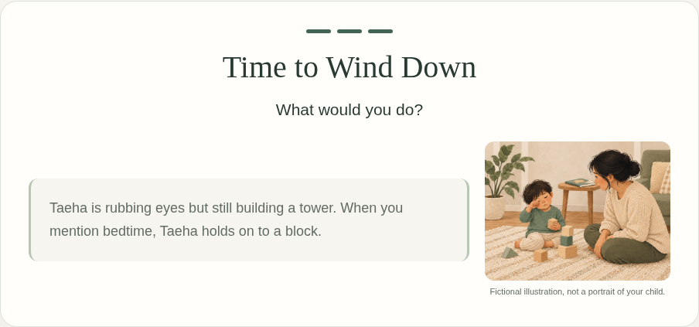
Figure 2. Desktop: the flexible text column sits beside a compact illustration.
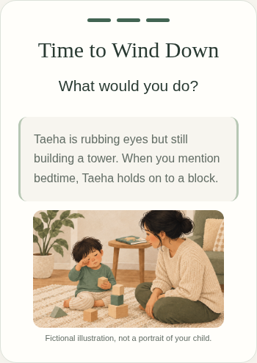
Figure 3. Mobile: the same content stacks into one readable column. The choices and feedback follow below the scenario.

Opening the Project
Open index.html inside the little-moments folder. Choose Create a child profile, Use Taeha sample, then Caregiver view. Keep the images folder beside index.html. No package installation is needed.
The source link at the beginning of this document opens the folder for this submission. The README explains the files and how to run the optional checks.

