OBJECTIVE QUESTIONS
Q1. What is the distribution of account balances across different regions?
Solution :
CODE :
SELECT g.GeographyLocation AS Region,
COUNT(*) AS Customers,
SUM(b.Balance = 0) AS Zero_Balance_Customers,
ROUND(MIN(b.Balance), 2) AS Min_Balance,
ROUND(AVG(b.Balance), 2) AS Avg_Balance,
ROUND(MAX(b.Balance), 2 ) AS Max_Balance,
ROUND(SUM(b.Balance), 2) AS Total_Balance,
ROUND(SUM(b.Balance) * 100 / SUM(SUM(b.Balance)) OVER (), 2) AS Pct_Of_Total_Balance
FROM bank_churn b
JOIN customerinfo c ON c.CustomerId = b.CustomerId
JOIN geography g ON g.GeographyID = c.GeographyID
GROUP BY g.GeographyLocation
ORDER BY Total_Balance DESC;

OUTPUT :
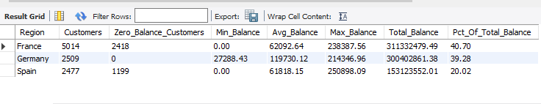

Answer: France holds the largest total balance (311.33M, 40.70% of all deposits) simply because it has half the customers (5,014). Germany has only 2,509 customers yet holds 300.40M (39.28%) because its average balance (119,730.12) is almost double France (62,092.64) and Spain (61,818.15). The shapes differ too: Germany has no zero-balance customers at all, while 2,418 French (48.2%) and 1,199 Spanish (48.4%) customers hold a zero balance. The single highest balance (250,898.09) is in Spain.
Q2. Identify the top 5 customers with the highest Estimated Salary in the last quarter of the year. (SQL)
Solution :

CODE :
SELECT c.CustomerId, c.Surname, c.Bank_DOJ, c.EstimatedSalary
FROM customerinfo c
WHERE QUARTER(c.Bank_DOJ) = 4
ORDER BY c.EstimatedSalary DESC
LIMIT 5;

OUTPUT :
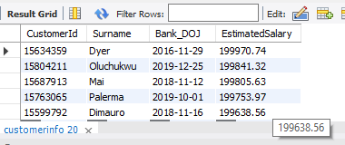

Answer: The top 5 customers by Estimated Salary among those who joined in Q4 (October–December) are 15634359 Dyer (199,970.74), 15804211 Oluchukwu (199,841.32), 15687913 Mai (199,805.63), 15763065 Palerma (199,753.97) and 15599792 Dimauro (199,638.56). "Last quarter" is interpreted through Bank_DOJ, the only date column in the data; all five sit just below the dataset maximum salary of 199,992.48.
Q3. Calculate the average number of products used by customers who have a credit card. (SQL)
Solution :
CODE :
SELECT COUNT(*) AS Card_Holders,
ROUND(AVG(NumOfProducts), 2) AS Avg_Products
FROM bank_churn
WHERE HasCrCard = 1;

OUTPUT :
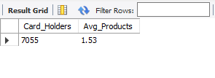
Answer: The 7,055 credit-card holders use 1.53 products on average — identical to the whole customer base (1.53). Holding a credit card is not associated with deeper product usage.

Q4. Determine the churn rate by gender for the most recent year in the dataset.
Solution :
CODE :
SELECT gd.GenderCategory AS Gender,
COUNT(*) AS Customers,
SUM(b.Exited) AS Exited,
ROUND(SUM(b.Exited) * 100.0 / COUNT(*), 2) AS Churn_Rate_Pct
FROM customerinfo c
JOIN bank_churn b ON b.CustomerId = c.CustomerId
JOIN gender gd ON gd.GenderID = c.GenderID
WHERE YEAR(c.Bank_DOJ) = (SELECT MAX(YEAR(Bank_DOJ)) FROM customerinfo)
GROUP BY gd.GenderCategory
ORDER BY Churn_Rate_Pct DESC;
OUTPUT :
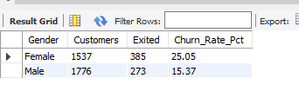
Answer: The most recent year in the data is 2019 (latest Bank_DOJ). For customers who joined in 2019, female churn is 25.05% (385 of 1,537) versus 15.37% for males (273 of 1,776) — a gap of 9.68 percentage points. The data has no exit date, so the year is taken from the joining date; the same female > male pattern holds across the full base.
Q5. Compare the average credit score of customers who have exited and those who remain. (SQL)
Solution :
CODE :
SELECT e.ExitCategory AS Status,
COUNT(*) AS Customers,
ROUND(AVG(b.CreditScore), 2) AS Avg_Credit_Score
FROM bank_churn b
JOIN exitcustomer e ON e.ExitID = b.Exited
GROUP BY e.ExitCategory;
OUTPUT :
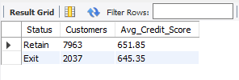
Answer: Exited customers average a credit score of 645.35 versus 651.85 for retained customers — only 6.5 points lower, and both sit in the same "Fair" band (580–669). Credit score alone is a weak separator of churners.
Q6. Which gender has a higher average estimated salary, and how does it relate to the number of active accounts? (SQL)
Solution :
CODE :
SELECT gd.GenderCategory AS Gender,
COUNT(*) AS Customers,
ROUND(AVG(c.EstimatedSalary), 2) AS Avg_Estimated_Salary,
SUM(b.IsActiveMember) AS Active_Accounts,
ROUND(SUM(b.IsActiveMember) * 100.0 / COUNT(*), 2) AS Active_Pct
FROM customerinfo c
JOIN bank_churn b ON b.CustomerId = c.CustomerId
JOIN gender gd ON gd.GenderID = c.GenderID
GROUP BY gd.GenderCategory
ORDER BY Avg_Estimated_Salary DESC;
OUTPUT :
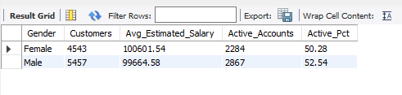
Answer: Females have the higher average estimated salary (100,601.54 vs 99,664.58, about 0.9% higher), but males hold more active accounts (2,867 vs 2,284) and a higher active share (52.54% vs 50.28%). Higher salary does not translate into more activity; the gap in active-account counts is mainly because there are more male customers (5,457 vs 4,543).
Q7. Segment the customers based on their credit score and identify the segment with the highest exit rate. (SQL)
Solution :
CODE :
WITH seg AS (
SELECT Exited,
CASE WHEN CreditScore >= 800 THEN 'Excellent (800-850)'
WHEN CreditScore >= 740 THEN 'Very Good (740-799)'
WHEN CreditScore >= 670 THEN 'Good (670-739)'
WHEN CreditScore >= 580 THEN 'Fair (580-669)'
ELSE 'Poor (300-579)' END AS Credit_Segment
FROM bank_churn
)
SELECT Credit_Segment,
COUNT(*) AS Customers,
SUM(Exited) AS Exited,
ROUND(SUM(Exited) * 100.0 / COUNT(*), 2) AS Exit_Rate_Pct
FROM seg
GROUP BY Credit_Segment
ORDER BY Exit_Rate_Pct DESC;
OUTPUT :
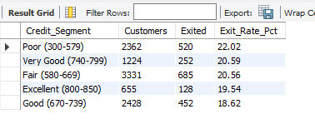
Answer: Using the credit bands from the project brief, the Poor segment (300–579) has the highest exit rate at 22.02% (520 of 2,362). The spread across all segments is narrow (18.62% for Good up to 22.02%), which confirms credit score is only a mild churn driver.
Q8. Find out which geographic region has the highest number of active customers with a tenure greater than 5 years. (SQL)
Solution :
CODE :
SELECT g.GeographyLocation AS Region,
COUNT(*) AS Active_Customers_Tenure_Gt5
FROM bank_churn b
JOIN customerinfo c ON c.CustomerId = b.CustomerId
JOIN geography g ON g.GeographyID = c.GeographyID
WHERE b.IsActiveMember = 1
AND b.Tenure > 5
GROUP BY g.GeographyLocation
ORDER BY Active_Customers_Tenure_Gt5 DESC;
OUTPUT :
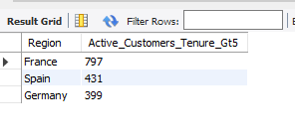
Answer: France has the most active customers with tenure above 5 years (797), followed by Spain (431) and Germany (399). If the 735 exited-but-flagged-active records from Q26 are excluded, the order is unchanged: France 705, Spain 393, Germany 307.
Q9. What is the impact of having a credit card on customer churn, based on the available data?
Solution :
CODE :
SELECT cc.Category AS Card_Status,
COUNT(*) AS Customers,
SUM(b.Exited) AS Exited,
ROUND(SUM(b.Exited) * 100.0 / COUNT(*), 2) AS Churn_Rate_Pct
FROM bank_churn b
JOIN creditcard cc ON cc.CreditID = b.HasCrCard
GROUP BY cc.Category;
OUTPUT :
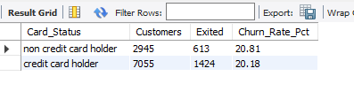
Answer: Card holders churn at 20.18% versus 20.81% for non-holders — a difference of only 0.63 percentage points. In this dataset a credit card has practically no impact on churn, which contradicts the brief's assumption that card holders are less likely to leave.
Q10. For customers who have exited, what is the most common number of products they have used?
Solution :
CODE :
SELECT NumOfProducts,
COUNT(*) AS Exited_Customers,
ROUND(COUNT(*) * 100.0 / SUM(COUNT(*)) OVER (), 2) AS Pct_Of_Exited
FROM bank_churn
WHERE Exited = 1
GROUP BY NumOfProducts
ORDER BY Exited_Customers DESC;
OUTPUT :
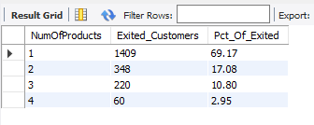
Answer: One product. 1,409 of the 2,037 exited customers (69.17%) held a single product; 2 products account for 17.08%, 3 for 10.80% and 4 for 2.95%.
Q11. Examine the trend of customers joining over time and identify any seasonal patterns (yearly or monthly). Prepare the data through SQL and then visualize it.
Solution :
CODE :
SELECT YEAR(Bank_DOJ) AS Join_Year,
COUNT(*) AS Customers_Joined,
ROUND((COUNT(*) - LAG(COUNT(*)) OVER (ORDER BY YEAR(Bank_DOJ))) * 100.0 / LAG(COUNT(*)) OVER (ORDER BY YEAR(Bank_DOJ)), 2) AS YoY_Growth_Pct
FROM customerinfo
GROUP BY YEAR(Bank_DOJ)
ORDER BY Join_Year;
OUTPUT :
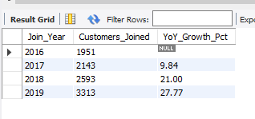

VISUALIZATION :
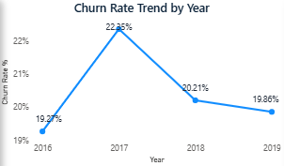
Figure: O11_yearly.png
Answer: Joining grows every year: 1,951 (2016) → 2,143 (+9.84%) → 2,593 (+21.00%) → 3,313 (+27.77%). There is a clear, repeating monthly pattern: September (1,356), November (1,437) and December (1,409) peak in all four years, while January (482) and February (324) are the weakest months. September–December brings in 5,033 customers, 50.3% of all joins — a strong year-end seasonality.
Q12. Analyze the relationship between the number of products and the account balance for customers who have exited.
Solution :

CODE :
SELECT NumOfProducts,
COUNT(*) AS Exited_Customers,
SUM(Balance = 0) AS Zero_Balance,
ROUND(AVG(Balance), 2) AS Avg_Balance,
ROUND(SUM(Balance), 2) AS Total_Balance_Lost
FROM bank_churn
WHERE Exited = 1
GROUP BY NumOfProducts
ORDER BY NumOfProducts;
OUTPUT :

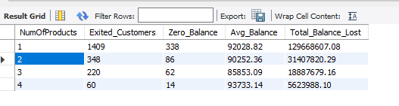
Answer: For exited customers, the average balance barely changes with product count (85,853 to 93,733), so there is no meaningful relationship between the number of products and balance. What differs is volume: single-product churners take away 129.67M, 69.9% of the 185.59M total balance lost to churn.

Q13. Identify any potential outliers in terms of balance among customers who have remained with the bank.
Solution :
CODE :
WITH retained AS (
SELECT CustomerId, Balance,
ROW_NUMBER() OVER (ORDER BY Balance) AS rn,
COUNT(*) OVER () AS n
FROM bank_churn
WHERE Exited = 0
),
q AS (
SELECT MAX(CASE WHEN rn = CEIL(0.25 * n) THEN Balance END) AS Q1,
MAX(CASE WHEN rn = CEIL(0.75 * n) THEN Balance END) AS Q3
FROM retained
)
SELECT q.Q1, q.Q3, (q.Q3 - q.Q1) AS IQR,
ROUND(q.Q1 - 1.5 * (q.Q3 - q.Q1), 2) AS Lower_Fence,
ROUND(q.Q3 + 1.5 * (q.Q3 - q.Q1), 2) AS Upper_Fence,
SUM(r.Balance < q.Q1 - 1.5 * (q.Q3 - q.Q1)
OR r.Balance > q.Q3 + 1.5 * (q.Q3 - q.Q1)) AS Outlier_Count,
MAX(r.Balance) AS Max_Balance
FROM retained r CROSS JOIN q
GROUP BY q.Q1, q.Q3;
-- Z-score check: retained customers more than 3 standard deviations from the mean
WITH stats AS (
SELECT AVG(Balance) AS mu, STDDEV_POP(Balance) AS sd
FROM bank_churn WHERE Exited = 0
)
SELECT b.CustomerId, b.Balance,
ROUND((b.Balance - s.mu) / s.sd, 2) AS Z_Score
FROM bank_churn b CROSS JOIN stats s
WHERE b.Exited = 0
ORDER BY b.Balance DESC
LIMIT 5;
OUTPUT :
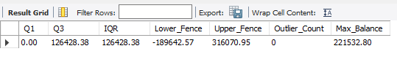
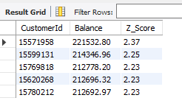
Answer: No statistical outliers. For the 7,963 retained customers Q1 = 0, Q3 = 126,428.38 and IQR = 126,428.38, giving an upper fence of 316,070.95; the highest retained balance is 221,532.80, so 0 customers breach the fence. The Z-score check agrees (maximum Z = 2.37, below 3). The notable feature is a mass point at zero: 3,117 retained customers (39.1%) hold no balance — a business segment rather than an outlier.
Q14. How many different tables are given in the dataset, out of these tables which table only consists of categorical variables?
Solution :
CODE :
SELECT TABLE_NAME,
COUNT(*) AS Column_Count,
GROUP_CONCAT(COLUMN_NAME ORDER BY ORDINAL_POSITION SEPARATOR ', ') AS Columns
FROM INFORMATION_SCHEMA.COLUMNS
WHERE TABLE_SCHEMA = 'bank_crm'
GROUP BY TABLE_NAME
ORDER BY Column_Count DESC, TABLE_NAME;
OUTPUT :
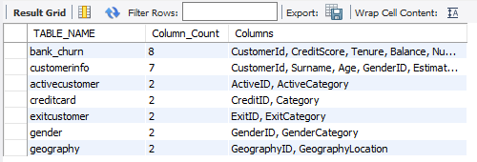
Answer: There are 7 tables: Bank_Churn, CustomerInfo, Geography, Gender, ActiveCustomer, CreditCard and ExitCustomer. The five lookup tables (Geography, Gender, ActiveCustomer, CreditCard, ExitCustomer) contain only categorical variables — an ID code plus its label, where the ID is a nominal code, not a quantity. Bank_Churn and CustomerInfo mix numerical and categorical columns.
Q15. Using SQL, write a query to find out the gender-wise average income of males and females in each geography id. Also, rank the gender according to the average value. (SQL)
Solution :
CODE :
SELECT c.GeographyID,
g.GeographyLocation,
gd.GenderCategory AS Gender,
ROUND(AVG(c.EstimatedSalary), 2) AS Avg_Income,
RANK() OVER (PARTITION BY c.GeographyID ORDER BY AVG(c.EstimatedSalary) DESC) AS Gender_Rank
FROM customerinfo c
JOIN gender gd ON gd.GenderID = c.GenderID
JOIN geography g ON g.GeographyID = c.GeographyID
GROUP BY c.GeographyID, g.GeographyLocation, gd.GenderCategory
ORDER BY c.GeographyID, Gender_Rank;
OUTPUT :
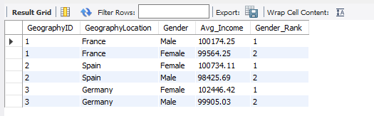
Answer: Females rank 1st in Spain (100,734.11 vs 98,425.69) and Germany (102,446.42 vs 99,905.03); males rank 1st only in France (100,174.25 vs 99,564.25). The gaps are small (at most 2.5%), so income is broadly balanced across genders in every region.
Q16. Using SQL, write a query to find out the average tenure of the people who have exited in each age bracket (18-30, 30-50, 50+).
Solution :
CODE :
SELECT CASE WHEN c.Age BETWEEN 18 AND 30 THEN '18-30'
WHEN c.Age BETWEEN 31 AND 50 THEN '31-50'
ELSE '50+' END AS Age_Bracket,
COUNT(*) AS Exited_Customers,
ROUND(AVG(b.Tenure), 2) AS Avg_Tenure
FROM bank_churn b
JOIN customerinfo c ON c.CustomerId = b.CustomerId
WHERE b.Exited = 1
GROUP BY Age_Bracket
ORDER BY Age_Bracket;

OUTPUT :
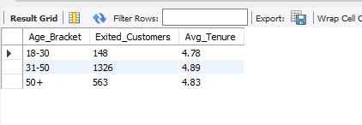
Answer: Average tenure of exited customers is 4.78 years (18–30, 148 customers), 4.89 years (31–50, 1,326) and 4.83 years (50+, 563). Brackets are made non-overlapping (18–30, 31–50, 51+). Tenure at exit is almost identical across age groups; what differs is the number of churners, concentrated in the 31–50 bracket.
Q17. Is there any direct correlation between salary and the balance of the customers? And is it different for people who have exited or not?
Solution :
CODE :
SELECT COALESCE(e.ExitCategory, 'All Customers') AS Customer_Group,
COUNT(*) AS Customers,
ROUND((COUNT(*) * SUM(c.EstimatedSalary * b.Balance) - SUM(c.EstimatedSalary) * SUM(b.Balance)) / (SQRT(COUNT(*) * SUM(c.EstimatedSalary * c.EstimatedSalary) - POW(SUM(c.EstimatedSalary), 2))
* SQRT(COUNT(*) * SUM(b.Balance * b.Balance) - POW(SUM(b.Balance), 2))), 4) AS Corr_Salary_Balance
FROM bank_churn b
JOIN customerinfo c ON c.CustomerId = b.CustomerId
JOIN exitcustomer e ON e.ExitID = b.Exited
GROUP BY e.ExitCategory WITH ROLLUP;
OUTPUT :
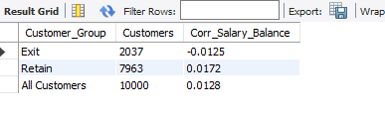
Answer: No. The Pearson correlation between salary and balance is 0.0128 for all customers, 0.0172 for retained and −0.0125 for exited customers — all effectively zero. The relationship does not differ between the two groups; salary tells us nothing about how much a customer keeps with the bank.
Q18. Is there any correlation between the salary and the Credit score of customers?
Solution :
CODE :
SELECT COUNT(*) AS Customers,
ROUND((COUNT(*) * SUM(c.EstimatedSalary * b.CreditScore) - SUM(c.EstimatedSalary) * SUM(b.CreditScore))
/ (SQRT(COUNT(*) * SUM(c.EstimatedSalary * c.EstimatedSalary) - POW(SUM(c.EstimatedSalary), 2))
* SQRT(COUNT(*) * SUM(b.CreditScore * b.CreditScore) - POW(SUM(b.CreditScore), 2))), 4) AS Corr_Salary_CreditScore
FROM bank_churn b
JOIN customerinfo c ON c.CustomerId = b.CustomerId;
OUTPUT :
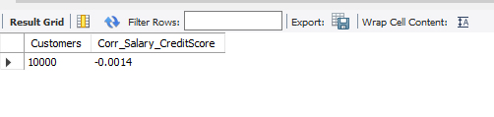
Answer: No. The correlation between Estimated Salary and Credit Score is −0.0014, i.e. none. Salary cannot be used as a proxy for creditworthiness in this data.
Q19. Rank each bucket of credit score as per the number of customers who have churned the bank.
Solution :
CODE :
WITH seg AS (
SELECT CASE WHEN CreditScore >= 800 THEN 'Excellent (800-850)'
WHEN CreditScore >= 740 THEN 'Very Good (740-799)'
WHEN CreditScore >= 670 THEN 'Good (670-739)'
WHEN CreditScore >= 580 THEN 'Fair (580-669)'
ELSE 'Poor (300-579)' END AS Credit_Bucket
FROM bank_churn
WHERE Exited = 1
)
SELECT Credit_Bucket,
COUNT(*) AS Churned_Customers,
DENSE_RANK() OVER (ORDER BY COUNT(*) DESC) AS Churn_Rank
FROM seg
GROUP BY Credit_Bucket
ORDER BY Churn_Rank;
OUTPUT :
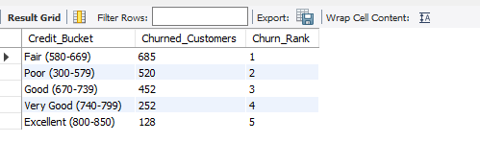
Answer: By number of churned customers: 1 Fair (685), 2 Poor (520), 3 Good (452), 4 Very Good (252), 5 Excellent (128). This count ranking follows segment size (Fair is the largest band); the rate-based view in Q7 shows Poor has the highest exit rate.
Q20. According to the age buckets find the number of customers who have a credit card. Also retrieve those buckets that have lesser than average number of credit cards per bucket.
Solution :
CODE :
WITH bucket AS (
SELECT CASE WHEN c.Age BETWEEN 18 AND 30 THEN '18-30'
WHEN c.Age BETWEEN 31 AND 50 THEN '31-50'
ELSE '50+' END AS Age_Bucket,
SUM(b.HasCrCard) AS Card_Holders
FROM bank_churn b
JOIN customerinfo c ON c.CustomerId = b.CustomerId
GROUP BY Age_Bucket
)
SELECT Age_Bucket, Card_Holders,
ROUND(AVG(Card_Holders) OVER (), 2) AS Avg_Per_Bucket,
CASE WHEN Card_Holders < AVG(Card_Holders) OVER ()
THEN 'Below Average' ELSE 'Above Average' END AS Flag
FROM bucket
ORDER BY Age_Bucket;
OUTPUT :

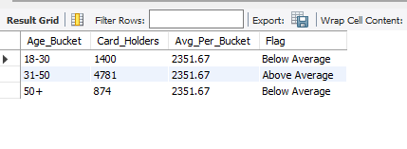
Answer: Card holders by age bucket: 18–30 = 1,400, 31–50 = 4,781, 50+ = 874. The average is 2,351.67 per bucket, so the 18–30 and 50+ buckets are below average; 31–50 is the only bucket above it.
Q21. Rank the Locations as per the number of people who have churned the bank and average balance of the customers.
Solution :
CODE :
SELECT g.GeographyLocation AS Location,
SUM(b.Exited) AS Churned_Customers,
ROUND(AVG(b.Balance), 2) AS Avg_Balance,
RANK() OVER (ORDER BY SUM(b.Exited) DESC) AS Rank_By_Churn,
RANK() OVER (ORDER BY AVG(b.Balance) DESC) AS Rank_By_Avg_Balance
FROM bank_churn b
JOIN customerinfo c ON c.CustomerId = b.CustomerId
JOIN geography g ON g.GeographyID = c.GeographyID
GROUP BY g.GeographyLocation
ORDER BY Rank_By_Churn;
OUTPUT :
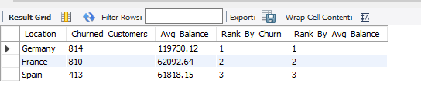Answer: Germany ranks 1st on both measures (814 churned, average balance 119,730.12), France 2nd (810, 62,092.64) and Spain 3rd (413, 61,818.15). Germany produces more churners than France with only half the customers, and those churners carry the highest balances.
Q22. As we can see that the “CustomerInfo” table has the CustomerID and Surname, now if we have to join it with a table where the primary key is also a combination of CustomerID and Surname, come up with a column where the format is “CustomerID_Surname”.
Solution :
CODE :
SELECT CustomerId, Surname,
CONCAT(CustomerId, '_', Surname) AS CustomerID_Surname
FROM customerinfo
LIMIT 10;
OUTPUT :
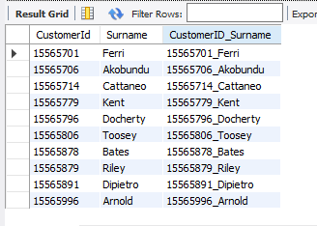
Answer: CONCAT(CustomerId, '_', Surname) creates the composite key, e.g. 15565701_Ferri. The query returns a key for all 10,000 customers (first 10 shown). Because CustomerId is already unique, the key is unique too; note that 92 surnames contain lost characters (e.g. "H?"), which must match exactly in the other table.

Q23. Without using “Join”, can we get the “ExitCategory” from ExitCustomers table to Bank_Churn table? If yes do this using SQL.
Solution :
CODE :
SELECT b.CustomerId, b.Exited,
(SELECT e.ExitCategory
FROM exitcustomer e
WHERE e.ExitID = b.Exited) AS ExitCategory
FROM bank_churn b
LIMIT 10;
OUTPUT :
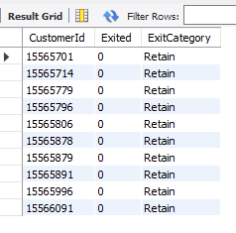
Answer: Yes. A correlated scalar subquery in the SELECT list looks up ExitCategory for each row's Exited value, so no JOIN is needed. Every one of the 10,000 rows receives a category (2,037 Exit, 7,963 Retain); the first 10 are shown.
Q24. Were there any missing values in the data, using which tool did you replace them and what are the ways to handle them?
Solution :

CODE :
SELECT 'bank_churn' AS Table_Name, COUNT(*) AS Total_Rows,
SUM(CustomerId IS NULL) + SUM(CreditScore IS NULL) + SUM(Tenure IS NULL) + SUM(Balance IS NULL)
+ SUM(NumOfProducts IS NULL) + SUM(HasCrCard IS NULL) + SUM(IsActiveMember IS NULL) + SUM(Exited IS NULL) AS Null_Cells
FROM bank_churn
UNION ALL
SELECT 'customerinfo', COUNT(*),
SUM(CustomerId IS NULL) + SUM(Surname IS NULL OR TRIM(Surname) = '') + SUM(Age IS NULL) + SUM(GenderID IS NULL)
+ SUM(EstimatedSalary IS NULL) + SUM(GeographyID IS NULL) + SUM(Bank_DOJ IS NULL)
FROM customerinfo;
OUTPUT :
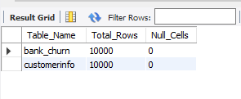
Answer: No — the supplied data has 0 NULL or blank cells in all 7 tables. This was checked in Power Query (View → Column quality / Column profile showed 0% empty), in Excel (COUNTBLANK) and confirmed with the SQL above, so no replacement was needed.
- Deletion: drop rows (few missing) or columns (mostly missing).
- Statistical imputation: mean or median for numbers (e.g. Balance), mode for categories (e.g. GeographyID).
- Business-rule fill: Power Query Replace Values / Fill Down, or an explicit "Unknown" category.
- Model-based imputation: predict the missing value from other columns (regression, KNN).
- The quality issues that did exist were handled instead: 92 garbled surnames were flagged and kept, and the 735 IsActiveMember conflicts are corrected in Q26.
Q25. Write the query to get the customer IDs, their last name, and whether they are active or not for the customers whose surname ends with “on”.
Solution :
CODE :
SELECT c.CustomerId,
c.Surname AS Last_Name,
a.ActiveCategory AS Active_Status
FROM customerinfo c
JOIN bank_churn b ON b.CustomerId = c.CustomerId
JOIN activecustomer a ON a.ActiveID = b.IsActiveMember
WHERE c.Surname LIKE '%on'
ORDER BY c.CustomerId;

-- supporting query

-- Summary of the same result set
SELECT a.ActiveCategory AS Active_Status, COUNT(*) AS Customers
FROM customerinfo c
JOIN bank_churn b ON b.CustomerId = c.CustomerId
JOIN activecustomer a ON a.ActiveID = b.IsActiveMember
WHERE c.Surname LIKE '%on'
GROUP BY a.ActiveCategory;
OUTPUT :
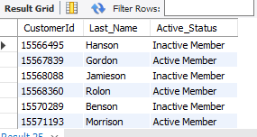

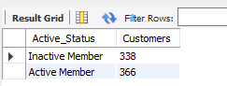
Answer: 704 customers have a surname ending in "on" (first 15 shown; the full list is produced by the query). Of these, 366 are Active Members and 338 are Inactive Members.

Q26. Can you observe any data disrupency in the Customer’s data? As a hint it’s present in the IsActiveMember and Exited columns. One more point to consider is that the data in the Exited Column is absolutely correct and accurate.
Solution :
CODE :

SELECT a.ActiveCategory AS IsActiveMember,
SUM(b.Exited = 0) AS Retained,
SUM(b.Exited = 1) AS Exited,
COUNT(*) AS Total,
ROUND(SUM(b.Exited) * 100.0 / COUNT(*), 2) AS Churn_Rate_Pct
FROM bank_churn b
JOIN activecustomer a ON a.ActiveID = b.IsActiveMember
GROUP BY a.ActiveCategory;

OUTPUT :

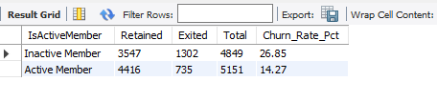

VISUALIZATION :
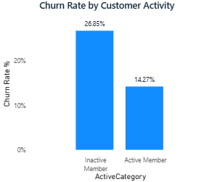
Figure: O26_discrepancy.png
Answer: Yes. 735 customers have Exited = 1 but IsActiveMember = 1. Since the Exited column is stated to be accurate, a customer who has left cannot still be an active member, so these 735 activity flags are wrong — they cover 36.1% of all 2,037 exited customers. The most likely cause is that the activity flag was not refreshed after account closure.
- Observed: active members churn 14.27%, inactive 26.85%; 735 of the active group have exited.
- Correction: IsActiveMember_Clean = 0 wherever Exited = 1 (SQL view vw_bank_churn_clean and a Power BI calculated column). Raw data is kept unchanged.
- After correction: 4,416 active members (all retained) and 5,584 inactive members.
Assumption (not provable from the data): the flag reflects status before exit. If so it is stale rather than wrong, but it still must not be reported as current activity.

SUBJECTIVE QUESTIONS

Q1. Customer Behavior Analysis: What patterns can be observed in the spending habits of long-term customers compared to new customers, and what might these patterns suggest about customer loyalty?
Solution :
CODE :
SELECT CASE WHEN b.Tenure <= 4 THEN 'New (3-4 yrs)'
WHEN b.Tenure = 5 THEN 'Mid (5 yrs)'
ELSE 'Long-term (6-7 yrs)' END AS Tenure_Group,
COUNT(*) AS Customers,
ROUND(AVG(b.Balance), 2) AS Avg_Balance,
ROUND(AVG(c.EstimatedSalary), 2) AS Avg_Salary,
ROUND(AVG(b.NumOfProducts), 2) AS Avg_Products,
ROUND(AVG(b.HasCrCard) * 100, 2) AS Card_Pct,
ROUND(AVG(b.IsActiveMember) * 100, 2) AS Active_Pct,
ROUND(AVG(b.Exited) * 100, 2) AS Churn_Rate_Pct
FROM bank_churn b
JOIN customerinfo c ON c.CustomerId = b.CustomerId
GROUP BY Tenure_Group
ORDER BY MIN(b.Tenure);
OUTPUT :
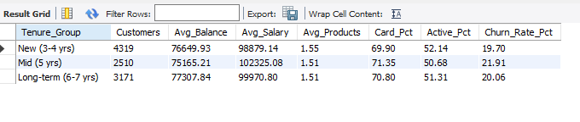

VISUALIZATION :
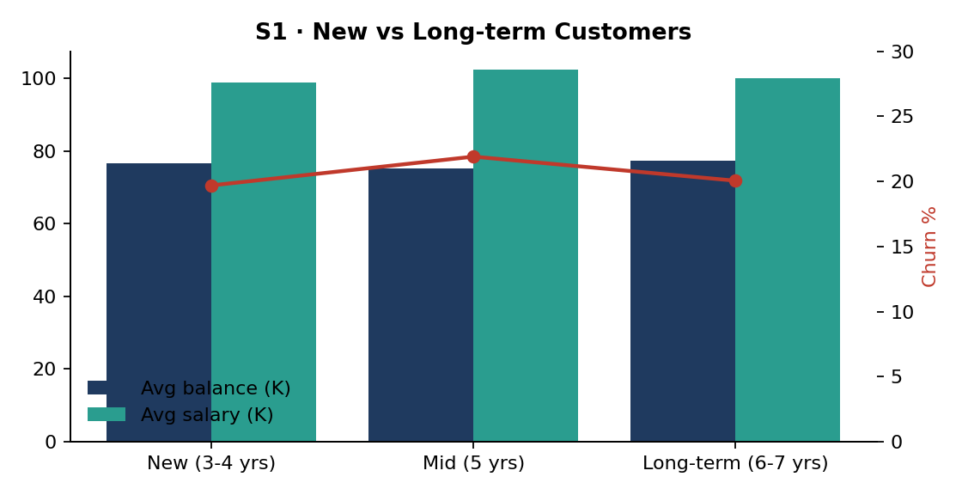
Figure: S1_tenure.png
APPROACH
The data has no transaction records, so "spending habits" are measured through the account-level proxies available: balance, products held, credit-card ownership and activity. Customers are grouped by tenure: New (3–4 years), Mid (5) and Long-term (6–7).
INSIGHTS
The three groups look almost the same. Average balance is 76,650 (new) vs 77,308 (long-term); products 1.55 vs 1.51; card ownership 69.9% vs 70.8%; activity 52.1% vs 51.3%. Churn does not fall with tenure either (19.70% new, 21.91% mid, 20.06% long-term). Long-term customers are not wealthier, deeper or more loyal — loyalty is not being built over time.
RECOMMENDATION
Introduce tenure-based rewards (fee waivers, rate boosts) that start before year 5, the tenure with the highest churn (21.91%). Track balance and product growth per tenure year as a loyalty KPI; transaction data would let the bank measure real spending.

Q2. Product Affinity Study: Which bank products or services are most commonly used together, and how might this influence cross-selling strategies?
Solution :
CODE :
SELECT b.NumOfProducts,
cc.Category AS Card_Status,
COUNT(*) AS Customers,
ROUND(COUNT(*) * 100.0 / SUM(COUNT(*)) OVER (), 2) AS Pct_Of_Base,
ROUND(AVG(b.Balance), 2) AS Avg_Balance,
ROUND(AVG(b.Exited) * 100, 2) AS Churn_Rate_Pct
FROM bank_churn b
JOIN creditcard cc ON cc.CreditID = b.HasCrCard
GROUP BY b.NumOfProducts, cc.Category
ORDER BY b.NumOfProducts, cc.Category;
OUTPUT :
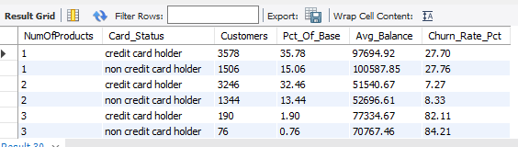

VISUALIZATION :
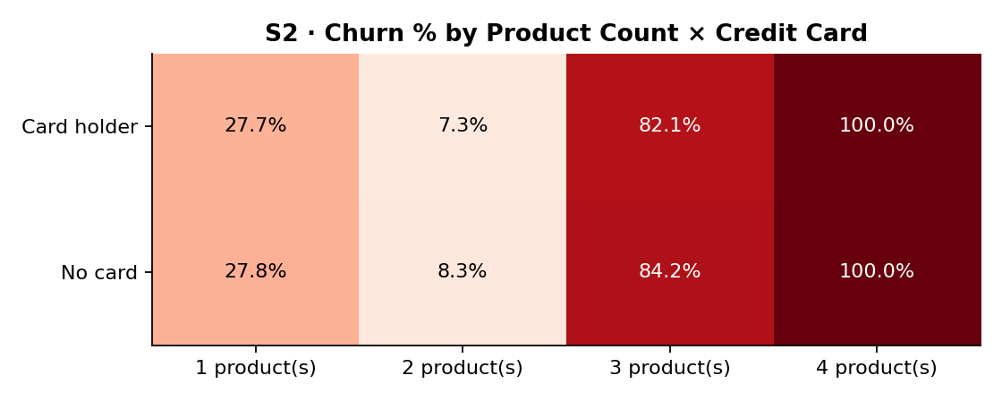
Figure: S2_affinity.png
APPROACH
Product identities are not in the dataset — only NumOfProducts and HasCrCard — so affinity is measured by which product-count and credit-card combinations occur most and how they behave.
INSIGHTS
The most common combinations are 1 product + credit card (35.78% of customers) and 2 products + credit card (32.46%). Two products is the sweet spot: churn is 7.27–8.33%, versus 27.70–27.76% for one product. Three or four products is toxic: 82–100% churn. Adding a credit card changes churn by only about 1 point in any group.
RECOMMENDATION
Make the 1 → 2 product move the main cross-sell target (5,084 single-product customers). Stop pushing a third or fourth product until the cause of the 3–4 product churn is investigated (likely mis-selling or poorly fitting bundles). Record product types to enable true basket analysis.

Q3. Geographic Market Trends: How do economic indicators in different geographic regions correlate with the number of active accounts and customer churn rates?
Solution :
CODE :
SELECT g.GeographyLocation AS Region,
COUNT(*) AS Customers,
ROUND(AVG(c.EstimatedSalary), 2) AS Avg_Salary,
ROUND(AVG(b.Balance), 2) AS Avg_Balance,
ROUND(AVG(b.CreditScore), 1) AS Avg_Credit_Score,
SUM(b.IsActiveMember) AS Active_Accounts,
ROUND(AVG(b.IsActiveMember) * 100, 2) AS Active_Pct,
ROUND(AVG(b.Exited) * 100, 2) AS Churn_Rate_Pct
FROM bank_churn b
JOIN customerinfo c ON c.CustomerId = b.CustomerId
JOIN geography g ON g.GeographyID = c.GeographyID
GROUP BY g.GeographyLocation
ORDER BY Churn_Rate_Pct DESC;
OUTPUT :
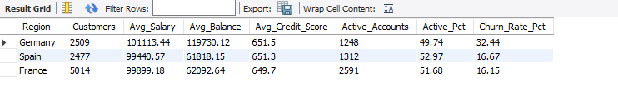
VISUALIZATION :
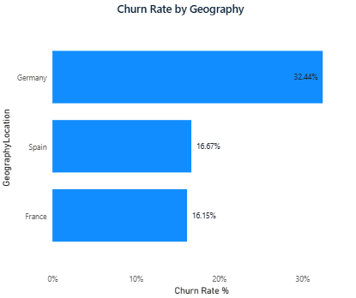Figure: S3_geo.png
APPROACH
The only economic indicators in the data are customer-level: salary, balance and credit score. They are compared by region with active-account share and churn rate. National indicators (GDP, interest rates, unemployment) are not in the dataset.
INSIGHTS
Germany is the outlier: the highest average salary (101,113) and balance (119,730), the lowest active share (49.74%) and double the churn (32.44% vs 16.15% France and 16.67% Spain). Salary and credit score are nearly identical across regions; balance is what separates Germany. Wealthier customers are more likely to leave — likely because they receive better offers from competitors.
RECOMMENDATION
Launch a Germany retention programme for high-balance customers: competitive savings rates, relationship managers and early-warning alerts when balances drop. Add external market data (rates offered by competitors, GDP) to test the competition hypothesis.

Q4. Risk Management Assessment: Based on customer profiles, which demographic segments appear to pose the highest financial risk to the bank, and why?
Solution :
CODE :
SELECT g.GeographyLocation AS Region,
gd.GenderCategory AS Gender,
CASE WHEN c.Age BETWEEN 18 AND 30 THEN '18-30'
WHEN c.Age BETWEEN 31 AND 50 THEN '31-50'
ELSE '50+' END AS Age_Bracket,
COUNT(*) AS Customers,
ROUND(AVG(b.Exited) * 100, 2) AS Churn_Rate_Pct,
ROUND(SUM(b.Balance * b.Exited), 2) AS Balance_Lost,
ROUND(AVG(CASE WHEN b.Exited = 1 THEN b.Balance END), 2) AS Avg_Balance_Of_Churners
FROM bank_churn b
JOIN customerinfo c ON c.CustomerId = b.CustomerId
JOIN geography g ON g.GeographyID = c.GeographyID
JOIN gender gd ON gd.GenderID = c.GenderID
GROUP BY Region, Gender, Age_Bracket
HAVING COUNT(*) >= 100
ORDER BY Churn_Rate_Pct DESC
LIMIT 8;
OUTPUT :
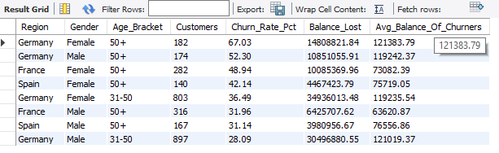
VISUALIZATION :
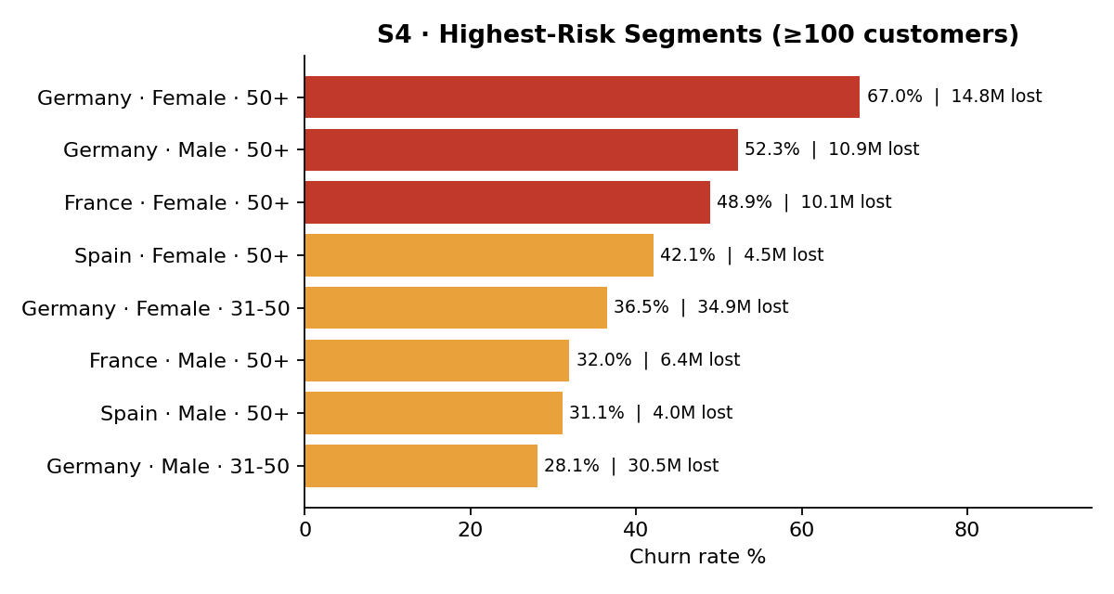
Figure: S4_risk.png
APPROACH
Financial risk is measured as deposit loss: the churn rate of each Region × Gender × Age segment (at least 100 customers) and the total balance that segment's churners took away.
INSIGHTS
The highest churn rates are among customers aged 50+: German females (67.03%), German males (52.30%) and French females (48.94%). The largest money loss comes from German females aged 31–50: 34.94M lost from 803 customers at 36.49% churn. German churners hold about 120K each, roughly double other regions.
RECOMMENDATION
Prioritise two watchlists: German customers aged 31+ (value at risk) and all customers aged 50+ (rate at risk). Offer retirement-oriented products and personal relationship management to the 50+ group, and monitor balance withdrawals as an early exit signal.

Q5. Customer Tenure Value Forecast: How would you use the available data to model and predict the lifetime (tenure) value in the bank of different customer segments?
Solution :
CODE :
SELECT CASE WHEN c.Age BETWEEN 18 AND 30 THEN '18-30'
WHEN c.Age BETWEEN 31 AND 50 THEN '31-50'
ELSE '50+' END AS Age_Bracket,
b.NumOfProducts,
COUNT(*) AS Customers,
ROUND(AVG(b.Tenure), 2) AS Avg_Tenure,
ROUND(AVG(b.Balance), 2) AS Avg_Balance,
ROUND(1 - AVG(b.Exited), 4) AS Retention_Rate,
ROUND(AVG(b.Balance) * (1 - AVG(b.Exited)), 2) AS Retention_Weighted_Balance
FROM bank_churn b
JOIN customerinfo c ON c.CustomerId = b.CustomerId
WHERE b.NumOfProducts <= 2
GROUP BY Age_Bracket, b.NumOfProducts
ORDER BY Retention_Weighted_Balance DESC;
OUTPUT :
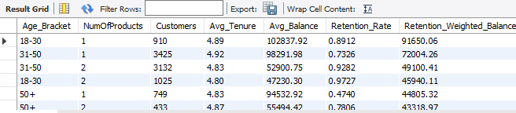
APPROACH
Tenure value = balance the customer keeps × how long they stay. With no exit dates, retention probability is estimated from churn rates. Segments here are Age × Products (1–2 products, where volumes are meaningful).
INSIGHTS
Young single-product customers (18–30) have the highest retention-weighted balance (91,650: 102,838 balance × 0.891 retention). Senior single-product customers have similar balances (94,533) but only 47.4% retention, which halves their value (44,805).
RECOMMENDATION
Model steps: (1) train a churn-probability model (logistic regression / random forest) on age, products, activity, balance and geography; (2) expected lifetime = 1 ÷ annual churn probability; (3) value = average balance × bank margin × expected lifetime, discounted; (4) rank segments and spend retention budget where value × churn risk is highest. Exit dates and product revenue would turn this into a proper survival model.

Q6. Marketing Campaign Effectiveness: How could you assess the impact of marketing campaigns on customer retention and acquisition within the dataset? What extra information would you need to solve this?
Solution :
CODE :
SELECT YEAR(c.Bank_DOJ) AS Join_Year,
QUARTER(c.Bank_DOJ) AS Join_Quarter,
COUNT(*) AS Customers_Acquired,
ROUND(AVG(b.Exited) * 100, 2) AS Cohort_Churn_Pct
FROM customerinfo c
JOIN bank_churn b ON b.CustomerId = c.CustomerId
GROUP BY Join_Year, Join_Quarter
ORDER BY Join_Year, Join_Quarter;
OUTPUT :
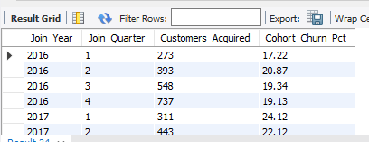

APPROACH
Not directly answerable from the supplied dataset because it contains no campaign data (no campaign names, dates, channels, spend or response flags). The closest proxy is acquisition and churn by joining quarter.

INSIGHTS
Every year Q4 brings the most joiners (737, 808, 918 and 1,214 from 2016 to 2019), which may reflect year-end campaigns. Those Q4 cohorts churn at a normal rate (19.13%–23.64%), so the extra customers are not lower quality.
RECOMMENDATION
Data needed: campaign ID, dates, channel and cost; the customers targeted and a control group; responses and products bought; exit dates and transactions. Methods: A/B tests with hold-out groups, cohort retention curves before vs after campaigns, cost per acquired customer and uplift modelling.

Q7. Customer Exit Reasons Exploration: Can you identify common characteristics or trends among customers who have exited that could explain their reasons for leaving?
Solution :
CODE :
SELECT e.ExitCategory AS Status,
COUNT(*) AS Customers,
ROUND(AVG(c.Age), 1) AS Avg_Age,
ROUND(AVG(b.CreditScore), 1) AS Avg_Credit_Score,
ROUND(AVG(b.Balance), 2) AS Avg_Balance,
ROUND(AVG(c.EstimatedSalary), 2) AS Avg_Salary,
ROUND(AVG(b.NumOfProducts), 2) AS Avg_Products,
ROUND(AVG(b.IsActiveMember) * 100, 1) AS Active_Pct,
ROUND(AVG(c.GenderID = 2) * 100, 1) AS Female_Pct,
ROUND(AVG(c.GeographyID = 3) * 100, 1) AS Germany_Pct
FROM bank_churn b
JOIN customerinfo c ON c.CustomerId = b.CustomerId
JOIN exitcustomer e ON e.ExitID = b.Exited
GROUP BY e.ExitCategory;
OUTPUT :

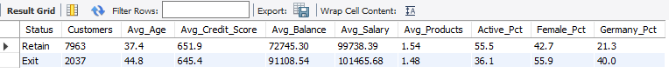
APPROACH
Exited and retained customers are profiled side by side across every attribute in the dataset.
INSIGHTS
Exited customers are older (44.8 vs 37.4 years), hold higher balances (91,109 vs 72,745), are much less active (36.1% vs 55.5%), are more often female (55.9% vs 42.7%) and more often German (40.0% vs 21.3%). Credit score (645 vs 652) and salary (101K vs 100K) barely differ. The likely story: established, mid-life customers with sizeable savings disengage and move their money elsewhere.
RECOMMENDATION
Build exit-risk triggers on age 40+, inactivity and high balance. Run exit interviews to capture the actual reason (not recorded in the data), and focus retention offers on German and female customers.

Q8. Are 'Tenure', 'NumOfProducts', 'IsActiveMember', and 'EstimatedSalary' important for predicting if a customer will leave the bank?
Solution :
CODE :
WITH base AS (
SELECT b.Exited, b.Tenure, b.NumOfProducts, b.IsActiveMember,
NTILE(4) OVER (ORDER BY c.EstimatedSalary) AS Salary_Quartile
FROM bank_churn b JOIN customerinfo c ON c.CustomerId = b.CustomerId
)
SELECT 'Tenure' AS Feature, CAST(Tenure AS CHAR) AS Level_, COUNT(*) AS Customers, ROUND(AVG(Exited)*100,2) AS Churn_Rate_Pct FROM base GROUP BY Tenure
UNION ALL
SELECT 'NumOfProducts', CAST(NumOfProducts AS CHAR), COUNT(*), ROUND(AVG(Exited)*100,2) FROM base GROUP BY NumOfProducts
UNION ALL
SELECT 'IsActiveMember', CAST(IsActiveMember AS CHAR), COUNT(*), ROUND(AVG(Exited)*100,2) FROM base GROUP BY IsActiveMember
UNION ALL
SELECT 'Salary Quartile', CONCAT('Q', Salary_Quartile), COUNT(*), ROUND(AVG(Exited)*100,2) FROM base GROUP BY Salary_Quartile;

OUTPUT :


VISUALIZATION :
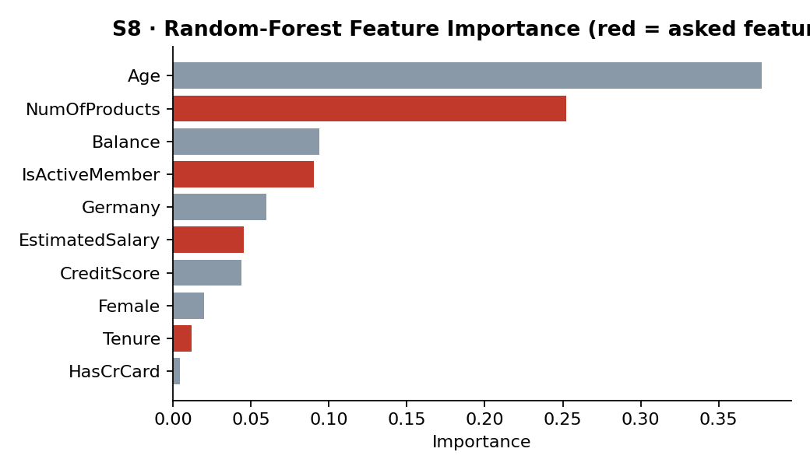
Figure: S8_importance.png
APPROACH
Each feature is tested two ways: the spread of churn rates across its levels (SQL) and a supporting random-forest feature importance computed in Python on the same data.
INSIGHTS
NumOfProducts — very important: churn 27.71% (1), 7.58% (2), 82.71% (3), 100% (4). Its linear correlation is only −0.05 because the effect is U-shaped, yet it ranks 2nd in the model (0.252). IsActiveMember — important: 26.85% inactive vs 14.27% active (importance 0.090). Tenure — not important: 19.14%–21.91% across all years (0.012). EstimatedSalary — not important: 19.80%–21.56% across quartiles (0.045). Age (0.378) and Balance (0.094) matter more than two of the four features asked about.
RECOMMENDATION
Keep NumOfProducts and IsActiveMember in any churn model and add Age, Balance and Geography. Tenure and EstimatedSalary can be dropped with little loss.

Q9. Utilize SQL queries to segment customers based on demographics and account details.
Solution :
CODE :
WITH seg AS (
SELECT b.CustomerId, b.Exited, b.Balance,
CASE WHEN b.Balance = 0 AND b.NumOfProducts >= 2 THEN 'Engaged - No Balance'
WHEN b.Balance >= 100000 AND b.IsActiveMember = 1 THEN 'High Value - Active'
WHEN b.Balance >= 100000 AND b.IsActiveMember = 0 THEN 'High Value - Inactive'
WHEN b.Balance = 0 THEN 'Dormant - Single Product'
ELSE 'Mass Market' END AS Value_Segment,
CASE WHEN c.Age BETWEEN 18 AND 30 THEN 'Young (18-30)'
WHEN c.Age BETWEEN 31 AND 50 THEN 'Middle (31-50)'
ELSE 'Senior (50+)' END AS Life_Stage
FROM bank_churn b JOIN customerinfo c ON c.CustomerId = b.CustomerId
)
SELECT Value_Segment, Life_Stage,
COUNT(*) AS Customers,
ROUND(AVG(Balance), 2) AS Avg_Balance,
ROUND(AVG(Exited) * 100, 2) AS Churn_Rate_Pct
FROM seg
GROUP BY Value_Segment, Life_Stage
ORDER BY Value_Segment, Life_Stage;

OUTPUT :
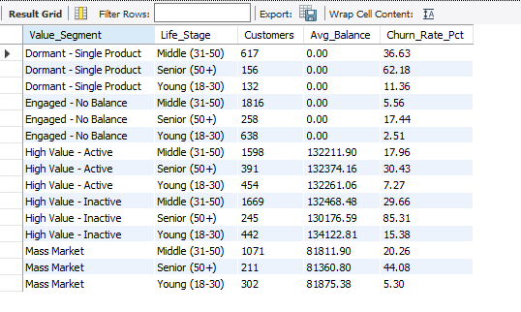
APPROACH
Customers are segmented with CASE logic on account value (balance, products, activity) and life stage (age), then churn is measured per segment.
INSIGHTS
Churn varies from 2.51% to 85.31% across segments. The worst is High Value – Inactive Seniors (245 customers, 85.31%, about 130K each). Engaged – No Balance Young customers are the safest (638 customers, 2.51%). Dormant single-product seniors also churn heavily (62.18%).
RECOMMENDATION
Assign each segment a treatment: reactivation calls for High Value – Inactive, cross-sell for Dormant – Single Product, and low-cost digital service for the Engaged – No Balance group.

Q10. How can we create a conditional formatting setup to visually highlight customers at risk of churn and to evaluate the impact of credit card rewards on customer retention?
Solution :
CODE :
WITH risk AS (
SELECT b.*, c.Age, c.GeographyID,
(c.Age BETWEEN 46 AND 65) + (b.IsActiveMember = 0) + (b.NumOfProducts >= 3)
+ (c.GeographyID = 3) + (b.NumOfProducts = 1 AND b.Balance > 0) AS Risk_Points
FROM bank_churn b JOIN customerinfo c ON c.CustomerId = b.CustomerId
)
SELECT CASE WHEN Risk_Points >= 3 THEN '1 High'
WHEN Risk_Points = 2 THEN '2 Medium'
ELSE '3 Low' END AS Risk_Level,
COUNT(*) AS Customers,
ROUND(AVG(Exited) * 100, 2) AS Actual_Churn_Pct,
ROUND(AVG(CASE WHEN HasCrCard = 1 THEN Exited END) * 100, 2) AS Churn_Pct_With_Card,
ROUND(AVG(CASE WHEN HasCrCard = 0 THEN Exited END) * 100, 2) AS Churn_Pct_No_Card
FROM risk
GROUP BY Risk_Level
ORDER BY Risk_Level;
OUTPUT :
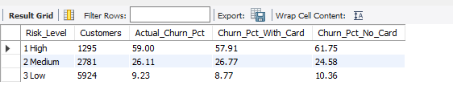
VISUALIZATION :
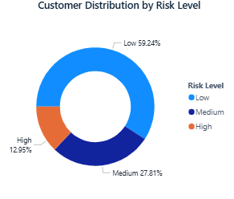
Figure: S10_risk_levels.png
APPROACH
A rule-based risk score (1 point each for: age 46–65, inactive, 3+ products, Germany, single product with a balance) is calculated in SQL and as a Power BI calculated column. Conditional formatting then colours customers: High (3+ points) red, Medium (2) amber, Low (0–1) green.
INSIGHTS
The score separates churn well: High risk 1,295 customers with 59.00% actual churn, Medium 2,781 at 26.11%, Low 5,924 at 9.23%. Credit cards barely change retention within any risk level (High: 57.91% with card vs 61.75% without; Low: 8.77% vs 10.36%), so the current card offer is not a meaningful retention tool.
RECOMMENDATION
Power BI setup: (1) Risk_Level column; (2) table visual with background colour rules on Risk_Level; (3) data bars on Balance; (4) icon set on churn rate; (5) a card-status slicer to compare retention with and without a card. Reward redemption data is needed to measure the real value of card rewards.

Q11. What is the current churn rate per year and overall as well in the bank? Can you suggest some insights to the bank about which kind of customers are more likely to churn and what different strategies can be used to decrease the churn rate?
Solution :
CODE :
SELECT CAST(YEAR(c.Bank_DOJ) AS CHAR) AS Join_Year,
COUNT(*) AS Customers,
SUM(b.Exited) AS Exited,
ROUND(SUM(b.Exited) * 100.0 / COUNT(*), 2) AS Churn_Rate_Pct
FROM customerinfo c
JOIN bank_churn b ON b.CustomerId = c.CustomerId
GROUP BY CAST(YEAR(c.Bank_DOJ) AS CHAR)
UNION ALL
SELECT 'Overall', COUNT(*), SUM(Exited), ROUND(SUM(Exited) * 100.0 / COUNT(*), 2)
FROM bank_churn
ORDER BY Join_Year;

-- Churn rate by age bracket and by activity (who churns most)
SELECT CASE WHEN c.Age BETWEEN 18 AND 30 THEN '18-30'
WHEN c.Age BETWEEN 31 AND 40 THEN '31-40'
WHEN c.Age BETWEEN 41 AND 50 THEN '41-50'
WHEN c.Age BETWEEN 51 AND 60 THEN '51-60'
ELSE '60+' END AS Age_Band,
COUNT(*) AS Customers,
ROUND(AVG(b.Exited) * 100, 2) AS Churn_Rate_Pct
FROM bank_churn b JOIN customerinfo c ON c.CustomerId = b.CustomerId
GROUP BY Age_Band
ORDER BY Age_Band;
OUTPUT :
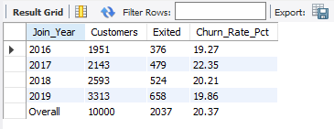

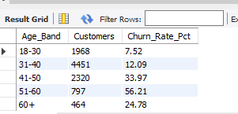
VISUALIZATION :

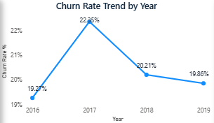
Figure: S11_year.png
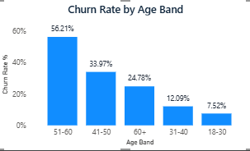
Figure: S11_age.png
APPROACH
Overall churn = exited ÷ all customers. The data has no exit date, so churn "per year" is measured per joining year (cohort).
INSIGHTS
Overall churn is 20.37% (2,037 of 10,000). By joining year: 2016 19.27%, 2017 22.35%, 2018 20.21%, 2019 19.86% — stable, with no improving trend. Most likely to churn: ages 51–60 (56.21%) and 41–50 (33.97%), German customers (32.44%), females, inactive members (26.85%), and holders of 3–4 products (82–100%).
RECOMMENDATION
(1) 50+ retention package and relationship managers; (2) Germany-specific rate and service review; (3) reactivation campaigns for inactive members; (4) cross-sell single-product customers to exactly two products and review 3–4 product bundles; (5) monthly early-warning list from the S10 risk score.

Q12. Create a dashboard incorporating all the KPIs and visualization-related metrics. Use a slicer in order to assist in selection in the dashboard.
Solution :
APPROACH
The dashboard is built in Power BI on the 7 tables in a star schema (Bank_Churn and CustomerInfo as facts, the five lookup tables as dimensions).
INSIGHTS
KPI cards: Total Customers 10,000; Exited 2,037; Churn Rate 20.37%; Active Customers 5,151 (4,416 after the Q26 correction); Average Credit Score 650.5; Average Balance 76,485.89; Balance Lost to Churn 185.59M. Visuals: churn by geography, gender, age band, credit segment, products and card status; joining trend by year and month; risk-level table with conditional formatting. Slicers: Geography, Gender, Age Band, Card Status, Active Status, Join Year.
DASHBOARD
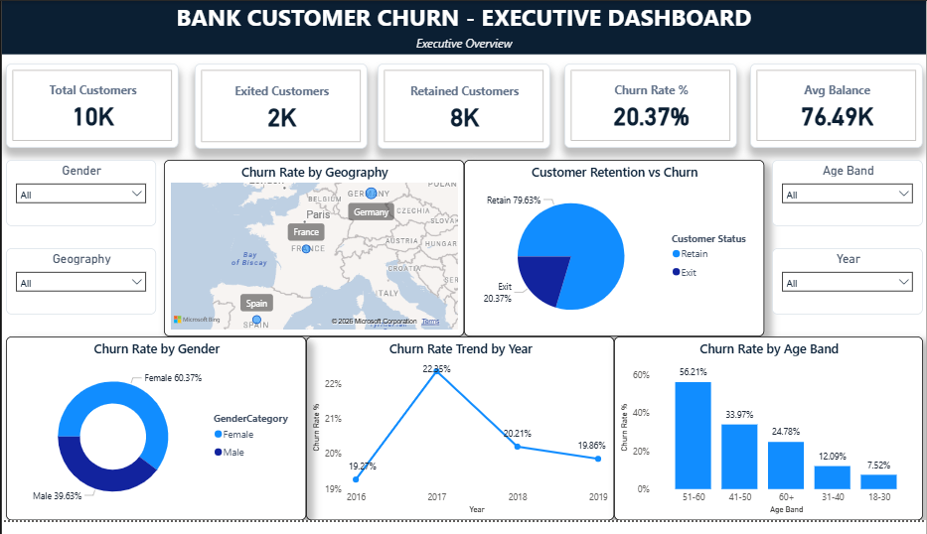

Q13. How would you approach this problem, if the objective and subjective questions weren't given?
Solution :
APPROACH
Start from the business goal (reduce churn, grow valuable customers) and let the data drive the questions.
- Understand the business: what counts as churn, which decisions the bank wants to make.
- Data understanding: inventory tables, keys and relationships; build an ERD.
- Data profiling and cleaning: nulls, duplicates, domain checks, logical conflicts (as done for IsActiveMember vs Exited).
- Descriptive analysis: churn rate overall and by every dimension (geography, gender, age, products, activity, balance).
- Driver analysis: correlations, churn-rate spreads and a simple model (logistic regression / random forest) to rank drivers.
- Segmentation: value × risk segments, sized by customers and balance at risk.
- Dashboard: KPIs, trends and slicers for self-service monitoring.
- Recommendations and measurement: targeted actions per segment, with A/B tests to measure impact.

Q14. In the “Bank_Churn” table how can you modify the name of the “HasCrCard” column to “Has_creditcard”?
Solution :
CODE :
ALTER TABLE bank_churn RENAME COLUMN HasCrCard TO Has_creditcard;
-- Verify
SELECT COLUMN_NAME FROM INFORMATION_SCHEMA.COLUMNS
WHERE TABLE_SCHEMA = 'bank_crm' AND TABLE_NAME = 'bank_churn';

OUTPUT :
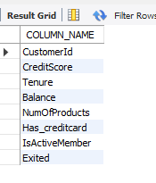
APPROACH
Renaming a column changes the table structure, so it needs the DDL command ALTER TABLE (not UPDATE, which changes row values).
INSIGHTS
ALTER TABLE bank_churn RENAME COLUMN HasCrCard TO Has_creditcard; works in MySQL 8.0 — verified above, the column list now shows Has_creditcard. In MySQL 5.7 use ALTER TABLE bank_churn CHANGE HasCrCard Has_creditcard INT NOT NULL; (the data type must be restated). In Power BI the same rename is done in Power Query (double-click the column header), which adds a Table.RenameColumns step.
NOTES
ALTER vs UPDATE: ALTER TABLE changes structure (add/rename/drop columns); UPDATE changes values in existing rows. TRUNCATE vs DELETE: TRUNCATE removes all rows at once with no WHERE clause and cannot be rolled back; DELETE removes selected rows and can be rolled back. Examples are in the SQL file appendix.

