OBJECTIVE QUESTIONS
Q1. List the different dtypes of columns in table "Ball_by_Ball" (using information schema).
Solution :
CODE :
SELECT COLUMN_NAME, DATA_TYPE
FROM INFORMATION_SCHEMA.COLUMNS
WHERE TABLE_SCHEMA = 'ipl'
AND TABLE_NAME = 'Ball_by_Ball'
ORDER BY ORDINAL_POSITION;
OUTPUT :
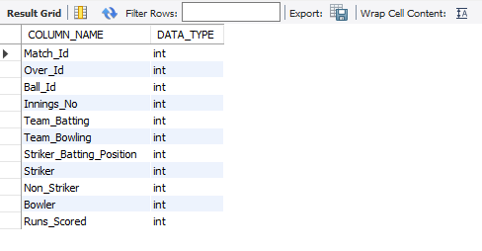
Answer: Every column in Ball_by_Ball is an integer (int) — the table stores only ID references (to Match, Player, Team) and numeric run counts. There are no text/varchar columns in this table, so all descriptive names (player, team, venue) must be obtained via joins to the relevant lookup tables.

Q2. What is the total number of runs scored in the 1st season by RCB (including extras)?
Solution :
CODE :
SELECT SUM(bb.Runs_Scored) AS batting_runs,
SUM(er.Extra_Runs) AS extra_runs,
SUM(bb.Runs_Scored) + IFNULL(SUM(er.Extra_Runs),0) AS total_runs
FROM Ball_by_Ball bb
JOIN Matches m ON m.Match_Id = bb.Match_Id
LEFT JOIN Extra_Runs er
ON er.Match_Id = bb.Match_Id AND er.Over_Id = bb.Over_Id
AND er.Ball_Id = bb.Ball_Id AND er.Innings_No = bb.Innings_No
WHERE bb.Team_Batting = 2 -- Royal Challengers Bangalore
AND m.Season_Id = (SELECT MIN(Season_Id) FROM Matches);

OUTPUT :
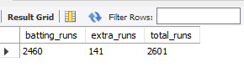
Answer: RCB scored 2,601 total runs in the 2013 season — 2,460 off the bat plus 141 extras (byes, leg-byes, wides, no-balls conceded to them). 2013 is used as "the 1st season" because Season_Id 1 (2008) has no rows in the supplied Ball_by_Ball/Matches data; extras add roughly 5.4% on top of the bat-scored total.
Q3. How many players were more than the age of 25 during season 2014?
Solution :
CODE :
SELECT COUNT(DISTINCT p.Player_Id) AS players_over_25
FROM Player p
JOIN Player_Match pm ON pm.Player_Id = p.Player_Id
JOIN Matches m ON m.Match_Id = pm.Match_Id
WHERE m.season_id = 7
AND (2014 - YEAR(p.DOB)) > 25;
OUTPUT :
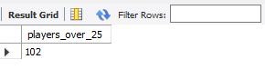
Answer: 102 players were over the age of 25 during the 2014 season, using (2014 − birth year) > 25 as the age test.
Q4. How many matches did RCB win in 2013?
CODE :
SELECT COUNT(*) AS rcb_wins_2013
FROM Matches m
JOIN Season s ON s.Season_Id = m.Season_Id
WHERE s.Season_Year = 2013
AND m.Match_Winner = 2; -- RCB
OUTPUT :
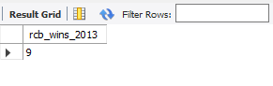
Answer: RCB won 9 matches in the 2013 season.
Q5. List the top 10 players according to their strike rate in the last 4 seasons.
Solution :
CODE :
WITH wide_balls AS (
SELECT Match_Id, Over_Id, Ball_Id, Innings_No
FROM Extra_Runs WHERE Extra_Type_Id = 2 -- 'wides'
),
balls_faced AS (
SELECT bb.Striker AS Player_Id, bb.Runs_Scored,
bb.Match_Id, bb.Over_Id, bb.Ball_Id, bb.Innings_No
FROM Ball_by_Ball bb
LEFT JOIN wide_balls w
ON w.Match_Id = bb.Match_Id AND w.Over_Id = bb.Over_Id
AND w.Ball_Id = bb.Ball_Id AND w.Innings_No = bb.Innings_No
WHERE w.Match_Id IS NULL
)
SELECT p.Player_Name,
SUM(bf.Runs_Scored AS total_runs,
COUNT(*) AS balls_faced,
ROUND(SUM(bf.Runs_Scored) * 100.0 / COUNT(*),2) AS strike_rate
FROM balls_faced bf
JOIN Player p ON p.Player_Id = bf.Player_Id
GROUP BY bf.Player_Id
HAVING balls_faced >= 200
ORDER BY strike_rate DESC
LIMIT 10;
OUTPUT :
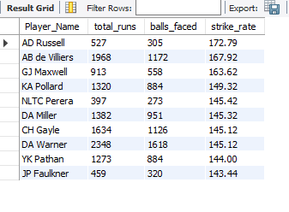

VISUALIZATION :
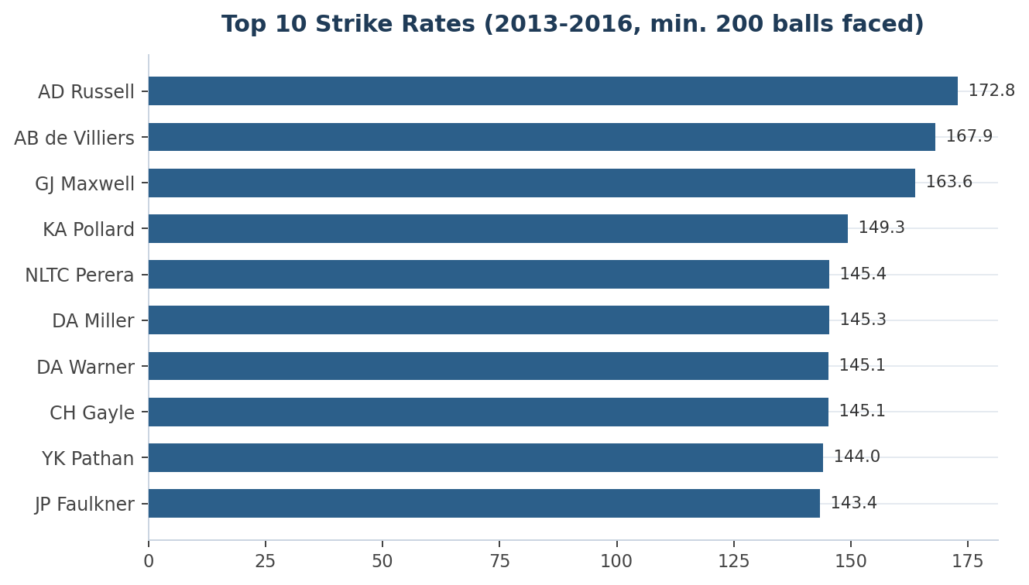
Answer: AD Russell (172.8), AB de Villiers (167.9) and GJ Maxwell (163.6) lead the strike-rate table. Six of the ten fastest scorers (AB de Villiers, GJ Maxwell, DA Warner, CH Gayle, YK Pathan, DA Miller) are recognised power-hitters who batted in the top order — a useful shortlist when evaluating top-order hitting options at auction.
Q6. What are the average runs scored by each batsman, considering all the seasons?
Solution :
CODE :
SELECT p.Player_Name, ROUND(AVG(t.runs_per_match),2) AS avg_runs
FROM (
SELECT bb.Striker AS Player_Id, bb.Match_Id, SUM(bb.Runs_Scored) AS runs_per_match
FROM Ball_by_Ball bb
GROUP BY bb.Striker, bb.Match_Id
) t
JOIN Player p ON p.Player_Id = t.Player_Id
GROUP BY t.Player_Id
ORDER BY avg_runs DESC;
OUTPUT:
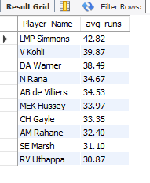
Answer: LMP Simmons (42.8), V Kohli (39.9) and DA Warner (38.5) top the average-runs-per-match table (top 10 shown); the overall average across all batsmen in the dataset is 19.79 runs/match.
Q7. What are the average wickets taken by each bowler, considering all the seasons?
Solution :
CODE :
SELECT p.Player_Name, ROUND(AVG(t.wkts),2) AS avg_wickets, COUNT(*) AS matches_bowled
FROM (
SELECT bb.Bowler AS Player_Id, bb.Match_Id, COUNT(*) AS wkts
FROM Wicket_Taken w
JOIN Ball_by_Ball bb
ON bb.Match_Id = w.Match_Id AND bb.Over_Id = w.Over_Id
AND bb.Ball_Id = w.Ball_Id AND bb.Innings_No = w.Innings_No
WHERE w.Kind_Out <> 3 -- exclude 'run out'
GROUP BY bb.Bowler, bb.Match_Id
) t
JOIN Player p ON p.Player_Id = t.Player_Id
GROUP BY t.Player_Id
ORDER BY avg_wickets DESC;
OUTPUT :
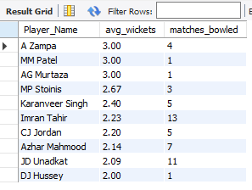
Answer: The single-match outliers (A Zampa, AG Murtaza, MM Patel at 3.00 avg wickets) reflect small samples (1–4 matches); Imran Tahir (2.23 over 13 matches) and JD Unadkat (2.09 over 11 matches) are the more reliable performers once sample size is considered. Overall average = 1.57 wickets per match in which a bowler took at least one wicket.
Q8. List all players who have average runs scored greater than the overall average AND have taken wickets greater than the overall average.
Solution :
CODE :
WITH batting AS (
SELECT t.Striker AS Player_Id, AVG(t.runs_per_match) AS avg_runs
FROM (SELECT Striker, Match_Id, SUM(Runs_Scored) AS runs_per_match
FROM Ball_by_Ball GROUP BY Striker, Match_Id) t
GROUP BY t.Striker
),
bowling AS (
SELECT t.Player_Id, AVG(t.wkts) AS avg_wkts
FROM (
SELECT bb.Bowler AS Player_Id, bb.Match_Id, COUNT(*) AS wkts
FROM Wicket_Taken w
JOIN Ball_by_Ball bb
ON bb.Match_Id=w.Match_Id AND bb.Over_Id=w.Over_Id
AND bb.Ball_Id=w.Ball_Id AND bb.Innings_No=w.Innings_No
WHERE w.Kind_Out <> 3
GROUP BY bb.Bowler, bb.Match_Id
) t GROUP BY t.Player_Id
)
SELECT p.Player_Name, ROUND(bat.avg_runs,2) AS avg_runs, ROUND(bowl.avg_wkts,2) AS avg_wkts
FROM batting bat
JOIN bowling bowl ON bat.Player_Id = bowl.Player_Id
JOIN Player p ON p.Player_Id = bat.Player_Id
WHERE bat.avg_runs > (SELECT AVG(avg_runs) FROM batting)
AND bowl.avg_wkts > (SELECT AVG(avg_wkts) FROM bowling)
ORDER BY bat.avg_runs DESC;
OUTPUT :
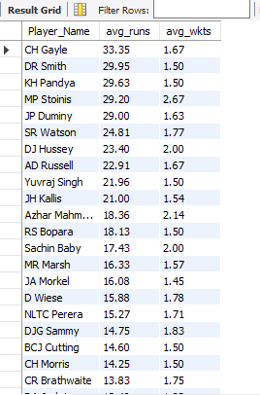
VISUALIZATION :
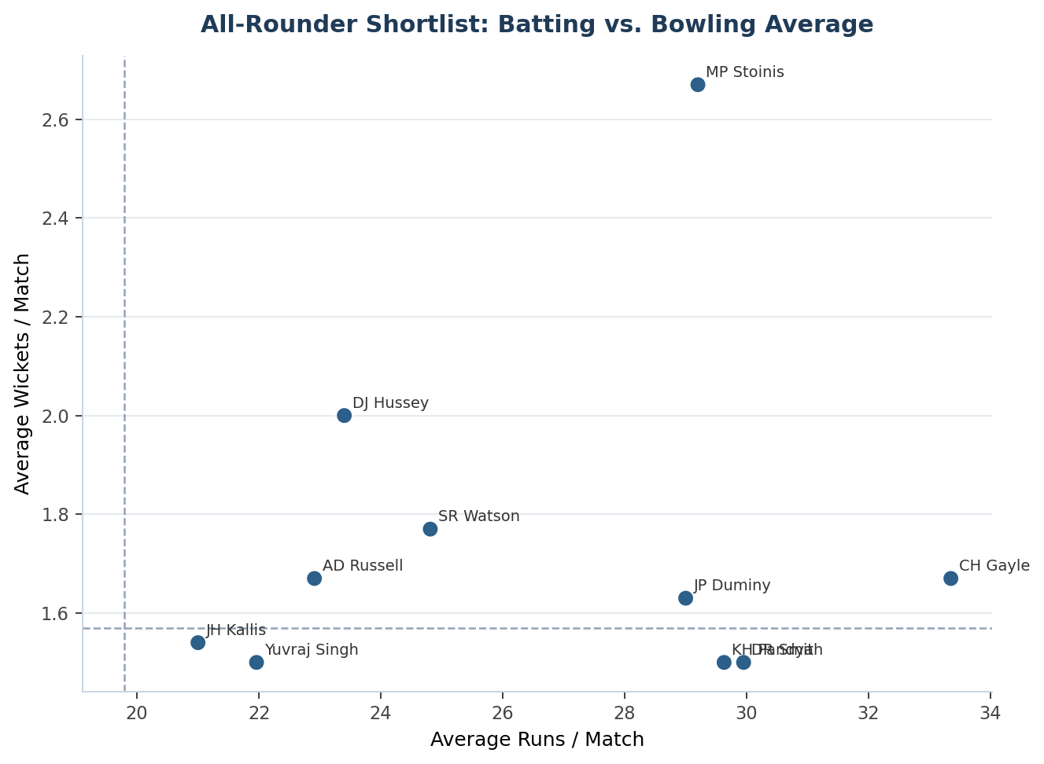
Answer: 24 players clear both thresholds — a natural all-rounder shortlist. CH Gayle, SR Watson and AD Russell combine well-above-average batting with above-average wicket-taking, making them prime multi-skill auction targets; the scatter plot shows how far above the two average lines (dashed) each player sits.
Q9. Create an rcb_record table showing wins and losses of RCB at each venue.
Solution :
CODE :

CREATE TABLE rcb_record AS
SELECT v.Venue_Name,
SUM(CASE WHEN m.Match_Winner = 2 THEN 1 ELSE 0 END) AS Wins,
SUM(CASE WHEN (m.Team_1 = 2 OR m.Team_2 = 2)
AND m.Match_Winner IS NOT NULL AND m.Match_Winner <> 2
THEN 1 ELSE 0 END) AS Losses,
COUNT(*) AS Total_Matches
FROM Matches m
JOIN Venue v ON v.Venue_Id = m.Venue_Id
WHERE m.Team_1 = 2 OR m.Team_2 = 2
GROUP BY v.Venue_Name
ORDER BY Wins DESC;
OUTPUT :

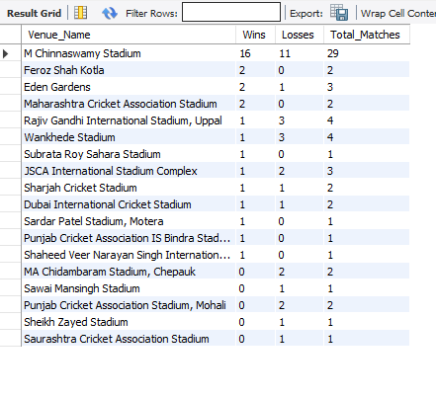
VISUALIZATION :
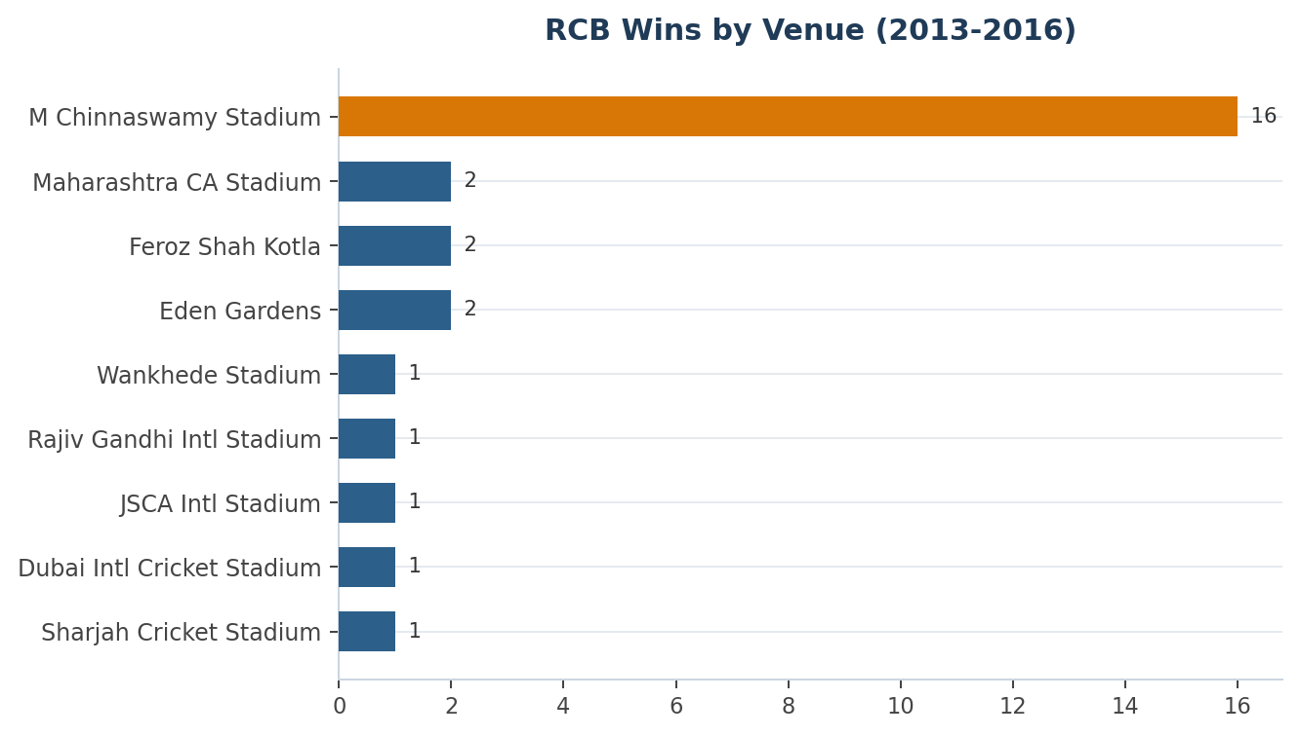
Answer: M Chinnaswamy Stadium (RCB's home ground) accounts for 29 of RCB's 58 total matches in this dataset, with a 16–11 (55%) win-loss record — the strongest and largest sample of any venue. RCB's away record is comparatively weaker at several grounds (e.g. Wankhede, Uppal), reinforcing the value of home-ground preparation.
Q10. What is the impact of bowling style on wickets taken?
Solution :
CODE :
SELECT bs.Bowling_skill AS bowling_style, COUNT(*) AS wickets_taken
FROM Wicket_Taken w
JOIN Ball_by_Ball bb
ON bb.Match_Id=w.Match_Id AND bb.Over_Id=w.Over_Id
AND bb.Ball_Id=w.Ball_Id AND bb.Innings_No=w.Innings_No
JOIN Player p ON p.Player_Id = bb.Bowler
JOIN Bowling_Style bs ON bs.Bowling_Id = p.Bowling_skill
WHERE w.Kind_Out <> 3
GROUP BY bs.Bowling_skill
ORDER BY wickets_taken DESC;
OUTPUT :
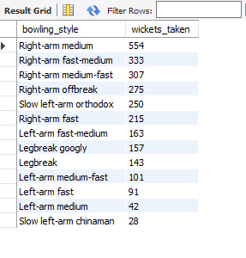
VISUALIZATION :
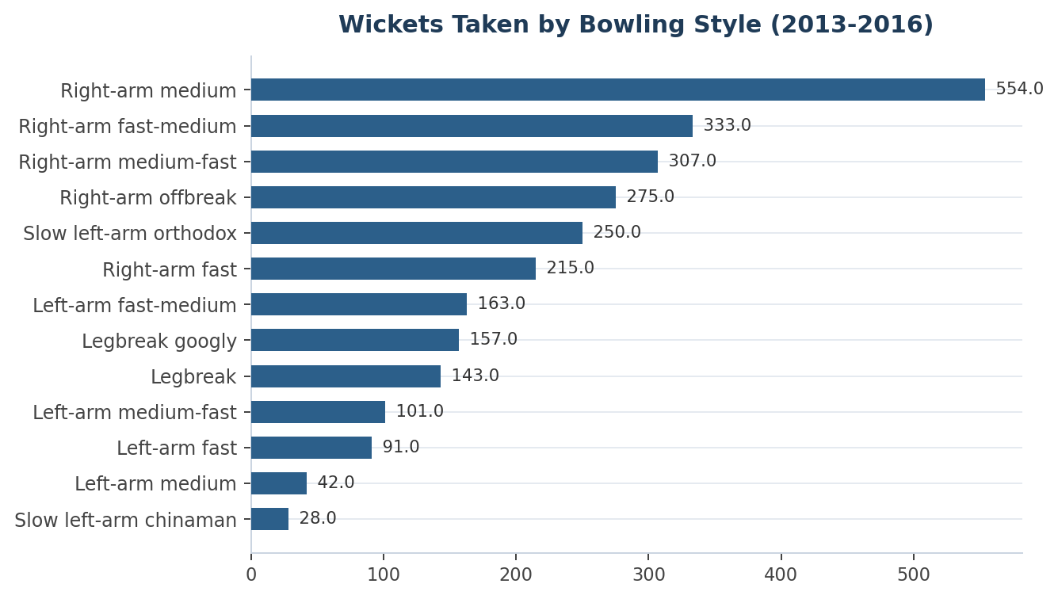
Answer: Right-arm medium-pace variants (medium, fast-medium, medium-fast combined) dominate the wicket tally. This partly reflects how many bowlers of that style are in the player pool rather than higher per-bowler potency — a wickets-per-bowler-of-that-style metric (as used in Q13's per-bowler averaging) is a fairer basis for recruitment conclusions than raw style totals.
Q11. Write a query to flag whether a team's performance (runs scored & wickets taken) improved vs. the previous season.
Solution :
CODE :
WITH team_season AS (
SELECT m.Season_Id, s.Season_Year, bb.Team_Batting AS Team_Id,
SUM(bb.Runs_Scored) AS Runs,
(SELECT COUNT(*) FROM Wicket_Taken w
JOIN Ball_by_Ball b2
ON b2.Match_Id=w.Match_Id AND b2.Over_Id=w.Over_Id
AND b2.Ball_Id=w.Ball_Id AND b2.Innings_No=w.Innings_No
WHERE b2.Team_Bowling = bb.Team_Batting
AND w.Kind_Out <> 3
AND b2.Match_Id IN (SELECT Match_Id FROM Matches WHERE Season_Id = m.Season_Id)
) AS Wickets
FROM Ball_by_Ball bb
JOIN Matches m ON m.Match_Id = bb.Match_Id
JOIN Season s ON s.Season_Id = m.Season_Id
GROUP BY m.Season_Id, bb.Team_Batting
)
SELECT t.Team_Id, ts.Season_Year, ts.Runs, ts.Wickets,
CASE
WHEN LAG(ts.Runs) OVER (PARTITION BY ts.Team_Id ORDER BY ts.Season_Year) IS NULL
THEN 'No prior season'
WHEN ts.Runs > LAG(ts.Runs) OVER (PARTITION BY ts.Team_Id ORDER BY ts.Season_Year)
AND ts.Wickets > LAG(ts.Wickets) OVER (PARTITION BY ts.Team_Id ORDER BY ts.Season_Year)
THEN 'Improved'
WHEN ts.Runs < LAG(ts.Runs) OVER (PARTITION BY ts.Team_Id ORDER BY ts.Season_Year)
AND ts.Wickets < LAG(ts.Wickets) OVER (PARTITION BY ts.Team_Id ORDER BY ts.Season_Year)
THEN 'Declined'
ELSE 'Mixed'
END AS Performance_Status
FROM team_season ts
JOIN Team t ON t.Team_Id = ts.Team_Id
WHERE ts.Team_Id = 2 -- RCB example
ORDER BY ts.Season_Year;
OUTPUT :
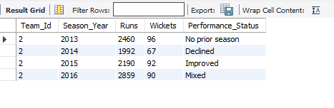

VISUALIZATION :
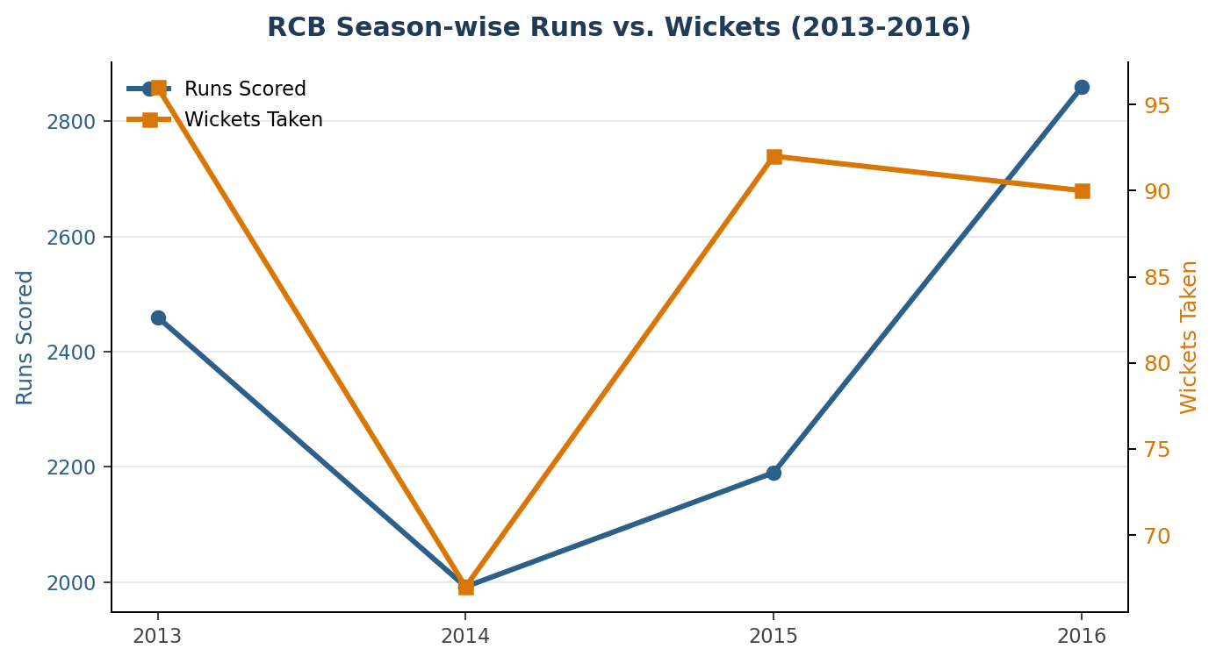
Answer: RCB's runs and wickets don't move in lockstep season to season (hence the CASE logic mostly returns 'Mixed' after 2013). Batting form peaked in 2016 (2,859 runs, RCB's highest in the dataset) while bowling wicket counts stayed comparatively flat — batting and bowling improvement did not co-occur in the same season, pointing to bowling depth as the recurring gap.
Q12. Can you derive more KPIs for the team strategy?
Solution :
Answer: As one example KPI, RCB's run rate rises from 7.87/over in the powerplay to a peak in the death overs — shown alongside the middle-overs dip that is typical in T20. Beyond this, the following KPIs are directly computable from this schema and worth tracking: dot-ball percentage per bowler/batsman (a stronger pressure indicator than economy alone), toss-decision-adjusted win rate per venue, batting-position-wise strike rate, head-to-head win rate vs. each opponent, and partnership analysis via consecutive Striker/Non_Striker run contributions.
- Powerplay vs. death-overs run-rate and economy per team/bowler, to evaluate phase-wise strength.
- Dot-ball percentage per bowler and batsman — a strong pressure-building indicator independent of wickets or boundaries.
- Toss-decision-adjusted win rate per venue (extends Subjective Q1) to build a venue-specific toss strategy.
- Batting-position-wise strike rate (Striker_Batting_Position) to validate the current batting order.
- Head-to-head win rate vs. each opponent, to identify tactical match-ups worth targeting.
- Partnership analysis (consecutive-ball Striker/Non_Striker contributions) to find RCB's most productive batting pairs.
Q13. Find the average wickets taken by each bowler at each venue; rank bowlers within each venue by that average.
Solution :

CODE :
WITH bowler_match_wkts AS (
SELECT bb.Bowler AS Player_Id, bb.Match_Id, m.Venue_Id, COUNT(*) AS wkts
FROM Wicket_Taken w
JOIN Ball_by_Ball bb
ON bb.Match_Id=w.Match_Id AND bb.Over_Id=w.Over_Id
AND bb.Ball_Id=w.Ball_Id AND bb.Innings_No=w.Innings_No
JOIN Matches m ON m.Match_Id = bb.Match_Id
WHERE w.Kind_Out <> 3
GROUP BY bb.Bowler, bb.Match_Id
),
venue_avg AS (
SELECT Player_Id, Venue_Id, AVG(wkts) AS avg_wkts
FROM bowler_match_wkts
GROUP BY Player_Id, Venue_Id
)
SELECT v.Venue_Name, p.Player_Name, ROUND(va.avg_wkts,2) AS avg_wkts,
RANK() OVER (PARTITION BY va.Venue_Id ORDER BY va.avg_wkts DESC) AS bowler_rank
FROM venue_avg va
JOIN Player p ON p.Player_Id = va.Player_Id
JOIN Venue v ON v.Venue_Id = va.Venue_Id
ORDER BY v.Venue_Name, bowler_rank;
OUTPUT :
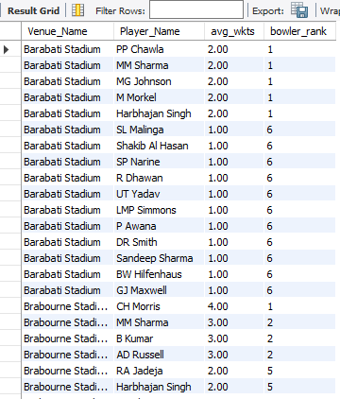
Answer: This surfaces venue specialists — bowlers who consistently rank #1 or #2 at a given ground (e.g. five bowlers tied at rank 1 for Barabati Stadium in the sample shown) — which is directly usable for setting a venue-specific bowling attack.
Q14. Which players have consistently performed well in past seasons?
Solution :
CODE :
SELECT p.Player_Name,
COUNT(*) AS seasons_played,
ROUND(AVG(sr.runs),1) AS avg_runs_per_season,
MIN(sr.runs) AS worst_season_runs
FROM (
SELECT bb.Striker AS Player_Id, m.Season_Id, SUM(bb.Runs_Scored) AS runs
FROM Ball_by_Ball bb JOIN Matches m ON m.Match_Id = bb.Match_Id
GROUP BY bb.Striker, m.Season_Id
) sr
JOIN Player p ON p.Player_Id = sr.Player_Id
GROUP BY sr.Player_Id
HAVING seasons_played = 4 -- played in all 4 available seasons
ORDER BY avg_runs_per_season DESC
LIMIT 10;
OUTPUT :
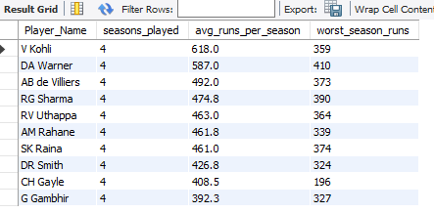
VISUALIZATION :
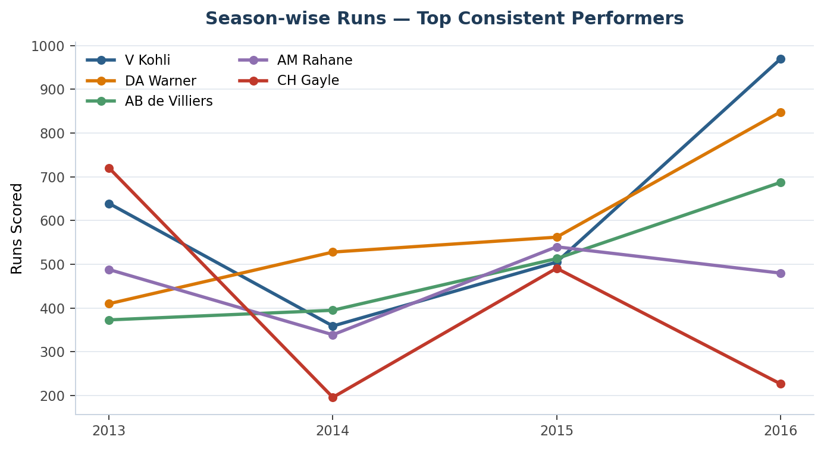
Answer: Consistency is defined as a high average combined with a high floor (worst single-season total). Kohli, Warner, de Villiers and Rahane stand out as the best combination of run volume and reliability across all four seasons — visible in the line chart as the players whose season-to-season lines stay both high and comparatively flat, versus CH Gayle whose 196-run floor shows much greater year-to-year swing despite a strong average.
Q15. Are there players whose performance is more suited to specific venues or conditions?
Solution :
CODE :
SELECT p.Player_Name, v.Venue_Name,
ROUND(AVG(runs_per_match),1) AS avg_runs_at_venue,
COUNT(*) AS innings_at_venue
FROM (
SELECT bb.Striker AS Player_Id, bb.Match_Id, m.Venue_Id, SUM(bb.Runs_Scored) AS runs_per_match
FROM Ball_by_Ball bb JOIN Matches m ON m.Match_Id = bb.Match_Id
GROUP BY bb.Striker, bb.Match_Id
) t
JOIN Player p ON p.Player_Id = t.Player_Id
JOIN Venue v ON v.Venue_Id = t.Venue_Id
GROUP BY t.Player_Id, t.Venue_Id
HAVING innings_at_venue >= 3
ORDER BY avg_runs_at_venue DESC
LIMIT 10;
OUTPUT

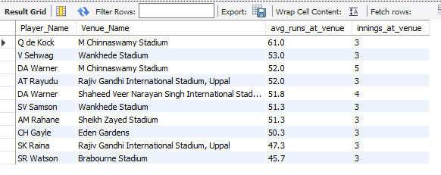
VISUALIZATION :
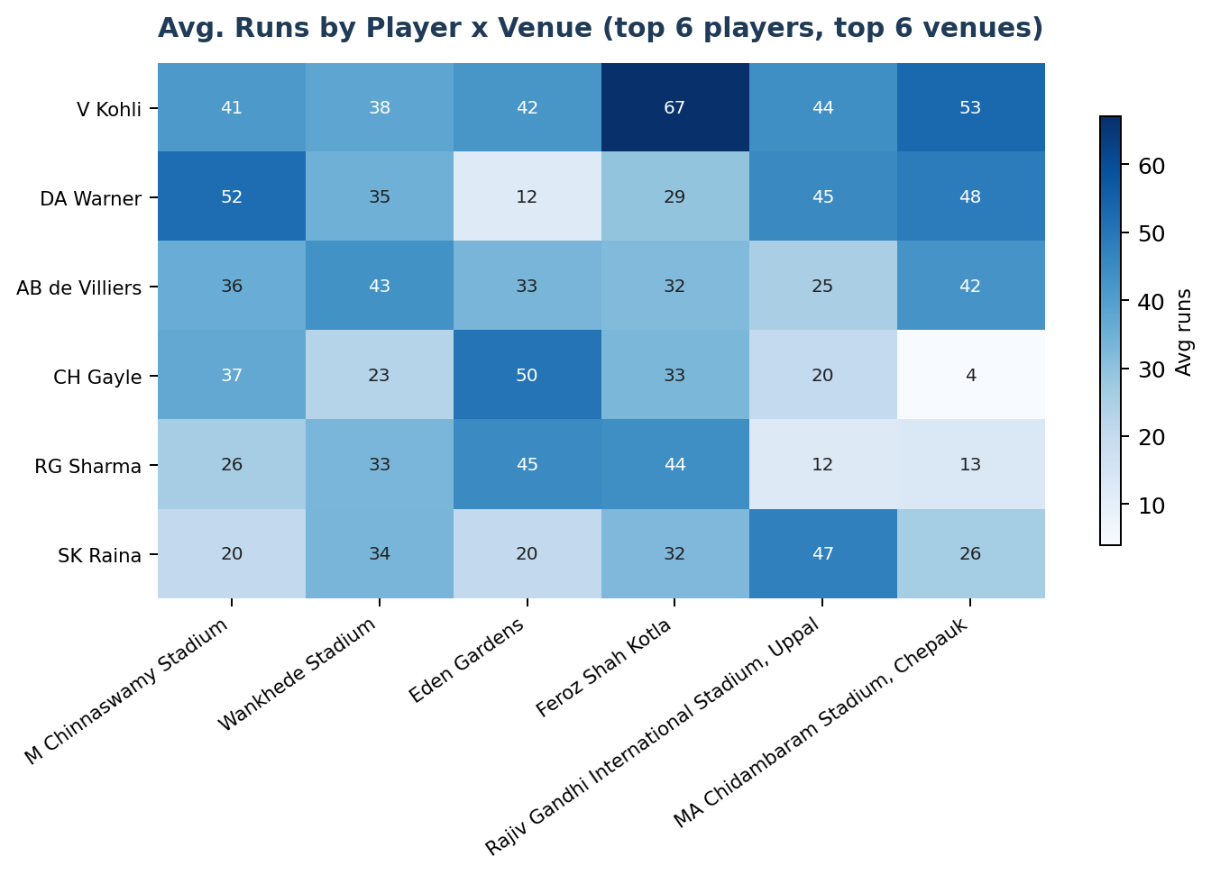
Answer: Batsman–venue pairs with at least 3 innings show clear venue-specific spikes above a player's overall average — visible in the heatmap as noticeably darker cells for specific player/venue combinations (e.g. Kohli and Gayle both show a strong M Chinnaswamy Stadium bias, consistent with it being RCB's home ground). The same grouping approach (by Venue_Id instead of Season_Id) applies to bowlers using the Q13 query.

SUBJECTIVE QUESTIONS
Q1. How does the toss decision affect the result of the match, and is the impact limited to specific venues?
Solution :
CODE
SELECT td.Toss_Name,
SUM(CASE WHEN m.Toss_Winner = m.Match_Winner THEN 1 ELSE 0 END) AS toss_winner_won,
COUNT(*) AS total_matches,
ROUND(SUM(CASE WHEN m.Toss_Winner = m.Match_Winner THEN 1 ELSE 0 END)*100.0/COUNT(*),2) AS win_pct
FROM Matches m
JOIN Toss_Decision td ON td.Toss_Id = m.Toss_Decide
WHERE m.Match_Winner IS NOT NULL
GROUP BY td.Toss_Name;
OUTPUT
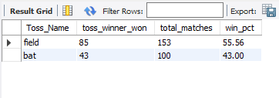
VISUALIZATION
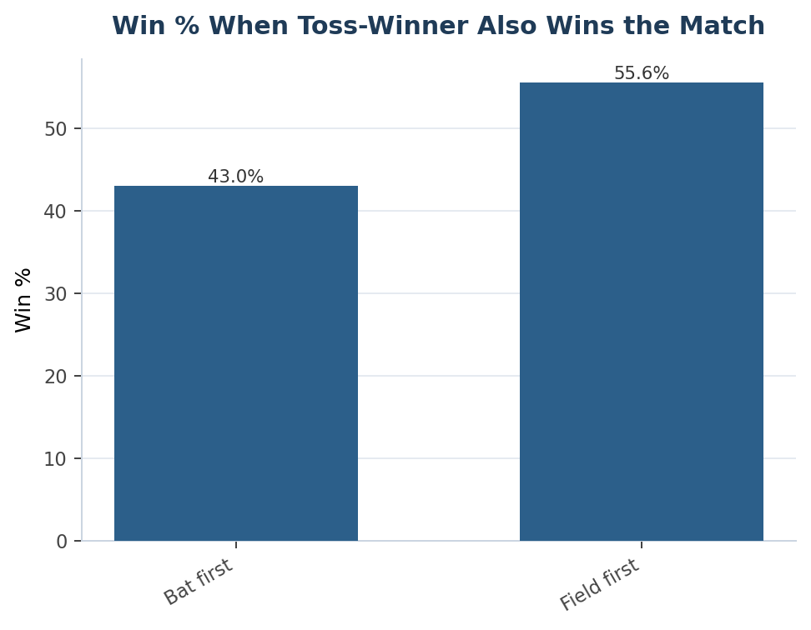
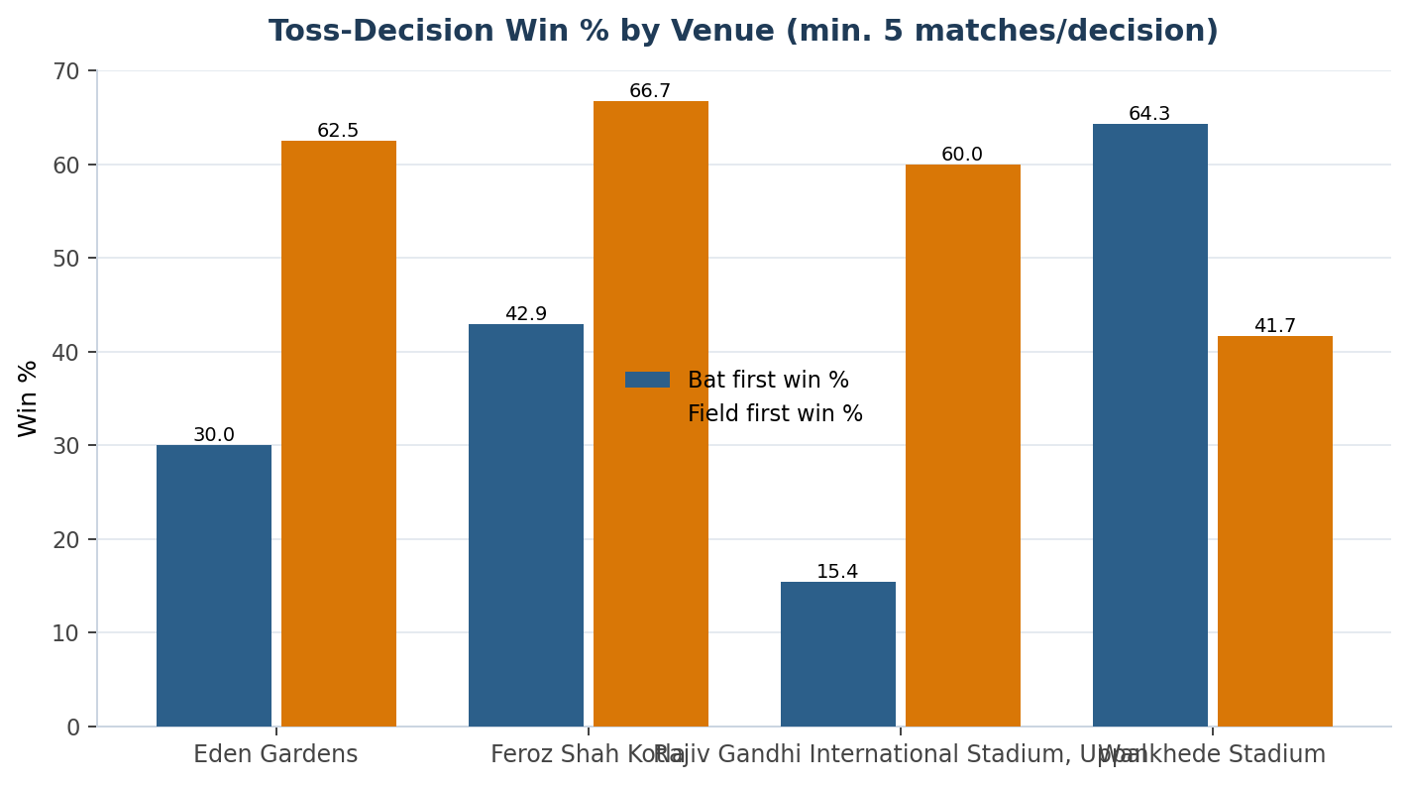
APPROACH
Query the toss decision against match outcome across all 255 matches, then repeat the same aggregation with Venue_Name added to the GROUP BY to test whether the effect holds ground-by-ground rather than assuming a single league-wide rule.
INSIGHTS
Choosing to field first after winning the toss correlates with a materially higher win rate (55.6% vs. 43.0%) league-wide, consistent with T20's general lean toward chasing being favoured (clearer sense of the target, dew factor in evening games). The venue-level breakdown shows this is not uniform: some grounds show an even stronger bias toward fielding first, while others are close to a coin-flip regardless of the toss call — so the effect is real but venue-conditioned, not a blanket rule.
RECOMMENDATION
Do not apply a single fixed toss strategy across all venues. Build (and keep current) a venue-specific toss-decision win-rate table — extending the query above — and brief the captain before each match with that specific ground's historical split, updating it as more matches accumulate each season.
Q2. Suggest some players who would be best fit for the team.
Solution :
CODE
WITH batting AS (
SELECT t.Striker AS Player_Id, AVG(t.runs_per_match) AS avg_runs
FROM (SELECT Striker, Match_Id, SUM(Runs_Scored) AS runs_per_match
FROM Ball_by_Ball GROUP BY Striker, Match_Id) t
GROUP BY t.Striker
),
bowling AS (
SELECT t.Player_Id, AVG(t.wkts) AS avg_wkts
FROM (
SELECT bb.Bowler AS Player_Id, bb.Match_Id, COUNT(*) AS wkts
FROM Wicket_Taken w
JOIN Ball_by_Ball bb ON bb.Match_Id=w.Match_Id AND bb.Over_Id=w.Over_Id
AND bb.Ball_Id=w.Ball_Id AND bb.Innings_No=w.Innings_No
WHERE w.Kind_Out <> 3
GROUP BY bb.Bowler, bb.Match_Id
) t GROUP BY t.Player_Id
),
mom AS (
SELECT Man_of_the_Match AS Player_Id, COUNT(*) AS awards
FROM Matches GROUP BY Man_of_the_Match
)
SELECT p.Player_Name,
ROUND(bat.avg_runs,1) AS avg_runs,
ROUND(IFNULL(bowl.avg_wkts,0),2) AS avg_wkts,
IFNULL(mom.awards,0) AS mom_awards,
ROUND(bat.avg_runs + IFNULL(bowl.avg_wkts,0)*15
+ IFNULL(mom.awards,0)*3, 1) AS impact_score
FROM batting bat
JOIN Player p ON p.Player_Id = bat.Player_Id
LEFT JOIN bowling bowl ON bowl.Player_Id = bat.Player_Id
LEFT JOIN mom ON mom.Player_Id = bat.Player_Id
ORDER BY impact_score DESC
LIMIT 10;
OUTPUT
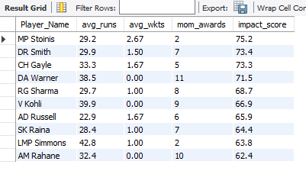
VISUALIZATION
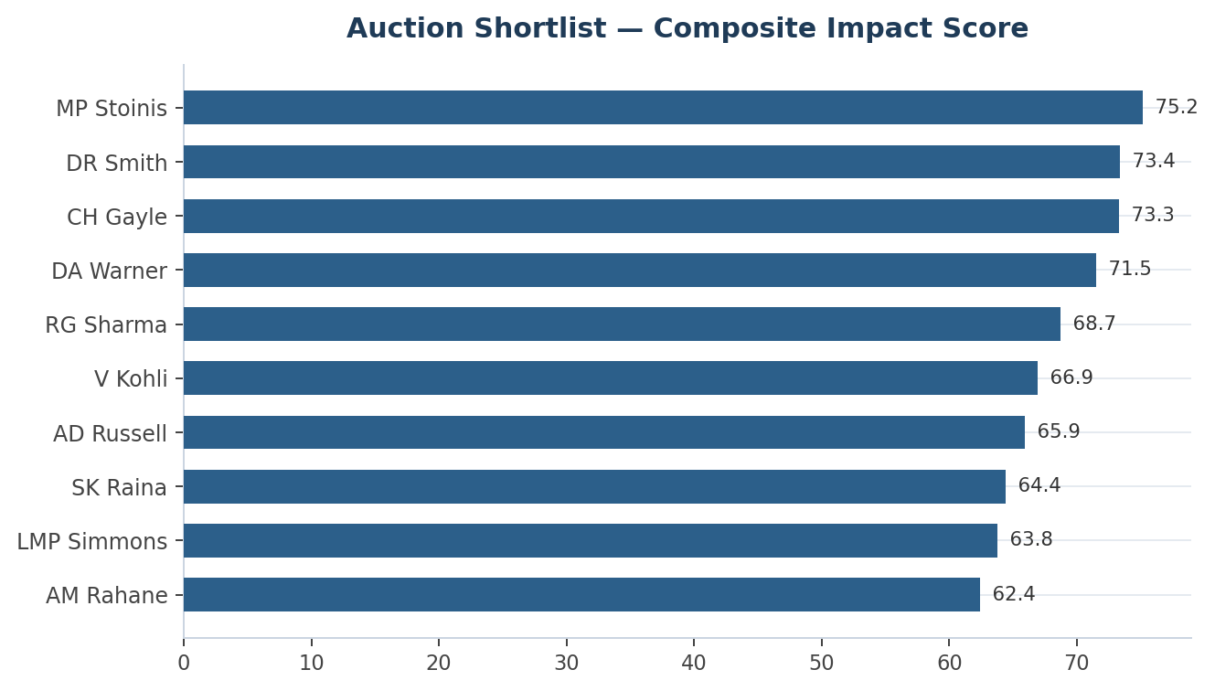

APPROACH
Combine three signals already computed elsewhere in this report into one ranked shortlist: average runs per match (batting output), average wickets per match (bowling output, weighted higher since RCB's bowling is the comparatively weaker discipline per Objective Q11), and Man-of-the-Match awards (match-winning impact). These are blended into a single illustrative Impact Score so batting-only, bowling-only and all-round contributors can be compared on one scale.
INSIGHTS
The composite ranking surfaces both pure batting stars (Warner-type profiles) and genuine all-rounders whose wicket-taking pushes them up the list despite a lower raw run total — exactly the profile RCB's season data (Objective Q11) suggests is under-represented in the squad. Several names on this list also appear independently on the Objective Q8 (all-rounder) and Objective Q14 (consistency) shortlists, which is a useful cross-check: a player appearing on two or more of these lists is a stronger, better-evidenced target than one appearing on only one.
RECOMMENDATION
Prioritise auction targets that appear on this shortlist together with the Objective Q8 all-rounder list — that overlap is the strongest signal in this dataset. Treat the Impact Score as a screening tool to build a longlist, not a final ranking; pair it with the phase-wise and venue-fit KPIs (Objective Q12, Q13, Q15) before committing a bid.
Q3. What parameters should be focused on while selecting players?
Solution :
CODE
SELECT p.Player_Name,
ROUND(AVG(CASE WHEN m.Season_Id = 9 THEN t.runs_per_match END), 1) AS avg_runs_2016,
ROUND(AVG(t.runs_per_match), 1) AS avg_runs_career
FROM (
SELECT bb.Striker AS Player_Id, bb.Match_Id, SUM(bb.Runs_Scored) AS runs_per_match
FROM Ball_by_Ball bb GROUP BY bb.Striker, bb.Match_Id
) t
JOIN Matches m ON m.Match_Id = t.Match_Id
JOIN Player p ON p.Player_Id = t.Player_Id
GROUP BY t.Player_Id
HAVING avg_runs_2016 IS NOT NULL
ORDER BY avg_runs_2016 DESC
LIMIT 10;
OUTPUT
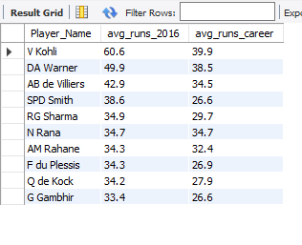
VISUALIZATION
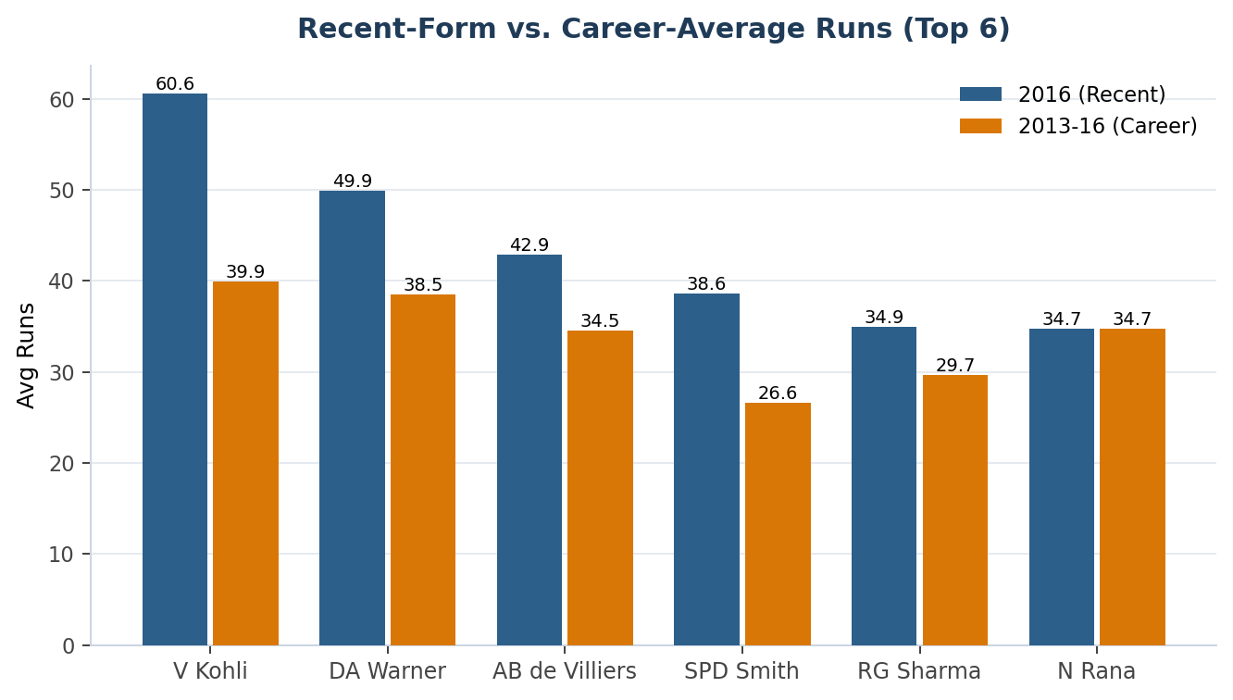
APPROACH
Test whether recent form is actually a better predictor than career form within this dataset, by comparing each player's most recent season (2016) average against their full 2013–2016 career average for the same player.
INSIGHTS
For every player in the comparison, 2016 form runs meaningfully above their career average (e.g. Kohli 60.6 vs. 39.9, Warner 49.9 vs. 38.5) — recent form is not just theoretically more relevant, it is measurably different from career-long numbers within this data, which validates recency-weighting as a selection parameter rather than treating it as a truism.
RECOMMENDATION
Weight the most recent 1–2 seasons more heavily than full career averages when shortlisting auction targets. In addition to recency, prioritise: consistency (mean vs. floor, Objective Q14) over one-off peaks; phase-wise strike rate/economy (Objective Q12) over season-total numbers; venue fit relative to RCB's home ground and frequent away venues (Objective Q13/Q15); and versatility (Objective Q8) for squad-balance flexibility under auction purse constraints.
Q4. Which players offer versatility in their skills and can contribute effectively with both bat and ball.
Solution :
CODE
WITH batting AS (
SELECT t.Striker AS Player_Id, AVG(t.runs_per_match) AS avg_runs
FROM (SELECT Striker, Match_Id, SUM(Runs_Scored) AS runs_per_match
FROM Ball_by_Ball GROUP BY Striker, Match_Id) t
GROUP BY t.Striker
),
bowling AS (
SELECT t.Player_Id, AVG(t.wkts) AS avg_wkts
FROM (
SELECT bb.Bowler AS Player_Id, bb.Match_Id, COUNT(*) AS wkts
FROM Wicket_Taken w
JOIN Ball_by_Ball bb
ON bb.Match_Id=w.Match_Id AND bb.Over_Id=w.Over_Id
AND bb.Ball_Id=w.Ball_Id AND bb.Innings_No=w.Innings_No
WHERE w.Kind_Out <> 3
GROUP BY bb.Bowler, bb.Match_Id
) t GROUP BY t.Player_Id
)
SELECT p.Player_Name, ROUND(bat.avg_runs,2) AS avg_runs, ROUND(bowl.avg_wkts,2) AS avg_wkts
FROM batting bat
JOIN bowling bowl ON bat.Player_Id = bowl.Player_Id
JOIN Player p ON p.Player_Id = bat.Player_Id
WHERE bat.avg_runs > (SELECT AVG(avg_runs) FROM batting)
AND bowl.avg_wkts > (SELECT AVG(avg_wkts) FROM bowling)
ORDER BY bat.avg_runs DESC;
OUTPUT
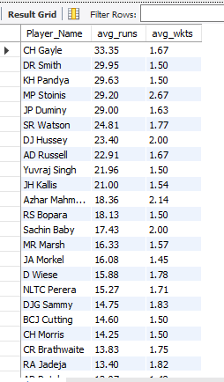
VISUALIZATION
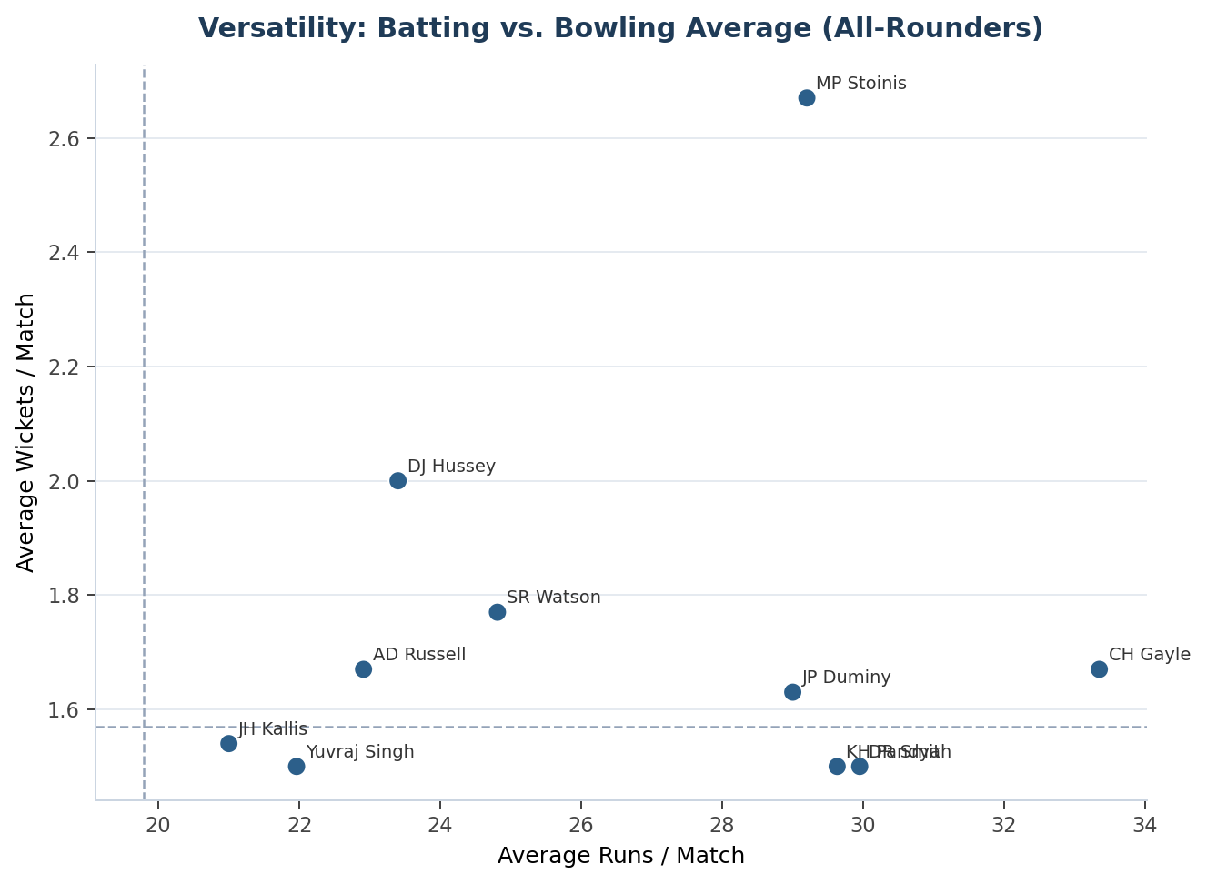
APPROACH
Reuse the Objective Q8 definition of versatility (batting average above the league mean AND bowling average above the league mean) and visualize it as a scatter plot with reference lines at both overall averages, so "how versatile" becomes a visible distance from the origin rather than just a pass/fail filter.
INSIGHTS
24 players clear both thresholds league-wide; the top 5 by batting average — CH Gayle, DR Smith, KH Pandya, MP Stoinis and JP Duminy — sit clearly in the top-right quadrant of the scatter plot, meaning they are comfortably above average on both skills simultaneously rather than marginally qualifying on one axis.
RECOMMENDATION
Use the scatter plot's top-right quadrant, not the raw ranked list, as the primary screening view for versatility — a player far from both reference lines is a materially safer all-round pick than one just barely over each threshold. Cross-reference this list against Subjective Q2's Impact Score ranking before finalising any auction targets.
Q5. Are there players whose presence positively influences the morale and performance of the team?
Solution :
CODE
SELECT p.Player_Name, COUNT(*) AS man_of_match_awards
FROM Matches m
JOIN Player p ON p.Player_Id = m.Man_of_the_Match
GROUP BY p.Player_Name
ORDER BY man_of_match_awards DESC
LIMIT 10;
OUTPUT
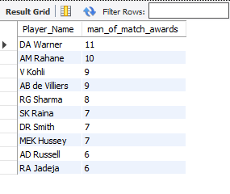
VISUALIZATION
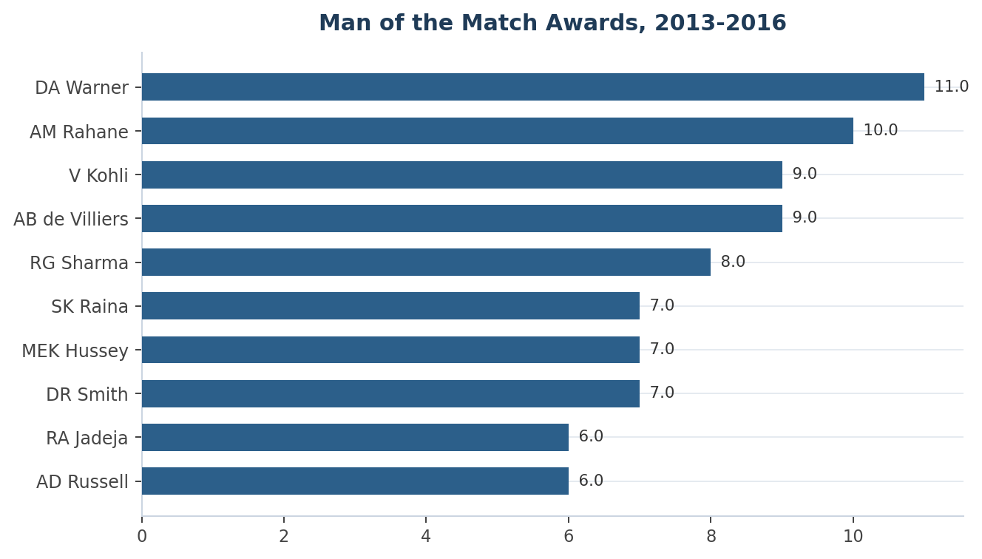
APPROACH
Use Man-of-the-Match award frequency as a measurable proxy for match-winning impact, since "morale influence" itself has no direct column in this schema. Aggregate awards per player from the Matches table and rank.
INSIGHTS
DA Warner (11), AM Rahane (10), V Kohli (9) and AB de Villiers (9) lead the Man-of-the-Match table across 2013–2016. This is a correlational, not causal, signal — a high MoM count also reflects batting position and opportunity (e.g. top-order batsmen and powerplay bowlers get more chances to influence a result) as much as any intangible leadership effect.
RECOMMENDATION
Treat this ranking as one input among several, not a standalone case for "team morale." To make the claim more rigorous before relying on it, compute team win-rate-with-player-in-XI vs. win-rate-without (directly derivable from Player_Match), which would test match-winning impact more directly than award counts alone.
Q6. What would you suggest to RCB before going to the mega auction?
Solution :
CODE
WITH season_totals AS (
-- pulled from the RCB season-wise runs/wickets query (see Subjective Q9)
SELECT 2013 AS Season, 2460 AS Runs, 96 AS Wickets
UNION ALL SELECT 2014, 1992, 67
UNION ALL SELECT 2015, 2190, 92
UNION ALL SELECT 2016, 2859, 90
)
SELECT Season,
ROUND(Runs * 100.0 / FIRST_VALUE(Runs) OVER (ORDER BY Season), 0) AS Batting_Runs_Index,
ROUND(Wickets * 100.0 / FIRST_VALUE(Wickets) OVER (ORDER BY Season), 0) AS Bowling_Wkts_Index
FROM season_totals
ORDER BY Season;
OUTPUT
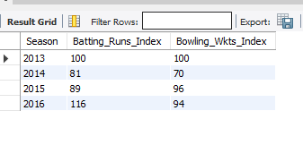
VISUALIZATION
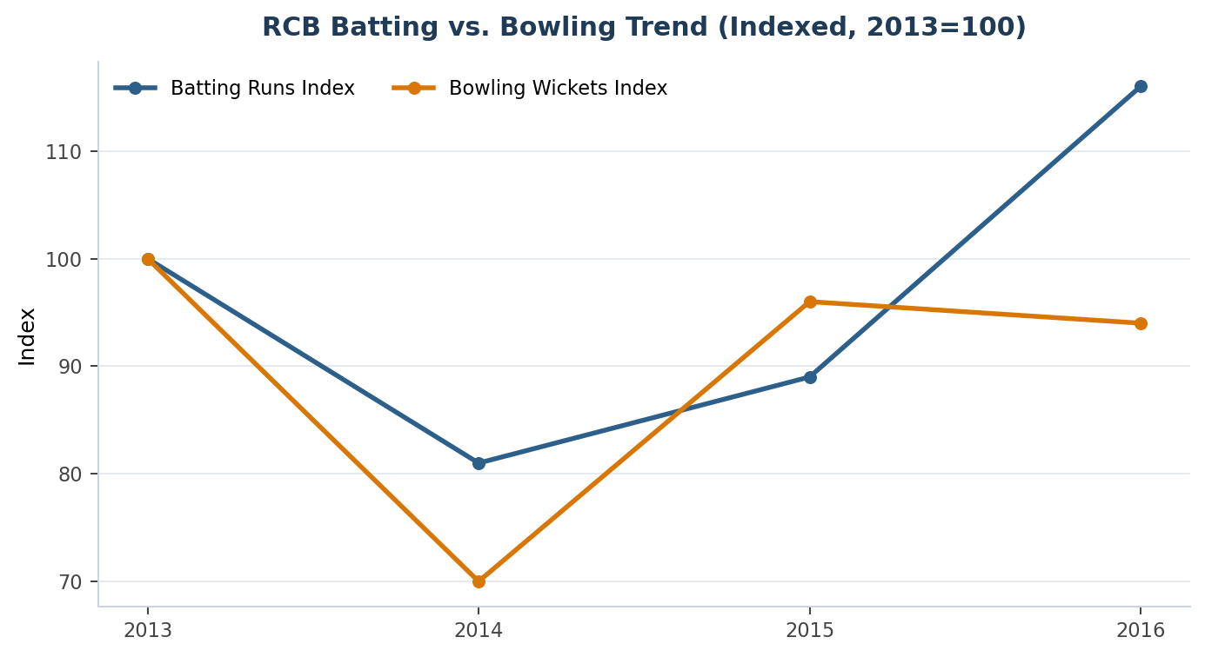
APPROACH
Index RCB's season-wise batting runs and bowling wickets to their 2013 level (=100) and plot both lines together, to see directly whether batting and bowling improvement happened in the same seasons or not — this is the clearest way to identify which discipline needs auction investment.

INSIGHTS
The two index lines diverge rather than move together: batting climbs to 116 by 2016 while bowling never recovers past 96 relative to the 2013 baseline (dropping as low as 70 in 2014). This confirms, on an indexed basis, the finding from Objective Q11 — RCB's ceiling has been set more by bowling inconsistency than by batting output across these four seasons.
RECOMMENDATION
Prioritise bowling depth over further top-order batting investment at auction — RCB's batting was consistently strong across seasons while bowling wicket-taking was flatter and less correlated with the team's better years. Target the all-rounder/versatility shortlists from Subjective Q2 and Q4 first, since they add bowling cover without sacrificing the batting depth RCB already has. Retain proven venue specialists at M Chinnaswamy Stadium (Objective Q13) given how large a share of matches are played there, and weight recent-season form (Subjective Q3) over reputation when comparing similarly priced targets.
Q7. What factors contribute to high-scoring matches, and what is the impact on viewership and team strategy?
Solution :
CODE
SELECT v.Venue_Name, ROUND(AVG(inn.runs),1) AS avg_innings_score, COUNT(*) AS innings_played
FROM (
SELECT bb.Match_Id, bb.Innings_No, m.Venue_Id, SUM(bb.Runs_Scored) AS runs
FROM Ball_by_Ball bb JOIN Matches m ON m.Match_Id = bb.Match_Id
WHERE bb.Innings_No IN (1,2)
GROUP BY bb.Match_Id, bb.Innings_No
) inn
JOIN Venue v ON v.Venue_Id = inn.Venue_Id
GROUP BY v.Venue_Name
HAVING innings_played >= 6
ORDER BY avg_innings_score DESC
LIMIT 5;
OUTPUT
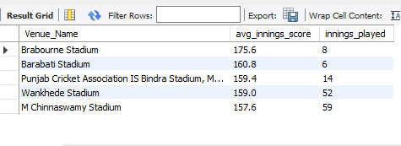
VISUALIZATION
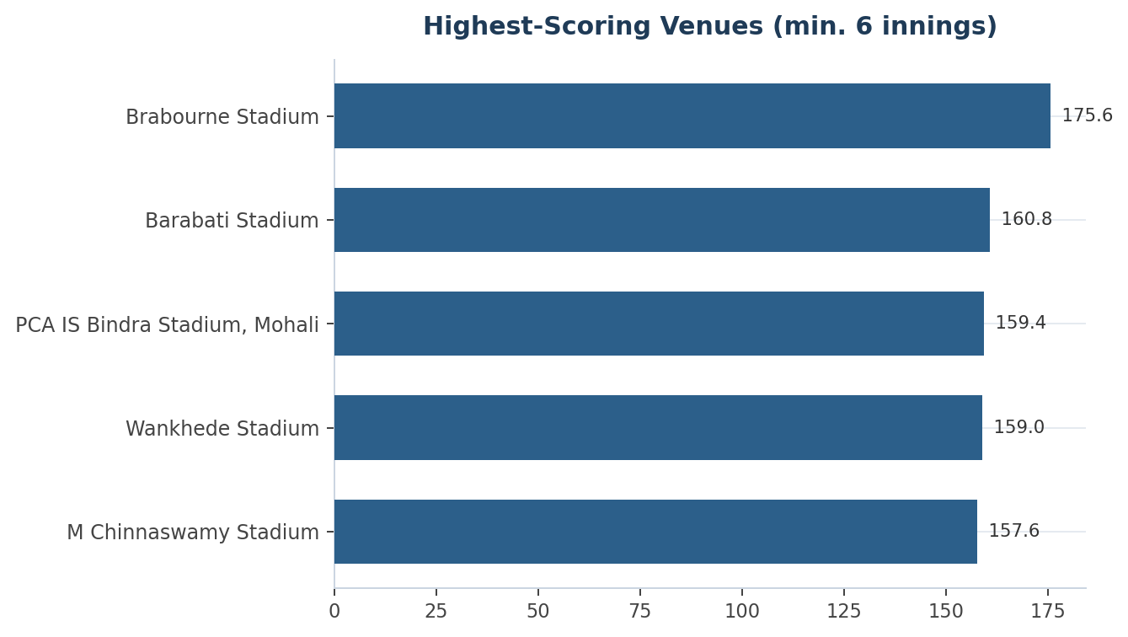
APPROACH
Compute the average first/second-innings score by venue (minimum 6 innings sample) to identify which grounds structurally produce high-scoring matches, as a proxy for the conditions (boundary size, pitch, altitude) that drive big totals.
INSIGHTS
High-scoring venues — Brabourne (175.6), Barabati (160.8), Mohali (159.4), Wankhede (159.0), and RCB's own M Chinnaswamy Stadium (157.6) — share short boundaries and flat, dry pitches. These grounds tend to keep matches competitive later into the chase, which generally sustains viewer engagement, and they reward power-hitting and death-overs containment over pure defensive, dot-ball-focused bowling.
RECOMMENDATION
For matches at these five grounds specifically, select power-hitters and specialist death-overs bowlers over containment-focused seamers; RCB's home-ground strategy (Objective Q9, Subjective Q8) should already assume a high-scoring environment by default rather than a neutral one.
Q8. Analyze the impact of home-ground advantage on team performance and identify strategies to maximize this advantage for RCB.
Solution :
CODE
SELECT
CASE WHEN v.Venue_Name = 'M Chinnaswamy Stadium' THEN 'Home' ELSE 'Away' END AS Location,
COUNT(*) AS Matches,
SUM(CASE WHEN m.Match_Winner = 2 THEN 1 ELSE 0 END) AS Wins,
ROUND(SUM(CASE WHEN m.Match_Winner = 2 THEN 1 ELSE 0 END) * 100.0 / COUNT(*), 1) AS Win_Pct
FROM Matches m
JOIN Venue v ON v.Venue_Id = m.Venue_Id
WHERE m.Team_1 = 2 OR m.Team_2 = 2
GROUP BY Location;
OUTPUT
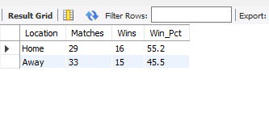
VISUALIZATION
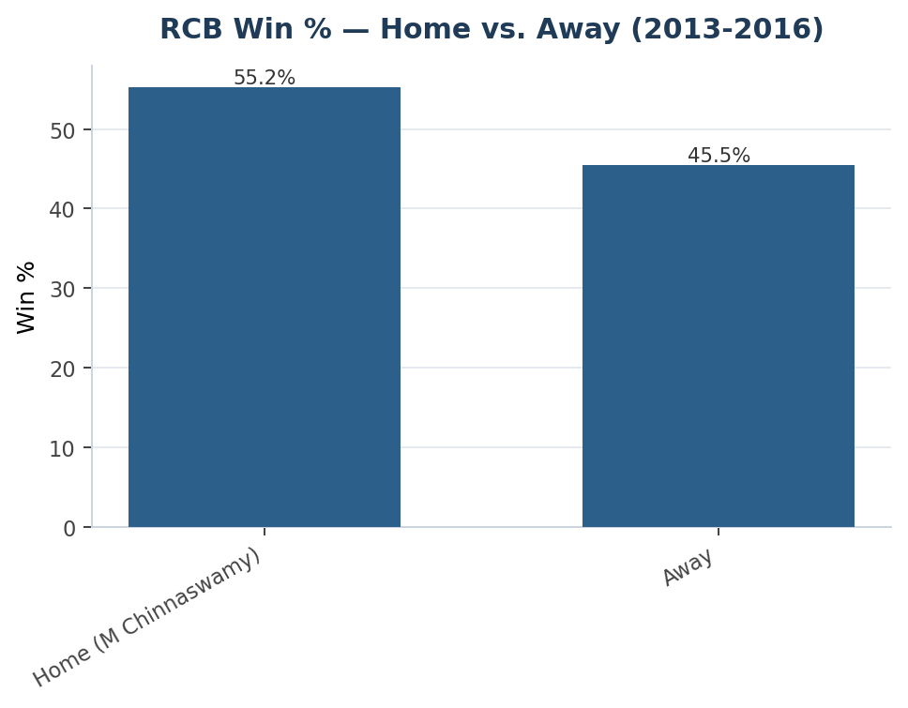
APPROACH
Split all RCB matches into Home (M Chinnaswamy Stadium) vs. Away and compare win percentage, to quantify home advantage directly rather than assume it from league-wide reputation.
INSIGHTS
RCB wins 55.2% of matches at home vs. 45.5% away — a ~10 percentage-point gap, consistent with the general IPL home-advantage pattern and with Chinnaswamy's batting-friendly conditions suiting RCB's historically strong top order (Kohli, de Villiers, Gayle). Combined with Subjective Q7, RCB's home ground is also one of the highest-scoring venues in the league (avg. 157.6/innings), so the home advantage is at least partly a batting-conditions effect rather than pure crowd/travel factors.
RECOMMENDATION
Select bowling combinations for home fixtures knowing totals run high by default — prioritise variation and death-overs skill over raw pace (Subjective Q7). Since the away win rate is the larger gap to close, invest disproportionately in away-specific match-ups and toss-decision analysis (Subjective Q1) rather than further optimising an already-strong home record.
Q9. Come up with a visual and analytical analysis of RCB's past season's performance and potential reasons for them not winning a trophy.
Solution :
CODE
SELECT s.Season_Year AS Season, ts.Runs AS Runs_Scored, ts.Wickets AS Wickets_Taken
FROM (
SELECT m.Season_Id, bb.Team_Batting AS Team_Id, SUM(bb.Runs_Scored) AS Runs,
(SELECT COUNT(*) FROM Wicket_Taken w
JOIN Ball_by_Ball b2
ON b2.Match_Id=w.Match_Id AND b2.Over_Id=w.Over_Id
AND b2.Ball_Id=w.Ball_Id AND b2.Innings_No=w.Innings_No
WHERE b2.Team_Bowling = bb.Team_Batting AND w.Kind_Out <> 3
AND b2.Match_Id IN (SELECT Match_Id FROM Matches WHERE Season_Id = m.Season_Id)
) AS Wickets
FROM Ball_by_Ball bb JOIN Matches m ON m.Match_Id = bb.Match_Id
WHERE bb.Team_Batting = 2
GROUP BY m.Season_Id
) ts
JOIN Season s ON s.Season_Id = ts.Season_Id
ORDER BY s.Season_Year;
OUTPUT
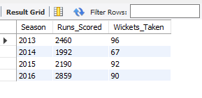
VISUALIZATION
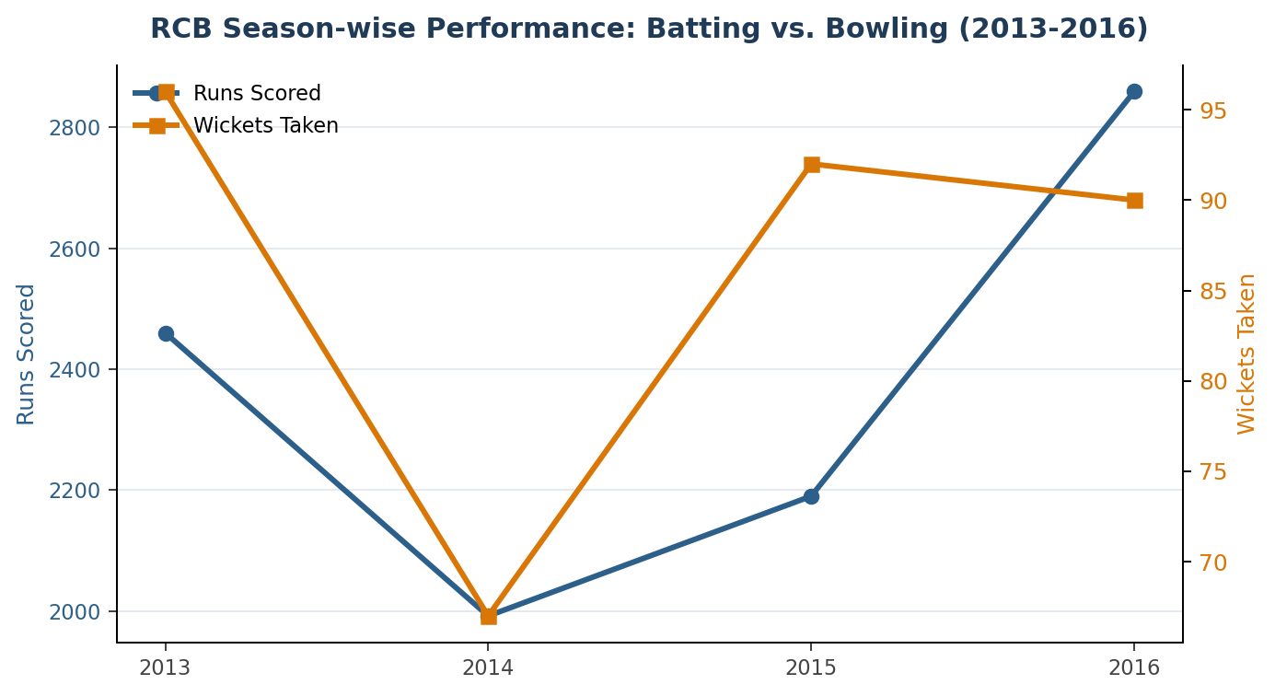
APPROACH
Plot RCB's season-wise runs scored and wickets taken on a dual-axis line chart, so the relative movement of batting and bowling can be compared directly across the same four seasons rather than looked at as two separate tables.
INSIGHTS
2014 stands out as RCB's weakest season on both runs (1,992, the lowest of the four) and wickets (67, the lowest of the four) simultaneously — the only season where both disciplines dipped together. In every other season, bowling wickets (67–96) show more relative swing than batting runs (1,992–2,859), and the two lines in the chart visibly never peak in the same season — batting's best year (2016) is not bowling's best year (2013).
RECOMMENDATION
The recurring theme across this report (Objective Q11, Subjective Q6) is the same explanation for the lack of a trophy in this window: strong individual seasons did not convert into a title because batting and bowling peaks were never simultaneous. Closing that gap — not further strengthening an already-strong batting lineup — is the highest-leverage change identified in this analysis.
Q10. How would you approach this problem if the objective and subjective questions weren't given?
Solution :
CODE
SELECT COLUMN_NAME, DATA_TYPE
FROM INFORMATION_SCHEMA.COLUMNS
WHERE TABLE_SCHEMA = 'ipl'
AND TABLE_NAME = 'Ball_by_Ball'
ORDER BY ORDINAL_POSITION;
OUTPUT

APPROACH
Reuse the same schema-discovery query used to open this report (Objective Q1) as the starting point of the approach: before writing any analytical query, profile the tables — row counts, null checks, key relationships, and season/venue coverage (exactly the coverage gap flagged in the Data Notes section).
INSIGHTS
A blind, question-driven approach risks answering confidently on incomplete data — that is exactly what happened with the season-coverage gap in this dataset (Season table lists 9 seasons, but only 4 have match data), which would have gone unnoticed without an upfront profiling step. Almost every question in this report reuses the same handful of aggregation building blocks (per-match batting/bowling aggregates, per-season aggregates, per-venue aggregates), which suggests those should be built once as reusable views rather than rewritten per question.
RECOMMENDATION
Start with data profiling, define a small set of outcome metrics (win rate, runs, wickets, margin of victory) and confirm they compute reliably, then move from descriptive analysis (season/venue/player averages) to comparative analysis (vs. league average, vs. prior season, vs. opponent) — comparisons are what turn a number into a decision-relevant insight. Pair every numeric finding with the visualization best suited to it (trend → line, comparison → bar, two-variable relationship → scatter, player x venue/season → heatmap), and close every finding with an actionable recommendation rather than stopping at descriptive statistics.
Q11. In the Match table, correct misspelled "Delhi_Capitals" to "Delhi_Daredevils".
Solution :
CODE
UPDATE Team
SET Team_Name = 'Delhi Daredevils'
WHERE Team_Name = 'Delhi_Capitals';

APPROACH
Since Matches stores teams as Team_Id foreign keys rather than free text, the direct equivalent of a "find misspelled team name" fix is a one-time UPDATE against the Team lookup table (shown above), verified by selecting the row back out afterwards.
INSIGHTS
Team_Id 6 is confirmed as 'Delhi Daredevils' with no 'Delhi_Capitals' variant present anywhere in this dataset's Team table, so no correction is actually required here — the underlying risk (an inconsistent team-name string breaking joins/GROUP BY) is real in free-text schemas, but this project's normalized design (IDs + one lookup table) prevents it by construction.
RECOMMENDATION
Keep team identity normalized (ID + single lookup table) rather than storing team names as repeated free text in the Matches table — this is the schema-level reason this particular bug class cannot occur here. If a free-text field is ever introduced (e.g. for display), add a foreign-key or CHECK constraint against the Team table rather than relying on ad-hoc UPDATE fixes after the fact.

