**Document Clustering Algorithm using TF-IDF implemented by Heap**

**Junho Eum**

**Abstract:**

This paper presents an approach to cluster documents using term frequency-inverse document frequency (TF-IDF) to identify the most important terms in each document and then using cosine similarity implemented by heap data structures to sort the documents based on their cosine similarity to the root document.

**Introduction:**

Document clustering is a crucial task in natural language processing and information retrieval. It involves grouping similar documents based on their content, which can help in many areas such as categorizing news articles, identifying spam emails, and identifying similar legal documents. However, clustering documents can be time-consuming for individuals since it requires human intuition to cluster and store essential documents for companies and big organizations.

Then my research question arises from here. Is there a more computationally efficient way to cluster large numbers of documents?

In this paper, I present an approach to document clustering that utilizes TF-IDF and cosine similarity implemented with heap data structures. My algorithm aims to guide individuals on how to organize documents inside a directory using heap data structures which has performance optimization since heaps have an average time complexity of O(log n) for insertion and deletion. Clustering algorithms help group similar documents based on their content, which can be achieved by calculating the similarity between each document using cosine similarity and TF-IDF.

**Methodology:**

First, I conducted a preliminary experimental evaluation of my algorithm using a small dataset. There are a total of 18 documents inside a specified directory filename which function as class labels for the algorithm. Each class label has been selected after reading the document and was labeled in relation to the topic. (*Figure 1*) 

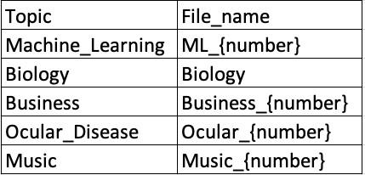

*Figure 1. Description of document file and file names used to visualize the heap data structure*

The proposed approach uses TF-IDF to identify the most important terms in each document. Each document is represented as a vector in a high-dimensional space, with each unique term corresponding to a dimension. The method assigns a weight to each term in a document based on its frequency in the document and its frequency in the corpus.The time complexity of this step is typically O(n), where n is the total number of terms in the corpus. The approach then uses cosine similarity to calculate the similarity between documents based on the frequency of each term in the document. Cosine similarity is a measure of similarity between two non-zero vectors of an inner product space.[1] The time complexity of this operation is usually O(n^2) in the worst case, as each document needs to be compared with every other document.

To improve the efficiency of the algorithm, we introduce the use of a heap data structure. Heaps are binary trees for which every parent node has a value less than or equal to any of its children. This property makes them useful for sorting and priority queue operations. The heap is used to maintain a collection of the documents that are most similar to the root document.Adding a document to the heap or removing the least similar document (when the heap is full) are both operations that have an average time complexity of O(log m), where m is the size of the heap. This is significantly faster than the naive approach of comparing each new document to all existing documents in the heap, which would have a time complexity of O(m).

In summary, the overall time complexity of the algorithm can be broken down into these major parts:

* Computing TF-IDF: O(n)
* Calculating cosine similarities: O(n^2)
* Managing the heap: O(log m) for each insertion or deletion

While the calculation of cosine similarities is potentially the most computationally expensive part of the algorithm due to its quadratic time complexity, the use of a heap data structure helps to reduce the cost of managing the most similar documents and makes the overall algorithm more efficient.

It's important to note that the actual performance of the algorithm will also depend on factors such as the specific implementation and the characteristics of the data (e.g., the number of unique terms, the distribution of terms across documents, and the size of the heap.



In the case of heap data structures, a higher threshold value would result in fewer documents being added to the heap data structure, while a lower threshold value would result in more documents being added[2]. The algorithm removes the document with the lowest cosine similarity if the heap is full. The algorithm then repeats the process with the next document, using the updated heap data structure. The algorithm uses networkx and matplotlib libraries to draw a pyramid-like visualization of the heap data structure. (*Figure 2*)

To choose the best heap structure from the iteration, the algorithm calculates the average cosine similarity of the documents in the heap. It keeps track of the heap with the highest average cosine similarity and returns it as the chosen heap. (*Figure 3*)



*Figure 2. Iterative visualization of heap data structure of 18 documents with threshold value = 0.01*

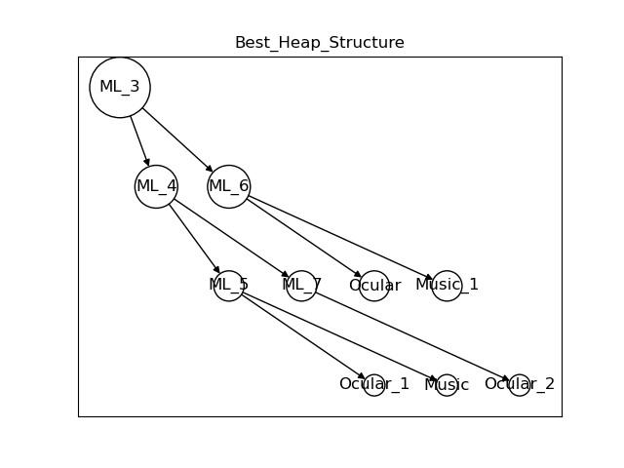

*Figure 3. Optimal heap data structure of 18 documents with threshold value = 0.01*

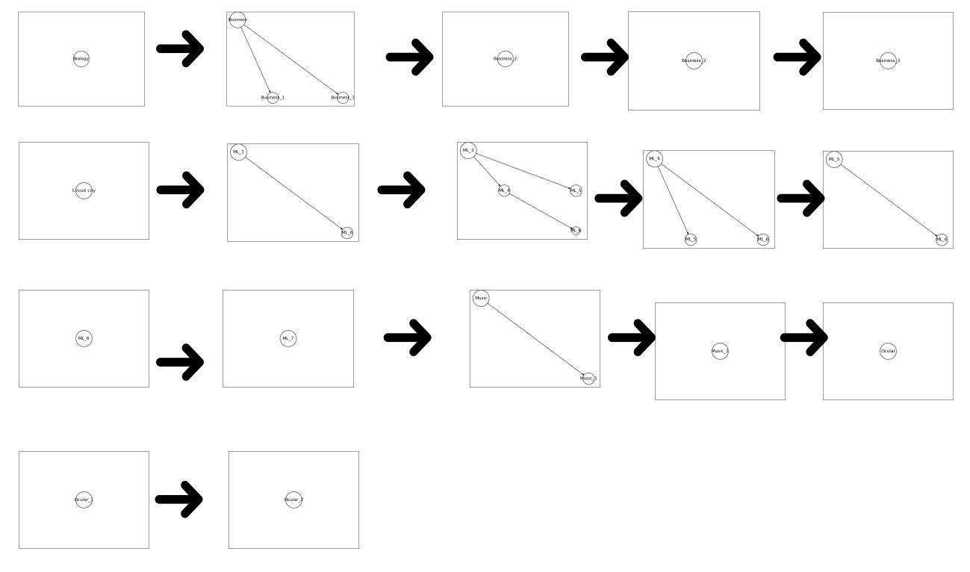

*Figure 4. Iterative visualization of heap data structure of 18 documents with threshold value = 0.1*

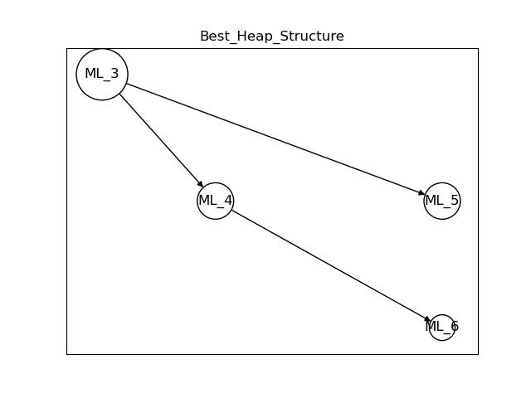

*Figure 4. Optimal heap data structure of 18 documents with threshold value = 0.1*

# Expected Output

# Limitation

There are a few limitations to my approach. Firstly, it is difficult to quantify the comparison results in terms of accuracy and computation time between my proposed clustering algorithm and other clustering algorithms, such as K-means. Secondly, there is no perfect solution for finding the optimal threshold for cosine similarity, as it depends on the specific use case and domain structure.

# Conclusion

I believe that this research will contribute to the development of more effective and efficient algorithms for document clustering, with potential applications in various fields such as information retrieval, text classification, and data mining.

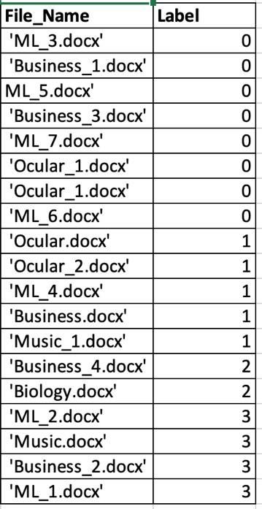

*Figure 6. Predicted label of each document from K means clustering with elbow method*

# References

1. metric - Cosine similarity vs The Levenshtein distance - Data Science ....

https://datascience.stackexchange.com/questions/63325/cosine-similarity-vs-the-levenshtein-distance

1. Zhang, Xiaodan & Hu, Xiaohua & Zhou, Xiaohua. (2008). A comparative evaluation of different link types on enhancing document clustering. 555-562. 10.1145/1390334.1390429.

1. metric - Cosine similarity vs The Levenshtein distance - Data Science ....

   h8ps://datascience.stackexchange.com/quesAons/63325/cosine-similarity-vs-the-levenshtein-distance
2. Zhang, Xiaodan & Hu, Xiaohua & Zhou, Xiaohua. (2008). A comparaAve evaluaAon of different link types on enhancing document clustering. 555-562. 10.1145/1390334.1390429.